**package** phase1Assignment;

**public** **class** DefModfier {

//1. Class is having Default access modifier

**void** display()

{

System.***out***.println("You are using defalut access specifier");

}

}

**package** phase1Package2;

**import** phase1Assignment.*;

**public** **class** AccessSpecifier1 {

**public** **static** **void** main(String[] args) {

// **TODO** Auto-generated method stub

//default

System.***out***.println("Dafault Access Specifier");

DefModifier obj = **new** DefModifier();

obj.display();

}

}

// output = compile time error

// java code to illustrate error while using class from different package with default modifier

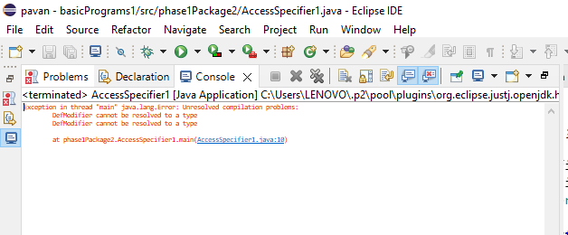

//2. using private access specifiers

**class** priaccessspecifier

{

**private** **void** display() {

System.***out***.println("You are using private access specifier");

}

}

**public** **class** accessSpecifiers2 {

**public** **static** **void** main(String[] args) {

//private

System.***out***.println("Private Access Specifier");

priaccessspecifier obj = **new** priaccessspecifier();

obj.display();

//trying to access private method of another class

//output = error : display() has private access in priaccesspecifier

obj.display

}

}

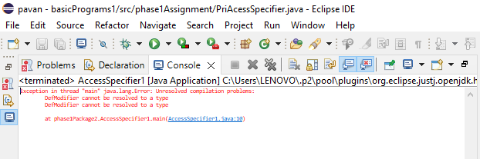

-----------------------------------------------------------------------------------------------------------------------

//3. using protected access specifiers

**package** phase1Assignment;

**public** **class** proaccessspecifiers {

**protected** **void** display()

{

System.***out***.println("This is protected access specifier");

}

}

//create another package

**package** phase1Package2;

**import** phase1Assignment.* ;

**public** **class** accessSpecifiers3 **extends** proaccessspecifiers {

**public** **static** **void** main(String[] args) {

accessSpecifiers3 obj = **new** accessSpecifiers3 ();

obj.display();

}

}

//output: This is Protected access specifier

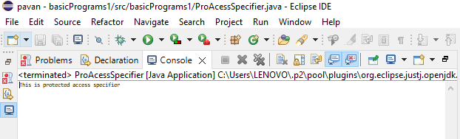

--------------------------------------------------------------------------------------------------------------------

//4. using public access specifiers

**package** phase1Assignment;

**public** **class** pubaccessspecifiers {

**public** **void** display()

{

System.***out***.println("This is Public Access Specifiers");

}

}

//create another package

**package** phase1Package2;

**import** phase1Assignment.*;

**public** **class** accessSpecifiers4 {

**public** **static** **void** main(String[] args) {

pubaccessspecifiers obj = **new** pubaccessspecifiers();

obj.display();

}

}

//Output: This public Access Specifier

