**Constructors**

**1)Default Constructor**

**package** Pack1;

**public** **class** Empinfo {

**int** id;

String name;

**void** display() {

System.***out***.println(id+" "+name);

}

}

**package** Pack1;

**public** **class** DefaultConstructor {

**public** **static** **void** main(String[] args) {

// **TODO** Auto-generated method stub

Empinfo emp1=**new** Empinfo();

Empinfo emp2=**new** Empinfo();

emp1.display();

emp2.display();

}

}

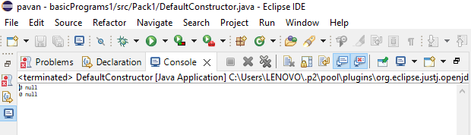

**2)Parametarised Constructor**

**package** Pack1;

**public** **class** Std {

//parameterized constructor

**int** id;

String name;

Std(**int** i,String n)

{

id=i;

name=n;

}

**void** display() {

System.***out***.println(id+" "+name);

}

}

**package** Pack1;

**public** **class** ParametarisedConstr {

**public** **static** **void** main(String[] args) {

// **TODO** Auto-generated method stub

Std std1=**new** Std(18,"pavan");

Std std2=**new** Std(26,"pavani");

std1.display();

std2.display();

}

}

