**Section-1**

22)Create a new assignments folder:

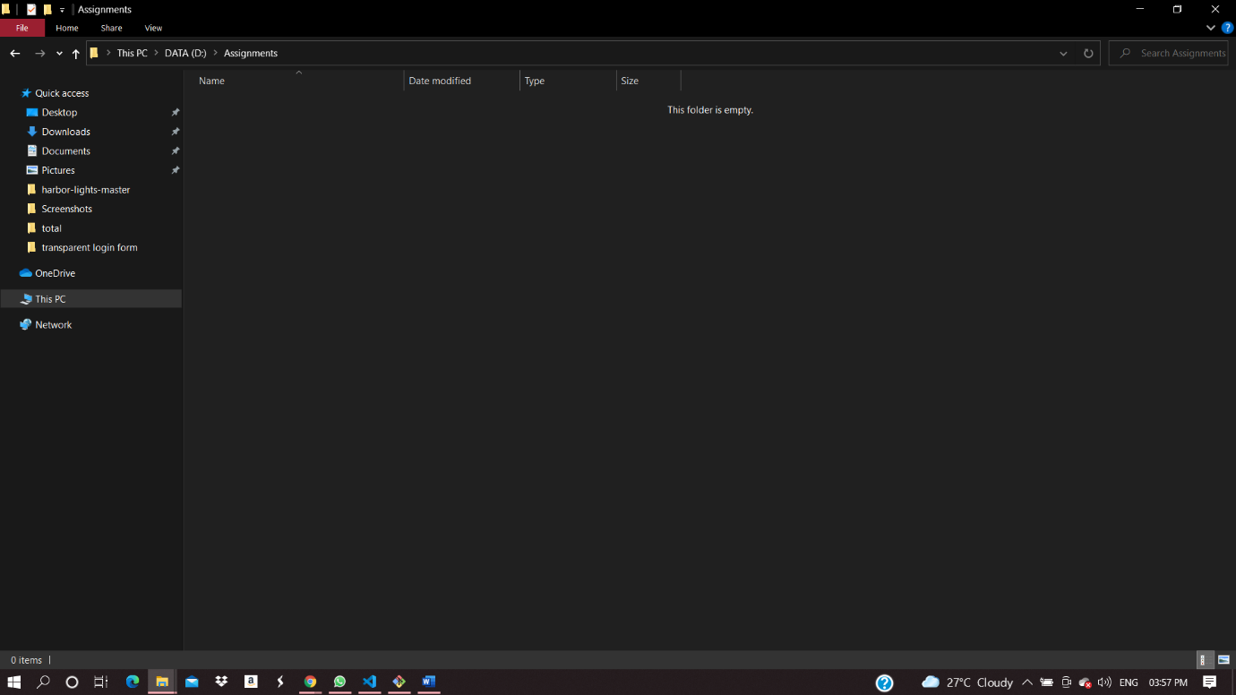

23)Creating Readme.txt :

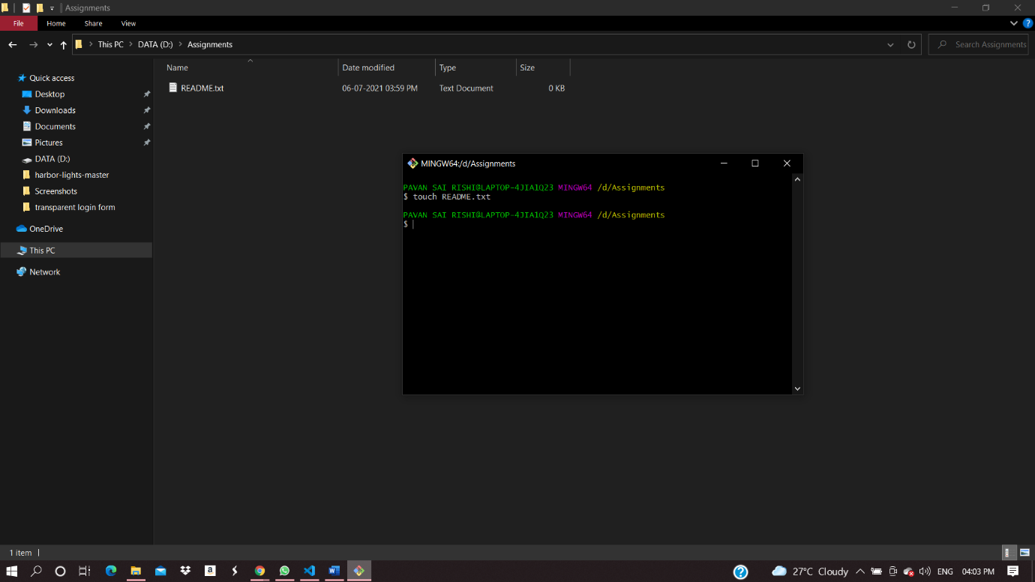

24)commit readme.txt:

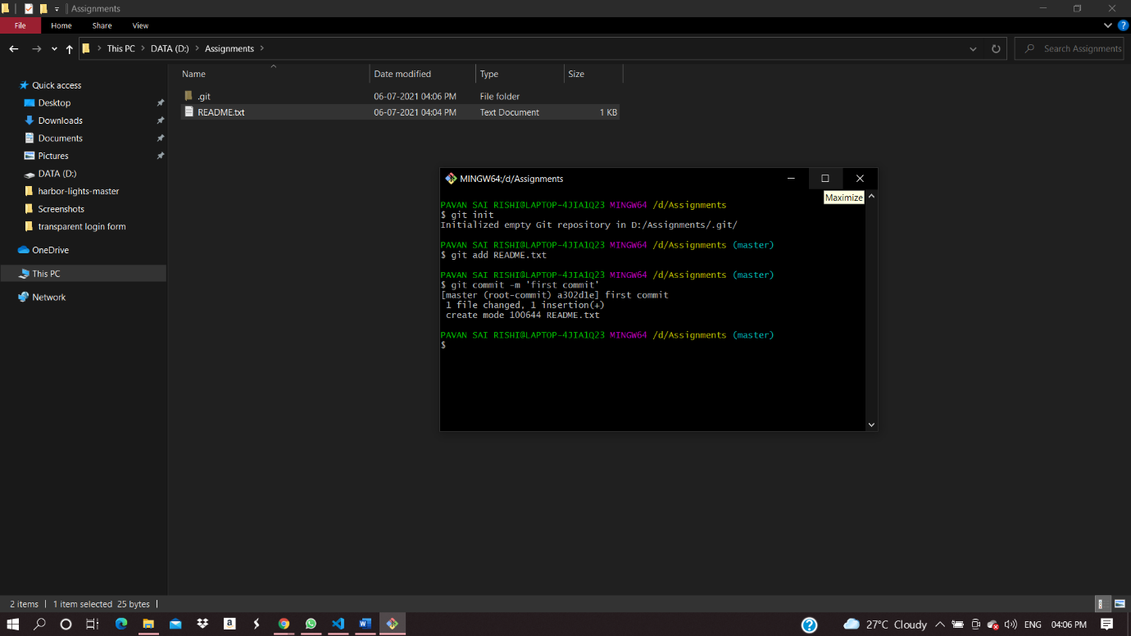

25)new branch html-assignments :

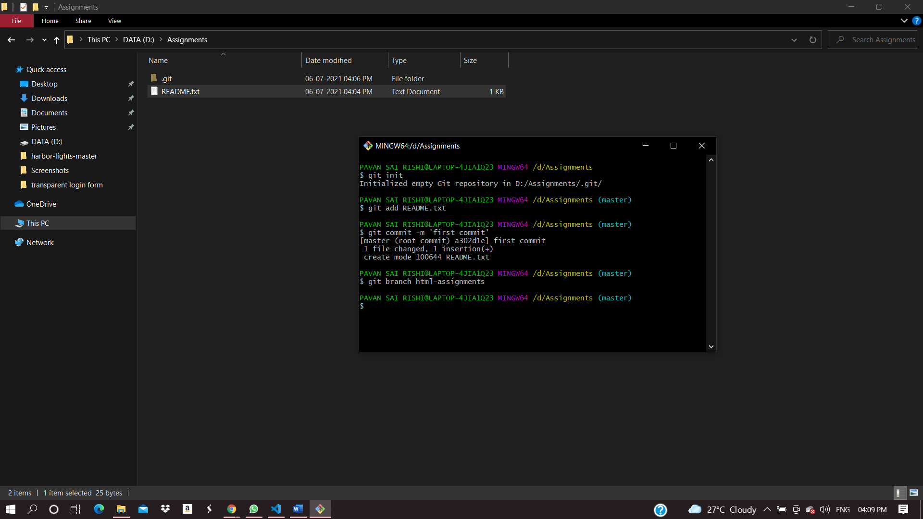

26)switch to html-assignments branch:

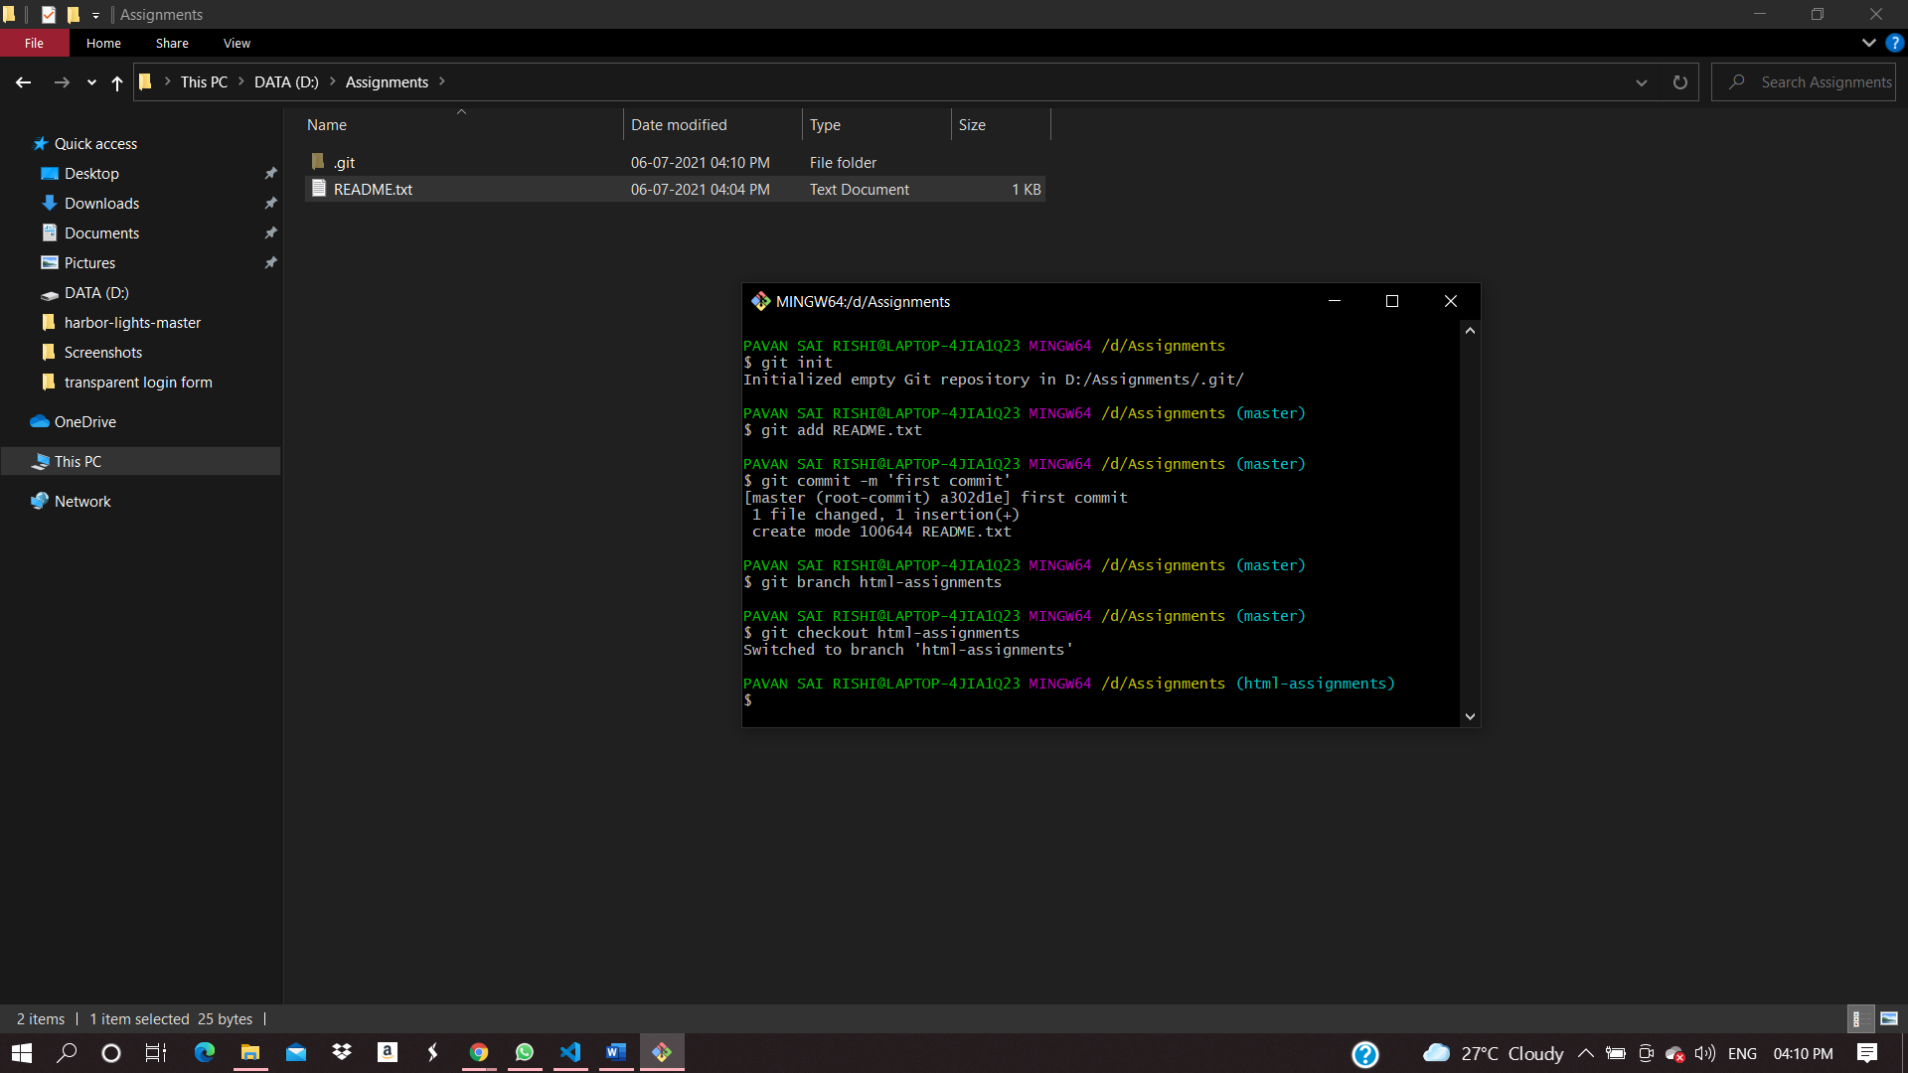

27) copy html assignments

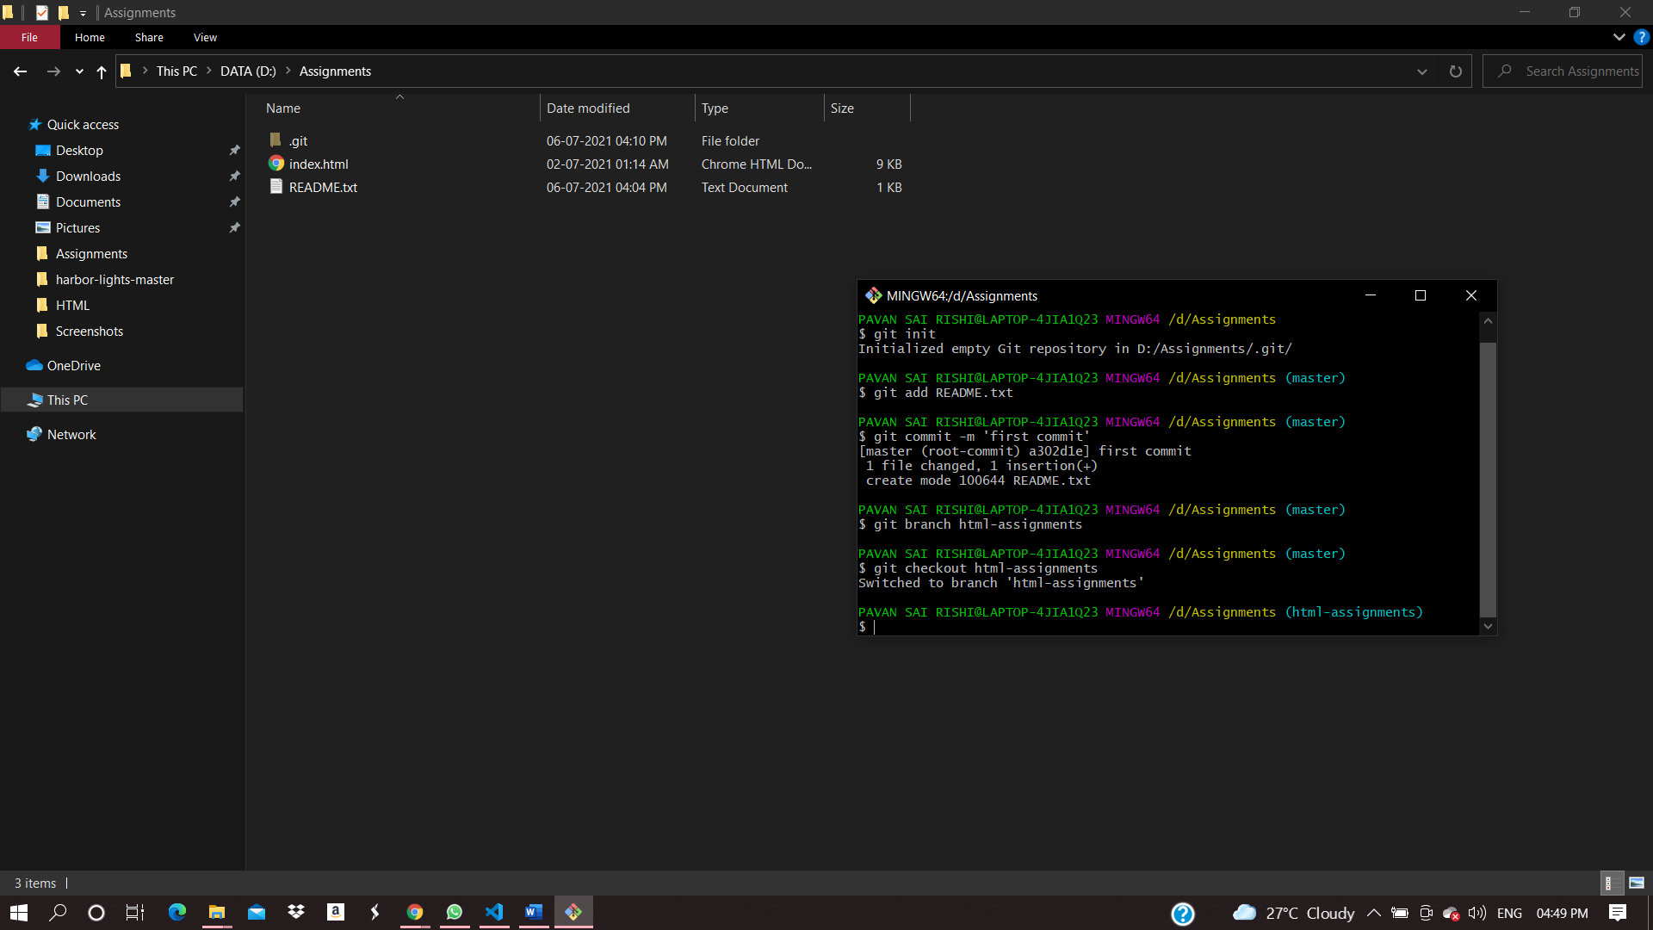

28)commit html assignments:

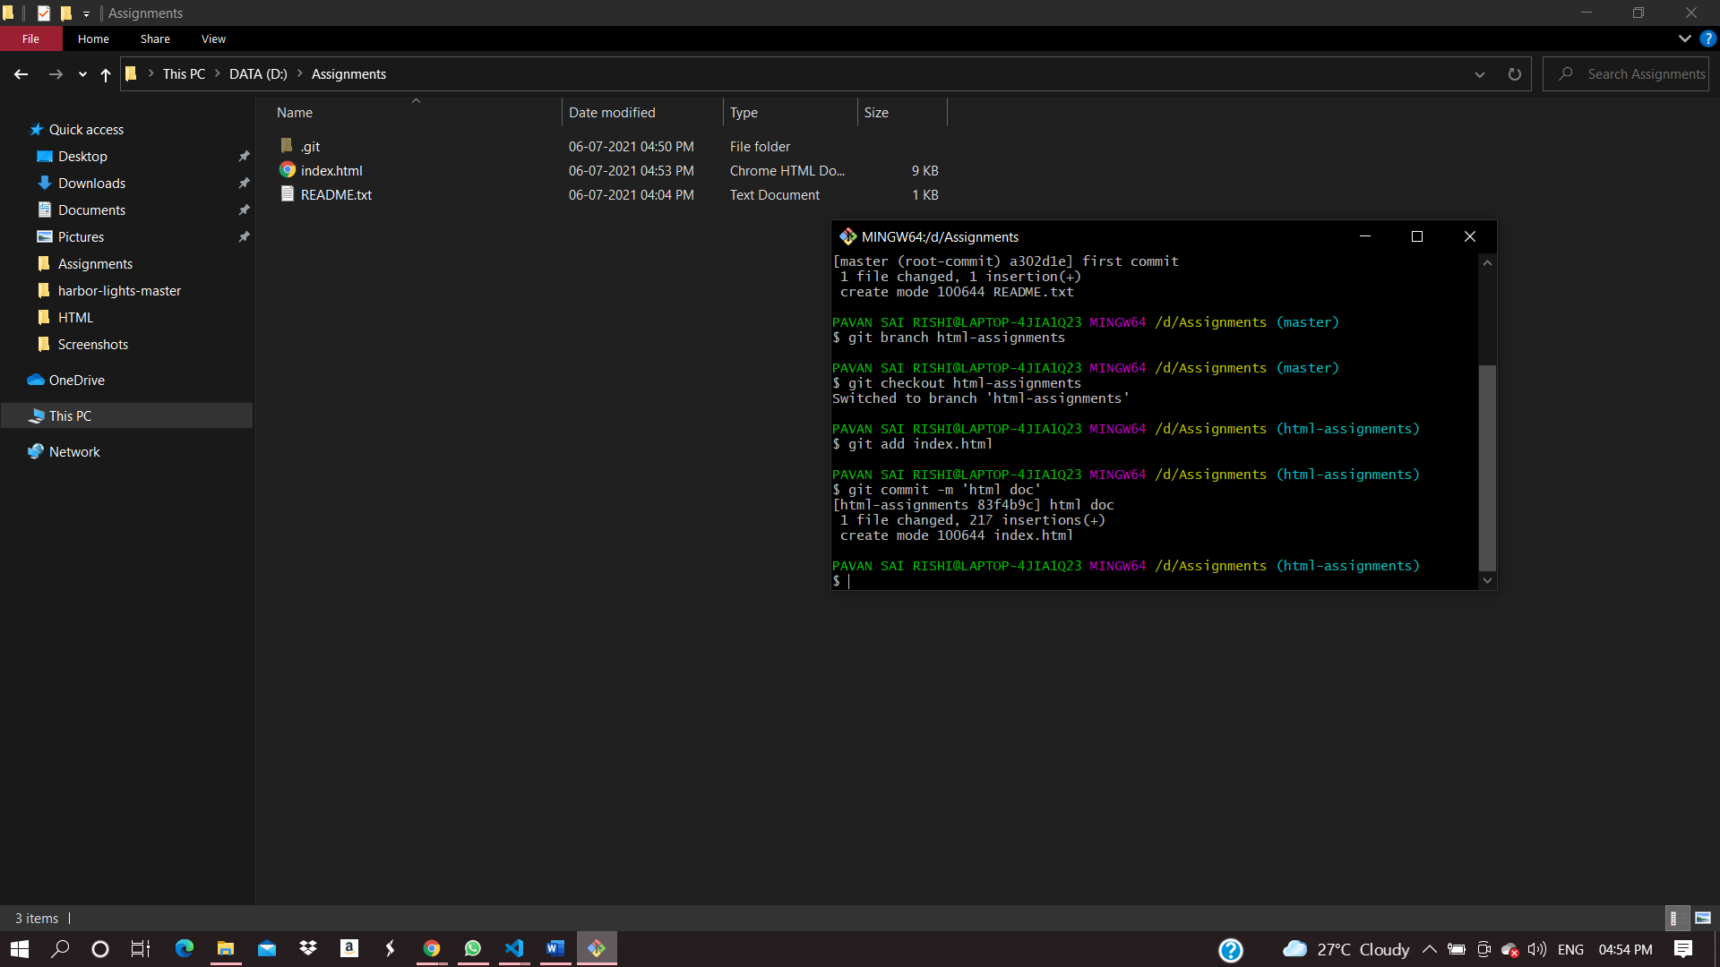

29)make minor changes in html file in html branch

30)commit

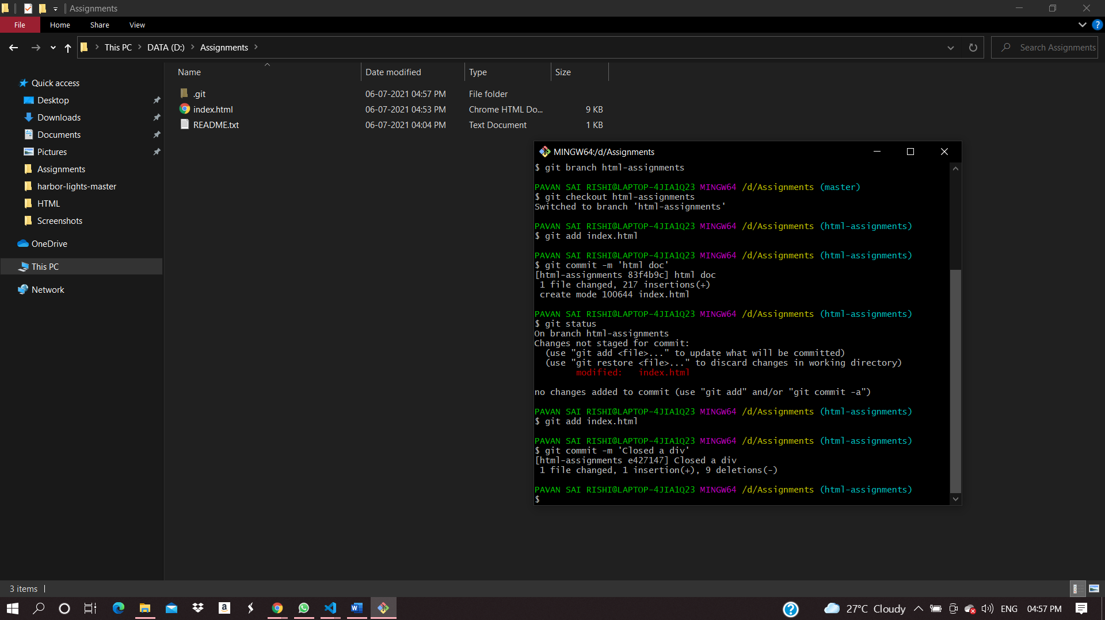

31)switch to master branch

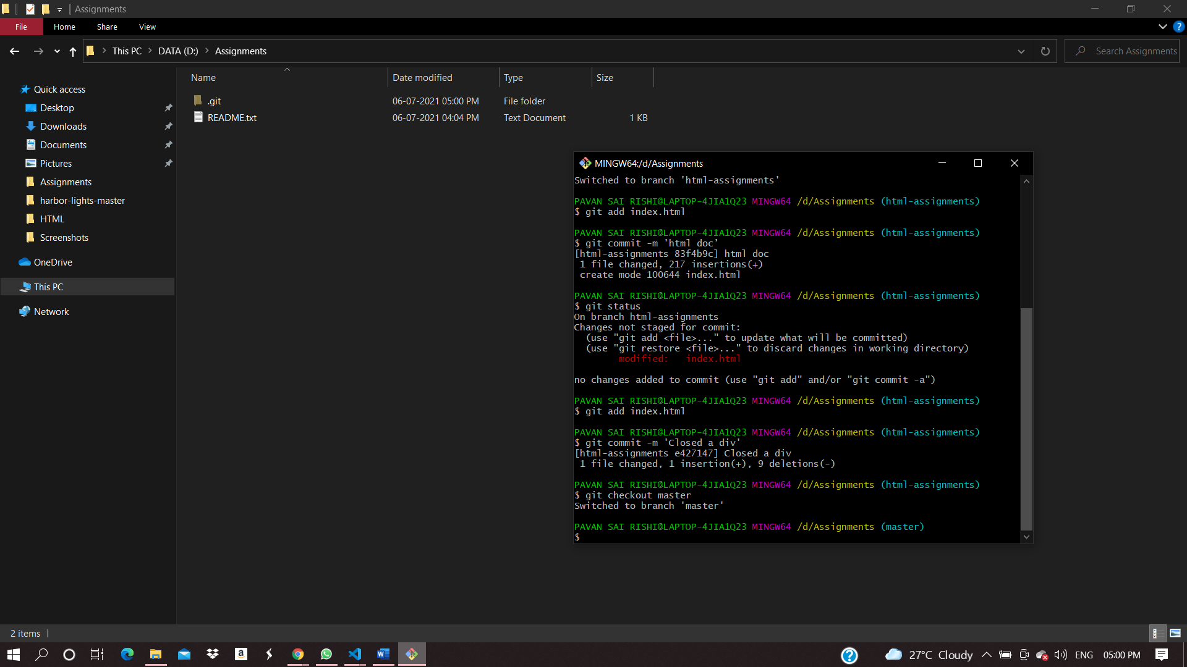

32)make minor changes in read me txt files and commit them to master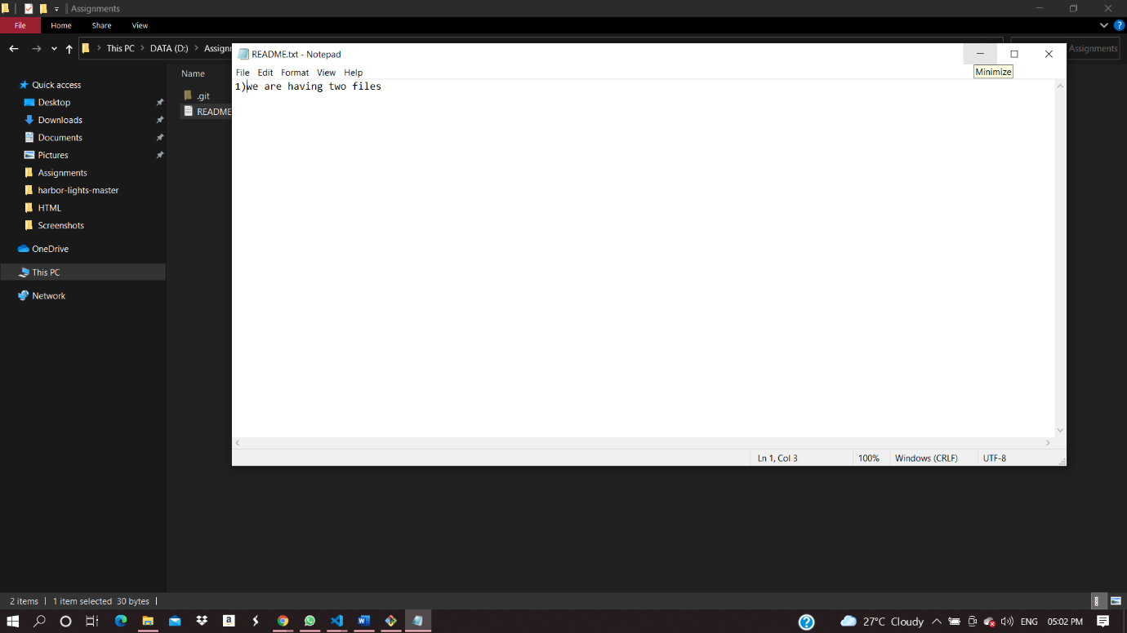

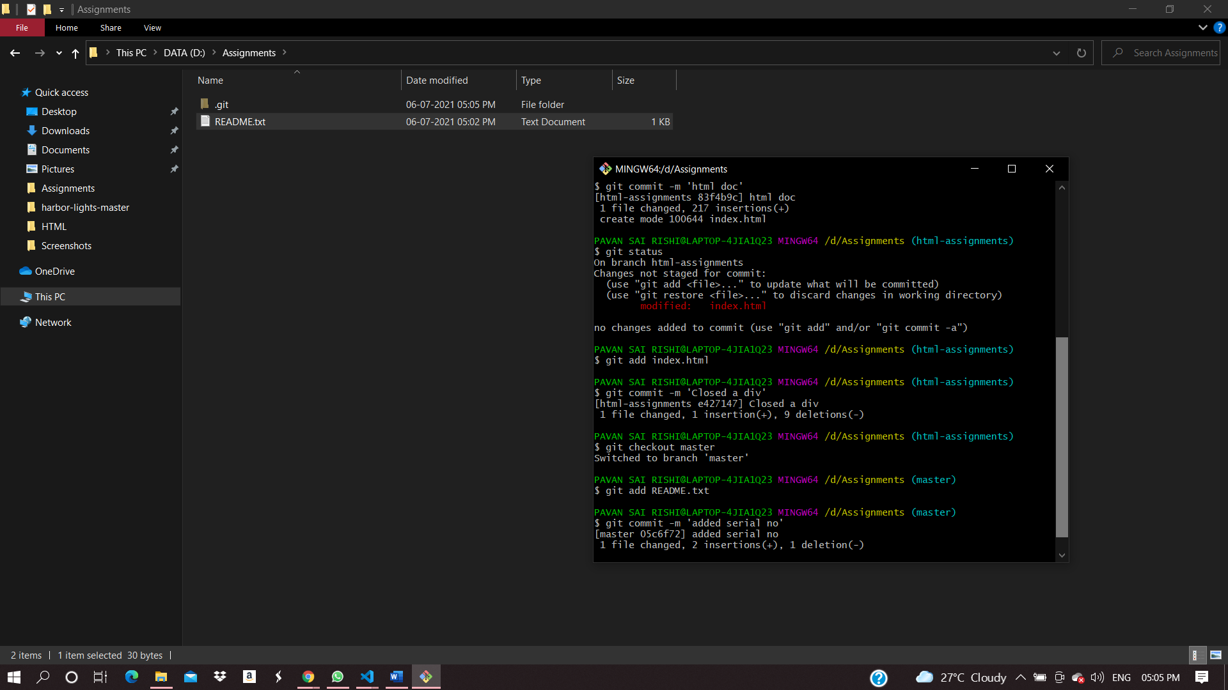

33)34)35)switch to html branch edit html file and commit it:

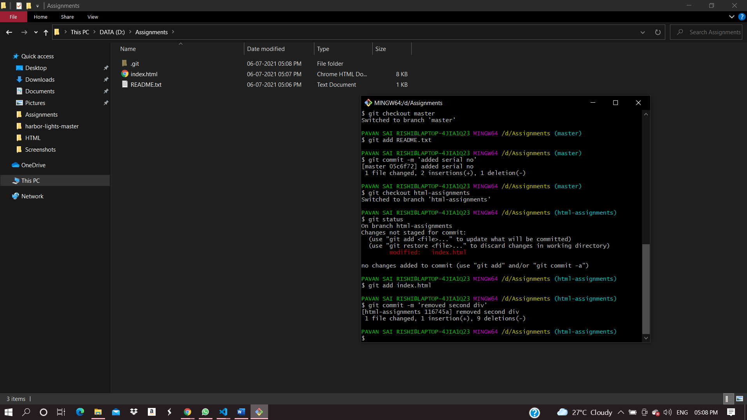

36)37)38) switch to master and merge branches and delete html branch: 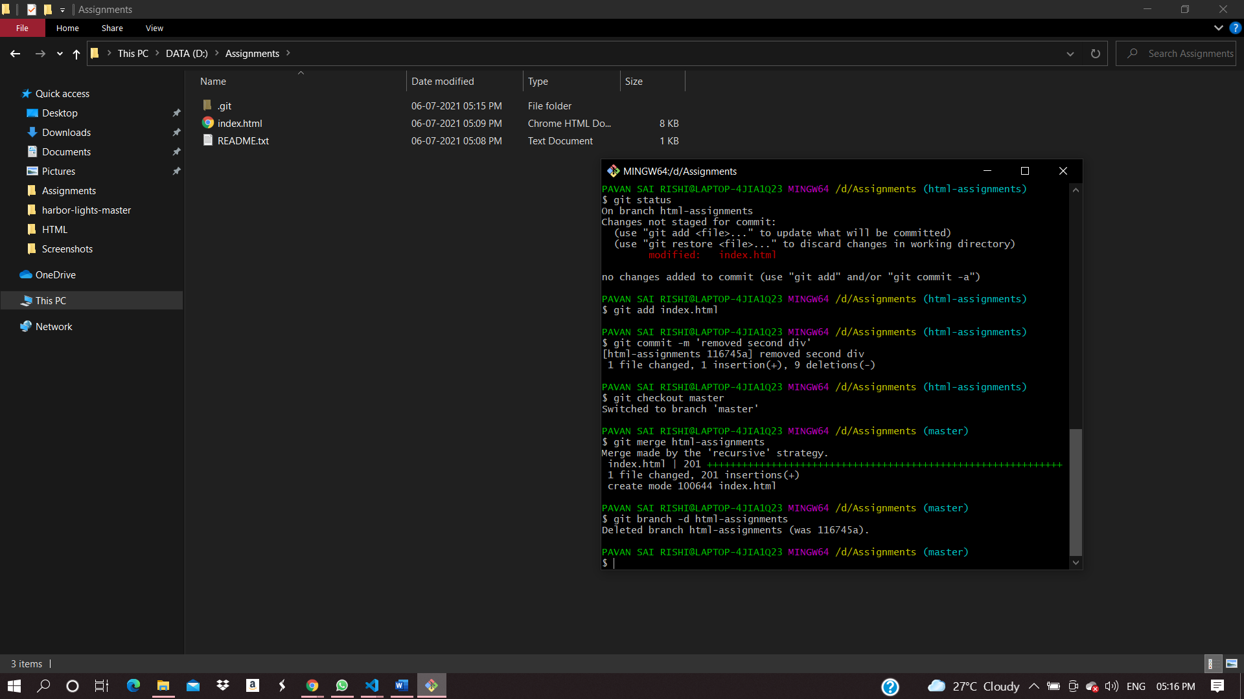

PAVAN SAI RISHI@LAPTOP-4JIA1Q23 MINGW64 /d/Assignments

$ git init

Initialized empty Git repository in D:/Assignments/.git/

PAVAN SAI RISHI@LAPTOP-4JIA1Q23 MINGW64 /d/Assignments (master)

$ git add README.txt

PAVAN SAI RISHI@LAPTOP-4JIA1Q23 MINGW64 /d/Assignments (master)

$ git commit -m 'first commit'

[master (root-commit) a302d1e] first commit

1 file changed, 1 insertion(+)

create mode 100644 README.txt

PAVAN SAI RISHI@LAPTOP-4JIA1Q23 MINGW64 /d/Assignments (master)

$ git branch html-assignments

PAVAN SAI RISHI@LAPTOP-4JIA1Q23 MINGW64 /d/Assignments (master)

$ git checkout html-assignments

Switched to branch 'html-assignments'

PAVAN SAI RISHI@LAPTOP-4JIA1Q23 MINGW64 /d/Assignments (html-assignments)

$ git add index.html

PAVAN SAI RISHI@LAPTOP-4JIA1Q23 MINGW64 /d/Assignments (html-assignments)

$ git commit -m 'html doc'

[html-assignments 83f4b9c] html doc

1 file changed, 217 insertions(+)

create mode 100644 index.html

PAVAN SAI RISHI@LAPTOP-4JIA1Q23 MINGW64 /d/Assignments (html-assignments)

$ git status

On branch html-assignments

Changes not staged for commit:

(use "git add <file>..." to update what will be committed)

(use "git restore <file>..." to discard changes in working directory)

modified: index.html

no changes added to commit (use "git add" and/or "git commit -a")

PAVAN SAI RISHI@LAPTOP-4JIA1Q23 MINGW64 /d/Assignments (html-assignments)

$ git add index.html

PAVAN SAI RISHI@LAPTOP-4JIA1Q23 MINGW64 /d/Assignments (html-assignments)

$ git commit -m 'Closed a div'

[html-assignments e427147] Closed a div

1 file changed, 1 insertion(+), 9 deletions(-)

PAVAN SAI RISHI@LAPTOP-4JIA1Q23 MINGW64 /d/Assignments (html-assignments)

$ git checkout master

Switched to branch 'master'

PAVAN SAI RISHI@LAPTOP-4JIA1Q23 MINGW64 /d/Assignments (master)

$ git add README.txt

PAVAN SAI RISHI@LAPTOP-4JIA1Q23 MINGW64 /d/Assignments (master)

$ git commit -m 'added serial no'

[master 05c6f72] added serial no

1 file changed, 2 insertions(+), 1 deletion(-)

PAVAN SAI RISHI@LAPTOP-4JIA1Q23 MINGW64 /d/Assignments (master)

$ git checkout html-assignments

Switched to branch 'html-assignments'

PAVAN SAI RISHI@LAPTOP-4JIA1Q23 MINGW64 /d/Assignments (html-assignments)

$ git status

On branch html-assignments

Changes not staged for commit:

(use "git add <file>..." to update what will be committed)

(use "git restore <file>..." to discard changes in working directory)

modified: index.html

no changes added to commit (use "git add" and/or "git commit -a")

PAVAN SAI RISHI@LAPTOP-4JIA1Q23 MINGW64 /d/Assignments (html-assignments)

$ git add index.html

PAVAN SAI RISHI@LAPTOP-4JIA1Q23 MINGW64 /d/Assignments (html-assignments)

$ git commit -m 'removed second div'

[html-assignments 116745a] removed second div

1 file changed, 1 insertion(+), 9 deletions(-)

PAVAN SAI RISHI@LAPTOP-4JIA1Q23 MINGW64 /d/Assignments (html-assignments)

$ git checkout master

Switched to branch 'master'

PAVAN SAI RISHI@LAPTOP-4JIA1Q23 MINGW64 /d/Assignments (master)

$ git merge html-assignments

Merge made by the 'recursive' strategy.

index.html | 201 +++++++++++++++++++++++++++++++++++++++++++++++++++++++++++++

1 file changed, 201 insertions(+)

create mode 100644 index.html

PAVAN SAI RISHI@LAPTOP-4JIA1Q23 MINGW64 /d/Assignments (master)

$ git branch -d html-assignments

Deleted branch html-assignments (was 116745a).