Bugs identified:
1.
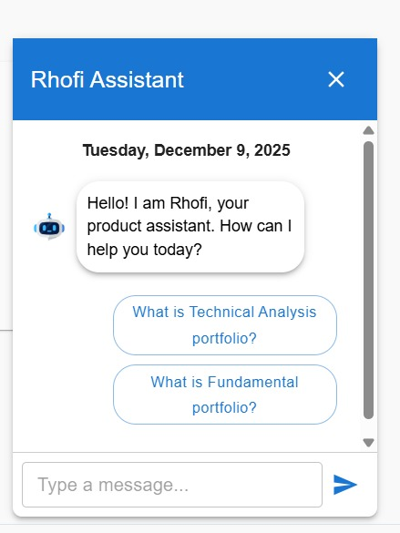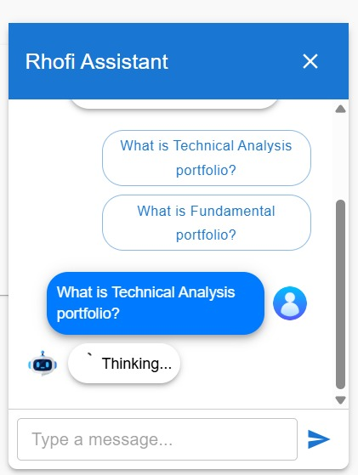

In chatbot whatever the query is given it loads and say as thinking.

2.
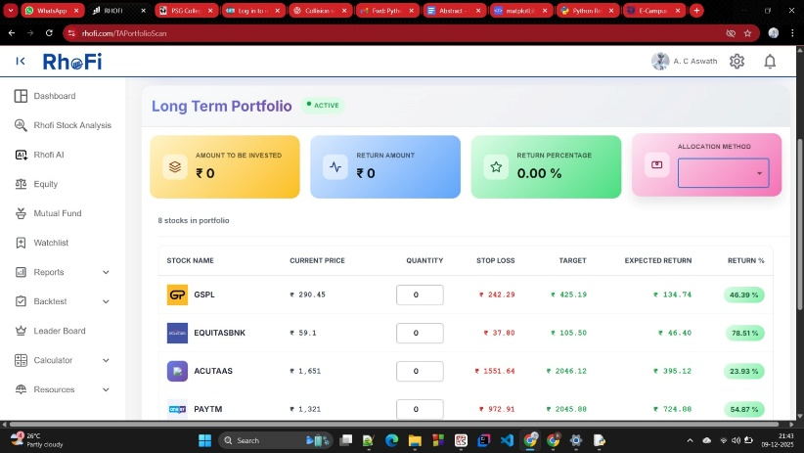
Dashboard->equality analysis->technical analysis->new portfolio ->allocation method down arrow is not giving properly.

3.
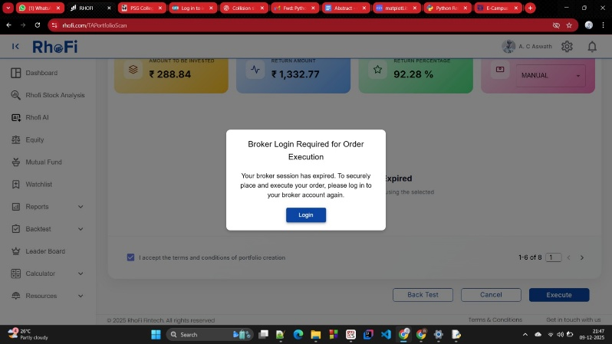
When we try to execute in portfolio after filling details it asks for new broker login which is not known to us.

4.
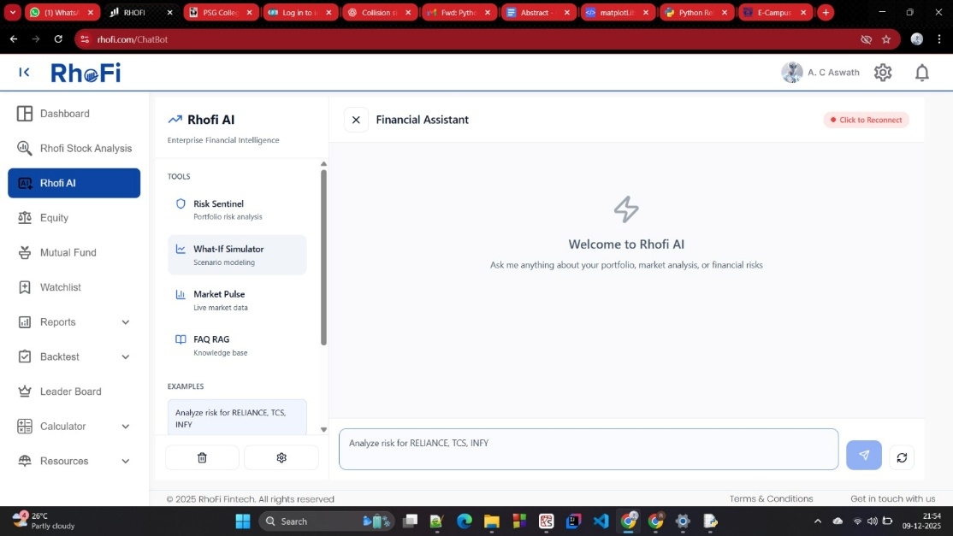
Rhofi ai is not at-all working

5.
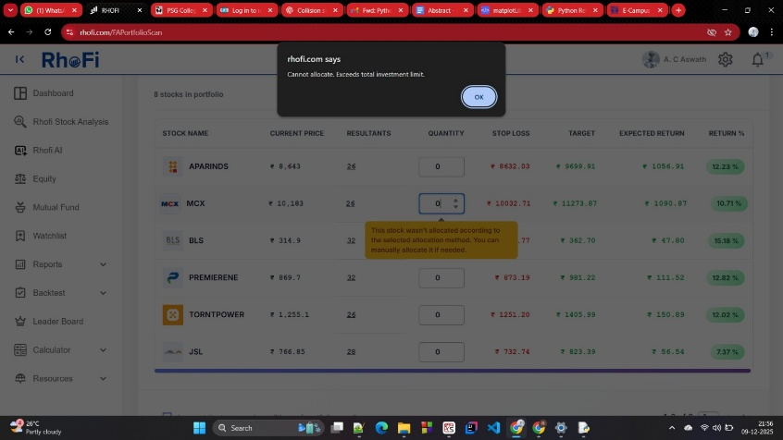
Don’t know the limit working.

6.
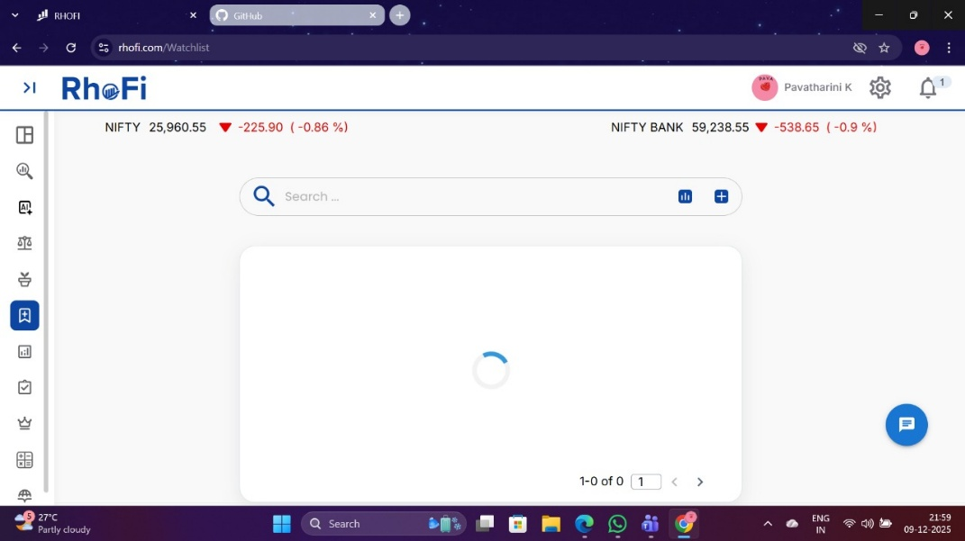
Watchlist is not working properly as it takes too much time for loading.

Need to know:
Mutual fund page explanation,backtest explanation

