**МИНОБРНАУКИ РОССИИ**

**Санкт-Петербургский государственный**

**электротехнический университет**

**«ЛЭТИ» им. В.И. Ульянова (Ленина)**

**Кафедра МО ЭВМ**

отчет

**по лабораторной работе №2**

**по дисциплине «Сети и телекоммуникации»**

Тема:**СЕТЕВОЙ УРОВЕНЬ: СТАТИЧЕСКАЯ МАРШРУТИЗАЦИЯ**

|  |  |  |
| --- | --- | --- |
| Студент гр. 8382 |  | Мирончик П.Д. |
| Преподаватель |  | Лавров А.А. |

Санкт-Петербург

2020

**Цель работы**

Изучить методы статической маршрутизации в IP-сетях. Научиться управлять таблицами маршрутизации на узлах сетевого уровня.

# Задание

# 1. Для всех узлов сети установить IP-адреса, маски подсетей и шлюзы п умолчанию, чтобы добиться успешного выполнения эхо-запроса ближайших соседей (находящихся в одной подсети).

2. Настроить таблицы маршрутизации на маршрутизаторах, чтобы добиться доставки пакетов от узла K1 к узлу K2 и обратно, от узла K2 к K3 и обратно, от узла K3 к K1 и обратно. Пакеты должны доходить до узлов кратчайшим путем

3. Настроить таблицы маршрутизации на узлах K1, K2 и K3 чтобы обеспечить кратчайшую доставку пакетов между этими узлами, если это невозможно было обеспечить в пункте 2.

В отчете привести конфигурацию TCP/IP для каждого из узлов, таблицы маршрутизации, результаты эхо-запросов между узлами K1, K2 и K3, а также обоснование правильности и оптимальности выбранных маршрутов.

*Вариант 13*. Файл со схемой сети: lab2_var13.jfst. Все маршрутизаторы и компьютеры имеют адреса из диапазона 172.1.1.1 -172.254.254.254. Обозначения в задании: K1 PC1, K2 PC2, K3 PC3.

# Ход работы

Структура сети:

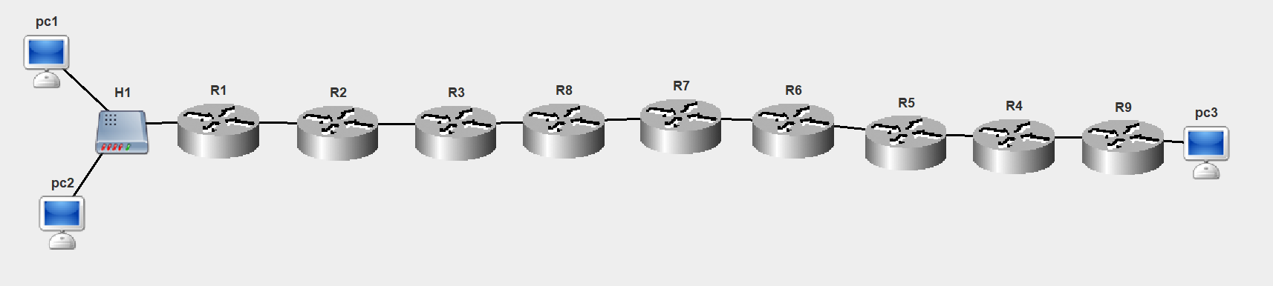

Для всех подсетей были выбраны одинаковые маски 255.255.0.0. Адреса подсетей выбирались по формуле 172.<Rigth router>.0.0, где Right router – номер роутера, который на графическом изображении подсети стоит правее самой подсети. Так, для подсети с компьютерами pc1 и pc2 был выбран адрес 172.1.0.0, для подсети между роутерами R1 и R2 – 172.2.0.0 и т.д. Компьютер pc3 находится в подсети 172.10.0.0. Такое назначение подсетей было выбрано исключительно для более удобного управления и не влияет на какие-либо другие характеристики сети (например, скорость доставки пакетов).

**Конфигурация TCP/IP для узлов.**

pc1: 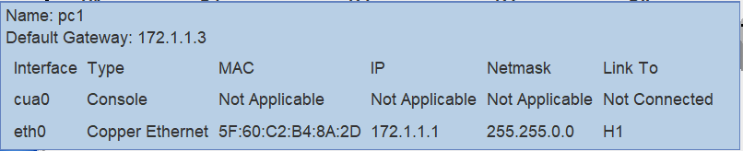

pc2: 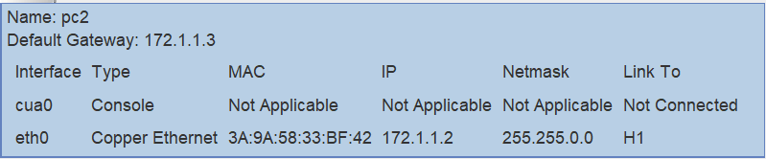

R1: 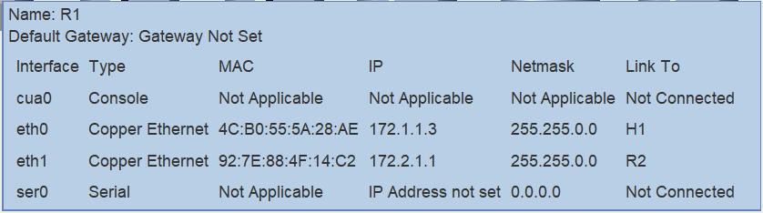

R2: 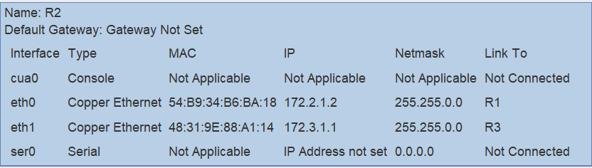

R3: 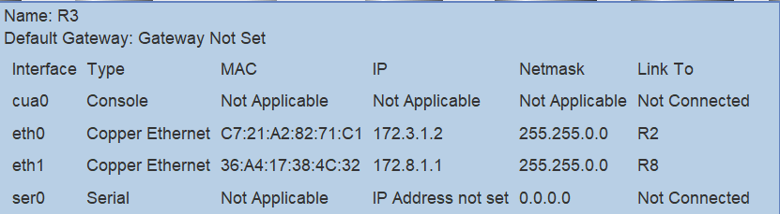

R8: 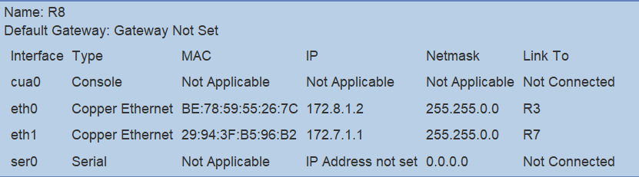

R7: 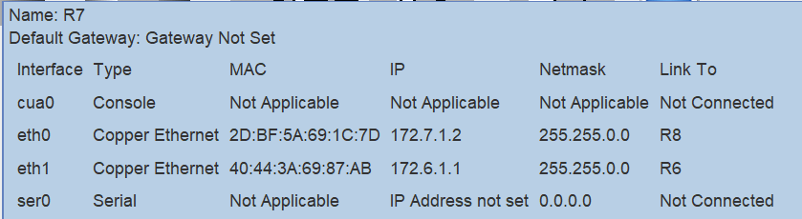

R6: 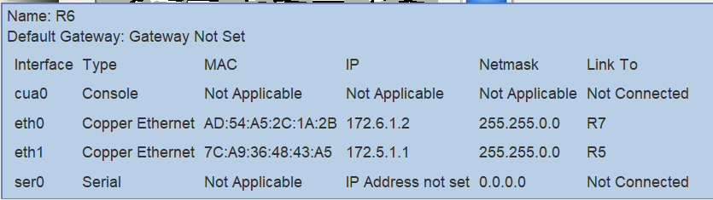

R5: 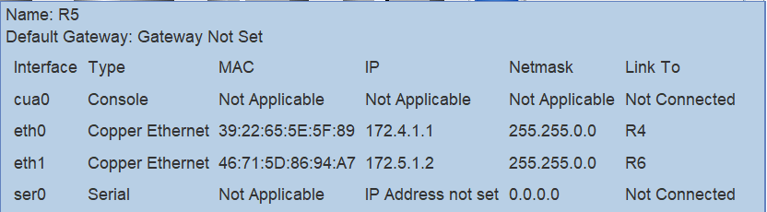

R4: 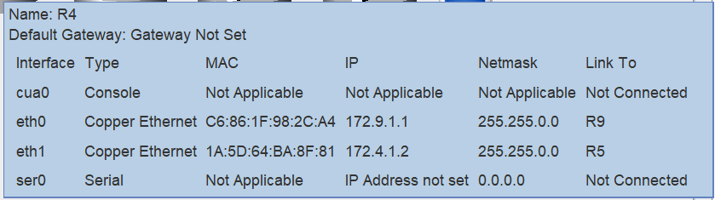

R9: 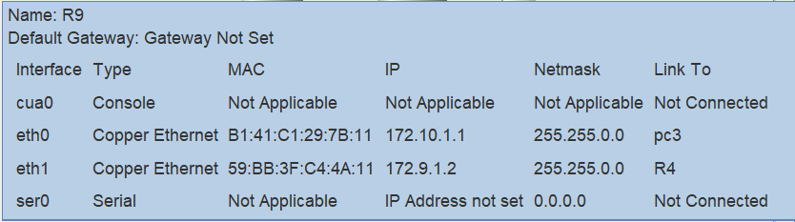

pc3: 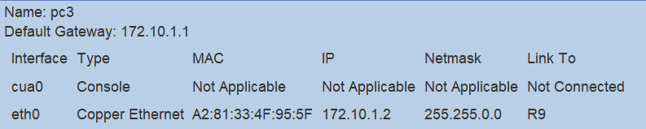

**Таблицы маршрутизации для узлов сети.**

pc1:

*S* default/0.0.0.0[0] via 172.1.1.3 (eth0)*

pc2:

*S* default/0.0.0.0[0] via 172.1.1.3 (eth0)*

R1:

*S 172.10.0.0/255.255.0.0[0] via 172.2.1.2 (eth1)*

R2:

*S 172.10.0.0/255.255.0.0[0] via 172.3.1.2 (eth1)*

*S 172.1.0.0/255.255.0.0[0] via 172.2.1.1 (eth0)*

R3:

*S 172.10.0.0/255.255.0.0[0] via 172.8.1.2 (eth1)*

*S 172.1.0.0/255.255.0.0[0] via 172.3.1.1 (eth0)*

R8:

*S 172.10.0.0/255.255.0.0[0] via 172.7.1.2 (eth1)*

*S 172.1.0.0/255.255.0.0[0] via 172.8.1.1 (eth0)*

R7:

*S 172.10.0.0/255.255.0.0[0] via 172.6.1.2 (eth1)*

*S 172.1.0.0/255.255.0.0[0] via 172.7.1.1 (eth0)*

R6:

*S 172.10.0.0/255.255.0.0[0] via 172.5.1.2 (eth1)*

*S 172.1.0.0/255.255.0.0[0] via 172.6.1.1 (eth0)*

R5:

*S 172.10.0.0/255.255.0.0[0] via 172.4.1.2 (eth0)*

*S 172.1.0.0/255.255.0.0[0] via 172.5.1.1 (eth1)*

R4:

*S 172.10.0.0/255.255.0.0[0] via 172.9.1.2 (eth0)*

*S 172.1.0.0/255.255.0.0[0] via 172.4.1.1 (eth1)*

R9:

*S 172.1.0.0/255.255.0.0[0] via 172.9.1.1 (eth1)*

pc3:

*S* default/0.0.0.0[0] via 172.10.1.1 (eth0)*

**Эхо-запрос K1-K3.**

## 22:58:02-575 pc1 Echo Request Packet Network Created Echo Request packet to 172.10.1.2

## 22:58:02-575 pc1 ARP Discovery Packet DataLink Created ARP discovery packet to source MAC address for IP 172.1.1.3

## 22:58:02-575 pc1 ARP_packet Network Sending broadcast packet from ProtocolStack.

## 22:58:02-575 pc1 Ethernet Packet Link Sending packet from interface 5F:60:C2:B4:8A:2D

## 22:58:02-575 pc2 Ethernet Packet Link Recieved and accepted packet at interface 3A:9A:58:33:BF:42

## 22:58:02-575 pc2 ARP_packet Network ProtocolStack received packet from local Interface.

## 22:58:02-575 R1 Ethernet Packet Link Recieved and accepted packet at interface 4C:B0:55:5A:28:AE

## 22:58:02-575 R1 ARP_packet Network ProtocolStack received packet from local Interface.

## 22:58:02-575 R1 ARP_packet Network Confirmed Packet is for this Network Layer Device.

## 22:58:02-575 R1 ARP Response Packet DataLink Created ARP Response packet to 172.1.1.1

## 22:58:02-575 R1 ARP_packet Network Sending packet from ProtocolStack (to 172.1.1.1).

## 22:58:02-575 R1 Ethernet Packet Link Sending packet from interface 4C:B0:55:5A:28:AE

## 22:58:02-575 pc2 Ethernet Packet Link Recieved and dropped packet at interface 3A:9A:58:33:BF:42

## 22:58:02-575 pc1 Ethernet Packet Link Recieved and accepted packet at interface 5F:60:C2:B4:8A:2D

## 22:58:02-575 pc1 ARP_packet Network ProtocolStack received packet from local Interface.

## 22:58:02-575 pc1 ARP_packet Network Confirmed Packet is for this Network Layer Device.

## 22:58:02-575 pc1 ICMP_packet Network Sending packet from ProtocolStack (to 172.1.1.3).

## 22:58:02-575 pc1 Ethernet Packet Link Sending packet from interface 5F:60:C2:B4:8A:2D

## 22:58:02-575 pc2 Ethernet Packet Link Recieved and dropped packet at interface 3A:9A:58:33:BF:42

## 22:58:02-575 R1 Ethernet Packet Link Recieved and accepted packet at interface 4C:B0:55:5A:28:AE

## 22:58:02-575 R1 ICMP_packet Network ProtocolStack received packet from local Interface.

## 22:58:02-575 R1 ICMP_packet Network Packet Received: Network Layer Device is Routable forwarding packet.

## 22:58:02-575 R1 ARP Discovery Packet DataLink Created ARP discovery packet to source MAC address for IP 172.2.1.2

## 22:58:02-575 R1 ARP_packet Network Sending broadcast packet from ProtocolStack.

## 22:58:02-575 R1 Ethernet Packet Link Sending packet from interface 92:7E:88:4F:14:C2

## 22:58:02-575 R2 Ethernet Packet Link Recieved and accepted packet at interface 54:B9:34:B6:BA:18

## 22:58:02-575 R2 ARP_packet Network ProtocolStack received packet from local Interface.

## 22:58:02-575 R2 ARP_packet Network Confirmed Packet is for this Network Layer Device.

## 22:58:02-575 R2 ARP Response Packet DataLink Created ARP Response packet to 172.2.1.1

## 22:58:02-575 R2 ARP_packet Network Sending packet from ProtocolStack (to 172.2.1.1).

## 22:58:02-575 R2 Ethernet Packet Link Sending packet from interface 54:B9:34:B6:BA:18

## 22:58:02-575 R1 Ethernet Packet Link Recieved and accepted packet at interface 92:7E:88:4F:14:C2

## 22:58:02-575 R1 ARP_packet Network ProtocolStack received packet from local Interface.

## 22:58:02-575 R1 ARP_packet Network Confirmed Packet is for this Network Layer Device.

## 22:58:02-575 R1 ICMP_packet Network Forwarding packet from ProtocolStack(to 172.2.1.2).

## 22:58:02-575 R1 Ethernet Packet Link Sending packet from interface 92:7E:88:4F:14:C2

## 22:58:02-575 R2 Ethernet Packet Link Recieved and accepted packet at interface 54:B9:34:B6:BA:18

## 22:58:02-575 R2 ICMP_packet Network ProtocolStack received packet from local Interface.

## 22:58:02-575 R2 ICMP_packet Network Packet Received: Network Layer Device is Routable forwarding packet.

## 22:58:02-575 R2 ARP Discovery Packet DataLink Created ARP discovery packet to source MAC address for IP 172.3.1.2

## 22:58:02-575 R2 ARP_packet Network Sending broadcast packet from ProtocolStack.

## 22:58:02-575 R2 Ethernet Packet Link Sending packet from interface 48:31:9E:88:A1:14

## 22:58:02-575 R3 Ethernet Packet Link Recieved and accepted packet at interface C7:21:A2:82:71:C1

## 22:58:02-575 R3 ARP_packet Network ProtocolStack received packet from local Interface.

## 22:58:02-575 R3 ARP_packet Network Confirmed Packet is for this Network Layer Device.

## 22:58:02-575 R3 ARP Response Packet DataLink Created ARP Response packet to 172.3.1.1

## 22:58:02-575 R3 ARP_packet Network Sending packet from ProtocolStack (to 172.3.1.1).

## 22:58:02-575 R3 Ethernet Packet Link Sending packet from interface C7:21:A2:82:71:C1

## 22:58:02-575 R2 Ethernet Packet Link Recieved and accepted packet at interface 48:31:9E:88:A1:14

## 22:58:02-575 R2 ARP_packet Network ProtocolStack received packet from local Interface.

## 22:58:02-575 R2 ARP_packet Network Confirmed Packet is for this Network Layer Device.

## 22:58:02-576 R2 ICMP_packet Network Forwarding packet from ProtocolStack(to 172.3.1.2).

## 22:58:02-576 R2 Ethernet Packet Link Sending packet from interface 48:31:9E:88:A1:14

## 22:58:02-576 R3 Ethernet Packet Link Recieved and accepted packet at interface C7:21:A2:82:71:C1

## 22:58:02-576 R3 ICMP_packet Network ProtocolStack received packet from local Interface.

## 22:58:02-576 R3 ICMP_packet Network Packet Received: Network Layer Device is Routable forwarding packet.

## 22:58:02-576 R3 ARP Discovery Packet DataLink Created ARP discovery packet to source MAC address for IP 172.8.1.2

## 22:58:02-576 R3 ARP_packet Network Sending broadcast packet from ProtocolStack.

## 22:58:02-576 R3 Ethernet Packet Link Sending packet from interface 36:A4:17:38:4C:32

## 22:58:02-576 R8 Ethernet Packet Link Recieved and accepted packet at interface BE:78:59:55:26:7C

## 22:58:02-576 R8 ARP_packet Network ProtocolStack received packet from local Interface.

## 22:58:02-576 R8 ARP_packet Network Confirmed Packet is for this Network Layer Device.

## 22:58:02-576 R8 ARP Response Packet DataLink Created ARP Response packet to 172.8.1.1

## 22:58:02-576 R8 ARP_packet Network Sending packet from ProtocolStack (to 172.8.1.1).

## 22:58:02-576 R8 Ethernet Packet Link Sending packet from interface BE:78:59:55:26:7C

## 22:58:02-576 R3 Ethernet Packet Link Recieved and accepted packet at interface 36:A4:17:38:4C:32

## 22:58:02-576 R3 ARP_packet Network ProtocolStack received packet from local Interface.

## 22:58:02-576 R3 ARP_packet Network Confirmed Packet is for this Network Layer Device.

## 22:58:02-576 R3 ICMP_packet Network Forwarding packet from ProtocolStack(to 172.8.1.2).

## 22:58:02-576 R3 Ethernet Packet Link Sending packet from interface 36:A4:17:38:4C:32

## 22:58:02-576 R8 Ethernet Packet Link Recieved and accepted packet at interface BE:78:59:55:26:7C

## 22:58:02-576 R8 ICMP_packet Network ProtocolStack received packet from local Interface.

## 22:58:02-576 R8 ICMP_packet Network Packet Received: Network Layer Device is Routable forwarding packet.

## 22:58:02-576 R8 ARP Discovery Packet DataLink Created ARP discovery packet to source MAC address for IP 172.7.1.2

## 22:58:02-576 R8 ARP_packet Network Sending broadcast packet from ProtocolStack.

## 22:58:02-576 R8 Ethernet Packet Link Sending packet from interface 29:94:3F:B5:96:B2

## 22:58:02-576 R7 Ethernet Packet Link Recieved and accepted packet at interface 2D:BF:5A:69:1C:7D

## 22:58:02-576 R7 ARP_packet Network ProtocolStack received packet from local Interface.

## 22:58:02-576 R7 ARP_packet Network Confirmed Packet is for this Network Layer Device.

## 22:58:02-576 R7 ARP Response Packet DataLink Created ARP Response packet to 172.7.1.1

## 22:58:02-576 R7 ARP_packet Network Sending packet from ProtocolStack (to 172.7.1.1).

## 22:58:02-576 R7 Ethernet Packet Link Sending packet from interface 2D:BF:5A:69:1C:7D

## 22:58:02-576 R8 Ethernet Packet Link Recieved and accepted packet at interface 29:94:3F:B5:96:B2

## 22:58:02-576 R8 ARP_packet Network ProtocolStack received packet from local Interface.

## 22:58:02-576 R8 ARP_packet Network Confirmed Packet is for this Network Layer Device.

## 22:58:02-576 R8 ICMP_packet Network Forwarding packet from ProtocolStack(to 172.7.1.2).

## 22:58:02-576 R8 Ethernet Packet Link Sending packet from interface 29:94:3F:B5:96:B2

## 22:58:02-576 R7 Ethernet Packet Link Recieved and accepted packet at interface 2D:BF:5A:69:1C:7D

## 22:58:02-576 R7 ICMP_packet Network ProtocolStack received packet from local Interface.

## 22:58:02-576 R7 ICMP_packet Network Packet Received: Network Layer Device is Routable forwarding packet.

## 22:58:02-576 R7 ARP Discovery Packet DataLink Created ARP discovery packet to source MAC address for IP 172.6.1.2

## 22:58:02-576 R7 ARP_packet Network Sending broadcast packet from ProtocolStack.

## 22:58:02-576 R7 Ethernet Packet Link Sending packet from interface 40:44:3A:69:87:AB

## 22:58:02-576 R6 Ethernet Packet Link Recieved and accepted packet at interface AD:54:A5:2C:1A:2B

## 22:58:02-576 R6 ARP_packet Network ProtocolStack received packet from local Interface.

## 22:58:02-576 R6 ARP_packet Network Confirmed Packet is for this Network Layer Device.

## 22:58:02-576 R6 ARP Response Packet DataLink Created ARP Response packet to 172.6.1.1

## 22:58:02-576 R6 ARP_packet Network Sending packet from ProtocolStack (to 172.6.1.1).

## 22:58:02-576 R6 Ethernet Packet Link Sending packet from interface AD:54:A5:2C:1A:2B

## 22:58:02-576 R7 Ethernet Packet Link Recieved and accepted packet at interface 40:44:3A:69:87:AB

## 22:58:02-576 R7 ARP_packet Network ProtocolStack received packet from local Interface.

## 22:58:02-576 R7 ARP_packet Network Confirmed Packet is for this Network Layer Device.

## 22:58:02-576 R7 ICMP_packet Network Forwarding packet from ProtocolStack(to 172.6.1.2).

## 22:58:02-576 R7 Ethernet Packet Link Sending packet from interface 40:44:3A:69:87:AB

## 22:58:02-576 R6 Ethernet Packet Link Recieved and accepted packet at interface AD:54:A5:2C:1A:2B

## 22:58:02-576 R6 ICMP_packet Network ProtocolStack received packet from local Interface.

## 22:58:02-576 R6 ICMP_packet Network Packet Received: Network Layer Device is Routable forwarding packet.

## 22:58:02-576 R6 ARP Discovery Packet DataLink Created ARP discovery packet to source MAC address for IP 172.5.1.2

## 22:58:02-576 R6 ARP_packet Network Sending broadcast packet from ProtocolStack.

## 22:58:02-576 R6 Ethernet Packet Link Sending packet from interface 7C:A9:36:48:43:A5

## 22:58:02-576 R5 Ethernet Packet Link Recieved and accepted packet at interface 46:71:5D:86:94:A7

## 22:58:02-576 R5 ARP_packet Network ProtocolStack received packet from local Interface.

## 22:58:02-576 R5 ARP_packet Network Confirmed Packet is for this Network Layer Device.

## 22:58:02-576 R5 ARP Response Packet DataLink Created ARP Response packet to 172.5.1.1

## 22:58:02-576 R5 ARP_packet Network Sending packet from ProtocolStack (to 172.5.1.1).

## 22:58:02-576 R5 Ethernet Packet Link Sending packet from interface 46:71:5D:86:94:A7

## 22:58:02-576 R6 Ethernet Packet Link Recieved and accepted packet at interface 7C:A9:36:48:43:A5

## 22:58:02-576 R6 ARP_packet Network ProtocolStack received packet from local Interface.

## 22:58:02-576 R6 ARP_packet Network Confirmed Packet is for this Network Layer Device.

## 22:58:02-576 R6 ICMP_packet Network Forwarding packet from ProtocolStack(to 172.5.1.2).

## 22:58:02-576 R6 Ethernet Packet Link Sending packet from interface 7C:A9:36:48:43:A5

## 22:58:02-576 R5 Ethernet Packet Link Recieved and accepted packet at interface 46:71:5D:86:94:A7

## 22:58:02-576 R5 ICMP_packet Network ProtocolStack received packet from local Interface.

## 22:58:02-576 R5 ICMP_packet Network Packet Received: Network Layer Device is Routable forwarding packet.

## 22:58:02-576 R5 ARP Discovery Packet DataLink Created ARP discovery packet to source MAC address for IP 172.4.1.2

## 22:58:02-576 R5 ARP_packet Network Sending broadcast packet from ProtocolStack.

## 22:58:02-576 R5 Ethernet Packet Link Sending packet from interface 39:22:65:5E:5F:89

## 22:58:02-576 R4 Ethernet Packet Link Recieved and accepted packet at interface 1A:5D:64:BA:8F:81

## 22:58:02-576 R4 ARP_packet Network ProtocolStack received packet from local Interface.

## 22:58:02-576 R4 ARP_packet Network Confirmed Packet is for this Network Layer Device.

## 22:58:02-576 R4 ARP Response Packet DataLink Created ARP Response packet to 172.4.1.1

## 22:58:02-576 R4 ARP_packet Network Sending packet from ProtocolStack (to 172.4.1.1).

## 22:58:02-576 R4 Ethernet Packet Link Sending packet from interface 1A:5D:64:BA:8F:81

## 22:58:02-576 R5 Ethernet Packet Link Recieved and accepted packet at interface 39:22:65:5E:5F:89

## 22:58:02-576 R5 ARP_packet Network ProtocolStack received packet from local Interface.

## 22:58:02-576 R5 ARP_packet Network Confirmed Packet is for this Network Layer Device.

## 22:58:02-576 R5 ICMP_packet Network Forwarding packet from ProtocolStack(to 172.4.1.2).

## 22:58:02-576 R5 Ethernet Packet Link Sending packet from interface 39:22:65:5E:5F:89

## 22:58:02-576 R4 Ethernet Packet Link Recieved and accepted packet at interface 1A:5D:64:BA:8F:81

## 22:58:02-576 R4 ICMP_packet Network ProtocolStack received packet from local Interface.

## 22:58:02-576 R4 ICMP_packet Network Packet Received: Network Layer Device is Routable forwarding packet.

## 22:58:02-576 R4 ARP Discovery Packet DataLink Created ARP discovery packet to source MAC address for IP 172.9.1.2

## 22:58:02-576 R4 ARP_packet Network Sending broadcast packet from ProtocolStack.

## 22:58:02-576 R4 Ethernet Packet Link Sending packet from interface C6:86:1F:98:2C:A4

## 22:58:02-576 R9 Ethernet Packet Link Recieved and accepted packet at interface 59:BB:3F:C4:4A:11

## 22:58:02-576 R9 ARP_packet Network ProtocolStack received packet from local Interface.

## 22:58:02-576 R9 ARP_packet Network Confirmed Packet is for this Network Layer Device.

## 22:58:02-577 R9 ARP Response Packet DataLink Created ARP Response packet to 172.9.1.1

## 22:58:02-577 R9 ARP_packet Network Sending packet from ProtocolStack (to 172.9.1.1).

## 22:58:02-577 R9 Ethernet Packet Link Sending packet from interface 59:BB:3F:C4:4A:11

## 22:58:02-577 R4 Ethernet Packet Link Recieved and accepted packet at interface C6:86:1F:98:2C:A4

## 22:58:02-577 R4 ARP_packet Network ProtocolStack received packet from local Interface.

## 22:58:02-577 R4 ARP_packet Network Confirmed Packet is for this Network Layer Device.

## 22:58:02-577 R4 ICMP_packet Network Forwarding packet from ProtocolStack(to 172.9.1.2).

## 22:58:02-577 R4 Ethernet Packet Link Sending packet from interface C6:86:1F:98:2C:A4

## 22:58:02-577 R9 Ethernet Packet Link Recieved and accepted packet at interface 59:BB:3F:C4:4A:11

## 22:58:02-577 R9 ICMP_packet Network ProtocolStack received packet from local Interface.

## 22:58:02-577 R9 ICMP_packet Network Packet Received: Network Layer Device is Routable forwarding packet.

## 22:58:02-577 R9 ARP Discovery Packet DataLink Created ARP discovery packet to source MAC address for IP 172.10.1.2

## 22:58:02-577 R9 ARP_packet Network Sending broadcast packet from ProtocolStack.

## 22:58:02-577 R9 Ethernet Packet Link Sending packet from interface B1:41:C1:29:7B:11

## 22:58:02-577 pc3 Ethernet Packet Link Recieved and accepted packet at interface A2:81:33:4F:95:5F

## 22:58:02-577 pc3 ARP_packet Network ProtocolStack received packet from local Interface.

## 22:58:02-577 pc3 ARP_packet Network Confirmed Packet is for this Network Layer Device.

## 22:58:02-577 pc3 ARP Response Packet DataLink Created ARP Response packet to 172.10.1.1

## 22:58:02-577 pc3 ARP_packet Network Sending packet from ProtocolStack (to 172.10.1.1).

## 22:58:02-577 pc3 Ethernet Packet Link Sending packet from interface A2:81:33:4F:95:5F

## 22:58:02-577 R9 Ethernet Packet Link Recieved and accepted packet at interface B1:41:C1:29:7B:11

## 22:58:02-577 R9 ARP_packet Network ProtocolStack received packet from local Interface.

## 22:58:02-577 R9 ARP_packet Network Confirmed Packet is for this Network Layer Device.

## 22:58:02-577 R9 ICMP_packet Network Forwarding packet from ProtocolStack(to 172.10.1.2).

## 22:58:02-577 R9 Ethernet Packet Link Sending packet from interface B1:41:C1:29:7B:11

## 22:58:02-577 pc3 Ethernet Packet Link Recieved and accepted packet at interface A2:81:33:4F:95:5F

## 22:58:02-577 pc3 ICMP_packet Network ProtocolStack received packet from local Interface.

## 22:58:02-577 pc3 ICMP_packet Network Confirmed Packet is for this Network Layer Device.

## 22:58:02-577 pc3 Echo Reply Packet Network Created Echo Reply packet to 172.1.1.1

## 22:58:02-577 pc3 ICMP_packet Network Sending packet from ProtocolStack (to 172.10.1.1).

## 22:58:02-577 pc3 Ethernet Packet Link Sending packet from interface A2:81:33:4F:95:5F

## 22:58:02-577 R9 Ethernet Packet Link Recieved and accepted packet at interface B1:41:C1:29:7B:11

## 22:58:02-577 R9 ICMP_packet Network ProtocolStack received packet from local Interface.

## 22:58:02-577 R9 ICMP_packet Network Packet Received: Network Layer Device is Routable forwarding packet.

## 22:58:02-577 R9 ICMP_packet Network Forwarding packet from ProtocolStack(to 172.9.1.1).

## 22:58:02-577 R9 Ethernet Packet Link Sending packet from interface 59:BB:3F:C4:4A:11

## 22:58:02-577 R4 Ethernet Packet Link Recieved and accepted packet at interface C6:86:1F:98:2C:A4

## 22:58:02-577 R4 ICMP_packet Network ProtocolStack received packet from local Interface.

## 22:58:02-577 R4 ICMP_packet Network Packet Received: Network Layer Device is Routable forwarding packet.

## 22:58:02-577 R4 ICMP_packet Network Forwarding packet from ProtocolStack(to 172.4.1.1).

## 22:58:02-577 R4 Ethernet Packet Link Sending packet from interface 1A:5D:64:BA:8F:81

## 22:58:02-577 R5 Ethernet Packet Link Recieved and accepted packet at interface 39:22:65:5E:5F:89

## 22:58:02-577 R5 ICMP_packet Network ProtocolStack received packet from local Interface.

## 22:58:02-577 R5 ICMP_packet Network Packet Received: Network Layer Device is Routable forwarding packet.

## 22:58:02-577 R5 ICMP_packet Network Forwarding packet from ProtocolStack(to 172.5.1.1).

## 22:58:02-577 R5 Ethernet Packet Link Sending packet from interface 46:71:5D:86:94:A7

## 22:58:02-577 R6 Ethernet Packet Link Recieved and accepted packet at interface 7C:A9:36:48:43:A5

## 22:58:02-577 R6 ICMP_packet Network ProtocolStack received packet from local Interface.

## 22:58:02-577 R6 ICMP_packet Network Packet Received: Network Layer Device is Routable forwarding packet.

## 22:58:02-577 R6 ICMP_packet Network Forwarding packet from ProtocolStack(to 172.6.1.1).

## 22:58:02-577 R6 Ethernet Packet Link Sending packet from interface AD:54:A5:2C:1A:2B

## 22:58:02-577 R7 Ethernet Packet Link Recieved and accepted packet at interface 40:44:3A:69:87:AB

## 22:58:02-577 R7 ICMP_packet Network ProtocolStack received packet from local Interface.

## 22:58:02-577 R7 ICMP_packet Network Packet Received: Network Layer Device is Routable forwarding packet.

## 22:58:02-577 R7 ICMP_packet Network Forwarding packet from ProtocolStack(to 172.7.1.1).

## 22:58:02-577 R7 Ethernet Packet Link Sending packet from interface 2D:BF:5A:69:1C:7D

## 22:58:02-577 R8 Ethernet Packet Link Recieved and accepted packet at interface 29:94:3F:B5:96:B2

## 22:58:02-577 R8 ICMP_packet Network ProtocolStack received packet from local Interface.

## 22:58:02-577 R8 ICMP_packet Network Packet Received: Network Layer Device is Routable forwarding packet.

## 22:58:02-577 R8 ICMP_packet Network Forwarding packet from ProtocolStack(to 172.8.1.1).

## 22:58:02-577 R8 Ethernet Packet Link Sending packet from interface BE:78:59:55:26:7C

## 22:58:02-577 R3 Ethernet Packet Link Recieved and accepted packet at interface 36:A4:17:38:4C:32

## 22:58:02-577 R3 ICMP_packet Network ProtocolStack received packet from local Interface.

## 22:58:02-577 R3 ICMP_packet Network Packet Received: Network Layer Device is Routable forwarding packet.

## 22:58:02-577 R3 ICMP_packet Network Forwarding packet from ProtocolStack(to 172.3.1.1).

## 22:58:02-577 R3 Ethernet Packet Link Sending packet from interface C7:21:A2:82:71:C1

## 22:58:02-577 R2 Ethernet Packet Link Recieved and accepted packet at interface 48:31:9E:88:A1:14

## 22:58:02-577 R2 ICMP_packet Network ProtocolStack received packet from local Interface.

## 22:58:02-577 R2 ICMP_packet Network Packet Received: Network Layer Device is Routable forwarding packet.

## 22:58:02-577 R2 ICMP_packet Network Forwarding packet from ProtocolStack(to 172.2.1.1).

## 22:58:02-577 R2 Ethernet Packet Link Sending packet from interface 54:B9:34:B6:BA:18

## 22:58:02-577 R1 Ethernet Packet Link Recieved and accepted packet at interface 92:7E:88:4F:14:C2

## 22:58:02-577 R1 ICMP_packet Network ProtocolStack received packet from local Interface.

## 22:58:02-577 R1 ICMP_packet Network Packet Received: Network Layer Device is Routable forwarding packet.

## 22:58:02-577 R1 ICMP_packet Network Forwarding packet from ProtocolStack(to 172.1.1.1).

## 22:58:02-577 R1 Ethernet Packet Link Sending packet from interface 4C:B0:55:5A:28:AE

## 22:58:02-577 pc2 Ethernet Packet Link Recieved and dropped packet at interface 3A:9A:58:33:BF:42

## 22:58:02-577 pc1 Ethernet Packet Link Recieved and accepted packet at interface 5F:60:C2:B4:8A:2D

## 22:58:02-577 pc1 ICMP_packet Network ProtocolStack received packet from local Interface.

## 22:58:02-577 pc1 ICMP_packet Network Confirmed Packet is for this Network Layer Device.

## 22:58:02-577 pc1 Echo Reply Packet Network Echo reply packet received from 172.10.1.2

**Эхо-запрос K2-K3.**

## 22:59:07-954 pc2 Echo Request Packet Network Created Echo Request packet to 172.10.1.2

## 22:59:07-954 pc2 ARP Discovery Packet DataLink Created ARP discovery packet to source MAC address for IP 172.1.1.3

## 22:59:07-954 pc2 ARP_packet Network Sending broadcast packet from ProtocolStack.

## 22:59:07-954 pc2 Ethernet Packet Link Sending packet from interface 3A:9A:58:33:BF:42

## 22:59:07-955 pc1 Ethernet Packet Link Recieved and accepted packet at interface 5F:60:C2:B4:8A:2D

## 22:59:07-955 pc1 ARP_packet Network ProtocolStack received packet from local Interface.

## 22:59:07-955 R1 Ethernet Packet Link Recieved and accepted packet at interface 4C:B0:55:5A:28:AE

## 22:59:07-955 R1 ARP_packet Network ProtocolStack received packet from local Interface.

## 22:59:07-955 R1 ARP_packet Network Confirmed Packet is for this Network Layer Device.

## 22:59:07-955 R1 ARP Response Packet DataLink Created ARP Response packet to 172.1.1.2

## 22:59:07-955 R1 ARP_packet Network Sending packet from ProtocolStack (to 172.1.1.2).

## 22:59:07-955 R1 Ethernet Packet Link Sending packet from interface 4C:B0:55:5A:28:AE

## 22:59:07-955 pc2 Ethernet Packet Link Recieved and accepted packet at interface 3A:9A:58:33:BF:42

## 22:59:07-955 pc2 ARP_packet Network ProtocolStack received packet from local Interface.

## 22:59:07-955 pc2 ARP_packet Network Confirmed Packet is for this Network Layer Device.

## 22:59:07-955 pc1 Ethernet Packet Link Recieved and dropped packet at interface 5F:60:C2:B4:8A:2D

## 22:59:07-955 pc2 ICMP_packet Network Sending packet from ProtocolStack (to 172.1.1.3).

## 22:59:07-955 pc2 Ethernet Packet Link Sending packet from interface 3A:9A:58:33:BF:42

## 22:59:07-955 pc1 Ethernet Packet Link Recieved and dropped packet at interface 5F:60:C2:B4:8A:2D

## 22:59:07-955 R1 Ethernet Packet Link Recieved and accepted packet at interface 4C:B0:55:5A:28:AE

## 22:59:07-955 R1 ICMP_packet Network ProtocolStack received packet from local Interface.

## 22:59:07-955 R1 ICMP_packet Network Packet Received: Network Layer Device is Routable forwarding packet.

## 22:59:07-955 R1 ICMP_packet Network Forwarding packet from ProtocolStack(to 172.2.1.2).

## 22:59:07-955 R1 Ethernet Packet Link Sending packet from interface 92:7E:88:4F:14:C2

## 22:59:07-955 R2 Ethernet Packet Link Recieved and accepted packet at interface 54:B9:34:B6:BA:18

## 22:59:07-955 R2 ICMP_packet Network ProtocolStack received packet from local Interface.

## 22:59:07-955 R2 ICMP_packet Network Packet Received: Network Layer Device is Routable forwarding packet.

## 22:59:07-955 R2 ICMP_packet Network Forwarding packet from ProtocolStack(to 172.3.1.2).

## 22:59:07-955 R2 Ethernet Packet Link Sending packet from interface 48:31:9E:88:A1:14

## 22:59:07-955 R3 Ethernet Packet Link Recieved and accepted packet at interface C7:21:A2:82:71:C1

## 22:59:07-955 R3 ICMP_packet Network ProtocolStack received packet from local Interface.

## 22:59:07-955 R3 ICMP_packet Network Packet Received: Network Layer Device is Routable forwarding packet.

## 22:59:07-955 R3 ICMP_packet Network Forwarding packet from ProtocolStack(to 172.8.1.2).

## 22:59:07-955 R3 Ethernet Packet Link Sending packet from interface 36:A4:17:38:4C:32

## 22:59:07-955 R8 Ethernet Packet Link Recieved and accepted packet at interface BE:78:59:55:26:7C

## 22:59:07-955 R8 ICMP_packet Network ProtocolStack received packet from local Interface.

## 22:59:07-955 R8 ICMP_packet Network Packet Received: Network Layer Device is Routable forwarding packet.

## 22:59:07-955 R8 ICMP_packet Network Forwarding packet from ProtocolStack(to 172.7.1.2).

## 22:59:07-955 R8 Ethernet Packet Link Sending packet from interface 29:94:3F:B5:96:B2

## 22:59:07-955 R7 Ethernet Packet Link Recieved and accepted packet at interface 2D:BF:5A:69:1C:7D

## 22:59:07-955 R7 ICMP_packet Network ProtocolStack received packet from local Interface.

## 22:59:07-955 R7 ICMP_packet Network Packet Received: Network Layer Device is Routable forwarding packet.

## 22:59:07-955 R7 ICMP_packet Network Forwarding packet from ProtocolStack(to 172.6.1.2).

## 22:59:07-955 R7 Ethernet Packet Link Sending packet from interface 40:44:3A:69:87:AB

## 22:59:07-955 R6 Ethernet Packet Link Recieved and accepted packet at interface AD:54:A5:2C:1A:2B

## 22:59:07-955 R6 ICMP_packet Network ProtocolStack received packet from local Interface.

## 22:59:07-955 R6 ICMP_packet Network Packet Received: Network Layer Device is Routable forwarding packet.

## 22:59:07-955 R6 ICMP_packet Network Forwarding packet from ProtocolStack(to 172.5.1.2).

## 22:59:07-955 R6 Ethernet Packet Link Sending packet from interface 7C:A9:36:48:43:A5

## 22:59:07-955 R5 Ethernet Packet Link Recieved and accepted packet at interface 46:71:5D:86:94:A7

## 22:59:07-955 R5 ICMP_packet Network ProtocolStack received packet from local Interface.

## 22:59:07-955 R5 ICMP_packet Network Packet Received: Network Layer Device is Routable forwarding packet.

## 22:59:07-955 R5 ICMP_packet Network Forwarding packet from ProtocolStack(to 172.4.1.2).

## 22:59:07-955 R5 Ethernet Packet Link Sending packet from interface 39:22:65:5E:5F:89

## 22:59:07-955 R4 Ethernet Packet Link Recieved and accepted packet at interface 1A:5D:64:BA:8F:81

## 22:59:07-955 R4 ICMP_packet Network ProtocolStack received packet from local Interface.

## 22:59:07-955 R4 ICMP_packet Network Packet Received: Network Layer Device is Routable forwarding packet.

## 22:59:07-955 R4 ICMP_packet Network Forwarding packet from ProtocolStack(to 172.9.1.2).

## 22:59:07-955 R4 Ethernet Packet Link Sending packet from interface C6:86:1F:98:2C:A4

## 22:59:07-955 R9 Ethernet Packet Link Recieved and accepted packet at interface 59:BB:3F:C4:4A:11

## 22:59:07-955 R9 ICMP_packet Network ProtocolStack received packet from local Interface.

## 22:59:07-955 R9 ICMP_packet Network Packet Received: Network Layer Device is Routable forwarding packet.

## 22:59:07-955 R9 ICMP_packet Network Forwarding packet from ProtocolStack(to 172.10.1.2).

## 22:59:07-955 R9 Ethernet Packet Link Sending packet from interface B1:41:C1:29:7B:11

## 22:59:07-955 pc3 Ethernet Packet Link Recieved and accepted packet at interface A2:81:33:4F:95:5F

## 22:59:07-955 pc3 ICMP_packet Network ProtocolStack received packet from local Interface.

## 22:59:07-955 pc3 ICMP_packet Network Confirmed Packet is for this Network Layer Device.

## 22:59:07-955 pc3 Echo Reply Packet Network Created Echo Reply packet to 172.1.1.2

## 22:59:07-955 pc3 ICMP_packet Network Sending packet from ProtocolStack (to 172.10.1.1).

## 22:59:07-955 pc3 Ethernet Packet Link Sending packet from interface A2:81:33:4F:95:5F

## 22:59:07-955 R9 Ethernet Packet Link Recieved and accepted packet at interface B1:41:C1:29:7B:11

## 22:59:07-956 R9 ICMP_packet Network ProtocolStack received packet from local Interface.

## 22:59:07-956 R9 ICMP_packet Network Packet Received: Network Layer Device is Routable forwarding packet.

## 22:59:07-956 R9 ICMP_packet Network Forwarding packet from ProtocolStack(to 172.9.1.1).

## 22:59:07-956 R9 Ethernet Packet Link Sending packet from interface 59:BB:3F:C4:4A:11

## 22:59:07-956 R4 Ethernet Packet Link Recieved and accepted packet at interface C6:86:1F:98:2C:A4

## 22:59:07-956 R4 ICMP_packet Network ProtocolStack received packet from local Interface.

## 22:59:07-956 R4 ICMP_packet Network Packet Received: Network Layer Device is Routable forwarding packet.

## 22:59:07-956 R4 ICMP_packet Network Forwarding packet from ProtocolStack(to 172.4.1.1).

## 22:59:07-956 R4 Ethernet Packet Link Sending packet from interface 1A:5D:64:BA:8F:81

## 22:59:07-956 R5 Ethernet Packet Link Recieved and accepted packet at interface 39:22:65:5E:5F:89

## 22:59:07-956 R5 ICMP_packet Network ProtocolStack received packet from local Interface.

## 22:59:07-956 R5 ICMP_packet Network Packet Received: Network Layer Device is Routable forwarding packet.

## 22:59:07-956 R5 ICMP_packet Network Forwarding packet from ProtocolStack(to 172.5.1.1).

## 22:59:07-956 R5 Ethernet Packet Link Sending packet from interface 46:71:5D:86:94:A7

## 22:59:07-956 R6 Ethernet Packet Link Recieved and accepted packet at interface 7C:A9:36:48:43:A5

## 22:59:07-956 R6 ICMP_packet Network ProtocolStack received packet from local Interface.

## 22:59:07-956 R6 ICMP_packet Network Packet Received: Network Layer Device is Routable forwarding packet.

## 22:59:07-956 R6 ICMP_packet Network Forwarding packet from ProtocolStack(to 172.6.1.1).

## 22:59:07-956 R6 Ethernet Packet Link Sending packet from interface AD:54:A5:2C:1A:2B

## 22:59:07-956 R7 Ethernet Packet Link Recieved and accepted packet at interface 40:44:3A:69:87:AB

## 22:59:07-956 R7 ICMP_packet Network ProtocolStack received packet from local Interface.

## 22:59:07-956 R7 ICMP_packet Network Packet Received: Network Layer Device is Routable forwarding packet.

## 22:59:07-956 R7 ICMP_packet Network Forwarding packet from ProtocolStack(to 172.7.1.1).

## 22:59:07-956 R7 Ethernet Packet Link Sending packet from interface 2D:BF:5A:69:1C:7D

## 22:59:07-956 R8 Ethernet Packet Link Recieved and accepted packet at interface 29:94:3F:B5:96:B2

## 22:59:07-956 R8 ICMP_packet Network ProtocolStack received packet from local Interface.

## 22:59:07-956 R8 ICMP_packet Network Packet Received: Network Layer Device is Routable forwarding packet.

## 22:59:07-956 R8 ICMP_packet Network Forwarding packet from ProtocolStack(to 172.8.1.1).

## 22:59:07-956 R8 Ethernet Packet Link Sending packet from interface BE:78:59:55:26:7C

## 22:59:07-956 R3 Ethernet Packet Link Recieved and accepted packet at interface 36:A4:17:38:4C:32

## 22:59:07-956 R3 ICMP_packet Network ProtocolStack received packet from local Interface.

## 22:59:07-956 R3 ICMP_packet Network Packet Received: Network Layer Device is Routable forwarding packet.

## 22:59:07-956 R3 ICMP_packet Network Forwarding packet from ProtocolStack(to 172.3.1.1).

## 22:59:07-956 R3 Ethernet Packet Link Sending packet from interface C7:21:A2:82:71:C1

## 22:59:07-956 R2 Ethernet Packet Link Recieved and accepted packet at interface 48:31:9E:88:A1:14

## 22:59:07-956 R2 ICMP_packet Network ProtocolStack received packet from local Interface.

## 22:59:07-956 R2 ICMP_packet Network Packet Received: Network Layer Device is Routable forwarding packet.

## 22:59:07-956 R2 ICMP_packet Network Forwarding packet from ProtocolStack(to 172.2.1.1).

## 22:59:07-956 R2 Ethernet Packet Link Sending packet from interface 54:B9:34:B6:BA:18

## 22:59:07-956 R1 Ethernet Packet Link Recieved and accepted packet at interface 92:7E:88:4F:14:C2

## 22:59:07-956 R1 ICMP_packet Network ProtocolStack received packet from local Interface.

## 22:59:07-956 R1 ICMP_packet Network Packet Received: Network Layer Device is Routable forwarding packet.

## 22:59:07-956 R1 ICMP_packet Network Forwarding packet from ProtocolStack(to 172.1.1.2).

## 22:59:07-956 R1 Ethernet Packet Link Sending packet from interface 4C:B0:55:5A:28:AE

## 22:59:07-956 pc2 Ethernet Packet Link Recieved and accepted packet at interface 3A:9A:58:33:BF:42

## 22:59:07-956 pc2 ICMP_packet Network ProtocolStack received packet from local Interface.

## 22:59:07-956 pc2 ICMP_packet Network Confirmed Packet is for this Network Layer Device.

## 22:59:07-956 pc2 Echo Reply Packet Network Echo reply packet received from 172.10.1.2

**Эхо-запрос K1-K2.**

## 22:59:44-528 pc1 Echo Request Packet Network Created Echo Request packet to 172.1.1.2

## 22:59:44-528 pc1 ARP Discovery Packet DataLink Created ARP discovery packet to source MAC address for IP 172.1.1.2

## 22:59:44-528 pc1 ARP_packet Network Sending broadcast packet from ProtocolStack.

## 22:59:44-529 pc1 Ethernet Packet Link Sending packet from interface 5F:60:C2:B4:8A:2D

## 22:59:44-529 pc2 Ethernet Packet Link Recieved and accepted packet at interface 3A:9A:58:33:BF:42

## 22:59:44-529 pc2 ARP_packet Network ProtocolStack received packet from local Interface.

## 22:59:44-529 pc2 ARP_packet Network Confirmed Packet is for this Network Layer Device.

## 22:59:44-529 pc2 ARP Response Packet DataLink Created ARP Response packet to 172.1.1.1

## 22:59:44-529 pc2 ARP_packet Network Sending packet from ProtocolStack (to 172.1.1.1).

## 22:59:44-529 pc2 Ethernet Packet Link Sending packet from interface 3A:9A:58:33:BF:42

## 22:59:44-529 pc1 Ethernet Packet Link Recieved and accepted packet at interface 5F:60:C2:B4:8A:2D

## 22:59:44-529 pc1 ARP_packet Network ProtocolStack received packet from local Interface.

## 22:59:44-529 pc1 ARP_packet Network Confirmed Packet is for this Network Layer Device.

## 22:59:44-529 R1 Ethernet Packet Link Recieved and dropped packet at interface 4C:B0:55:5A:28:AE

## 22:59:44-529 R1 Ethernet Packet Link Recieved and accepted packet at interface 4C:B0:55:5A:28:AE

## 22:59:44-529 R1 ARP_packet Network ProtocolStack received packet from local Interface.

## 22:59:44-529 pc1 ICMP_packet Network Sending packet from ProtocolStack (to 172.1.1.2).

## 22:59:44-529 pc1 Ethernet Packet Link Sending packet from interface 5F:60:C2:B4:8A:2D

## 22:59:44-529 pc2 Ethernet Packet Link Recieved and accepted packet at interface 3A:9A:58:33:BF:42

## 22:59:44-529 pc2 ICMP_packet Network ProtocolStack received packet from local Interface.

## 22:59:44-529 pc2 ICMP_packet Network Confirmed Packet is for this Network Layer Device.

## 22:59:44-529 pc2 Echo Reply Packet Network Created Echo Reply packet to 172.1.1.1

## 22:59:44-529 pc2 ICMP_packet Network Sending packet from ProtocolStack (to 172.1.1.1).

## 22:59:44-529 pc2 Ethernet Packet Link Sending packet from interface 3A:9A:58:33:BF:42

## 22:59:44-529 pc1 Ethernet Packet Link Recieved and accepted packet at interface 5F:60:C2:B4:8A:2D

## 22:59:44-529 pc1 ICMP_packet Network ProtocolStack received packet from local Interface.

## 22:59:44-529 pc1 ICMP_packet Network Confirmed Packet is for this Network Layer Device.

## 22:59:44-529 pc1 Echo Reply Packet Network Echo reply packet received from 172.1.1.2

В связи с простой организацией сети между подсетями 172.1.0.0 и 172.10.0.0 может быть только один путь, следовательно, он является оптимальным. Для ускорения доставки пакетов можно было бы использовать статические ARP записи, однако это не влияет на количество элементов в цепи при пересылке пакетов и не является обязательным. Опять же при маленьком количестве пакетов время, затрачиваемое на создание ARP таблиц, не играет особой роли. Если же пакеты идут часто, то вполне достаточно будет динамических таблиц.

PS: к сожалению обнаружилось, что javaNetSim не может сохранить все данные – часть узлов теряет таблицы маршрутизации и данные о состоянии интерфейсов (ip адрес и маска). Жаль :(

# Вывод

Во второй лабораторной работе были изучены возможности статической маршрутизации в TCP-IP сетях при помощи создания таблиц маршрутизации на узлах сетевого уровня. Исследованы возможности задания параметров узлов при помощи консоли, в частности были использованы команды:

*conf t*

*interface <cr> ip address*

*ip route*

Также применялись возможности графического интерфейса для более удобного представления связей в сети. Была проведена настройка на сетевом уровне и проверка сети при помощи команды *ping*.

**Вопросы на защиту**

1. traceroute - принцип действия и назначение

<https://ru.wikipedia.org/wiki/Traceroute>

2. Таблица маршрутизации - поля, назначения полей, типы записей.

<https://ru.wikipedia.org/wiki/%D0%A2%D0%B0%D0%B1%D0%BB%D0%B8%D1%86%D0%B0_%D0%BC%D0%B0%D1%80%D1%88%D1%80%D1%83%D1%82%D0%B8%D0%B7%D0%B0%D1%86%D0%B8%D0%B8>

3. Принцип действия маршрутизатора - этапы определения шлюза, на который нужно отправить пакет.

<https://habr.com/ru/post/335090/>

сетевая модель OSI (уровни): <https://ru.wikipedia.org/wiki/%D0%A1%D0%B5%D1%82%D0%B5%D0%B2%D0%B0%D1%8F_%D0%BC%D0%BE%D0%B4%D0%B5%D0%BB%D1%8C_OSI>