**מטלה 1**

**מגיש: פבל בוטוב**

**Q1**

using System;

using System.Collections.Generic;

using System.Linq;

using System.Text;

using System.Threading.Tasks;

namespace HW1

{

internal class Q1

{

static void Main(string[] args)

{

string name = "exchange", customer = "";

const double rate = 3.42, commission = 0.015;

uint amount = 0;

double convertedAmount = 0, fee = 0, totalPrice = 0;

Console.WriteLine($"Welcome to {name}'s Store.\n");

Console.Write("Please enter your name: ");

customer = Console.ReadLine();

Console.Write("Please enter the amount of $USD you wish to receive: ");

amount = uint.Parse(Console.ReadLine());

convertedAmount = amount * rate;

fee = convertedAmount * commission;

totalPrice = convertedAmount + fee;

Console.WriteLine($"\t#Price of USD: {amount}");

Console.WriteLine($"\t#Price in Shekels: {convertedAmount}");

Console.WriteLine($"\t#The fee in one payment: {fee:F2}");

Console.WriteLine($"\t#The fee in three payment: {fee/3:F2}");

Console.WriteLine($"\t#Total price to pay: {totalPrice:F2}");

}

}

}

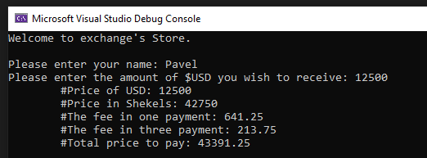

**Q2**

using System;

using System.Collections.Generic;

using System.Linq;

using System.Text;

using System.Threading.Tasks;

namespace HW1

{

internal class Q2

{

static void Main(string[] args)

{

const int size = 9;

int[] arr = new int[size];

int[] arr2 = new int[size];

Console.WriteLine("Please enter 9 numbers between 0 - 100:");

for (int i = 0; i < arr.Length; i++)

{

arr[i] = int.Parse(Console.ReadLine());

if (arr[i] < 0 || arr[i] > 100)

{

Console.WriteLine("Please re-enter a number between 0 and 100");

i--;

}

}

arr2 = arr.Distinct().ToArray();

Console.Write("[ ");

for (int i = 0; i < arr2.Length; i++)

{

if (i == arr2.Length-1)

{

Console.Write(arr2[i] + " ");

}

else

{

Console.Write(arr2[i] + ", ");

}

}

Console.Write("]");

}

}

}

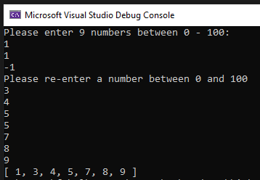

**Q3**

using System;

using System.Collections.Generic;

using System.Linq;

using System.Text;

using System.Threading.Tasks;

namespace HW1

{

internal class Q3

{

static void Main(string[] args)

{

const int cols = 3;

int rowCount = 0, index = 0;

int[] arr = new int[] { -1, 0, 1, 2, -1, 4, -3, -4, 2 };

for (int i = 0; i < arr.Length-2; i++)

{

for (int j = i+1; j < arr.Length-1; j++)

{

for (int k = j+1; k < arr.Length; k++)

{

if(arr[i] + arr[j] + arr[k] == 0 && i != j && i != k && j != k)

{

rowCount++;

}

}

}

}

int[,] newArr = new int[rowCount, cols];

for (int i = 0; i < arr.Length - 2; i++)

{

for (int j = i + 1; j < arr.Length - 1; j++)

{

for (int k = j + 1; k < arr.Length; k++)

{

if (arr[i] + arr[j] + arr[k] == 0 && i != j && i != k && j != k)

{

newArr[index, 0] = arr[i];

newArr[index, 1] = arr[j];

newArr[index, 2] = arr[k];

index++;

}

}

}

}

for (int i = 0; i < newArr.GetLength(0); i++)

{

for (int j = 0; j < newArr.GetLength(1); j++)

{

Console.Write($"{newArr[i, j]}\t");

}

Console.WriteLine();

}

}

}

}

