

1. Curve logo - replace with 0x logo



1. Balancer logo - replace with Paraswap logo
2. Add a a Throswap logo





Could we add Solana and Bitcoin logos here?

 - remove this icon in order that we will have 3 rows with 7 icons in each row.

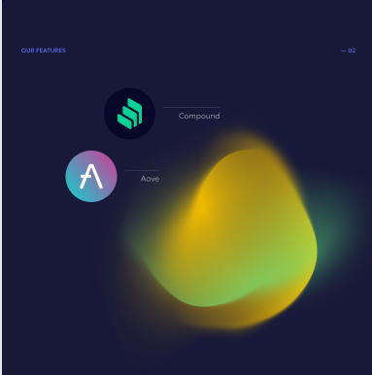

Can we add Radiant Capital logo

<https://coinmarketcap.com/currencies/radiant-capital/>



Can we add Spart finance logo

<https://spark.fi/>





Can we add Yearn Finance logo?

<https://yearn.fi/>

