**What you need to do:**

1. Install Docker

(<https://docs.docker.com/docker-for-windows/release-notes/#docker-community- edition-17031-ce-win12--2017-05-12>)

1. Download vnc image: **docker pull selenoid/vnc:chrome_65.0**
2. Download image for video recording **docker pull selenoid/video-recorder:latest-release**
3. On C disk create folders **selenoid\video\aerokube**
4. From folder with **docker-compose.yml** file and execute from command line command: **docker-compose up**
5. Wait until all necessary images are downloaded :)
6. Verify images and containers **docker ps -a**, **docker images**

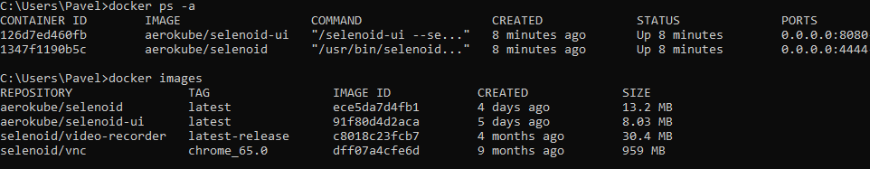

1. Navigate to the **localhost:9090**

[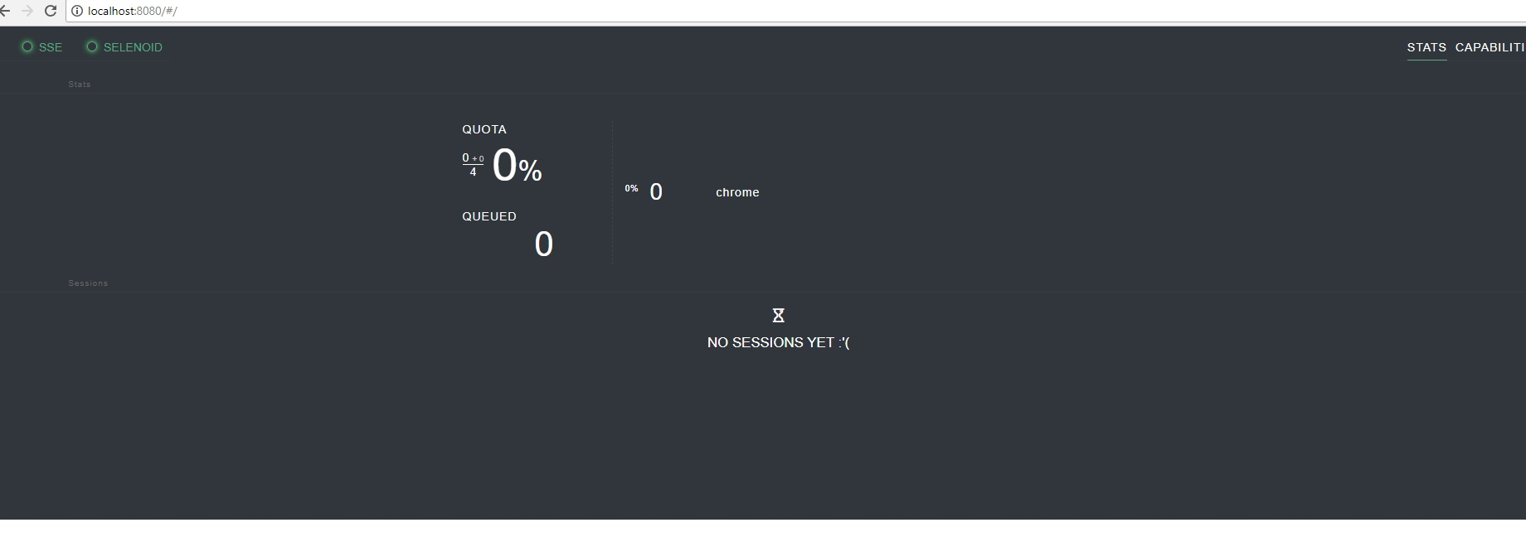](https://user-images.githubusercontent.com/26840848/39272875-e926f05a-48e5-11e8-806f-9847aaa59e52.jpg)

* 1. Don't forget to add some changes in your code see:

DesiredCapabilities browser = new DesiredCapabilities();  
 browser.setBrowserName("chrome");  
 browser.setVersion("65.0");  
 browser.setCapability("enableVNC", true);  
 browser.setCapability("enableVideo", true);  
 browser.setCapability("screenResolution", "1920x1080x24");

*driver* = new RemoteWebDriver(URI.*create*("http://localhost:4444/wd/hub").toURL(), browser);  
 *driver*.manage().window().setSize(new Dimension(1920, 1080));

1. Run out tests: **(See how test pass)**

[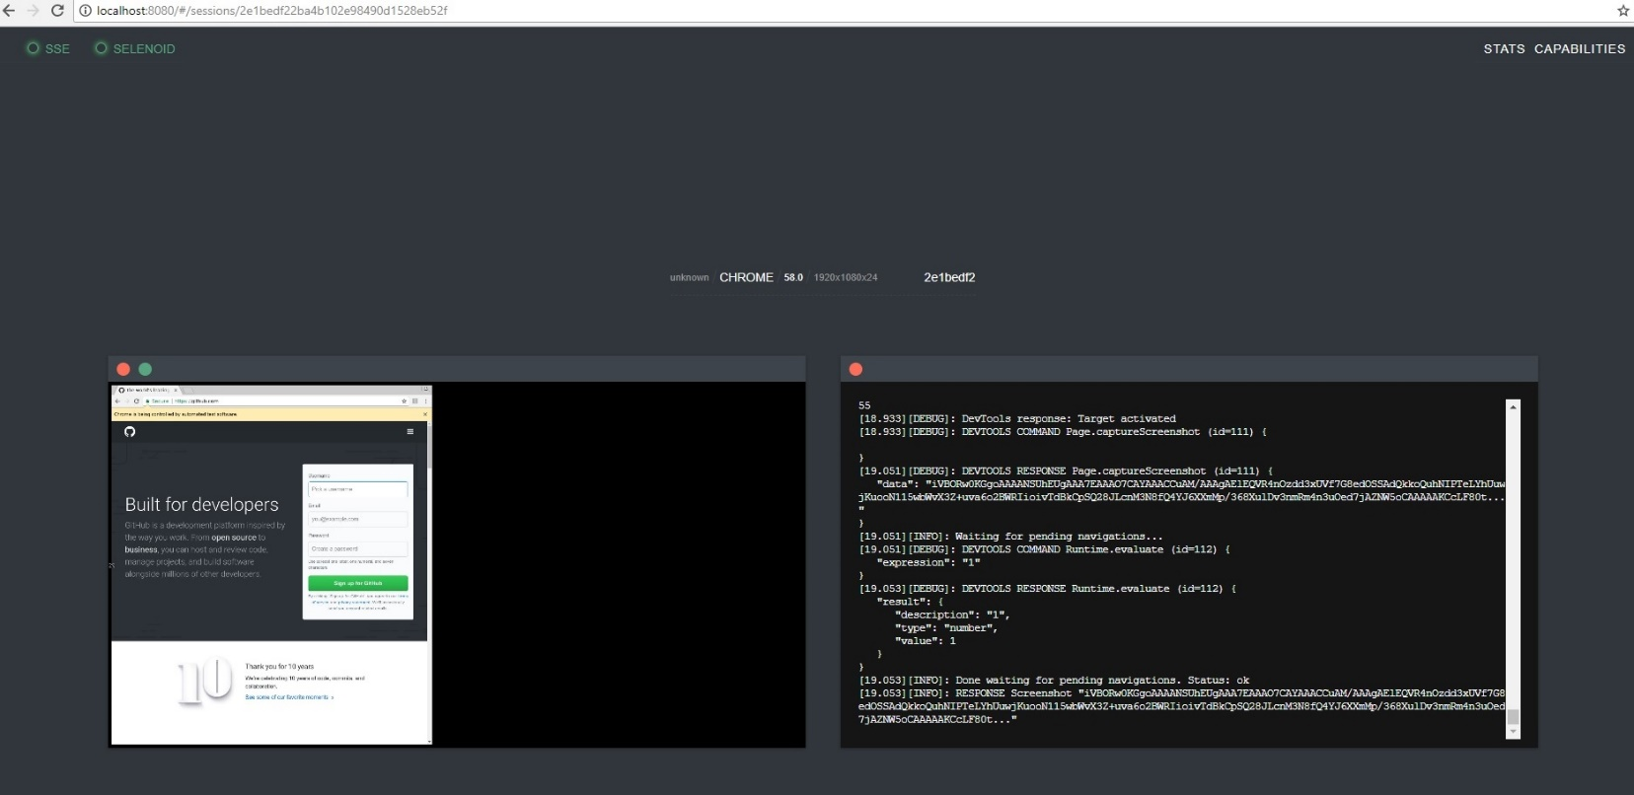](https://user-images.githubusercontent.com/26840848/39272905-fedb162e-48e5-11e8-9284-bdbb73b106dc.jpg)

1. Verify created video in the C:\selenoid\video\aerokube