GPU Dashboards in Jupyter Lab

We are excited to announce NVDashboard, a new dashboard server and Jupyter-Lab extension for the real-time visualization of NVIDIA GPU diagnostics.  NVDashboard is a great way for all GPU users to monitor system resources, but it is especially valuable for users of RAPIDS, NVIDIA’s open-source suite of GPU-accelerated data-science software libraries.

Given the computational intensity of modern data-science workflows, it is absolutely necessary for the underlying software to utilize system resources efficiently.  The overall execution time can depend on a number of inter-dependent factors, like CPU/GPU utilization, memory consumption, and inter-process communication. The practice of directly querying the relevant hardware metrics is often the best way to validate efficient run-time behavior.

The value of direct hardware diagnostics is amplified when the user interface is an interactive Jupyter-Lab notebook and the system is composed of GPUs.  In this case, improper GPU utilization can result in a huge loss of productivity, because the user is often waiting for each cell to execute in real time.  Wasted time can be avoided in many cases when the user is made aware of inappropriate resource utilization immediately. NVDashboard accomplishes just this by making it simple to track critical GPU diagnostics, like processor utilization, memory consumption, and PCIe/NVLink data throughput.

**## NVDashboard Package Details**

The `nvdashboard` package is available on PyPI, and consists of two basic components:

* **Server**:  Uses pynvml to collect diagnostics from your NVIDIA GPUs and turns them into useful dashboards using bokeh.
* **Lab Extension**:  Allows you to view dashboards as movable windows within your Jupyter Lab environment.

**## Using the Jupyter-Lab Extension**

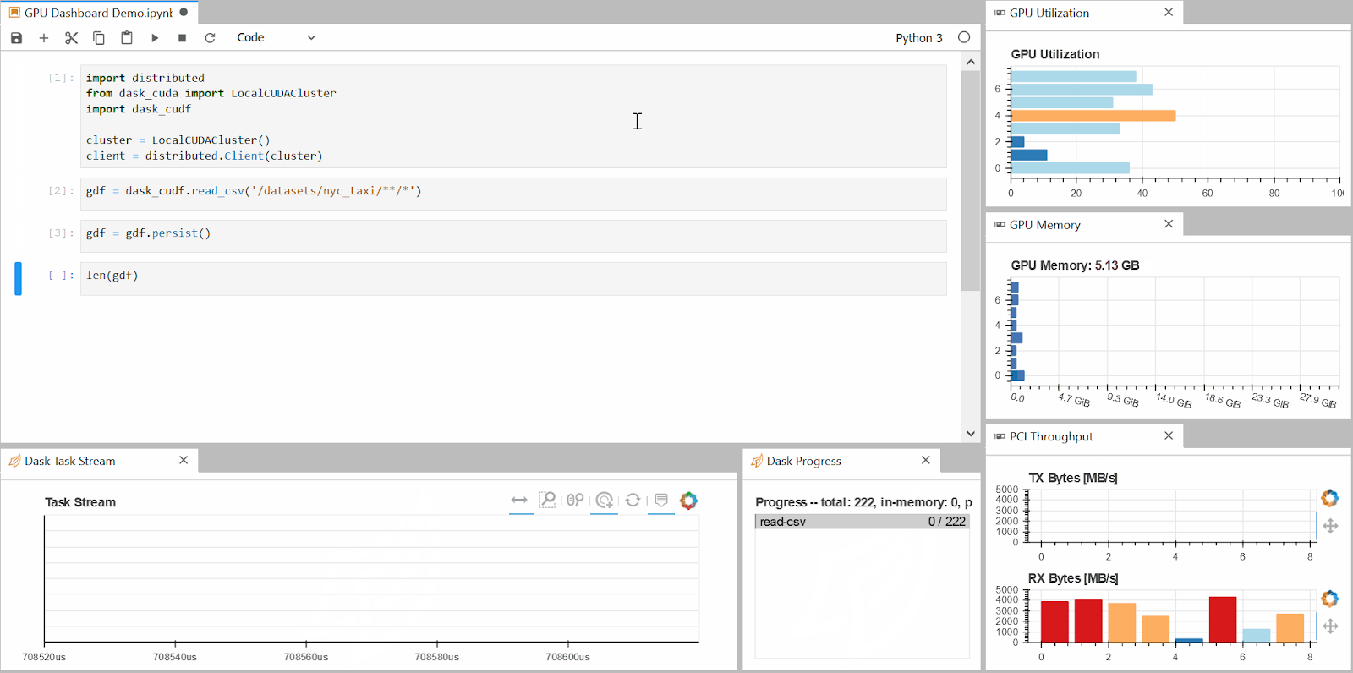

## Using the Stand-alone Server

## Adding Custom Dashboards