YAM-Hackathon 2018

First, I would like to say thanks to all of you at T-Systems who made it possible for bringing me to the hackathon where I can c spend my time building something tech cool with colleagues from around the world.

So what is YAM-Hackathon?

Hackathon-style spreads to every sector in the economy. The contests, where small teams of “hackers” build tech products in marathon all-night coding sessions, are a hallmark of Silicon Valley culture. Recall Facebook’s most famous hackathon, thrown on the eve of its IPO to show the world that the demands of being a public company would not kill the “hacker way” at One Hacker Way.

They’ve become part of a “toolkit” for large organizations seeking a veneer of innovation. Some organizers view them as recruiting opportunities, others as opportunities to evangelize their company’s technology platforms, and others simply want to be associated with something cool and techie.

Hackathon participants at this event almost universally viewed the event positively. Hackathons are often social, emotionally charged, and a way to learn. A lot of participants say they learn skills and believe skills they learned at a hackathon help them in their job. To the tech industry and its imitators, these are normal ideas.

This year YAM-Hackathon in Budapest it was decided to follow the International Barcamp motto **Magenta United** and build mixed teams from all participants, to create a true united feeling across borders and silos. This means randomly were selected 5 participants for each team, which makes 9 teams out of 45 applicants.

These groups were presented to each other and my team "TOM YAM", for example, was working on a solution to embed Instagram tile in YAM in order to allow users to see feed of photos and videos for certain hashtags and have a self-customization of this widget in YAM.

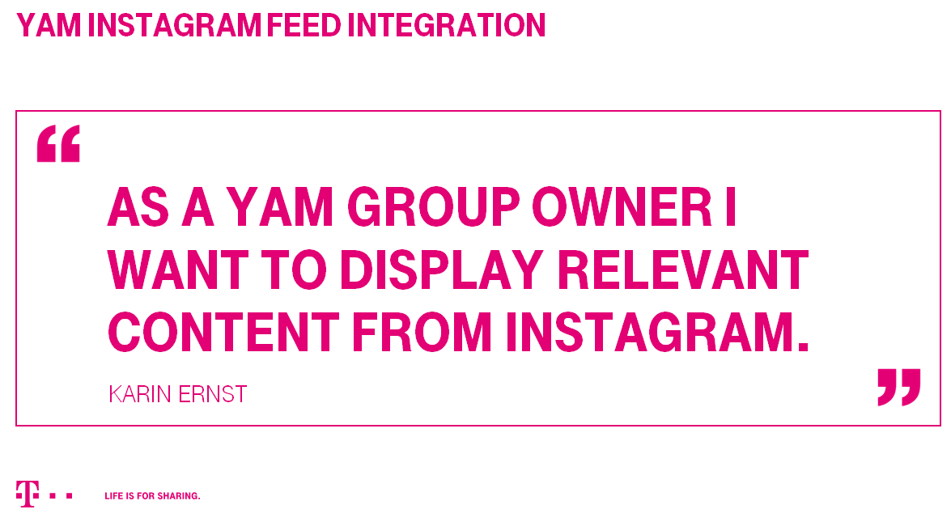

Why TOM YAM? Tom yam is a type of hot and sour Thai soup. The words "tom yam" are derived from two Thai words. Tom refers to the boiling process, while yam refers to a Thai spicy and sour salad.

In our case, we left the first word, it characterize the nature of the hackathon event, so to say the brainstorming. And YAM will stand for YAM network.

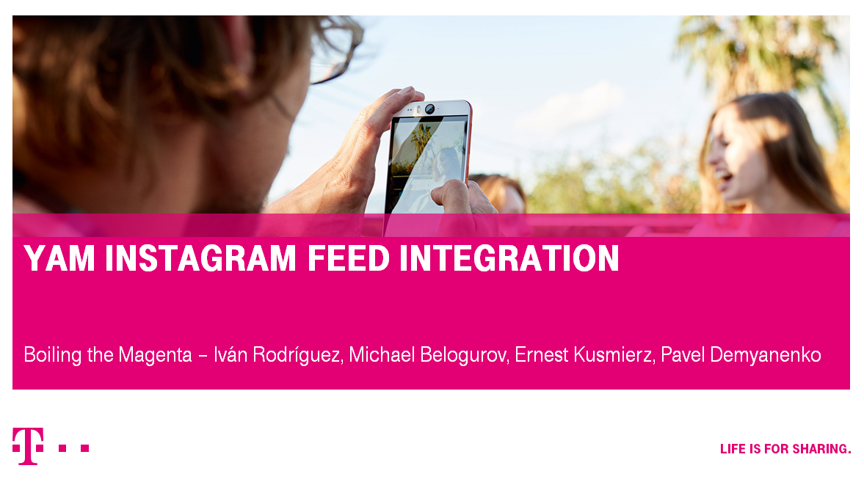

Also we had to create logo for our team and I suggested this kind of design. Magenta color refers to Telekom colors and it's like boiling soup. Shrimp something which refers to team, as if we are in magenta soup. Also some design matters to connect with camera applications.

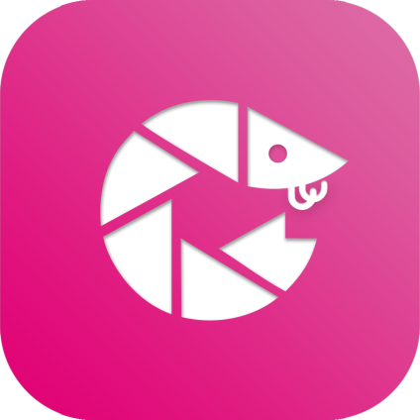

We had to define prototype the overall solution. What exactly should the solution look like? What technology stack to use and how to work with infrastructure?

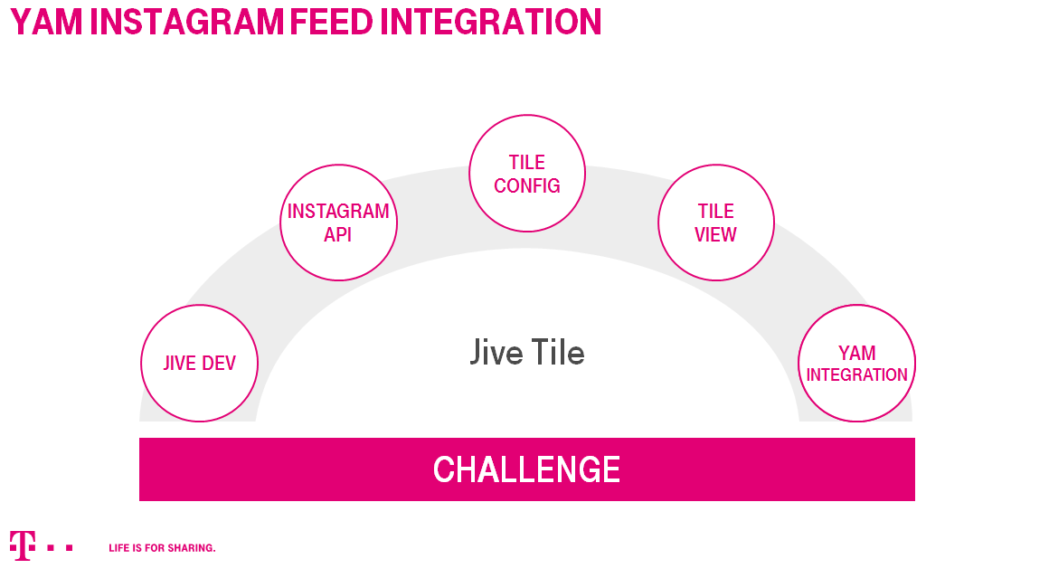

In our project we used all modern technologies, like Docker for YAM instance and Vue.js to build our application. We even had a monitoring screen for all Docker instances and overall performance of the infrastructure.

All cool stuff surrounded us was like magenta kingdom with magenta unicorns and magenta magic.

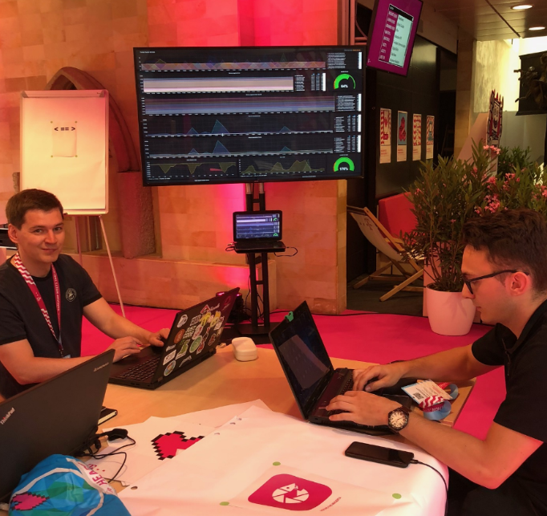

Coding all day long we managed to develop a fully working example of application prototype. By the way you can check the code. For your interest I made a public repository for this [project](https://dol.telekom.de/gitlab/pdemian/yam-instagram-tile) .

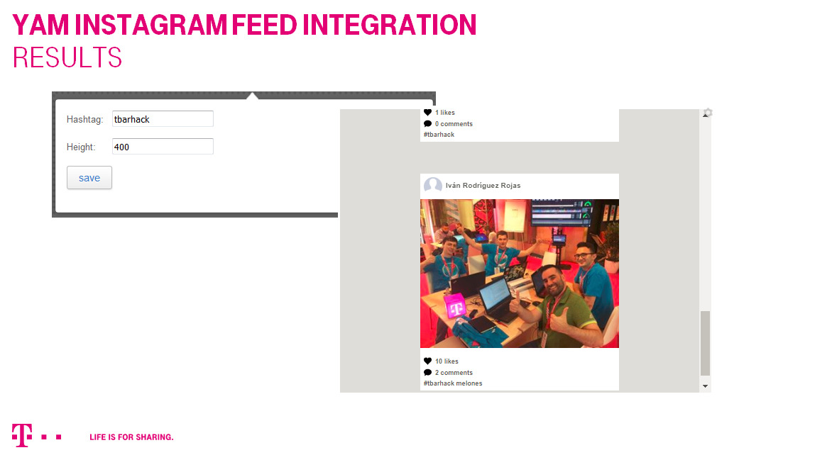

As web service APIs, the Instagram API is robust, and in my experience works very well. So we managed to show not just photos but also videos in our custom feed.

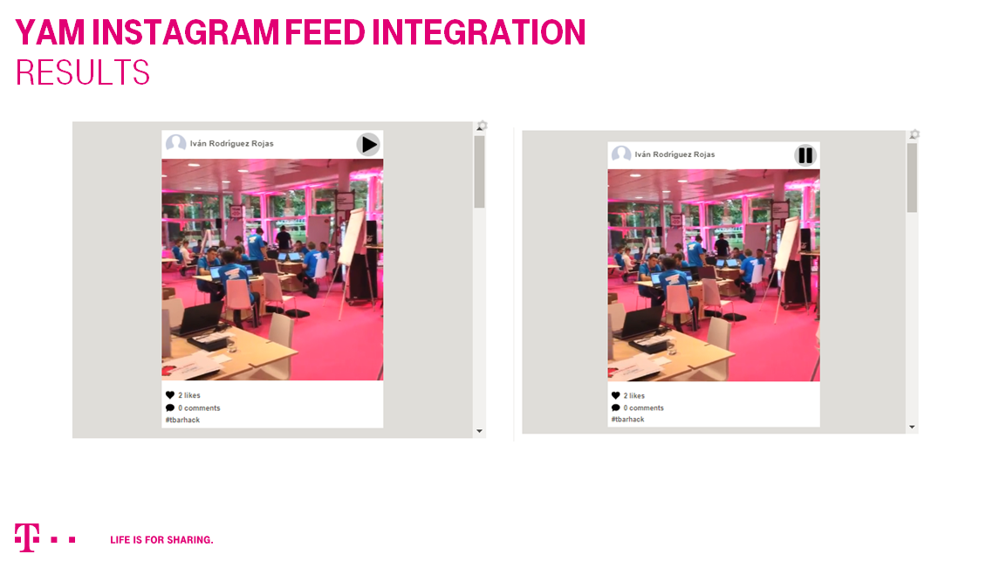

At the end of all session we had a closing ceremony where all team presented cool projects.

