1

SELECT name FROM Passenger

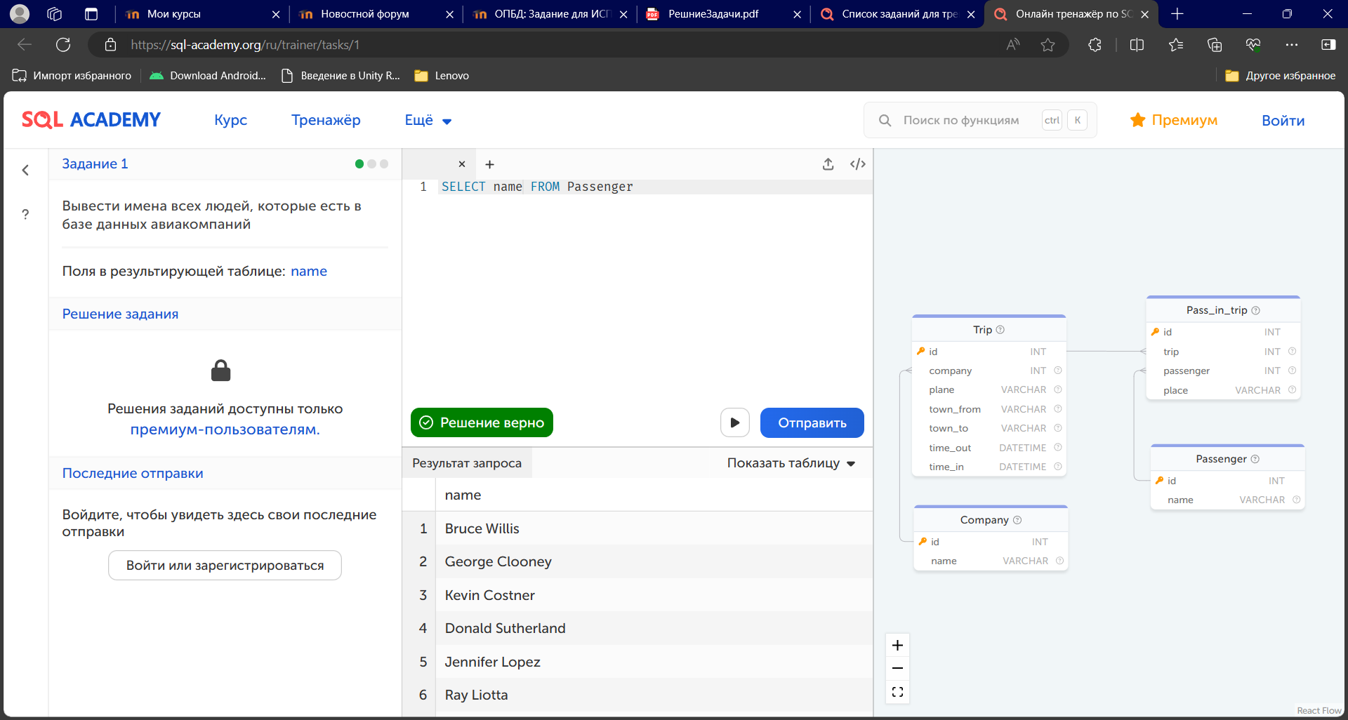

2

SELECT name FROM Company

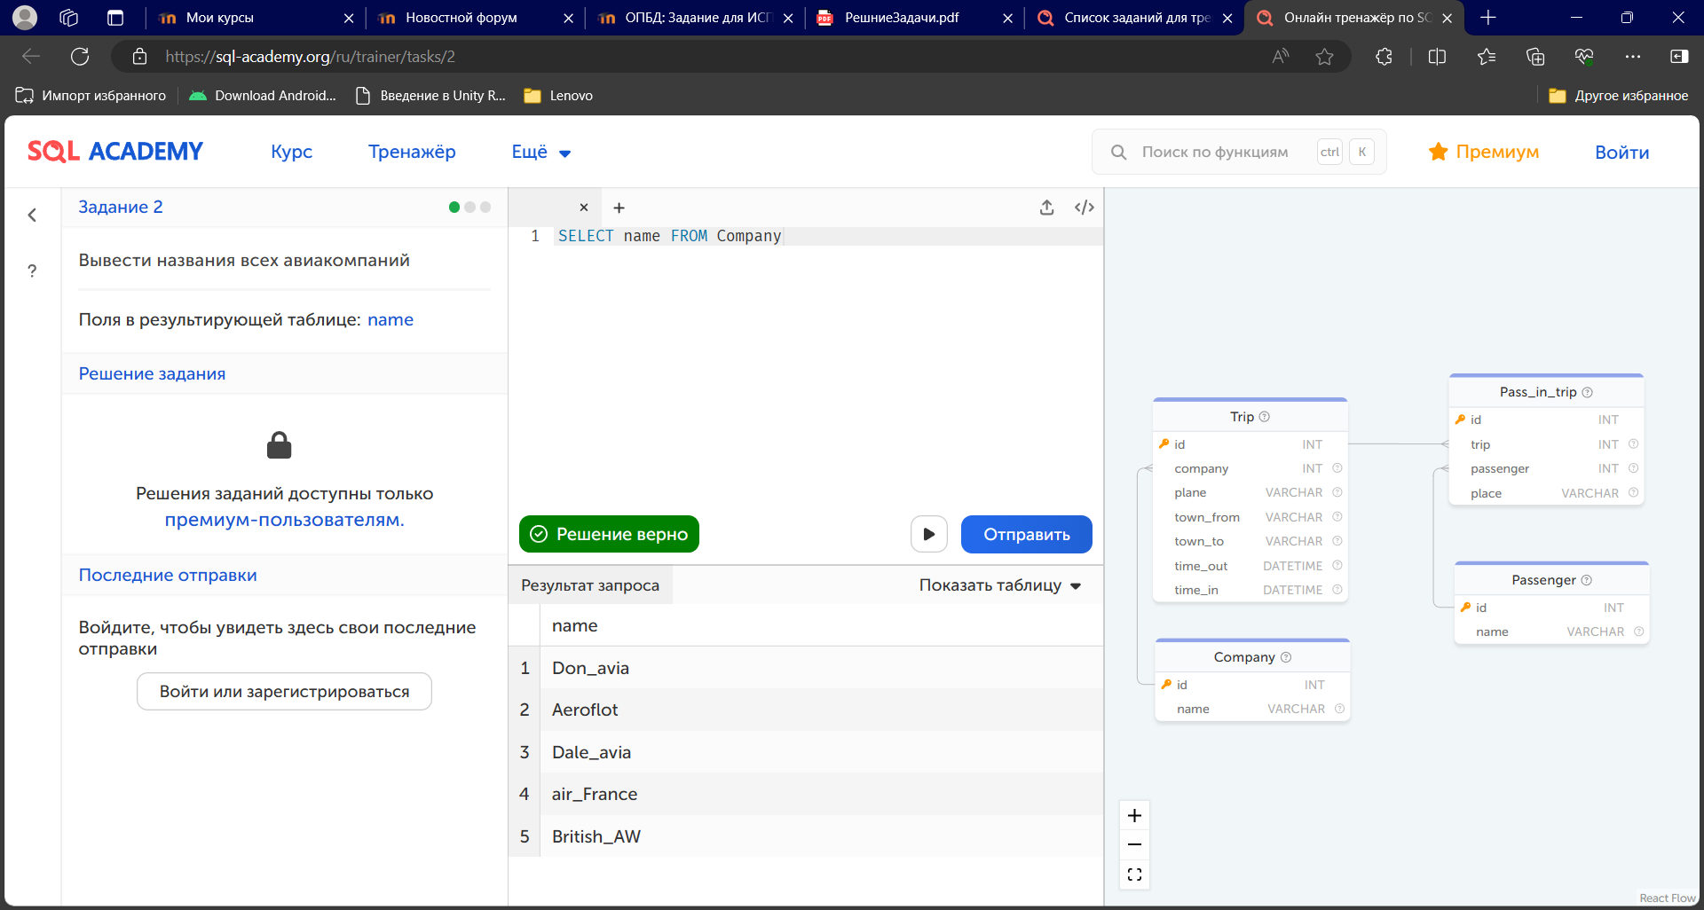

3

SELECT town_from FROM Trip

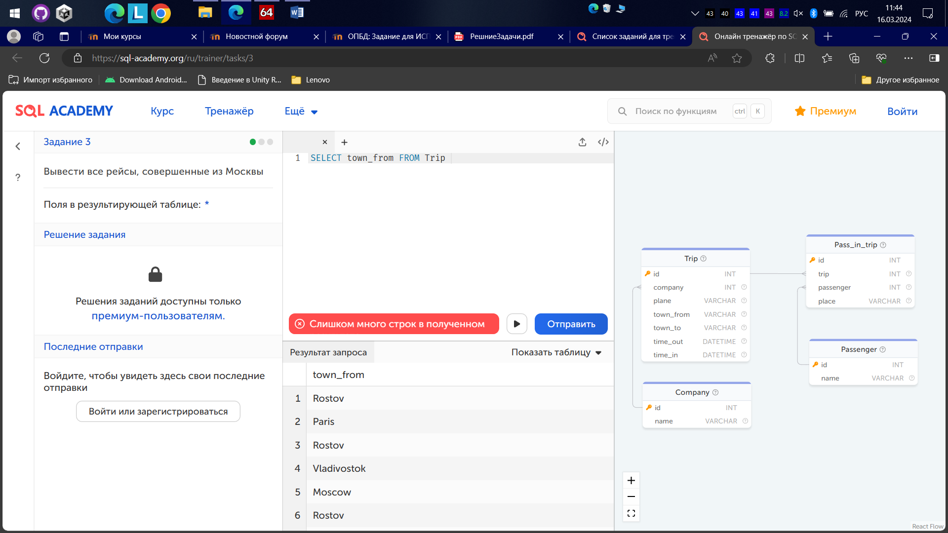SELECT * FROM Trip

WHERE town_from = "Moscow"

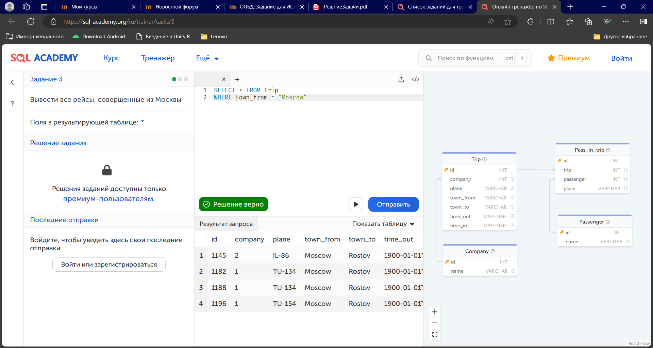

4

SELECT name FROM passenger

WHERE name LIKE "%man"

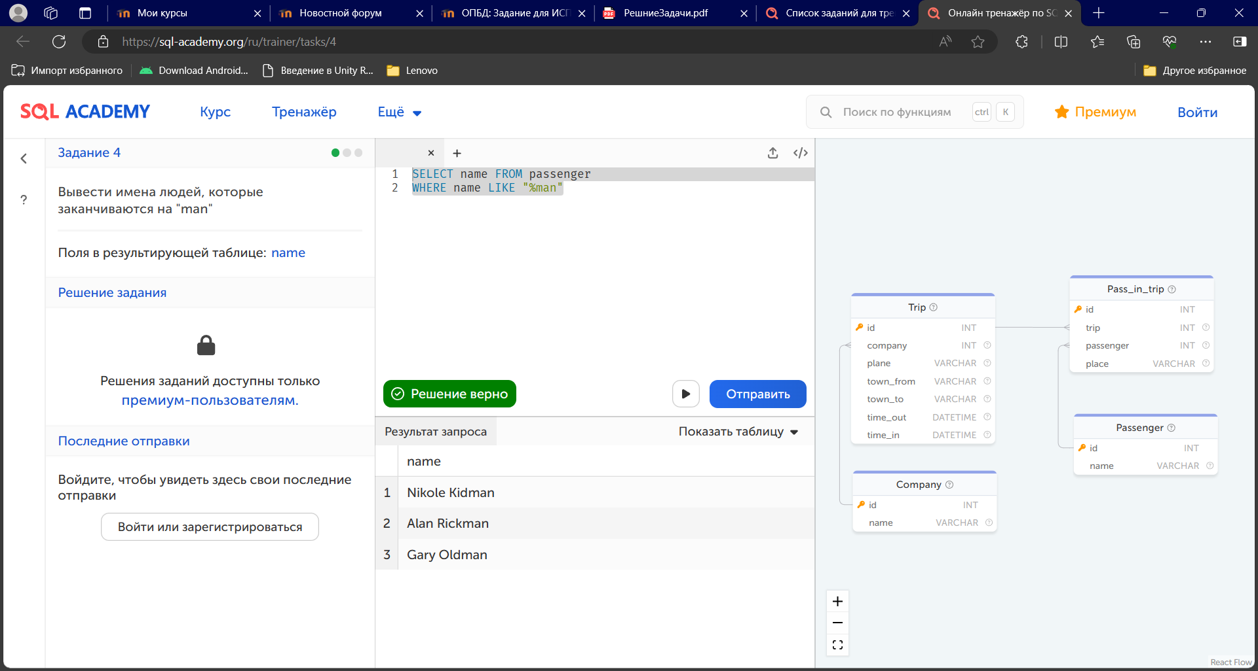

5

SELECT COUNT(*) as count FROM Trip

WHERE plane = "TU-134"

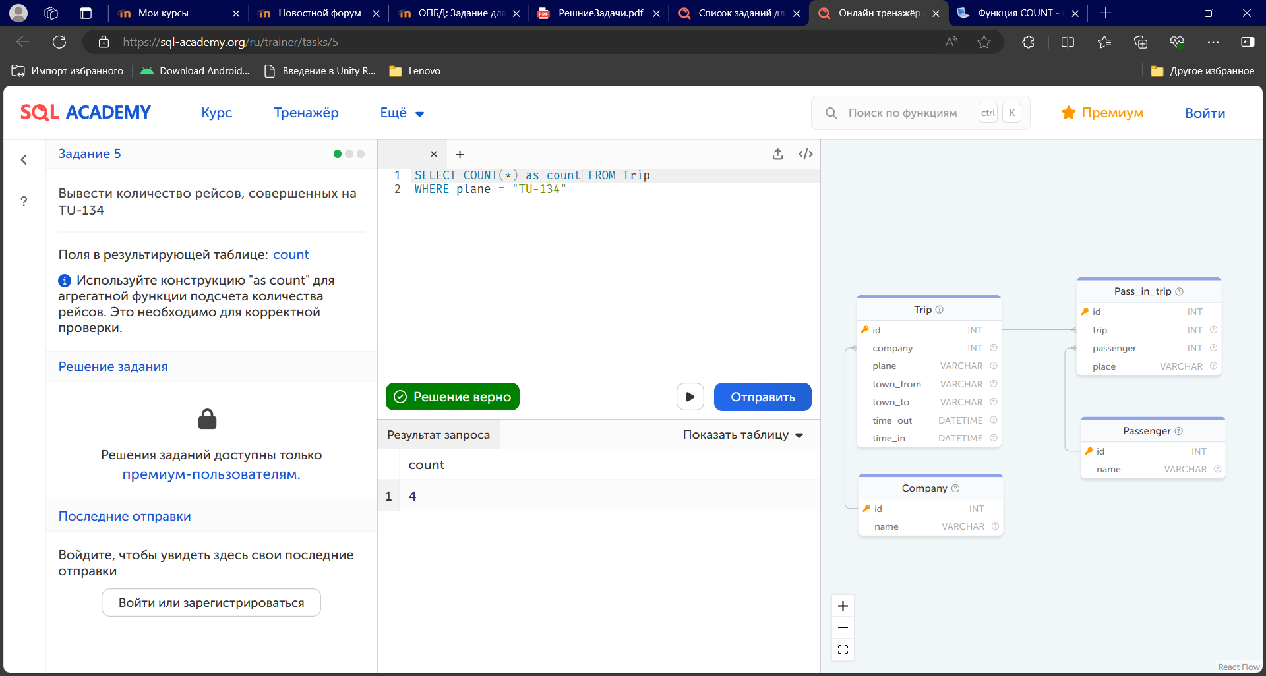

6

SELECT DISTINCT

c.name

FROM Trip AS t

JOIN Company AS c ON t.company = c.id

WHERE

t.plane = 'Boeing'

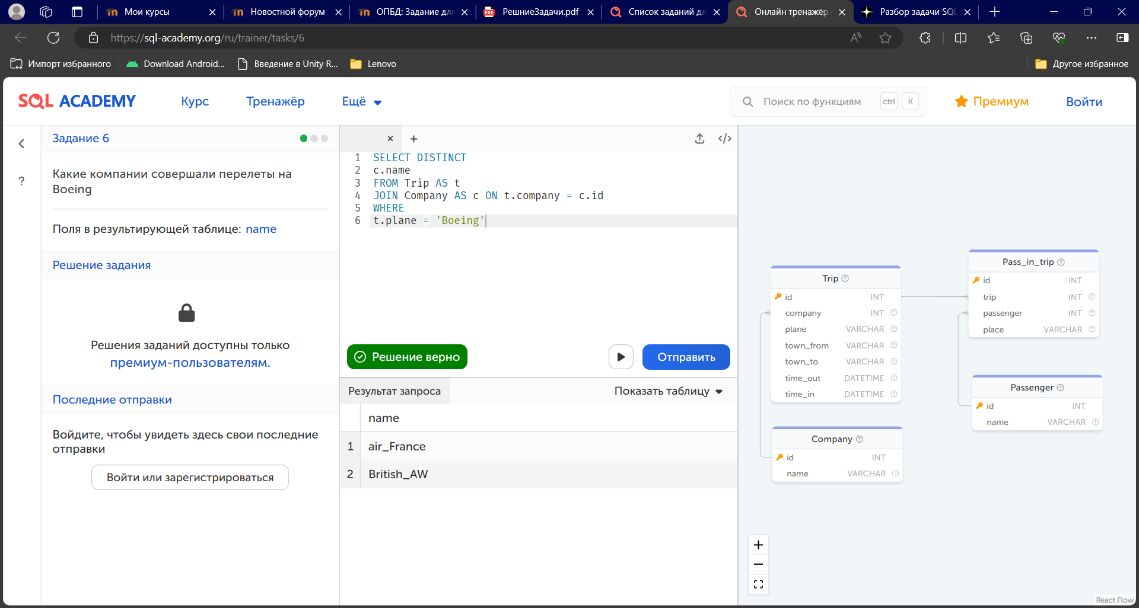

7

SELECT DISTINCT plane FROM trip

WHERE town_to = "Moscow"

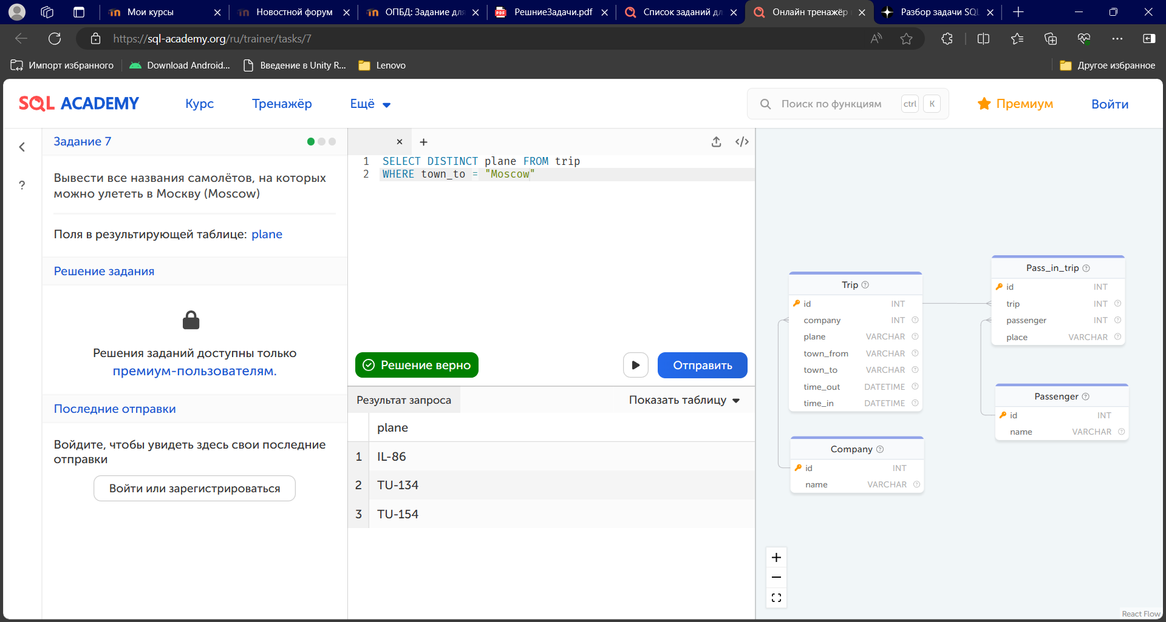

9

SELECT DISTINCT

c.name

FROM Trip AS t

JOIN Company AS c ON t.company = c.id

WHERE

t.town_from = 'Vladivostok'

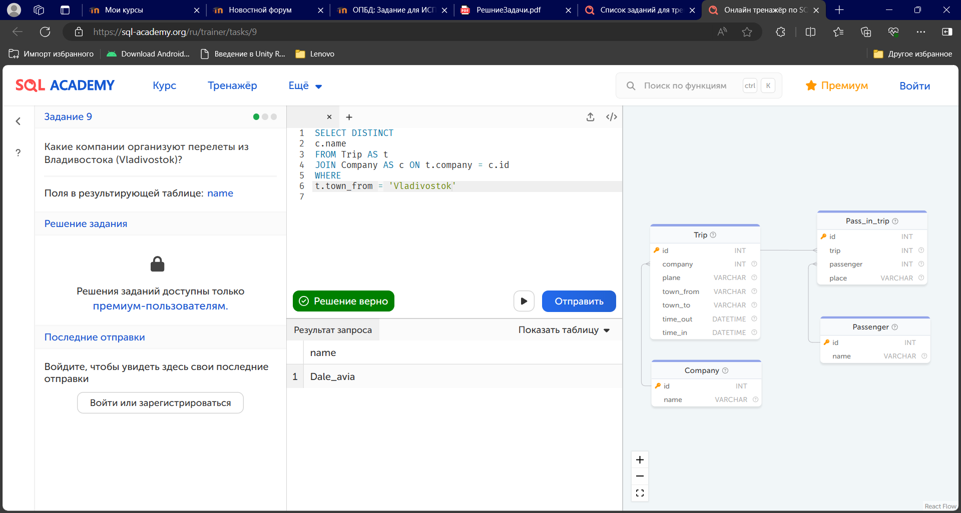

12

SELECT trip, COUNT(passenger) as count

FROM Pass_in_trip

GROUP BY trip;

