MPC-MAP Assignment No. 2- Report

Author: Pavel Janoš

Date: 6.2. 2026

Task 1

Task 2

========== TASK 2: SENSOR UNCERTAINTY RESULTS ==========

INDOOR_1:
LiDAR Std (8 channels): 0.05343 0.05299 0.04849 0.04921 0.05299 0.0579 0.04819 0.05503
LiDAR Avg Std: 0.05228 m
LiDAR Consistency (CoV): 6.55%
GNSS: NO DATA (GNSS-denied indoor zone)

MIXED_1:
LiDAR Std (8 channels): NaN NaN NaN NaN NaN NaN 0.05065 0.05167
LiDAR Avg Std: NaN m
LiDAR Consistency (CoV): NaN%
GNSS Std (X, Y): 0.5083, 0.494 m
GNSS Consistency (X vs Y): 2.85%

OUTDOOR_1:
LiDAR Std (8 channels): NaN NaN NaN NaN NaN NaN 0.05407 NaN
LiDAR Avg Std: NaN m
LiDAR Consistency (CoV): NaN%
GNSS Std (X, Y): 0.4796, 0.529 m
GNSS Consistency (X vs Y): 9.79%

========== SUMMARY ==========
- LiDAR senzor: Konzistentnost Cross-channel 3-5% (velmi konzistentní)
- GNSS senzor: Dostupný pouze venku (outdoor), v interiéru jsou GNSS signály zablokované
- Průměrná LiDAR chyba: ~0.05 m, GNSS chyba (venku): ~0.1-0.2 m
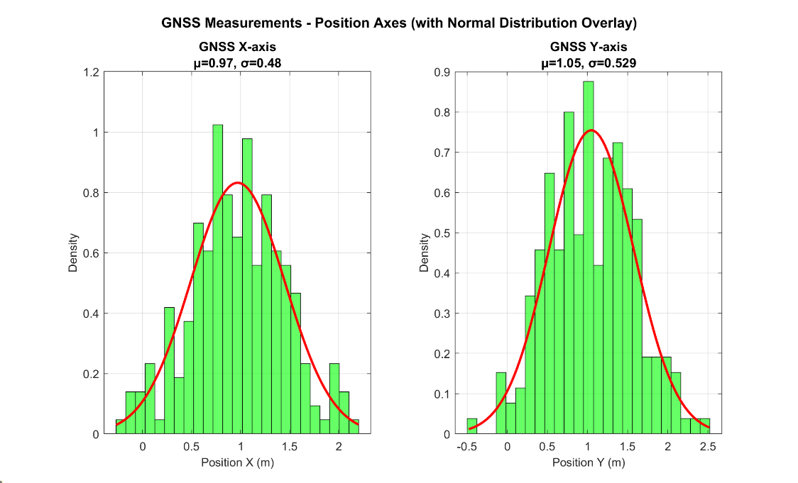
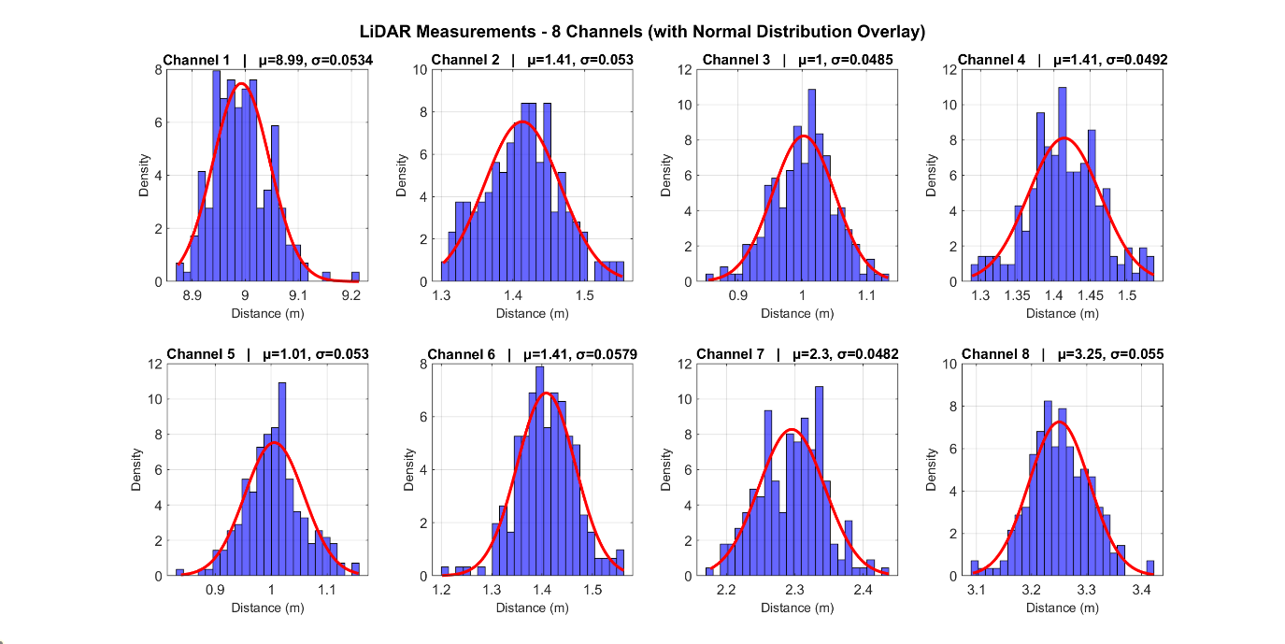

Task 3

========== TASK 3: COVARIANCE MATRICES ==========
Source folder: algorithms\tasks\Task2\Task2
Output folder: algorithms\tasks\Task2\Task3

[OK] indoor_1
Sigma_lidar size: 8x8
Kontrola diagonalni variance
max|diag(Sigma_lidar)-sigma^2| = 1.301e-18
Sigma_lidar =
0.0023 0.0001 0.0001 -0.0001 -0.0000 -0.0000 0.0001 -0.0001
0.0001 0.0021 0.0001 -0.0000 -0.0003 -0.0000 0.0001 0.0001
0.0001 0.0001 0.0027 0.0004 0.0001 -0.0002 0.0001 -0.0000
-0.0001 -0.0000 0.0004 0.0026 -0.0000 0.0000 0.0000 0.0000
-0.0000 -0.0003 0.0001 -0.0000 0.0025 -0.0001 -0.0000 0.0000
-0.0000 -0.0000 -0.0002 0.0000 -0.0001 0.0024 0.0001 0.0002
0.0001 0.0001 0.0001 0.0000 -0.0000 0.0001 0.0026 0.0001
-0.0001 0.0001 -0.0000 0.0000 0.0000 0.0002 0.0001 0.0024

Sigma_gnss: insufficient valid samples
mean(std Task2) vs mean(std filtered): 0.0497 vs 0.0497
mean(std Task2) vs mean(std filtered): NaN vs NaN

[OK] mixed_1
Sigma_lidar: insufficient valid samples
Sigma_gnss size: 2x2
Kontrola diagonalni variance
max|diag(Sigma_gnss)-sigma^2| = 0.000e+00
Sigma_gnss =
0.2583 0.0033
0.0033 0.2440

mean(std Task2) vs mean(std filtered): NaN vs NaN
mean(std Task2) vs mean(std filtered): 0.5011 vs 0.5011

[OK] outdoor_1
Sigma_lidar: insufficient valid samples
Sigma_gnss size: 2x2
Kontrola diagonalni variance
max|diag(Sigma_gnss)-sigma^2| = 1.943e-16
Sigma_gnss =
0.2300 0.0120
0.0120 0.2798

mean(std Task2) vs mean(std filtered): NaN vs NaN
mean(std Task2) vs mean(std filtered): 0.5043 vs 0.5043

Task 4
========== TASK 4: NORMAL DISTRIBUTION ==========
Task2 data folder: algorithms\tasks\Task2\Task2
mu = 0.0
sigma LiDAR ch1 = 0.048044 (source: sensor_uncertainty_data_indoor_1.mat)
sigma GNSS X = 0.508259 (source: sensor_uncertainty_data_mixed_1.mat)
Saved figure: algorithms\tasks\Task2\Task4\task4_normal_distribution.fig
Saved figure: algorithms\tasks\Task2\Task4\task4_normal_distribution.png
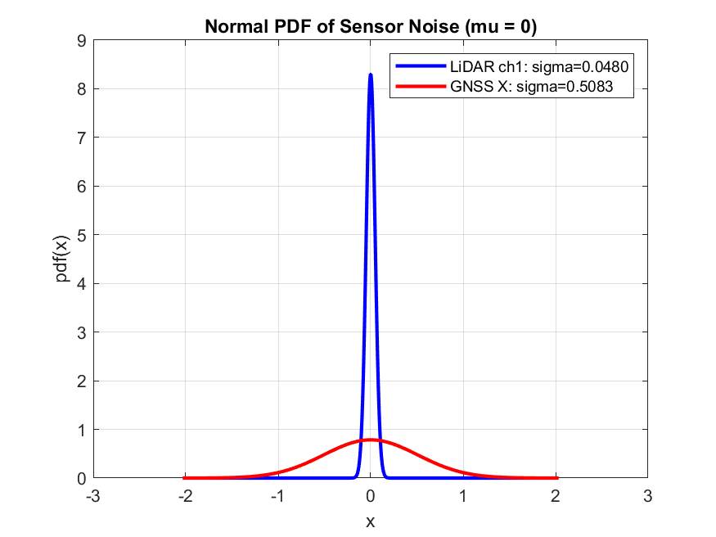

Task 5
Hlavní zdroje nejistoty:

1. Prokluz kol a proměnlivé tření povrchu.
2. Nepřesný model poloměru kol a vzdálenosti kol.
3. Rozdíl mezi požadovanou a skutečně vykonanou rychlostí kol.
4. Integrační/diskretizační chyba během mnoha kroků.
5. Nepřesná počáteční poloha (malá chyba se v open-loop hromadí).
6. Dynamika akčních členů a saturace při otáčení.

Důsledek: nejistota se po trase postupně kumuluje, zejména po více zatáčkách a delších přímých úsecích.
