MPC-MAP Assignment No. 3 - Report

Author: Pavel Janoš

Date: 7.2. 2026

Task 1
\algorithms\tasks\Task3\Task1\task1_vyznam_parametru_mapy.md

Task 2
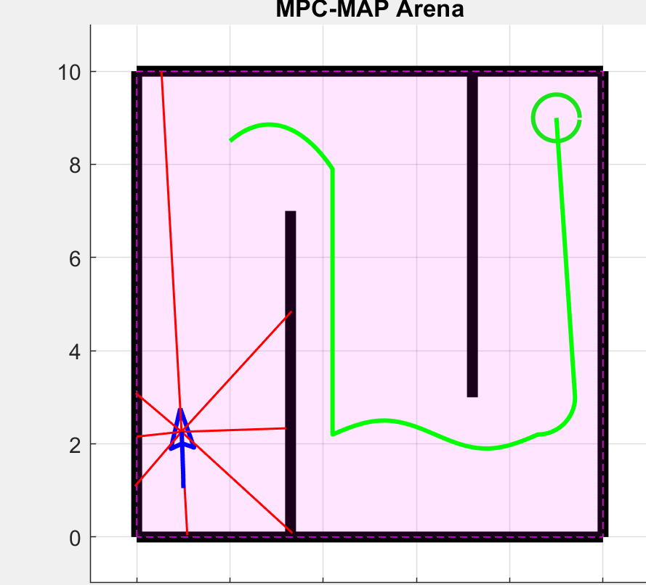

Task 3

Testovano na mape indoor_1 se startem (2, 8.5) a MoCap polohou.
- Pocet pokusu na metodu: 20
- Maximalni delka behu: 550 kroku
- Metody: waypoint_p, pure_pursuit, cross_track_pd, stanley
Vysledky
Metoda | Uspesnost [%] | Prum. kroky (jen uspech) | RMSE od trasy [m] | Kolize [pocet] | Mimo mapu [pocet]
waypoint_p | 100.0 | 364.6 | 0.021 | 0 | 0
pure_pursuit | 100.0 | 437.4 | 0.071 | 0 | 0
cross_track_pd | 95.0 | 434.0 | 0.282 | 1 | 0
stanley | 75.0 | 488.2 | 0.358 | 5 | 0

Diskuze parametru metody
- waypoint_p: hlavni parametry jsou K_heading, v_nom, wp_tol. Vyssi K_heading zrychli nataceni, ale muze zpusobit kmitani.
- pure_pursuit: hlavni parametry jsou lookahead_dist, v_nom, k_curve_slow. Mensi lookahead zvysuje presnost, ale zhorsuje stabilitu.
- cross_track_pd: K_cte, K_heading, K_d urcuji kompromis mezi rychlou korekci a prekmitanim.
- stanley: k_stanley, K_w, v_soft ovlivnuji citlivost na pricnou chybu. Vyssi k_stanley drzi trasu tesneji, ale byva mene hladky.

