Supplementary information
Table of Contents
File importer 2
Settings 3
Component structure 4
The Primary Setup 4
Settings 4
Component structure 8
The Secondary Setup 11
The File Exporter 13
Use case #1 – Creating a dose-response layout 15
Use case #2 – Double-concentration screen 21

Upon importing to KNIME, the workflow folder includes the MOLD application and a data folder. For MOLD to function properly, the MOLD application must reside in the same folder as the data folder.
- default_values.csv – used to store the current setting of the components
- default_values_reset.csv – stores the original settings of the components
- destination_plate_names.csv – stores the destination plate names, can be overwritten with custom names
- input_example.csv –example input for MOLD used in documented Use case 1# and 2#
The default values files are used to store the current settings used in the Primary Setup. The settings are then automatically loaded to the Setup components, even after restart. The original settings can be always reset by executing the Reset Default Settings component at the bottom. MOLD comprises 4 components – File Importer, Primary Setup, Secondary Setup, and File Exporter. Each component is described in detail below. The user interphase of all the components can be accessed by choosing the “open view” option by right-clicking on the component.
For the transfer of various liquids (DMSO or H₂O), the following source plate types (ECHO defaults) are used (Supplementary Table 1).
Supplementary Table 1 Source plate types
Plate | DMSO | H₂O
1536LDV | 1536LDV_DMSO | Not available
384LDV | 384LDV_DMSO | 384LDV_AQ_B2
384PP | 384PP_DMSO2 | 384PP_AQ_CP

File importer
The File Importer component (Supplementary Figure 1) serves as the entry point for external data into the MOLD workflow. It is responsible for reading and parsing input files containing critical information about source plates, such as compound IDs, well locations, solvent types, and concentrations. This data is then validated and prepared for further processing.
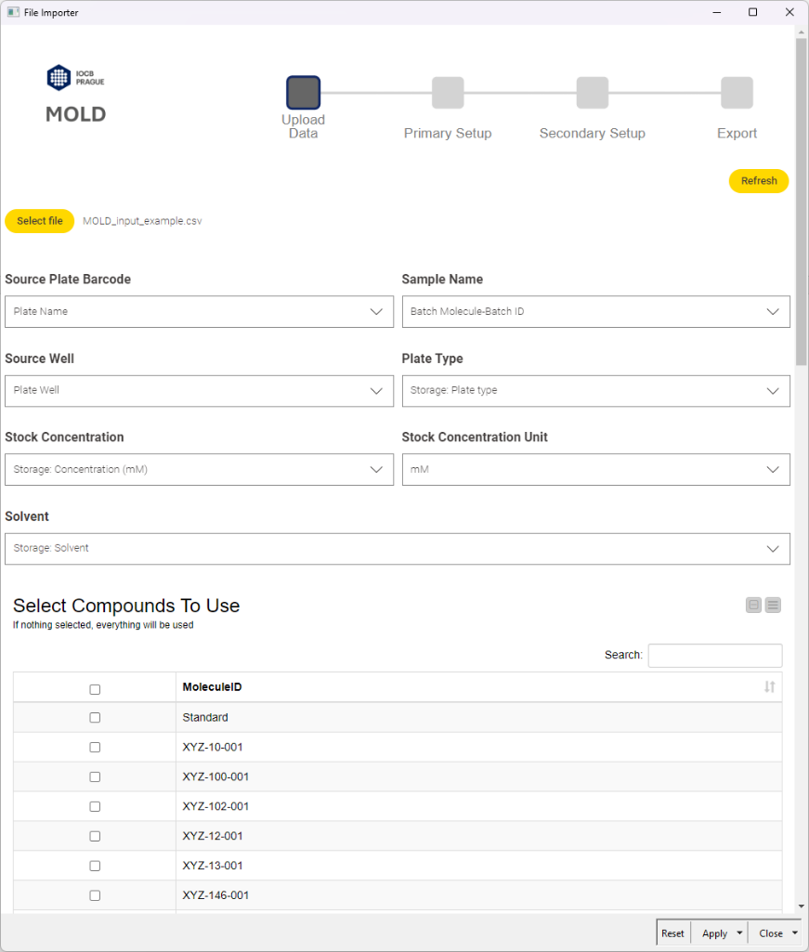
Supplementary Figure 1 The GUI of the File Importer component.

Settings
The “Select file” button in the components' graphical user interface (GUI) allows the user to select the desired .csv file on the local disk. Once the file is chosen, the “Refresh” button needs to be pressed to load it.
Natively MOLD needs 6 data columns to work:
- Source Plate Barcode (Integer data format)
- Sample Name (Unique ID of the sample)
- Source Well (“A1” or “A01” format)
- Plate Type (384PP, 384LDV, 1536LDV)
- Stock Concentration
- Solvent (DMSO, dmso, H2O, h2o, water, D2O, d2o, DMSO-d6, dmso-d6)
These columns must be present in the input data file. The columns are mapped in the File Importer component using the drop-down menus, so the input file does not have to have any specific column naming. File Exporter renames and validates the columns. The concentration unit must also be specified using the drop-down menu (M, mM, µM, nM, pM). If the input file contains multiple compounds the compound selection table can be used to select the compounds to use. If no compound is selected, then all the compounds will be used.

Component structure
First, the selected input file is loaded using the CSV Reader node. Then the column names are chosen using the series of Column Selection Widgets (Supplementary Figure 2). Next, the data are processed – columns are renamed, and the concentration column is converted to µM. All the other columns are filtered out and the solvent labels are renamed to DMSO or H2O (Supplementary Figure 3). The output is then passed to the Primary Setup or Secondary Setup components.
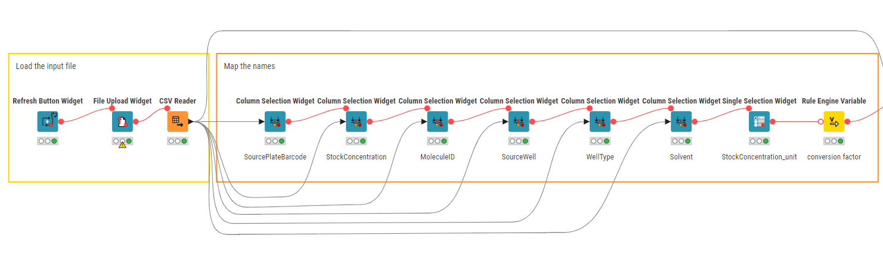
Supplementary Figure 2 Input widgets in the File Importer.
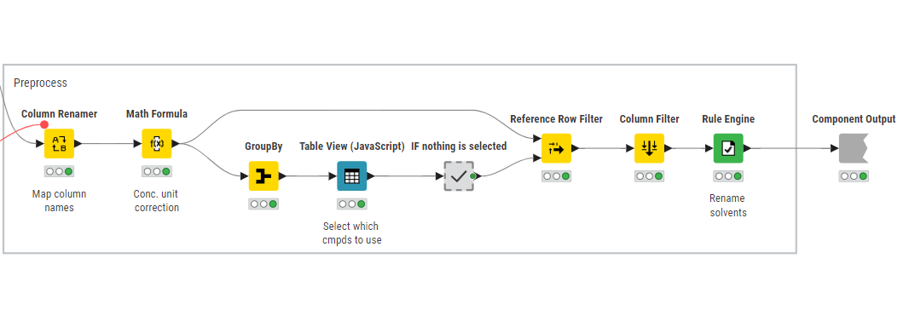
Supplementary Figure 3 Data preprocessing in the File Importer.

The Primary Setup
The Primary Setup is the central component of MOLD, where users define the parameters for their destination plates. This node calculates dilution series, assigns well positions, determines backfill volumes, and prepares a comprehensive plan for liquid handling operations.

Settings
The settings can be divided into multiple sections. In the first section general information can be set up (Supplementary Figure 4).
- Echo transfer volume [nL] – the volume of the drop acoustically transferred, 2.5 or 25 nL can be chosen depending on the Echo instrument used
- Conc. Correction Threshold [%] – the maximum change when correcting the concentrations caused by the discrete minimal transfer volume
- Destination plate format – 96-, 384-, 1536-well plate formats
- Fill By – by columns or by rows, determines the direction of destination plate filling
- Destination plate barcode – must be an integer value, when multiple destination plates are created, this barcode is incremented by one for each plate
- Destination plate name – the name of the destination plates, the options can be customized by replacing the destination_plate_names.csv file in the data folder
After the general information, the concentration points can be set up.
- Start conc. [uM] – the highest desired concentration of the series
- No. of conc. points – desired number of concentration points in the series
- Dilution factor
- Final volume [uL] – final reaction volume used in the experiment
- Maximal transfer volume [uL] – maximal volume that the Echo instrument can transfer
- Multiplicate – number of replicates that will be created
- Multiplicate arrangement – arrangement of the replicates (Next to each other or Blocks)
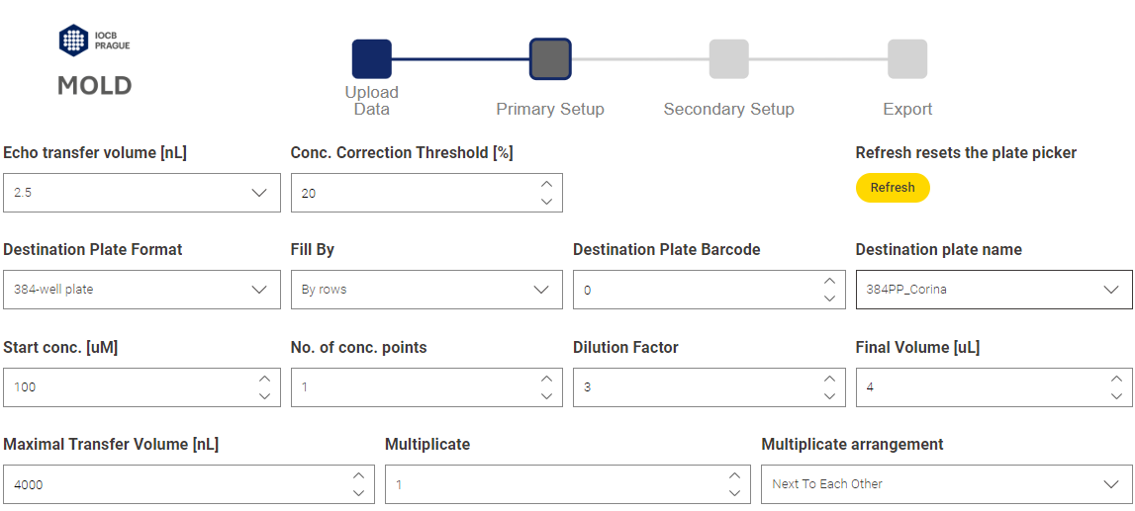
Supplementary Figure 4 The first section of the Primary Setup component settings.
After setting up these settings, the refresh button needs to be pressed to update the rest of the GUI. Below the first section are two tables (Supplementary Figure 5). These tables report the calculated concentration series. The left table can be edited to achieve custom concentrations. Since the desired concentration values must be corrected for the Echo transfer, the corrected concentration series is not the same for all the compounds. This is due to the source plate dilution. The compounds are usually available in different dilutions or different number of wells, depending on the source plate layout design. Of course, if the compounds had the same dilution in all source plates, the final corrected concentration series would be the same for all the compounds.
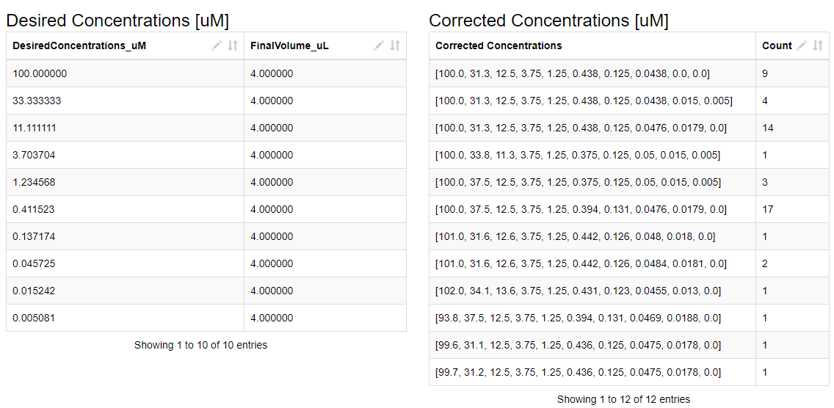
Supplementary Figure 5 The second section of the Primary Setup GUI. The left table summarizes the desired concentration series. The table on the right summarizes the actual corrected concentration series that will be created by the Echo transfer, and their count.
The third section refers to the backfill/solvent normalization of the destination plate wells (Supplementary Figure 6). Four parameters can be customized:
- Backfill plate format – 384PP (30 µL), 384LDV (8 µL) or 1536LDV (2.5 µL), each format uses pre-defined usable volume
- Backfill plate barcode - must be an integer value
- Backfill volume [nL] – desired backfill volume
- Backfill solvent
Two tables display the calculated backfill and transfer volumes with the current settings. There is also the “Needed Backfill Wells” table, displaying the approximate number of wells of the selected plate format that are needed for the backfill.
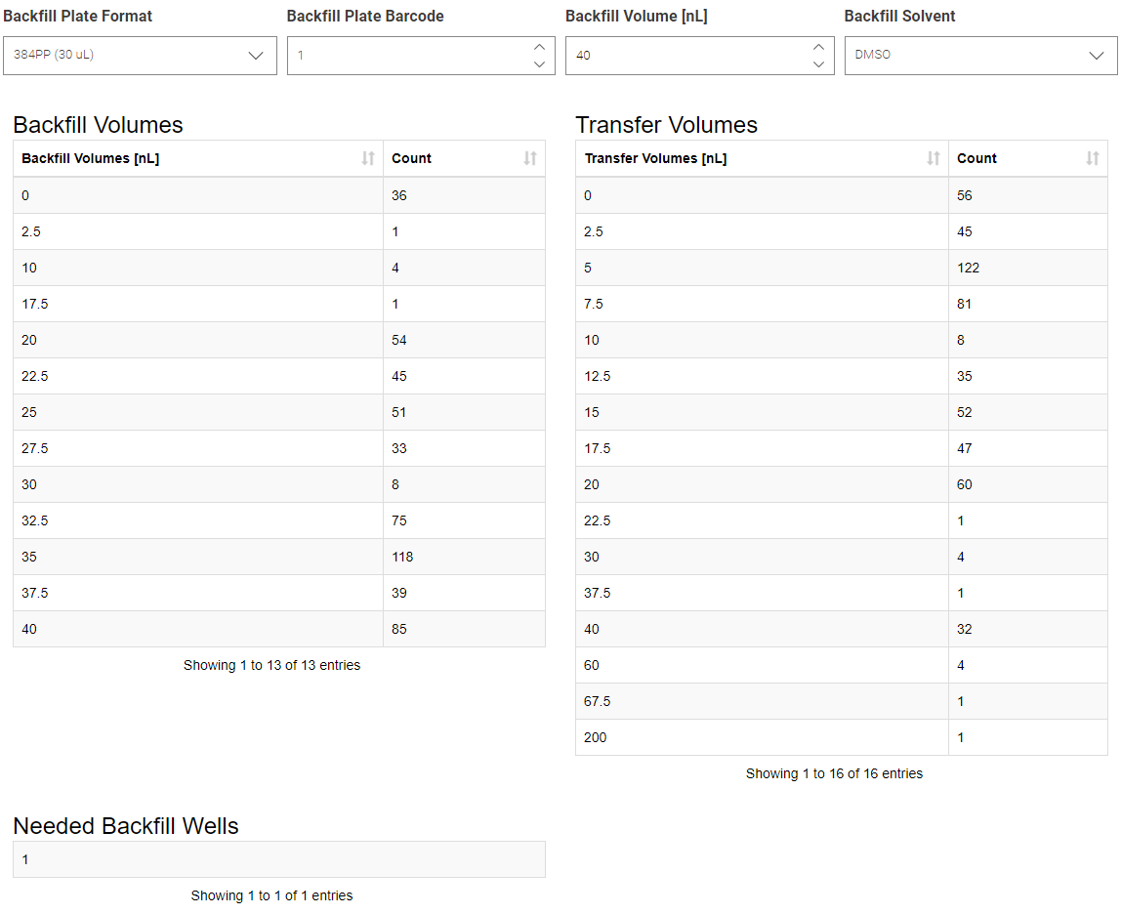
Supplementary Figure 6 The third section of the Primary Setup component.
The last section comprises the plate area pickers (Supplementary Figure 7). If no well is selected, MOLD will use the entire plate. On the other hand, an area can be selected, in this case, MOLD will use only the selected wells. If the selected destination area does not contain enough wells to fit the concentration series it will create another destination plate with the same settings and auto-incremented barcode.
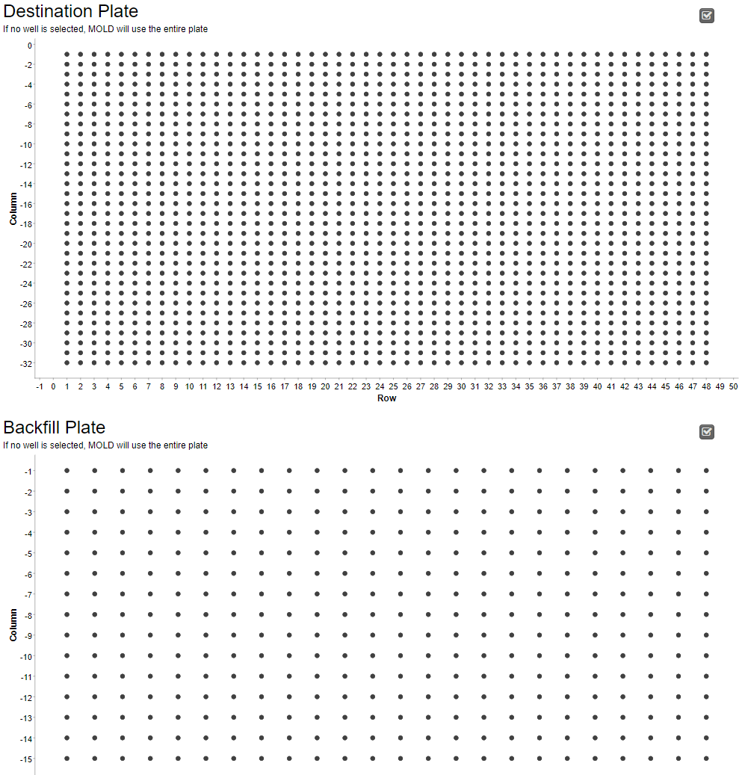
Supplementary Figure 7 Last section of the Primary Setup component.

Component structure
Besides the input widget nodes, the Primary Setup component calculates the transfer volumes from the input concentration and the desired concentrations. This is done for each concentration of each molecule separately using a Group loop and a Chunk loop node (Supplementary figure 8). The desired concentrations (either automatically generated or user-customized) are cross-joined to each well of each molecule. Using the information about the source well and the user settings, transfer volumes are calculated for each well. A series of filters is then applied to pick the most suitable source well for the transfer.
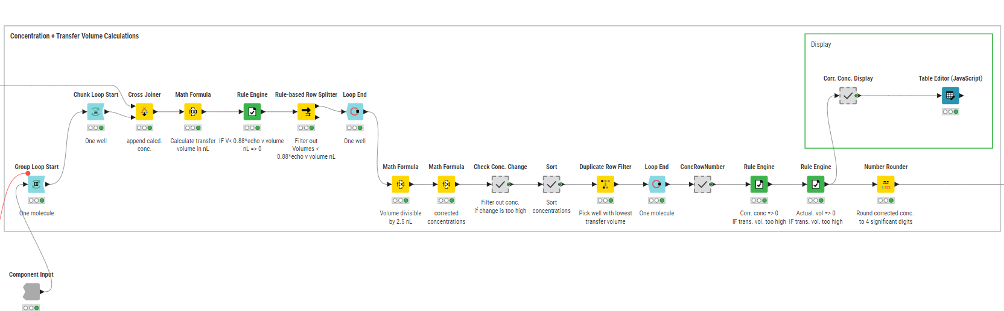
Supplementary Figure 8 Concentration and transfer volume calculation.
If the calculated transfer volume is less than 2.2 nL (or 22 nL, depending on the Echo instrument), this volume is replaced by 0. The estimated volumes are rounded to be divisible by the Echo drop volume (2.5 or 25 nL). The corrected concentrations are then calculated from these corrected volumes. The “Check Conc. Change” metanode filters out concentrations with changes bigger than 20% (or custom-defined value). If there is no better option, concentration points with changes bigger than 20% are used. The points are then sorted, and the source well resulting in the lowest transfer volume is picked for the transfer. This process is repeated for all the molecules and concentration points.
Desired replicates are generated using a Recursive loop node (Supplementary Figure 9). If the user selects the replicate arrangement “Next to Each Other”, the replicates are clustered according to the source plate barcodes. This is done in the “Sort to Fill” metanode (Supplementary Figure 10). The replicates are sorted to the desired arrangement, and the source plate barcode datatype is extracted. The transformation of the table is the same for both string and integer barcode datatypes. The Group By node groups the molecule information into lists, where each row represents one molecule instead of one destination plate well. The resulting table is then sorted using the first member of the source plate barcode list. The table is then ungrouped to the original format and passed to the next section.
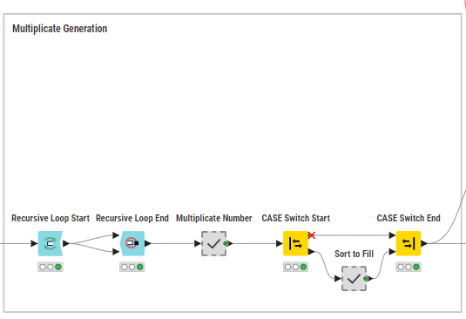
Supplementary Figure 9 Replicate generation.
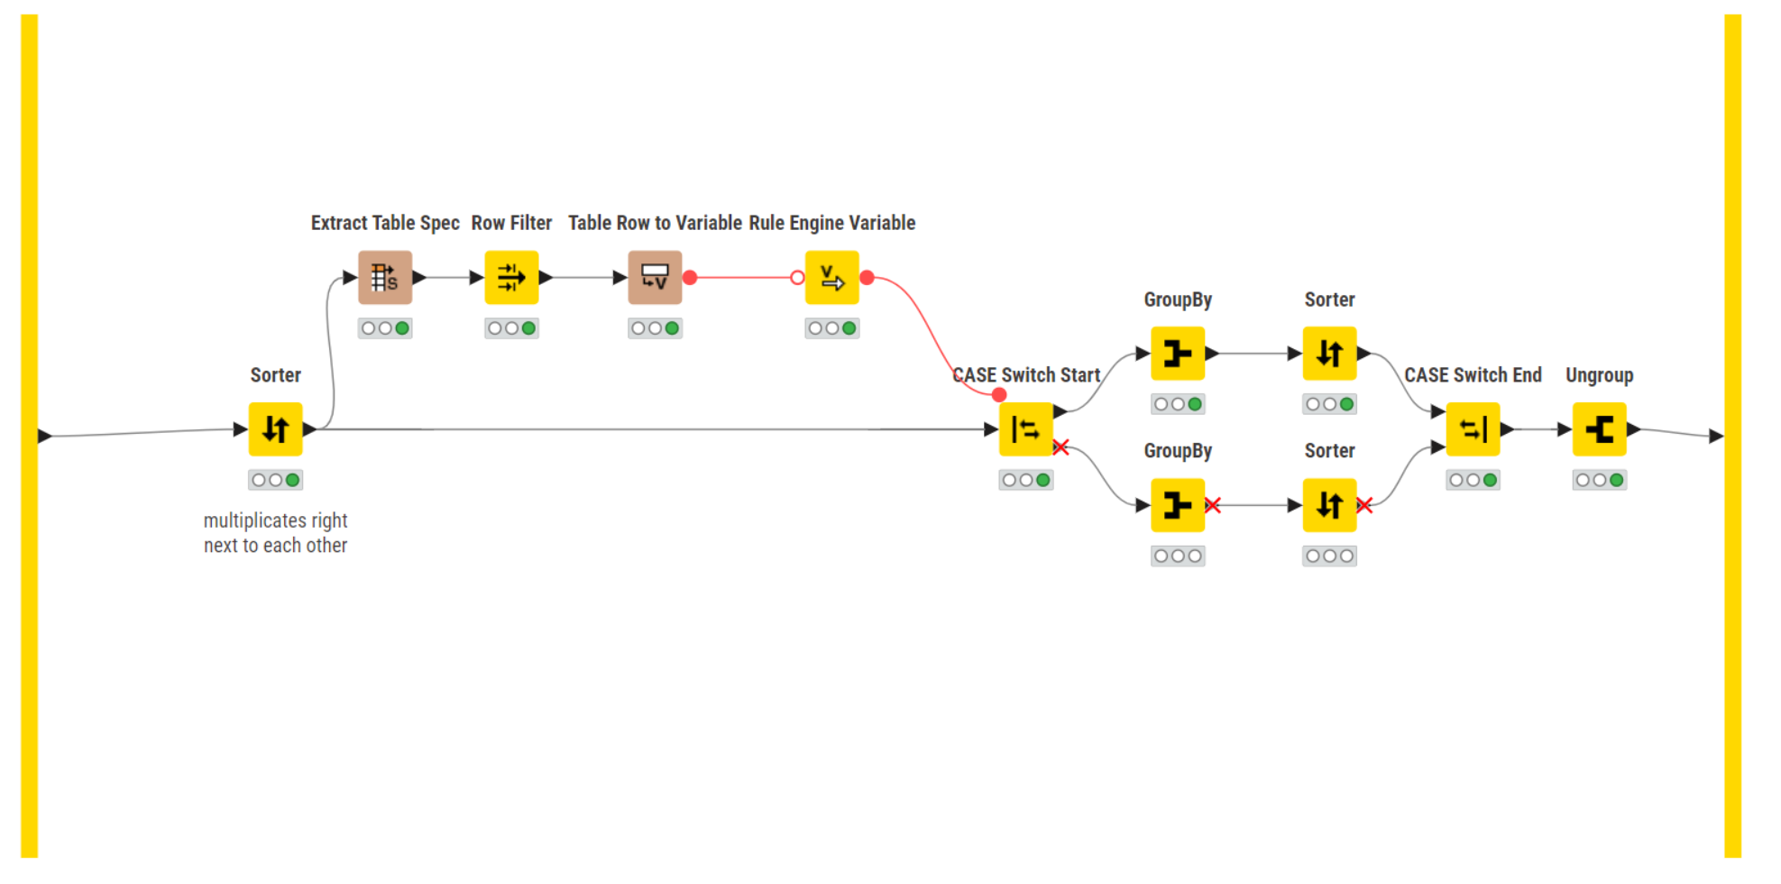
Supplementary Figure 10 "Sort to Fill" metanode structure.
The destination plates are filled using this slightly more complex algorithm (Supplementary Figure 11). The number of destination plates that are needed is calculated and the destination well positions are generated. The number of concentration series per plate is equal to the floor value of the number of selected destination wells divided by the concentration series length. Therefore, a single concentration series will not be split between two plates. The concentration rows are then concatenated with the well positions, resulting in the plate layout.
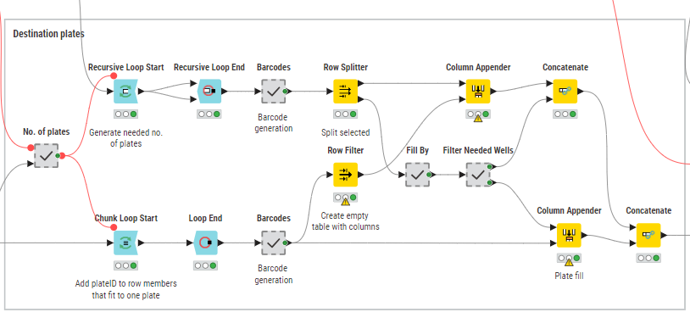
Supplementary Figure 11 Destination plate generation
Backfill volumes are calculated and assigned to the corresponding wells (Supplementary Figure 12). If there are multiple wells selected for the backfill, MOLD uses all the wells in a loop to prevent unexpected depletions. If there are 3 selected wells (A1, A2, A3) for the backfill, and there are 4 destination wells to be backfilled (B1, B2, B3, B4), the algorithm uses the wells to backfill the destination plate in this arrangement: A1 → B1, A2 → B2, A3 → B3, A1 → B4
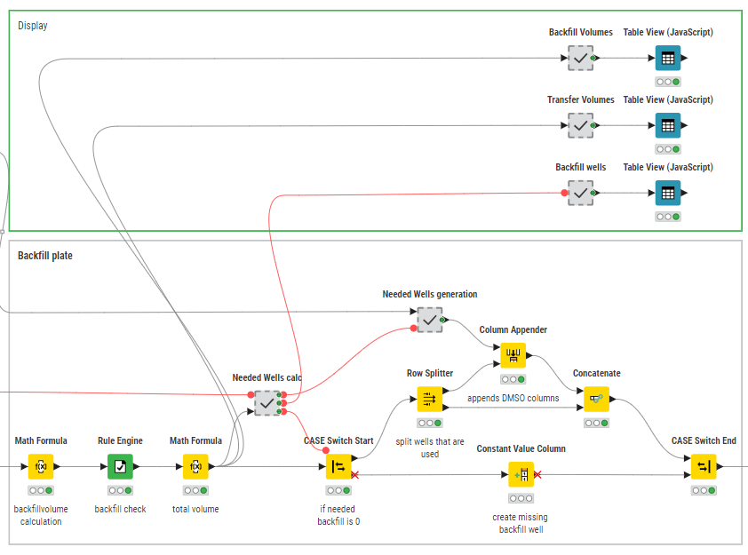
Supplementary Figure 12 Backfill volumes
Finally, some final post-processing happens such as plate names and plate types generation for the destination, source, and backfill plates.

The Secondary Setup
This node works in the same way as the Primary Setup. Some settings available in the Primary Setup are not available here. These are transferred from the Primary Setup and cannot be changed. (Supplementary Figure 13).
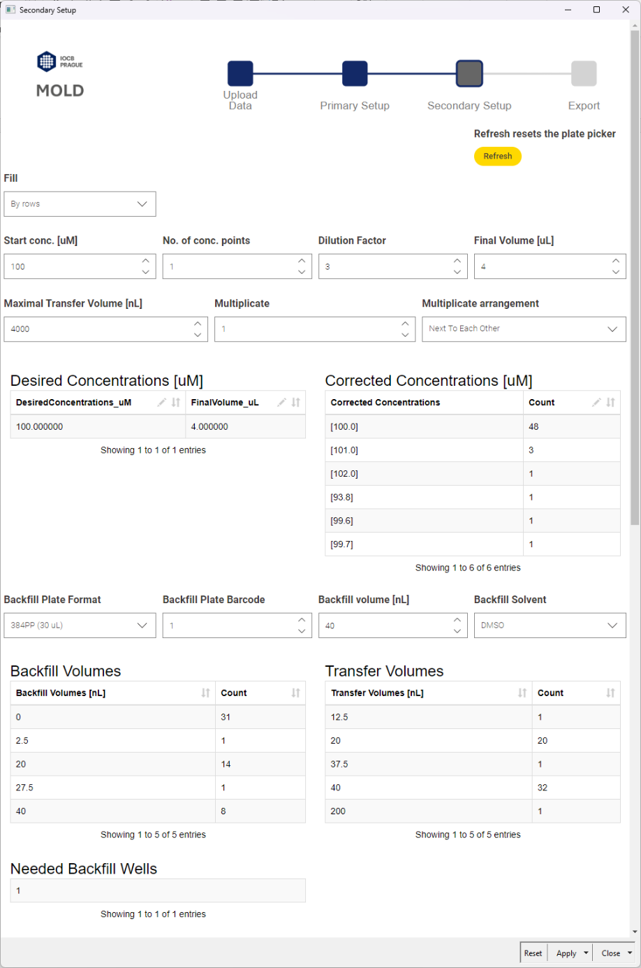
Supplementary Figure 13 The Secondary Setup component settings.
The main feature of the Secondary Setup component is the plate picker (Supplementary Figure 14), which displays available wells. If the well was used in any previous Setup component, the well appears red, and MOLD will not use them, even if they are selected again. The Secondary Setup calculates necessary Backfill plate wells separately. It is the scientists’ responsibility to select a sufficient amount of backfill wells for each usage of the Secondary setup node. For that reason, a solvent summary consumption check is recommended.
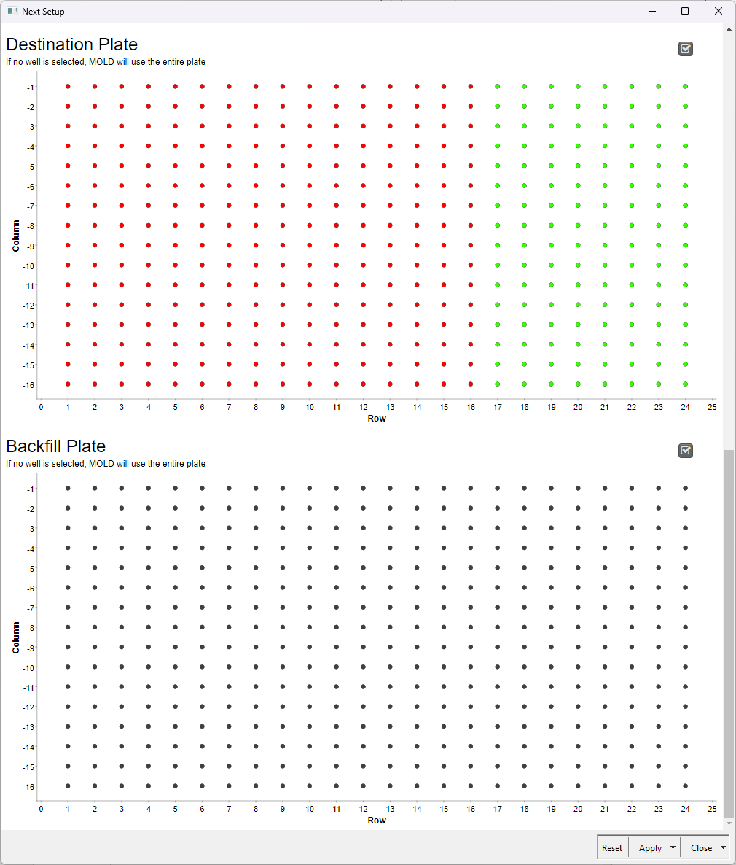
Supplementary Figure 14 The Secondary Setup plate pickers

The File Exporter
This component allows us to pick an output format for both well notation and the overall instruction files for Echo (Supplementary Figure 15). A save location can be customized by modifying the storage path, as well as the file names.
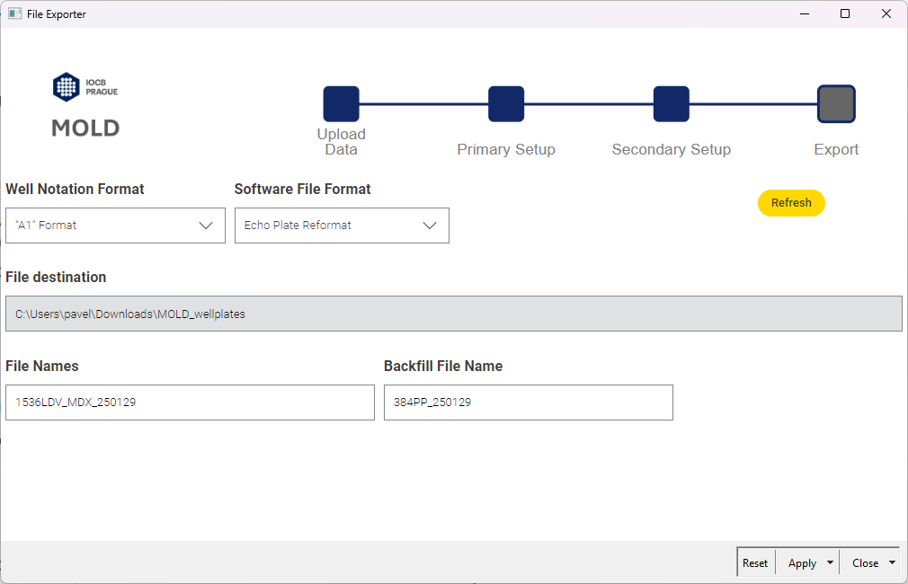
Supplementary Figure 15 User interphase of the File Exporter.
The component sorts, filters, and separates the main table with all the data into multiple files according to the chosen software format (Supplementary Figure 16). It also calculates the total volumes transferred from each source and backfill well and extracts all the barcodes used, this is saved into the report file with multiple sheets.
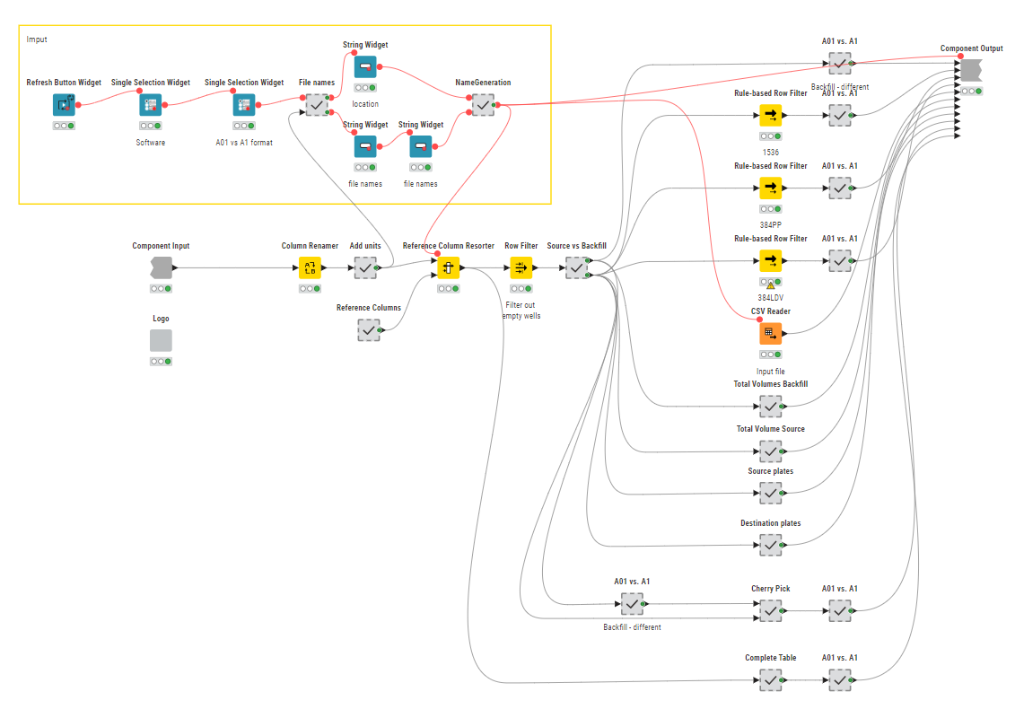
Supplementary Figure 16 File Exporter component structure.

Use case #1 – Creating a dose-response layout
We wanted to create a layout for a dose-response experiment with approximately 50 compounds from different source plates with varying concentrations of stock solutions. Also, we wanted to add positive and negative controls. To do this we added another Secondary setup (Supplementary Figure 17).
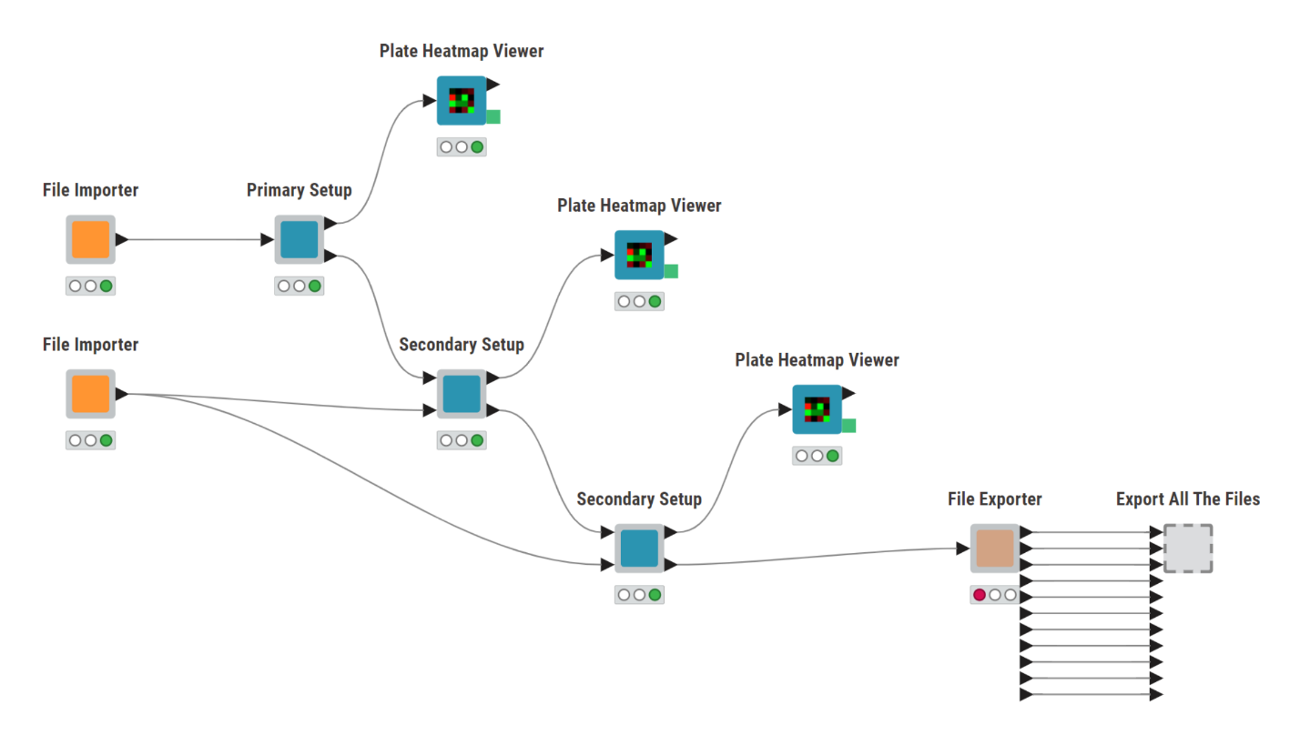
Supplementary Figure 17 Use case #1 MOLD architecture
The MOLD_input_example.csv file was loaded using File Importer. All available compounds were selected for import, except compound Standard (Supplementary Figure 18).
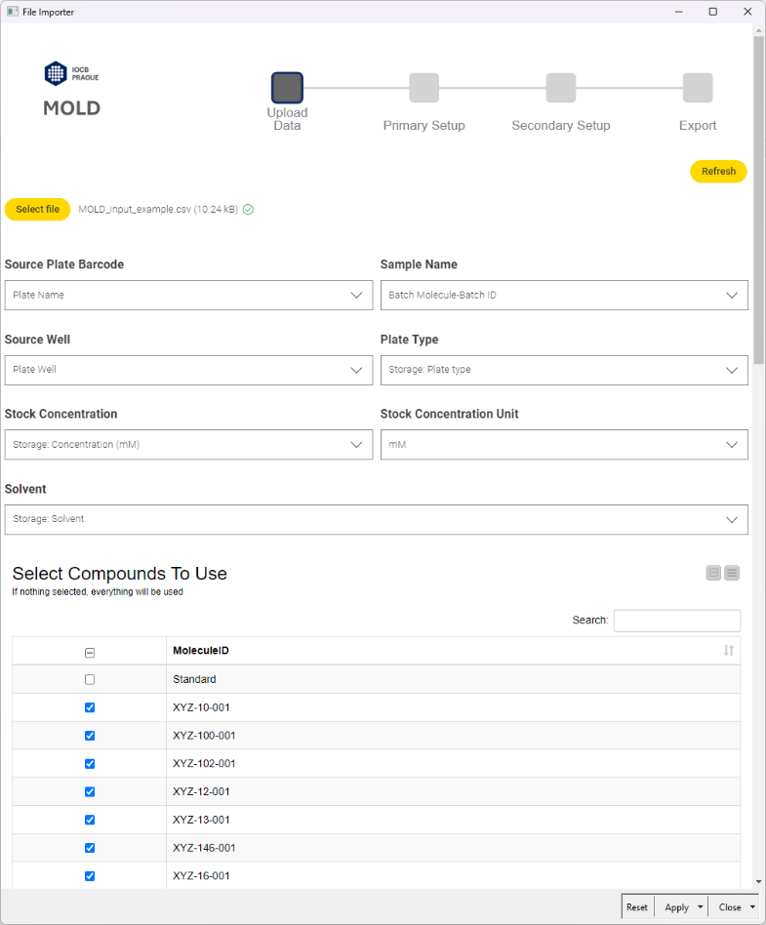
Supplementary Figure 18 File Importer setup
Using the Primary Setup component we wanted to generate 1536-well destination plates with 3 replicates of a 10-point dose-response series with a dilution factor equal to 3. The sorting of replicates was set to “Next to Each Other” (Supplementary Figure 19). 384PP plate format was used for the backfill plate with the backfill volume set to 40 nL. MOLD suggested using 2 backfill wells, to ensure enough solvent is available, we selected 6 wells that can be used.
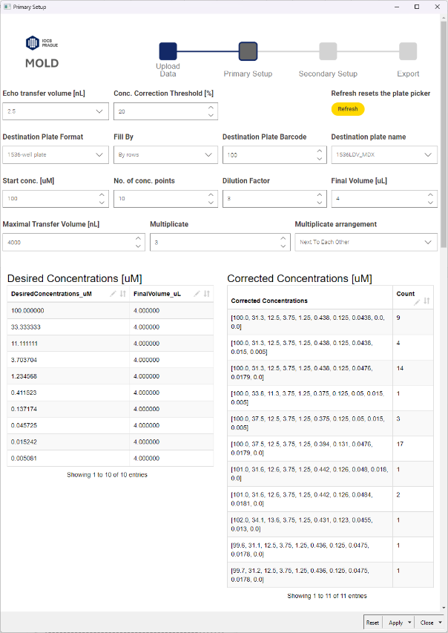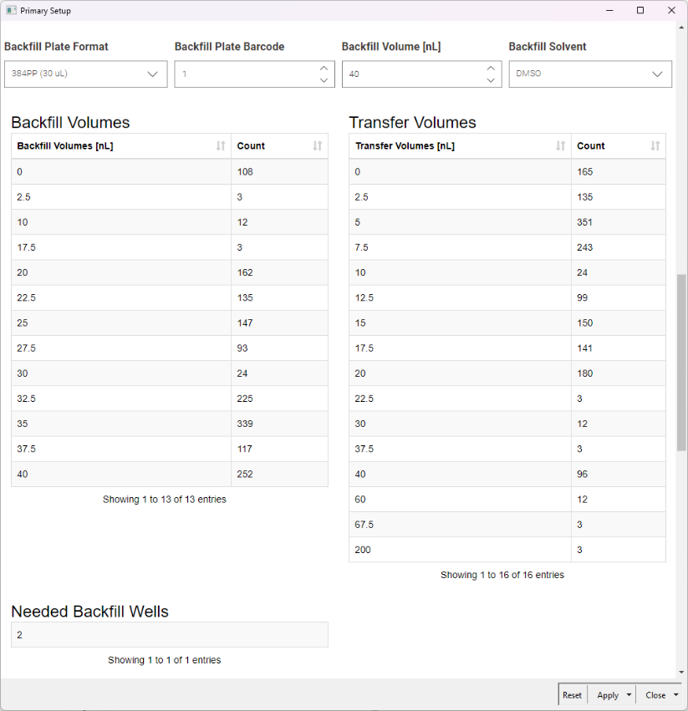
Supplementary Figure 19 The Primary Setup settings
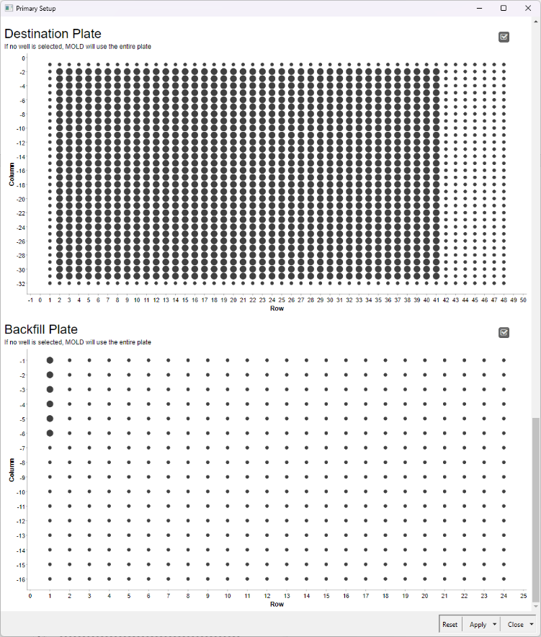
Supplementary Figure 20 The Primary Setup plate picker.
The created concentration series can be seen in the Supplementary Figure 21 (top). Also, the clustering of the wells from the same source plate can be observed in the Supplementary Figure 21 (bottom). Each color represents a different source plate from which the destination well was created. As a result of the clustering, the source plates used to make the wells of the left destination plate are not used for the right destination plate and vice versa.
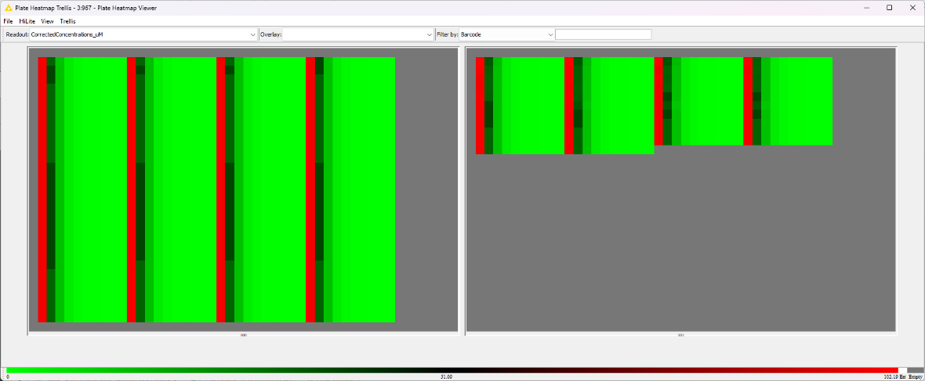
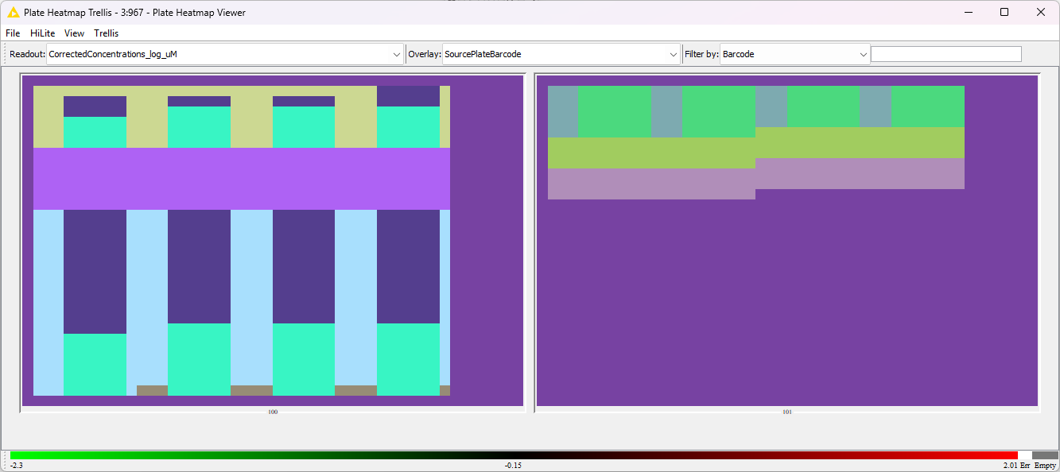
Supplementary Figure 21 Plate Heatmap Viewer with the created layout, concentration series (top) with linear color coding, and source plate barcodes (bottom).
The Secondary Setup component was used twice in a row to add a positive (Supplementary Figure 22) and negative control (Supplementary Figure 23) to the layout. The same file was imported using the File Importer, however, in this case, only the Standard compound was selected. The standard compound was added to the layout as 60 replicates of 100 µM points (corrected to 93.8 µM), and the wells were backfilled using DMSO (Supplementary Figure 22). The negative control was added as 60 replicates of the standard compound with 0 µM points. The solvent was normalized using DMSO (Supplementary Figure 23). The final layout can be examined using the HCS Plate Heatmap viewer (Supplementary Figure 24).
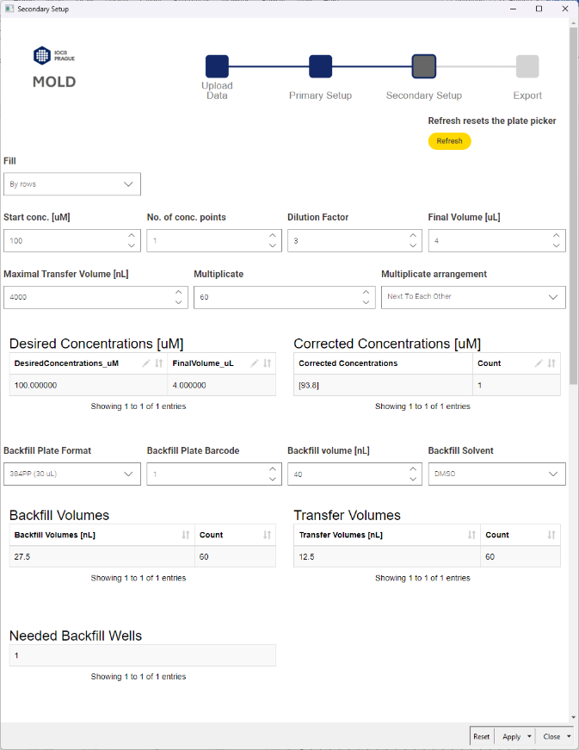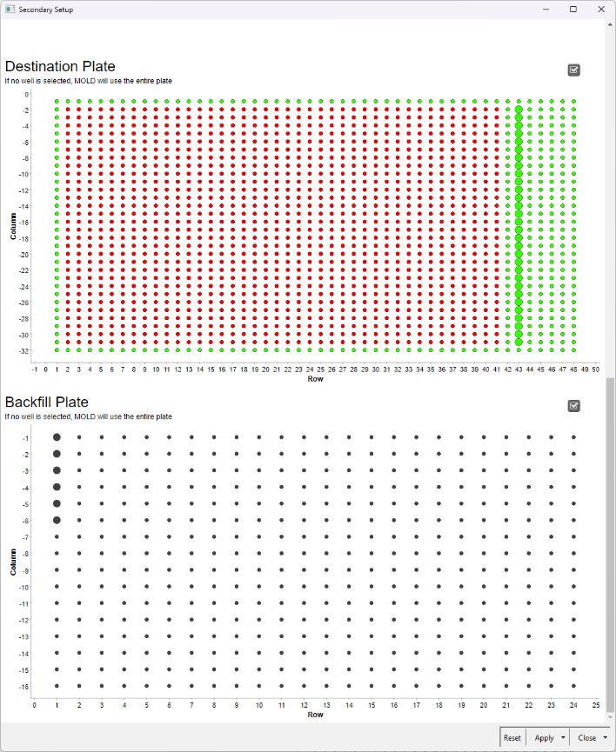
Supplementary Figure 22 The secondary Setup settings for positive control.
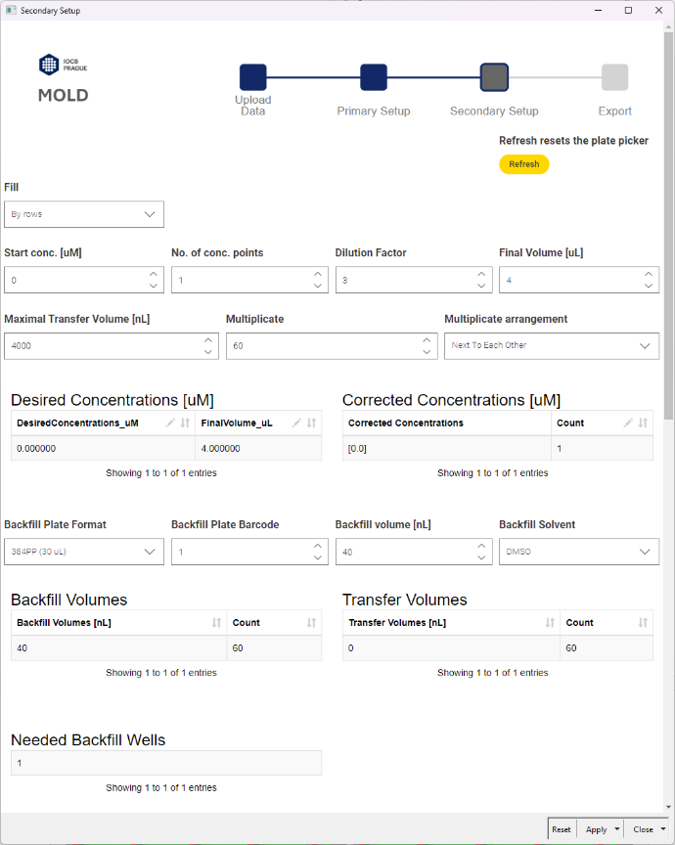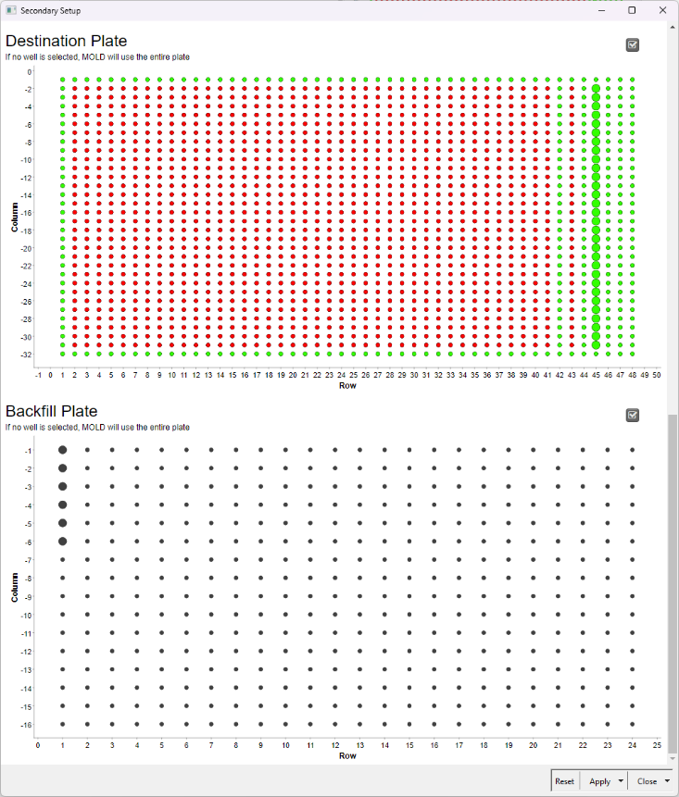
Supplementary Figure 23 The secondary Setup settings for negative control.

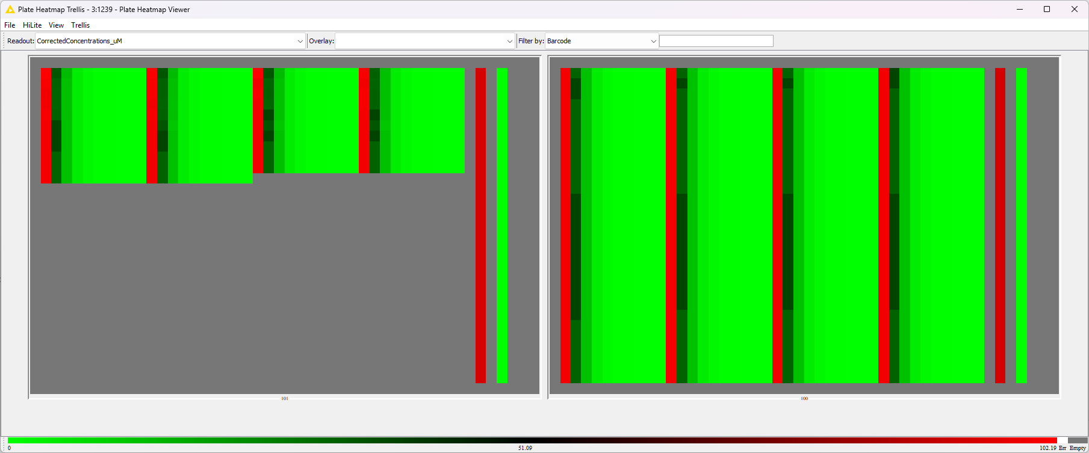
Supplementary Figure 24 The final layout of the destination plates.

Use case #2 – Double-concentration screen
In this example, we wanted to create a layout for a double-concentration screen with custom concentrations in triplicates. Only the Primary Setup was used to perform this task (Supplementary Figure 25).
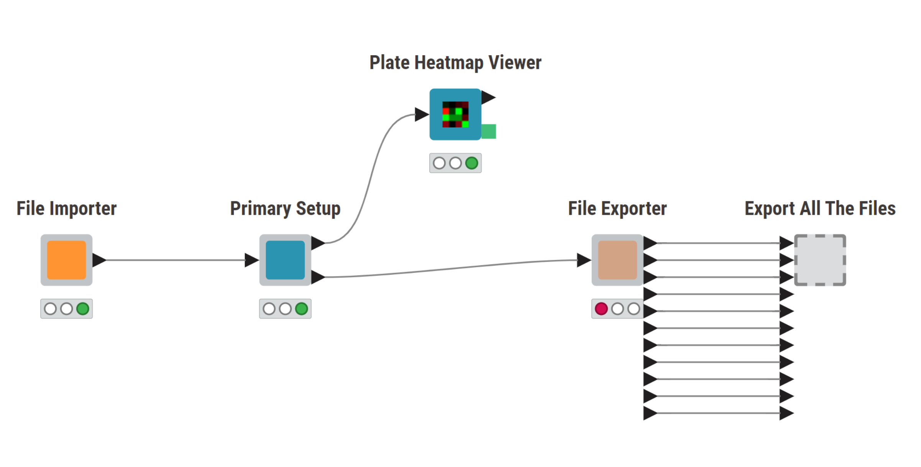
Supplementary Figure 25 Use case #2 MOLD architecture.
The data was imported using the File Importer component. Since no compound was selected, MOLD utilized all the compounds.
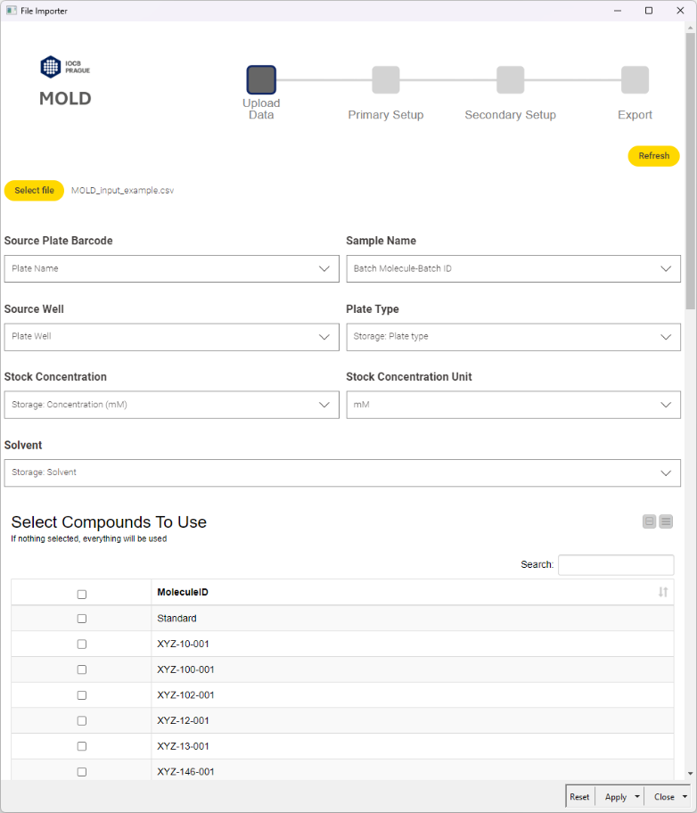
Supplementary Figure 26 The File Importer for the use case #2.
Using the Primary Setup component, we set up the basic settings (Supplementary Figure 27). A 384-well plate was used, fill of the plate was set to “Columns”. The start concentration was set to 100 µM with two concentration points and dilution factor 3. However, the generated concentration series was edited in the left Desired Concentrations table to 10 and 1 µM (from the original 100 and 33 µM). The multiplicate arrangement was set to “Block” and the plate backfill volume to 80 nL with DMSO. The plate picker was not used for the destination plate, therefore, MOLD used all available wells (Supplementary Figure 28). Three wells were selected from the backfill plate.
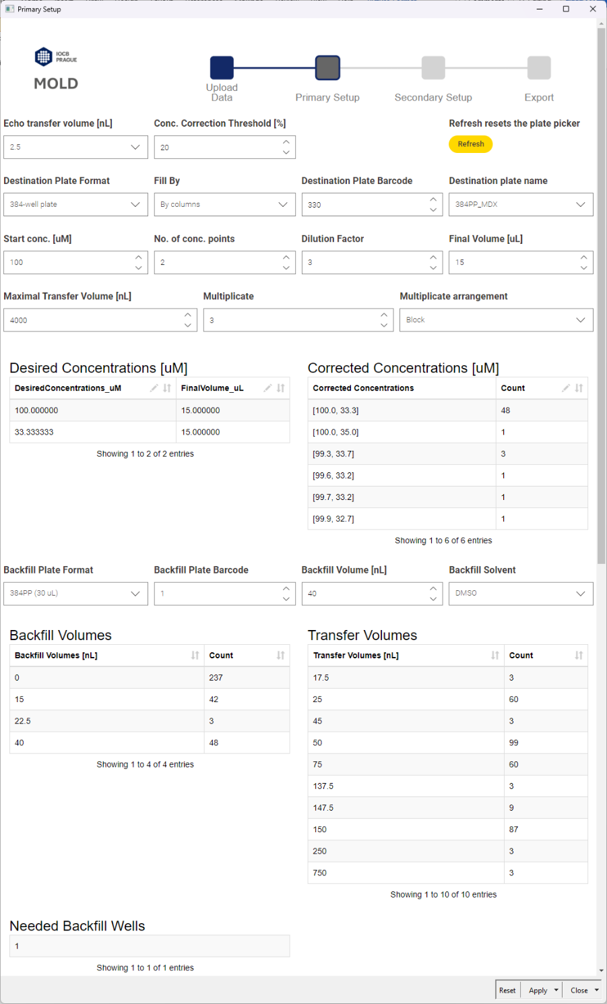
Supplementary Figure 27 The Primary Setup component settings for use case #2.
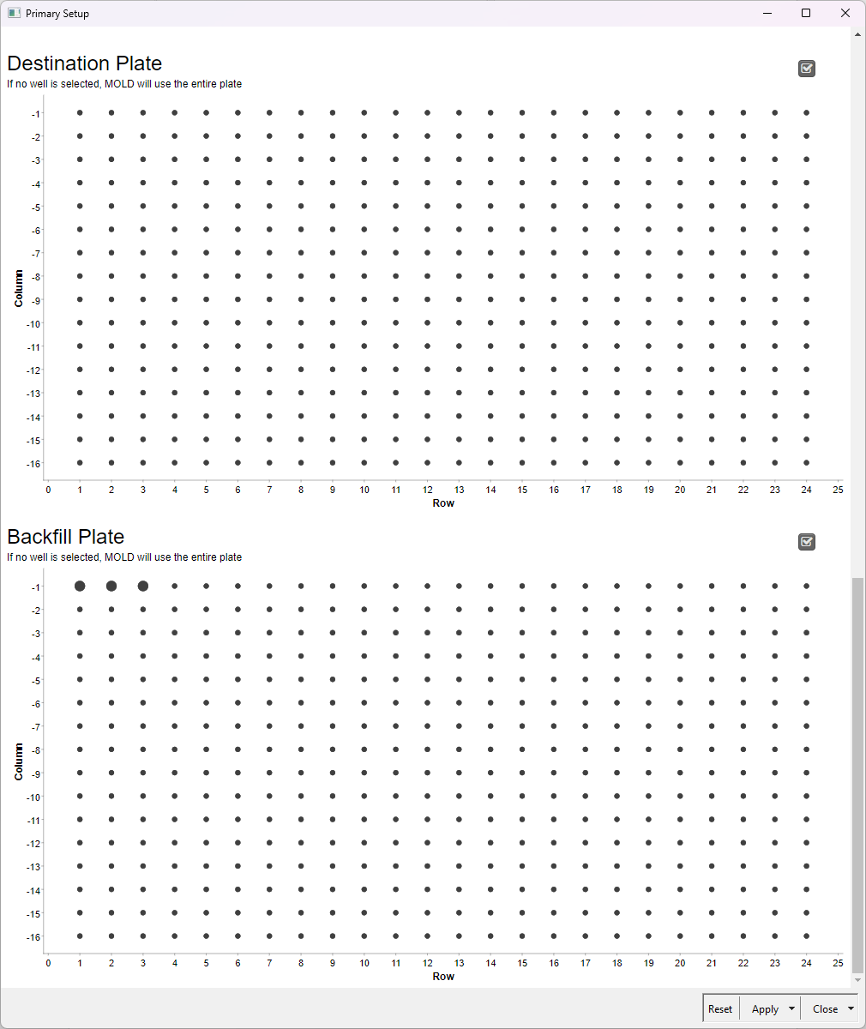
Supplementary Figure 28 The Primary Setup plate pickers.
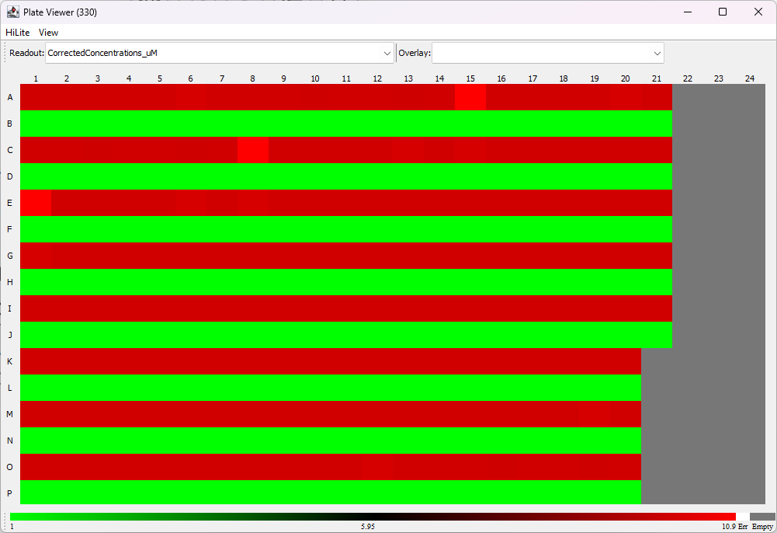
Supplementary Figure 29 Use case #2 final layout. The color scale represents concentrations.
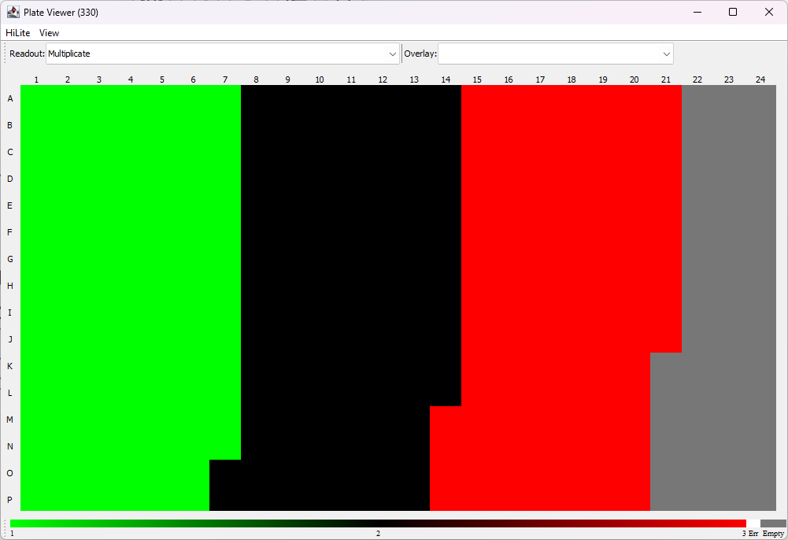
Supplementary Figure 30 Use case #2 final layout. The color scale represents the area of replicates.

