.Net – Pavel Pavlov

1. Technologies Used:

* Razor Pages - For UI
* MVC – for API controllers
* EntityFrameworkCore – Abstraction of database
* AutoMapper – for mapping
* NUnit – for unit tests
* Moq – for mocking in unit tests
* EntityFrameworkCore Proxies – for lazy loading

2. Database Diagram:

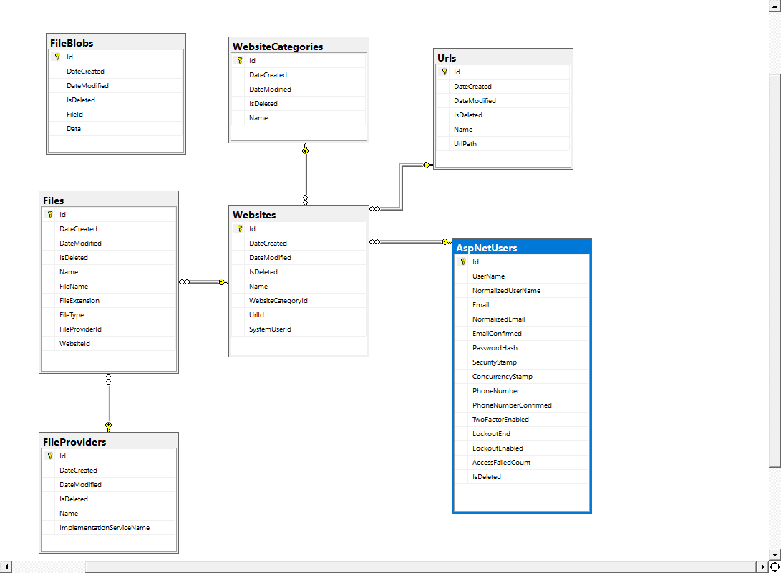

3. Layer Diagram

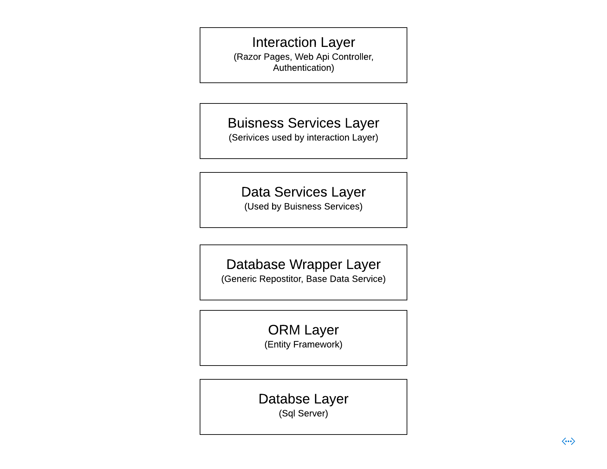

4. Create Website Process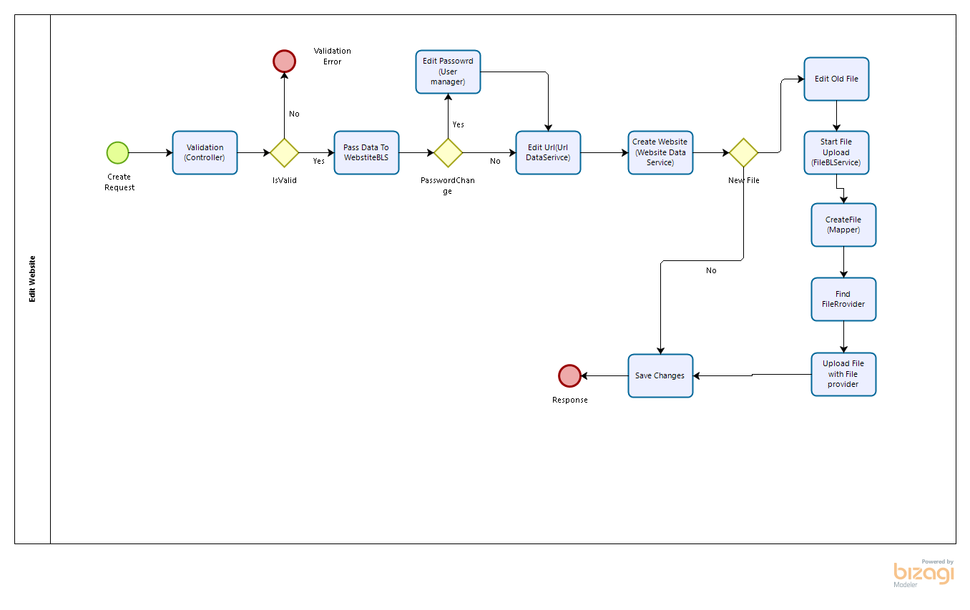

5. Edit Website Process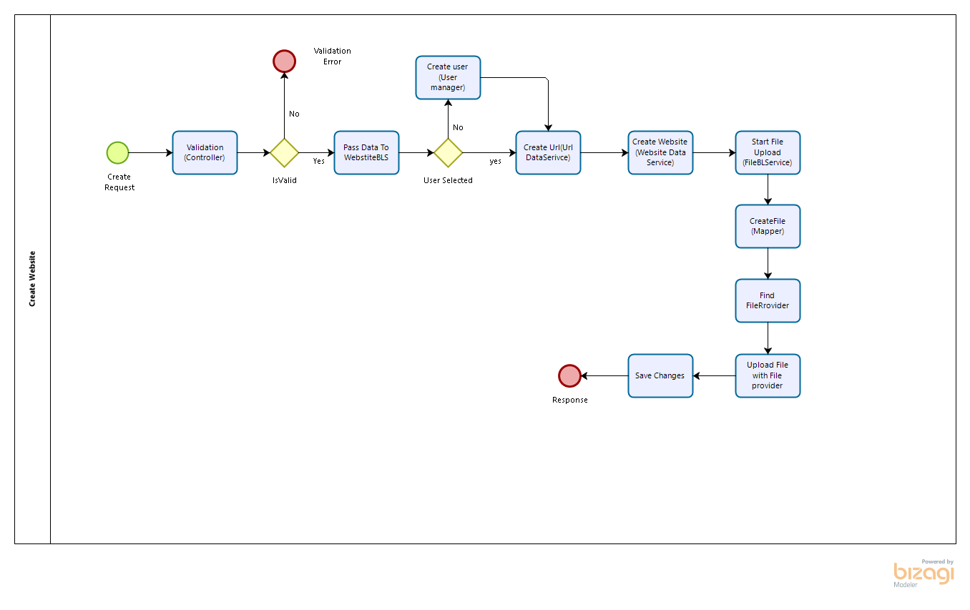

6. General Case