# Express.JS Retake Exam - SharedTripp

## Exam rules:

* You have 4 hours **from** **14:30 to 18:30**
* When you are ready, delete the ***node_modules***folder, make sure all dependencies are listed in the ***package.json*** file and submit your archived project at: [**SoftUni**](https://judge.softuni.bg/Contests/Compete/Index/1963#0)
* You are provided with **HTML & CSS** resources, which you can **modify**
* Use **Express.js** as a back-end framework
* Use **MongoDB** as a database with **mongoose**
* You can use **JWT** to authenticate users or **PassportJS**
* You can use whatever **view engine** you like (Handlebars, EJS, Pug etc.…)

## Application Overview

Get familiar with the provided **HTML & CSS** and create an application for **shared tripp's plans**.

## Functional Requirements

The Functionality Requirements describe the functionality that the **Application** must support.

### Guest (not logged in)

The **application** should provide Guest (not logged in) users with the functionality to login, register and **view** the Home page.

### Users (logged in)

The **application** should provide **Users** (logged in) with the functionality to:

* **View home page and all other pages with logged-in navigation**
* **View all shared tripps**
* **Create new tripp [Offer Tripp!]**
* **Access tripp details page [Find Out More!]**
* **Deleting or joining some tripp depending of user's authentication**

## Database Models (10 pts)

The **Database** of the **SharedTripp** application needs to support **2 entities**

### User

* Email - string (required), unique
* Password - string (required)
* **Tripps History – a collection of Tripps (reference to the Tripp Model)**

### Tripp

* **Start Point - string (required),**
* **End Point – string (required)**
* **Date – string (required),**
* **Time – string (required),**
* **Seats – number (required),**
* **Description – string (required),**
* **Car Image – string (required),**
* **Buddies – Reference to the User model – creator (required)**

Implement the entities with the **correct datatypes**.

## Application Pages (70 pts)

### Guest Pages (15 pts)

These are the pages and functionalities, accessible by **Guests (logged out users).**

#### Home Page (logged out user)

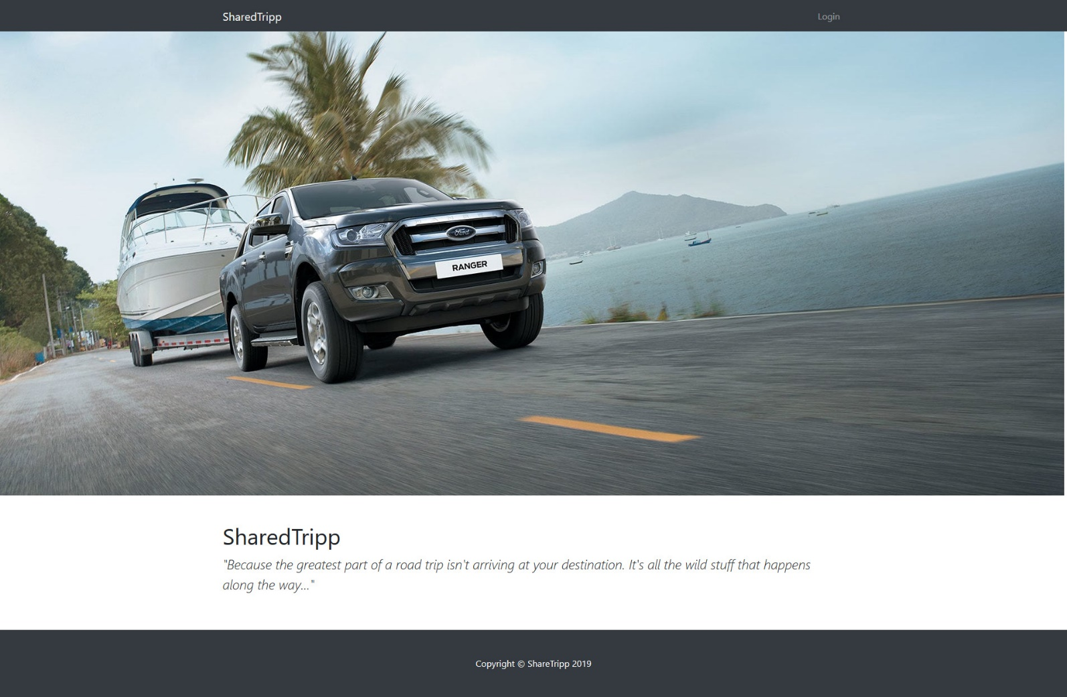

#### Login Page (logged out user)

Logging an already registered user with correct email and password

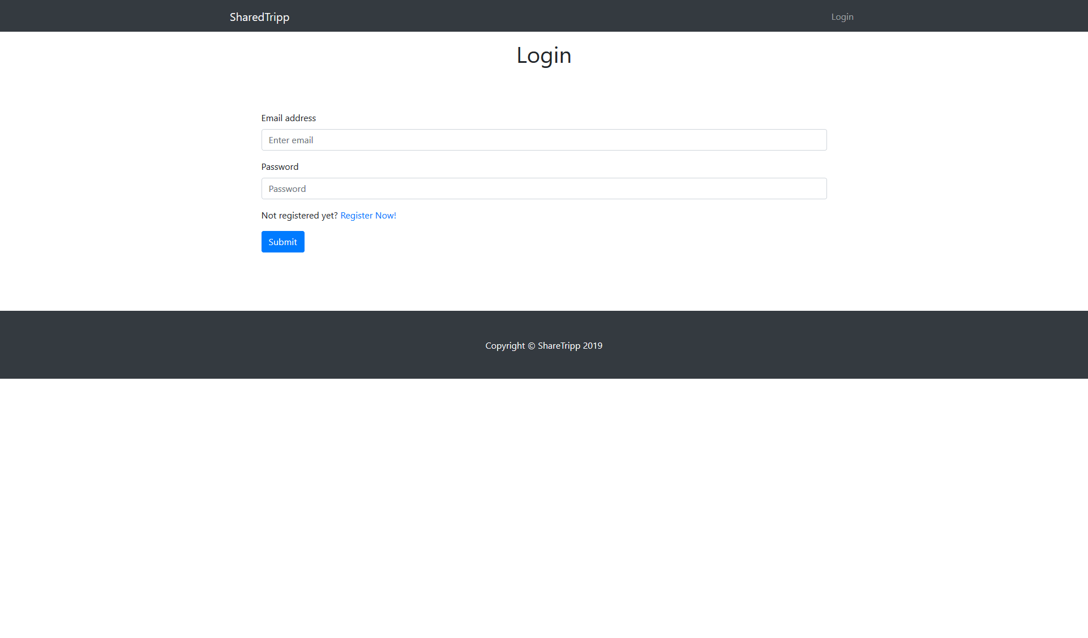

#### Register Page (logged out user)

Register a user inside the database with **email**, **password**. Both **passwords** must **match**!

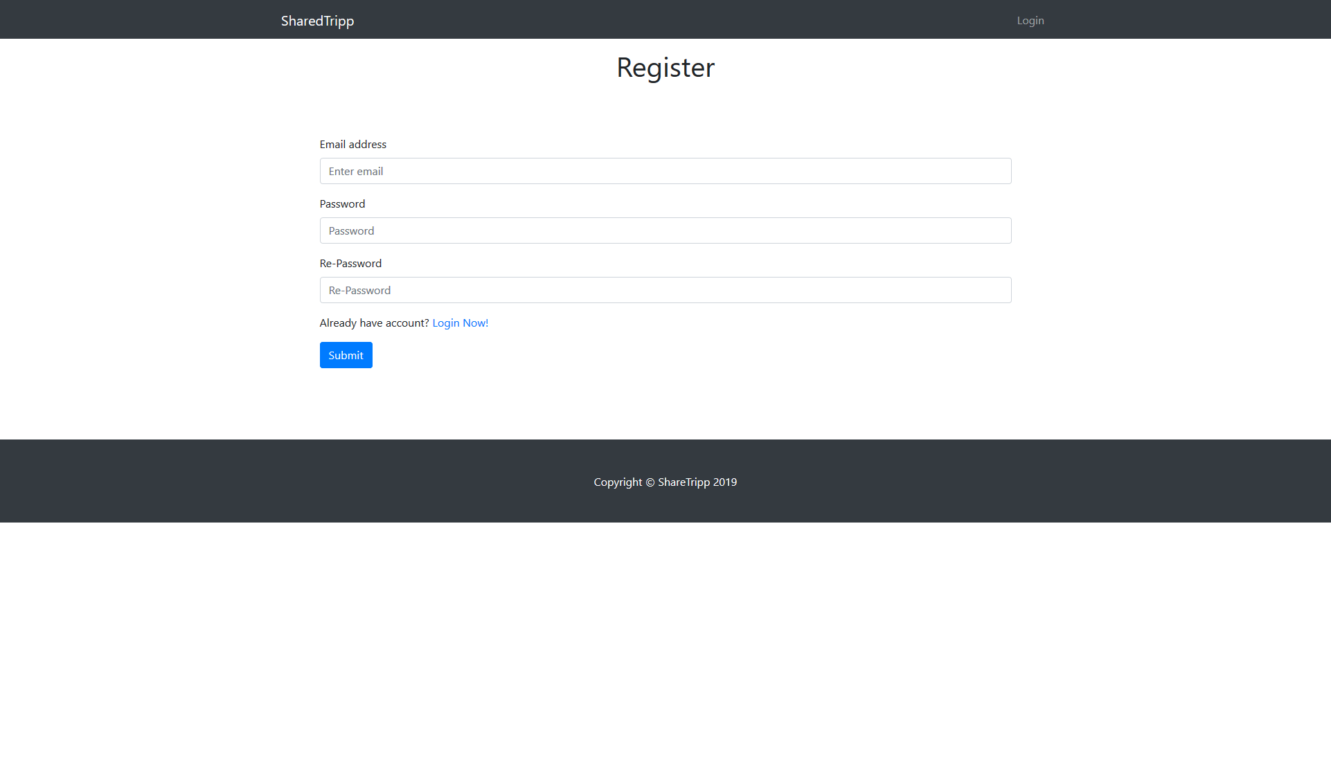

### User Pages (55 pts)

These are the **templates** and **functionalities**, accessible by Users (**logged in** users).

#### Home Page (logged in user)

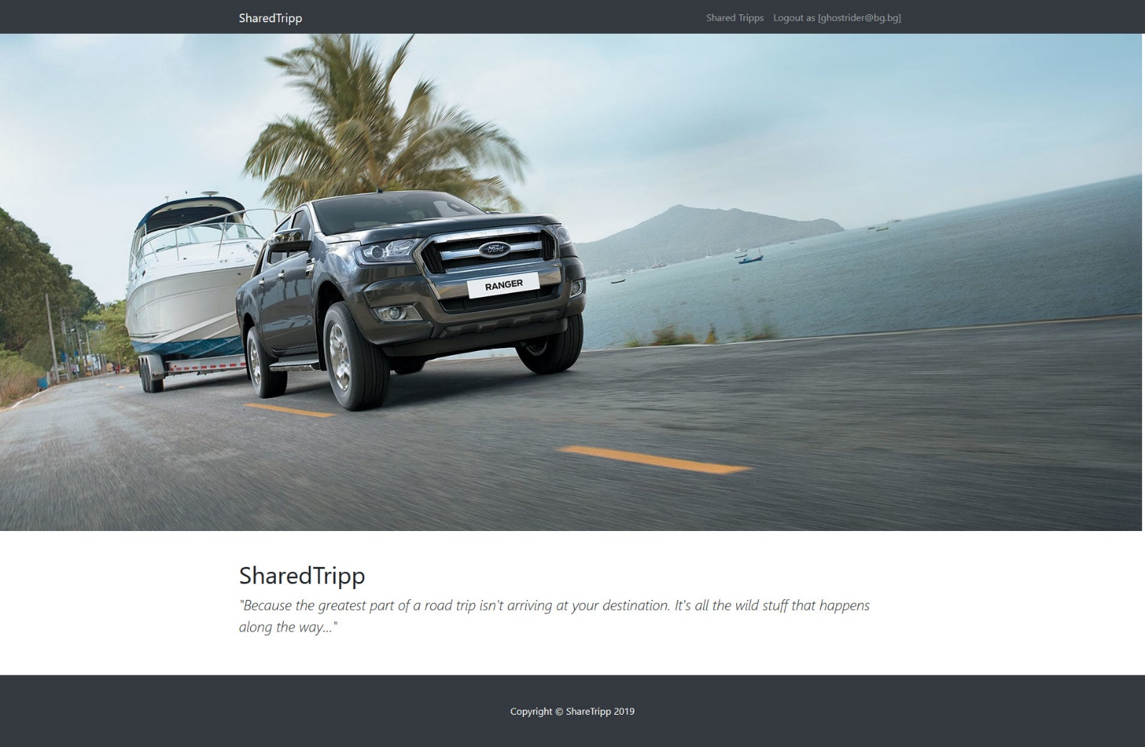

#### Shared Tripps

List all **shared tripps**. **Each tripp** should be showing an information about **tripp's car image, destination** (**from** - **to**), Like in the picture below:

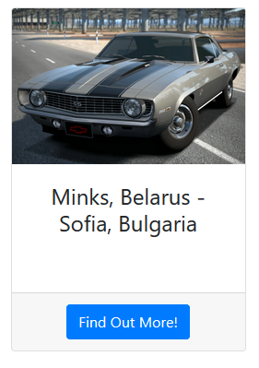

[**Find Out More!**] button should be a link to the **details** **page** for the current tripp.

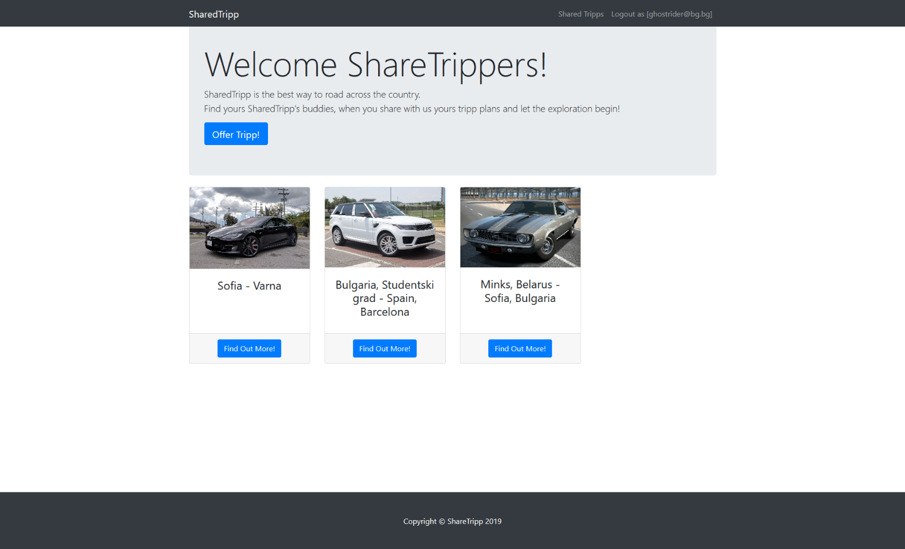

If there are **no shared tripps in the database**, display the following view:

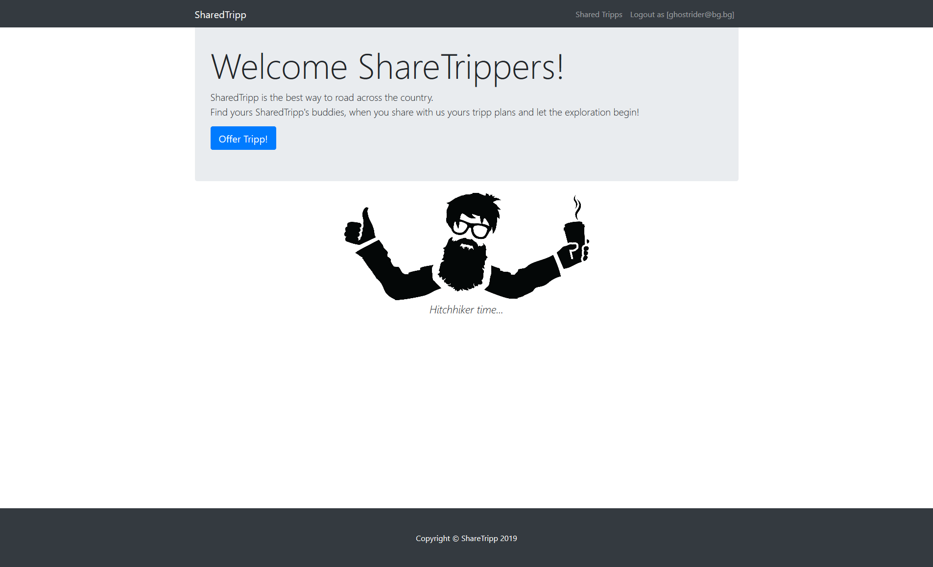

#### Offer New Tripp Page (logged in user)

Enter **Tripp**:

* **Destination -** in (**starting point - end point**) format
* **DateTime** -in (**date** **-** **time**) format
* **CarImage** - **http** or **https** **link** to the car
* **Seats** - **available** **seats** for this trip
* **Description** - A little description or something specific for the tripp

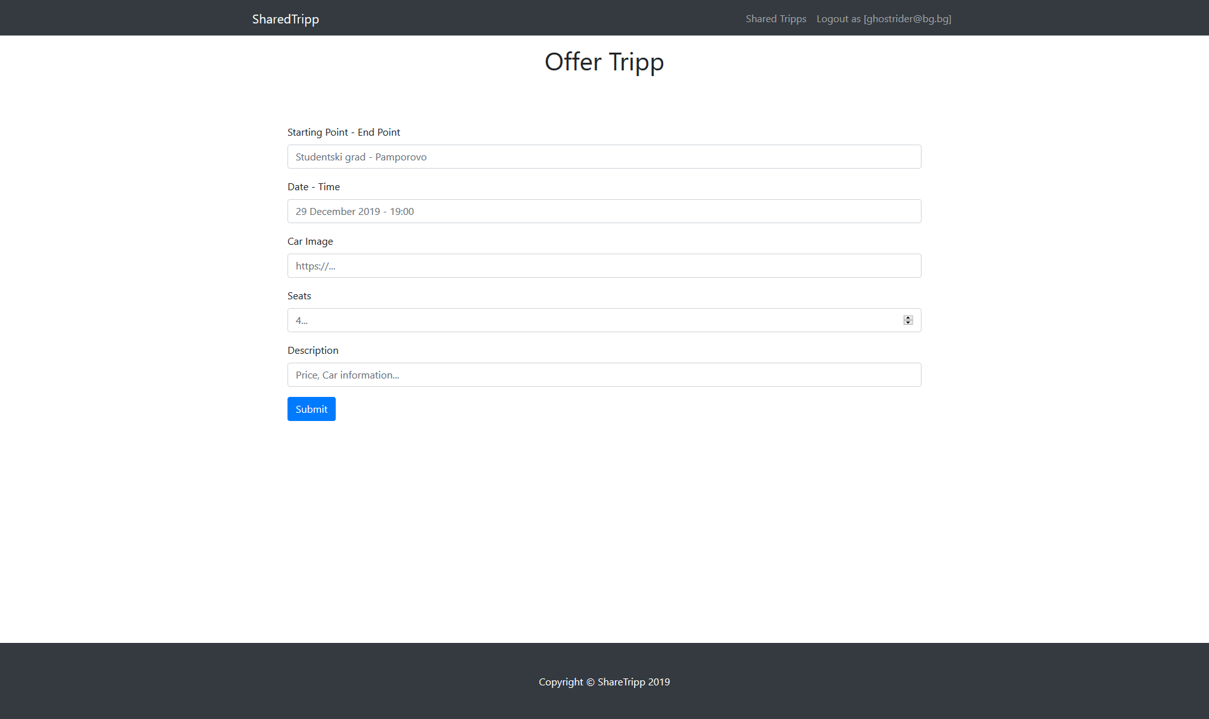

#### Find Out More (Tripp Details Page) - (logged in user)

**The find out more** page is accessed by clicking over the [**Find Out More**] **button's** SharedTripp (if any) and there are shown the tripp's:

* **Destination (from - to)**
* **Date and Time (date - time)**
* **SharedTripp Buddies**
  + If any, separate them with **space** and **comma** (", ")
  + If not, display 5 dots separated with space (**". . . . ."**)
  + Below that, the **email** **on** **the** **driver** should be displayed
* **Car Image**
* **Description**
* **Button** (Depending the status of the currently logged in user)

Check the pictures below for more clarity:

#### SharedTripp Details - Driver view

If the currently logged-in user is the driver (user who's created the tripp), he should see the [**Close this tripp**]which **deletes** the **current** **trip**.

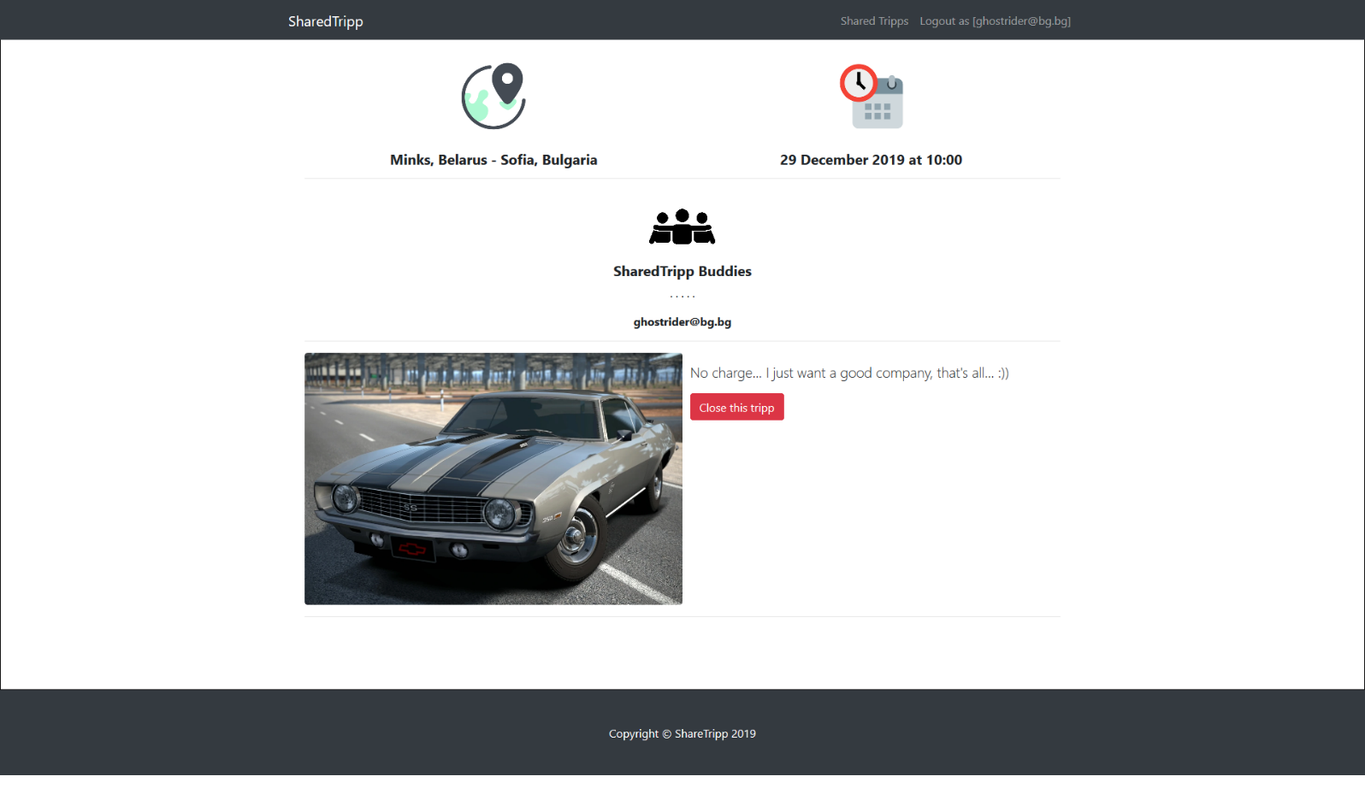

#### SharedTripp Details with available seats

If the currently logged-in user is **not the driver** (user that is not the creator for that tripp) he should see button like [**Join now, {availableSeats} left**]. If there is at **least 1 seat left**

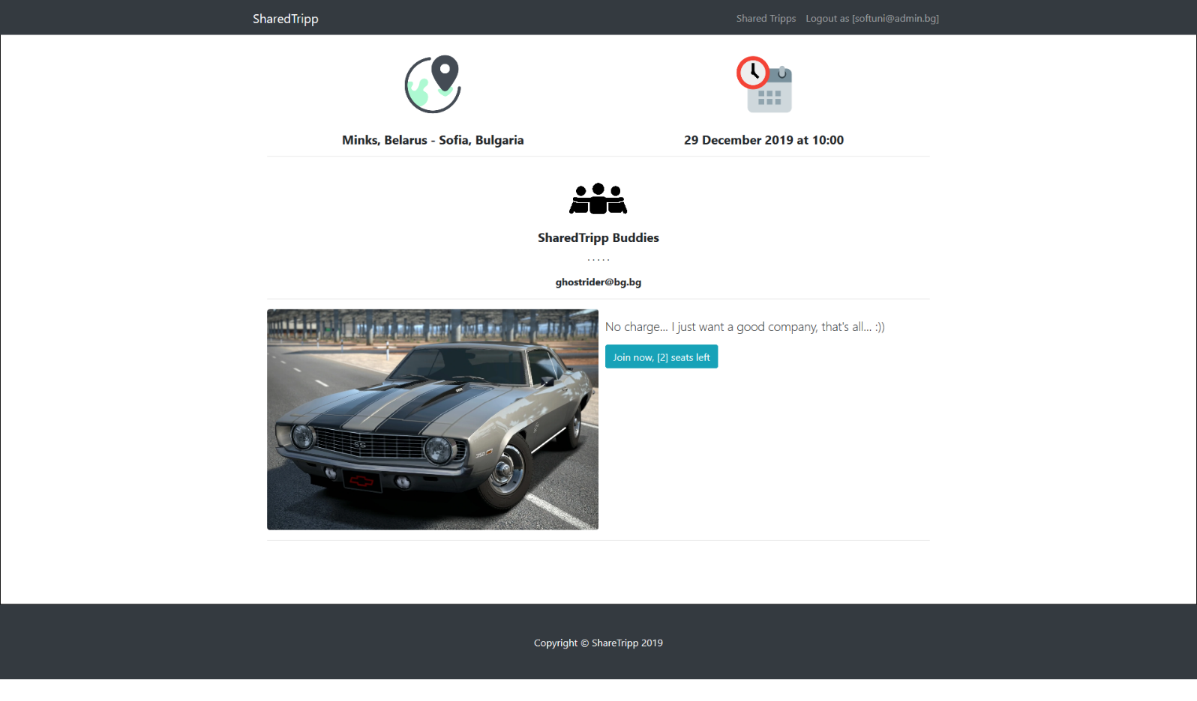

#### SharedTripp details - Already joined the tripp

If the currently logged-in user is already joined some tripp, he should see the [**Already joined. Don't be late**] button.

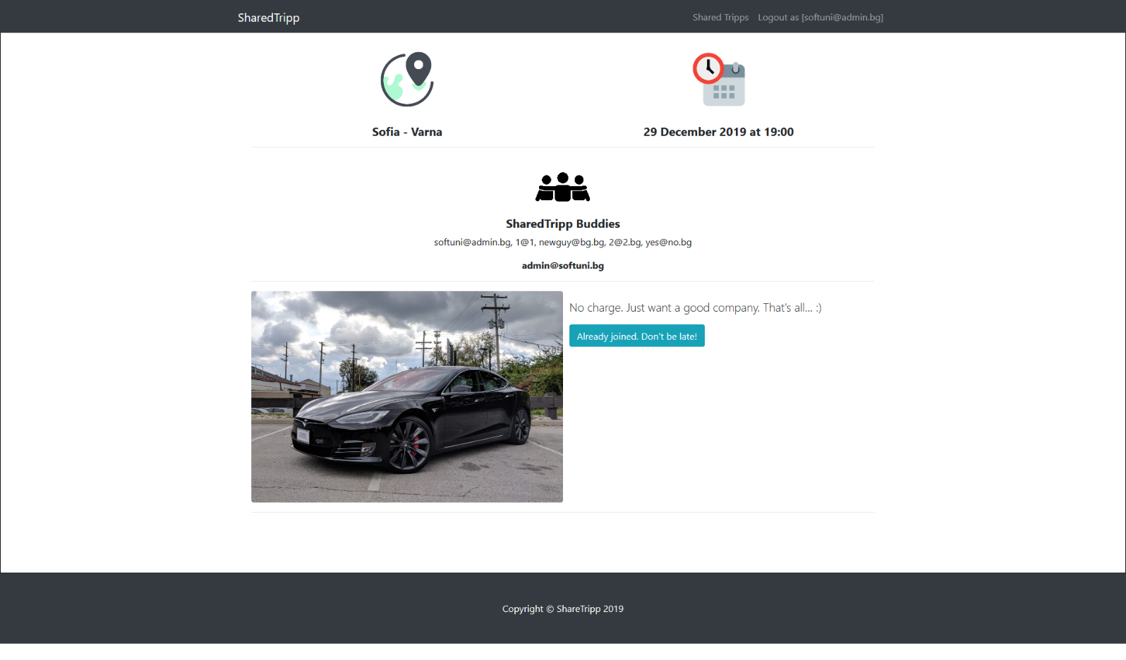

##### SharedTripp Details with no available seats

If the currently logged-in user is not the driver and there are no available seats for the current tripp, he should see the [**No seats available [0]**] button.

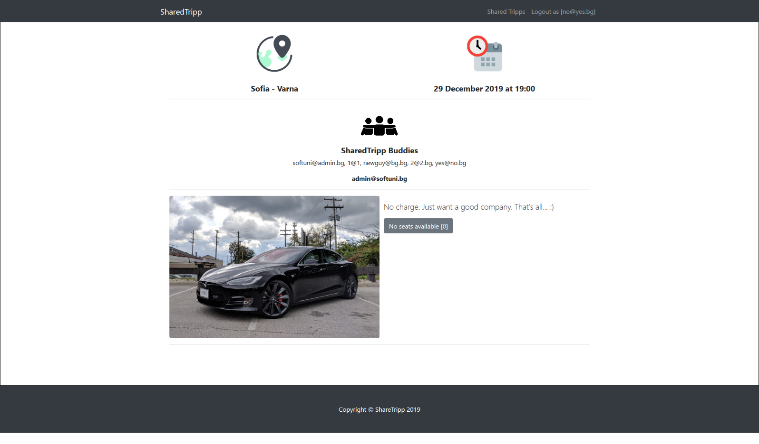

#### Join Tripp (logged in user)

**Every logged-in user** which is **not** the current **tripp** **creator** (driver) should be able to join tripp (**if seats available**). If he manages to **join successfully** to some tripp, his **email** should be **added** to the current trip's **sharedTripp buddies**'s collection and the **seats** for the current tripp should be **decreased by 1**.

If some user once joined a current tripp, he should see the "**already joined button"**.

If there are no seats available, he should see the "**no seats available button**".

Check the pictures above for more clarity.

#### Close Tripp (logged in user)

**Every tripp creator** should be able to click over [**Close this tripp**] **button** and deleting the current tripp from the database.

## Security Requirements (10 pts)

The Security Requirements are mainly **access** requirements. Configurations about which users can access specific functionalities and pages.

* Guest (not logged in) users can access Home page (where users can register and login)
* Guest (not logged in) users can access Login page and functionality
* Guest (not logged in) users can access Register page and functionality
* Users (logged in) can access Shared Tripps page (Listed all tripps) page and functionality
* Users (logged in) can access **Offer Tripp** page and functionality
* Users (logged in) can access **Find Out More** page and functionality
* Users (logged in) can acces to Join tripp and Delete tripp (depending on the user authorization) functionality in the home page
* Users (logged in) can access Logout functionality

Use **JWT** or **PasswortJS** to provide pages and functionality only to **authorized** **users**. And **allow** **actions** like creating offering new trip, view details about some tripp report etc... only to **authenticated** **users**.

Use the following view for **invalid** **paths**:

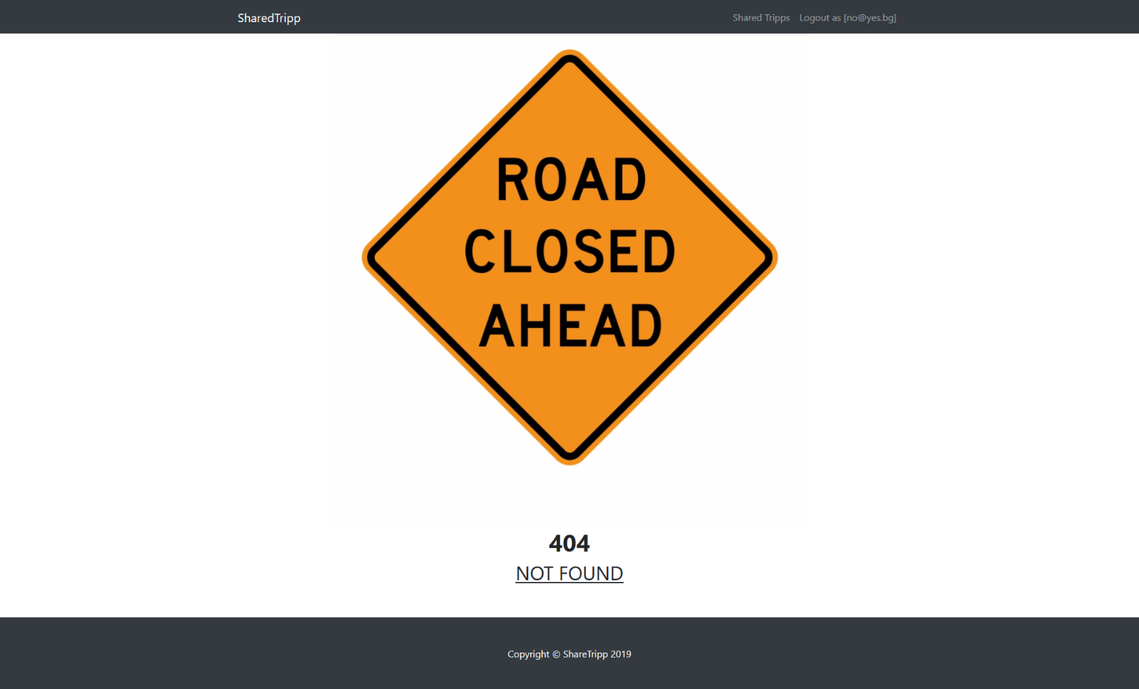

## Validation and Error Handling (10 pts)

The application should notify the users about result of their actions.

### Login / Register

You should make the following validations:

* The **email** should be **in the following format** (mailboxname **@** domainname) - "**username@domain.bg**"
* The **password** should be **at least 6 characters** long
* The **repeat password** should be **equal to the password**

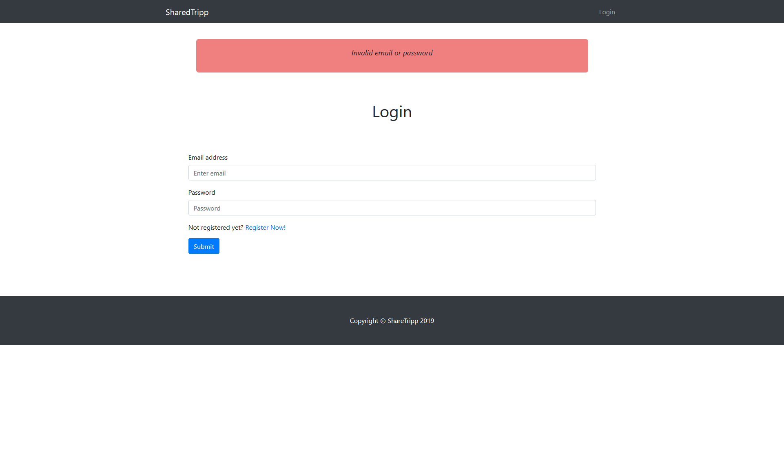

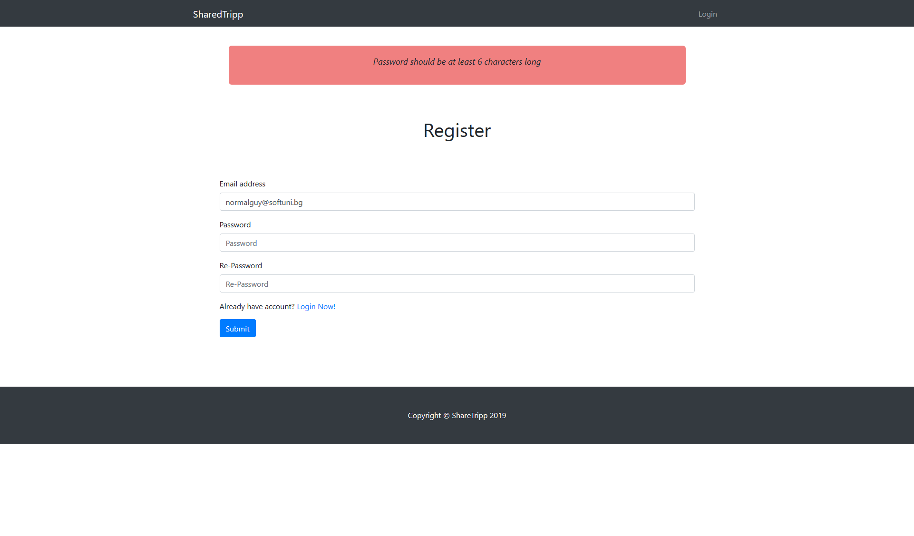

### Tripp

You should make the following validations while **offering tripp**:

* The **Starting Point - End Point** - **Starting** and **End** point should be **at least 4 characters long (each)** and should be separated with single space, dash and another single space (**" - "**)
* The **Date - Time - Date** and **Time** should be **at least 6 characters long** (**each**)and should be separated with single space, dash and another single space (**" - "**)
* The **CarImage -** should be **actual link** refering to the car image
* The **Seats** should be positive number
* The **description** should be minimum **10 characters** long

