*“Student complex”*

**Design document**

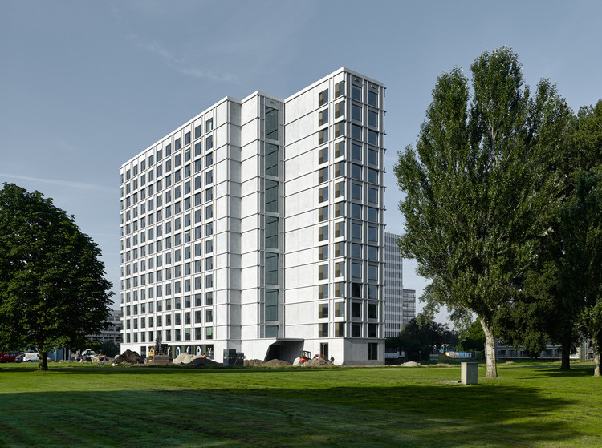

**Date:** 04-12-2024

**Group:** Aminatou

**Version:** Version 1

**Project plan:** “Student complex”

Table of content

Requirements 3

What should the system be able to do? 3

- Functional Requirements 3

- Non-Functional Requirements 3

- Prioritization 3

System setup 3

Architecture Description 3

Network Configuration 3

Network diagram 4

Description of the services 4

GUI Design 5

Website Wireframe 5

References 7

# Requirements

## What should the system be able to do?

### Functional Requirements

* + LAN setup, web server hosting, ad-blocking

### Non-Functional Requirements

* + security levels, energy monitoring accuracy, and usability
* Prioritization
  + [MoSCoW Matrix](Semester_1/Infra_First_Semester/Group_project/Aminatou/Paperwork/Project_planning/MoSCoW_Matrix_Group_Project.pdf)

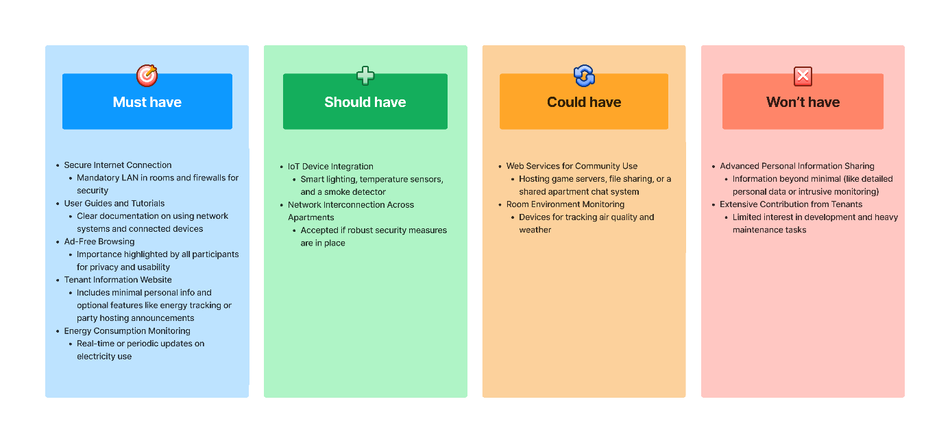

# System setup

## Architecture Description

* Centralized internet connection shared across apartments with individual LANs;

## Network Configuration

* Each apartment has a router connected to a centrally managed switch that utilizes VLANs to isolate each apartment's network. The main router provides internet access to all flats through this switch, allowing residents to connect to their apartment's network via Ethernet or Wi-Fi. This setup ensures privacy and security while sharing a single internet connection, combining convenience with robust network isolation.

## [Network diagram](https://drive.google.com/file/d/1bNLz60Y6vaQfIfr7NBWV3Y8xFwJhzsYu/view?usp=sharing)

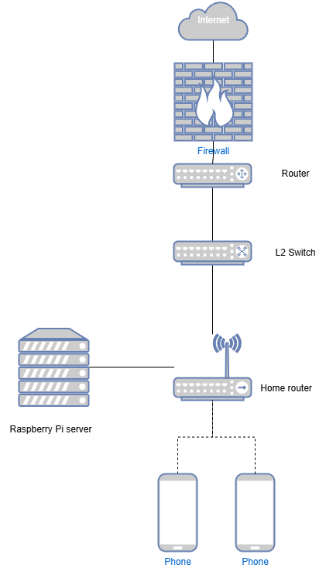

## Description of the services

1. Local webserver functionality: Each apartment hosts a simple website on a representative web server. This website contains tenant information and details about all available services in their network;
2. Ad-blocking service: Every apartment implements an advertisement blocker, allowing students to browse without advertisements;
3. Energy monitoring IoT service: To increase awareness of energy consumption, each apartment monitors electricity consumption in real time. This is implemented as an IoT service for tracking and displaying energy usage data;

# GUI Design

## Website Wireframe

* The goal is to create an interface that encourages students to engage with the apartment's digital services by making them easy to use and understand. This approach aims to attract more students to interact with the apartment's website and IoT services by removing complexity and potential barriers to usage.

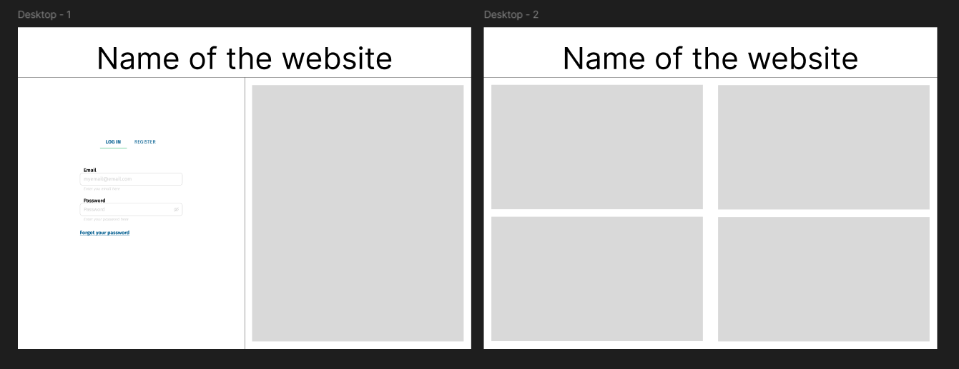

Project Overview

* [Project Overview](https://www.figma.com/board/mlVaaaNtbwDXNiST5zNENh/Design-Brief-Template-(Copy)?node-id=0-1&node-type=canvas&t=X5xr6MGjVvsSj5nx-0)

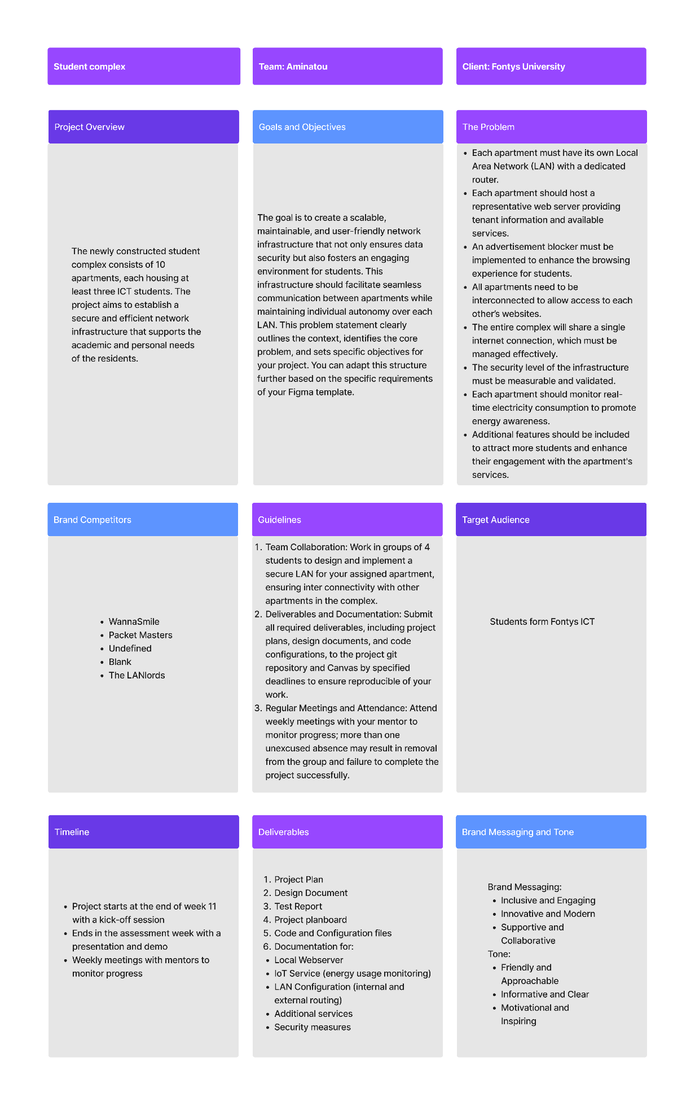

# References

MoSCoW:

* Clegg, D., & Barker, R. (1994). Case Method Fast-Track: A RAD Approach. Addison-Wesley.