*“Student complex”*

**Project Plan**

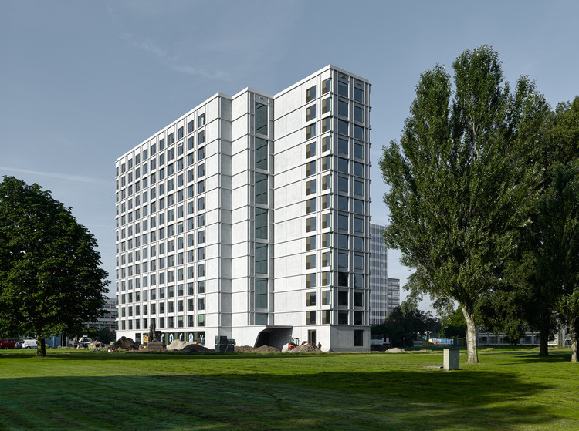

**Date:** 13-11-2024

**Group:** Aminatou

**Version:** Version 1

**Project plan:** “Student complex”

Table of content

Project definition 3

Problem deffinition 3

Project goal 3

Expected Result 3

Way of Working 3

Scope 3

Project Structure 3

Development Team 3

Aminatou team 3

Dividing of the tasks - Trello 4

Tutor 4

Deliverables 4

Planning 4

5 Whys 5

Problem Statement 6

Project Overview 7

SWOT Analysis 8

Risk Management 9

Gantt chart 9

MoSCoW Matrix 10

References 11

# Project definition

Project Background

* A newly built student complex consisting of 10 apartments, each housing at least 3 ICT students, requires a secure and efficient network infrastructure.

## Problem deffinition

* How to design and implement a secure student house infrastructure that meets specific requirements for connectivity, services, and energy monitoring.

## Project goal

* To create a functional, secure, and interconnected network infrastructure for the student complex that enhances the living experience of ICT students.

## Expected Result

* A fully operational network infrastructure with individual LANs for each apartment, connected to a shared internet connection, featuring webservers, ad blocking, and energy monitoring capabilities.

## Way of Working

* Group of 4 students
* Two-week sprint cycles
* Weekly supportive courses and practical sessions
* Regular meetings with mentors
* Regularly getting feedback

## Scope

* Setting up individual LANs for each apartment
* Implementing required services (webserver, ad blocker, energy monitoring)
* Connecting all apartments' networks
* Ensuring security and shared internet access

# Project Structure

## Development Team

* Group of 4 students responsible for setting up and managing one apartment's infrastructure;

### Aminatou team

#### Leaders: Pavel Voykov and Georgi Katushev

They will be in charge of the coding of the project and will also supervise the work of the other group members.

Contact: [p.voykov@student.fontys.nl](mailto:p.voykov@student.fontys.nl)

Contact: [g.katushev@student.fontys.nl](mailto:g.katushev@student.fontys.nl)

#### Infrastructure: Bozhidara Zlankova and Emilija Degutyte

Bozhidara and Emilija are in charge of the Infrastructure part of the project.

Contact: [b.zlankova@student.fontys.nl](mailto:b.zlankova@student.fontys.nl)

Contact: [e.degutyte@student.fontys.nl](mailto:e.degutyte@student.fontys.nl)

### Dividing of the tasks - [Trello](https://trello.com/b/KufMGi6y/go4itpedal)

## Tutor

* Veerhoff, Lars A.L.
* Goyal-Paldiwal, Gayatri G.V.
* Jansma, Tim T.C.A.J.
* Pu, Xuemei X.

# Deliverables

* Project Plan
* Design Document
* Test Report
* Project planboard
* Code and Configuration files
* Documentation for:
  + Local Webserver
  + IoT Service (energy usage monitoring)
  + LAN Configuration
  + Security measure

# Planning

* Project starts at the end of week 11 with a kick-off session
* Weekly supportive courses and practical sessions
* Two-week sprint cycles
* Weekly meetings with mentors
* Project ends in the assessment week with a presentation and demo

# 5 Whys

* [5 Whys](https://www.figma.com/board/qON4rrY45YOMphGLhPeT40/5-Whys-(Copy)?node-id=0-1&node-type=canvas&t=ysNRxF89NH9G9jku-0)

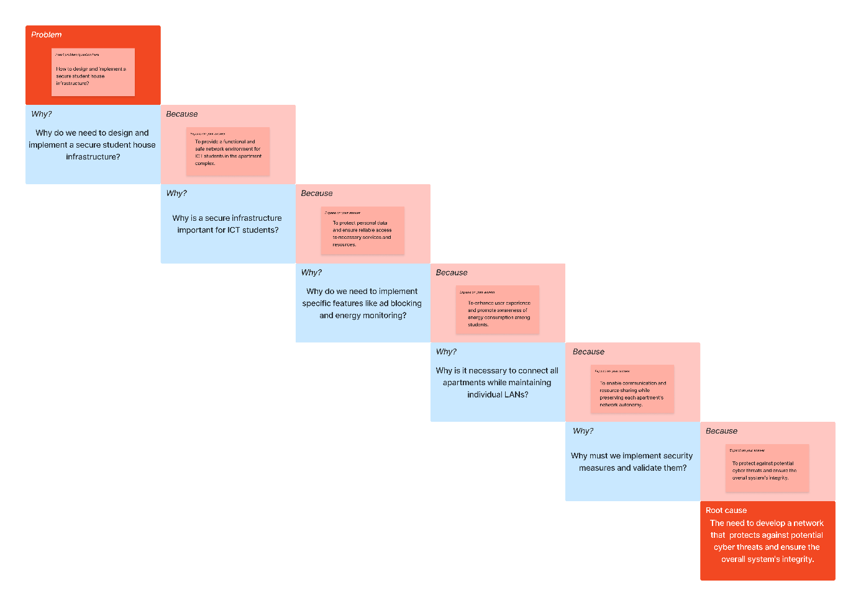

# Problem Statement

* [Problem Statement](https://www.figma.com/board/SEBp2b2QzyQXkrfkhePS4z/Problem-Statement-(Copy)?node-id=0-1&node-type=canvas&t=Pl1Fc9IBqyXAXgAI-0)

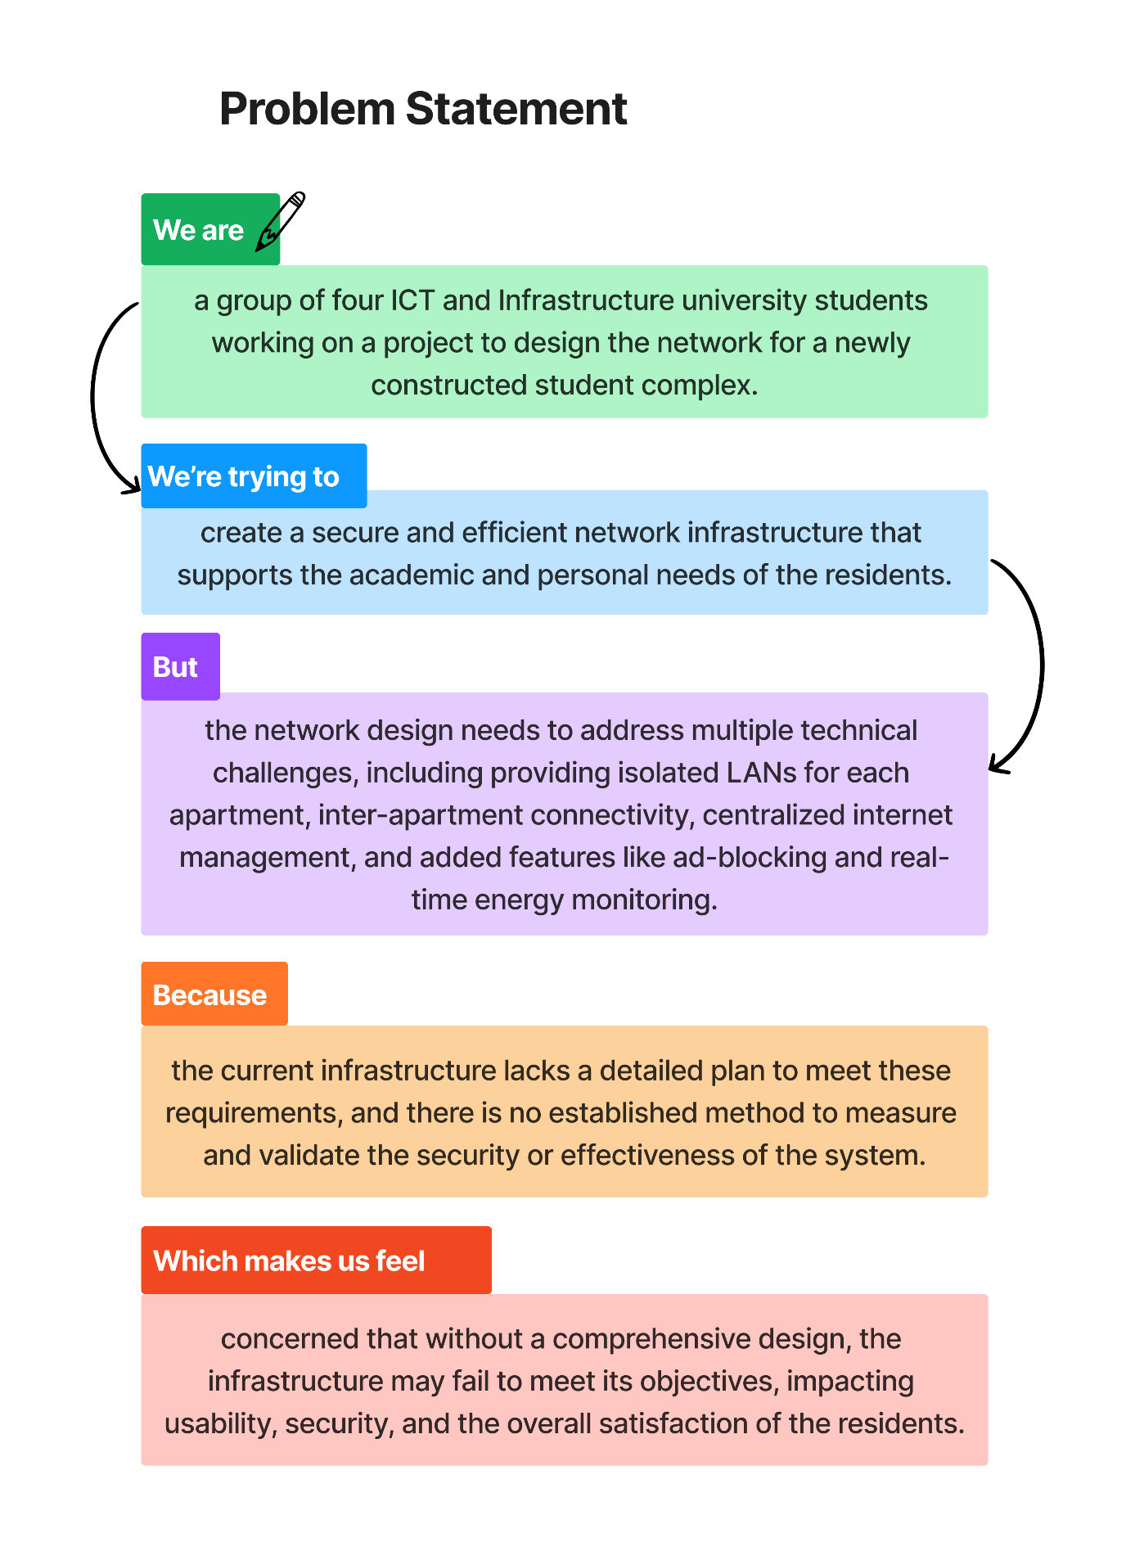

# Project Overview

* [Project Overview](https://www.figma.com/board/mlVaaaNtbwDXNiST5zNENh/Design-Brief-Template-(Copy)?node-id=0-1&node-type=canvas&t=X5xr6MGjVvsSj5nx-0)

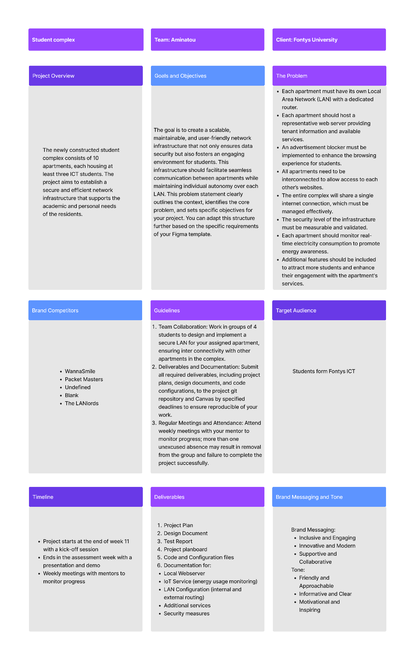

# SWOT Analysis

* [SWOT Analysis](https://www.figma.com/board/mZLPxK5HMCyy9vCpBRLywG/SWOT-Analysis-(Community)-(Copy)?node-id=0-1&node-type=canvas&t=1MVSVVfetvWLKn1v-0)

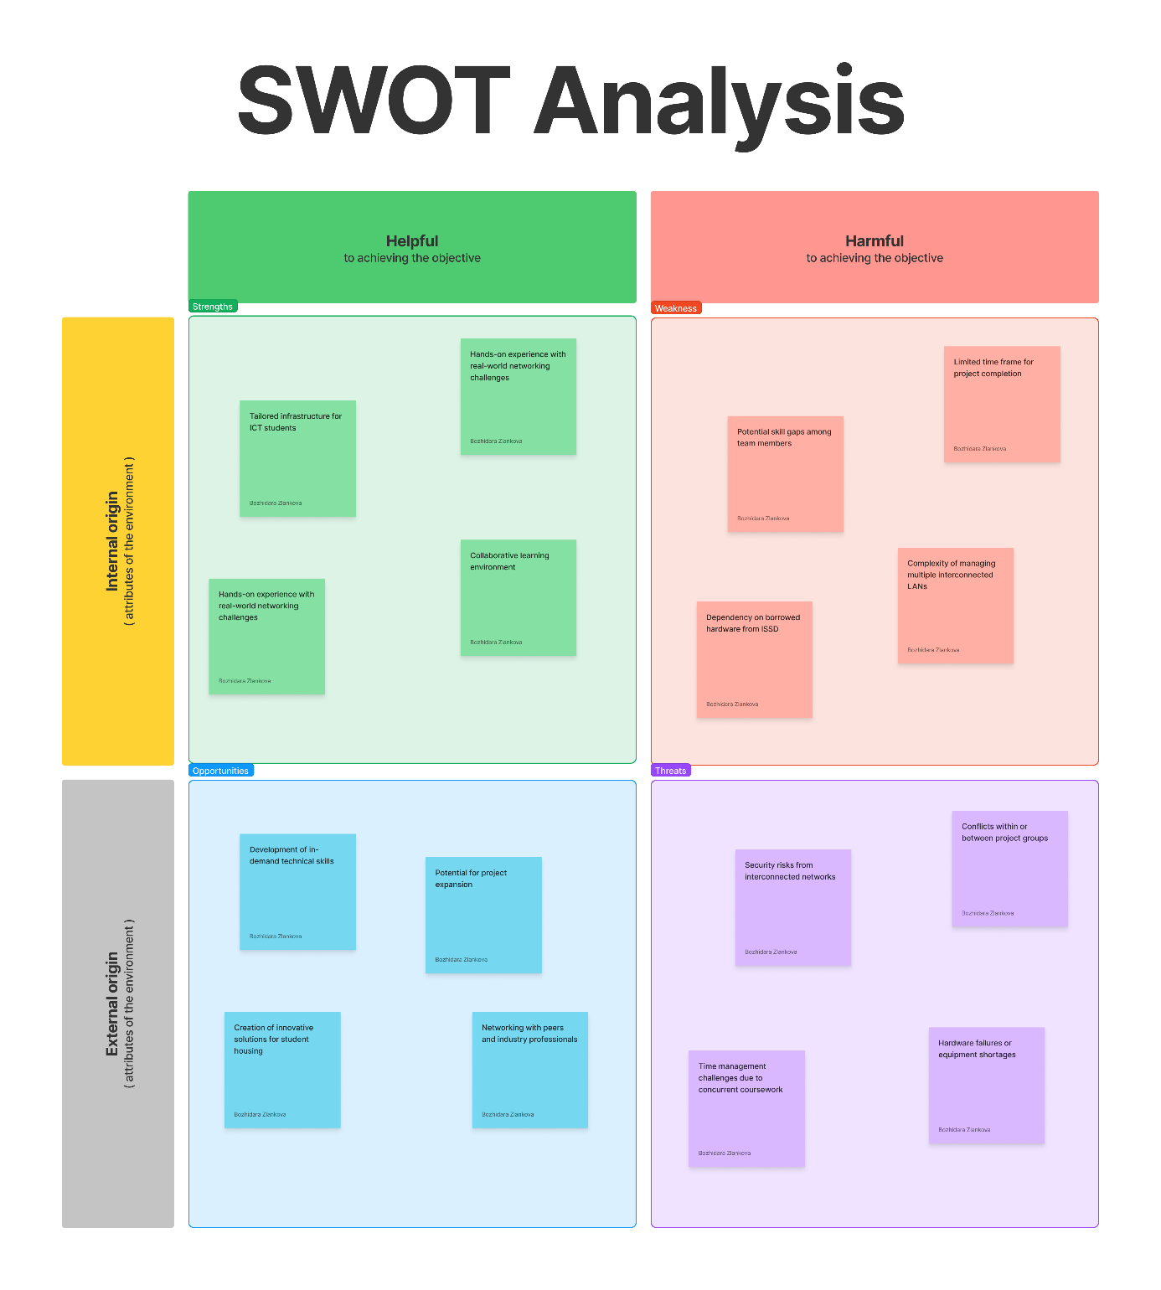

# Risk Management

* [Risk Analysis](https://www.figma.com/board/yca6yNJtnshLwBecht4ffC/Risk-Assessment-Template-%7C-The-Conference-Room-(Community)?node-id=0-1&node-type=canvas&t=b4U5n0P7YCXdCUdF-0)

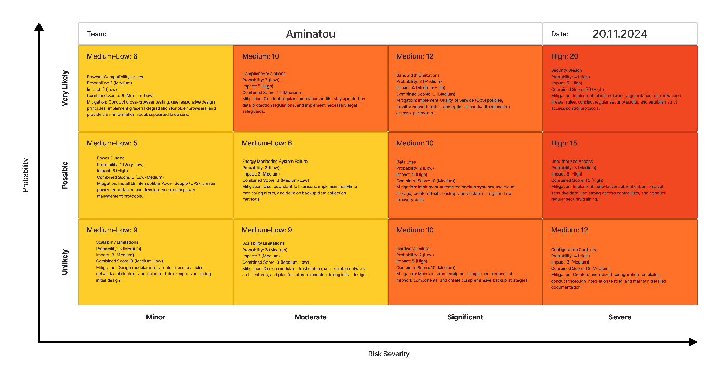

# Gantt chart

* [Gantt chart](https://stichtingfontys-my.sharepoint.com/personal/546173_student_fontys_nl/Documents/Desktop/Semester_1/Infra_First_Semester/Group_project/Aminatou/Paperwork/Project_planning/Student_housing_group_project.pod)

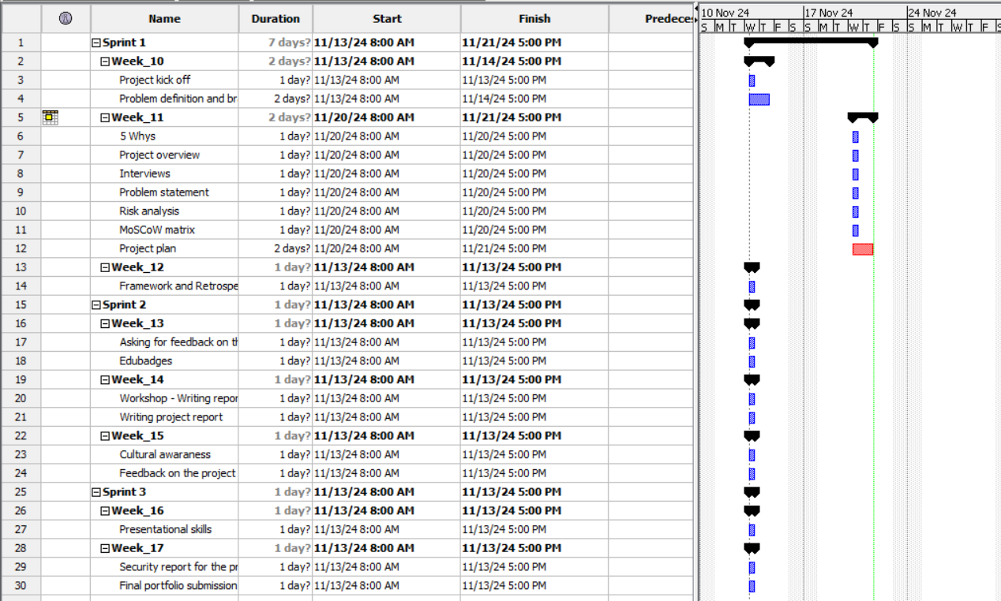

# MoSCoW Matrix

* [MoSCoW Matrix](https://www.figma.com/board/44ipRcj8pCG5ldxdOH2uCh/MoSCoW-Matrix-Group-Project?node-id=0-1&node-type=canvas&t=xWlQ1iZcZotZawx8-0)

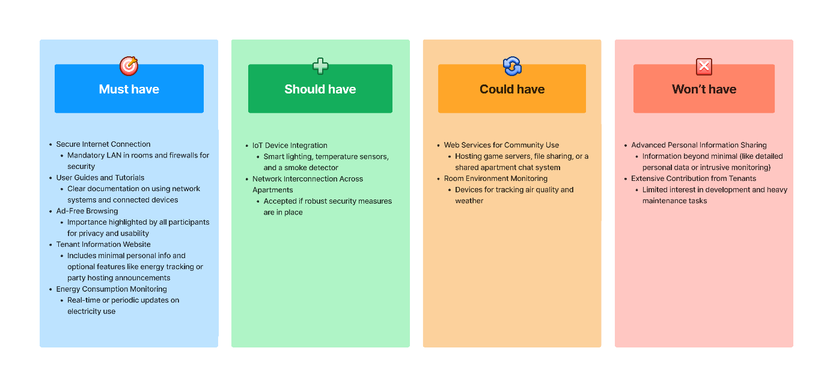

# References

MoSCoW:

* Clegg, D., & Barker, R. (1994). Case Method Fast-Track: A RAD Approach. Addison-Wesley.

5 Whys:

* Ohno, T. (1988). Toyota Production System: Beyond Large-Scale Production. Productivity Press.

Problem Statement:

* Project Management Institute. (2017). A Guide to the Project Management Body of Knowledge (PMBOK Guide) (6th ed.). Project Management Institute.

SWOT Analysis:

* Humphrey, A. S. (2005). SWOT Analysis for Management Consulting. SRI Alumni Newsletter (SRI International).

Risk Assessment:

* ISO 31000:2018 Risk Management – Guidelines. International Organization for Standardization.