# Exercise: Testing Introduction

Problems for exercises and homework for the ["QA Fundamentals" course @ Software University](https://softuni.bg/courses/qa-fundamentals-internal).

## Find the Errors

You are given a picture of the homepage of Google, opened with a Google Chrome browser. Examine the picture and list the errors you can detect on a first glance. Then, you can open the google.com for comparison and list the rest of the errors you have found after seeing it.

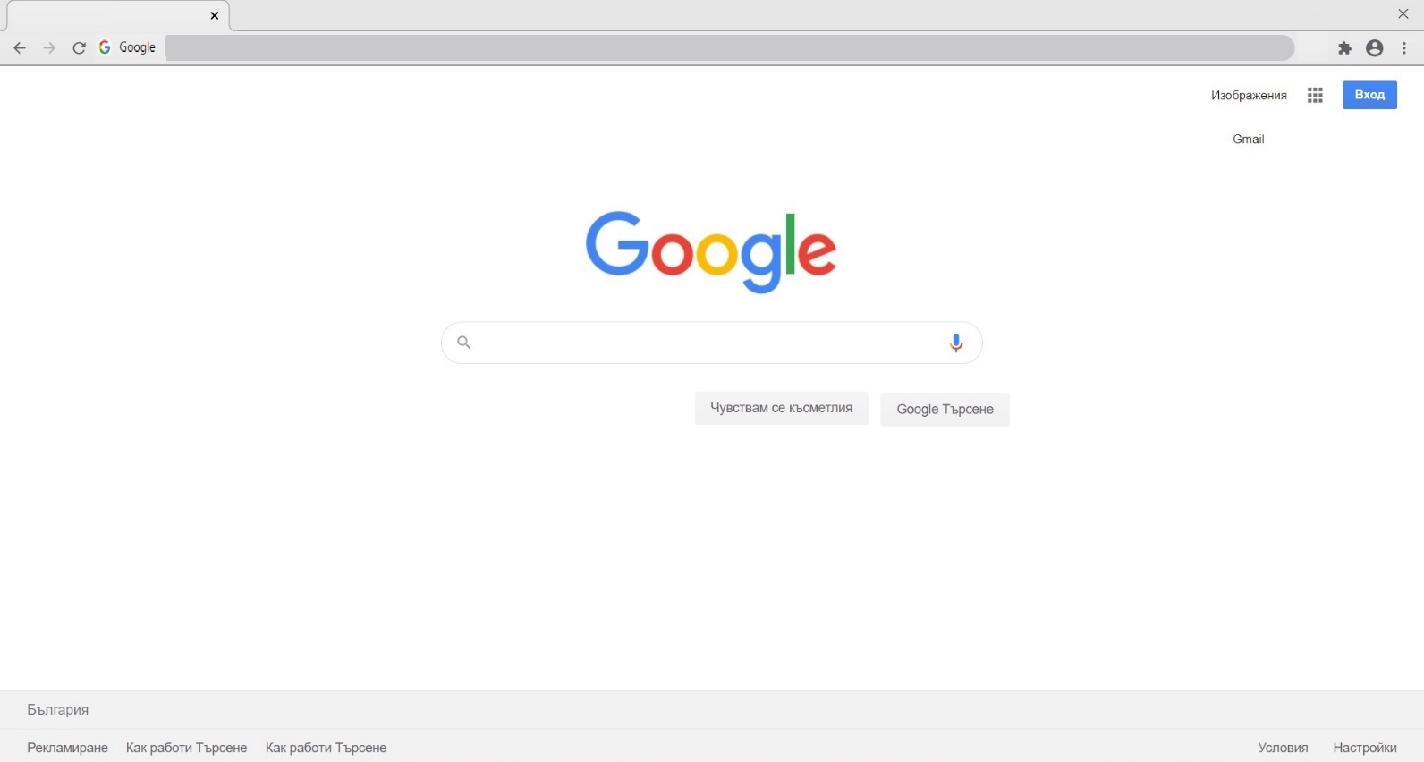

Fill in the table below the number of defects you have found.

|  |  |
| --- | --- |
| Defects: |  |

Look at the legend to judge your results:

|  |  |
| --- | --- |
| Defects Found |  |
| 0 – 2 | **Poor** |
| 2 – 4 | **Average** |
| 5 – 7 | **Good** |
| 8 – 10 defects | **Excellent** |
| 1st defect | **The “Google” name and logo sould be on the top left corner on the tab section** |
| 2nd defect | **The 2 buttons (“Чувствам се късметлия”, “Google търсене”) are not in the center right bellow the text box where we type what we want to search** |
| 3rd defect | **Mising ”Maximize/ Restore Down” button** |
| 4th defect | **“Gmail” must be in line with “Изображения”** |
| 5th defect | **There is no link on the link section** |
| 6th defect | **“Privacy” is missing from the buttons on the bottom right corner** |
| 7th defect | **“About” is missing from the buttons on the bottom left corner** |
| 8th defect | **The “keyboard” symbol is missing from the text box** |
| 9th defect | **Bookmarks bellow are missing** |
| 10th defect | **On the tab section the button “+” is missing** |

## Suggest Improvements

The extension of a Software Testing job is to provide suggestions for quality improvements. Take a look at this sign in form. Think of how user experience can be improved for the following sign-in page:

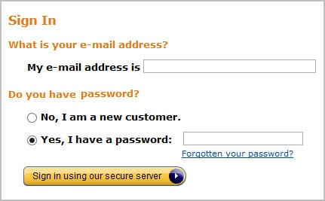

Suggestions:

1. Different label on the button for signing in. Just “Sign In”
2. There should be 2 sections for Sign In and Register. So when you open the “Sign In” window you fill your email addres and you password if you have an account. Bellow these text boxes there should be a link which says “You don’t have an account? Register here!”.
3. The link for the forgotten password should be named “Forgot your password?”.
4. “Do you have password ?” is not necessary we can go without it.
5. By second suggestion the “No, I am a new customer.” loses its meening, so we should remove it.
6. We can change the labels for “My email address is” and “Yes, I have a password” to just “E-mail” and “Password”. It just looks cleaner.
7. “Cancel” button could be added.
8. “Close” button could be added.

## Think Testing

Here are a couple of cases. Think of all the different and appropriate solutions to them.

* A woman fired a shot at another woman with her gun but the other woman did not die. Why? List the possible reasons.

1. There was no bullet in the gun.
2. She missed her.
3. Her shot wasn’t deadly.
4. The gun was “Gas pistol”.
5. The gun could be equiped with rubber bullets or other non-lethal bullets.

* How would you test a 5 kg capacity grocery shopping paper bag?

1. Fill the bag with groceries that make exactly 5kg to see if the bag will tear.
2. Fill the bag with groceries that make more than 5kg to see if the bag will tear.
3. Fill the bag with as much groceries as I can fit in but the total weight to be less than 5kg to see whether the bag will last.
4. Put 1 thing in the bag but that thing will weight more than 5kg to see whether the bag will last.
5. Fill the bag with groceries that make exactly 5kg and walk around for long period of time to see if the bag will tear.
6. Check if the bag is kid friendly.

* It is time to teach your child to brush its teeth alone. It needs a clear step-by-step instruction, so list the steps and be as detailed as you can.

1. Wash the toothbrush
2. Put some toothpaste on it.
3. Put some water just a little.
4. Start brushing.
5. Make circle moves.
6. Start from the outside surface of all lower or uper teeth your choice.
7. Than do the other outside surface.
8. After that brush the inside surface of all lower or uper teeth your choice.
9. Than again do the other inside surface.
10. Brush the tongue.
11. Clean your mouth with water.
12. Do this at least twice a day ☺.

## Test Psychology

This is an exercise from the ISQB textbook "Fundamentals of Software Testing ISTQB Certification".

Read the email below, and see what clues you find to help you identify problems in the scenario described. Categorize the clues/problems as:

• Possible people, psychology and attitude problems;

• Other problems, e.g. possible test management and role problems, possible product problems.

Hi there!

Well, I nearly caused a panic today because I thought I had found a mega showstopper on the trading system we are testing. The test manager and others got involved examining databases first on the server and then on the gateway that feeds the clients, checking update logs from processes that ran overnight as well as checking data passed to the client. Eventually I found the problem. I had mis-clicked on a **.bat** file when running up a client and had run up the wrong client environment. By that time the test manager was ready to say a few short words in my ear, particularly as the development people had started to get involved and they have zero tolerance for mistakes made by testers. The only saving grace was that I found the mistake and not one of the developers.

It was, objectively, an interesting mistake. When you log into the server test environments, the panels always show the environment to which you are connected. In our case we have two test environments called Systest14 and Systest15 and my tests were set up in Systest15. To run up the clients, we have to run .bat files for either a 14 or 15 client. I had started two clients, that is two exchange participants, so I could do some trading between them.

It appears I started the first client OK in environment 15 but when I started the second, I accidentally moved the mouse a fraction so it ran the 14 .bat file that is next to it in the Explorer file list. To make matters worse, the client screens do not show the environment to which you are attached.

At first I felt a bit stupid having caused much hectic and wasted activity. On reflection I thought that if I, as a reasonably competent person, can make a mistake like this then something is wrong. On the server side when I log on to a test environment, I have to enter the environment name and it's shown on all the panels. On the client side, I run a client test environment by selecting a .bat file from a list of many and have to ensure I click on the right file. There is neither a display nor the ability to determine the client environment in which I am working.

So I am going to log this as a high priority, or even showstopper, error - the client does not show the environment. In real life terms, it means a real user could be connected to the production system and think he is connected to a test system and screw up trading. I know this happened once on the equities trading system, when a trader entered a load of test transactions into the production system by mistake and caused mayhem.

As an addendum to this story, a couple of days later one of the testers found what appeared to be another mega showstopper. He and the test manager spent three hours crawling all over the system before they discovered the 'error'. A new filter had been added to the client software to filter transactions displayed in panels by geographical market. Unknown to them, it was set to a default of the German market, whereas they thought they were in the UK market. Consequently, at first sight, it appeared there were fundamental problems with the network transaction bus and the message-broadcasting systems. Apart from the issue that they should have been informed of this change, it raised a similar problem to the one I had experienced -the client system does not display the market in which you are trading.

Well - I'm off for another happy day at the office! All the best

**People, psychology and attitude** **PROBLEMS:**

1. Not enough communication between the test manager, the test team and the developers.
2. Initial diffidence overcome by revisiting the problem.
3. Understandable use of sarcasm.
4. Again not enough communication this time its with the Configuration management.

**There are some Product PROBLEMS, not funcional or technical. Here we see NON-FUNCTIONAL PROBLEMS-to be more specific usabilty:**

1. Mis-click: ” I had mis-clicked on a **.bat** file”.
2. No information about made changes: “'Unknown to them, it was set to a default of the German market, whereas they thought they were in the UK market”
3. There is just not enough clarity for the tester: “There is neither a display nor the ability to determine the client environment in which I am working.' And 'To make matters worse, the client screens do not show the environment to which you are attached.”
4. Huge mistakes made by developers: ” In real life terms, it means a real user could be connected to the production system and think he is connected to a test system and screw up trading. I know this happened once ... when a trader entered a load of test transactions into the production system by mistake and caused mayhem.”