# Exercise: Test Techniques

Problems for exercises and homework for the ["QA Fundamentals" course @ Software University](https://softuni.bg/courses/qa-fundamentals-internal).

These are exercises from the ISQB textbook "Fundamentals of Software Testing ISTQB Certification".

## Equivalence Partitioning / Boundary Value Analysis

**Scenario:** If you take the train before 9:30 am or in the afternoon after 4:00 pm until 7:30 pm ('the rush hour'), you must pay full fare. A saver ticket is available for trains between 9:30 am and 4:00 pm, and after 7:30 pm.

What are the partitions and boundary values to test the train times for ticket types? Which are valid partitions and which are invalid partitions? What are the boundary values? (A table may be helpful to organize your partitions and boundaries.) Derive test cases for the partitions and boundaries.

Are there any questions you have about this 'requirement'? Is anything unclear?

Full fare

Saver ticket

Full fare

Saver ticket

**9:30 am 4:00 pm 7:30 pm**

The boundry values will be:

|  |  |
| --- | --- |
| **Test Scenario Description** | **Expected Outcome** |
| 9:29 am | Pay full fare |
| 9:30 am | Saver ticket |
| 9:31am | Saver ticket |
| 3:59 pm | Saver ticket |
| 4:00 pm | Saver ticket |
| 4:01 pm | Pay full fare |
| 7:29 pm | Pay full fare |
| 7:30 pm | Pay full fare |
| 7:31 pm | Saver ticket |

## Decision Table

**Scenario:** If you hold an 'over 60s' rail card, you get a 34% discount on whatever ticket you buy. If you are traveling with a child (under 16), you can get a 50% discount on any ticket if you hold a family rail card, otherwise you get a 10% discount. You can only hold one type of rail card.

Produce a decision table showing all the combinations of fare types and resulting discounts and derive test cases from the decision table.

|  |  |  |  |  |  |  |  |  |
| --- | --- | --- | --- | --- | --- | --- | --- | --- |
| Conditions | Rule 1 | Rule 2 | Rule 3 | Rule 4 | Rule 5 | Rule 6 | Rule 7 | Rule 8 |
| Over 60 (34%) | T | T | T | T | F | F | F | F |
| Family rail card (10%) | T | T | F | F | T | T | F | F |
| Child also traveling (50%) | T | F | T | F | T | F | T | F |
| Actions |  |  |  |  |  |  |  |  |
| Discount (%) | X | X | 34% | 34% | 50% | 0% | 10% | 0 |

## State Transition

**Scenario**: A website shopping basket starts out as empty. As purchases are selected, they are added to the shopping basket. Items can also be removed from the shopping basket. When the customer decides to check out, a summary of the items in the basket and the total cost are shown, for the customer to say whether this is OK or not. If the contents and price are OK, then you leave the summary display and go to the payment system. Otherwise you go back to shopping (so you can remove items if you want).

a. Produce a state diagram showing the different states and transitions. Define a test, in terms of the sequence of states, to cover all transitions.

b. Produce a state table. Give an example test for an invalid transition.

A.

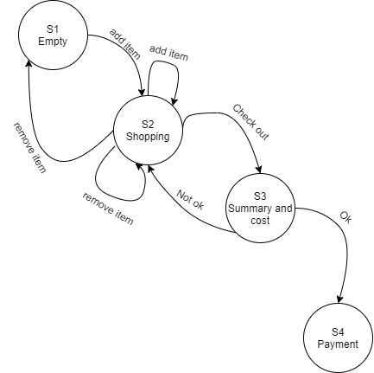

|  |  |
| --- | --- |
| **State** | **Event(Action)** |
| S1 | Add item |
| S2 | Remove (last) item |
| S1 | Add item |
| S2 | Add item |
| S2 | Remove item |
| S2 | Checkout |
| S3 | Not ok |
| S2 | Check out |
| S3 | Ok |
| S4 |  |

B. **State table**

|  |  |  |  |  |  |  |
| --- | --- | --- | --- | --- | --- | --- |
| **State or event** | **Add item** | **Remove** | **Remove item (last item)** | **Checkout** | **Not ok** | **Ok** |
| S1 empty | S2 | - | - | - | - | - |
| S2 shopping | S2 | S2 | S1 | S3 | - | - |
| S3 Checkout | - | - | - | - | S2 | S4 |
| S4 Payment | - | - | - | - | - | - |

## Statement and Decision Testing

Scenario: A vending machine dispenses either hot or cold drinks. If you choose a hot drink (e.g. tea or coffee), it asks if you want milk (and adds milk if required), then it asks if you want sugar (and adds sugar if required), then your drink is dispensed.

a. Draw a control flow diagram for this example. (Hint: regard the selection of the type of drink as one statement.)

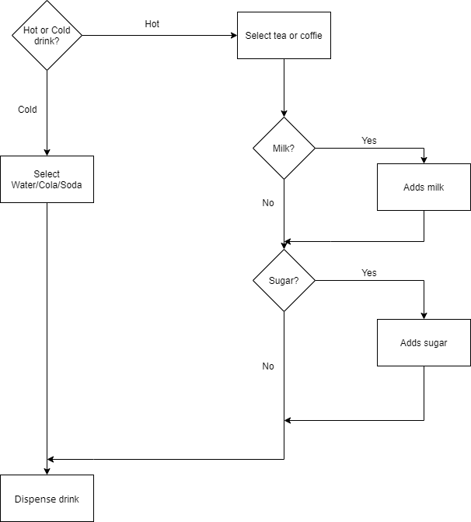

b. Given the following tests, what is the statement coverage achieved? What is the decision coverage achieved?

Test 1: Cold drink

Test 2: Hot drink with milk and sugar

***Given the coverage formula and this test cases the statement coverage is : 100%***

c. What additional tests would be needed to achieve 100% statement coverage? What additional tests would be needed to achieve 100% decision coverage?

***We don’t need additional tests because with these 2 we have 100% statement coverage! Every statement is represented as a box in our diagram and you can see all statements have been tested!***