1. Let f(x) be the image that would be formed on the image plane if the camera were  
   absolutely still. The actually formed digital image of the k-th frame can be described as

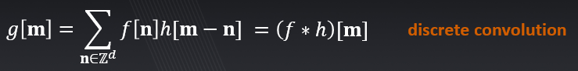



where hk(x) is the effective PSF (point spread function) corresponding to the k-th frame. Express hk in terms of the camera motion.

Answer:

PSFs are obtained by sampling the continuous trajectory o(t) on a regular pixel grid using subpixel linear interpolation. We have o(t) and we want to get o[n], let T be 1/f, so:

**2.** Express the Fourier transform of *hk*.

**3.** Show that the action of the camera can be expressed fully in the digital domain as





Write an expression for the frequency response of the discrete kernel *Pk*.

**4.** Write an upper bound on |Pk[]|.

**5.** Assume that on the interval *τ 2* [*k; k* + 1), the camera moves with constant velocity *v*in the horizontal direction, **o**(*τ*) = (*τ - k -* 0*:*5) *v* **e**1, where **e**1 = (1*;* 0*;* 0)T. Express *Pk*[] in  
this case. How does |Pk[]|depend on *v*?