**Question 8:**

1. **Derive the analytical expressions of gradient and Hessian of Rosenbrock function.**

Rosenbrock function:

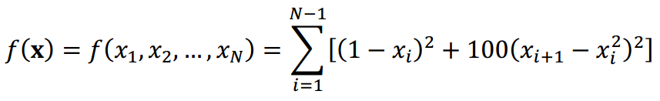

i.e:

Denote the sum:

Rosenbrock function gradient:

Rosenborck Hessian:

|  |  |  |  |  |  |
| --- | --- | --- | --- | --- | --- |
|  |  | 0 | 0 | … | 0 |
|  |  |  | 0 | … | 0 |
| 0 |  |  |  | … | 0 |
| 0 | 0 |  |  | … | 0 |
| 0 | 0 | 0 | … |  |  |
| 0 | 0 | 0 | … |  |  |

1. **Use the gradient descend method to find the optimal point of the Rosenbrock function:**

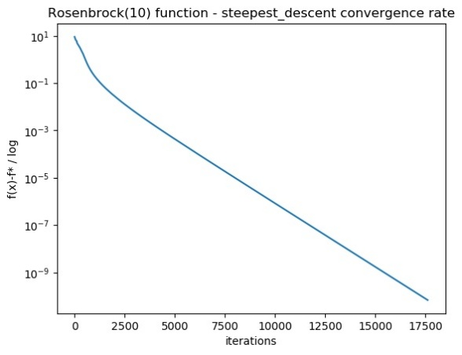

1. **Use the gradient descend method to optimize the following quadratic function:**

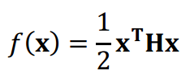

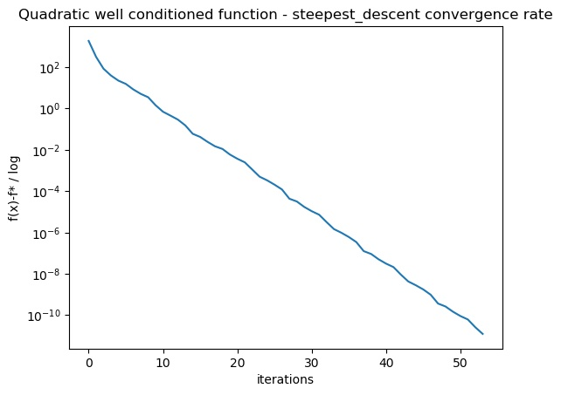

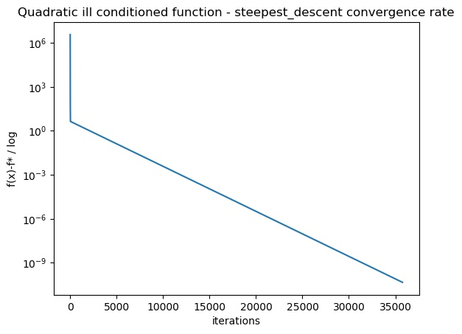

**Question 9:**

1. **Repeat the previous task but now use the Newton method:**

On the plots, mark the point where the convergence rate changes from linear to quadratic. Do all the graphs have this transition?

**Answer:** No, because Quadratic function converges to optimal point in single step.



