EXPENSE MANAGEMENT SYSTEM
Business Workflow Document
How the Module Works, End to End — From an Everyday Expense to Its Closure
A module of the Enterprise Resource Planning (ERP) Suite
Version 1.0 · Prepared for Stakeholder Review

1. Why the Organization Needs an Expense Management System
Employees regularly spend their own money on travel, client visits, software, and other business costs, and then ask to be paid back. Without a proper system, this is usually managed through spreadsheets, emails, and paper receipts — and that creates real problems:
- Reimbursements take too long, with no clear owner or queue.
- Receipts get lost, weakening the proof behind a claim.
- Policy is applied inconsistently across managers.
- Leadership has no real-time view of spend.
- Client-billable costs get forgotten, billed late, or billed twice.
- Cash advanced to employees isn't tracked against what they actually spend.
The Expense Management System (EMS) solves this by giving everyone one place to raise, evidence, approve, verify, and settle every expense — internal or client-related — with full visibility at every step.
What This Means for Each Stakeholder
- Employees — one simple way to submit reports and advances, in any currency.
- Managers — one approval queue, automatically covered when they're away.
- Finance — one repeatable way to verify claims and track reimbursement or client recovery.
- Invoice Team — a clean, verified feed of client costs ready to bill, with no duplicates.
- Leadership — live dashboards of real spend, not month-end guesswork.
2. The People Behind the Process
Five groups of people carry an expense forward, each responsible for a distinct part of the journey.
Participant | Role in the Process
Employee | Creates expense reports, attaches receipts, requests cash advances, and tracks status through to reimbursement.
Manager / Delegate | Reviews reports and advance requests — approves, rejects, or sends back for correction. A Delegate covers this automatically when the manager is away.
Finance | Verifies every approved expense, then tracks it through reimbursement, or hands client-billable expenses to the Invoice Team.
Invoice Team | Attaches verified client expenses to the client invoice and confirms back to EMS once billed.
Administrator | Configures categories, policies, cost centers, currencies, tax rules, and user roles.
The sections that follow show how a single expense passes through these hands in a fixed order — whether it's an everyday cost, a cash advance, or a client expense.
3. The Complete Expense Journey, at a Glance
Every expense follows the same first four stages, then splits based on who bears the cost: it's created and evidenced, checked against policy, approved by a manager, and verified by Finance. From there, an internal expense goes straight to reimbursement, while a client expense is reimbursed to the employee first and then recovered from the client.
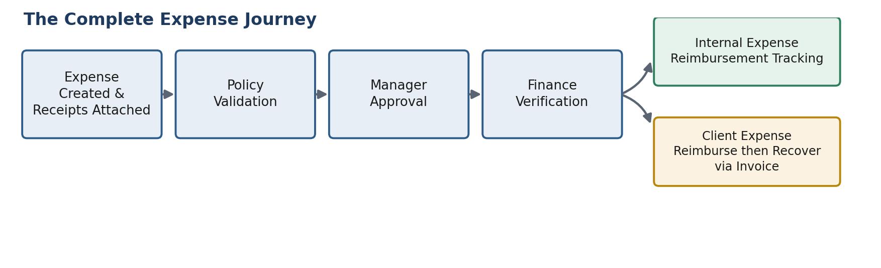
Figure 1 — The Complete Expense Journey, from creation to reimbursement or client recovery.
The sections below walk through each stage, plus two flows that run alongside it: cash advances, which fund spend before it happens, and cost allocation, which decides who ultimately absorbs each cost.
4. Starting the Journey — Creating an Expense Report
A business trip might involve a flight, hotel nights, and meals. Instead of submitting each separately, an employee builds one Expense Report and adds a Line Item for each cost.
Draft, Build, Submit
A report starts in Draft — the employee can save, revisit, and edit it freely. Nothing reaches a manager until it's submitted.
What Each Line Item Carries
- Category — travel, food/hotel, internet/software, supplies, or training — each with its own rules.
- Amount and currency — foreign costs are captured in the original currency and converted to home currency at the transaction-date rate.
- Tax — VAT/GST is captured separately so Finance sees true cost apart from recoverable tax.
- A supporting receipt or invoice.
Receipts, with a Helping Hand from OCR
Every line item needs supporting evidence — a receipt or bill (PDF, JPG, or PNG), with multiple attachments allowed where needed. To save time, EMS offers OCR-assisted capture: attaching a receipt image pre-fills the merchant, amount, and date for the employee to confirm. It's a convenience, not a replacement for review — every value is still checked by the employee and by Finance.
Once complete, the employee submits the report, and it enters the workflow described next.
5. Cash Advances — Funding Expenses Before They Happen
Some costs can't be paid by the employee first and reclaimed later — a client trip booked weeks ahead, for example. EMS handles this through a Cash Advance lifecycle that runs alongside the standard expense process.
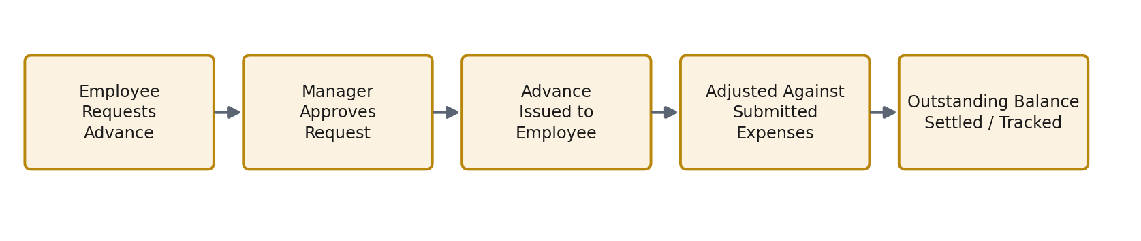
Figure 2 — The Cash Advance Lifecycle, from request through to settlement.
- Request — the employee requests an advance, stating purpose, amount, and client/project if relevant.
- Approval — the manager reviews and approves before any money is issued.
- Issuance — the advance is paid out and recorded as an outstanding balance.
- Adjustment — as the employee submits expenses the advance was meant to cover, EMS reduces the outstanding balance accordingly.
- Settlement — once expenses fully account for the advance, the balance is closed. Anything still outstanding stays visible until cleared.
This gives the organization a live, accurate picture of how much cash is out with employees at any time.
6. Keeping Spend Honest — Policy & Compliance Validation
Before an expense reaches a manager, EMS checks it against company policy — so spend stays consistent and Finance has an objective standard to verify against.
Policy Example | Business Effect
Maximum hotel cost per night | Caps accommodation spend regardless of city or rating.
Meal allowance per day | Keeps food spend predictable.
Receipt mandatory above a set amount | Cuts paperwork on small costs, protects on large ones.
Approval required above a limit | Routes higher-value spend to senior review automatically.
Out-of-policy warning at submission | Surfaces a breach immediately, not after the fact.
A line item that breaches a rule — a hotel cost above the nightly cap, say — is flagged Out-of-Policy at submission. This doesn't block the employee; it just requires a short justification, visible to the manager and Finance from the first review. The same check also catches duplicate receipts and missing mandatory receipts.
7. The Approval Workflow — Review, Delegation, and Correction
Every report — internal or client-related — follows the same chain: the employee submits, a manager or active delegate reviews, and Finance performs the final check.
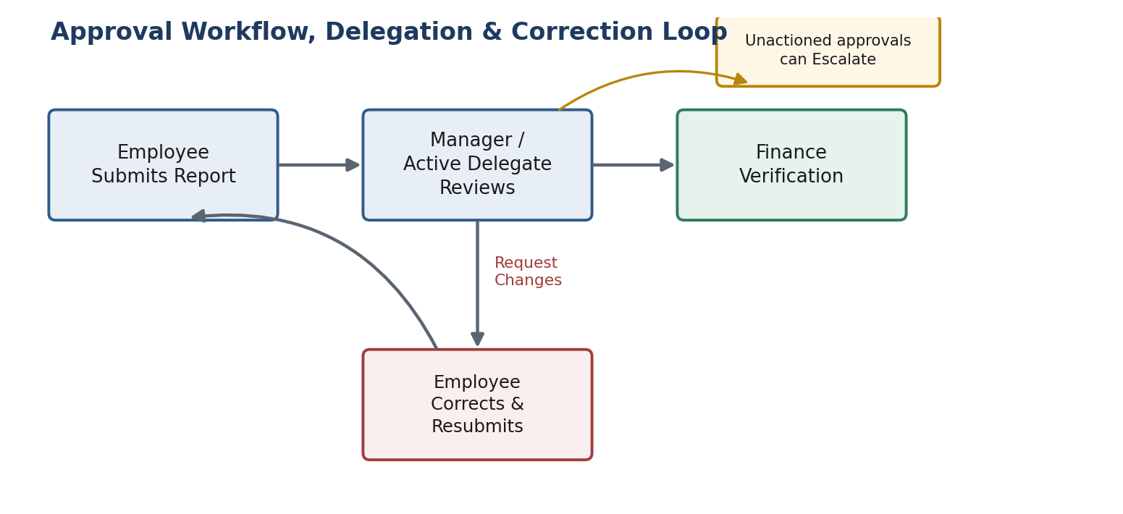
Figure 3 — The Approval Workflow, showing manager review, the correction loop, and escalation.
What a Manager Can Do
- Approve — the expense proceeds to Finance.
- Reject — the employee is notified with a reason.
- Request Changes — sends the report back with comments, opening the Correction Loop.
The Correction Loop
"Request Changes" is a repeatable loop: the employee corrects and resubmits, and the manager reviews again — as many times as needed. Every round trip is logged with the reviewer's comment.
Coverage While a Manager Is Away
When a manager is Out-of-Office, their queue automatically routes to a designated Delegate, who can approve, reject, or request changes just like the manager. Every Delegate decision is logged against both identities.
Escalation
An approval left unactioned too long can be escalated to a senior manager, so reports keep moving. Every decision, comment, and escalation is kept in a permanent Approval History.
8. Finance Verification — The Last Checkpoint
Manager approval confirms an expense is a legitimate business cost. Finance verification confirms it's accurate, compliant, and ready to close or bill — the last checkpoint before money moves. Only Finance can perform this step.
Finance Checks | Purpose
Receipt authenticity & amount | Confirms the document supports the claimed value and currency.
Category & policy compliance | Confirms classification, limits, and any Out-of-Policy justification.
Duplicate claims | Confirms the cost hasn't already been claimed elsewhere.
Approval completion | Confirms manager or delegate approval genuinely happened first.
What happens next depends on who the cost belongs to. An internal expense moves into reimbursement tracking (Section 9). A client-billable expense moves into the reimburse-then-recover flow (Section 10).
9. Completing an Internal Expense
Internal expenses are costs the organization absorbs itself — an internet reimbursement, a training course, a routine travel claim. Once verified, EMS tracks the claim to settlement using a manual reimbursement status, updated by Finance as money actually moves.
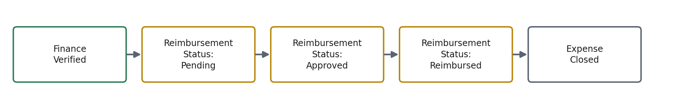
Figure 4 — Completing an Internal Expense: from verification through reimbursement to closure.
- Pending — verified and awaiting payment action.
- Approved — the claim is settled and payable; only payment is left to occur.
- Reimbursed — money has actually moved to the employee.
Keeping Approved and Reimbursed separate gives Finance a clean view of what's payable but not yet paid. Since EMS doesn't yet integrate with a payment system, Finance makes this final status change manually, once payment is confirmed. Once Reimbursed, the expense is Closed.
10. Completing a Client-Billable Expense
Some costs are incurred on behalf of a client and are meant to be recovered through billing — a consultant's flight to a client site, for example. EMS looks after the employee first, then recovers the cost from the client.
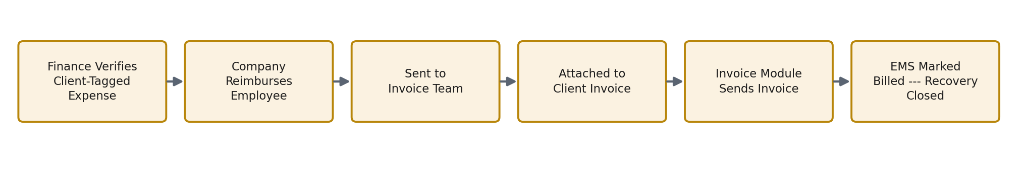
Figure 5 — Completing a Client-Billable Expense: reimburse first, then recover through the client invoice.
Reimburse First, Recover Later
The employee is reimbursed by the organization first, exactly as an internal expense would be. Only afterward does the organization recover that amount from the client, by attaching the expense to the client's invoice through the Invoice Module.
The Handoff to the Invoice Team
- Once verified, the client-tagged expense is sent to the Invoice Team.
- The Invoice Team attaches it to the client's invoice — invoice creation and delivery belong to the Invoice Module; EMS's role ends at the handoff.
- Once the invoice is actually sent, EMS is notified and marks the expense Billed — closing the loop.
This prevents an expense from ever being billed twice, and gives Finance a clear view of what's genuinely invoiced versus still queued.
11. Allocating Costs — Cost Centers, Departments, Projects and Clients
Every expense needs to be attributed to something — a department, a project, or a client engagement. Cost Center and Expense Allocation lets a cost be tagged to wherever it genuinely belongs, without a full budget-planning exercise inside EMS.
Split Allocation
Not every cost belongs to just one place. One line item can be split across multiple cost centers, departments, or projects — by percentage or fixed amount — so the cost lands where it truly belongs.
For example, a workshop trip tagged to Marketing might also serve a second project. Rather than charging Marketing in full, the cost can split — say 70/30 — giving both teams an accurate view of what the trip cost them.
This gives managers and Finance real visibility into where spend lands, without adding budget-forecasting complexity to EMS itself.
12. Staying Informed — Dashboards, Reports, Notifications, Audit Logs and Search
An expense moving correctly through the workflow is only half the value. The other half is making sure everyone can see where things stand, without chasing anyone.
Dashboards
Role | What Their Dashboard Shows
Employee | Draft, submitted, and in-correction reports, plus advance status.
Manager | Team's pending approvals, delegate coverage, and spend by cost center.
Finance | Verification queue, reimbursement status counts, and Out-of-Policy flags.
Invoice Team | Verified client expenses awaiting invoicing, and Billed confirmations, by client.
Reports, Notifications, Audit Logs & Search
Reports answer recurring questions — spend by employee, department, or category; multi-currency reconciliation; client-billable spend ahead of invoicing. Notifications alert people the moment something needs their attention: a manager when a report needs review, an employee when changes are requested, the Invoice Team when a client expense is ready to bill.
Every expense keeps a permanent, uneditable audit trail covering its full history — creation, corrections, approvals, and status changes. Global search and filters let anyone quickly find a report by employee, category, client, status, or date.
13. Working Together — How EMS Connects with Other Systems
EMS relies on, and feeds into, other systems the organization already runs, so information is entered once and trusted everywhere.
Connects With | What This Enables
HRMS | Supplies employee identity, department, and manager relationships for approval routing.
Project Management System | Supplies valid clients and projects to tag expenses and advances against.
Invoice Module | Receives verified client expenses for invoicing and returns the Billed confirmation.
Document Management System | Stores and retrieves receipts and supporting attachments.
Notification Service | Delivers alerts to the right person at the right moment.
Exchange Rate Services | Supplies transaction-date rates to convert foreign-currency line items.
As systems mature, EMS is expected to extend this same closed-loop approach to Accounting and Payroll, so reimbursement status can eventually be confirmed automatically.
14. Business Scenarios
Scenario 1 — Internal Expense with a Correction
An employee submits a $45 internet reimbursement with the ISP bill attached. The manager spots a date mismatch and requests changes; the employee corrects and resubmits; the manager approves. Finance verifies, marks it Approved, then Reimbursed once payment goes out — Closed.
Scenario 2 — Cash Advance Ahead of a Client Trip
An employee requests a $2,000 advance for a client workshop. Their manager, Out-of-Office, has it approved by their Delegate. After the trip, flight and hotel costs in USD/EUR are submitted, tagged to the client and split 70/30 across two cost centers. As these are verified, the advance balance reduces accordingly.
Scenario 3 — Client Expense Through to Invoice Recovery
Finance verifies the client-tagged costs from the same trip. The employee is reimbursed immediately. The expenses go to the Invoice Team, who attach them to the client's invoice. Once sent, EMS is notified and marks them Billed — the recovery loop is closed.
15. Summary — The Value This Brings
EMS replaces spreadsheets and email with one continuous process every expense follows, start to finish. Employees always have one place to submit a report or advance. Managers always have one queue, covered automatically when they're away. Finance always has one repeatable way to verify a claim and track it to reimbursement or client recovery. Leadership always has an accurate, current view of what the organization — and its clients — actually owe.
By treating cash advances, internal reimbursement, and client billing as three related paths through one shared workflow, EMS brings consistency where there was improvisation, and visibility where there was guesswork.

