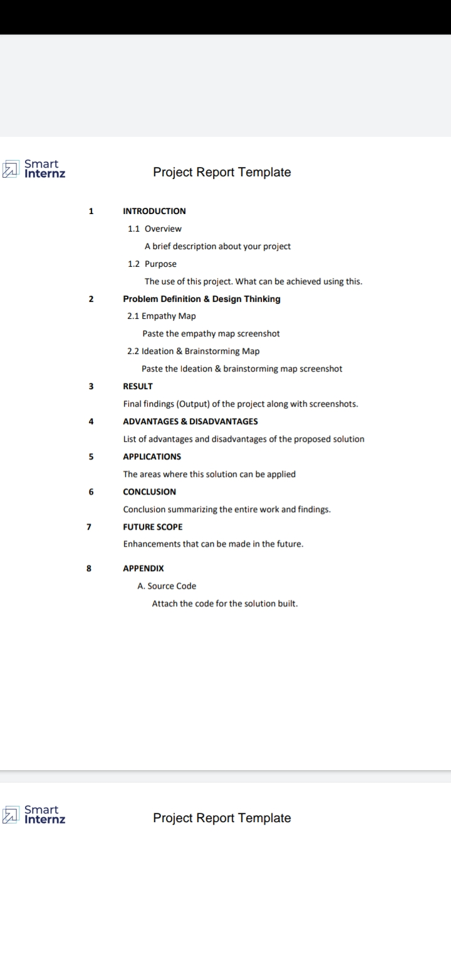1.Introduction

1.1 Overview

Let as analyse the text on your channel’s about page .It helps viewers understand what to expect from your brand and can be used to exaplain why they should subscribe to your channel.

1.2 Purpose

The most-subscribed channel is the Indian record label T-series,which hosts its music vedios on its channel.With over 250 million subcribers as October 2023,the channel has held the top position since April14,2019.

2.Problem Definition & Design Thinking

2.1 Empathy Map

Paste the empathy map screenshot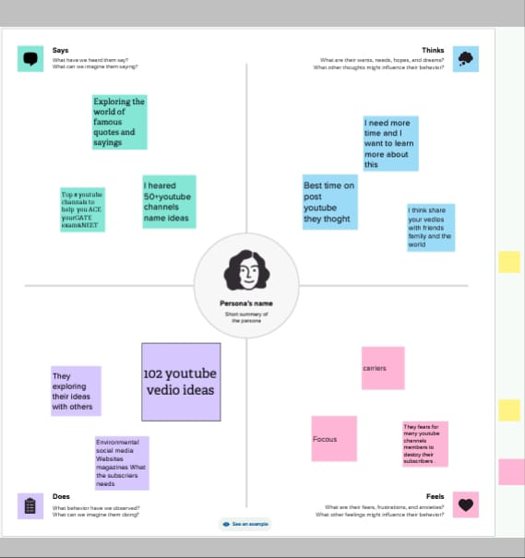

2.2 Ideation & Brainstorming Map

Paste the Ideation & Brainstorming map screenshot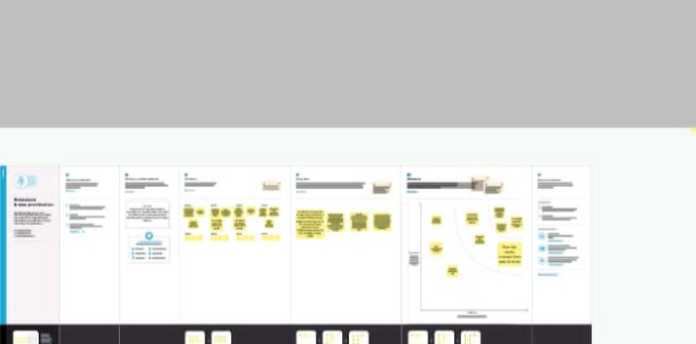

3.Result

Final finding (output) of the project along with screenshots.

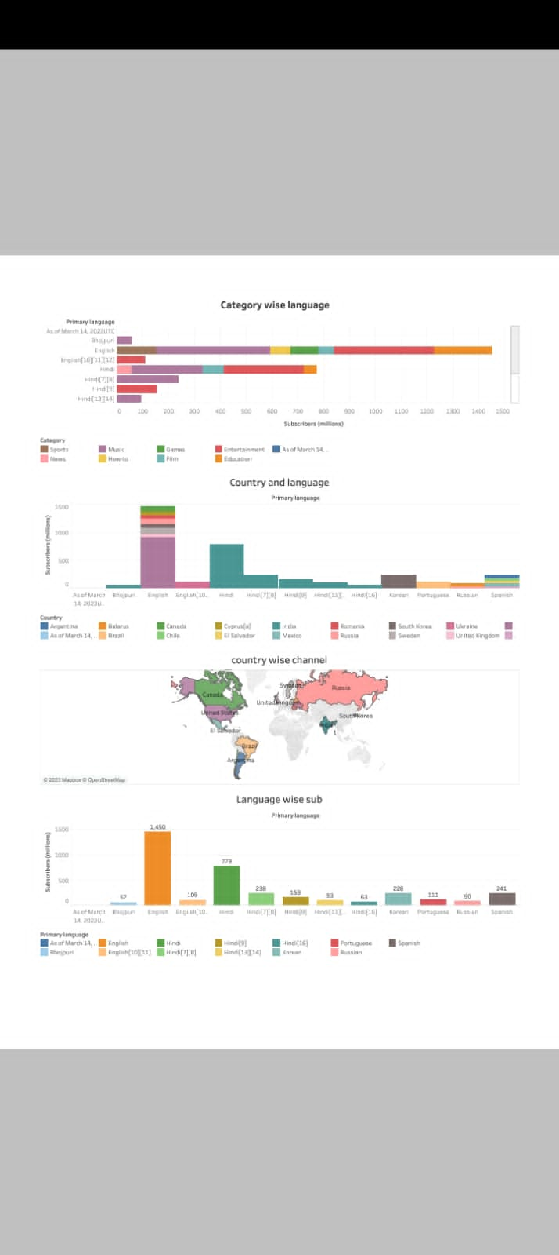

# 

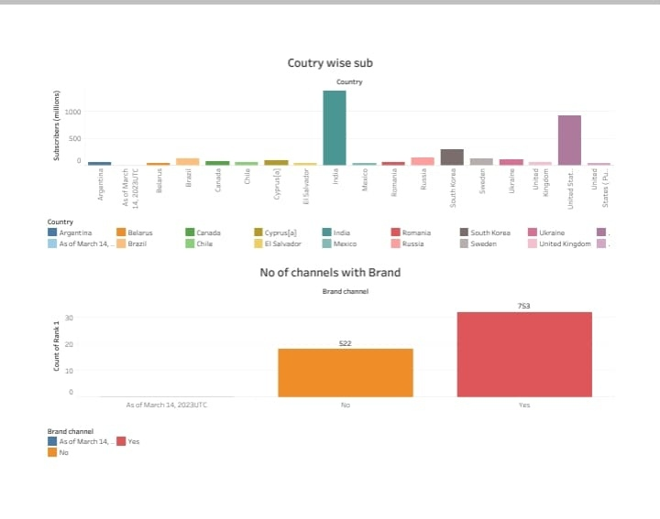

4.Advantages & Disadvantages

List of Advantages & Disadvantages of the proposed solution

|  |  |
| --- | --- |
| Advantages | Disadvantages |
| You can express your ideas. | Ads- a draw back of youtubes for the audience. |
| Ideas for youtube channels are endless. | Inappropriate content also uploade. |
| You will be quite flexible regarding when to publishing vedios. | Bullying and defomation is easily done |
| You can shae ideas with feauture generations. | Not easy to concentrate on a single topic |

5.Applications

The area where this solution can be applied

Get free subcribers,viewers,&Links For your vedio&channel.TubeMine is the best application to help you boost your subscribers number, grow your channel, &make your vedio viral.

6.Conclution

Conclution summarizing the entire work and finding.

You can use analytics to better understand your veios and channel performance with key metrics and reports in youtube studio.

Note:some data, such as geography,traffic sources or gender may be limited.

7.Future scope

Enhancements that can be made in the future.

Knowledge and information for all,technical knowledge is so necessary for all of us. You can earn from freelancing by most wanted skills from this channel.