VPC (Network Layer)
Friday, October 18, 2024
12:58 AM

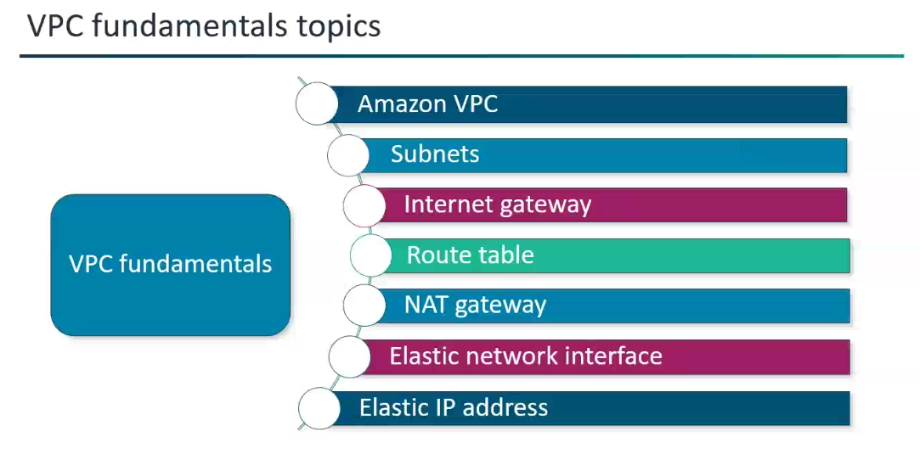

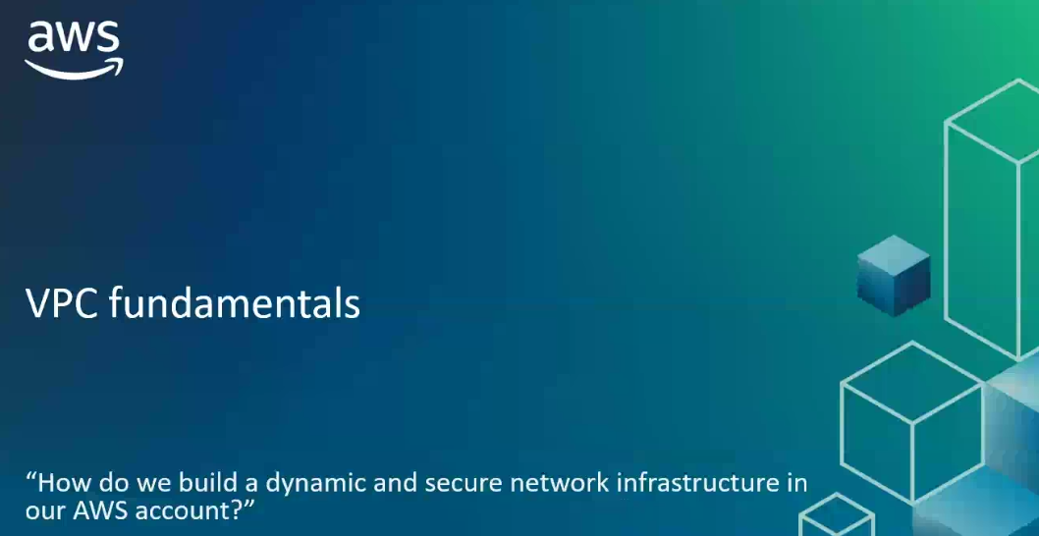
How do we build a dynamic and secure network infrastructure in our AWS account?
VPC
Note: Dynamic --> Average
VPC (Implicit Router) -->"Brain of the Network"
Why Implicit --> Because it is invisible, software-defined backbone of AWS Network.
* VPC Implicit Router: The VPC implicit router is the "traffic director" or "engine" that actually performs the routing based on the instructions provided in the route table.
*When a packet arrives at the implicit router (e.g., from an EC2 instance), the router consults the associated route table, finds the most specific matching rule for the packet's destination IP, and then forwards the packet to the specified target.

So, in essence:
Route Table = "What to do" (the rules/map)
VPC Implicit Router = "How to do it" (the mechanism that executes the rules)
They are inseparable for traffic to flow correctly within and out of your VPC.
*VPC is a private network space, where we can launch AWS resources.
*Each private network you create on the cloud will be logically separated from other virtual networks in the cloud.
*VPC-->Select Region and CIDR ; 5 VPC's per region. (We can increase it by quota increase request)
*All the default VPC's are Public.
*Name Default Adjustable Comments
VPCs per Region 5 Yes Increasing this quota increases the quota on internet gateways per Region by the same amount. You can increase this limit so that you can have hundreds of VPCs per Region.
Subnets per VPC 200 Yes -

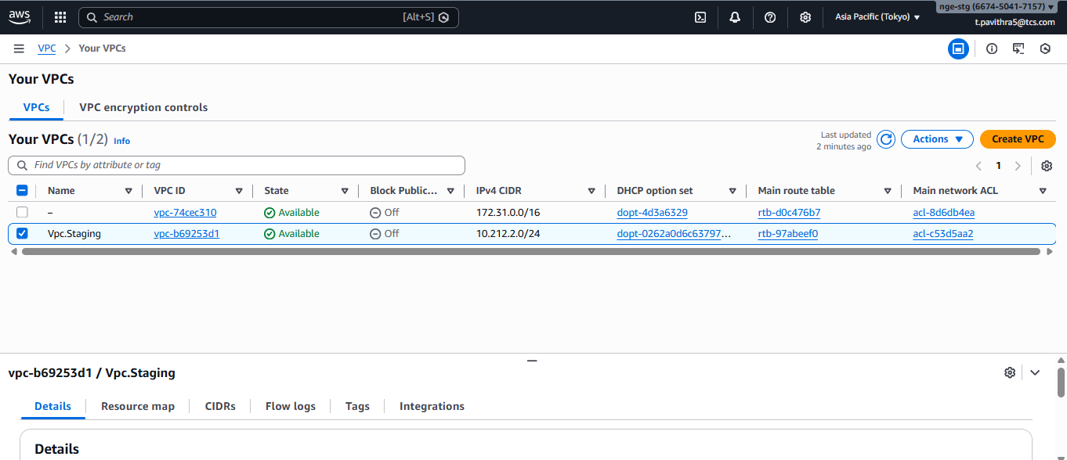
AZ --> The physical location where the servers are…
*AZ1 and AZ2 should possesses in the same range of IP addresses (Same LAN) to communicate with each other.
*All Availability Zones in a Region are logically separated and interconnected with high-bandwidth, low-latency networking, over fully redundant,
dedicated metro fiber.
*For a Virtual Private Cloud (VPC) to perform routing, subnets within the VPC must be associated with a route table, not the VPC.
*When you create a Virtual Private Cloud (VPC) in AWS, a main route table (default route table) is automatically created and
associated with that VPC, however, the initial creation and association ensure that your VPC is immediately functional for internal communication.
(even though we are not configured any route table; but in reality we are configuring route table to the subnets).

*When you start using Amazon VPC, you have a default VPC in each AWS Region. A default VPC comes with a public subnet in each Availability Zone, an internet gateway, and settings to enable DNS resolution. Therefore, you can immediately start launching Amazon EC2 instances into a default VPC.
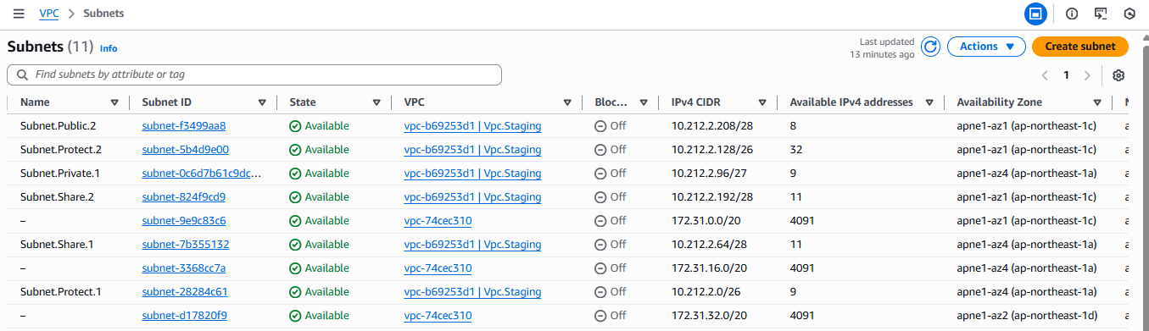
What happens if both VPC have same CIDR Ranges..?
*Each Virtual Private Cloud (VPC) is logically isolated from other VPCs, even if they use the same CIDR (Classless Inter-Domain Routing) range, there won't be an issue for their independent operations, Problems arise with interconnectivity as the overlapping IP addresses create confusion for routing.
Think of it like two different houses in different cities both having the address "123 Main Street" – they're distinct because they're in different locations.

* Problems arise with interconnectivity: The issues begin when you try to connect your VPC with another VPC that has an overlapping CIDR range.
VPC Peering: You cannot create a VPC peering connection between two VPCs that have overlapping CIDR blocks. AWS simply doesn't allow it because it wouldn't know how to route traffic correctly (e.g., if a packet is addressed to 10.0.0.5, which VPC's 10.0.0.5 should it go to?).
AWS Transit Gateway: While Transit Gateway is more flexible than VPC peering, if you have overlapping CIDRs, you still can't propagate identical routes.
This means you'll run into routing complexities and limitations.
Workflow:
1.VPC A (10.0.0.0/16) sends a packet.
2.The Private NAT Gateway translates the source to 192.168.1.5 (Unique).
3.Transit Gateway receives the packet and sees a unique source and unique destination.
4.Transit Gateway looks up its route table and successfully forwards the traffic to VPC B (10.0.0.0/16).
Note: Without NAT, Transit Gateway cannot route between two VPCs with the exact same CIDR if they need to communicate directly, as the destination IP would be technically "local" to both.
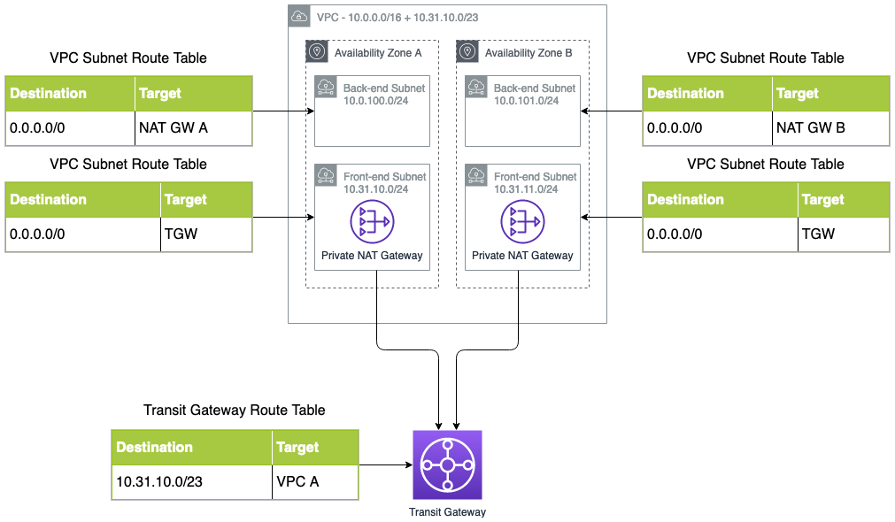

Therefore, best practice in AWS is to plan your CIDR ranges carefully to avoid overlaps, especially if you anticipate future needs for inter-VPC communication or hybrid cloud connectivity. AWS offers tools like IP Address Manager (IPAM) to help with this planning and prevent conflicts across multiple accounts.
IPAM ( IP Address Manager) -->Acts as a central hub for efficiently managing your entire IP address space, for preventing conflicts and ensuring optimal utilization.
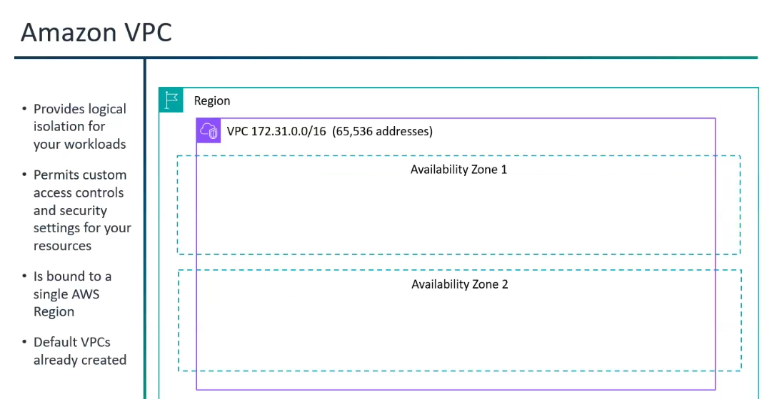

What is default tenancy in AWS VPC?
Default tenancy is shared Tenancy.
Tenancy:
*Tenancy- குத்தகை
Tenancy- a legal arrangement in which someone has the right to live in or use a building or land owned by someone else in exchange for paying rent to its owner.
Tenant- A tenant is someone who lives in a place owned by someone else, usually paying rent.
Shared Tenancy – Default:
Multiple customers will share the same pieces of hardware even though they don’t interact with each other.
The default tenancy model is the one most commonly used with AWS.
Tenancy itself not has a price, the billing will be the depends on the resources used within the shared VPC.

Dedicated Tenancy:
The physical hardware that is reserved entirely for one customer use, and not shared with any other customers.

Dedicated Hosts:
With a dedicated host, you purchase an entire physical host from AWS and that host is billed to you on an hourly basis just like EC2 instances are billed. Once you’ve purchased that host, you’re allowed to spin up as many EC2 instances as that host will allow for no additional charges.
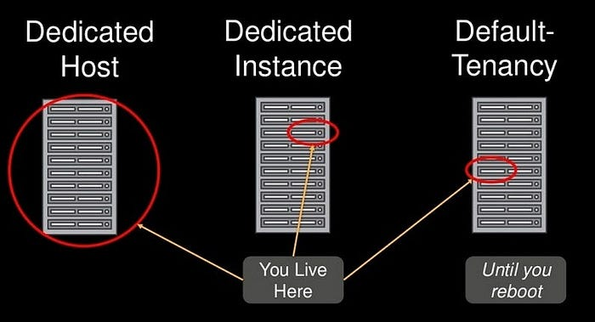

VPC Peering and AWS Transit Gateway:
VPC Peering and AWS Transit Gateway, while both helps to achieve inter-VPC communication.
VPC Peering:
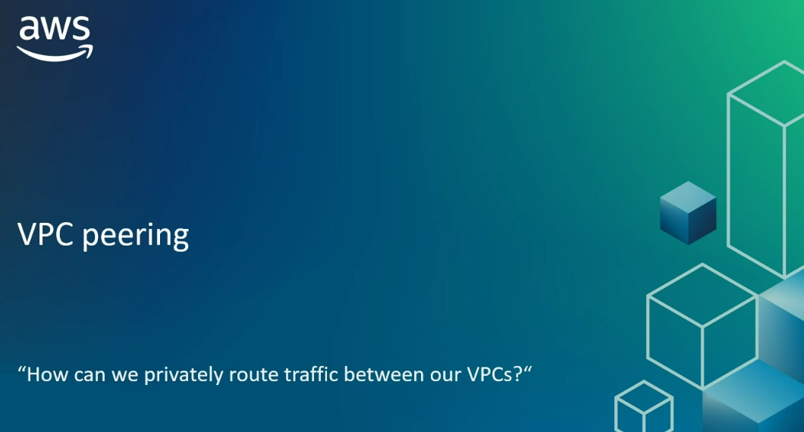
How can we privately route traffic between our VPC..?
VPC Peering
VPC Peering:
*If we want only two or three VPCs that need to talk, and their CIDRs don't overlap, VPC Peering is often the simpler and more cost-effective choice.

How it works:
* You send a peering request from one VPC (requester) to another VPC (accepter).
* The owner of the accepter VPC must accept the request.
* Once the connection is established, you must manually update the route tables in both VPCs to direct traffic.
* Traffic flows directly between the two VPCs over the AWS backbone network, never traversing the public internet.
Key Characteristics:
* Point-to-Point: It's always a direct connection between two VPCs.
* Non-Transitive: This is a crucial limitation. If VPC A is peered with VPC B, and VPC B is peered with VPC C, VPC A cannot communicate with VPC C through VPC B. You would need a separate peering connection between VPC A and VPC C.
* No Overlapping CIDRs: You cannot create a VPC peering connection between two VPCs that have overlapping CIDR blocks (even if they have unique secondary CIDRs).
* Low Latency: Since traffic flows directly, latency is generally very low.
* Cost-Effective for Small Scale: For a few VPCs, it's very economical as you only pay for data transfer that crosses Availability Zones or Regions.
* Supports Cross-Account and Cross-Region: You can peer VPCs across different AWS accounts and in different AWS Regions.
Non-transitive --> The relation does not follow the rule of transitivity, where if "a is related to b" and "b is related to c", then "a is related to c" must also be true.

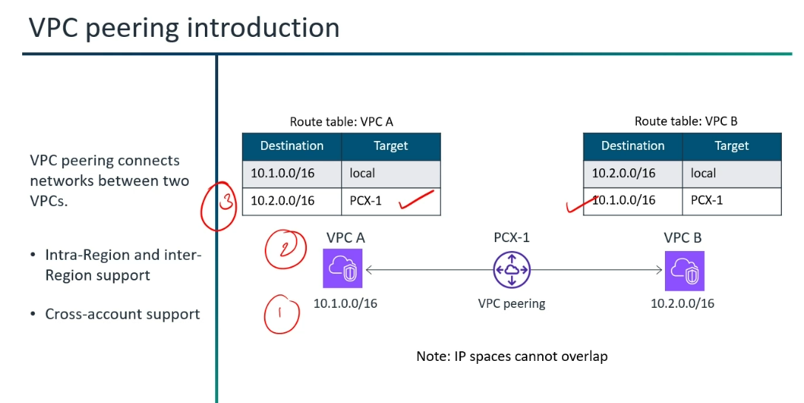

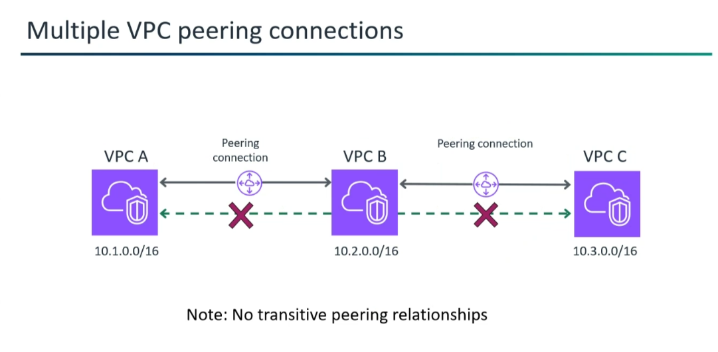

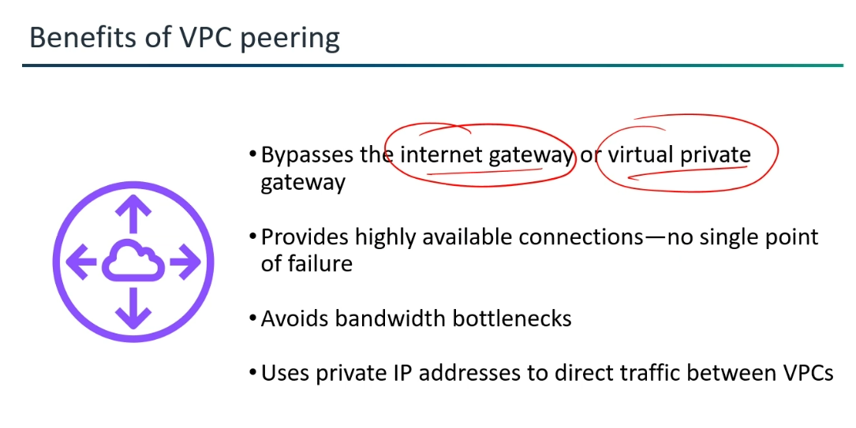

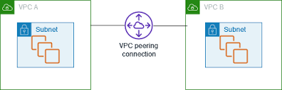

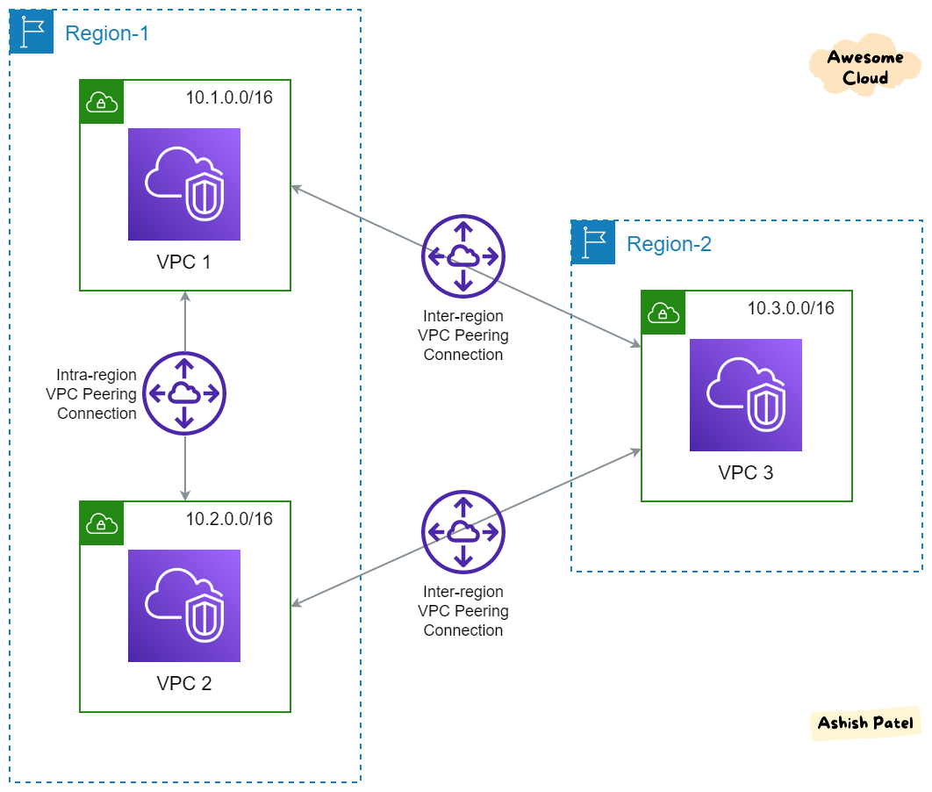

AWS Transit Gateway:
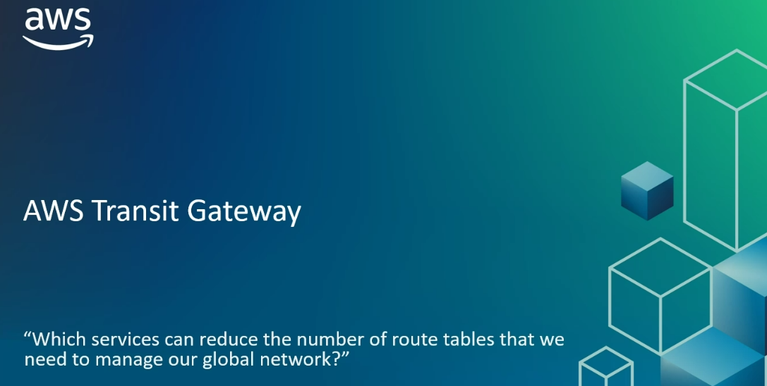
Which service can reduce the number of route tables that we need to manage our global network..?
AWS Transit Gateway
AWS Transit Gateway (Centralized network transit hub, Highly scalable cloud router)
*Centralized network transit hub that allows you to connect multiple Amazon VPCs and on-premises networks through a single gateway.
It acts as a highly scalable cloud router.
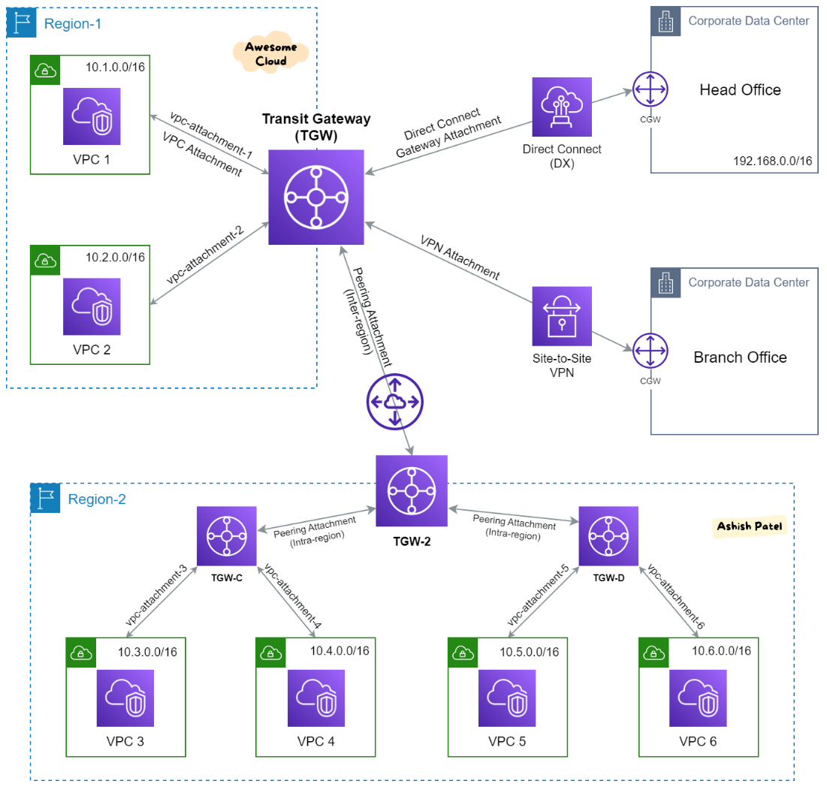
How it works:
* You create a Transit Gateway in a specific AWS Region.
* You then create attachments to the Transit Gateway. These attachments can be:
* VPCs
* Site-to-Site VPN connections (from on-premises)
* Direct Connect Gateways (from on-premises)
* Other Transit Gateways (for inter-region peering)
* Transit Gateway Connect attachments (for SD-WAN integration)
*The Transit Gateway uses route tables (similar to VPC route tables, but for the TGW itself) to control how traffic is routed between all attached networks.
Routes can be static or dynamically propagated.
Static routing is a method where manually configure the routes by the network administrators in a router's routing table.
Static routing is best for small, stable networks.

Dynamic routing is a method where routers automatically learn and exchange routing information with other routers in the network. They use routing protocols (Routing Information Protocol (RIP)) to adapt to changes in the network topology, find the most optimal paths, and update their routing tables without manual intervention. Dynamic routing is essential for large, complex, and evolving networks.

In many real-world scenarios, a combination of both static and dynamic routing is used to leverage the advantages of each.
*Simplify network connectivity - AWS Transit Gateway (Complex to Simple)
*Transit Gateway (Regionally Bounded) - Central Hub for all connections.
(5000 VPC can be connected.)
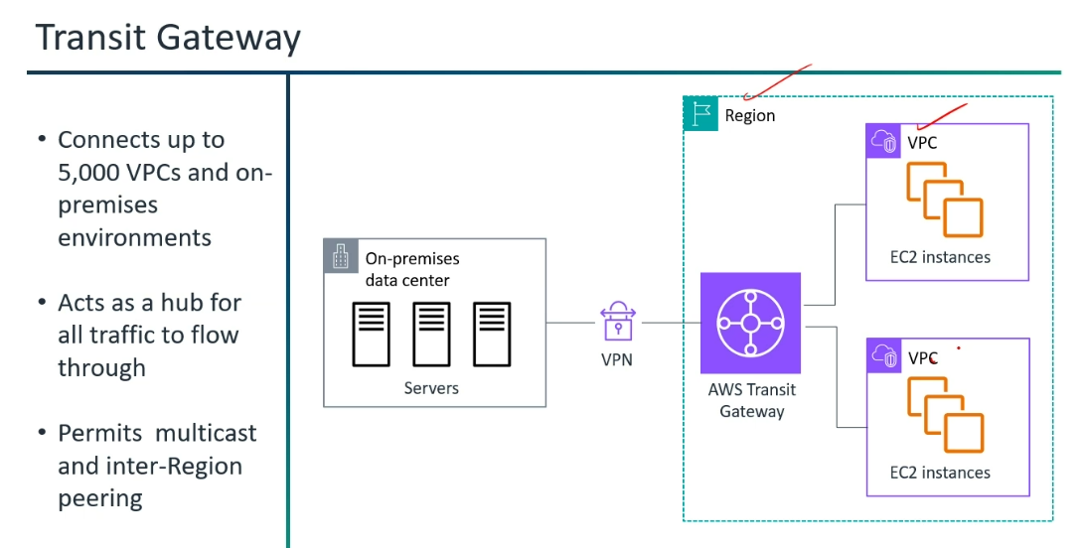

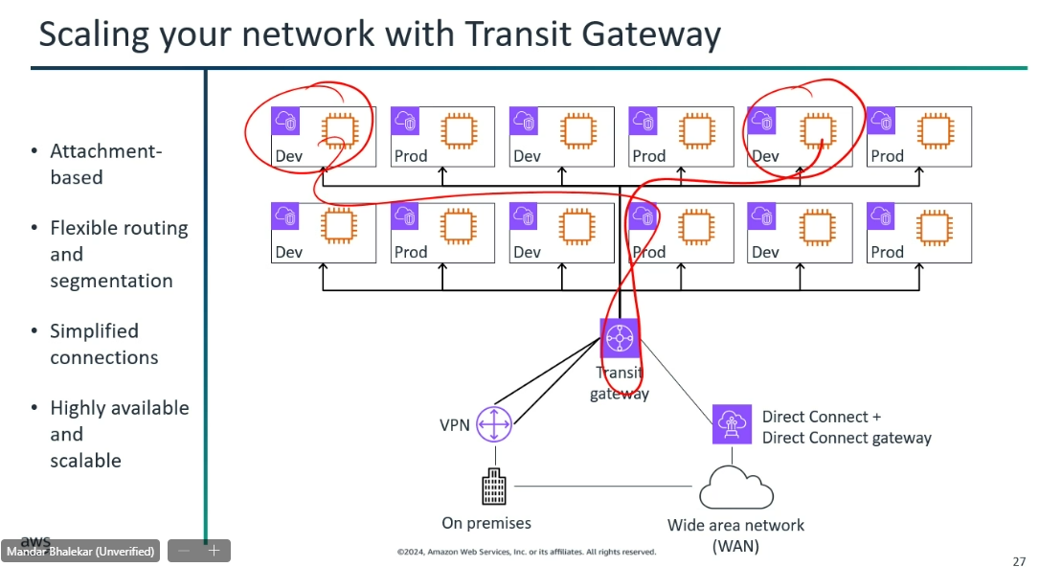

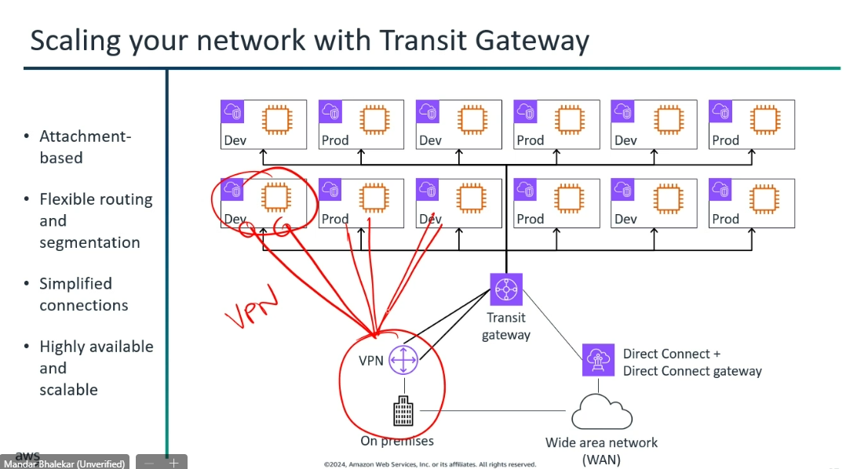

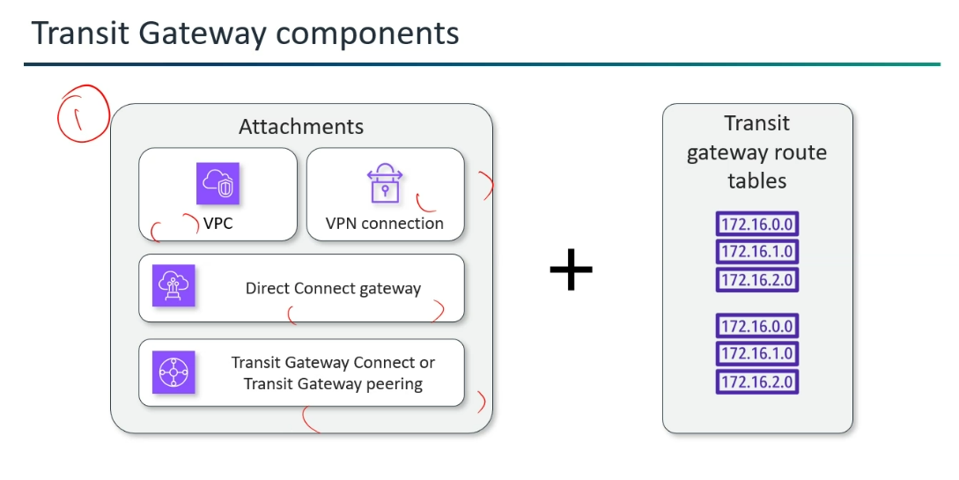
*Privately Dev to Dev Communicate:
(Dev --> Transit Gateway -->Dev ---- To connect Privately)
*More VPCs can be connected in "Transit Gateway ".
*Once every attachments get connected then "Everyone can connect".
"Isolated connection also possible."
*Resource Access Manager --> Share the service. (Google it)
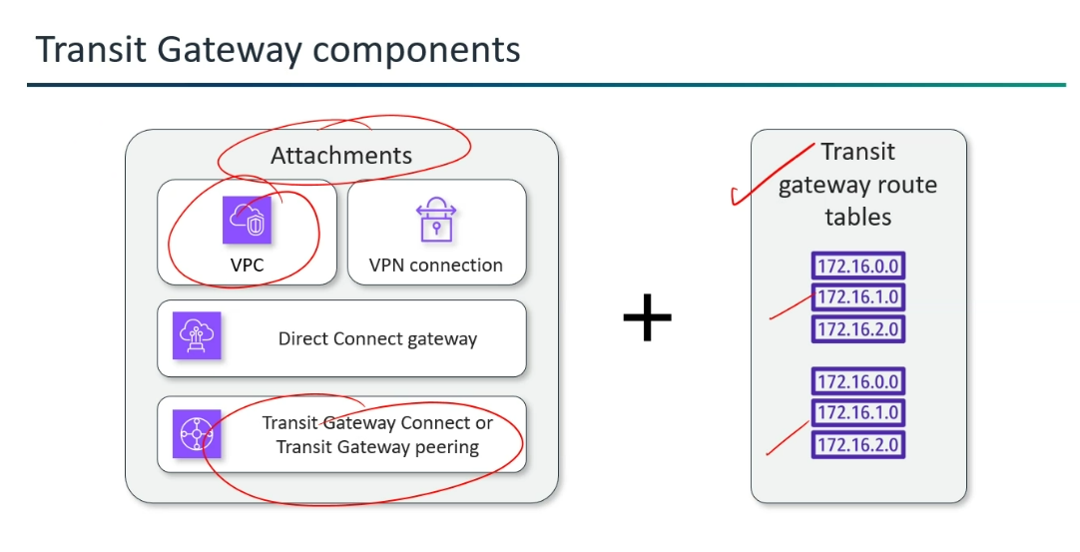

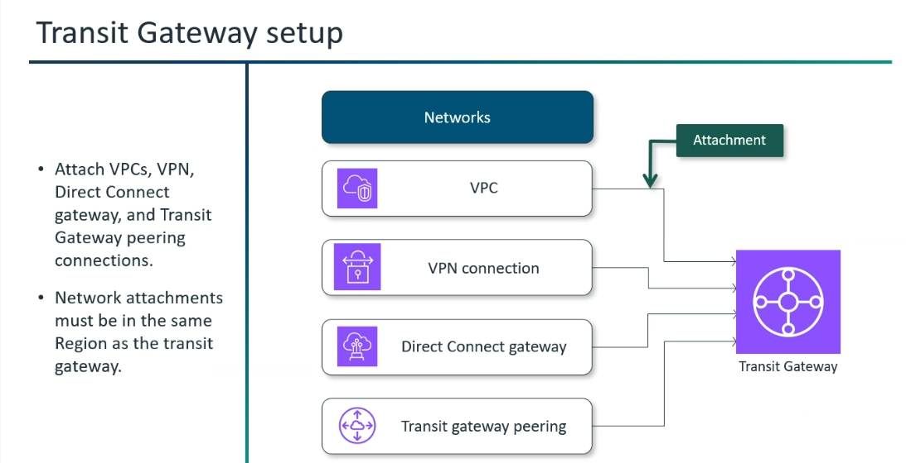
*VPC 1 , VPC 2 and Transit Gateway -->Transit Gateway Peering (3 Attachments)
VPC 3 , VPC 4 and Transit Gateway -->Transit Gateway Peering (3 Attachments)
*Every VPC can talk to every other region VPC privately.
*Peering --> One to One connection.
*Isolation will be done by the Route table.
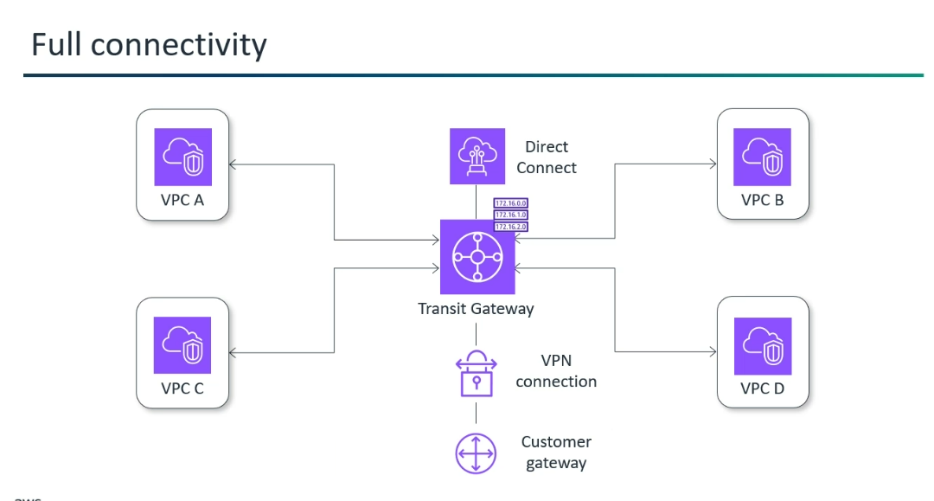

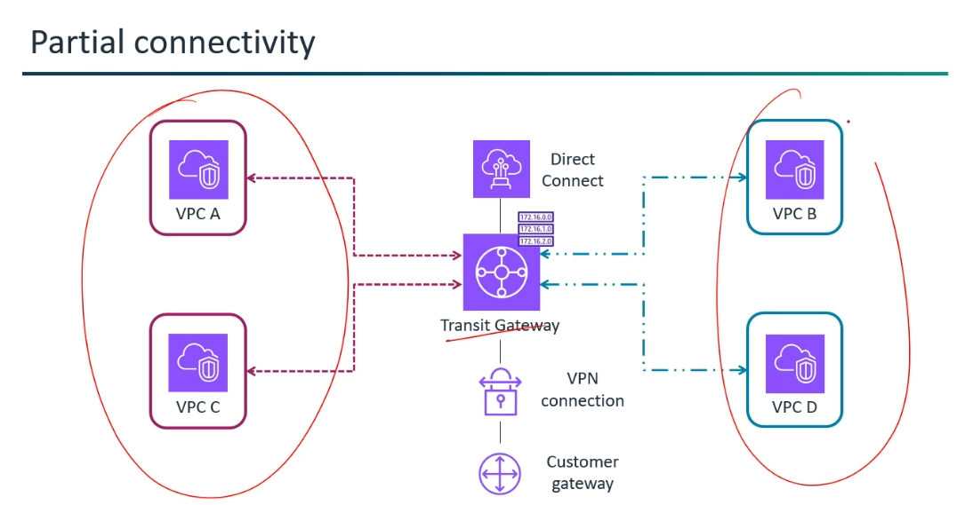

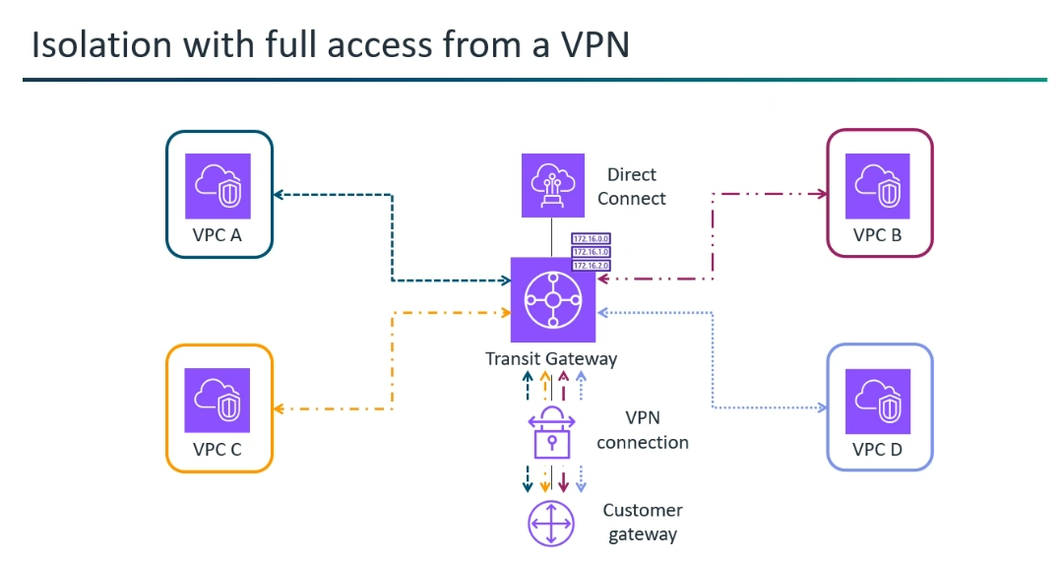

Site-to-Site VPN connection --> Secure tunnel over the public internet.
*A secure, encrypted connection (IPsec VPN) between your on-premises network and your Amazon VPCs over the public internet.
*Single Site-to-Site VPN connection (with Virtual Private Gateway)
*Single Site-to-Site VPN connection with a transit gateway
*Multiple Site-to-Site VPN connections (with Virtual Private Gateway)
*Multiple Site-to-Site VPN connections with a transit gateway
*Site-to-Site VPN connection with AWS Direct Connect
*Private IP Site-to-Site VPN connection with AWS Direct Connect
*Single Site-to-Site VPN connection (with Virtual Private Gateway):
The VPC has an attached virtual private gateway, and your on-premises (remote) network includes a customer gateway device, which you must configure to enable the VPN connection. You must update the VPC route tables so that any traffic from the VPC bound for your network goes to the virtual private gateway.
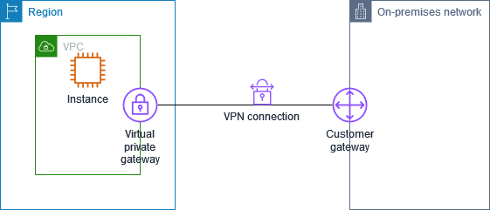
*Single Site-to-Site VPN connection with a transit gateway:
The VPC has an attached transit gateway, and your on-premises (remote) network includes a customer gateway device, which you must configure to enable the VPN connection. You must update the VPC route tables so that any traffic from the VPC bound for your network goes to the transit gateway.
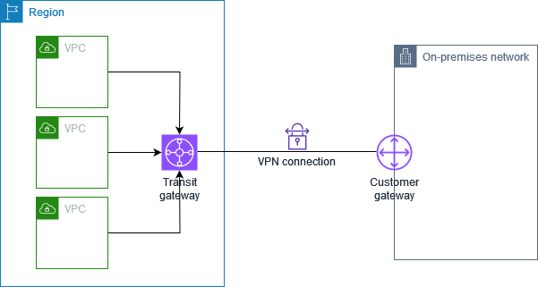

*Multiple Site-to-Site VPN connections (with Virtual Private Gateway):
The VPC has an attached virtual private gateway, and you have multiple Site-to-Site VPN connections to multiple on-premises locations. You set up the routing so that any traffic from the VPC bound for your networks is routed to the virtual private gateway.
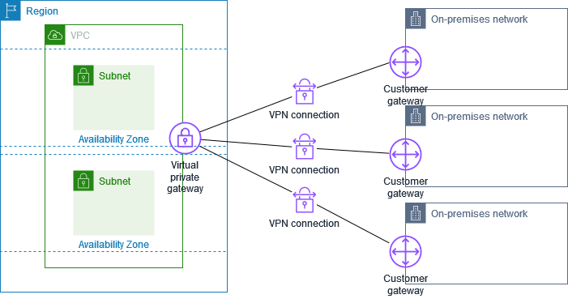

*Multiple Site-to-Site VPN connections with a transit gateway:
The VPC has an attached transit gateway, and you have multiple Site-to-Site VPN connections to multiple on-premises locations. You set up the routing so that any traffic from the VPC bound for your networks is routed to the transit gateway.
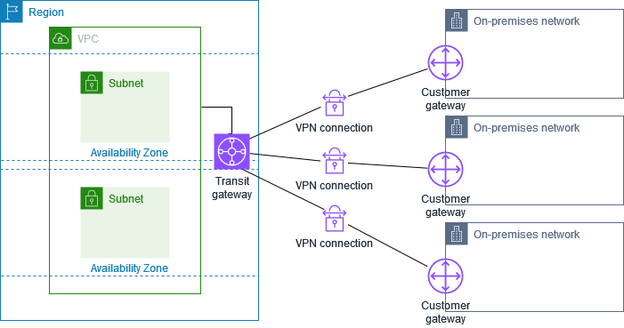

*Site-to-Site VPN connection with AWS Direct Connect:
The VPC has an attached virtual private gateway, and connects to your on-premises (remote) network through AWS Direct Connect. You can configure an AWS Direct Connect public virtual interface to establish a dedicated network connection between your network to public AWS resources through a virtual private gateway. You set up the routing so that any traffic from the VPC bound for your network routes to the virtual private gateway and the AWS Direct Connect connection.
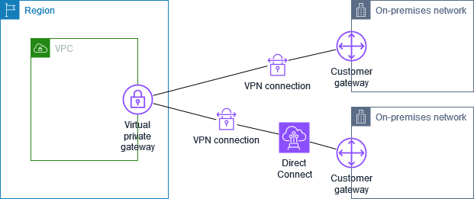

*Private IP Site-to-Site VPN connection with AWS Direct Connect:
With a private IP Site-to-Site VPN you can encrypt AWS Direct Connect traffic between your on-premises network and AWS without the use of public IP addresses. Private IP VPN over AWS Direct Connect ensures that traffic between AWS and on-premises networks is both secure and private, allowing customers to comply with regulatory and security mandates.
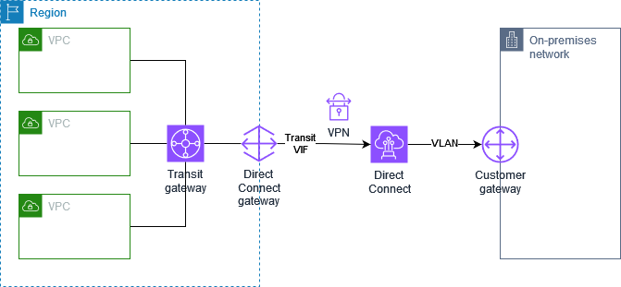

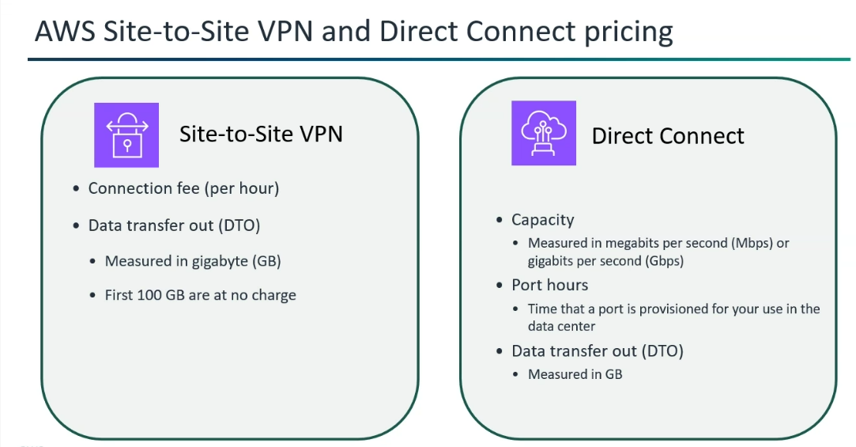

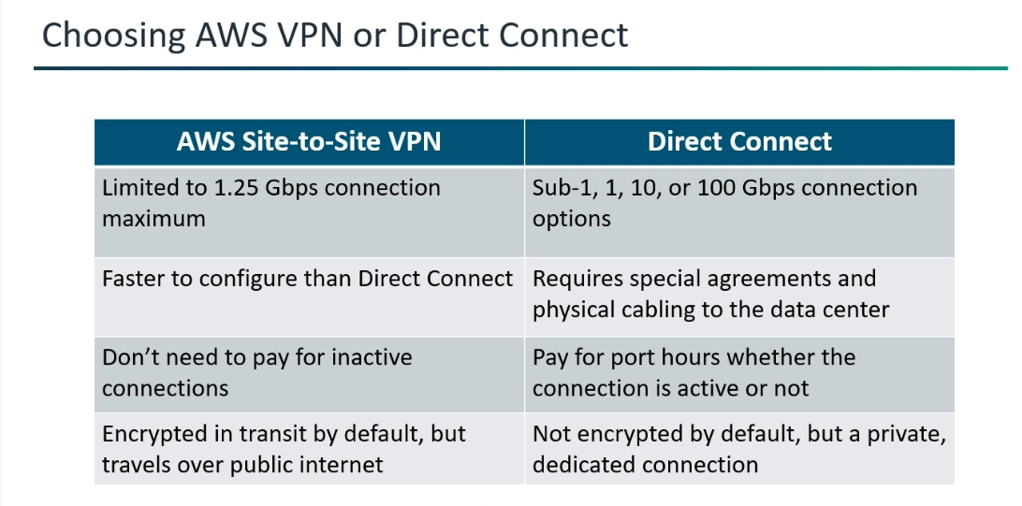

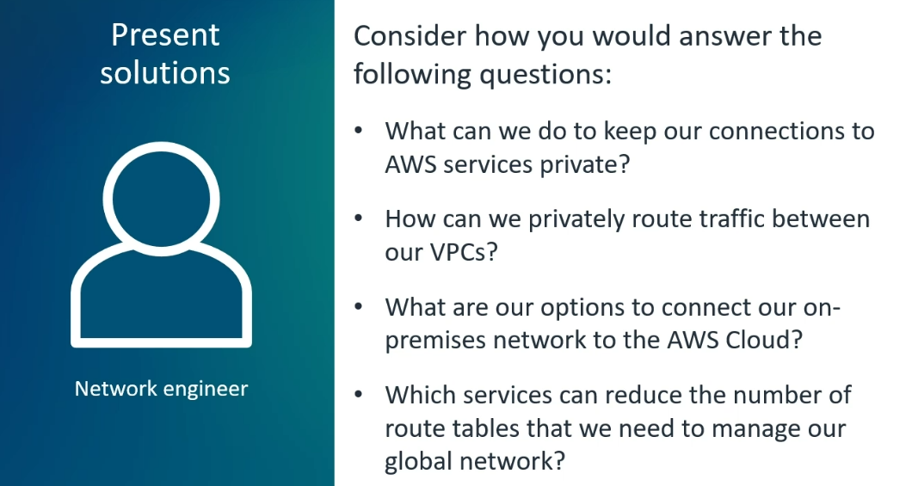

Summary:
VPC Peering --> VPC to VPC
Site-to-Site --> On-prem to VPC VPN
Transit Gateway--> Everything to Everything

AWS Transit Centers - AWS's Global Internet Peering Points:
* AWS Transit Centers are the physical locations and infrastructure (data centers, peering agreements, routing hardware, etc.) that AWS itself uses to connect its
vast global network to the public internet.
* Each Availability Zone in a Region connects to the internet through two transit centers , where AWS establishes direct connections with Tier-1 ISPs, ensuring low latency and high bandwidth for all AWS services globally.
* AWS's Global Internet Peering Points --> an Internet peering point is essentially the physical location where "peering" (the direct exchange of internet traffic between two or more networks) happens.
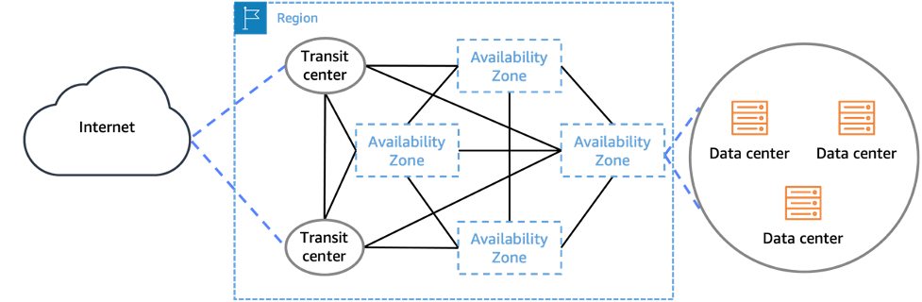
*Local ISP connects to the Transit Centre (or Transit Provider).
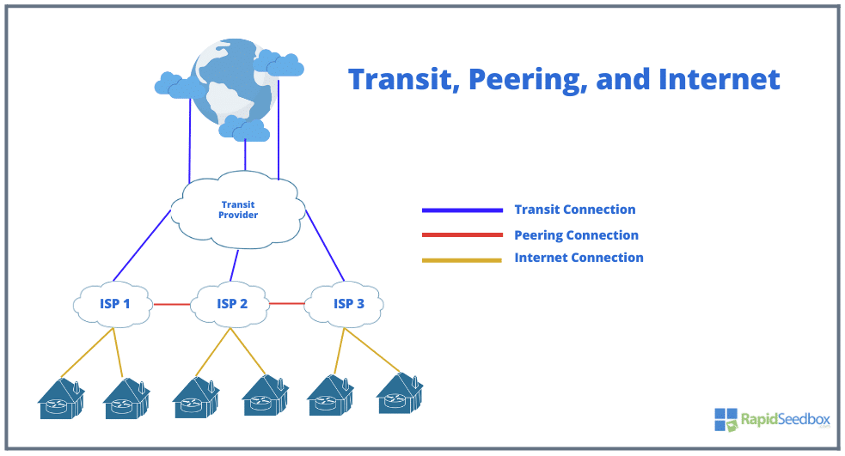

Local ISP (like Comcast, Airtel, or Orange) is just one of those 100,000 pieces.
The internet is built like a pyramid. Most "local" ISPs are at the bottom, and they have to pay their way to the top to reach the rest of the world.
Tier 3 (Local ISPs): These are the providers that connect to your home. They have a small "footprint" (maybe just your city or country).
Tier 2 (Regional ISPs): These are larger and cover entire countries or continents. They own more fiber but still can't reach everywhere.
Tier 1 (The Backbone): These are the "Kings of the Internet" (like AT&T, Lumen, or Tata). They own the massive undersea cables and satellites that connect continents.
The Transit Center (The Physical Place):
A Transit Center (often called an IXP—Internet Exchange Point—or a Carrier-Neutral Data Center) is the physical building where the connection actually happens.

The Transit Provider (The Service):
A Transit Provider is a Tier 1 or Tier 2 network company that sells you a "key" to the whole world.

In summary: The Local ISP goes to the Transit Center (the building) to buy a connection from a Transit Provider (the network).
Inside one building, an ISP can find hundreds of different Transit Providers and other ISPs.
Finding other ISPs in a "Transit Center" (IXP) and talking to them is a standard part of running a network. It’s like being in a large office building and wanting to know which other companies are on your floor so you can collaborate.

*Tier 1 ISPs acting as the central nervous system in the global internet ecosystem, that allows data to flow across continents and between millions of interconnected networks.
Tier 1 ISP --> Global internet ecosystem
Tier 2 ISP --> Regional or National level internet ecosystem

*Each Availability Zone (AZ) connects to the internet through two transit centers.
Two transit centers --> High availability and fault tolerance.

* Transit Center: How AWS connects to the internet (AWS's job).
Transit Gateway: How your different AWS networks connect to each other and your on-premises network (Your job, simplified by AWS).
*Data are spread across AZ not in the region ( Datum -Plural form).
For instance:
Instance 1:
* Your VPC is a house.
* The Internet Gateway(IGW) is the front door of your house.
* AWS's global network is the entire neighborhood, city, and national road system.
* The Transit Centers are the main exit/entry points from that national road system onto the global highways (the Internet).
When an EC2 instance in your VPC (with a public IP and proper routing configured) wants to reach the internet:
* Traffic leaves the EC2 instance.
* It hits the Internet Gateway (because your VPC's route table says "for internet traffic, send it to the IGW").
When traffic exits IGW, it immediately enters the AWS global network backbone. This backbone is Amazon's private, high-speed, and secure fiber network that connects all AWS Regions, Availability Zones, and Edge Locations worldwide. By bringing traffic onto its global network first, it can apply DDoS Protection protections before the traffic even reaches your specific VPC or resources.
* The AWS Global Network then routes this internet-bound traffic to one of the AWS transit centers (Internet Peering Points).
* From the Transit Center, the traffic is handed off to the public internet via AWS's peering connections.
(The return traffic will then come back via the same, or potentially the other, transit center depending on global routing and network conditions.)
* No "Routing" from IGW to Backbone (in the traditional sense): You don't configure explicit routes from the IGW to the backbone.
The IGW's function is to provide the on-ramp from your VPC to the public internet via the backbone. All public internet traffic for AWS services, by default, traverses this backbone.
*on-ramp --> allow you to connect.
*The connection between the AWS Internet Gateway (IGW) and the AWS Global Network is not a direct, single cable-like connection.
Instead, it's a logical and highly integrated connection within the AWS infrastructure.

*Again, there isn't a direct cable between the IGW and a specific Transit Center. The connection is logical and managed by AWS's software-defined networking, which dynamically routes traffic to the optimal Transit Center.

*Logically --> Formally true or valid.

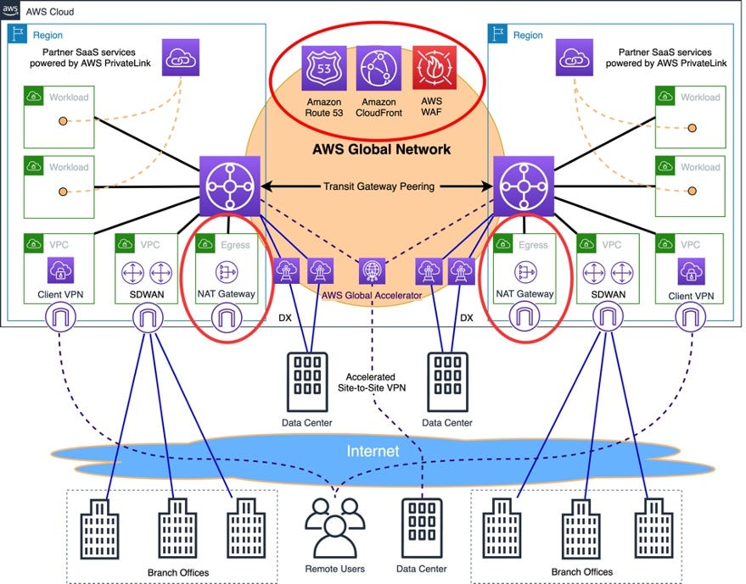

Why the traffic moves to AWS Global network not directly to AWS Transit Center? (Traffic moves from AWS Global Network to Transit Center)
AWS owns and operates its own global fiber optic network. When your traffic enters this AWS Global network, AWS has complete control over its routing. They can intelligently choose the fastest, least congested, and most reliable path to the appropriate transit center, even if that transit center isn't geographically the absolute closest one initially. This means consistent, low-latency performance for your applications.
AWS's highly optimized internal network is.
* It's Private and Global: AWS has built its own vast, private network that spans the entire globe, connecting all its data centers (Regions and Availability Zones).

