* Super-fast and Reliable: This "data highway" is built with the best-of-the-best technology (like 400 GbE fiber connections) to ensure data travels incredibly fast with minimal delays (low latency) and very few interruptions. It's like having dedicated express lanes for your data.
* Highly Redundant: They've built in tons of backup routes and systems. So, if one path or piece of equipment goes down, your data automatically reroutes through another, often without you even noticing. This ensures your applications and services stay available.
* Secure: Data traveling across this internal network is automatically encrypted at the physical layer, adding a significant layer of security beyond what you might add at the application level. (Usually "Encryption" will be done at the "Presentation layer")
* Optimized for AWS Services: This network is specifically designed to make all AWS services work seamlessly and efficiently together, regardless of where they are located.
* Enables Global Reach: AWS offers its services globally, letting businesses deploy applications closer to their users around the world for better performance and user experience.
In essence, AWS has invested heavily in building its own super-efficient, super-reliable, and super-secure private network to ensure that applications running on its cloud perform at their best, no matter where they are or how much data they need to move.

*If an internet request (IG hit),it is destined for the public internet, it will flow through one of the two transit centers that AWS uses for public internet egress from that specific AZ and region. AWS's network intelligently chooses the best path at that moment.

Public internet egress refers to the traffic leaving a private network or cloud environment and going out to the public internet.
Acts as the "exit ramp" for your data to reach external destinations like websites, public APIs, or users' devices.(egress -->exit ramp)

Public internet ingress refers to the process of data entering a private network or system from the public internet.
It's essentially the "front door" through which external traffic gains access. (ingress--> entry ramp)
Instance 2:
Let's break down how a request moves, Scenario: You (in India) want to access a website hosted in the USA.
* Your Computer (Origin): You type a website address. Your computer generates IP packets containing the request.
* Your Local ISP (Entry Point): Your packets leave your computer and go to your Internet Service Provider (ISP) in India. Your ISP has connections to larger networks.
(ISP (Internet Service Provider) in India will definitely be present in various "transit centers" )
* Transit Center 1 (India - Tier 2/1 Provider): Your ISP likely doesn't have a direct connection to the USA. They connect and pay to a large Tier 2 or Tier 1 transit provider in India for IP transit. Your packets arrive at this provider's network (their "transit center" or point of presence).
* Action of Transit Center 1 (From India to USA):
* Receives your packets from your Local ISP.
* It looks at the destination IP address (the website in the USA).
* It consults its routing table and determines the best path to reach the USA. This path might be a direct connection to another large transit provider in the USA, or it might be to an undersea cable landing station that connects to another major transit provider.
(Transit -->Transit refers to the movement of people or goods from one place to another. 🚚🚶)
* Forwards your packets out towards the next hop on that path.
* Undersea Cable/Long-Haul Fiber (Physical Link): The packets then travel across the physical infrastructure (like an undersea fiber optic cable) connecting India to the USA. This is the "transport layer", not a transit center itself, but it's what physically carries the data between distant transit centers.
* Transit Center 2 (USA - Another Tier 2/1 Provider): The packets arrive at a transit provider's network in the USA (their "transit center"). This might be a transit provider that Transit Center 1 in India directly connects to, or it might be one that Transit Center 1 reaches via another intermediary.
* Action of Transit Center 2 (From USA to India):
* Receives your packets from the connection coming from India.
* It looks at the destination IP address (the website in the USA).
* It consults its routing table and determines the best path to reach the specific network where the website is hosted. (Inside USA)
Forwards your packets out towards the website's hosting provider (Destination Network): and the packets finally reach the network of the web hosting provider in the USA.
Output:
* Web Server (Final Destination): The web server receives the request, processes it, and generates a response (the webpage content).
Response Travels Back (Reverse Path): The response packets then travel back to your computer. They will likely traverse Transit Center 2 (USA), then Transit Center 1 (India), and finally to your ISP, and then to your computer. Each transit center in the reverse path performs the same "receive and forward" function.

IP packet (Digital Letter) --> Header + Data (Payload):
IP packet is like a digital letter that carries information across the internet.
It has two main parts:
* Header (the "envelope"): This part contains all the crucial information needed to deliver the packet. Think of it as the address on an envelope. Key things found in the header include:
* Source IP address: Where the packet came from.
* Destination IP address: Where the packet is going.
* Packet length: How big the entire packet is.
* Protocol: Indicates what kind of data is inside (e.g., web page data, email, video stream).
* Time to Live (TTL): How long a piece of information should "live" before it is thrown away or updated. This prevents packets from endlessly looping if there's a problem.
Time to Live," we are usually referring to one of two distinct technologies. They share the same name because they both act as an "expiration date," but they function differently.
1. Networking TTL (The "Hop" Count)
In networking, TTL is a value in the header of an Internet Protocol (IP) packet. It acts as a safety mechanism to prevent data from getting stuck in an infinite loop if there is a routing error.

How it works: Every time a packet passes through a router (a "hop"), the router subtracts 1 from the TTL value.
The Limit: If the TTL reaches 0, the router discards the packet and usually sends a "Time Exceeded" message back to the sender.
Analogy: The driver is told, "If you don't find the house after 10 turns, stop looking and go home." (This prevents them from driving in circles forever).

2.Caching TTL (The "Freshness" Timer)
In the world of DNS and Web Browsers, TTL is a timer that determines how long to keep a local copy of data.

How it works: It is measured in seconds. When your computer asks for a website's address (IP), the server says, "Here is the address, and the TTL is 3600."
The Limit: Your computer will "remember" that address for exactly 3,600 seconds (1 hour). During that hour, it won't ask the server again.
Analogy: It’s like a "best before" date on a carton of milk. You don't need to buy a new one every time you want cereal; you just use the one in your fridge until the date expires.

Context Measured In What it prevents
Networking Hops (Steps) Packets getting lost in infinite loops.
DNS / Caching Seconds Your computer asking for the same info too often

* Data/Payload (the "letter content"): This is the actual information being sent. It could be a small piece of a webpage, part of an email, a section of a video, or any other digital data. Large files are broken down into many smaller packets, and each packet carries a portion of the original data.
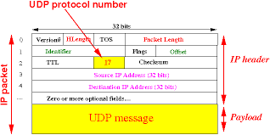

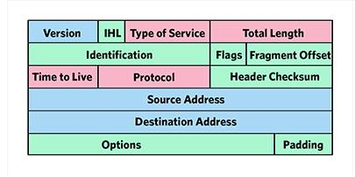

Subnets:
*Subnets are the "Subset of the VPC CIDR block".
*Each subnet must be associated with a route table.
*(Traffic arises from the subnet)..
What is subnet traffic?
A subnet, or subnetwork, is a network inside a network. Subnets make networks more efficient.
Through subnetting, network traffic can travel a shorter distance without passing through unnecessary routers to reach its destination.
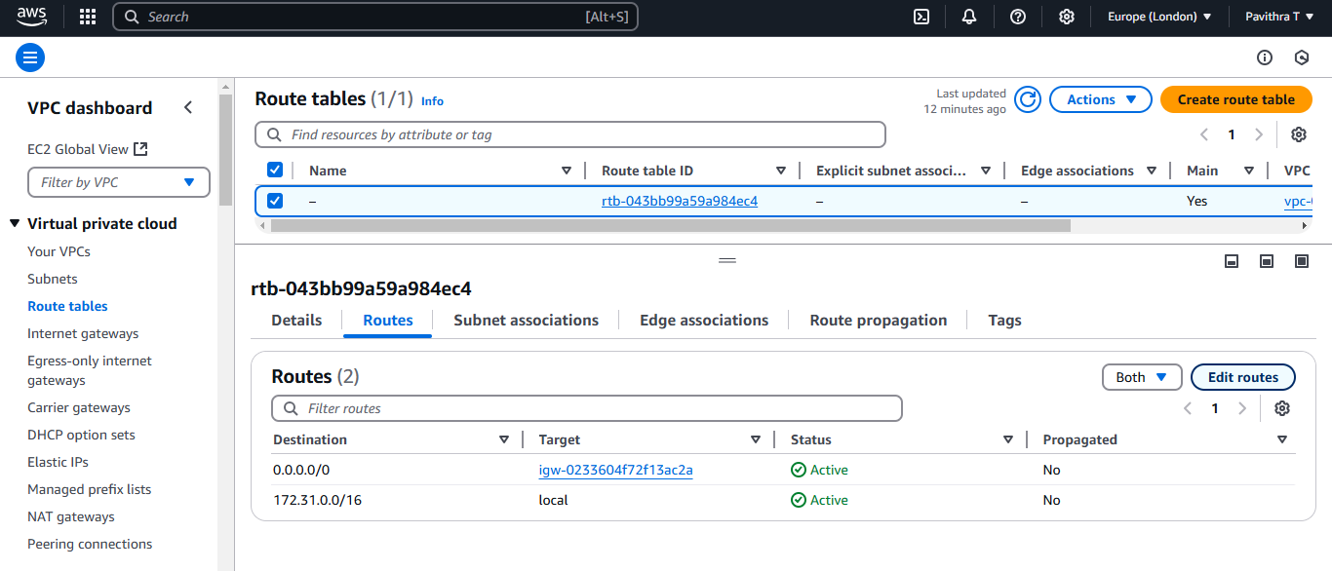

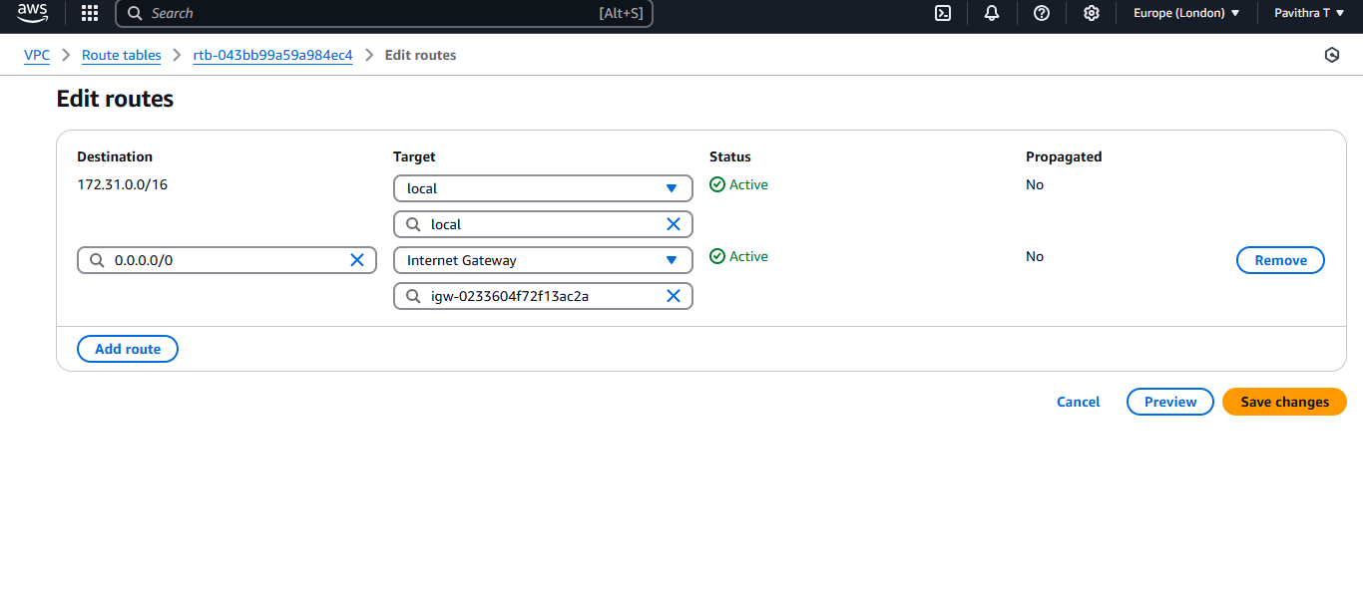

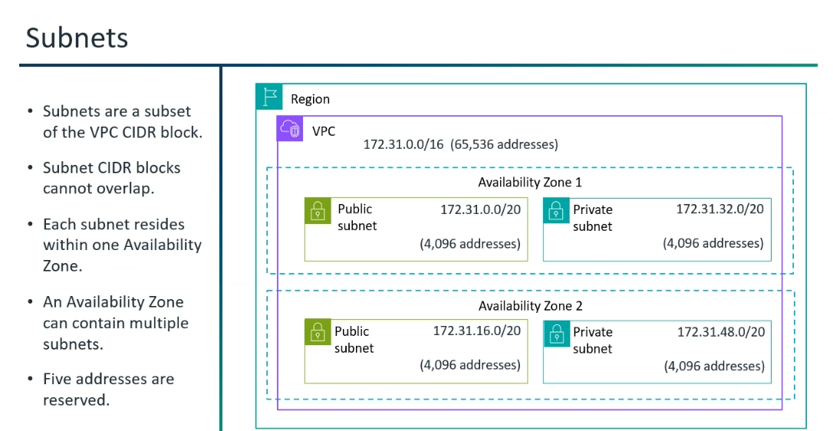
*Subnet-->Subnet's CIDR range should not overlap with any other subnets. (It should have non-overlapping range)
*Subnets are to a particular AZ. (Every subnet is bounded by AZ.)
*What is the use of subnet?
One goal of a subnet is to split a large network into a grouping of smaller, interconnected networks to help minimize traffic. This way, traffic doesn't have to flow through unnecessary routes, increasing network speeds.
*In every subnet mask there will be 5 reserved IP addresses by AWS.(If 65,536 IP address , 65,536-5 = 65,531).
Here, potentially useful IP address is 65,531.

*The allowed IPv4 CIDR block size for a subnet is between a /28 netmask and /16 netmask.
*The first four IP addresses and the last IP address in each subnet CIDR block are not available for your use, and they cannot be assigned to a resource, such as an EC2 instance.
Ex: In a subnet with CIDR block 10.0.0.0/24,

10.0.0.0: Network address.

10.0.0.1: Reserved by AWS for the VPC router.

10.0.0.2: Reserved by AWS for DNS Server.
10.0.0.3: Reserved by AWS for future use.

10.0.0.255: Network broadcast address. We do not support broadcast in a VPC, therefore we reserve this address.
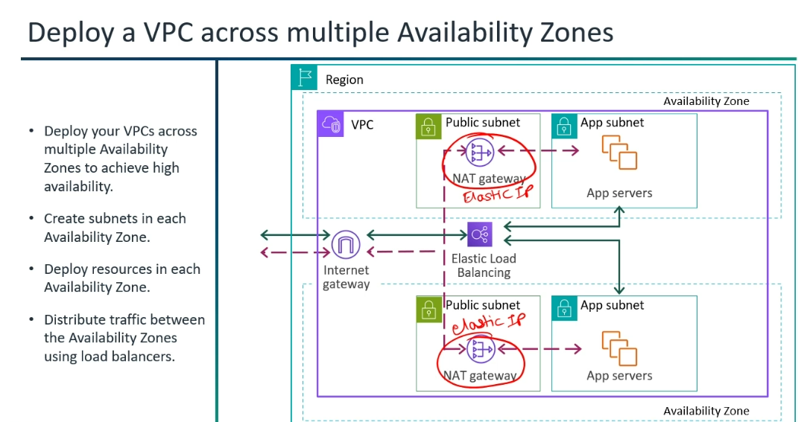

Public Subnet:
A public subnet is a subdivision of a larger network (like a Virtual Private Cloud or VPC) that allows direct communication with the public internet.
This means resources launched within a public subnet can send and receive traffic directly to and from the internet.
How Traffic Flows:
Outbound Traffic from a Public Subnet (e.g., a web server downloading updates)
* Scenario: An EC2 instance in a public subnet needs to download software updates from the internet.
* Flow:
* EC2 Instance Request: The instance initiates an outbound connection (e.g., HTTP/HTTPS).
* Security Group (Outbound): The Security Group attached to the EC2 instance evaluates the outbound traffic. If allowed (e.g., all outbound traffic allowed, or specific ports 80/443), it passes through.
* NACL (Outbound): The Network ACL associated with the public subnet evaluates the outbound traffic. If allowed, it passes through.
* Public Subnet Route Table: The route table associated with the public subnet has a default route (0.0.0.0/0) pointing to the Internet Gateway. The traffic is directed to the IGW.
* Internet Gateway (IGW): The IGW sends the traffic out to the internet.
* Internet: The request reaches the destination on the internet.
* Response (Inbound): The internet service sends a response back.
* Internet Gateway (IGW): The IGW receives the response.
* NACL (Inbound): The NACL for the public subnet evaluates the inbound response. If allowed, it passes through.
* Security Group (Inbound): The Security Group of the EC2 instance evaluates the inbound response. As Security Groups are stateful, if the outbound request was allowed, the return traffic for that request is automatically allowed.
* EC2 Instance: The instance receives the response.
Inbound Traffic to a Public Subnet (e.g., a web server)
* Scenario: A user on the internet wants to access a website hosted on an EC2 instance in a public subnet.
Vice Versa will be performed.
*If the subnet is pubic, It should have public IP.
Dynamic IP - Dynamic IP is provided by Dynamic Host Control Protocol.
Static IP - Static IP is provided by Elastic IP.
*Public Subnet:
1)All the workloads should be in public IP.
2)Need to have Internet Gateway.
3)Create Route Table (Update the entries, traffic initiated by the subnet)
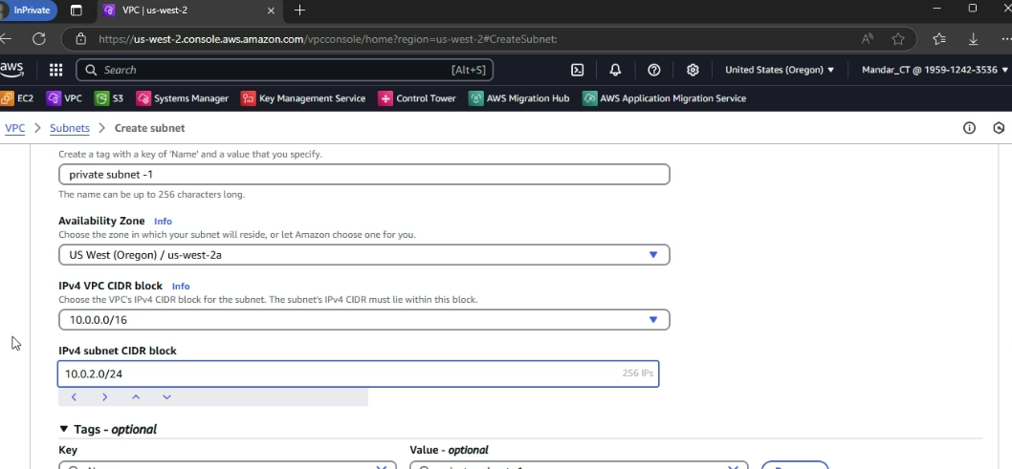

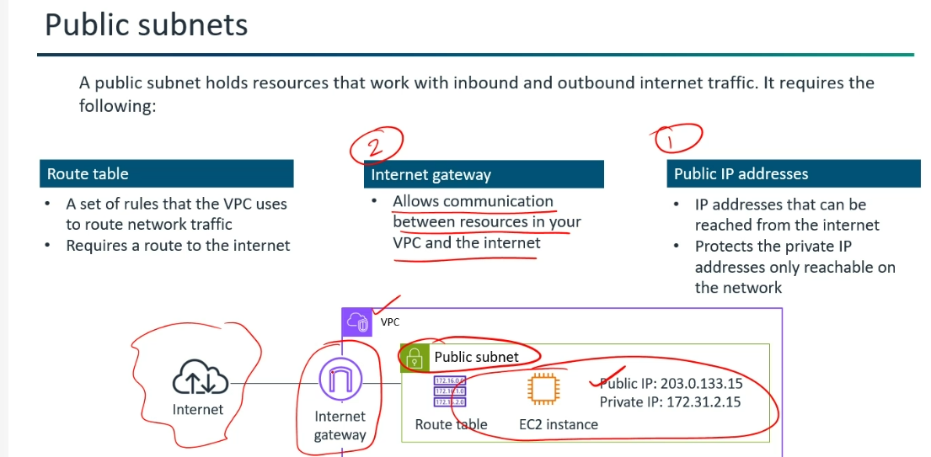

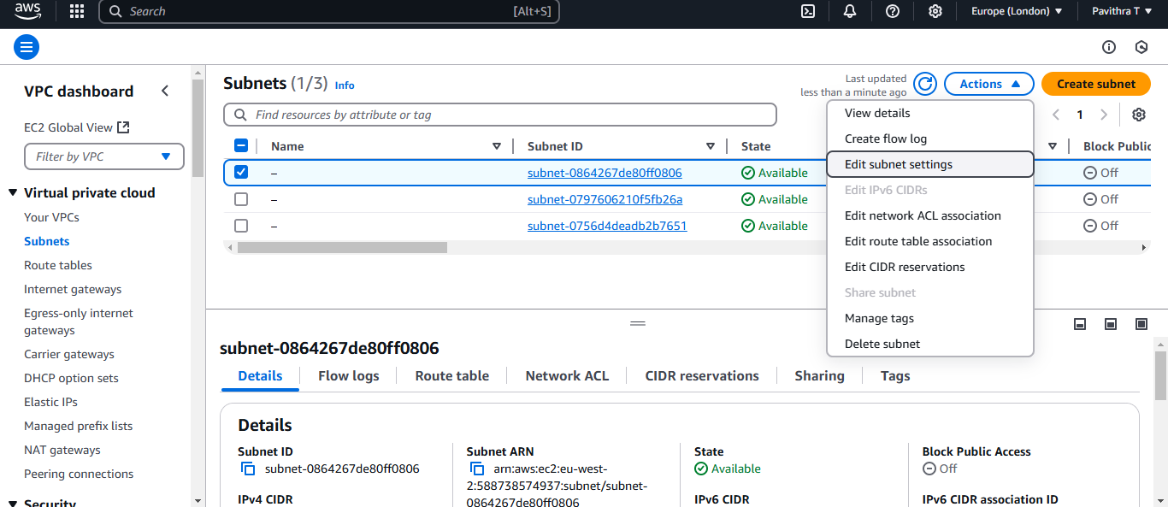

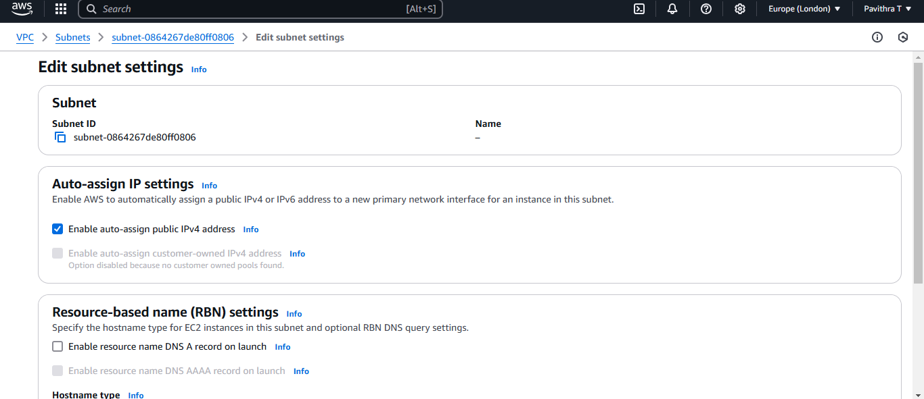
Public Subnet Components:
*Route Table
*Internet Gateway (IGW)
*Public IP Addresses
*NACL and Security Groups
Route Table (Acts as the "Map"):
(Route Table will not perform routing.)
* The route tables acts as the "map", it has a set of rules/ instructions that tells the engine how to route traffic to reach its specific destinations.
You provide the rules (in route tables), and the VPC implicit router performs the routing.
*Each entry in a route table specifies a destination CIDR block and the target (e.g., an Internet Gateway, NAT Gateway, VPC Peering Connection, another network interface, etc.) to which traffic for that CIDR should be sent.
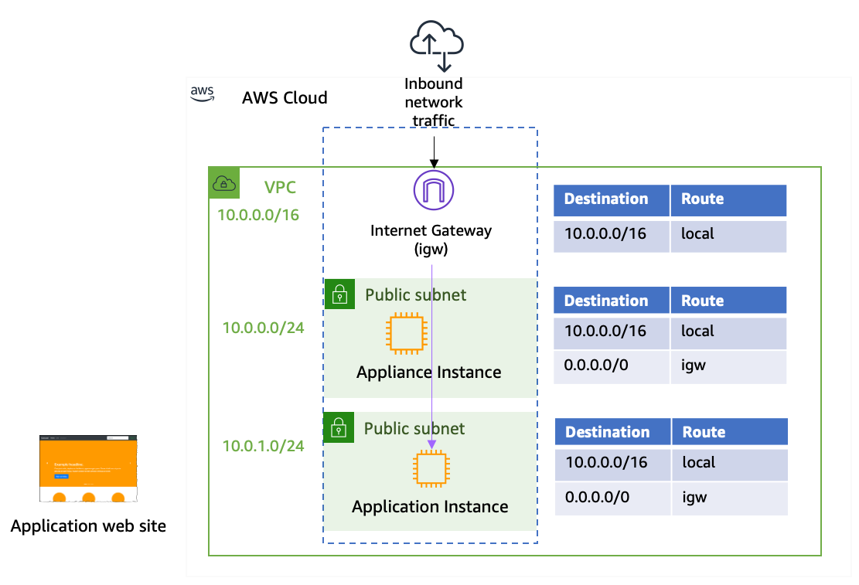

* VPC Implicit Router: The VPC implicit router is the "traffic director" or "engine" that actually performs the routing based on the instructions provided in the route table.
*When a packet arrives at the implicit router (e.g., from an EC2 instance), the router consults the associated route table, finds the most specific matching rule for the packet's destination IP, and then forwards the packet to the specified target.

So, in essence:
Route Table = "What to do" (the rules/map)
VPC Implicit Router = "How to do it" (the mechanism that executes the rules)
They are inseparable for traffic to flow correctly within and out of your VPC.
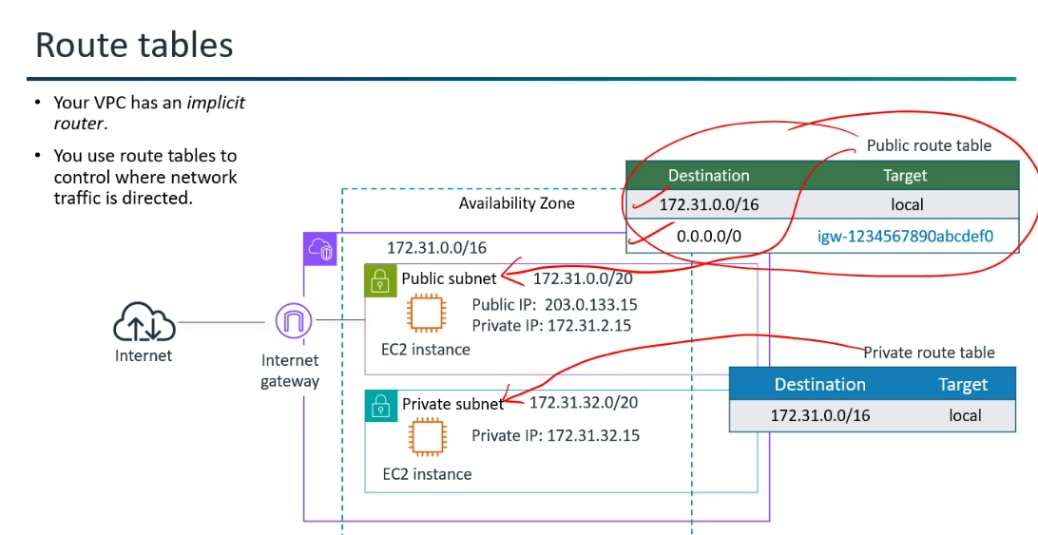

Internet Gateway (IGW):
*Internet Gateway allows traffic to flow in and out of your VPC to and from the internet.
An IGW supports both inbound and outbound communication (Bidirectional Traffic).
*Internet Gateway (IGW) is fully AWS managed service that is inherently highly available and horizontally scalable by design.
*No Single Point of Failure: An IGW is not tied to a single Availability Zone (AZ). AWS automatically distributes and manages the IGW's components across multiple AZs within a region. If an AZ or component experiences an issue, traffic will be automatically routed through healthy components in other AZs.

*When do you use it?
Whenever you need any resource in your VPC to have direct, public internet access (e.g., a web server, a bastion host, a public load balancer).
*Why do we need both public and private IP addresses?
A public IP address is unique and visible to everyone. It ensures that you can be clearly identified on the internet. By contrast, a private IP address is only used within a private network. This allows the devices within a network to connect securely to one another.

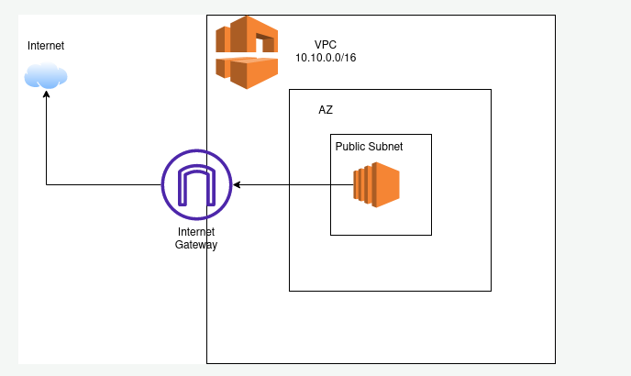

*Internet gateway--> Providing you a path to transmit traffic between networks.
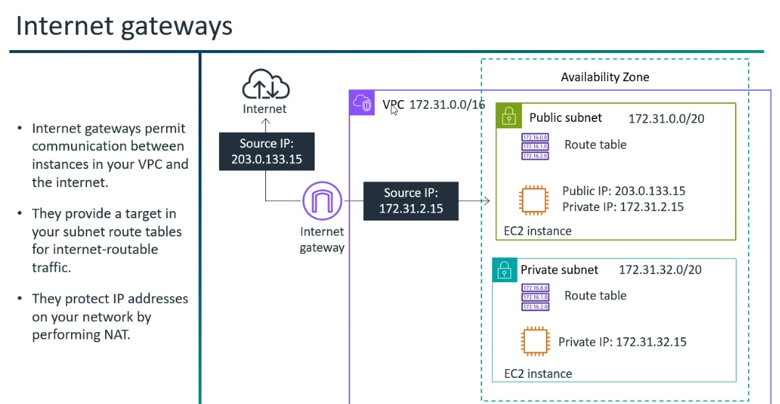
Public IP Addresses:
Instances or resources launched within a public subnet are typically assigned public IP addresses.
These can be:
* Public IPv4 addresses: These are globally unique IP addresses that allow direct communication over the internet.
* Elastic IP addresses (EIPs) (AWS specific): These are static public IPv4 addresses that you can associate with your instances or network interfaces.
They remain the same even if the underlying instance is stopped and started.
* Public IPv6 addresses: For IPv6-enabled environments, instances in a public subnet can also have public IPv6 addresses.
NACL (Main Gate) and Security Groups (The Office Door):
* Network Access Control Lists (NACLs) are stateless firewalls that operate at the subnet level, providing an additional layer of security by allowing or denying traffic to and from the entire subnet. They are processed in order, and you need to explicitly allow both inbound and outbound traffic. 🔒

*Security Groups act as stateful firewalls for individual instances, controlling inbound and outbound traffic based on rules you define (e.g., allowing HTTP traffic on port 80)🛡️ rules that specify allowed protocols, port ranges, and source/destination IP addresses.
Stateless Firewalls (Packet Filtering Firewall or Access Control List - ACL) --> Network Access Control Lists (NACLs)
A stateless firewall does not contain Memory (It doesn't remember past connections or the context of a conversation).
Stateless Firewalls treats each network packet as an independent entity and inspects individual packet headers (e.g., source IP, destination IP, source port, destination port, protocol).

Stateful Firewall (Stateful Packet Inspection - SPI firewall) --> Security Group
A stateful firewall has a memory, called a state table (or connection table). This table stores information of every active "conversation" or connection (active connections, including source and destination IP addresses, port numbers, and the current stage of the connection) happening through the firewall.
*Two security groups needs to communicate then need to define the outbound rules.
*Virtual Firewall Advantage:
1)One security group attached to multiple instances.
2)One NACL attached to multiple subnets.
NACL and Security Groups:
*Two Firewalls:
NACL- Firewall at the subnet level.
SG- Firewall at the Instance level.
*NACL- 1)Optional in Nature.
2)Filters out the traffic at the subnet level.
3)Stateless in Nature.(NACLs are stateless, which means that information about previously sent or received traffic is not saved.)
*If Australia is trying to access the server in X region --->Deny Rule -->NACL-->X (Will deny)
*Security Group- 1)Compulsory Firewall.
2)Stateful in Nature.
By default,
Block-All Inbound Traffic
Allow-All Outbound Traffic
Here, Write/Define only Inbound rules …( No need to modify outbound rules)
Inbound --> The traffic --> They come to you.
Outbound --> The traffic --> You go to them,
*Route table is not a firewall X .
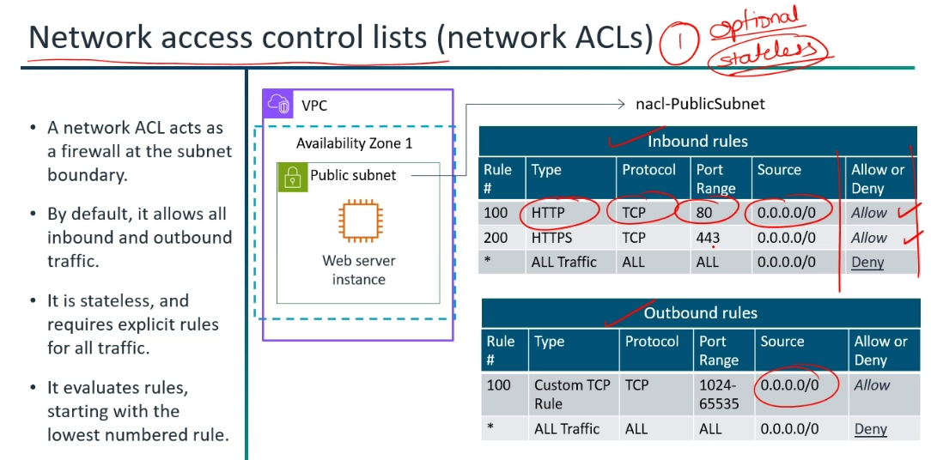

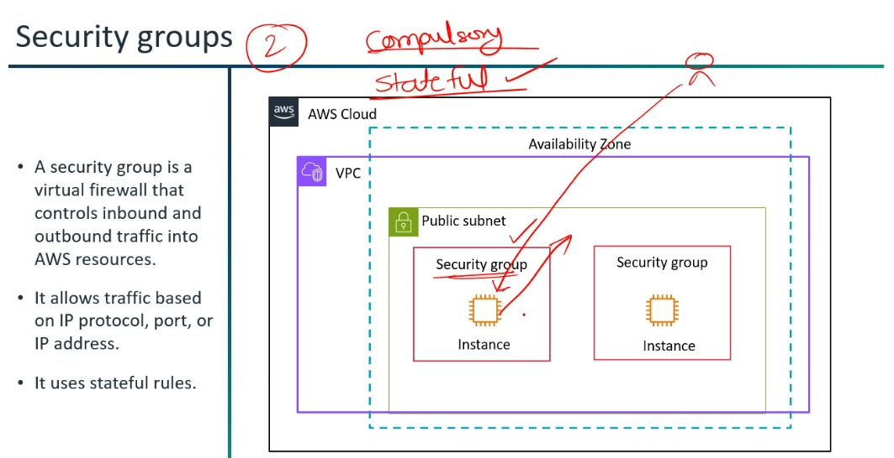

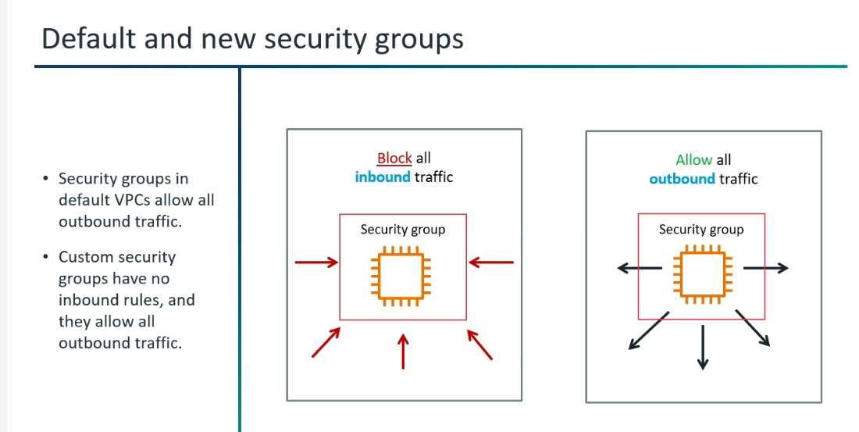

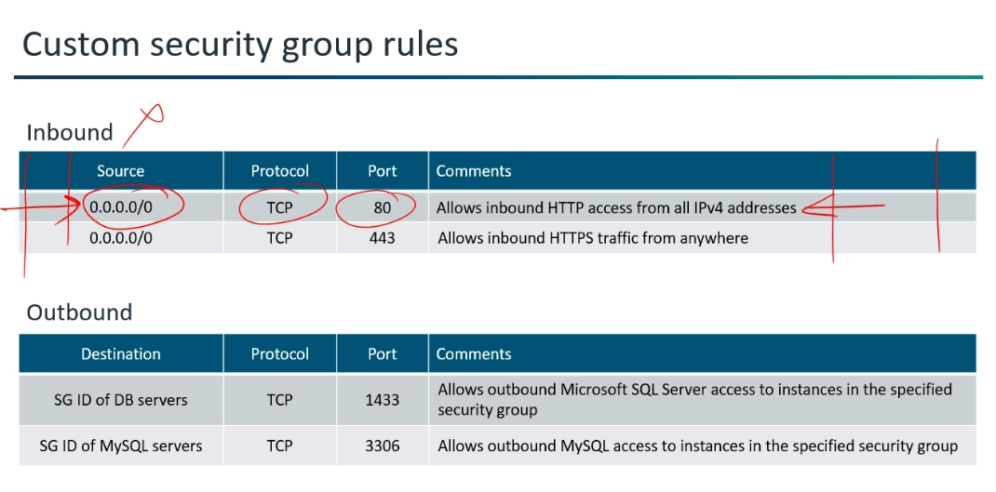

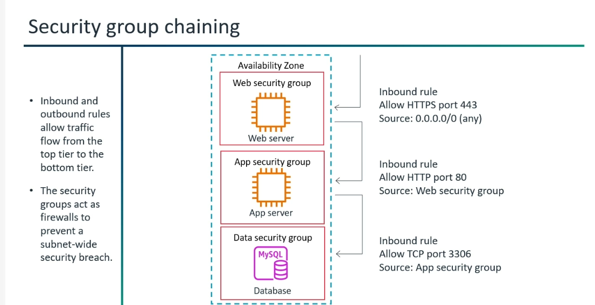

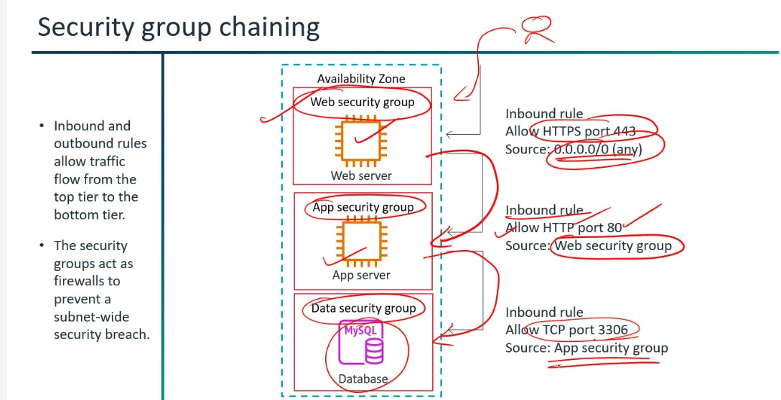

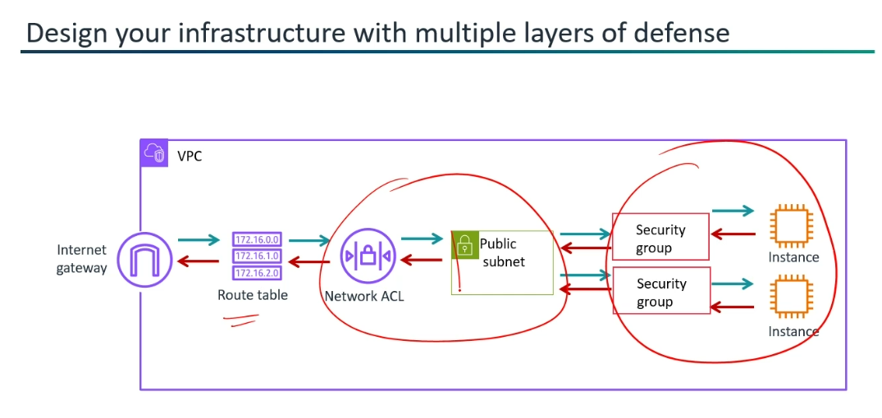

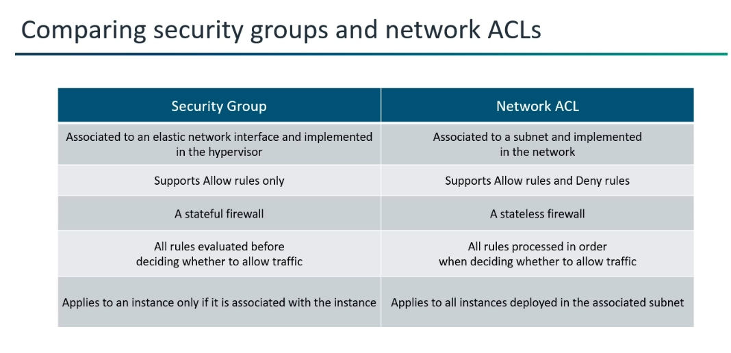
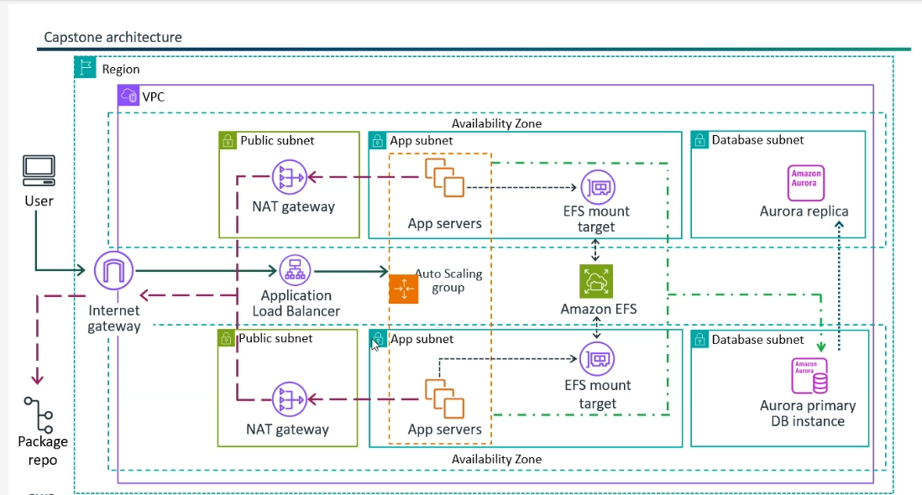

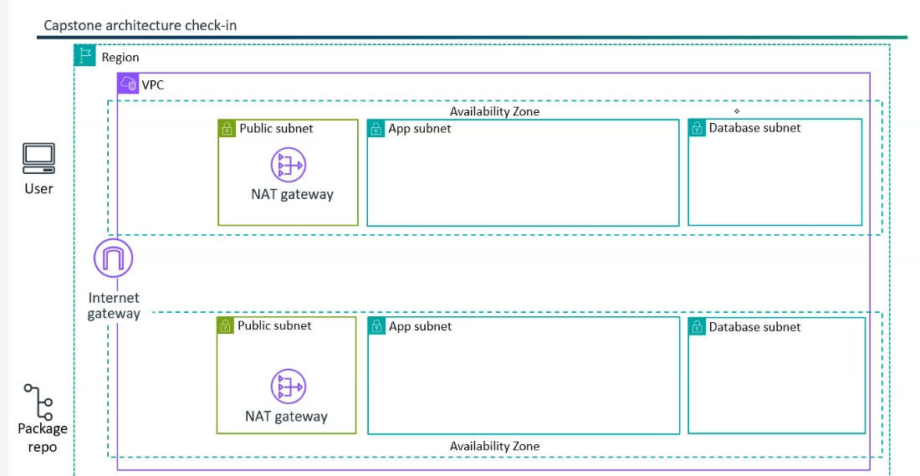

Private Subnet:
A private subnet is a subdivision of a larger network (like a Virtual Private Cloud or VPC) that does not allow direct communication with the public internet. This means resources launched within a private subnet cannot send and receive traffic directly to the internet.
*A private subnet is associated with a route table that doesn’t have a route to an internet gateway. Resources in private subnets cannot communicate with the public internet. Resources in a private subnet can use the NAT Gateway to communicate to the Internet. A NAT Gateway is deployed in a public subnet.
NAT gateway translates private IP address to public IP address.
*"Internet resource" blocked to private subnet. (Blocked by IG).
How it works:
Outbound Traffic from a Private Subnet (e.g., a database server updating itself)
* Scenario: A database instance in a private subnet needs to download security patches or connect to an external API.
* Flow:
* Private Instance Request: The instance in the private subnet initiates an outbound connection.
* Security Group (Outbound): The Security Group attached to the private instance evaluates the outbound traffic. If allowed, it passes through.
* NACL (Outbound): The Network ACL associated with the private subnet evaluates the outbound traffic. If allowed, it passes through.
* Private Subnet Route Table: The route table associated with the private subnet has a default route (0.0.0.0/0) pointing to the NAT Gateway. The traffic is directed to the NAT Gateway.
* NAT Gateway (in Public Subnet): The NAT Gateway receives the traffic. It then performs Network Address Translation (NAT), changing the source IP address from the private IP of the instance to the NAT Gateway's public IP address (Elastic IP).
* NAT Gateway Route Table (Public Subnet): The NAT Gateway itself is in a public subnet, and its associated route table directs internet-bound traffic to the Internet Gateway.
* Internet Gateway (IGW): The IGW sends the traffic (with the NAT Gateway's public IP as the source) out to the internet.
* Internet: The request reaches the destination on the internet.
* Response (Inbound): The internet service sends a response back to the NAT Gateway's public IP.
* Internet Gateway (IGW): The IGW receives the response and forwards it to the NAT Gateway.
* NAT Gateway: The NAT Gateway receives the response. It then performs NAT in reverse, translating the destination IP address back from its public IP to the original private IP of the instance that initiated the connection.
* NACL (Inbound): The Network ACL associated with the private subnet evaluates the inbound traffic. If allowed, it passes through.
* Security Group (Inbound): The Security Group of the private instance evaluates the inbound response. As Security Groups are stateful, the return traffic for the initiated request is automatically allowed.
* Private Instance: The instance receives the response.

Inbound Traffic to a Private Subnet (Blocked by Design):
* Scenario: An external user on the internet tries to initiate a direct connection to a private IP address of an instance in a private subnet.
* Flow: This traffic is prevented by design. Since the private subnet's route table does not have a direct route to an Internet Gateway, and private IP addresses are not routable on the public internet, there's no path for unsolicited inbound traffic from the internet to reach instances in a private subnet directly.
The NAT Gateway is for outbound-initiated connections only.
*No, a NAT Gateway is not directly attached to an Internet Gateway (IGW) ; Yes, a Virtual Private Cloud (VPC) must be explicitly attached to an Internet Gateway (IGW) to enable direct internet connectivity for resources within that VPC.
*NAT Gateway "translates" a public IP, it's not that it automatically adds to the route table, but rather that it uses the route table entry to receive the traffic for translation and forward it to the internet; The NAT Gateway itself resides in a public subnet. The route table associated with this public subnet is already configured to send internet-bound traffic (0.0.0.0/0) to the Internet Gateway (IGW). This configuration is also static.

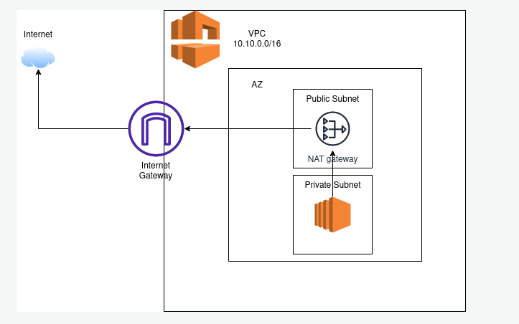
Communication of Public Subnet and Private Subnet within same VPC:
Within the same VPC, public and private subnets communicate seamlessly through the VPC's internal routing mechanism, with security groups and NACLs acting as crucial guardians of network traffic.

Imagine an EC2 instance in a public subnet (e.g., a web server) needing to connect to an EC2 instance in a private subnet (e.g., a database server):
* The web server initiates a connection to the database server's private IP address.
* The web server's operating system checks its routing table. Since the database server's IP address falls within the VPC's CIDR block, the traffic is sent to the implicit VPC router.
* The implicit VPC router receives the traffic and, based on its internal routing logic, forwards it to the correct private subnet where the database server resides.
* Before reaching the database server, the traffic is evaluated against the inbound rules of the database server's security group and the NACL associated with the private subnet.
* If the security group and NACL rules permit the traffic, it reaches the database server.
* The database server processes the request and sends a response back to the web server, following a similar path in reverse. The traffic is routed by the implicit VPC router, checked against the security group and NACL rules, and then delivered to the web server.

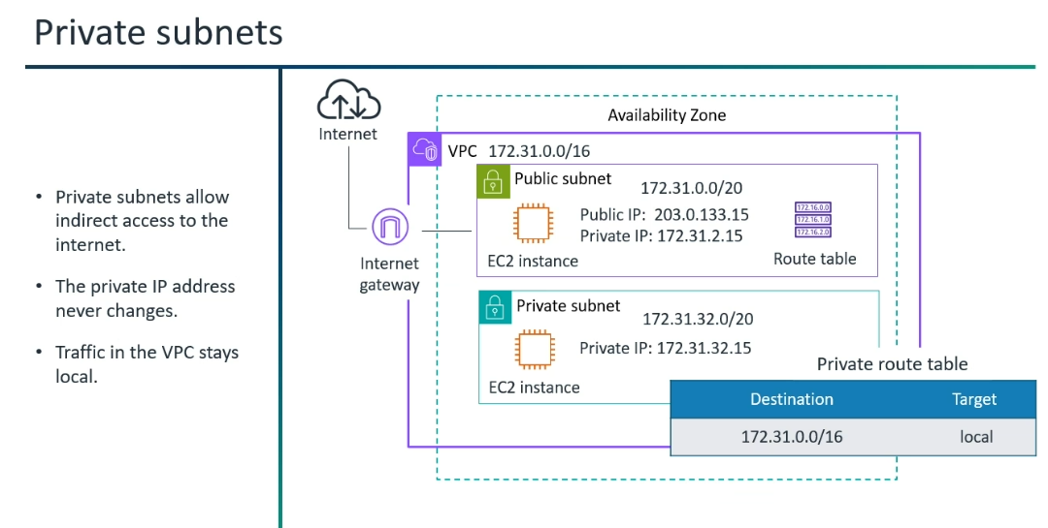
Private Subnet Components:
*Route Table
*NACL and Security Groups
Commonly associated, but not strictly essential for existence.
*NAT Gateway
*VPC Endpoints
*Bastion Host
NAT Gateway:
*A NAT gateway helps to connect resources in a private subnet to the internet.
*NAT(Network Address Translation (NAT) service) -->Part of your Public Subnet.✓
NAT gateway --> Unidirectional Path.
NAT Gateway-->Fully managed Service.
NAT-->Helps to connect Private subnet resources to the internet.
*Update the private route table for NAT Gateway.
