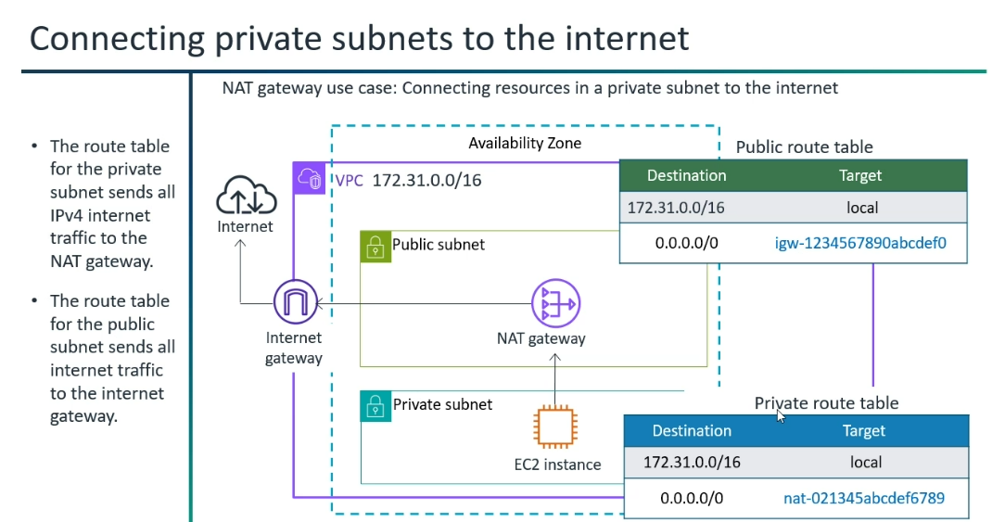
*VPC Endpoints:
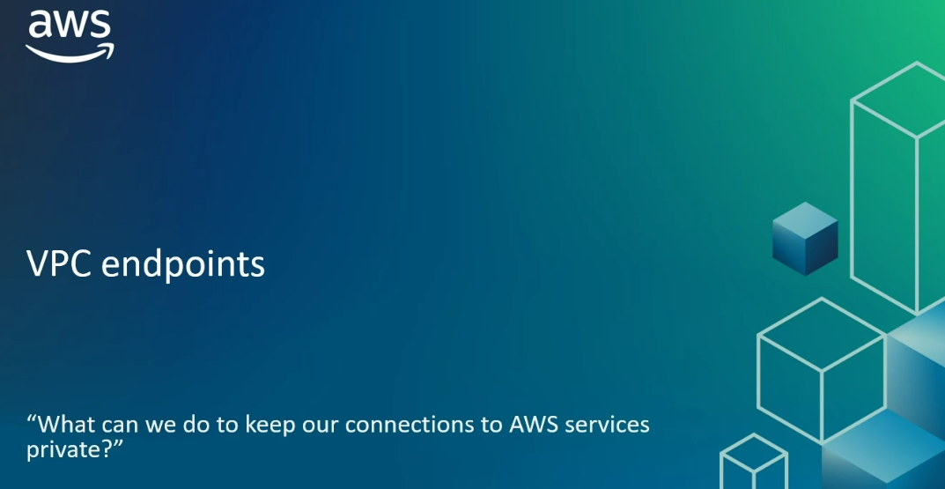
What can we do to keep our connections to AWS services private..?
VPC endpoints
VPC Endpoints:
"VPC Endpoint" connecting directly to the AWS service within the Amazon network.
VPC Endpoint is a private "shortcut".
VPN Endpoints (Site-to-Site VPN): Use when you need to securely connect your on-premises network to your AWS VPC over the public internet. (Not includes the private network)

VPC Peering: Use when you need full, direct Layer 3 network connectivity between a limited number of non-overlapping VPCs within AWS, and you want simplicity and cost-effectiveness for that direct communication.
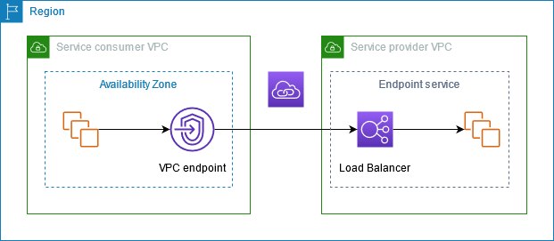

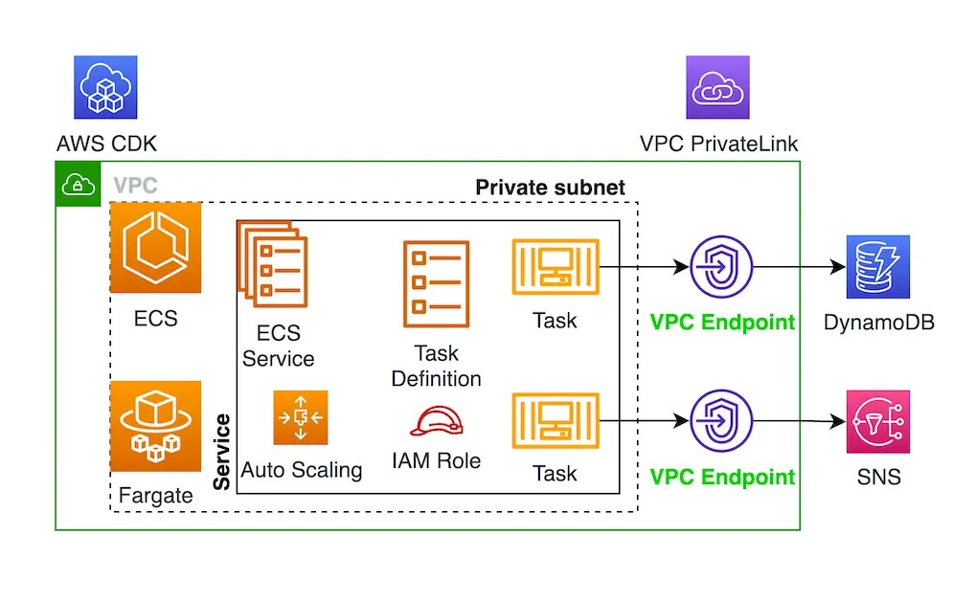
Interface Endpoints and Gateway Endpoints:
Two main types of VPC Endpoints:
* Interface Endpoints --> Most AWS services use Interface Endpoints; Powered by AWS Private Link.
* Gateway Endpoints --> Amazon S3 and DynamoDB (Gateway Endpoints, and also Interface Endpoints for S3 now)
*While Gateway Endpoints are free, Interface Endpoints have hourly charges and data processing costs.
*Regional Specificity: Gateway Endpoints are regional and only work for S3 and DynamoDB in the same region. If your application needs to access S3 in a different region, you would still need an IGW/NAT GW for that cross-region S3 access, or use an Interface Endpoint for S3 (which supports cross-region access if your network topology allows it, e.g., via Transit Gateway).
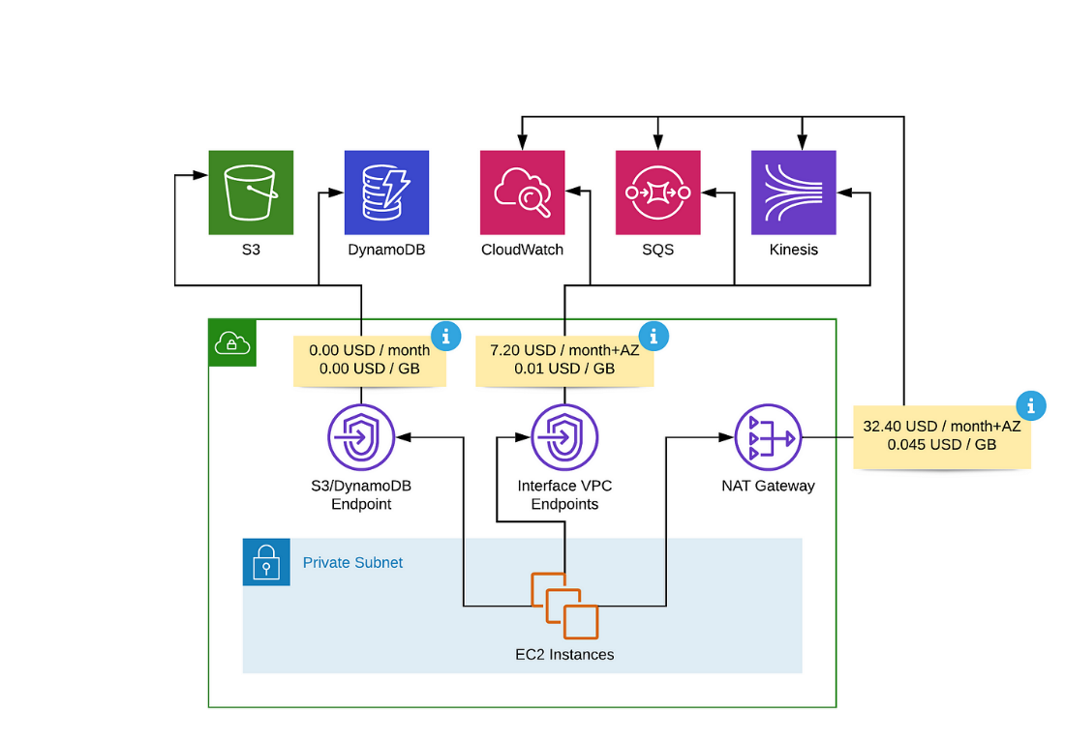

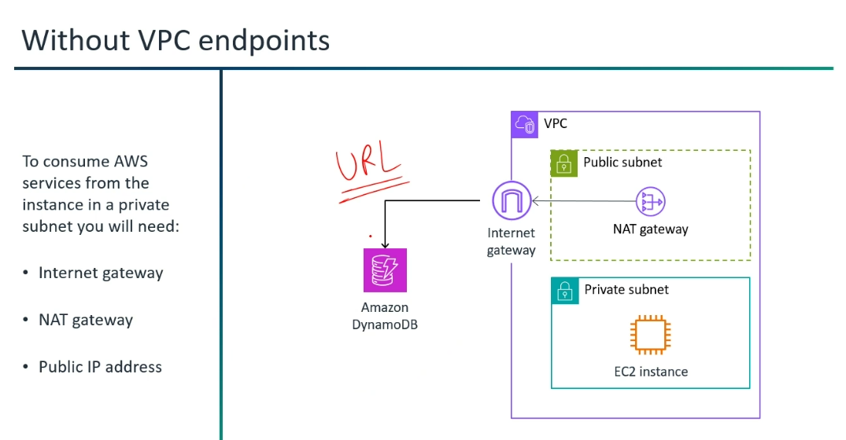

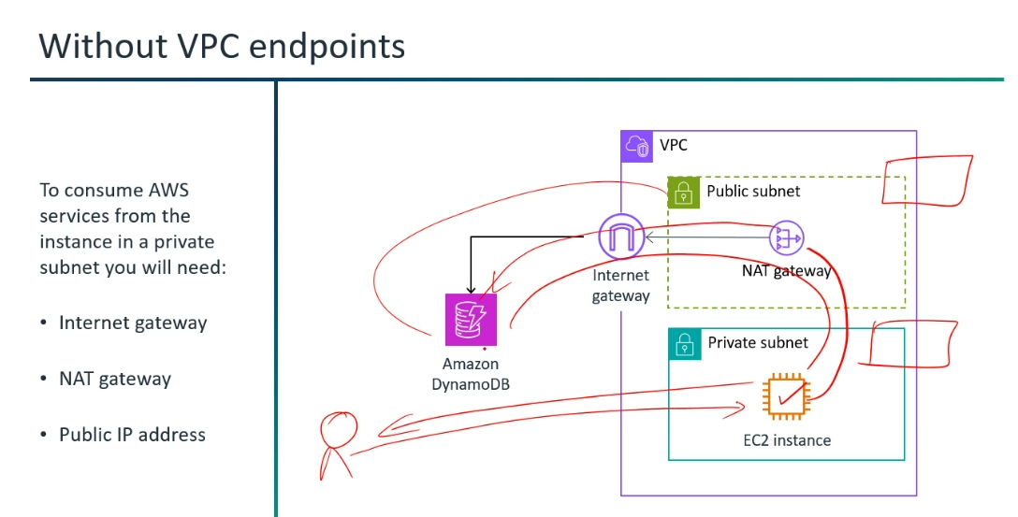

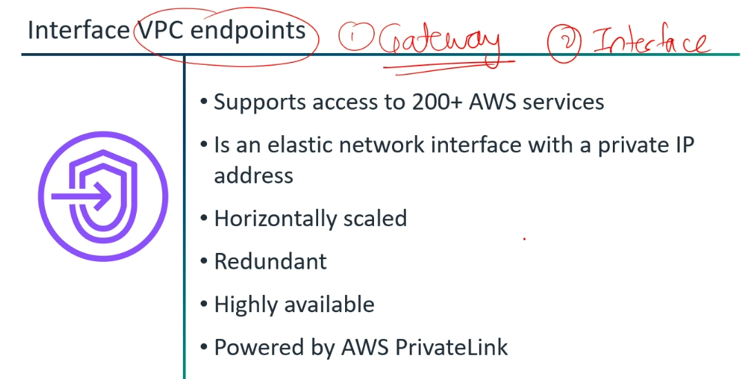

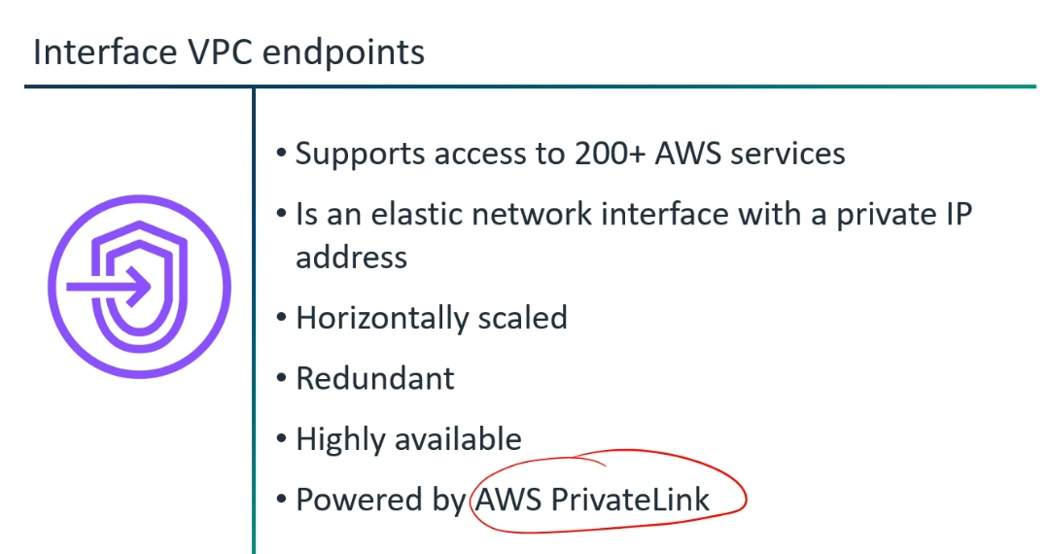

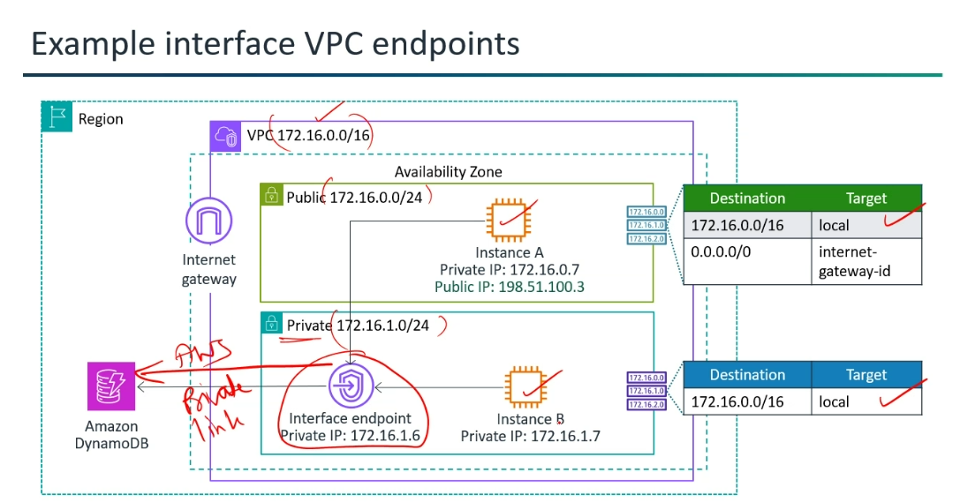
*Bastion Host/Jump Server/Jump Box:
A bastion host a specialized server that acts as a secure gateway to an organization's internal or private network from an external, less trusted network (like the public internet).

How it Works:
* Placement: A bastion host is typically placed in a Demilitarized Zone (DMZ), which is a small, isolated network between the public internet and your private network.
* Connection Flow:
* External User to Bastion Host: An administrator or authorized user connects to the bastion host from their external machine (e.g., their laptop at home) using secure protocols like SSH (for Linux servers) or RDP (for Windows servers).
* Bastion Host to Internal Resources: Once authenticated to the bastion host, the user then initiates another connection from the bastion host to the desired internal servers, databases, or applications within the private network.
* No Direct Access: All external access to the private network must go through the bastion host.

* SSH (Secure Shell) is the standard and most common protocol for securely accessing and managing Linux and other Unix-like operating systems remotely.
* RDP (Remote Desktop Protocol) is the standard and most common protocol for securely accessing and managing Windows operating systems graphically.
What is the difference between Bastion Host and AWS Private Link?
While both a bastion host and AWS PrivateLink (specifically, VPC Endpoints) are about private connectivity, they serve different purposes and address different security and architectural needs.
Bastion Host: Imagine a secure, highly guarded security gate at the entrance of a fortress. You go to this gate, prove your identity, and then a guard escorts you inside the fortress to the specific room you need to access (your private server). It's about controlled human access for management.
AWS PrivateLink: Imagine a series of private tunnels built directly from specific rooms within your fortress to various essential supply depots (AWS services) outside the fortress. Goods (data) can flow securely and directly through these private tunnels without ever touching the public road outside. It's about secure, private machine-to-service communication.
In summary:
* You use a bastion host to SSH/RDP into and manage your private EC2 instances.
* You use AWS Private Link (VPC Endpoints) to enable your applications to privately communicate with AWS services

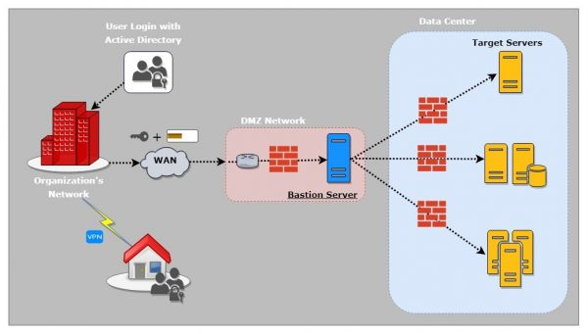

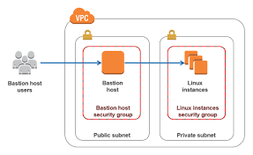
Elastic Network Interface (NIC Card):
When you launch an EC2 instance, a Primary Elastic Network Interface (ENI) is automatically created and attached to it.
This primary ENI is essential for the instance's network connectivity within its Amazon Virtual Private Cloud (VPC).
ENI handles the primary private IP address of the instance.
*In ENI, all IP addresses can be attached.(Elastic IP address, Static IP address, MAC address)
Here's a breakdown of what happens:
* Primary ENI: Every EC2 instance must have a primary ENI. This interface handles the primary private IP address of the instance, and it cannot be detached from the instance or moved to another instance as long as the original instance exists.
* Secondary ENIs (Optional): While the primary ENI is automatic, you can manually create and attach secondary ENIs to an EC2 instance. Secondary ENIs are detachable and can be moved between instances within the same Availability Zone. They are useful for scenarios like:
* Having multiple IP addresses on an instance.
* Creating separate network paths for different applications or services.
* Implementing high-availability solutions.
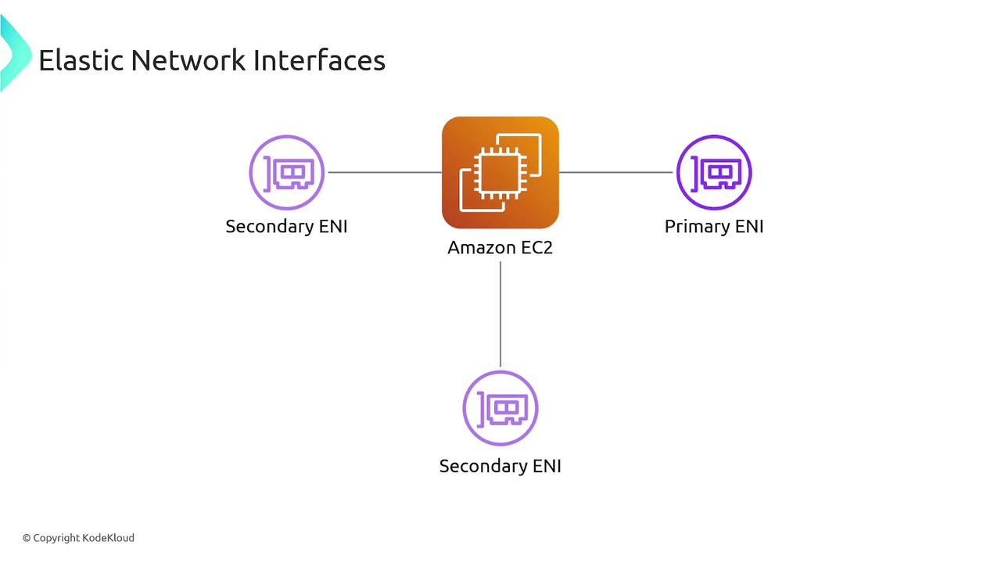

* Auto Scaling Groups: For Auto Scaling Groups, if you want instances to launch with more than just the primary ENI, you'll configure this in the Launch Template associated with the Auto Scaling Group. You can also use AWS Lambda functions triggered by lifecycle hooks to attach additional ENIs during the instance launch process for more complex scenarios.
* Customization via Launch Templates: If you're using Launch Templates for your EC2 instances (especially for Auto Scaling Groups), you can define multiple network interfaces within the template. This allows you to automatically attach additional ENIs to instances as they are launched.

In summary, the foundational network interface (the primary ENI) is always automatically attached when you launch an EC2 instance. You have options to add more ENIs automatically through launch configurations or programmatically if your architecture requires it.
*NIC-Network Interface Card (Physical Card) is a computer hardware component that connects a computer to a computer network.
*ENI- An elastic network interface (Virtual Network Card), you can create and configure network interfaces and attach them to instances that you launch in the same Availability Zone. (ENI -Door of the EC2 Instance; Security Group- Firewall at the EC2 Instance level.)
*ENI is defaultly attached when EC2 got launched.
*If AZ's fail, we can use Elastic IP, if it is dynamic IP then IP address will be lost.
*Security group(Firewall) at the Instance level.
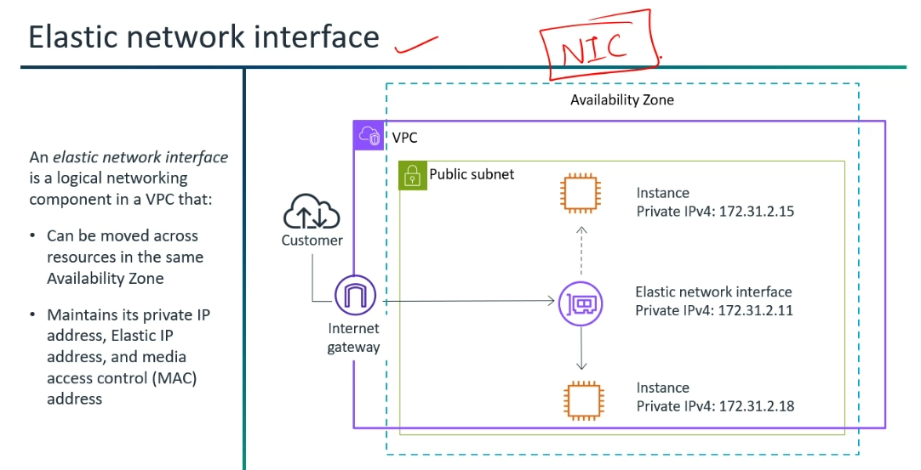
Elastic IP Address:

Elastic IP: Remains the same (persists) when an EC2 instance is stopped and started.
Regular Public IP: Changes when an EC2 instance is stopped and started.
(DNS records: If your domain name points to your instance's IP, a changing IP means you'd constantly have to update your DNS.)
*Pay as you "don't use" and Bring Your Own IP (BYOP).

Common Use Cases:
* Database Servers: Providing a stable entry point for database connections.
* VPN Endpoints: Maintaining a consistent IP for VPN client connections.
* Game Servers: Allowing players to connect to a fixed IP address.

The Golden Rule to Avoid Unexpected Bills:
Release any Elastic IPs you are not actively using and associated with a running EC2 instance. If an EIP isn't connected to a live, working server, it's probably costing you money.
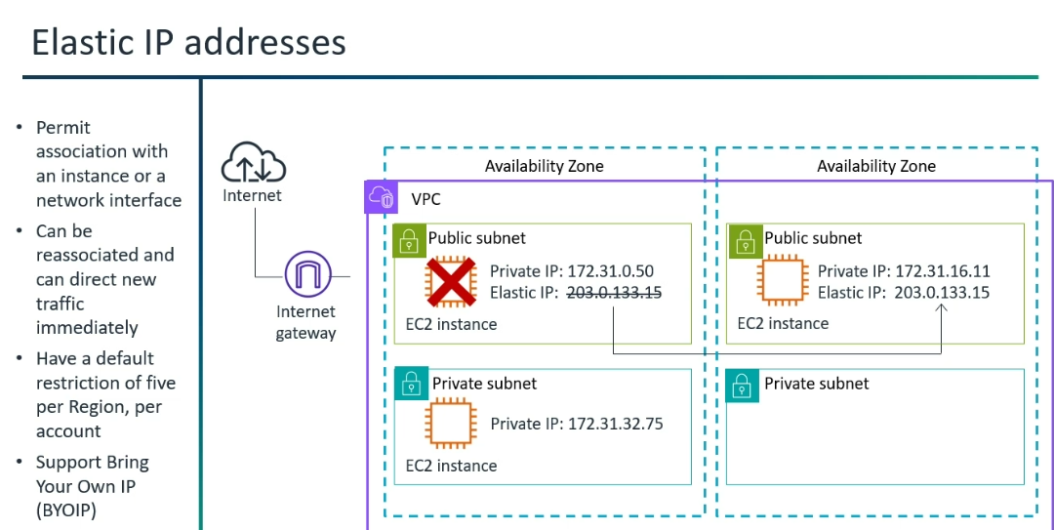

*Elastic IP costs higher than Dynamic IP.
*Elastic IP:
1)Offered by AWS.
(Allocating Elastic IP from the pool of IP addresses should be attached to any of the workloads - You will not get billed; If you don't use Elastic IP you will get billed)
*VPC-->DHCP ( Dynamic Host Configuration Protocol) option
(Dynamic IP address allocate from the public IP address pool--> DHCP)
*The Domain Name System (DNS) turns domain names into IP addresses, which browsers use to load internet pages.
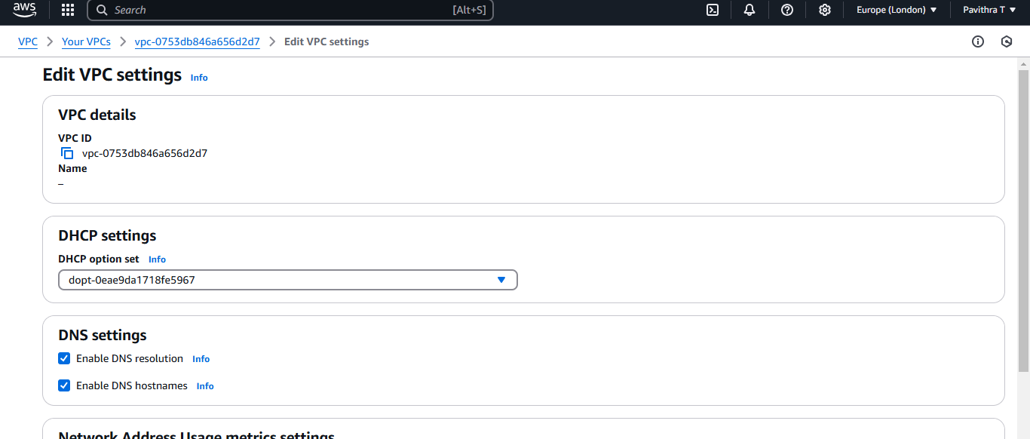
Hybrid Networking:
Hybrid networking refers to an IT architecture that combines different types of network infrastructures to create a unified and interconnected environment. Most commonly, this involves linking:
* On-premises data centers: Your traditional physical servers and network infrastructure located within your own facilities.
* Public cloud environments: Services and infrastructure provided by public cloud providers like AWS, Azure, Google Cloud, etc.
* Private cloud environments: A cloud infrastructure dedicated to a single organization, which can be hosted on-premises or by a third-party.
The goal of hybrid networking is to enable seamless communication, data flow, and application deployment across these disparate environments, treating them as a single, extended network.
IP (Network Layer):

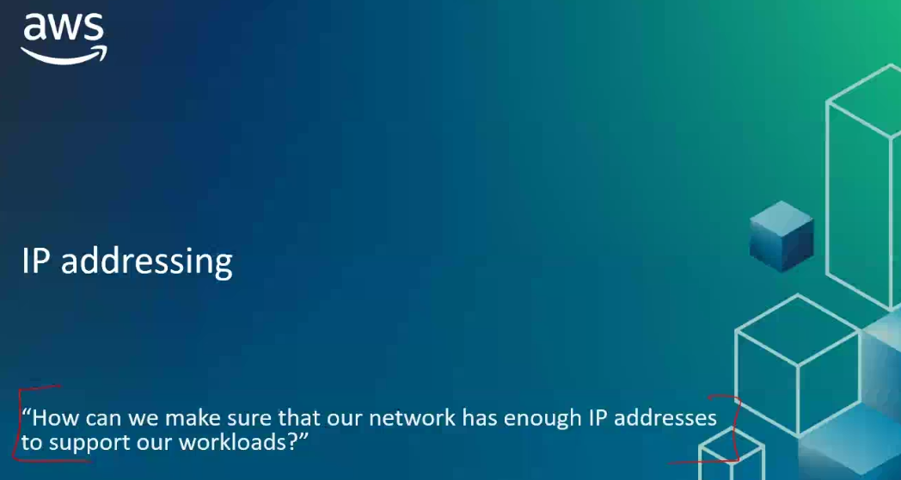
How can we make sure that our network has enough IP addresses to support our workloads..?
IP addressing

*An IP address is the unique identifying number assigned for a computer or device to communicate with the internet. IP address is assigned by an internet service provider (ISP).

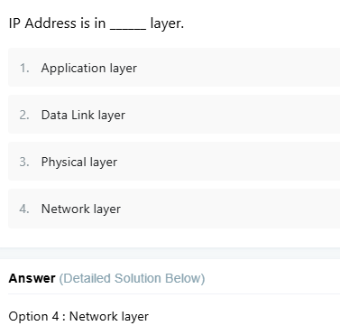

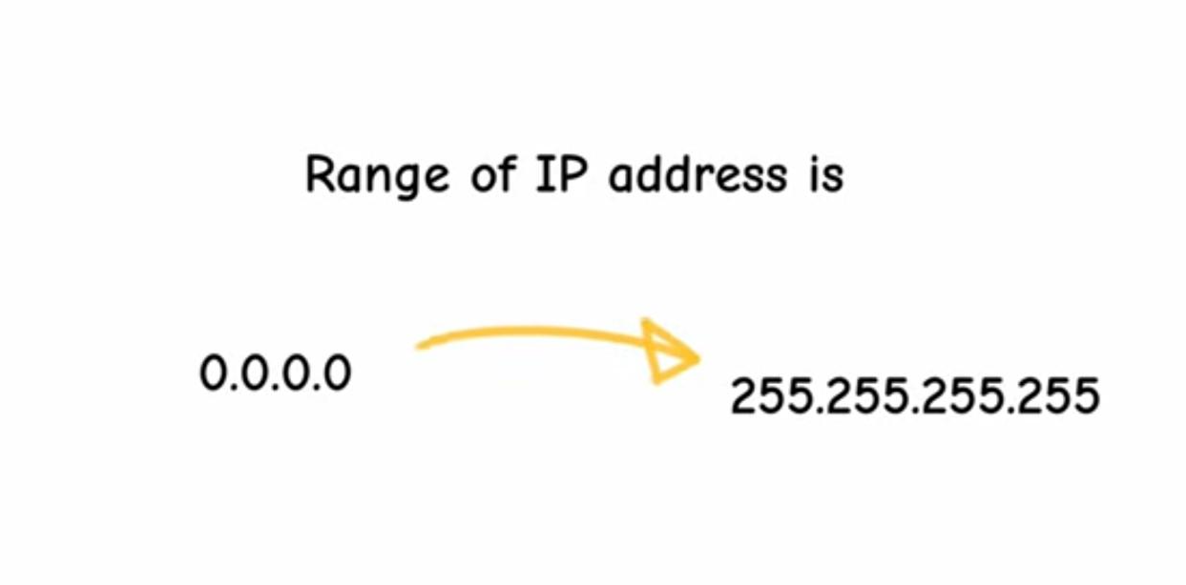

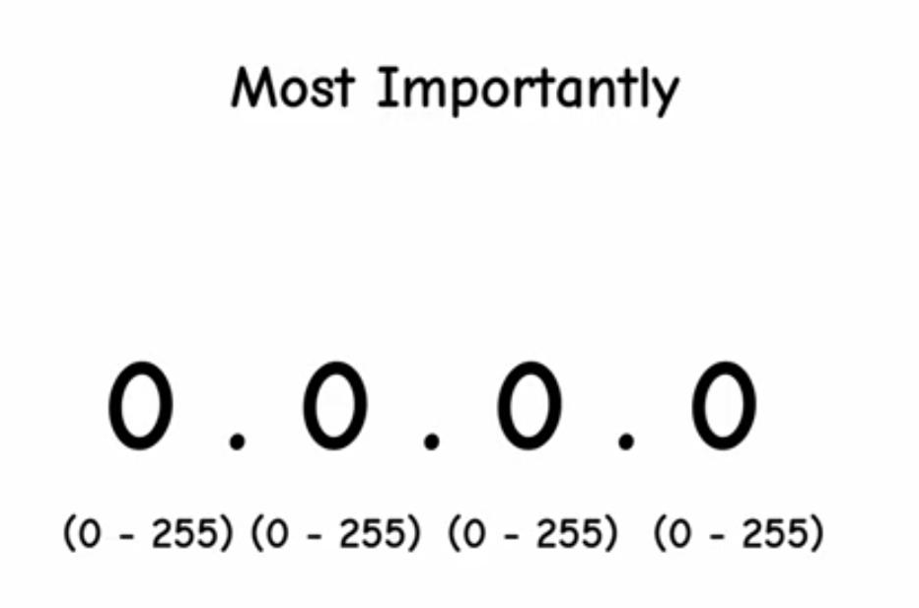

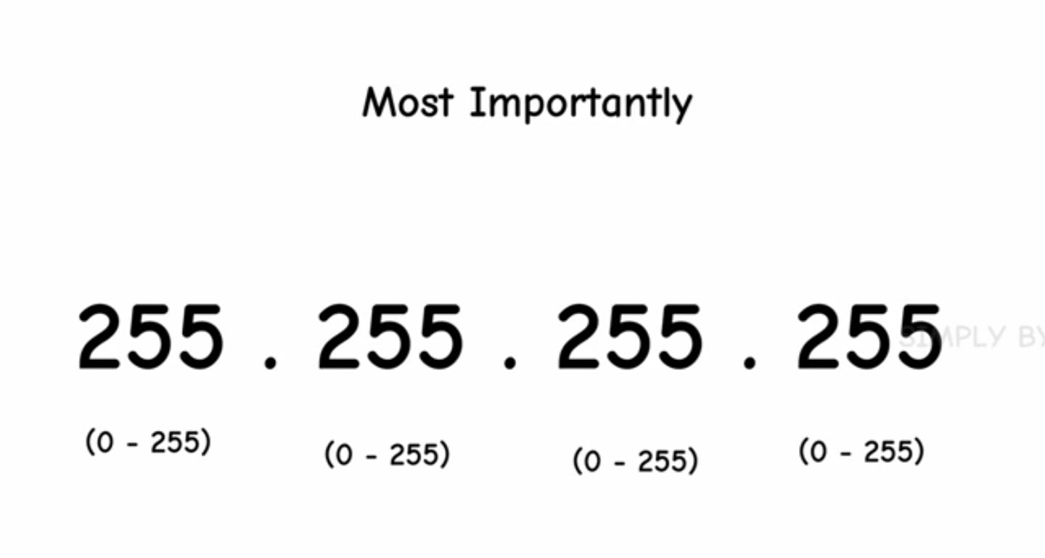

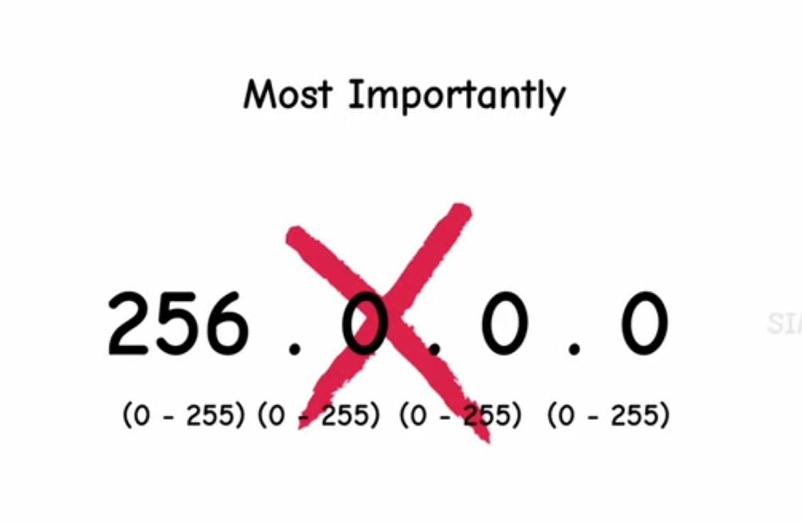

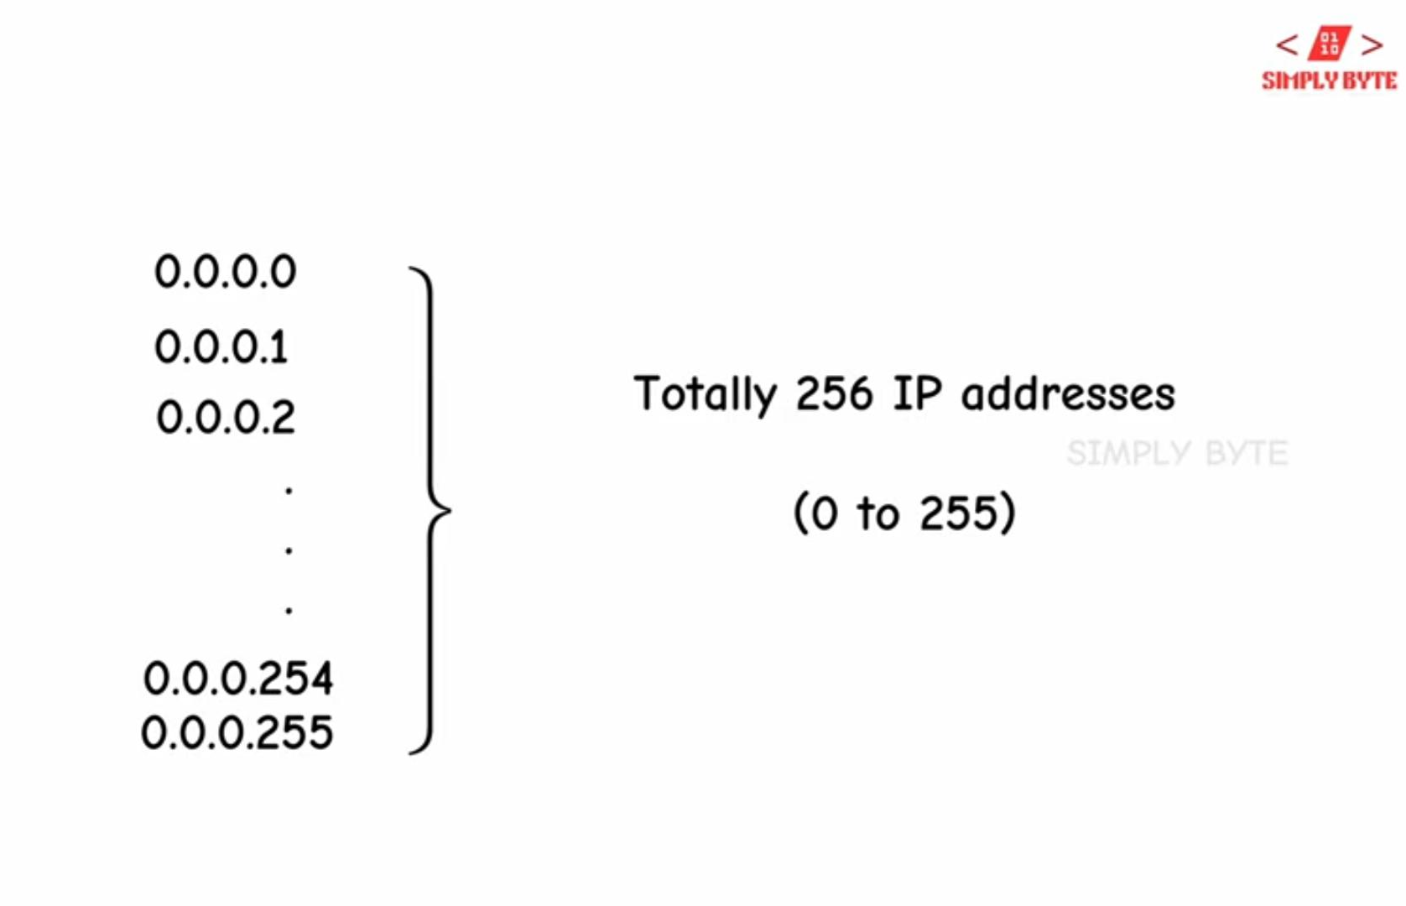

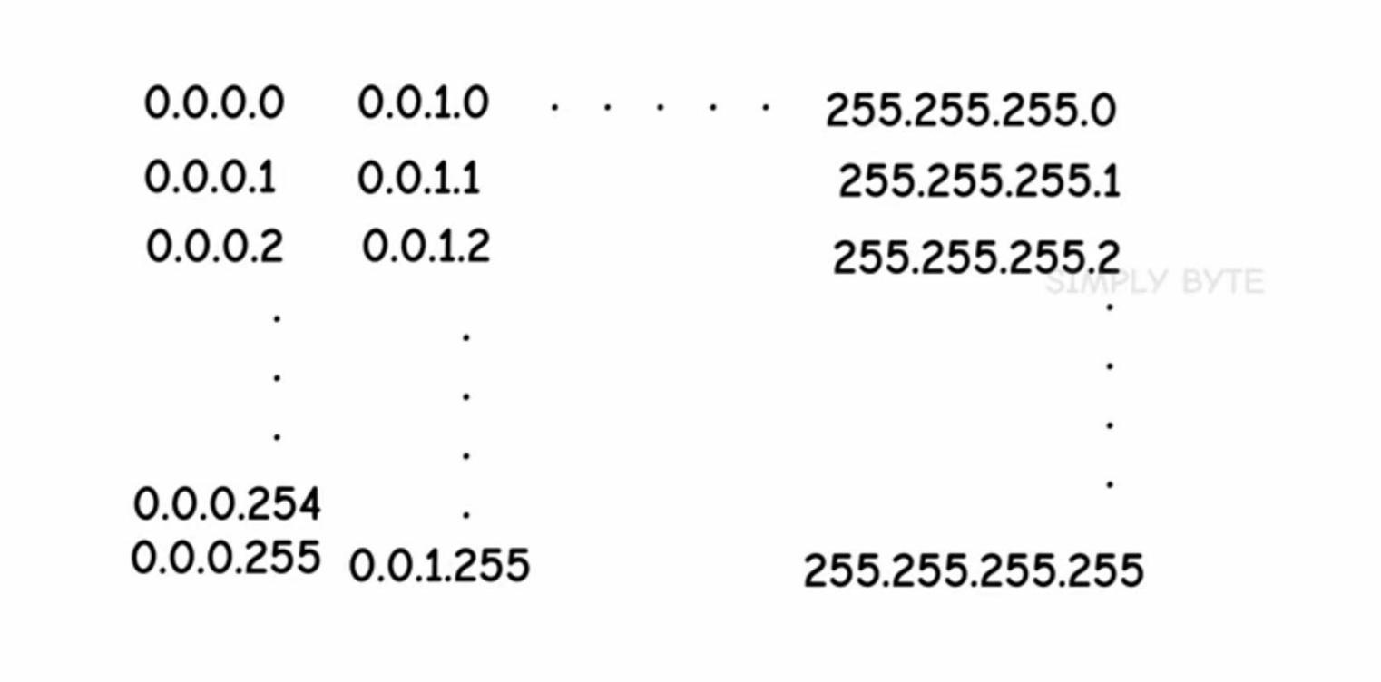

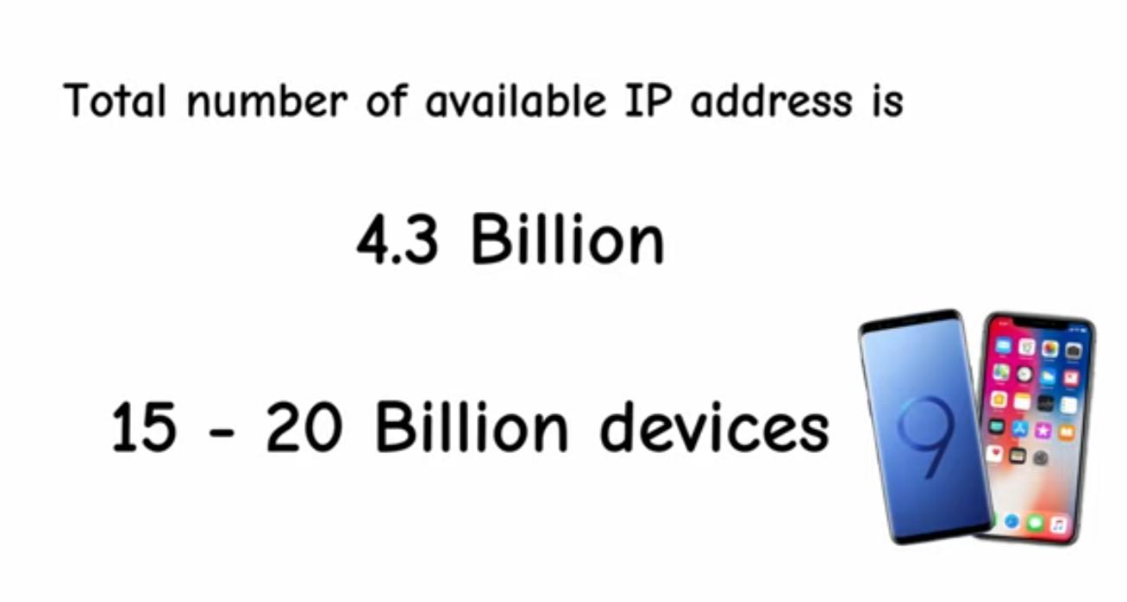
For instance: 10.0.0.0 taking this range…

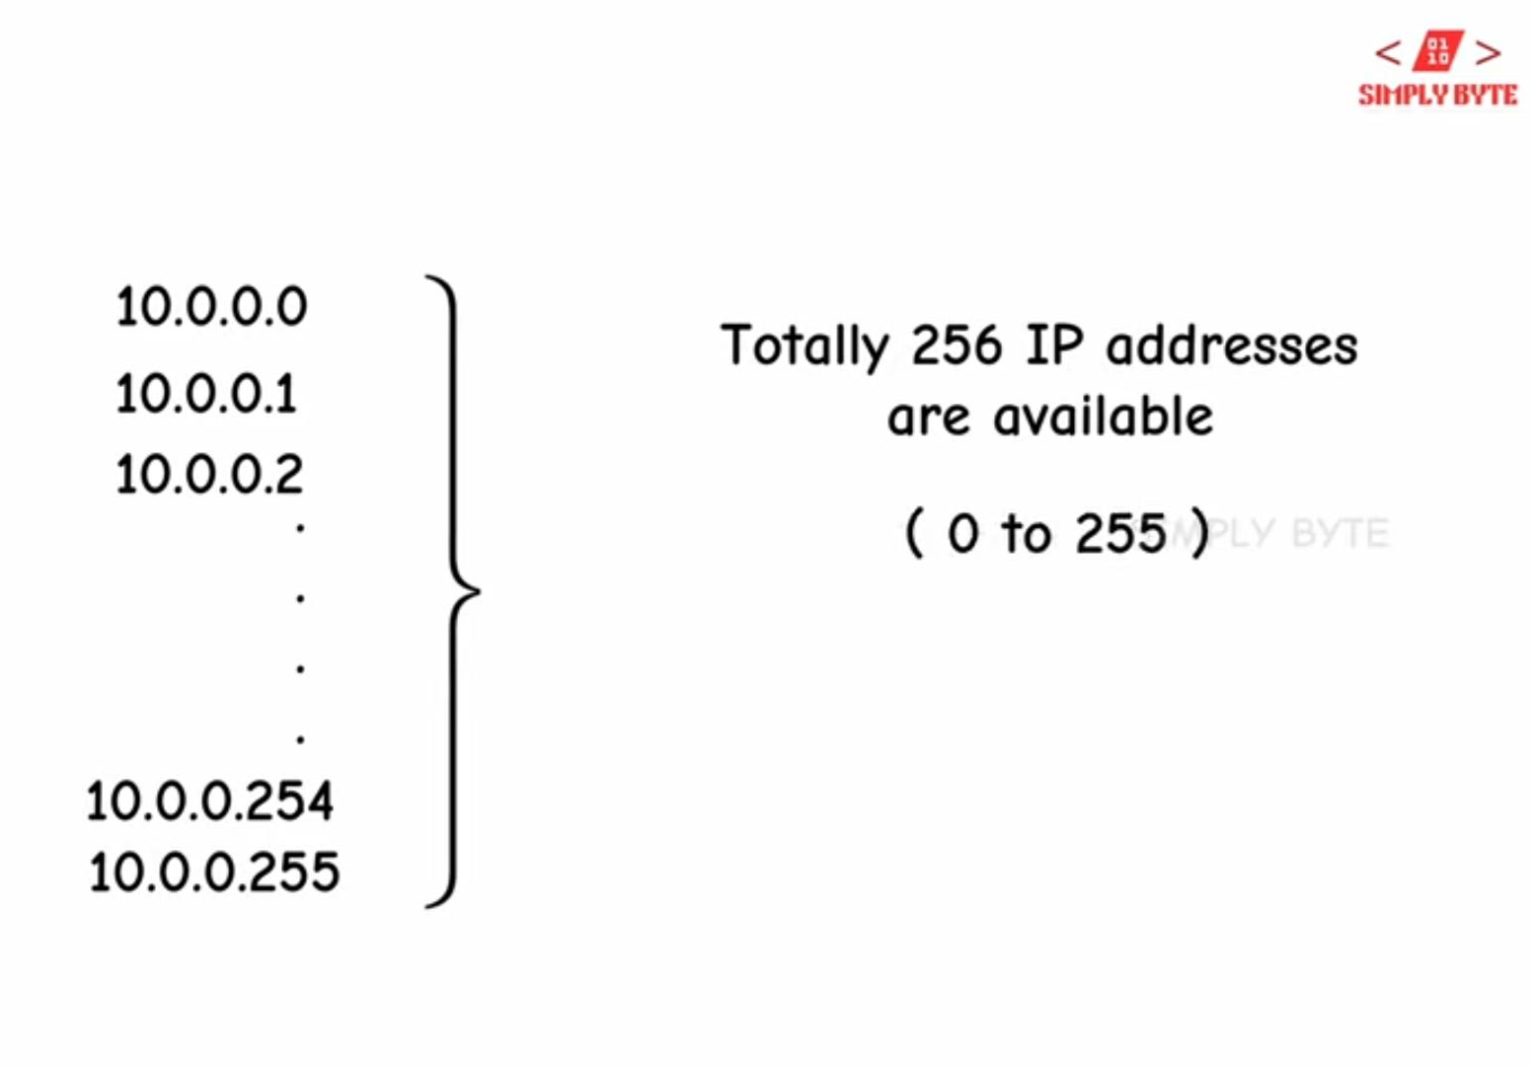

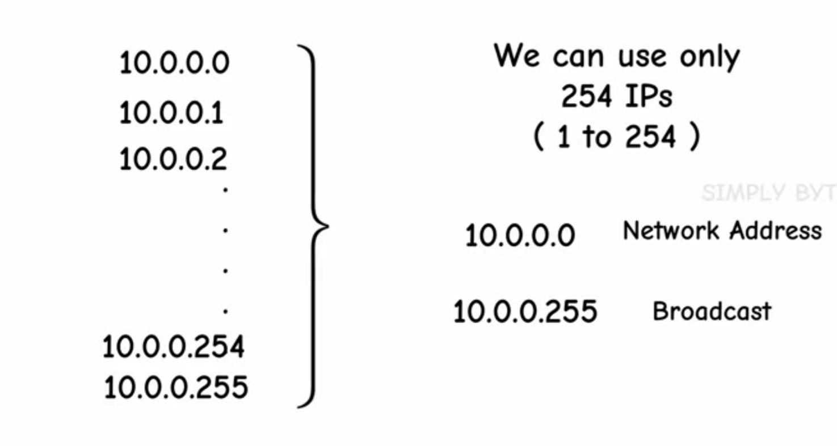

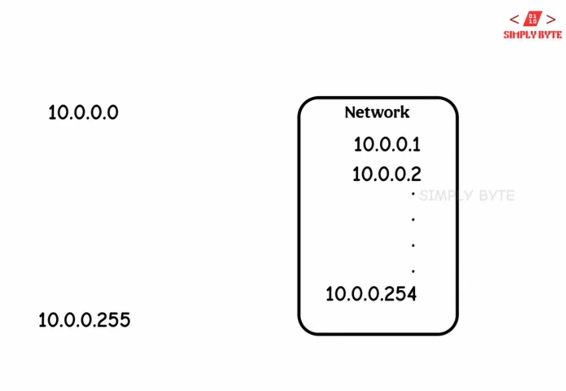

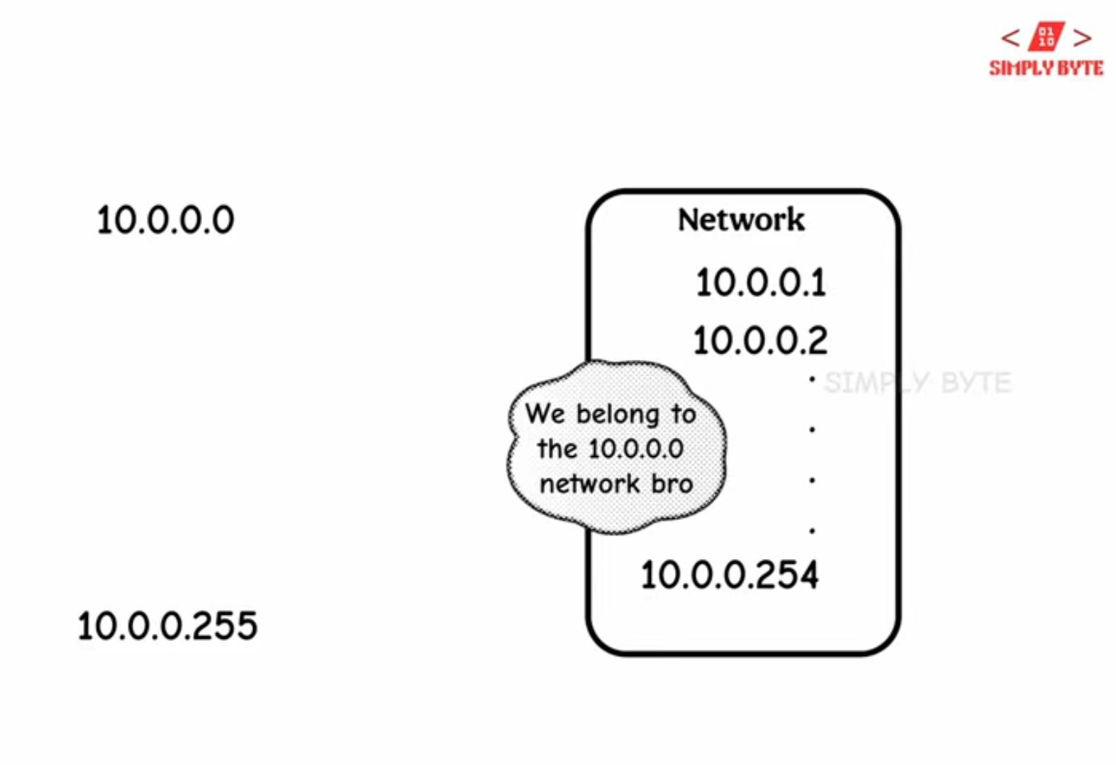

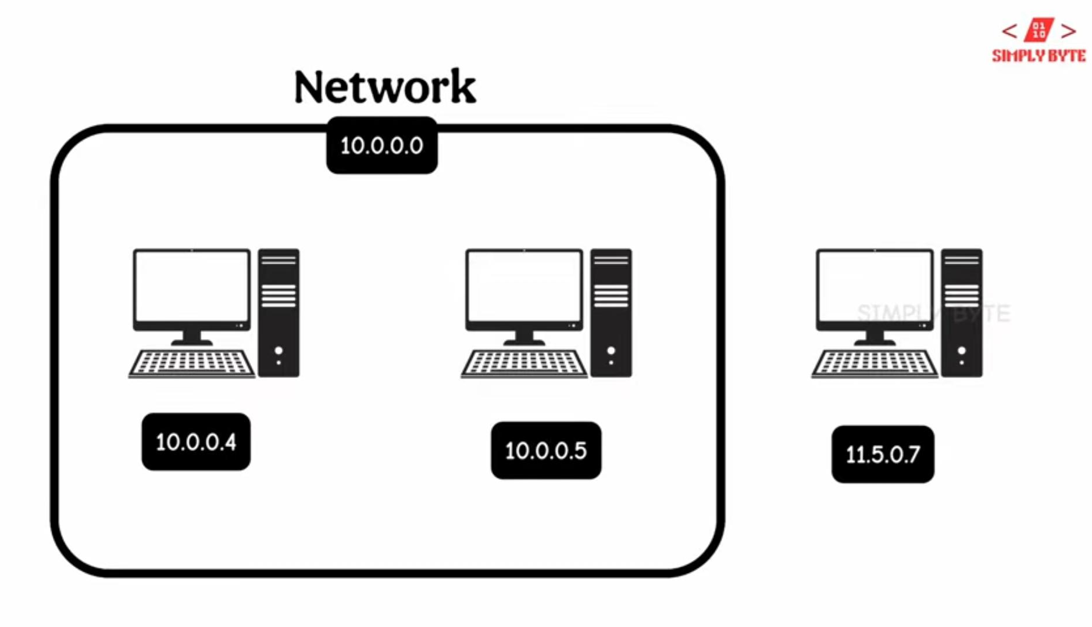

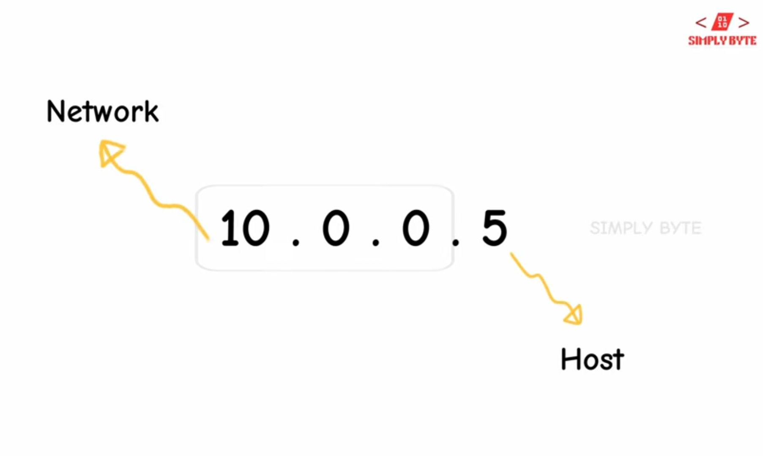

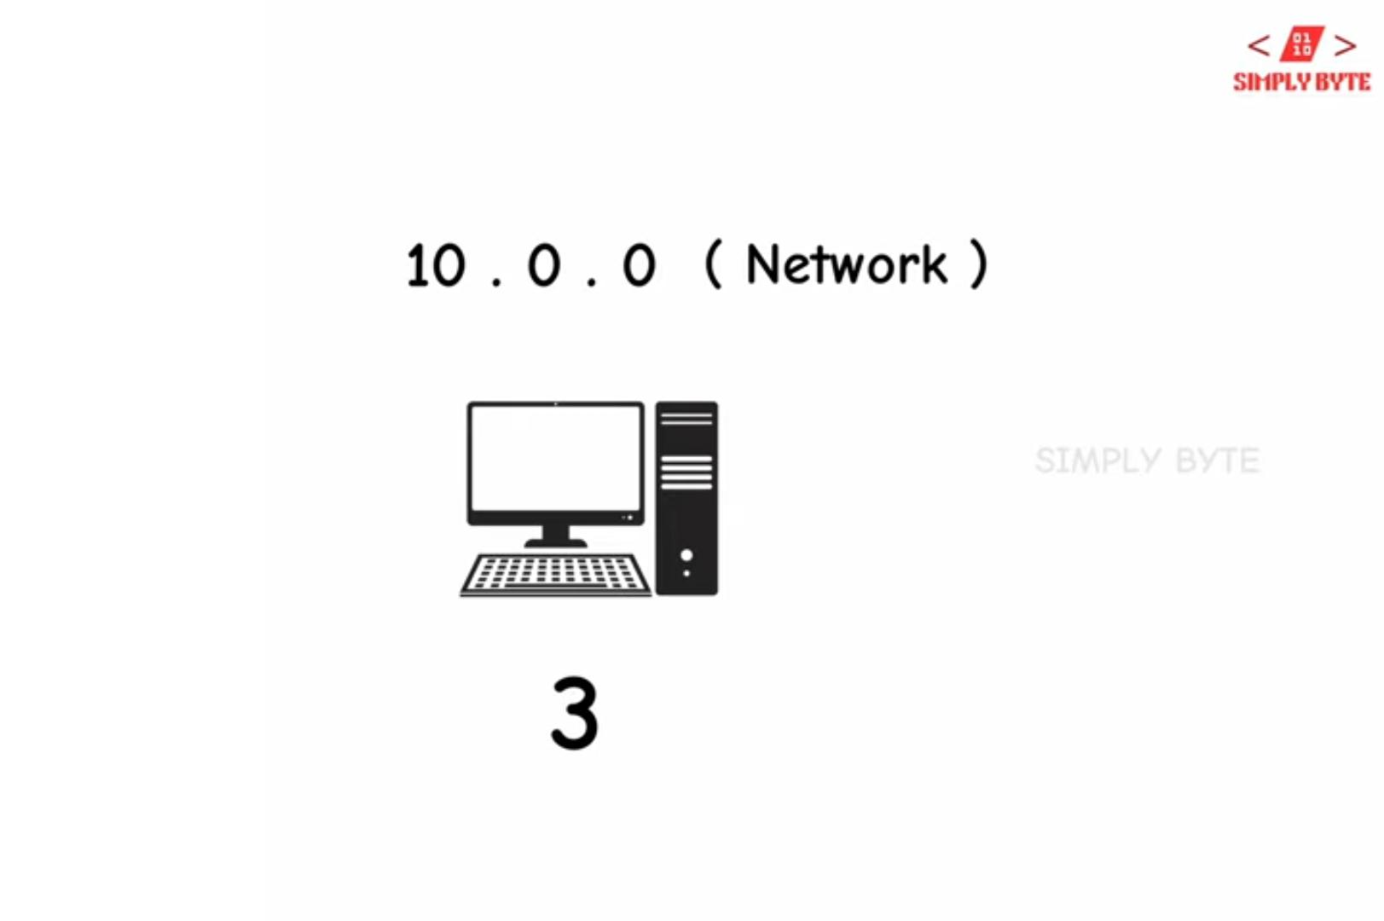

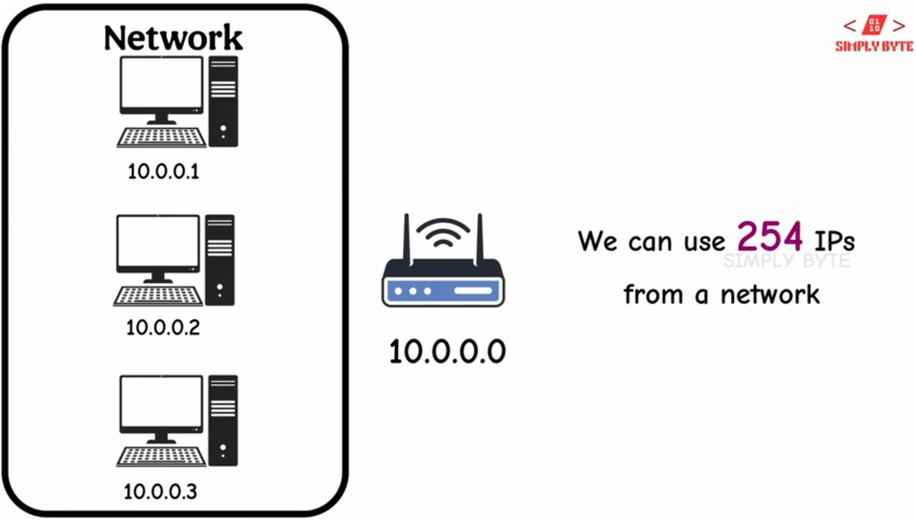

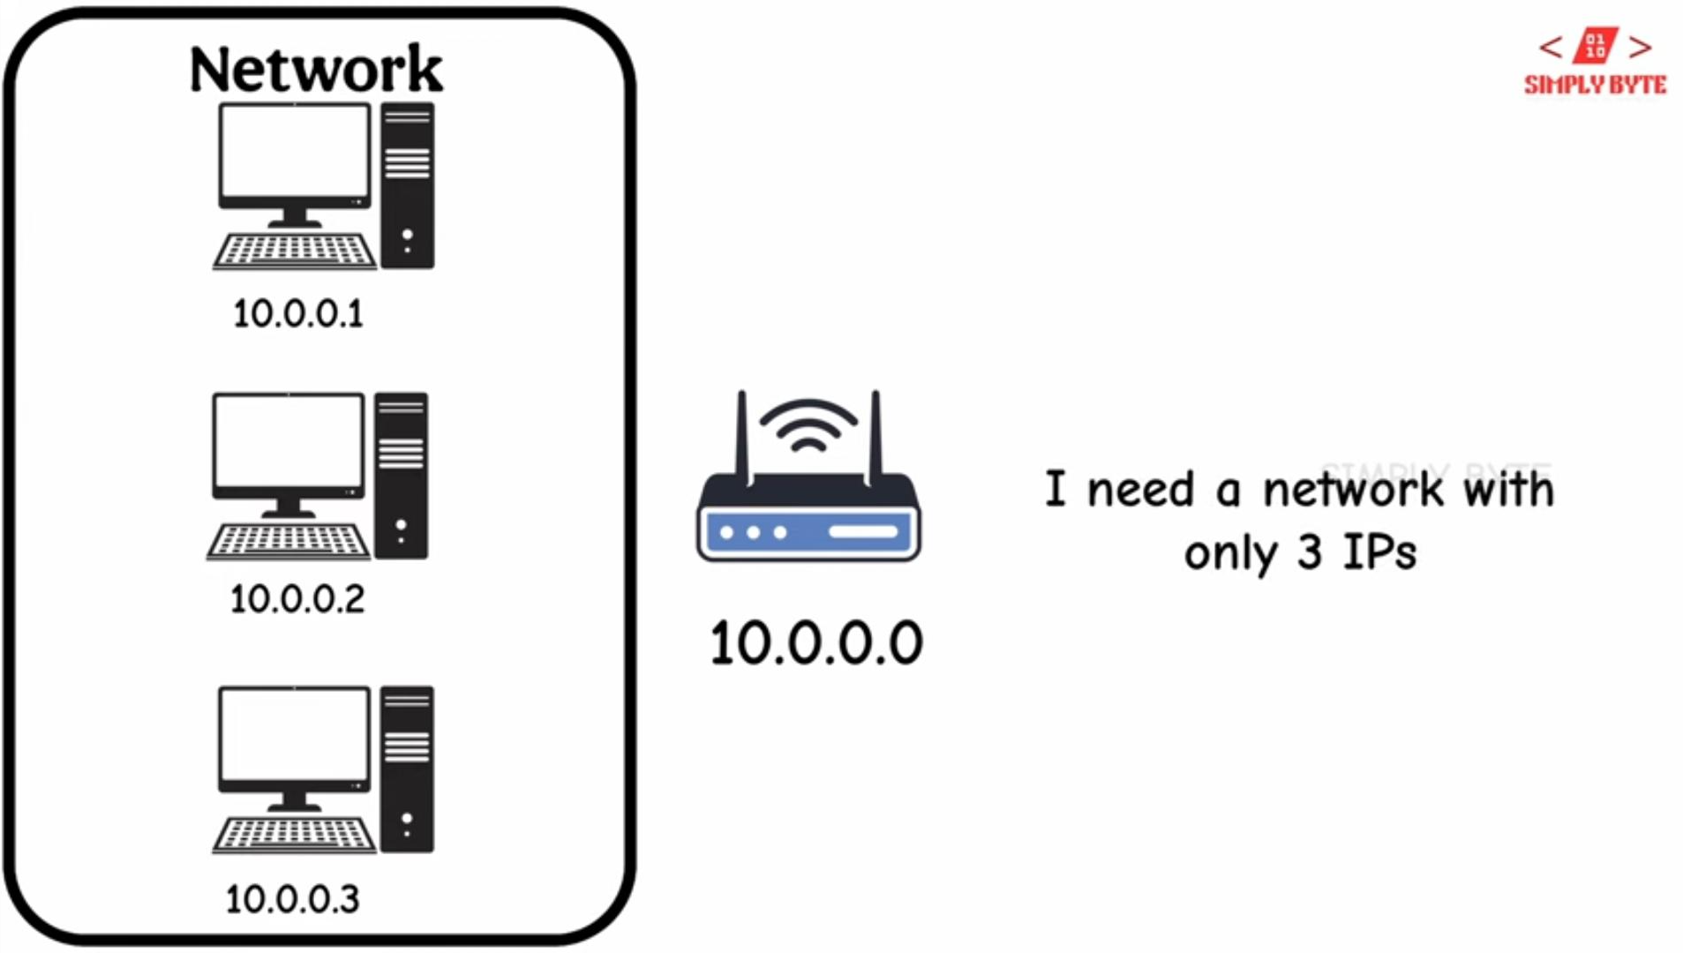



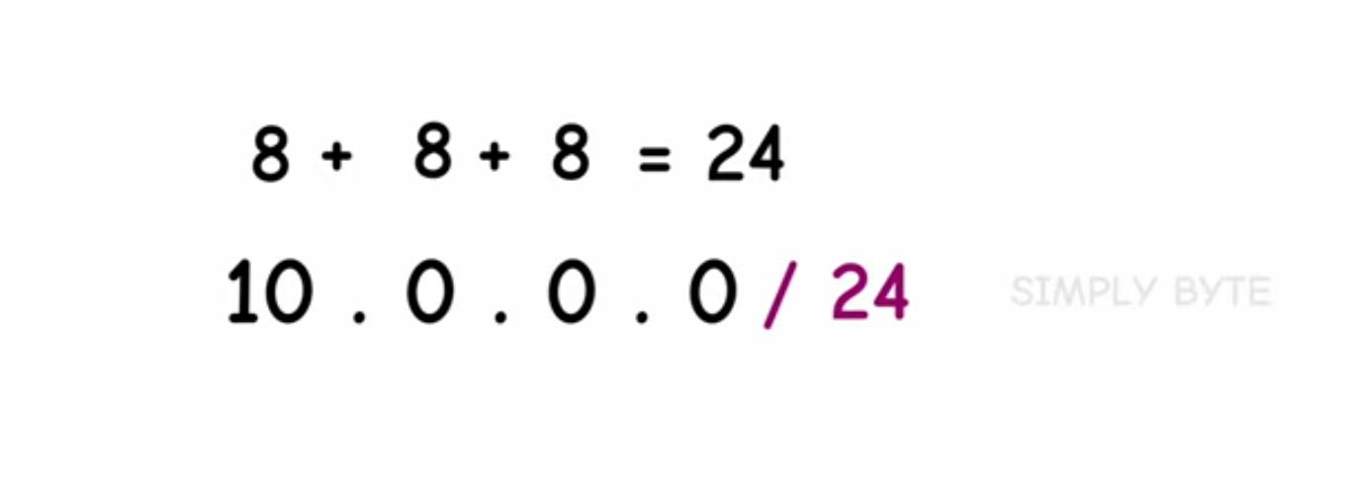

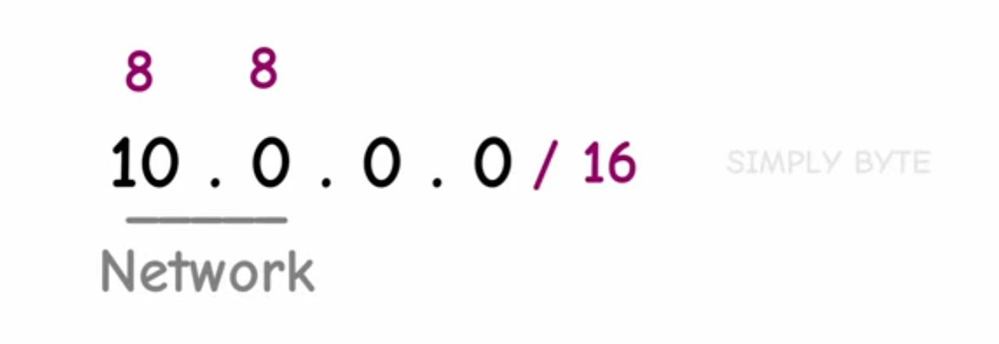

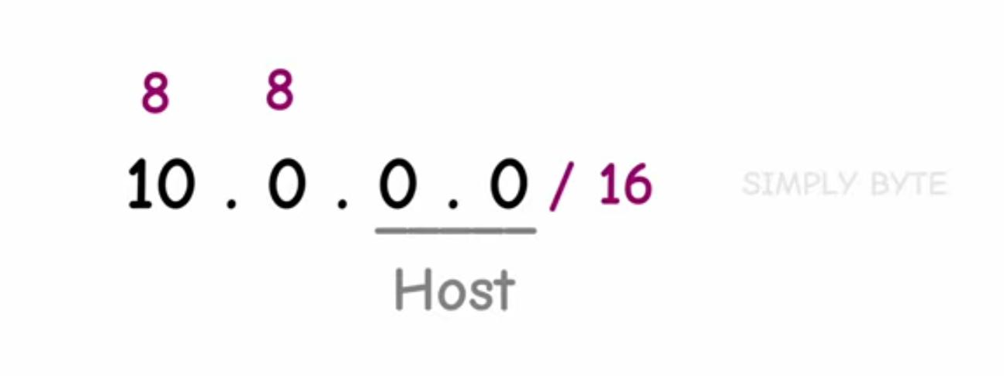

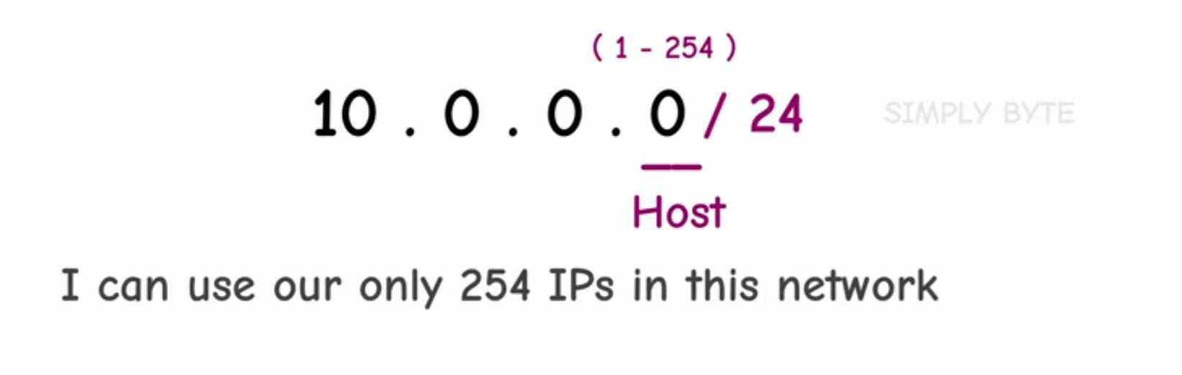

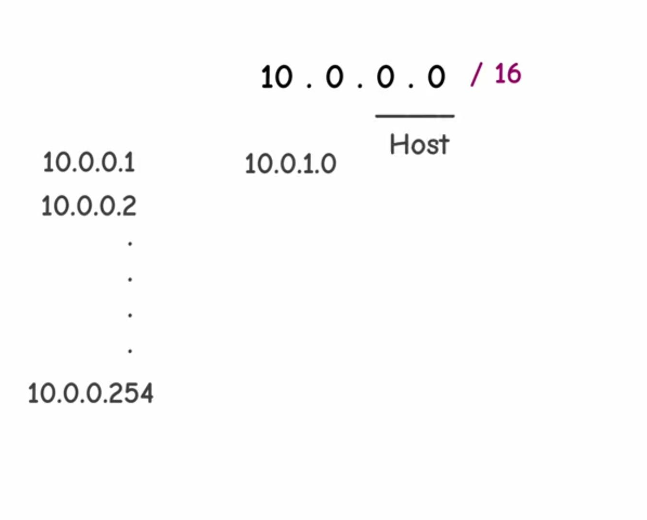

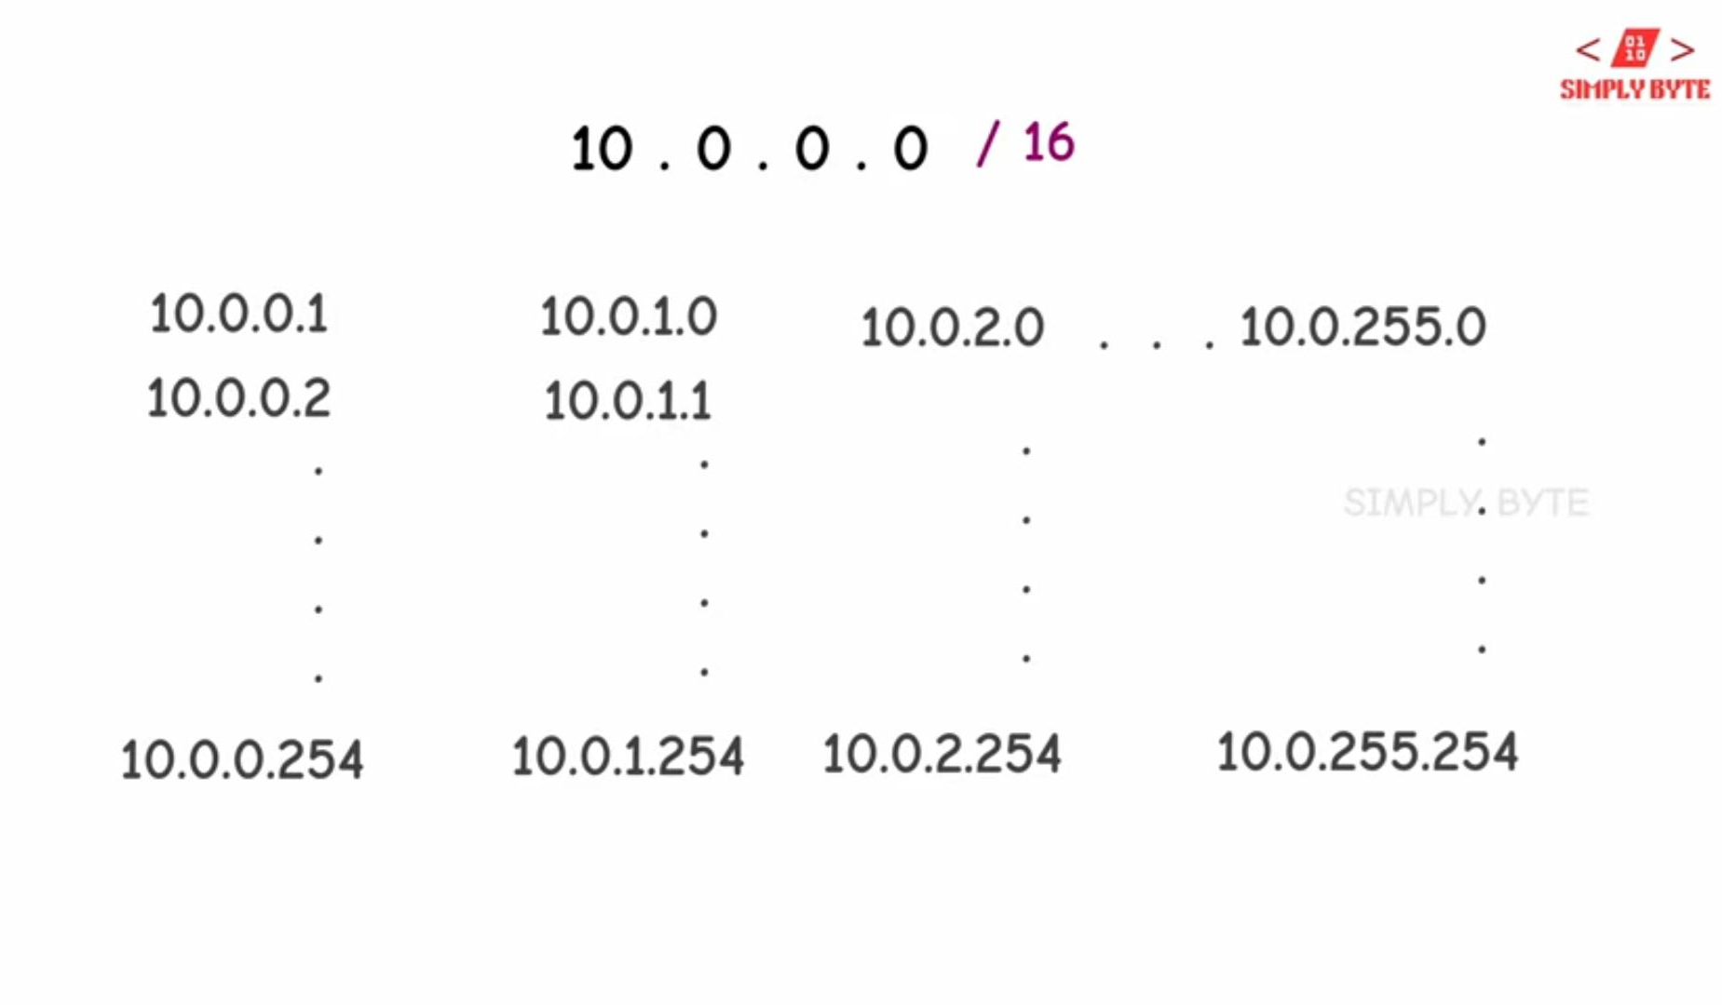

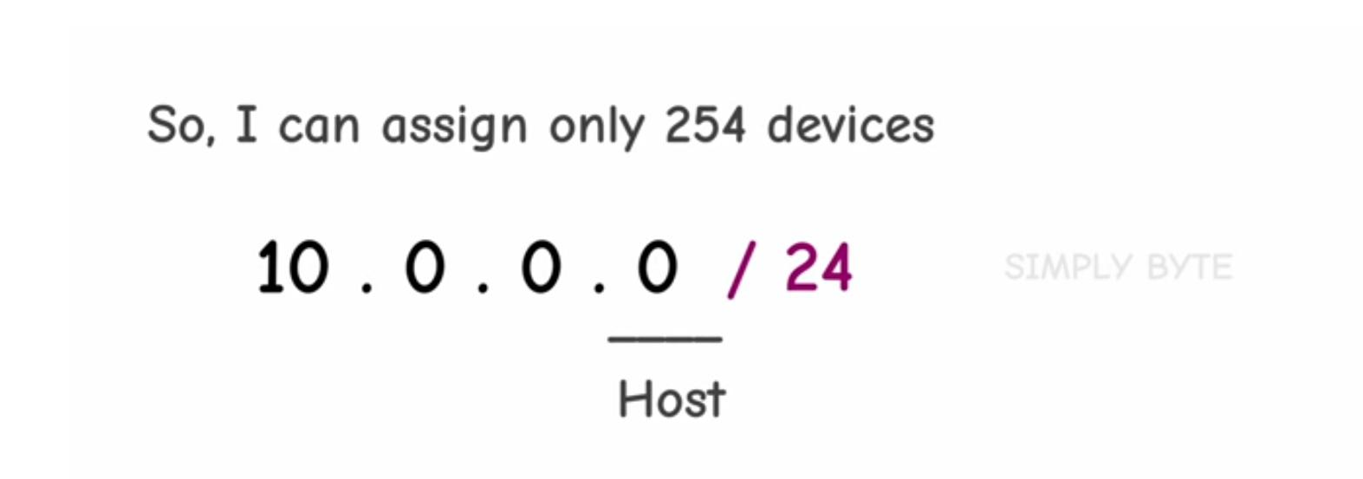

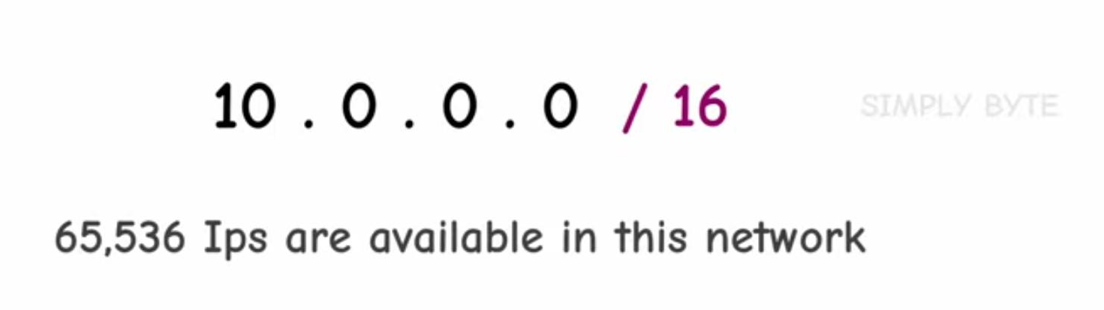

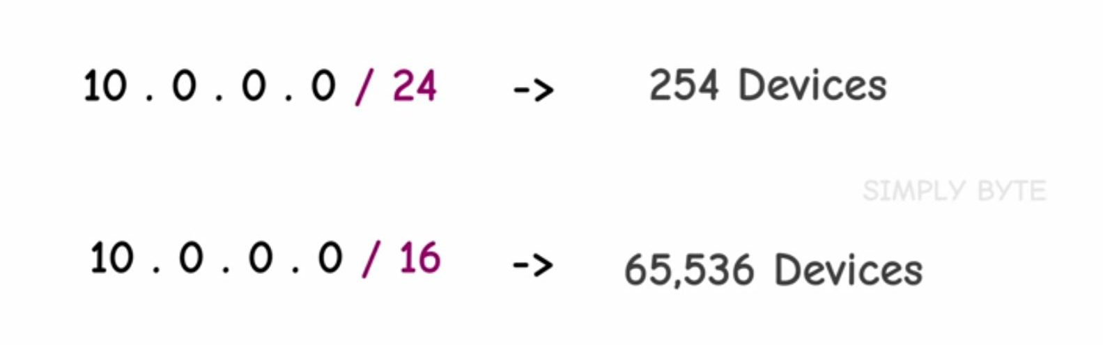

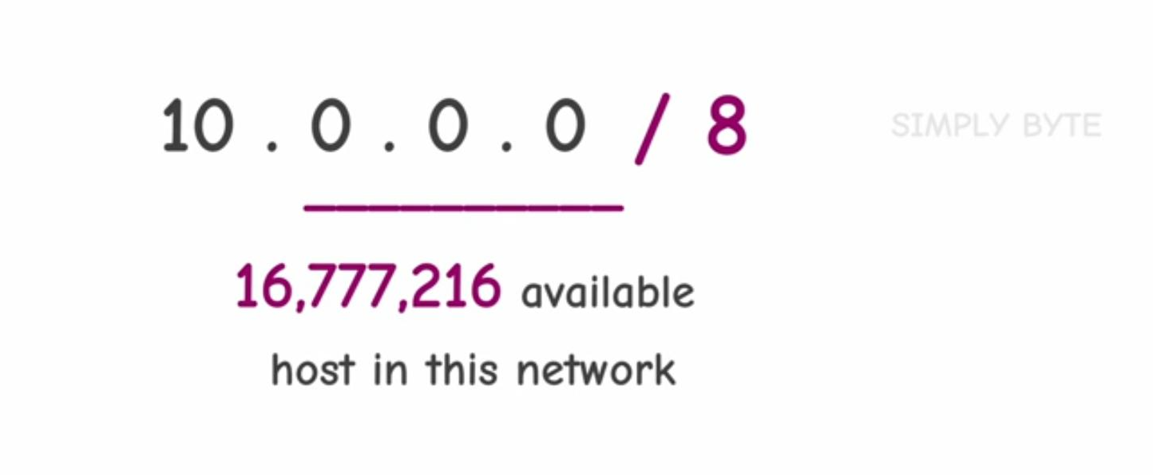

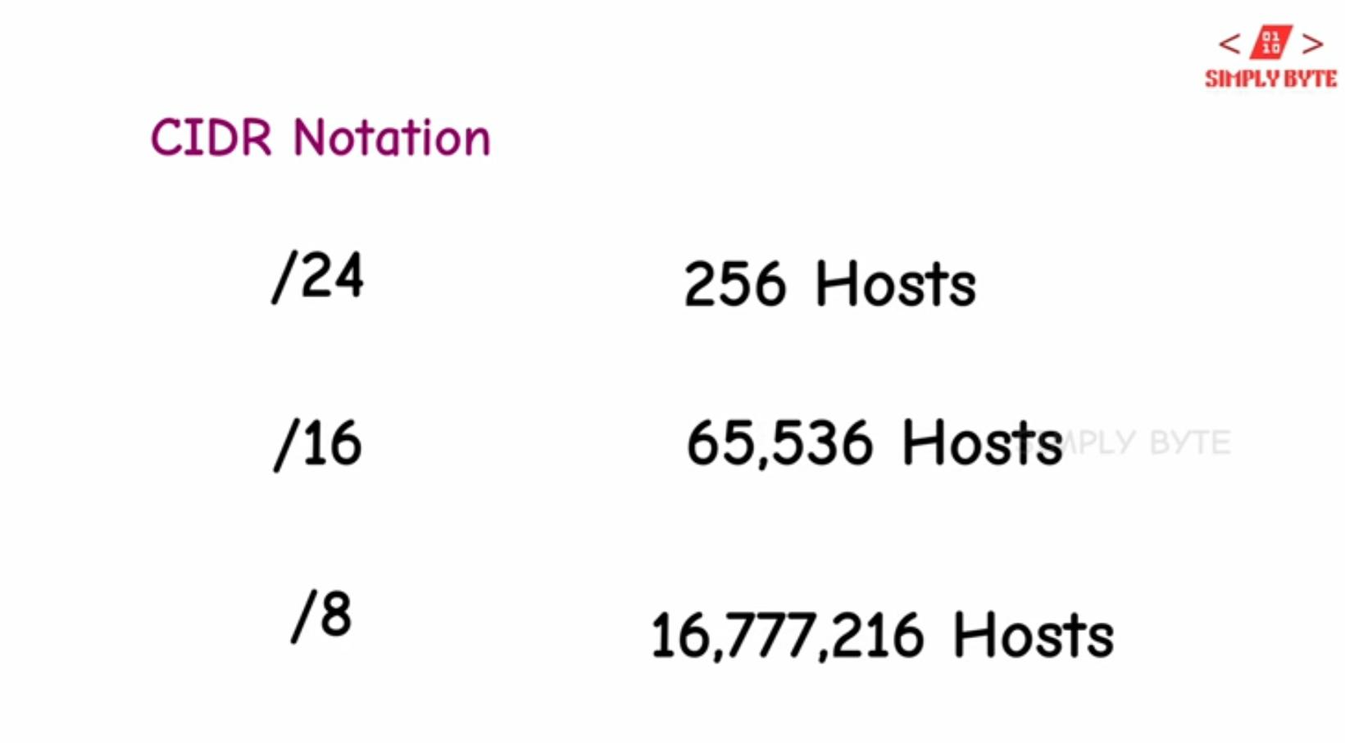

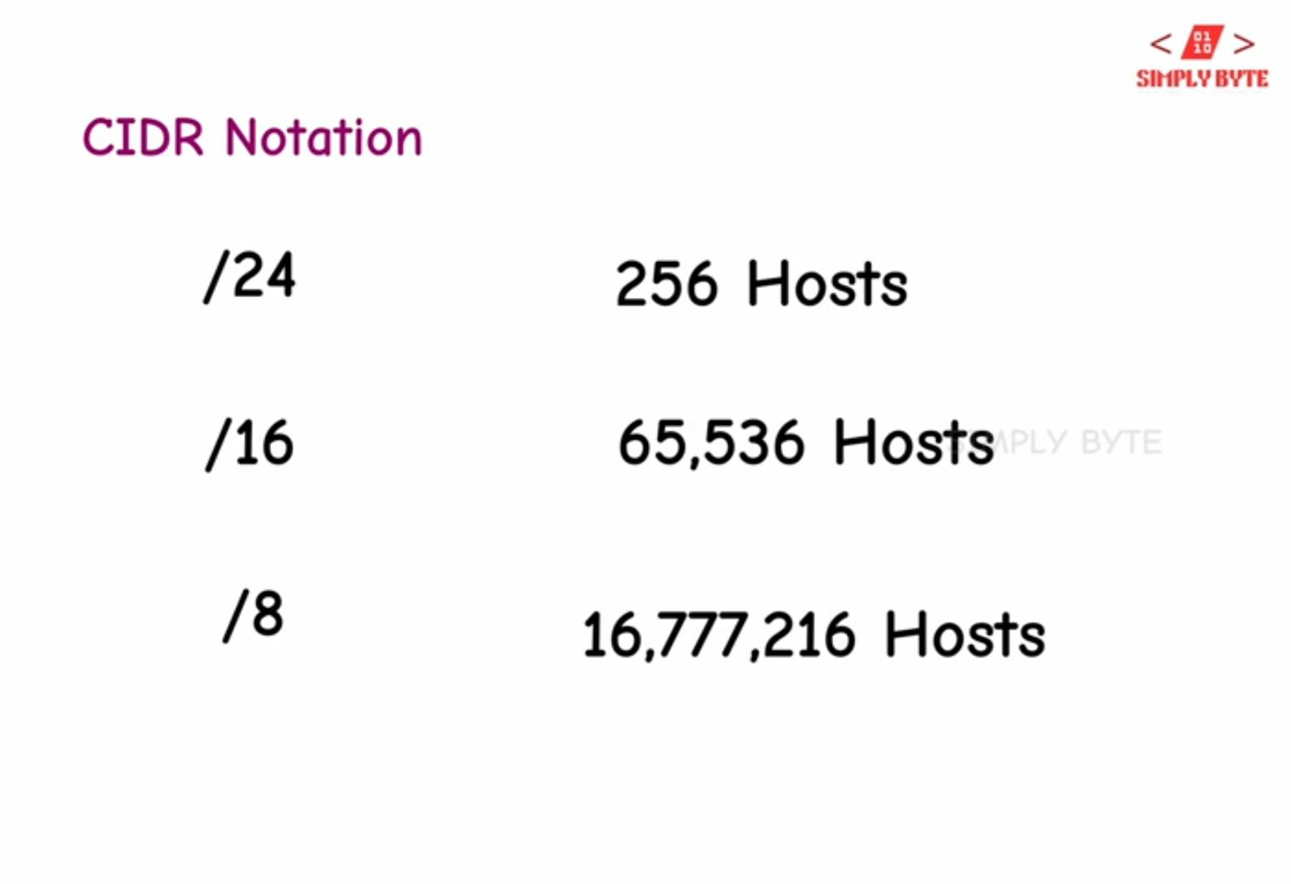

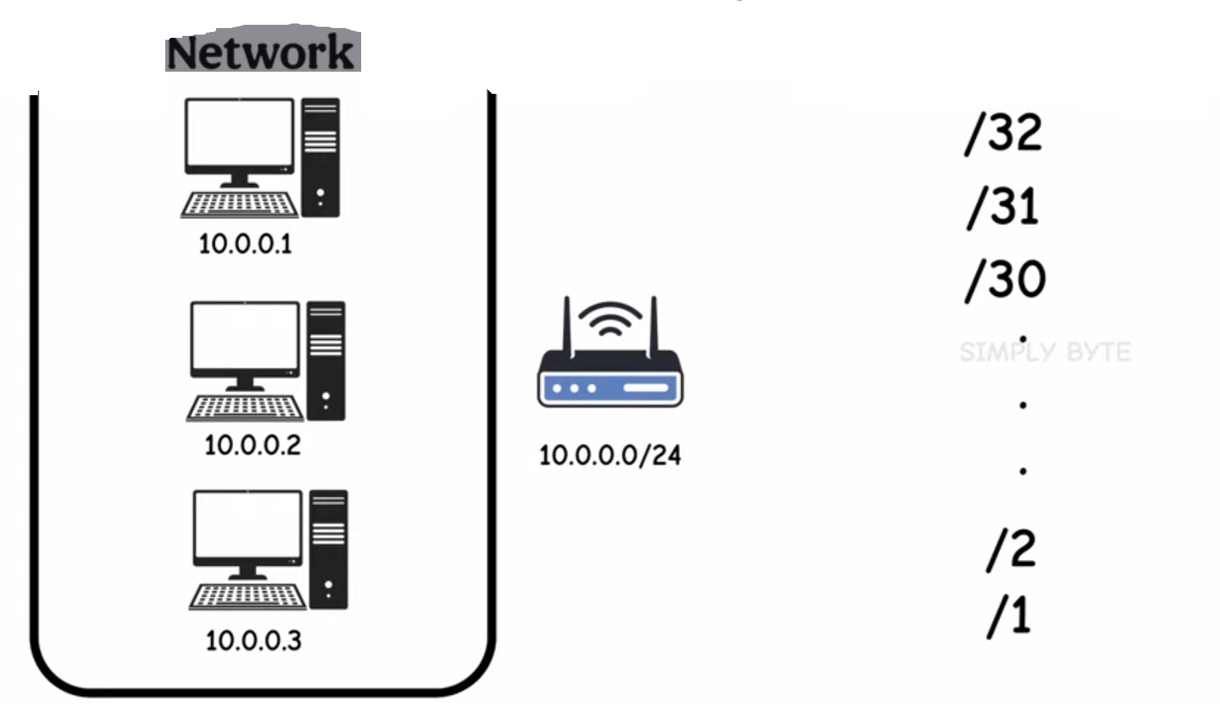

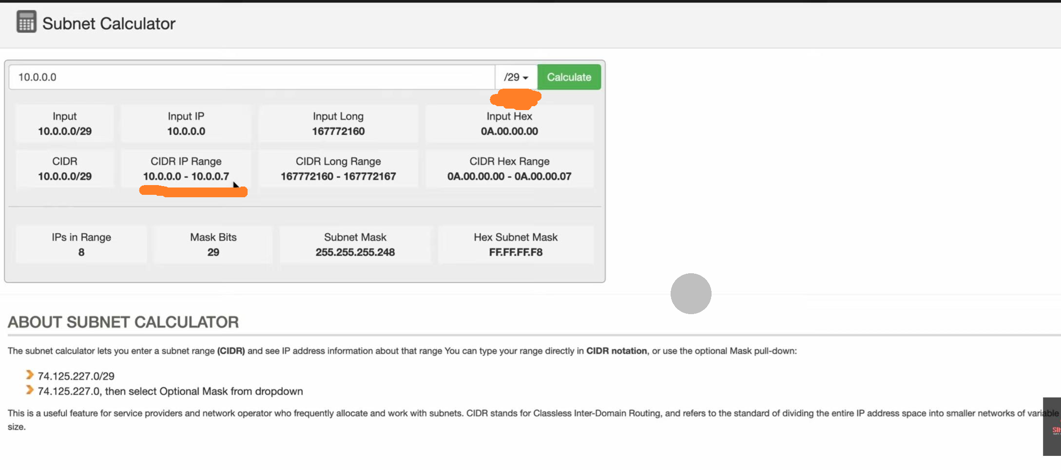

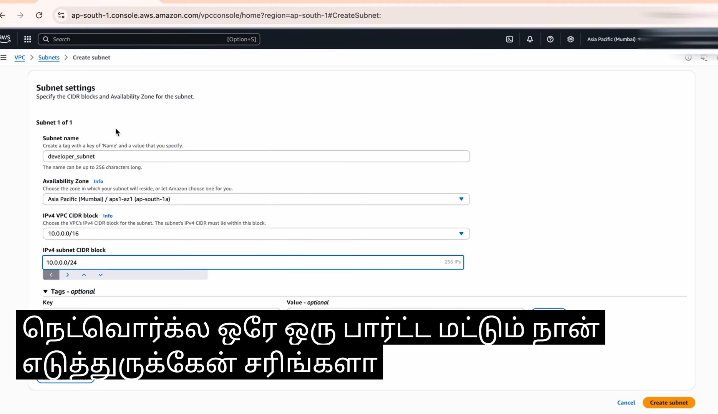

*The IPv4 is a 32-bit address, whereas IPv6 is a 128-bit hexadecimal address.
IPv4 addresses are 32-bit numbers that are typically displayed in dotted decimal notation.

*An IP address is 32 bits long and made up of two components, a network portion and a host portion.

*Will IP address of my system change automatically?
Most of the time, you'll find that your IP address doesn't change…even though technically it is classified as a dynamic IP address.

*The 32-bit IP address is grouped to 8 bits at a time, each group of 8 bits is called an octet. Each of the four octets are separated by a dot, and represented in decimal format, this is known as dotted decimal notation.

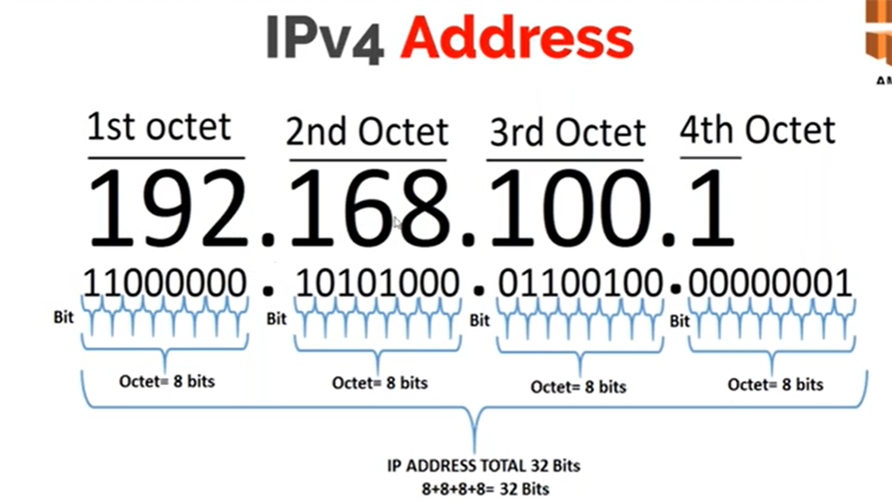

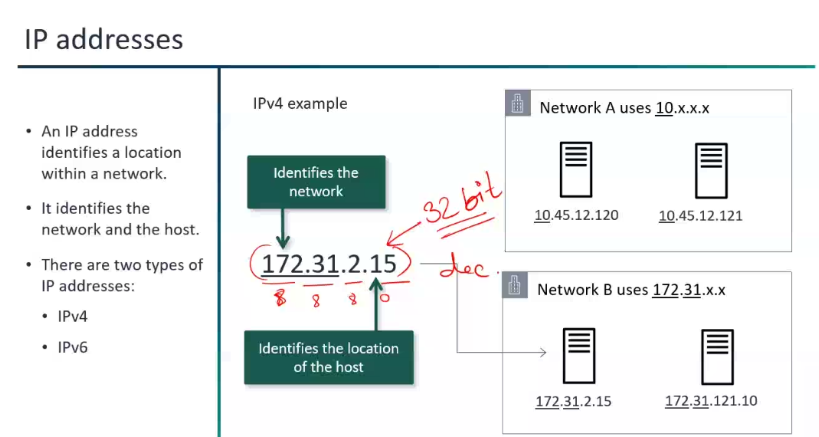

Subnetting…
*Subnetting is the process of dividing a large network into smaller networks called as “subnets”.
*Subnetting will be done with the help of IP address and default subnet mask.
*Subnetting will be done by "Changing the default subnet mask (Ex:255.255.255.0) by borrowing some of the bits from the host portion."
*Host=IP address.

*A subnet is a range of IP addresses that falls within the assigned VPC. The subnet must use a CIDR block.
*A subnet is a smaller network within a network that requires a subnet mask.
*A subnet mask is a number that distinguishes the network address and the host address within an IP address.

*By using subnets, we can minimize traffic and the data need not to travel through unnecessary routes, this helps to increase the network speeds.

*What does 32 mean in CIDR?
Adding /32 after an IP address means that you are specifying all
32 bits of the IP address are used for the network address, and so you are not talking about a range of IP addresses.

A 32-bit address contains two primary parts: the network prefix and the host number. All hosts within a single network share the same network address. Each host also has an address that uniquely identifies it.

If you instead used /24 (subnet mask) for example, you are specifying
only the first 24 bits of the IP address are used for the network address and
the remaining 8 bits are used for the host address.

*Host such as Computers, servers, tablets ,routers and so on.

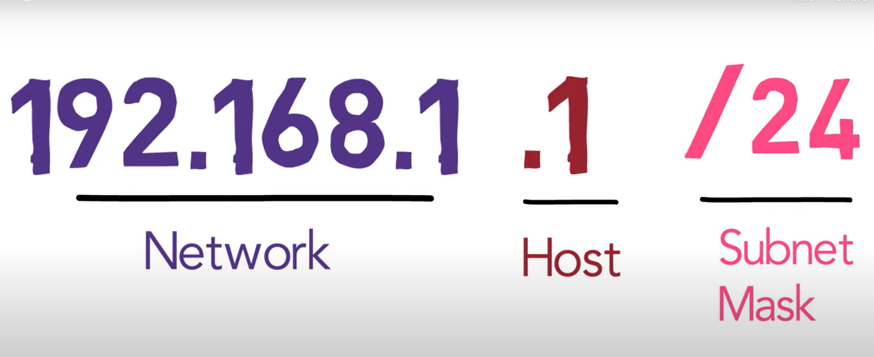

*Subnet mask can also be expressed as CIDR Range (Classless Inter-Domain Routing) or Slash Notation.
Slash Notation is a shorter way to write a subnet mask.

