*For Instance, In a business, Taking 12 computers on a single network. Dividing into three departments (Networks) as of each department has 4 computers(Hosts). Dividing this because, no other department can see other's network traffic.
Instead of having 1 network in business, breaking into 3 smaller networks--> Subnetting.

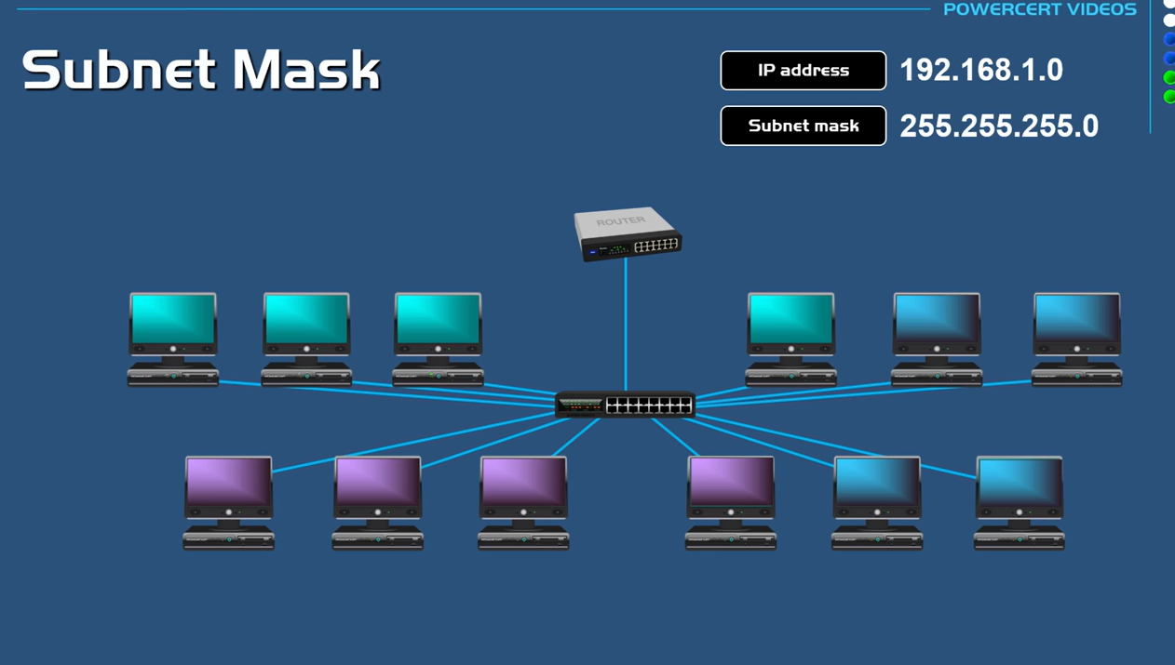

Subnetting will be done with the help of "IP address and Default Subnet mask".
Subnetting will be done by "Changing the default subnet mask (Ex:255.255.255.0) by borrowing some of the bits from the host portion.

*IP address:192.168.1.0
Default Subnet mask:255.255.255.0

Customized Subnet Mask:255.255.255.192(Default network part will never get change. We need to break the larger network into 3 networks or subnets; we found this subnet mask finally after breaking the networks)

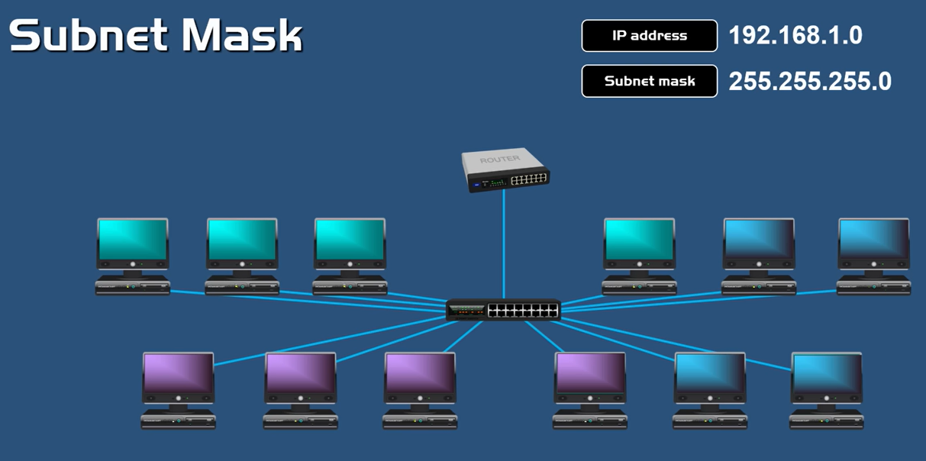

*If we want to get break this network down into 3 smaller networks or subnets, we should borrow 2 bits from the host portion. Even though we only need 3 networks, this subnet mask will give us at least 4 networks.
[We should not borrow one bit as we want the network to be broken down to 3 networks, we need to borrow 2 bits(2^2=4;2^1)]

To calculate subnet --> 2^n
To calculate valid hosts--> (2^n)-2

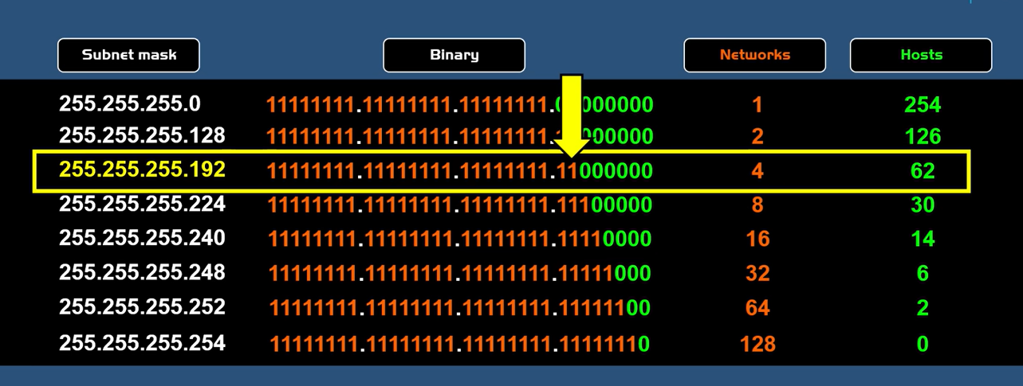

*Customized IP:255.255.255.192
We broke the larger network into 3 subnets.

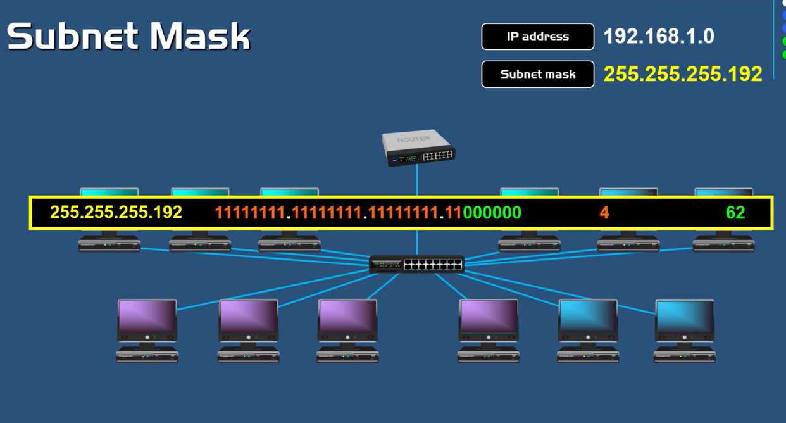

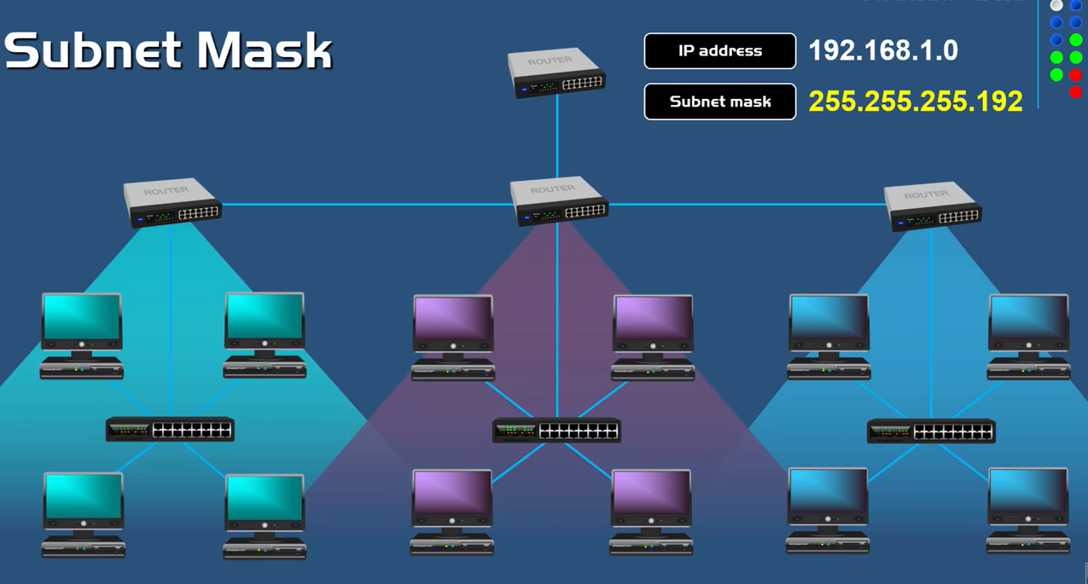

*If any organization need very large amount of hosts, they need Class A IP address.
A Class A IP address can produce up to 16 million hosts.

You can see, in a default subnet mask, the host part is very large, 3 octets are used for hosts and so it can produce so many hosts. This organization would need this many hosts would be something like internet service provider, because they would need to distribute millions of IP addresses to their customers.

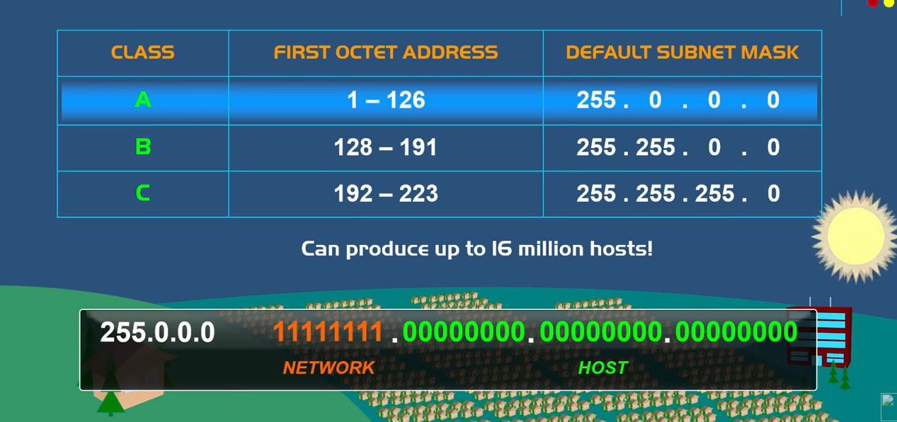

*A Class B IP address can produce up to 65,000 hosts. This class is given to medium to large organizations.

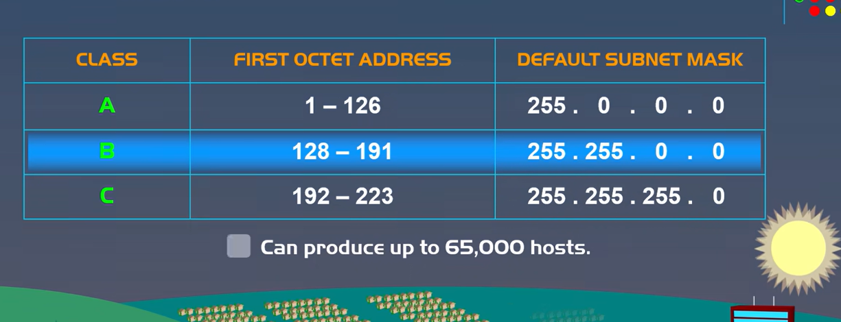

*A Class C IP address can produce up to 254 hosts. Class C IP addresses are used in small organizations and homes don't have a lot of hosts.

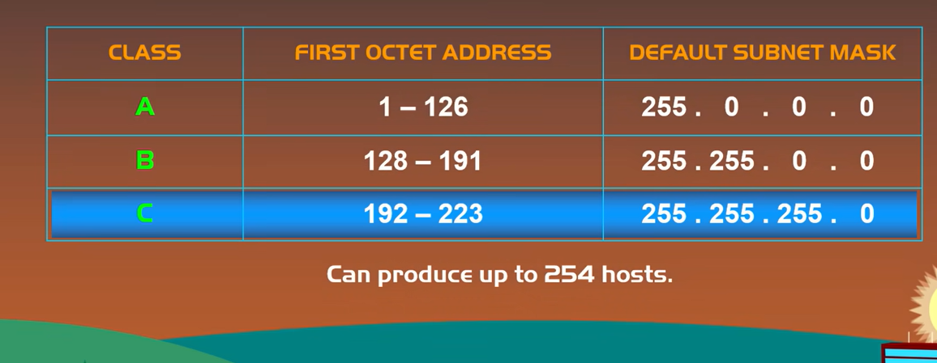

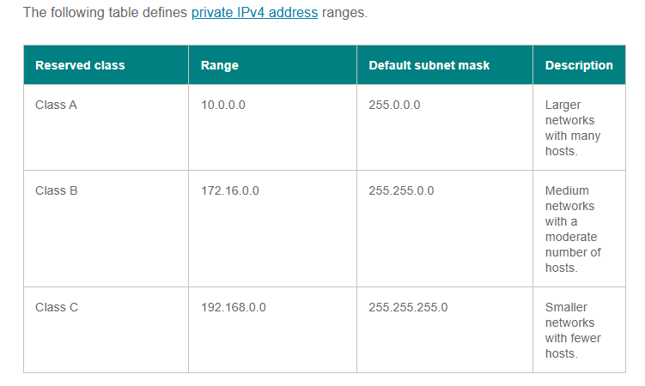

IP address classes:

IPv4 addresses divide into five classes. The primary difference between the first three classes -- Class A, Class B and Class C -- is the number of subnets versus the number of hosts per subnet.

*Class A, Class B and Class C is using for Commercial purpose.
(Commercial- connected with buying and selling goods and services.)

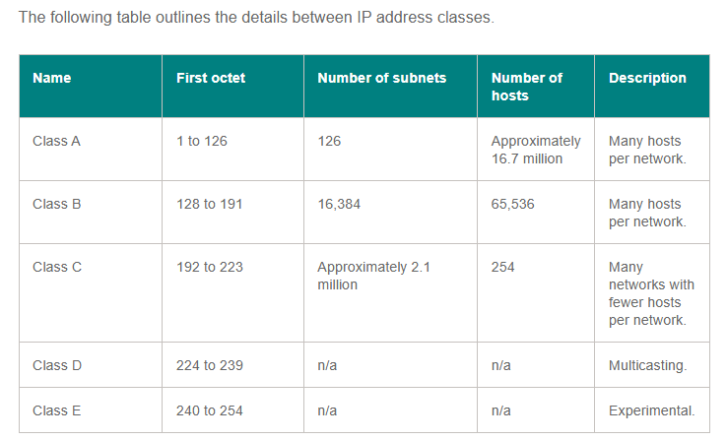

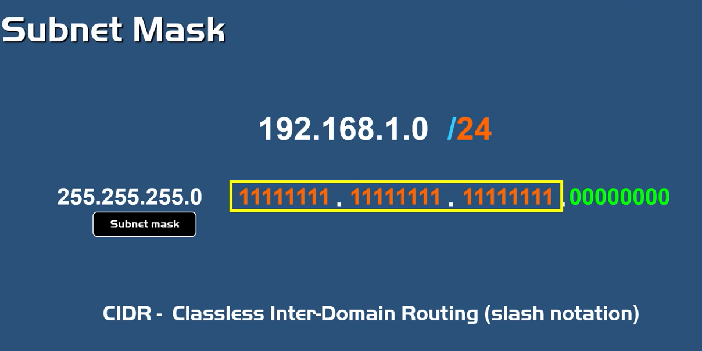

* With the help of IP Address and Subnet mask, we can find the Network Address and Host Address.
Ex: 192.168.1.0/28 Or

The very first 24 bits --> Network Address
The remaining 4 bits --> Host Address (1 host)--> 2^4 =16 hosts will be there --> 16-2=14 valid Hosts.

Host part identifies the host (computer); the other part (Network Part) identifies which network it belongs to.

*Subnetting will be done with the help of IP address and default subnet mask.
*Subnetting will be done by "Changing the default subnet mask (Ex:255.255.255.0) by borrowing some of the bits from the host portion."
*Host=IP address.

We can find the no. of subnets and valid hosts, after subnetting.

Subnet = Networks
Host = IP Address

Finding no. of subnets hosts using bits --> 2^n
Finding no. of IPs /valid hosts using bits--> (2^n)-2 Or Finding no. of IPs using Subnet mask --> 2^(32-Subnet mask)-2

Subnet Mask Cheat Sheet

*Why we are borrowing bits from left to right?
Bits with a lower number have less weight.

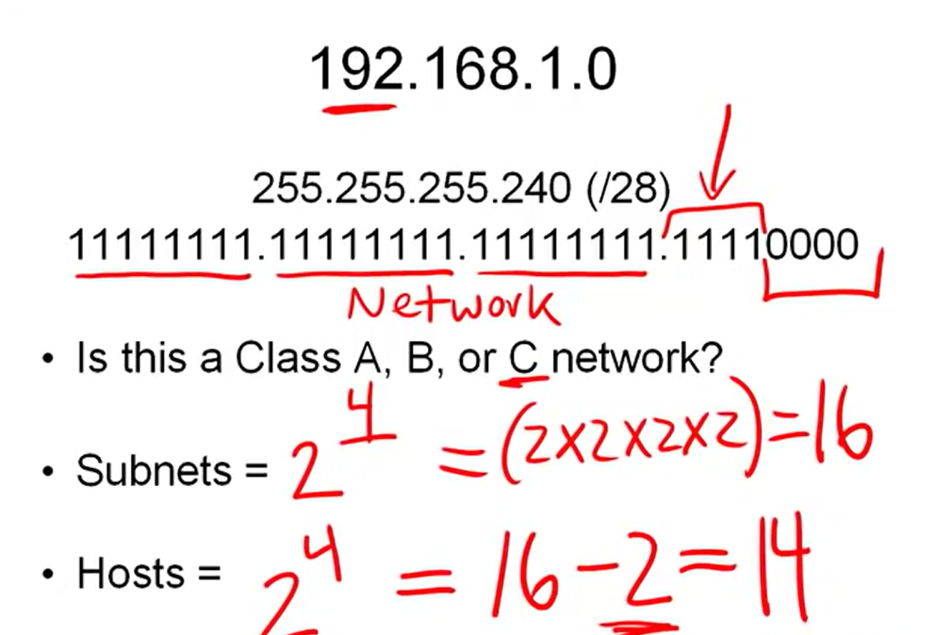

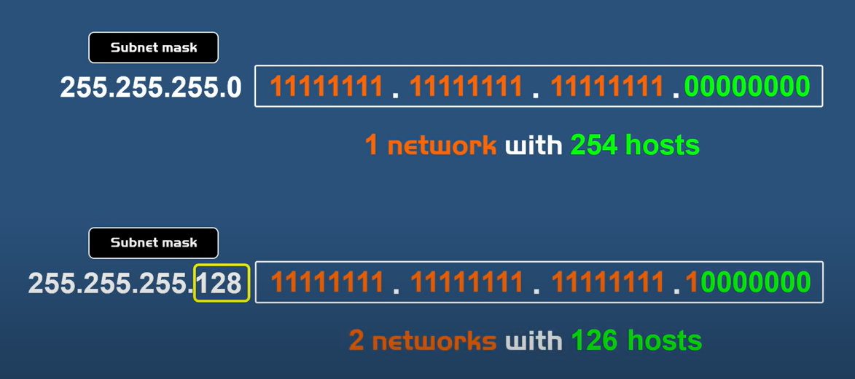

*How many IPs is 22?
/22 (255.255. 252.0) – 1,024 IPs / 1,022 usable.
CIDR Base IP and Broadcast IP is not usable.

Finding no. of IPs using Subnet mask --> 2^(n-Subnet mask)
Ex: 10.244.4.0/22--> for the prefix length /22 you have 2^(32–22) = 2^10 = 1024 addresses --> 1,022 usable addresses.

*The first address in a subnet is the network address (10.244.4.0) and the last number is the broadcast address.

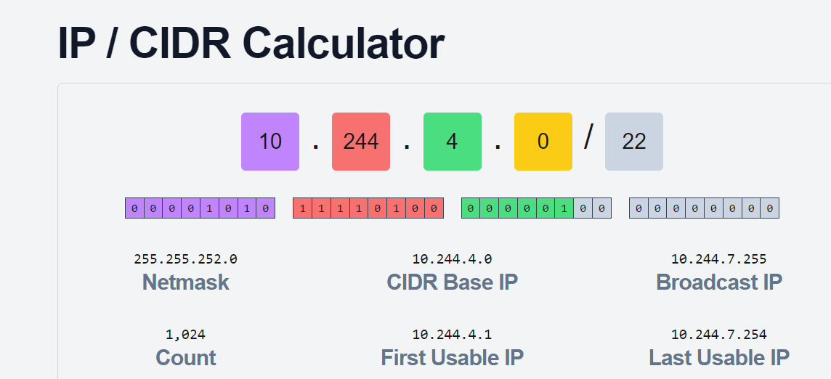

*Why does an IP address have a network and host part?
The reason is manageability .It's for breaking down a larger network into a smaller network or subnetworks, which is known as subnetting.
In a larger network, if one computer wants to communicate with the other, then it will send the Broadcast IP to all to find out the target one.

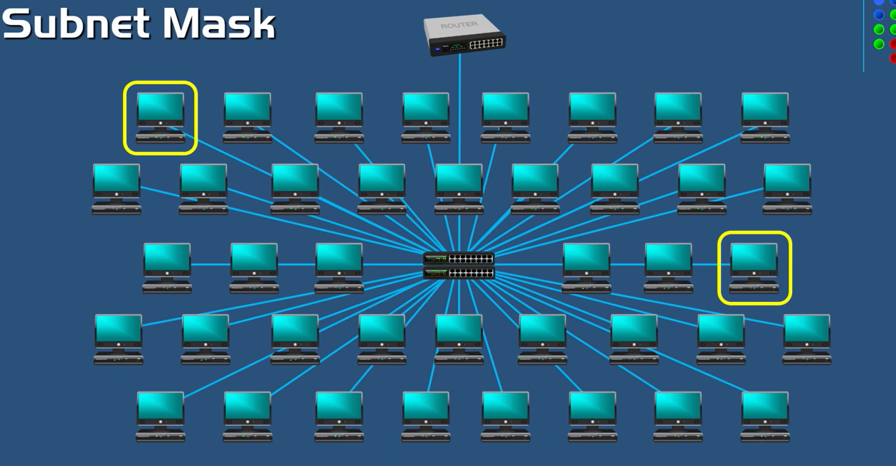

*The problem is that, if it sends the broadcast, then every computer on the network will also receive the broadcast.

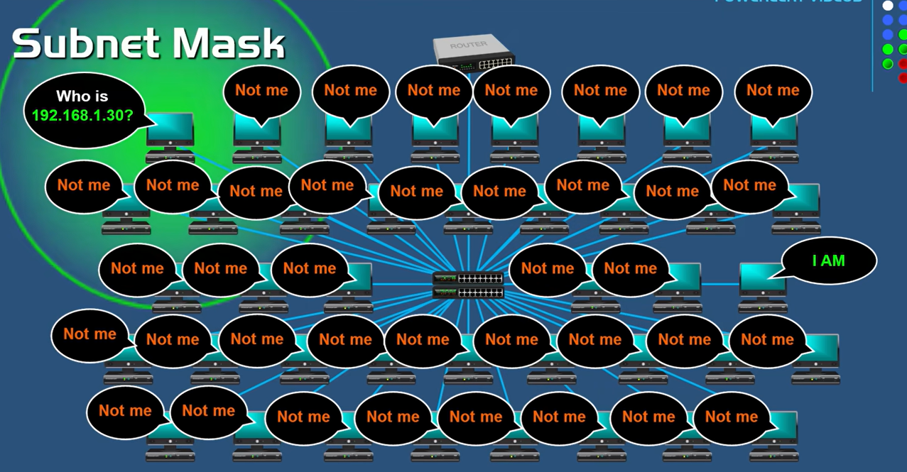

*Every computer on this larger network sends broadcast to every other computer, just to communicate, it would be chaos. It will slow down the traffic and brings tremendous amount of broadcast traffic.

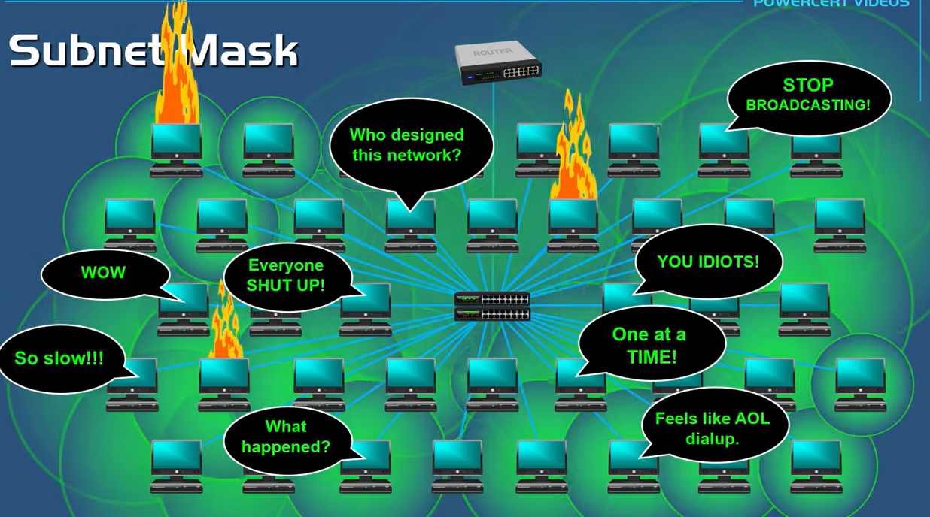

*In order to prevent this, networks are broken down (subnetting) and physically separated by using routers.
Using "Router" we can alleviate this problem, "Broadcasts do not pass routers".

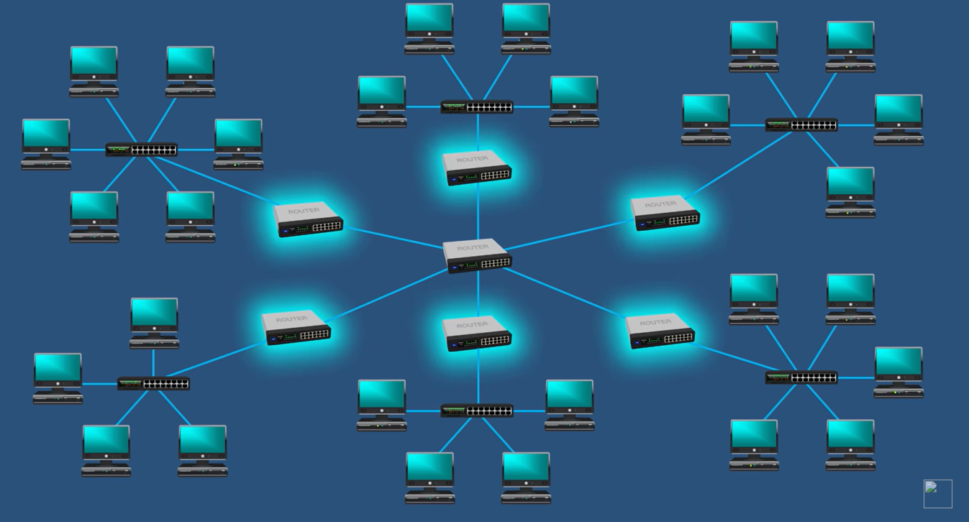

Broadcasts stay within the network, instead of moving to the large network, making the network broken down into subnetworks or subnets.(For instance, 6 subnets(In Colors) here)

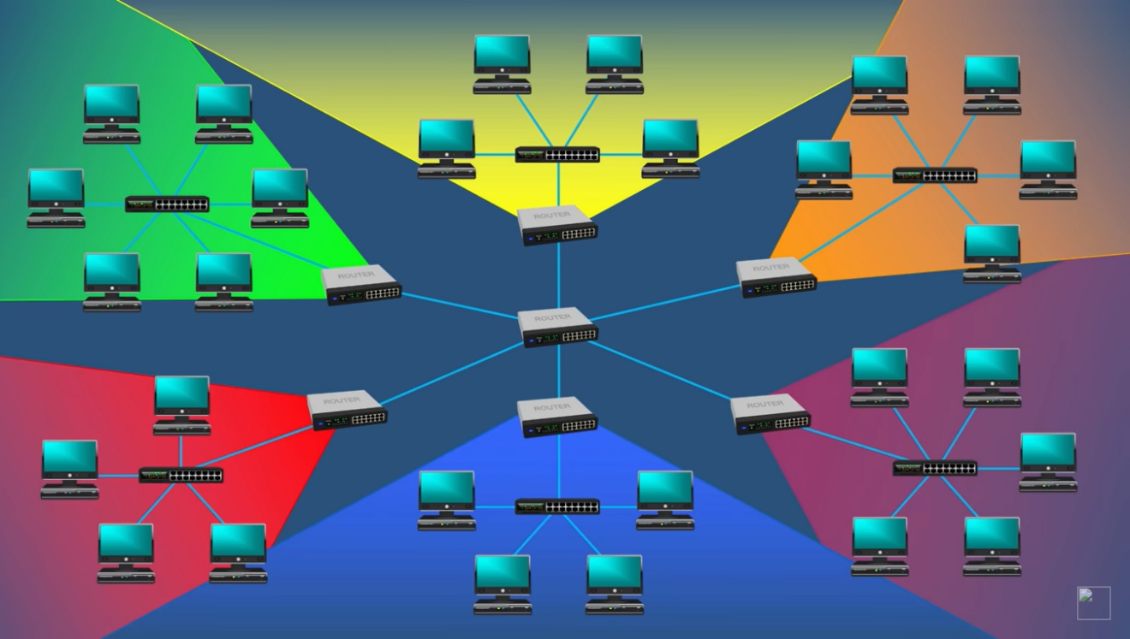

(In a larger network, if one computer wants to communicate with the other, then it will send the Broadcast IP to all to find out the target one).

After breaking into small networks, if one computer wants to communicate with the other , then the broadcast will receive to only the computers in its subnetworks, no other computers will receive this broadcast in this larger network.

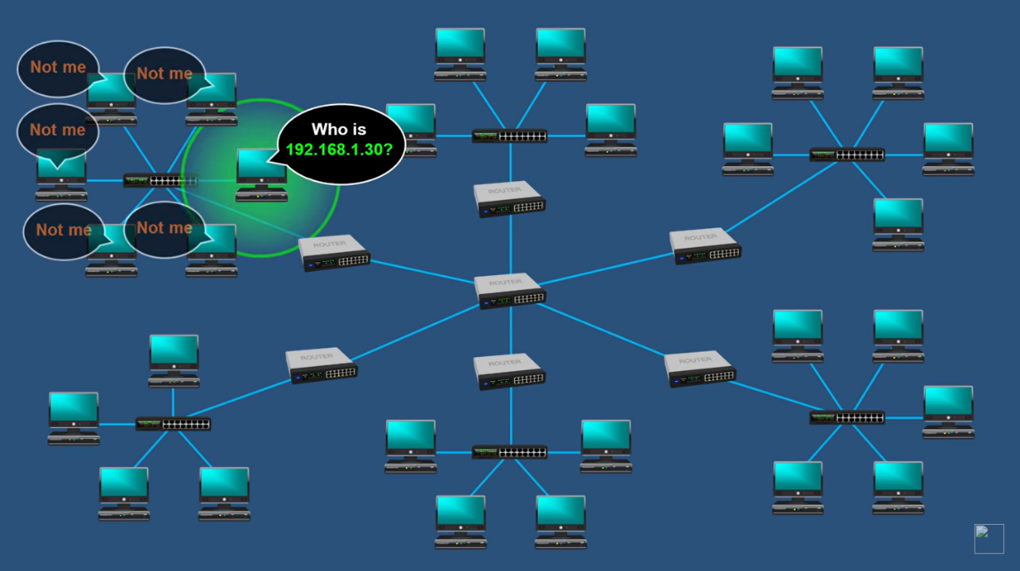

*Since the target computer which is on different subnet, the data will sent to the "Default gateway which is called Router". Then the Router will intelligently "Route data to the destination".

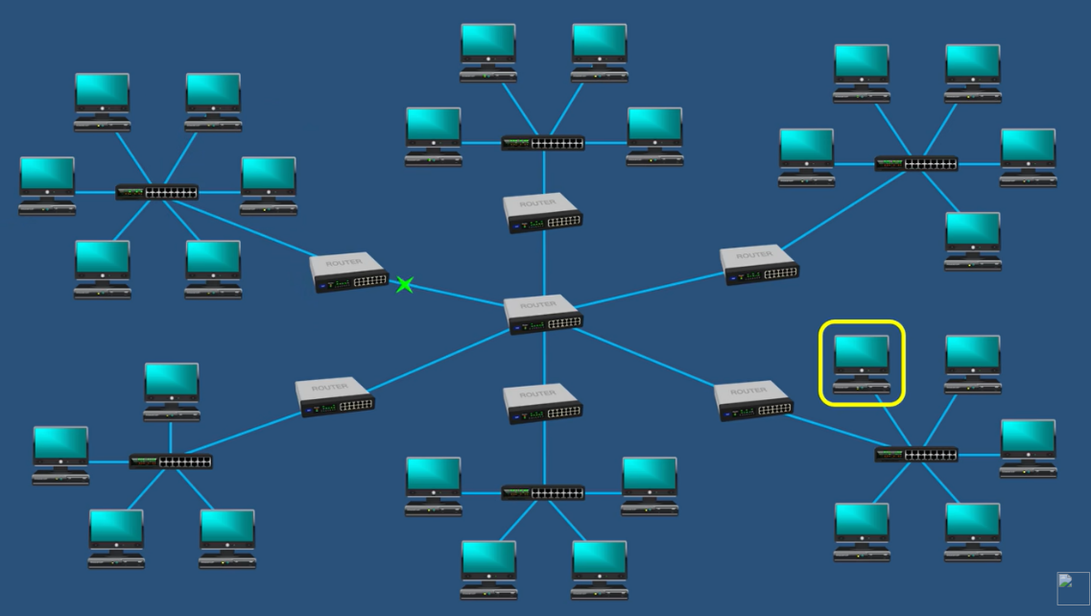

Q&A:
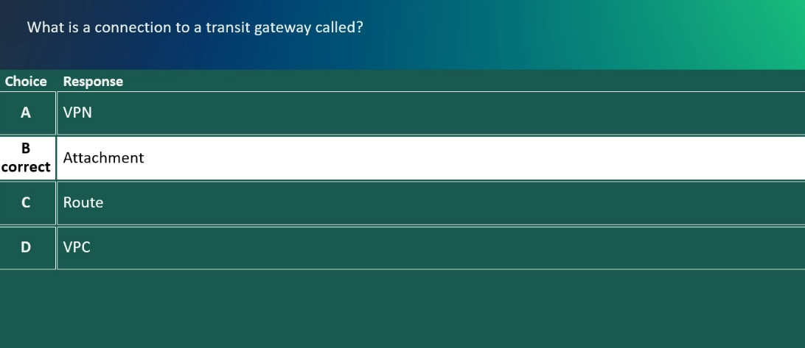

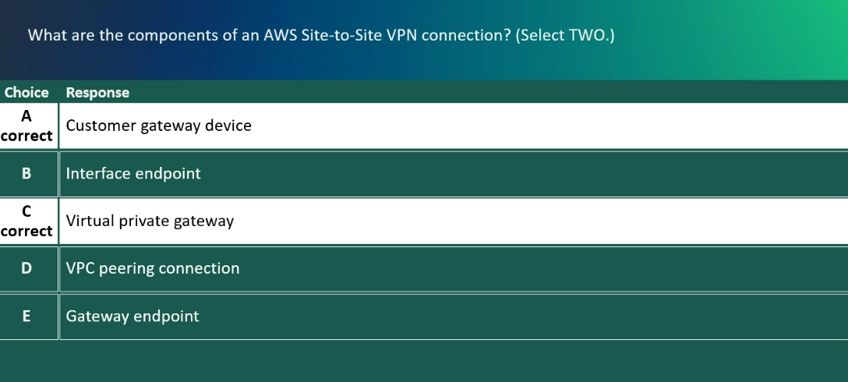

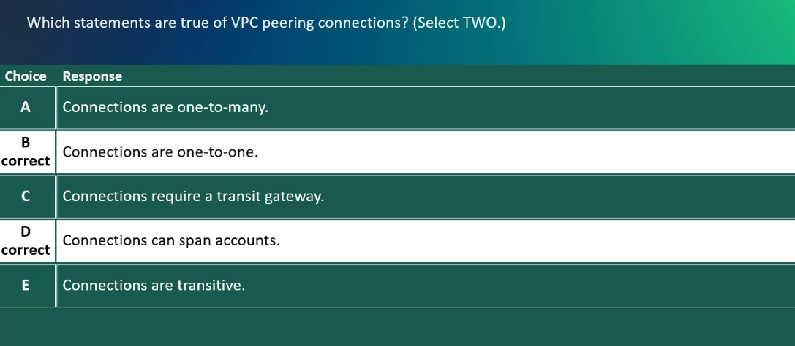

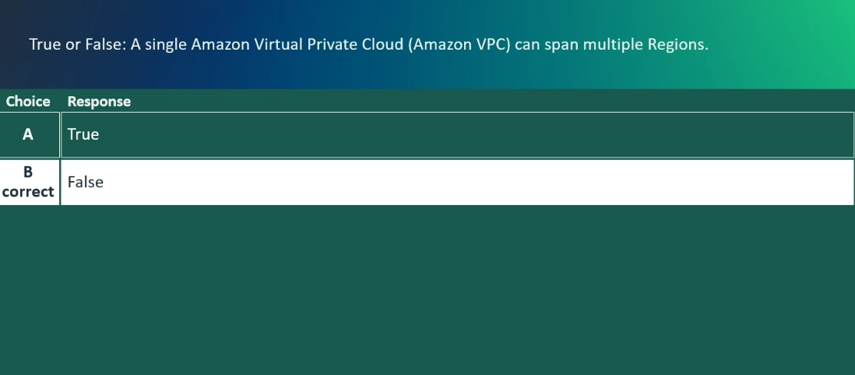

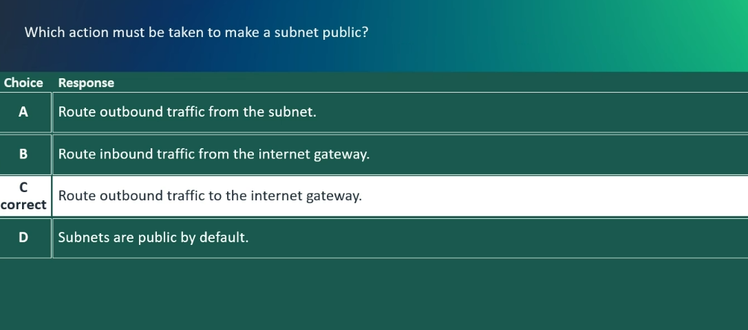

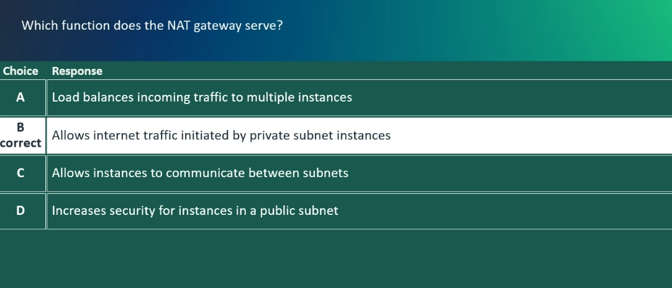

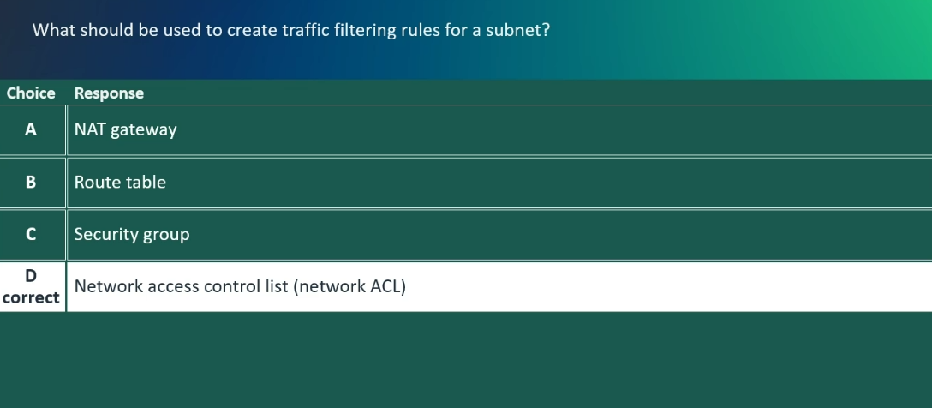

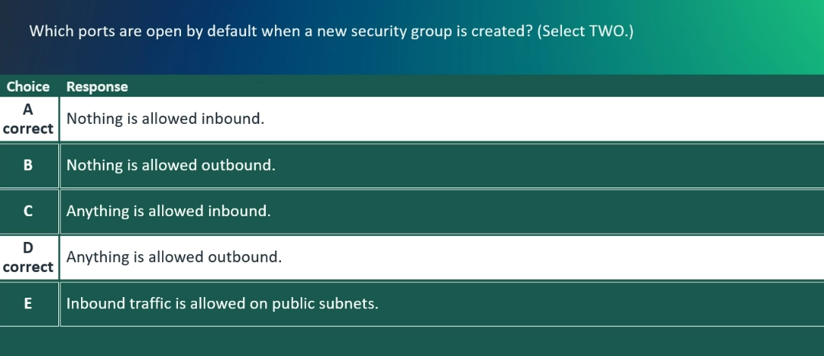
Others:
* If you have many VPCs (5+), multiple AWS accounts, hybrid cloud requirements, or need transitive routing, AWS Transit Gateway is the recommended, scalable, and manageable solution.
*All attachments should be in the same region for "Transit Gateway".
We can share VPC to other region and from there you can connect to "Transit Gateway".
*Public Subnet:
A public subnet is a subnet that is associated with a Route Table that has a route to an Internet Gateway (Igw). This route allows access from the Public Internet to the subnet.
*All the members of a “public” subnet are able to obtain both a public and a private IP address.
Tips:
* Owner ID in AWS is indeed the AWS account ID.
*AWS sets default quota to select 3AZs while creating VPCs.
*The us-east-1 region (North Virginia) has the most Availability Zones with a total of 5.
*We can accommodate all the AZs in one VPC. (Or we can span VPC can span many AZs).
*Is it a good practice to delete default VPC?
There shouldn't be any problems if you delete the default VPC.

*for the peer VPC's CIDR range to the peering connection.

