AWS Cloud Project: Fitness Tracker Deployment
This document describes the end-to-end implementation of a Fitness Tracker application deployed on AWS EC2 with MongoDB, AWS Secrets Manager, AWS KMS, and Amazon S3 integration.

1. Project Overview
The Fitness Tracker application is a monolithic Node.js backend deployed on an EC2 instance. It uses MongoDB for database storage and AWS services for security, secrets management, encryption, and log storage.
Fitness Tracker Application – Business Requirements
1. 📌 Business Objective
The Fitness Tracker application is designed to help users track, manage, and improve their fitness journey through a simple digital platform. It aims to provide personalized fitness tracking, goal setting, and progress monitoring in a secure and scalable cloud-based system.

2. 🎯 Business Requirements
2.1 User Management
- Users should be able to register and log in securely.
- Role-based access (Client / Admin / Trainer).
- Passwords must be securely encrypted.

2.2 Fitness Goal Tracking
- Users can set fitness goals such as:
  - Weight loss
  - Muscle gain
  - Daily activity targets
- System should track progress against goals.

2.3 Activity Management
- Users can log daily activities:
  - Workouts
  - Calories burned
  - Exercise duration
- Historical activity data should be stored and retrievable.

2.4 Progress Monitoring
- Dashboard should show:
  - Weekly / monthly progress
  - Graphical representation of fitness data
- Enable comparison between past and current performance.

2.5 Secure Data Storage
- All sensitive data must be encrypted using AWS KMS.
- User credentials and secrets must be stored in AWS Secrets Manager.
- Media/files (if any) should be stored in Amazon S3.

2.6 Scalability & Availability
- Application must run on cloud infrastructure (AWS EC2).
- Should support future scaling using Load Balancer and Auto Scaling Group.
- High availability with minimal downtime.

2.7 Performance Requirement
- API response time should be under 2 seconds.
- System should support concurrent users without failure.

3. 🔐 Security Requirements
- HTTPS communication via Nginx reverse proxy.
- IAM-based access control for AWS services.
- Secure secret management (no hardcoded credentials).
- Logging and monitoring using CloudWatch.

4. 📊 Business Alignment with Cloud Architecture
4.1 Cloud-Native Architecture
The application is deployed using AWS cloud services to ensure reliability and scalability:
- EC2 → Hosts Node.js backend application
- Nginx → Acts as reverse proxy and load handler
- PM2 → Ensures application uptime and process management
- MongoDB → Stores user and fitness data
- S3 → Stores static files and media content
- KMS → Encrypts sensitive data
- Secrets Manager → Securely manages DB credentials

4.2 Business Value Mapping
Business Need | Technical Solution
Secure user authentication | Encrypted passwords + Secrets Manager
Data reliability | MongoDB + EC2 persistence
Scalability | EC2 + Load Balancer ready architecture
Performance | Nginx reverse proxy + PM2 clustering
Data security | AWS KMS encryption
File storage | Amazon S3 integration
Monitoring | CloudWatch logs

4.3 Business Impact
- Improves user fitness awareness and consistency
- Provides centralized health tracking system
- Reduces manual tracking effort
- Enables cloud-based secure access anytime, anywhere
- Supports future expansion into mobile apps and AI fitness recommendations

2. EC2 Deployment
The application is deployed on an AWS EC2 Ubuntu instance. Node.js and PM2 are used to run and manage the backend service.
Steps performed:
• Installed Node.js and dependencies
• Cloned GitHub repository
• Started application using PM2
• Verified API endpoints using curl/browser

Application test Script:
#!/bin/bash

set -e

cd /home/ubuntu

# Update system
apt-get update -y

# Install required packages
apt-get install -y nginx git nodejs npm

# Clone project
git clone https://github.com/PaviTechDeveloper/Fitness_Tracker

# Configure Nginx reverse proxy
cat <<EOF > /etc/nginx/sites-available/custom
server {
listen 80;
server_name _;

location / {
proxy_pass http://localhost:5000;
proxy_http_version 1.1;
proxy_set_header Upgrade \$http_upgrade;
proxy_set_header Connection 'upgrade';
proxy_set_header Host \$host;
proxy_cache_bypass \$http_upgrade;
}
}
EOF

# Enable site
ln -sf /etc/nginx/sites-available/custom /etc/nginx/sites-enabled/custom

# Remove default nginx config
rm -f /etc/nginx/sites-enabled/default

# Restart nginx
systemctl restart nginx

# Move to backend folder
cd /home/ubuntu/Fitness_Tracker/server

# Install dependencies
npm install

# Install PM2
npm install -g pm2

# Start application
pm2 start app.js --name "fitness-app"

pm2 save
pm2 startup systemd -u ubuntu --hp /home/ubuntu

3. MongoDB Setup
MongoDB is installed on the EC2 instance and used as the primary database for storing user and fitness data.

4. AWS Secrets Manager Integration
AWS Secrets Manager is used to securely store MongoDB configuration details such as host, port, and authentication source.
Placeholder for Secrets Manager Output Screenshot:
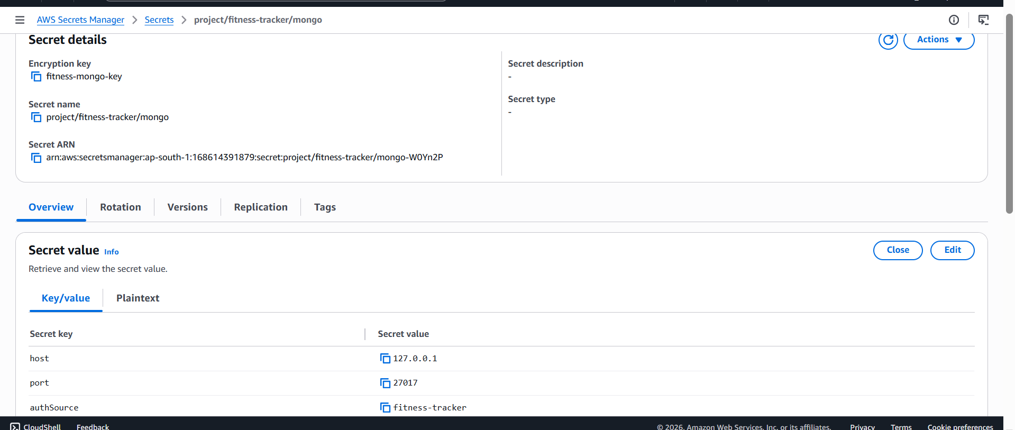
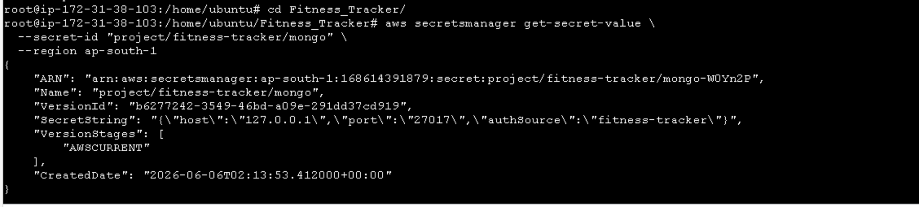

5. AWS KMS (Key Management Service)
AWS KMS is used to encrypt secrets stored in AWS Secrets Manager, providing an additional security layer.
Placeholder for KMS Output Screenshot:
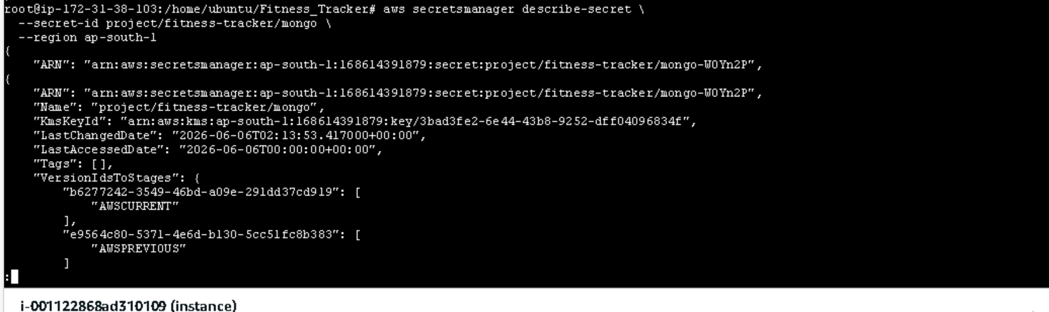

6. Amazon S3 Integration
Amazon S3 is used for storing application logs, error logs, and MongoDB backups.
S3 folder structure:
• logs/app/
• logs/errors/
• audit/auth/
• backups/mongodb/
Placeholder for S3 Output Screenshot:
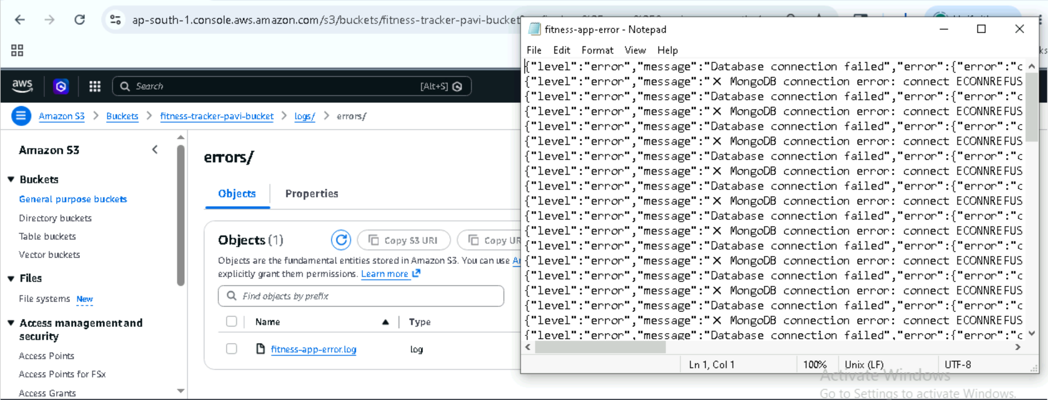

7. PM2 Process Management
PM2 is used to run the Node.js application in production mode and manage logs and process lifecycle.

8. Security Architecture
The system follows a secure architecture using IAM roles, AWS Secrets Manager, and KMS encryption. No credentials are hardcoded in the application.

9. Overall Architecture Flow
User → EC2 (Node.js App) → MongoDB
↓
AWS Secrets Manager (Encrypted by KMS)
↓
Amazon S3 (Logs & Backups)

