­­­­ Experiment 020 Thing Speak

Overview

In this experiment, you will use the use the ESP8266 Wifi module to upload sensor data to the Thing Speak web server.

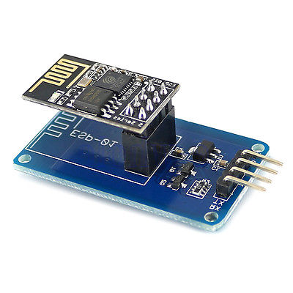

Outcomes

By the end of this experiment you will be able to:

* Configure the ESP8266 via the AT command set.
* Connect the ESP8266 to a wifi access point.
* 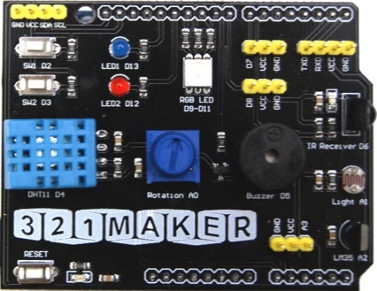Setup a Thingspeak account.
* Upload sensor data to the Thingspeak Cloud

REquirements

* Arduino-Compatible board
* 321Maker Things Shield & USB cable
* ESP8266 Wifi module with serial adapter board.
* Arduino Software

PREREQUISITES

* Getting Started Tutorial: <http://321maker.com/start>
* ESP8266 Command Reference: <https://git.io/vXG8o>
* Source Code: On Blackboard.

Video Tutorial

<http://youtube.com/indevelopment>

Background

**ESP8266**

The ESP8266 WiFi Module contains and integrated TCP/IP protocol stack that can give any microcontroller access to your WiFi network. The ESP8266 is capable of either hosting an application or offloading all Wi-Fi networking functions from another application processor. Each ESP8266 module comes pre-programmed with an AT command set firmware, meaning, you can simply hook this up to your Arduino device and connect your programs to the Internet of Things in order to communicate with the ESP8266 you use a serial connection.

This Speak is an Open source data platform for Internet of Things (IoT) devices. Thingspeak can securely collect, analyze and visualize sensor data, as well as trigger a reaction to events.

Level 1 procedure

* Connect your Arduino to your computer using the USB port. Open the Arduino software.
* Click on **File,** **Examples**, **04.Communications**, **SerialPassthrough**
* Modify Line 28 of this program from

**Serial1.begin(9600);**

To

**Serial1.begin(115200);**

* Make sure you have the correct Arduino Board and Communications port setup.
* Click the upload button in the upper left corner to compile and upload the code to the Arduino device. If you see an Orange error in the bottom of your screen, then something went wrong.
*  Open the serial Monitor window. (CTRL-SHIFT-M) Make sure your serial port settings are as follows.
* Connect the ESP8266 to the 321Maker board. In the upper right hand corner. Make the following connections.

**321Maker Board ESP8266**

GND ------ GND

VCC ------ VCC

RXD ------ TX

TXD ------ RX

* Enter the command **AT+RST** into the serial monitor textbox and press enter.
* This command should reset the ESP8266. You should see the ESP8266 output the reboot.
* Enter the following command **AT+CWMODE=1** the ESP8266 chip should say ok. This makes sure the ESP8266 is in client mode.
* To connect the ESP8266 to a wireless network use the following command.
* **AT+CWJAP="SSID","PASSWORD"** if your access point has no pass you command will look like this. **AT+CWJAP="SSID",”"** The SSID is the name of the wireless network.

**NOTE: The SSID is case sensitive.**

* Unplug and plug in the ESP8266 GND wire to reboot the ESP8266. It should remember the network name and password.

Experiment 020 Think Speak

Level 2 Program Modification­­

* Download the Thing Speak code as directed by your instructor.
* Setup you Thing Speak Account as shown in class.

LEVEL 3 Advanced Application

* Modify the Thing Speak program to upload the value from another sensor value on the board. IE) Humidity, Rotation, light or push button.

Level 4 Project Challenege

* **TBD**