Module V – Internet of Things

Course Overview
The Internet of Things (IoT) Laboratory is designed to provide practical exposure to the concepts of IoT systems, including sensing, communication, networking, and cloud integration. The laboratory emphasizes hands-on implementation using embedded systems, enabling students to understand the end-to-end workflow of IoT applications.

Course Objectives
- To understand the architecture and building blocks of IoT systems
- To interface sensors and actuators with embedded platforms
- To implement web-based monitoring and control systems
- To develop communication systems using IoT protocols such as MQTT
- To integrate IoT devices with cloud platforms for data logging and monitoring
- To design and implement complete IoT applications

Hardware and Software Platform

Hardware
- ESP32 Development Board
- Sensors: DHT11/DHT22, LDR
- Actuators: LED, Relay Module
- Breadboard, jumper wires, resistors

Software
- Arduino IDE
- MQTT Client and Broker (e.g., HiveMQ)
- Cloud Platform (e.g., Firebase)

General Instructions
- Verify all hardware connections before powering the system
- Use appropriate GPIO pins as per the microcontroller specifications
- Ensure stable Wi-Fi connectivity during experiments involving networking
- Use serial debugging tools for troubleshooting
- Maintain proper documentation of observations and results

Experiment 1

Title
Implementation of Sensor Data Acquisition System using ESP32

Aim
To acquire temperature and light intensity data using ESP32.

Components Required
- ESP32 Development Board
- DHT11 Sensor
- LDR
- 10kΩ Resistor
- Breadboard and Jumper Wires

Theory
Sensors provide input to IoT systems by converting physical parameters into electrical signals. The ESP32 reads digital data from DHT11 and analog data from LDR using its ADC.

Procedure
- Connect DHT11 (VCC → 3.3V, GND → GND, DATA → GPIO 4).
- Connect the LDR in a voltage divider to GPIO 34.
- Power the ESP32.
- Open Arduino IDE and install the DHT library.
- Upload the program.
- Open Serial Monitor (9600 baud).
- Observe readings and record values.

Code

#include "DHT.h"

#define DHTPIN 4
#define DHTTYPE DHT11

#define LED_PIN 2 // Built-in LED (usually GPIO 2)

DHT dht(DHTPIN, DHTTYPE);

int ldrPin = 34;

void setup() {
Serial.begin(9600);
dht.begin();

pinMode(LED_PIN, OUTPUT); // Set LED pin as output
}

void loop() {
float temp = dht.readTemperature();
int light = analogRead(ldrPin);

Serial.print("Temp: ");
Serial.println(temp);

Serial.print("Light: ");
Serial.println(light);

// Simple logic to control built-in LED
if (light < 2000) { // Dark condition (adjust threshold as needed)
digitalWrite(LED_PIN, HIGH); // LED ON
} else {
digitalWrite(LED_PIN, LOW); // LED OFF
}

delay(2000);
}

Observation Table Temperature
Time (s) | Temperature (°C)
1 | 31.9
2 | 32.0
3 | 32.0
4 | 32.0
5 | 32.0

Output Image for temperature
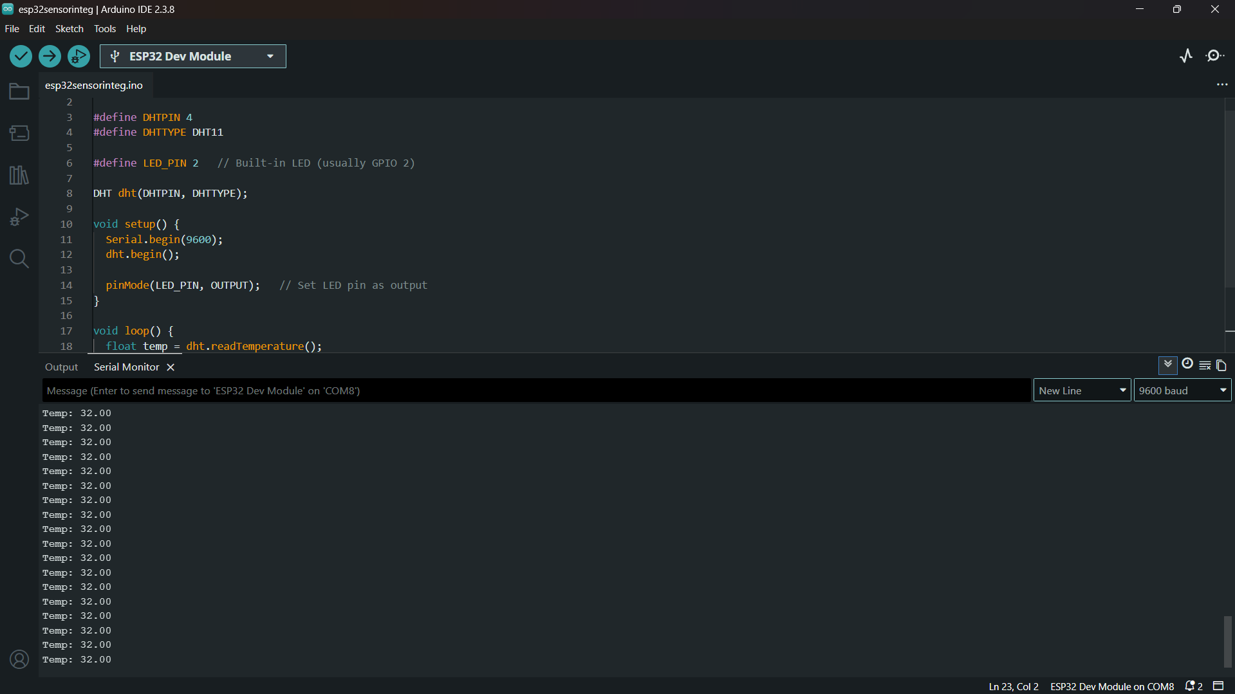

Observation Table Light
Light Value | Condition (Bright / Dark)
1 | 31.9
2 | 32.0
3 | 32.0
4 | 32.0
5 | 32.0

Output Image for temperature:
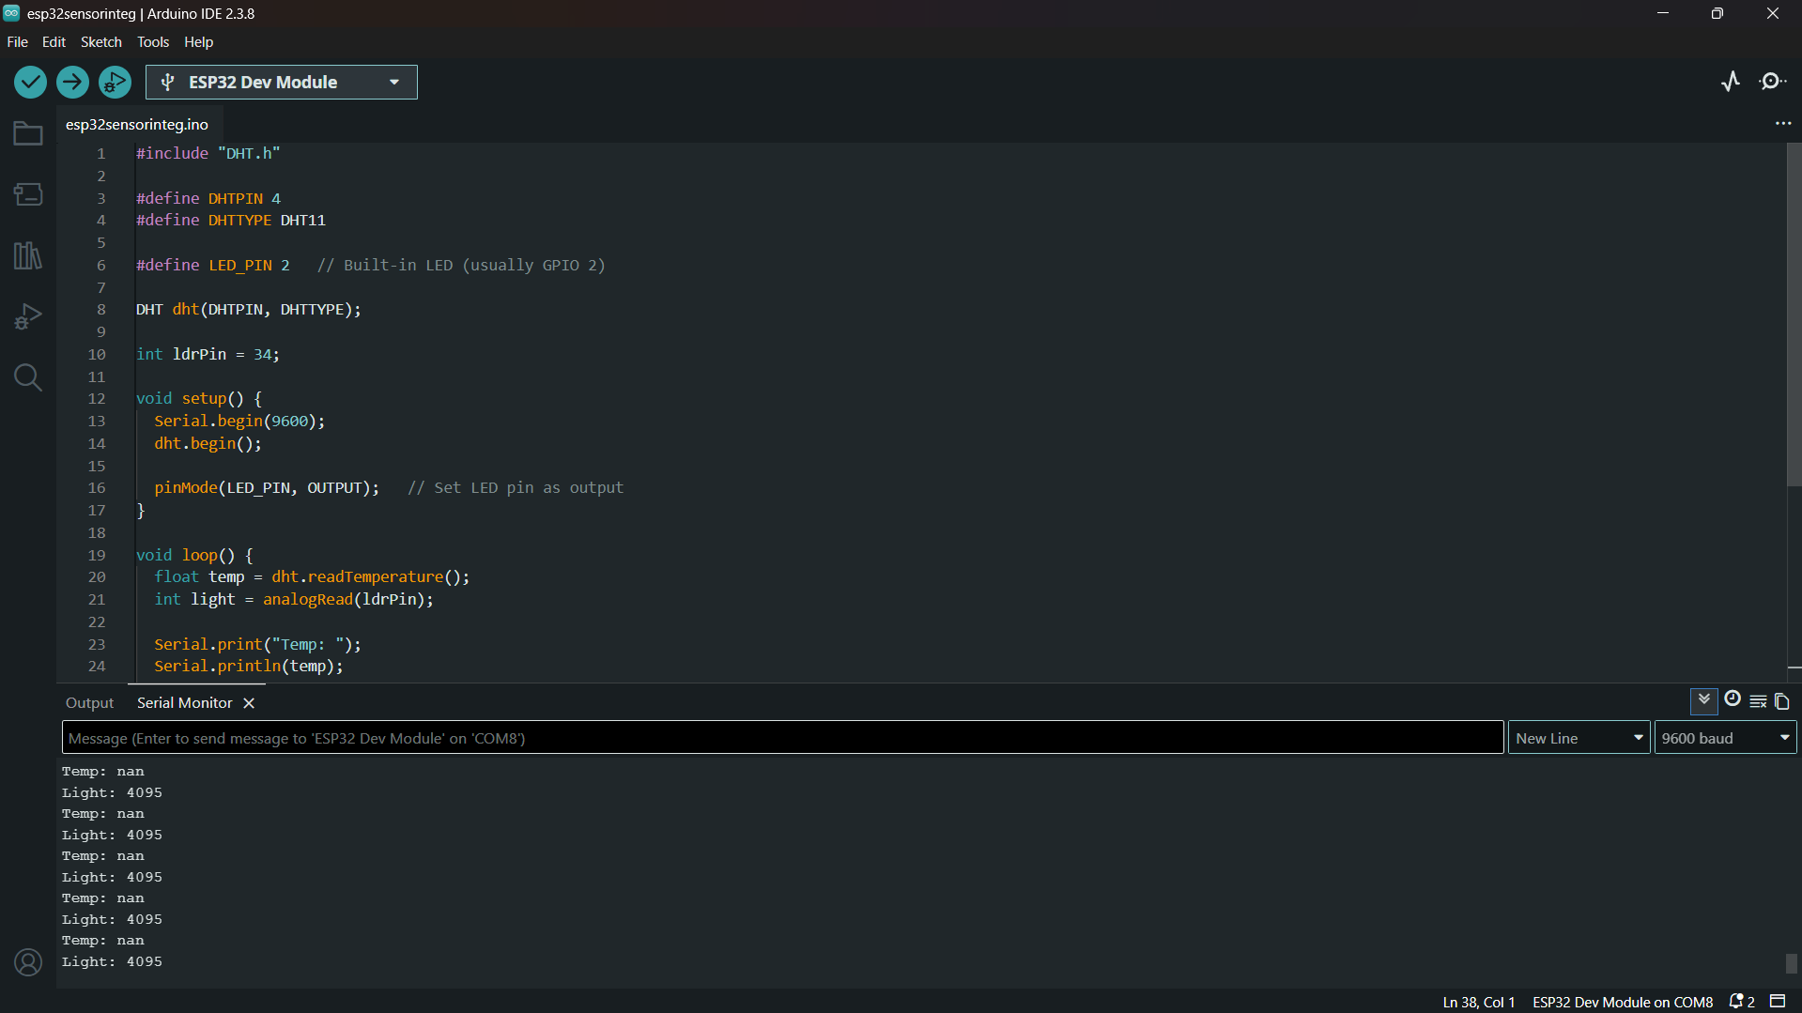

Result
Sensor data was successfully acquired using ESP32, and the Built-in LED Turn on.

Experiment 2 - Design of Web-Based LED Control System using ESP32

Aim
To control an LED using a web browser.

Components Required
- ESP32
- LED
- 220Ω Resistor

Theory
ESP32 acts as a web server and responds to HTTP requests from a browser to control hardware.

Procedure
- Connect the LED to GPIO 2 with a resistor.
- Enter WiFi credentials in code.
- Upload program.
- Open the Serial Monitor to get an IP address.
- Enter the IP in the browser.
- Control the LED using a webpage.

Code

#include <WiFi.h>

const char* ssid = "YOUR_WIFI";
const char* password = "YOUR_PASSWORD";

WiFiServer server(80);
int ledPin = 2;

void setup() {
Serial.begin(115200);
pinMode(ledPin, OUTPUT);

WiFi.begin(ssid, password);
while (WiFi.status() != WL_CONNECTED) {
delay(1000);
}

Serial.println(WiFi.localIP());
server.begin();
}

void loop() {
WiFiClient client = server.available();
if (client) {
String request = client.readStringUntil('\r');

if (request.indexOf("/ON") != -1) digitalWrite(ledPin, HIGH);
if (request.indexOf("/OFF") != -1) digitalWrite(ledPin, LOW);

client.println("HTTP/1.1 200 OK");
client.println("Content-Type: text/html\n");
client.println("<a href=\"/ON\">ON</a><br>");
client.println("<a href=\"/OFF\">OFF</a>");
client.stop();
}
}

Observation Table
Action |  | LED Status
ON |  | ON
OFF |  | OFF

Output Image

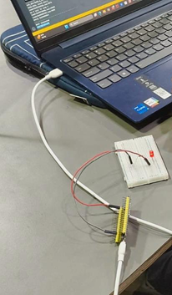

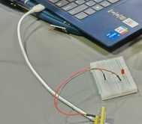

Result
The LED was successfully controlled using a web interface,

Experiment 3

Title
Voice-Controlled Smart Lighting System using ESP32, Adafruit IO, IFTTT, and Relay Module

Aim
To control a 240V AC bulb using voice commands by integrating ESP32 with Adafruit IO cloud and IFTTT platform.

Objectives
- To understand cloud-based IoT communication
- To implement MQTT-based data exchange using Adafruit IO
- To integrate voice control using IFTTT and Google Assistant
- To safely control an AC load using a relay module

Components Required
- ESP32 Development Board
- 1-Channel Relay Module (5V, opto-isolated preferred)
- AC Bulb with holder
- Connecting wires
- Breadboard (for ESP32 side only)

Software / Platforms
- Adafruit IO
- IFTTT
- Google Assistant
- Arduino IDE

Theory
This experiment demonstrates a cloud-mediated IoT control system.

Working Principle
- User gives voice command
- Google Assistant triggers IFTTT
- IFTTT updates a feed in Adafruit IO
- ESP32 subscribes to that feed via MQTT
- ESP32 receives updated value
- Relay is triggered
- AC bulb turns ON/OFF

Circuit Connections

ESP32 to Relay
Relay Pin | ESP32 Connection
VCC | VIN / 5V
GND | GND
IN | GPIO 2

AC Bulb Wiring
Connection | Description
Live Wire | Connected to COM
NO Terminal | Connected to Bulb Live
Neutral | Directly to Bulb

Safety Precautions
- Ensure power is OFF while wiring AC connections
- Do not touch live wires
- Use insulated connectors
- Perform under supervision
- Prefer enclosed relay setup

Procedure

Step 1: Adafruit IO Setup
- Create an account in Adafruit IO
- Navigate to “Feeds”
- Create new feed:
- led-control

- Note:
  - Username
  - AIO Key

Step 2: ESP32 Programming
- Open Arduino IDE
- Install:
  - Adafruit MQTT Library
  - Adafruit IO Library
- Enter:
  - WiFi credentials
  - Adafruit username
  - AIO key
- Upload program
- Open the Serial Monitor to confirm the connection

Step 3: IFTTT Configuration
- Create a new Applet
- Select Google Assistant as a trigger
- Configure phrase:
  - “Turn on light.”
- Select Adafruit IO as an action
- Set:
  - Feed: led-control
  - Data: ON
Repeat for OFF command

Step 4: System Testing
- Power the ESP32
- Ensure WiFi connection
- Say:
  - “Turn on light.”
  - “Turn off light.”
- Observe relay switching
- Verify bulb ON/OFF

Code
#include <WiFi.h>
#include "Adafruit_MQTT.h"
#include "Adafruit_MQTT_Client.h"

#define WIFI_SSID "YOUR_WIFI"
#define WIFI_PASS "YOUR_PASSWORD"

#define AIO_SERVER "io.adafruit.com"
#define AIO_SERVERPORT 1883
#define AIO_USERNAME "YOUR_USERNAME"
#define AIO_KEY "YOUR_AIO_KEY"

WiFiClient client;

Adafruit_MQTT_Client mqtt(&client, AIO_SERVER, AIO_SERVERPORT, AIO_USERNAME, AIO_KEY);

Adafruit_MQTT_Subscribe ledFeed = Adafruit_MQTT_Subscribe(&mqtt, AIO_USERNAME "/feeds/led-control");

int relayPin = 2;

void setup() {
Serial.begin(115200);
pinMode(relayPin, OUTPUT);

WiFi.begin(WIFI_SSID, WIFI_PASS);
while (WiFi.status() != WL_CONNECTED) {
delay(1000);
}

mqtt.subscribe(&ledFeed);
}

void loop() {
MQTT_connect();

Adafruit_MQTT_Subscribe *subscription;
while ((subscription = mqtt.readSubscription(5000))) {
if (subscription == &ledFeed) {
String value = (char *)ledFeed.lastread;

if (value == "ON") digitalWrite(relayPin, HIGH);
else digitalWrite(relayPin, LOW);
}
}
}

void MQTT_connect() {
if (mqtt.connected()) return;

while (mqtt.connect() != 0) {
delay(5000);
}
}

Observation

Time (Seconds) | Feed Value | Relay State | Bulb Status
3 | 1 | ON | ON
6 | 0 | OFF | OFF

Output Image

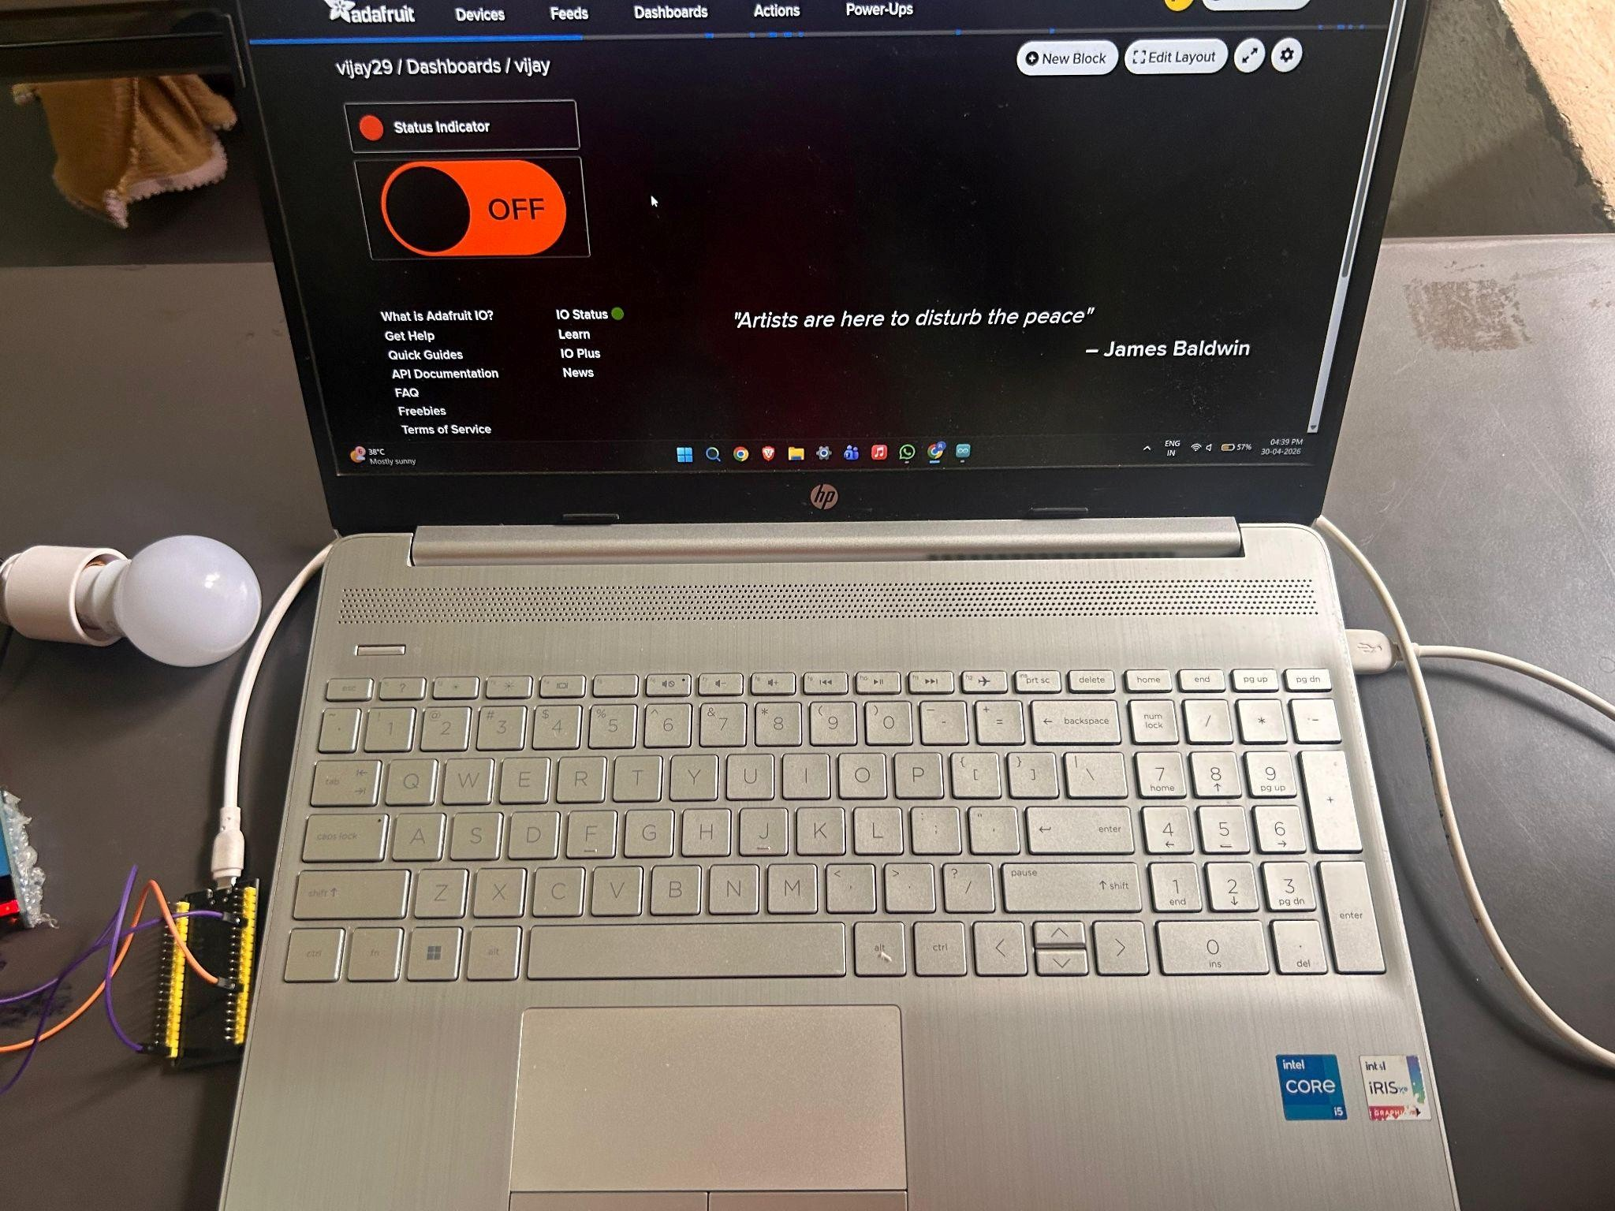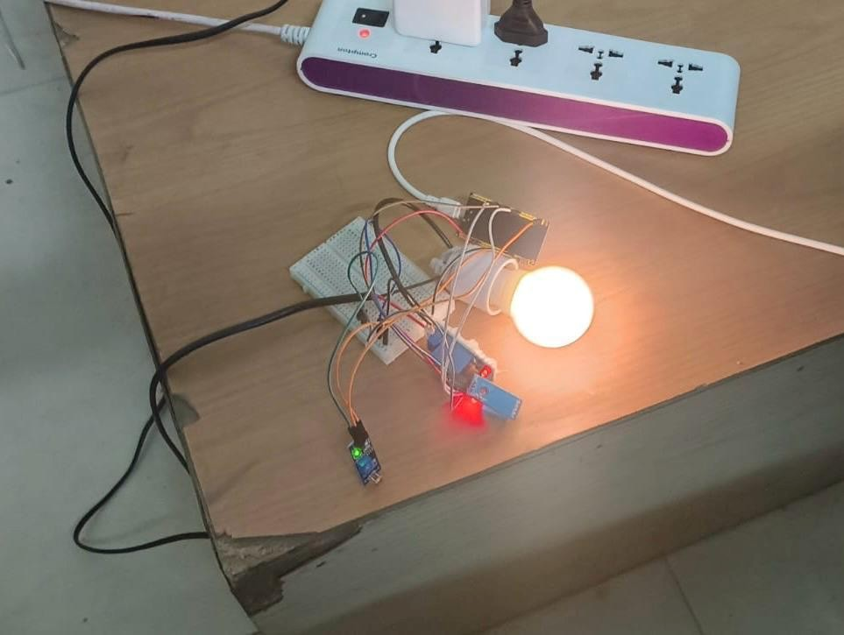

Result
The AC bulb was successfully controlled using voice commands through Adafruit IO and IFTTT integration.

Experiment 4

Title
Cloud-Based IoT Monitoring and Control using ESP32 with Firebase

Aim
To store sensor data in the cloud and control an AC bulb using Firebase and web application.

Components Required
- ESP32
- Relay Module (for 240V AC control)
- Bulb
- Sensor DHT11

Theory
Firebase acts as a real-time database:
- ESP32 sends sensor data → stored in Firebase
- Web app reads data → displays to user
- User sends command → Firebase updates
- ESP32 reads command → controls relay

Procedure

Step 1: Hardware Setup
- Connect the relay IN pin to GPIO 2
- Connect AC bulb through the relay (COM & NO terminals)
- Ensure proper isolation and safety

Firebase Setup
- Go to Firebase Console and create a new project
- Enable Realtime Database
- Select Test Mode (for lab use)
- Copy:
  - Database URL
  - API Key

- Create structure:
/control/relay : "OFF"
/sensor/value : 0

Step 3: ESP32 Programming
- Connect ESP32 to WiFi
- Use the Firebase library
- Read/write values from the database

#include <WiFi.h>
#include <Firebase_ESP_Client.h>

// WiFi credentials
#define WIFI_SSID "YOUR_WIFI"
#define WIFI_PASSWORD "YOUR_PASSWORD"

// Firebase credentials
#define API_KEY "YOUR_API_KEY"
#define DATABASE_URL "https://YOUR_PROJECT.firebaseio.com/"

// Firebase objects
FirebaseData fbdo;
FirebaseAuth auth;
FirebaseConfig config;

int relayPin = 2;
int sensorPin = 34;

void setup() {
Serial.begin(115200);

pinMode(relayPin, OUTPUT);
digitalWrite(relayPin, LOW);

WiFi.begin(WIFI_SSID, WIFI_PASSWORD);
while (WiFi.status() != WL_CONNECTED) {
delay(1000);
Serial.println("Connecting to WiFi...");
}

Serial.println("Connected to WiFi");

config.api_key = API_KEY;
config.database_url = DATABASE_URL;

Firebase.begin(&config, &auth);
Firebase.reconnectWiFi(true);
}

void loop() {

// --------- Sensor Upload ---------
int sensorValue = analogRead(sensorPin);

if (Firebase.RTDB.setInt(&fbdo, "/sensor/value", sensorValue)) {
Serial.println("Sensor updated");
} else {
Serial.println(fbdo.errorReason());
}

// --------- Read Control ---------
if (Firebase.RTDB.getString(&fbdo, "/control/relay")) {
String state = fbdo.stringData();

if (state == "ON") {
digitalWrite(relayPin, HIGH);
Serial.println("Relay ON");
} else {
digitalWrite(relayPin, LOW);
Serial.println("Relay OFF");
}
} else {
Serial.println(fbdo.errorReason());
}

delay(3000);
}

Step 4: Web App
- Create simple HTML page
- Add ON/OFF buttons
- Update Firebase value on click
<!DOCTYPE html>
<html>
<head>
<title>IoT Control</title>
</head>
<body>

<h2>ESP32 Control Panel</h2>

<button onclick="turnOn()">ON</button>
<button onclick="turnOff()">OFF</button>

<p>Sensor Value: <span id="sensor">0</span></p>

<script src="https://www.gstatic.com/firebasejs/8.10.0/firebase-app.js"></script>
<script src="https://www.gstatic.com/firebasejs/8.10.0/firebase-database.js"></script>

<script>
var firebaseConfig = {
apiKey: "YOUR_API_KEY",
databaseURL: "https://YOUR_PROJECT.firebaseio.com/"
};

firebase.initializeApp(firebaseConfig);
var db = firebase.database();

function turnOn() {
db.ref("/control/relay").set("ON");
}

function turnOff() {
db.ref("/control/relay").set("OFF");
}

// Read sensor value
db.ref("/sensor/value").on("value", (snapshot) => {
document.getElementById("sensor").innerText = snapshot.val();
});
</script>

</body>
</html>

Observation Table
Time | Sensor Value | Relay state | Bulb status
0 | 30.0 | Off | Off
3 | 30.3 | Off | Off
6 | 32.0 | On | On
9 | 32.0 | On | On
12 | 31.6 | Off | Off

Output Image

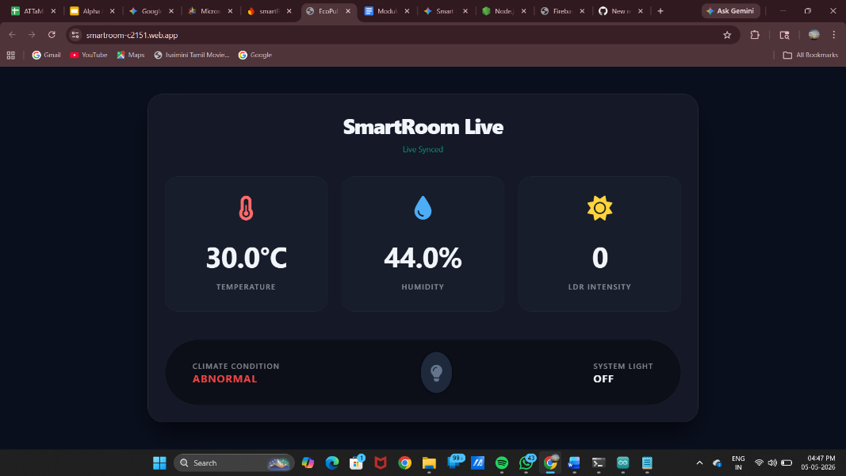
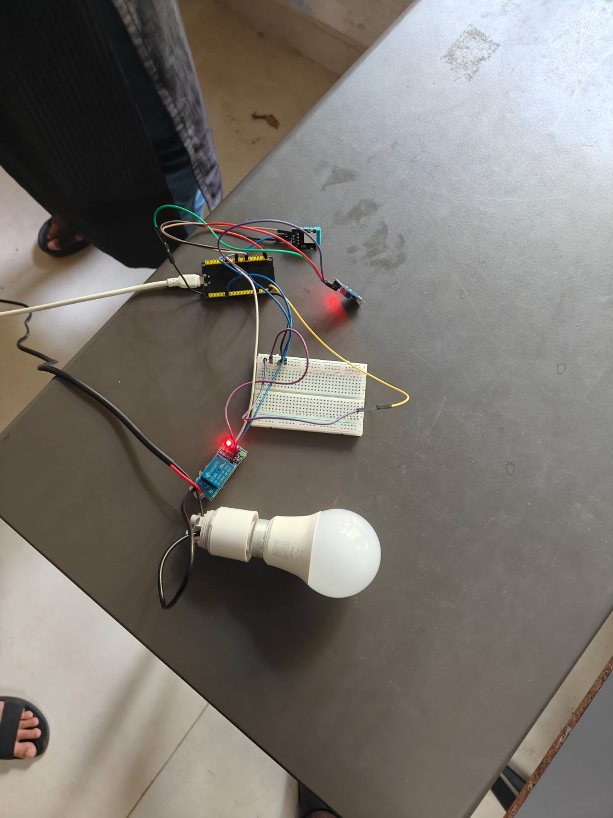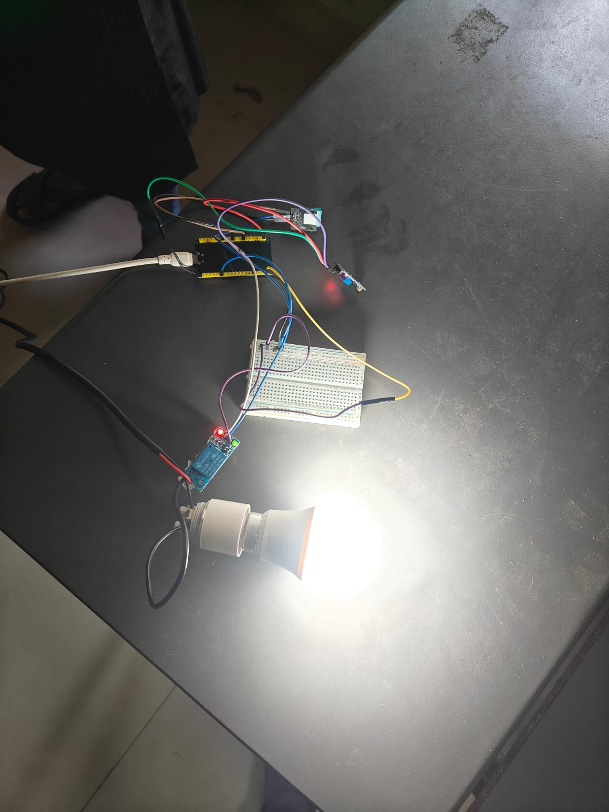

Result
- Sensor data was successfully uploaded to Firebase
- The AC bulb was controlled through the web interface
- Real-time communication between ESP32 and the cloud was established

