**Actions In Tableau**

"Actions" are interactive features that allow users to dynamically filter, highlight, or navigate between different views within a dashboard by clicking on specific marks on a chart, essentially creating a more engaging and interactive experience for data analysis. Actions are used to add an interactive element to these dashboards and let the user build customized dashboards.

**Why we need Actions?**

In Tableau, "actions" are crucial because they allow users to interact dynamically with visualizations on a dashboard, enabling them to explore data more deeply ultimately creating a more engaging and insightful user experience.

**Types of actions**

1.Go to URL: Create hyperlinks to external resources, such as a web page or file.

2.Go to Sheet: Simplify navigation to other worksheets, dashboards, or stories in the same workbook.

3.Filter: Use the data from one view to filter data in another.

Highlight: Call attention to marks of interest by dimming all others.

Change Parameter: Let users change parameter values by directly interacting with marks.

Change Set Values: Let users change the values in a set by directly interacting with marks.

Now lets see one by one

**1.Go to URL :**

A URL action is a hyperlink that points to a web page, file, or other web-based resource outside of Tableau.When you set up a URL Action, you can specify an external URL to be opened when a user clicks on a specific part of the visualization, such as a mark, field, or a dashboard element.A URL action builds on this and allows your end users to control what is shown on the web page by passing a value into the URL link when the user interacts with a chart.

**How to Create a URL Action in Tableau:**

Go to the "Worksheet" or "Dashboard": Open the worksheet or dashboard where you want to create the action. Select Dashboard > Actions. Add a New Action: Click on Add Action and then choose URL.

Give a name for the action and select source sheet from the dropdown menu .Then select the type of trigger for the action . Here we have selected Menu .Then give the required URL link .Now we can add different objects to the URL to make it more dynamic. Here we have an option to select the details about specific sub category by selecting the required field from the insert menu. Similarly we can make the URL name more dynamic by selecting the <sub-category> from the drop box.

Now we can click on one of the marks .Here we see a link is displayed .The link is dynamic with the required subcategory name.

Once the link is clicked it automatically takes us to the required Wikipedia page .Thus by adding URL actions we can add more context to the visualizations thereby making it more interactive.In this case selecting phones takes us to the corresponding Wikipedia page.

We can also use URL action to send an email .For this we need to give the URL link as

**mailto:Organ Recipient@gmail.combody ?subject=Estimated Waiting Time for Organ Transplant&body=<EmailAlert>.**

You need to specify the recipient name in mailto: and give subject and body for the email.Body of the email could be elaborate so in general its given as a user defined calculated field.For instance here we have <EmailAlert>.

Now lets move on to Go To Sheet Action.

**2.Go To Sheet Action:**

This action helps to jump from one worksheet to another. First we have the source sheet Sales insights_src and the target sheet is the Profit Insights.To create an action that would take us from the source to the target sheet first lets create an Action.

Click on worksheet > Actions .Click on Add action and select Go to Sheet .Then we get a new window.Here give a name to the action say Go To Profits Insights.Select the type of trigger in the Run action On say Menu Option.Then select the source and the target sheet and click OK.

Once the action is created .We click on one of the marks .A link with the name Go To Profits Insights is created as shown below.

Selecting the link takes us to the Target sheet Profit Insights.

**3.Filter Action:**

Selecting data from one sheet will filter data in another sheet. The information selected in the source sheet will be displayed in the target sheet.

Click on worksheet > Actions. Click on Add action and select Filter .Then we get a new window. Here give a name to the action, Select the type of trigger in the Run action On say Menu Option. Then select the source and the target sheet .

We have another menu clearing the selection will. It has three options for users to decide on how they want the target sheet to be displayed after de selecting the fields in the source sheet. Depending on whether we want to display filtered values or show all values in the target sheet we can select the option. Based on the selected option the target sheet will display the values.A screenshot of a computer

This is the sample source and target sheet .

Here we see that the subcategories Machines,Accessories,Copiers and Bookcases were selected in the sales source sheet .So the corresponding categories were displayed in the profits target sheet.

**4.Highlight Actions in Tableau :**

Selecting data from one sheet will highlight the data in another sheet. It allows users to highlight specific data points or marks across visualizations when they interact with a specific element in a worksheet or dashboard. When a user selects or hovers over a mark in one visualization, related marks in other views can be highlighted, making it easier for the user to see the relationships between the data points.

Here an example shows that when we hover on the phones subcategory in source the target sheet is highlighted with profit insights of phone subcategory.

Highlight actions can be created by two more ways .First option is as seen in above image click on the pencil icon and choose the required option .Another option is select

Analysis > Highlighters > Sub category.

**5. Set Action in Tableau:**

SetActions are a powerful way to interactively modify a set based on user input, such as a selection or hover. A set is a custom grouping of data based on certain conditions or logic, and it can be used to isolate specific data points

Sets can split data into 2 groups in group and the out group.Users can change the values in the set by directly interacting with the data.

To create a Set Add Sales in column and Profit in rows and Customer id in Details.Then right click on any id on the chart and select create set. Then 2 sets are created .Give the colour of your choice for the sets.

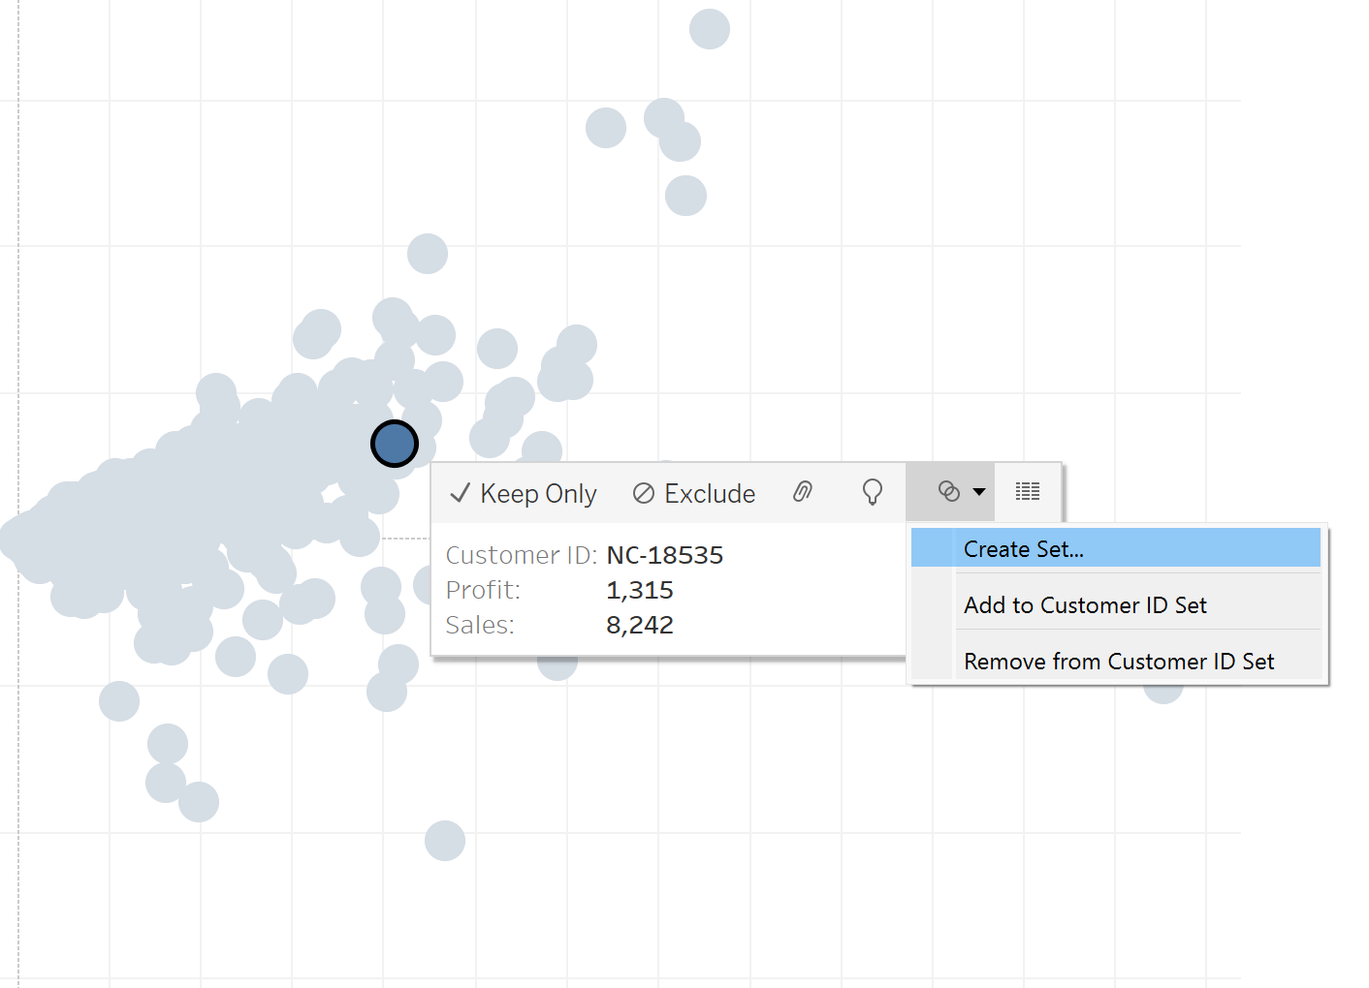

To create action Worksheet > Actions > Add Actions. Select Change Set Values .Give a name for the action. Select the Trigger ,source sheet and Target Sets.

Run the action menu displays choices to add the selected data points to the set or remove them. This defines how the set is modified.

Clearing the selection menu define what happens when the user clears their selection (e.g., clicking outside of the selection area). You can choose to either keep the selection or remove it from the set.

**6.Parameter Actions :**

Parameter action allows users to interactively control the value of a parameter by selecting elements within the view (e.g., marks, fields, or dashboard objects). Parameter actions enable dynamic updates to your dashboard, which can enhance interactivity and user experience.

The visualization shows the distribution of sales across different months. Based on the users selection of months in the sourcesheet the total sales for the selected months is displayed as Total sales. This can be achieved by Parameter actions .First we need to create a Parameter named Total Sales .Then create a calculated field Total Final Sales to hold the value of the parameter say <Total Sales>.This can be used as a label in another sheet .Now add both the source sheet and the sheet with the label that is sheet11 to the dashboard .

Then lets create Parameter action by selecting Worksheet >Action >Add action > Change Parameter .Then give a name for the parameter and select sourcesheets and Target Parameter and specify the source field and Aggregation.

Now we see that based on the months selected in the Parameter Actions sheet the sheet 11 displays the total sales for the selected months.

**Conclusion :**

Actions in Tableau enhances the user experience, making dashboards interactive and insightful by enabling users to drill down into data, filter specific information, and explore different perspectives. By effectively using actions, you can create a more engaging, user-friendly, and informative experience that supports deeper data analysis and decision-making. Thankyou for reading and I hope it has given you insights on the different actions in Tableau.