**Machine Learning on Embedded Systems to Assess Correct Form During Weight Training**

**Student:** Devesh Nath

**Mentor:** Dr. Chao Wang, School of Electrical, Computer and Energy Engineering

The research question that this project seeks to address is: How can machine learning classify common weight training exercises in real-time through motion data collected on a strategically placed IMU while also being able to judge correct form and posture?

The research aims to be able to be able to create a system to classify weight training exercises in real-time and generate reliable motion data.

This research advances knowledge in machine learning and motion recognition using Inertial Measurement Units (IMUs) by investigating the role of contemporary machine learning algorithms to identify complex recurring patterns in real-time by relying on motion data collected on a microcontroller, IMU and additional peripheral sensors. The research goals strongly align to the **Fulton Research Theme of Health,** as the work in this project can directly affect the long-term muscle and bone health of athletes. Being able to recognize correct posture and movement during workouts is extremely important for proper muscle growth and to prevent chronic injuries. Dr. Wang's knowledge and experience in machine learning, embedded systems and TinyML will help guide the research.

At completion, the resulting system will be handheld, will be able to **classify exercises in real-time, and collect and train on the data** (on the handheld embedded device or externally). A pipeline will be created to make the data collection and training process faster. Future development will include training/classification with multiple handheld nodes for complex exercises.

**Abstract**

Machine learning has seen a great increase in popularity in the past few years due to its outstanding pattern recognition within complex systems and even replicating those patterns for generation [1]. When it comes to detecting patterns in body movements during exercises, personal trainers can instinctively recognize patterns in a bad form or a bad movement. Good personal trainers can help an individual prevent injury and help them achieve their goals in fitness [2]. They help with a lot more stuff than form corrections like workout routines and diet. However, **it is hard to find personal trainers** either because there aren’t as many to train every individual, or their services are expensive. There is a **need for a device that can help athletes train safely** by monitoring their form and keeping them safe. The device cannot be too heavy or big to influence the movement of the athlete or cause them any discomfort while also being sturdy and have a high computing power.

**Current literature and state of the art**

1. Detection of Human Body Movement Patterns Using IMU and Barometer [3] : SVM algorithm for motion detection with IMU and Barometer data.
2. Deep-Learning-Based Character Recognition from Handwriting Motion Data Captured Using IMU and Force Sensors [4] : Multiple deep learning algorithms tested to classify handwriting motion data using a system of force sensors combined with IMU data.
3. Improving gait classification in horses by using inertial measurement unit (IMU) generated data and machine learning [5] : Gait classification for Horses from motion data (collected using multiple IMUs) using BLSTM segmentation method.
4. Golf Swing Segmentation from a Single IMU Using Machine Learning [6] : Classification of golf swing phases from motion data using CNN and BLSTM segmentation method.
5. A hierarchical hand motions recognition method based on IMU and EMG sensors [7] : Using data from multiple sensor types to recognize motion patterns with SVM segmentation and classical (non-ML) methods.

**Research Plan**

**Research Method:** The research method will begin by analyzing the state of the art. Then a data collection method will be devised followed by collecting the required data. The results will be analyzed through implementation of various ML algorithms.

**Materials/Resources:**

1. Arduino Nicla Sense ME: Advanced sensor board with Bosch Sensors and Bluetooth
2. Arduino Nano 33 BLE Sense Rev 2: Compact Sensor Board with Wi-Fi and Bluetooth
3. Raspberry Pi 5: Small and powerful single board computer with low power consumption
4. ESP32 : Cheap and powerful microcontroller
5. Adafruit 9-DOF Absolute Orientation IMU Fusion Breakout - BNO055 : External IMU
6. ASU Agave Cluster / Google Collab : Resources for training ML Models

**Procedure:**

1. **Documentation** will be carried out throughout the research.
2. A comparison will be drawn from **reviewing the state of the art** to determine which microcontrollers, IMUs and algorithms have been used for similar problems. **This part of the process has already been started (October 2023) and is in its early stages.**
3. A complete **research plan** will be devised. Data collection methods will be decided and the hardware to support that data collection will be designed.
   1. Microcontrollers, IMU and additional hardware will be finalized.
   2. Some machine learning algorithms will be narrowed down.
   3. We will narrow down the classes we want to detect. Example: Correct Repetition, Bad Repetition, Fatigue, Incomplete Repetition etc.
   4. A simple exercise will be selected (e.g., Bicep Curls). The appropriate device placement for data collection will be decided.
4. in parallel to step 3 **ASU IRB** authorization will be requested.
5. **Materials** will be ordered, and a rough 15-day arrival time will be expected.
6. **Hardware synthesis**. A system for our data collection method will be designed and fabricated. It will involve microcontrollers, IMUs, and other sensors that are TBD from the hardware synthesis plan. A pipeline for data collection will be created for the next step.
7. **Data will be collected** from multiple users to reduce bias and have a broad range of observations. The data will be pre-processed to suit the algorithm’s architecture.
8. We will then **experiment with different Neural Network architectures** to find the best fit for our use case with the highest accuracy. The following process will be followed:
   1. Process Data
   2. Build a Neural Network architecture
   3. Train
   4. Measure accuracy. If good enough, next step. If not, start again from step a.
9. **Summarize findings**, results and methods into a research paper.

**Facilities:**

SCAI manufacturing lab 3D printers will be used for any 3D printing related tasks. BYENG 387 will be used for soldering related tasks and for signal analysis using oscilloscopes and signal analyzers.

**Expected Outcome:**

The built system should be able to classify a performed exercise in one or more of the determined classes in real-time.

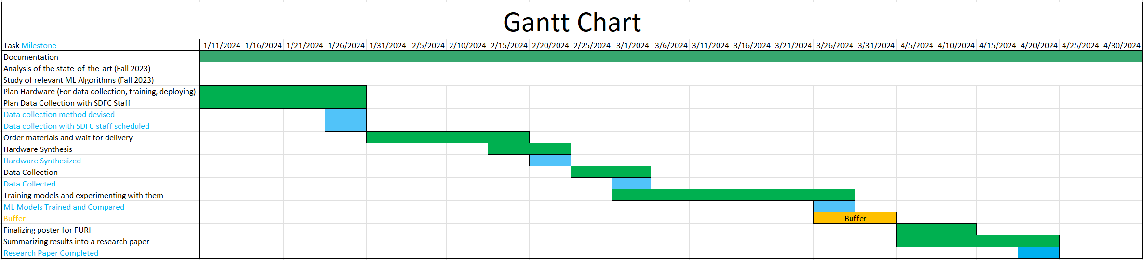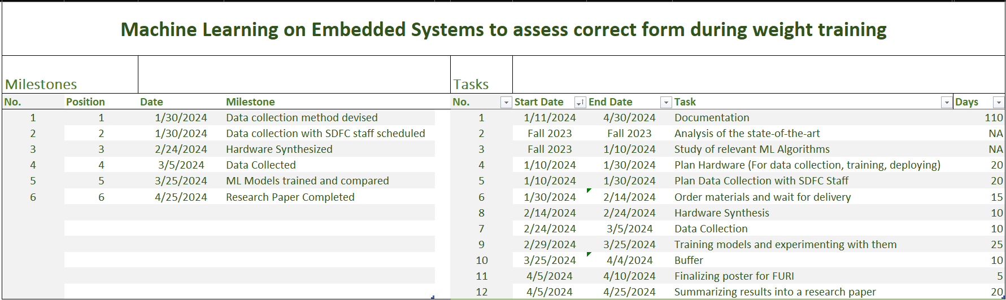**Timeline:**

**References**

1. M. Hausknecht, W. -K. Li, M. Mauk and P. Stone, "Machine Learning Capabilities of a Simulated Cerebellum," in IEEE Transactions on Neural Networks and Learning Systems, vol. 28, no. 3, pp. 510-522, March 2017, doi: 10.1109/TNNLS.2015.2512838.
2. Waryasz GR, Daniels AH, Gil JA, Suric V, Eberson CP. Personal Trainer Demographics, Current Practice Trends and Common Trainee Injuries. Orthop Rev (Pavia). 2016 Oct 3;8(3):6600. doi: 10.4081/or.2016.6600. PMID: 27761219; PMCID: PMC5066109.
3. M. Alarfaj, Y. Qian and H. Liu, "Detection of Human Body Movement Patterns Using IMU and Barometer," 2020 International Conference on Communications, Signal Processing, and their Applications (ICCSPA), Sharjah, United Arab Emirates, 2021, pp. 1-6, doi: 10.1109/ICCSPA49915.2021.9385750.
4. Alemayoh TT, Shintani M, Lee JH, Okamoto S. Deep-Learning-Based Character Recognition from Handwriting Motion Data Captured Using IMU and Force Sensors. Sensors. 2022; 22(20):7840. <https://doi.org/10.3390/s22207840>
5. Serra Bragança, F.M., Broomé, S., Rhodin, M. et al. Improving gait classification in horses by using inertial measurement unit (IMU) generated data and machine learning. Sci Rep 10, 17785 (2020). <https://doi.org/10.1038/s41598-020-73215-9>
6. Kim M, Park S. Golf Swing Segmentation from a Single IMU Using Machine Learning. Sensors. 2020; 20(16):4466. <https://doi.org/10.3390/s20164466>
7. W. Chang, L. Dai, S. Sheng, J. Too Chuan Tan, C. Zhu and F. Duan, "A hierarchical hand motions recognition method based on IMU and sEMG sensors," 2015 IEEE International Conference on robotics and Biomimetics (ROBIO), Zhuhai, China, 2015, pp. 1024-1029, doi: 10.1109/ROBIO.2015.7418906.

***Personal statement***

My career goal is to be able to design and build smart machines that are perceptive of their surroundings. For the same reason I will be doing my masters in Robotics and Autonomous Systems. This research aims to build a machine that can ‘perceive’ through IMU’s measurements and use that data to intelligently classify it into the required class. This exactly relates to my goal of making smart machines. While working on this, I will also advance the field of machine learning and motion recognition which is always a plus.

Moreover, I go to the gym very often. Many of my friends do too and some of them have suffered from an injury which happened in the gym due to incorrect form. Thankfully, I have never suffered such an injury due to my attention to my form. A personal trainer can prevent such mishaps and help their students work on their posture. However, in my experience, personal trainers can be very expensive for a regular college student or may not be available at the student’s schedule. Such a limitation never stopped me from working out safely but may have indirectly led to injuries that my friends have suffered.

I have gained several skills in my time at ASU in Machine Learning and Signal Processing on Embedded Devices. Such skills make me capable of taking on such a project. In the process, I will also make myself a better fit for many career opportunities that involve Machine Learning and Signal Processing.

Summarizing, I want to be able to build a reliable device that can recognize patterns in body movement like that of a personal trainer. Such a goal stems from the need to have a device that is cheap and reliable so that everyone who is working out can access it. I want to be able to help people to prevent injury while making such a goal align to my career interests.