|  |
| --- |
| CRUD Operations |

**Case Study:**

* Create a new collection named as users and insert a document with userID: 1092, Name: Simon, and Password: abcd123.

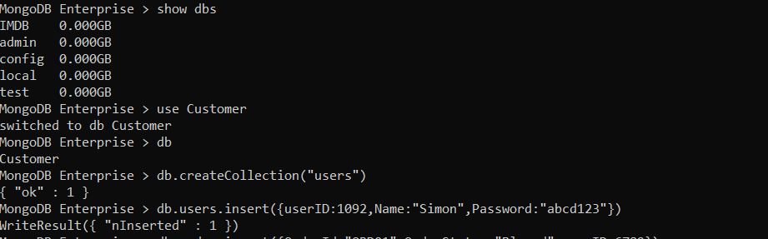

* The orderStatus of orderId ORD34 has changed from ‘Placed’ to ‘Scheduled for Manufacturing’. However, it is not reflected in the document. You are responsible for updating it in the order collection.

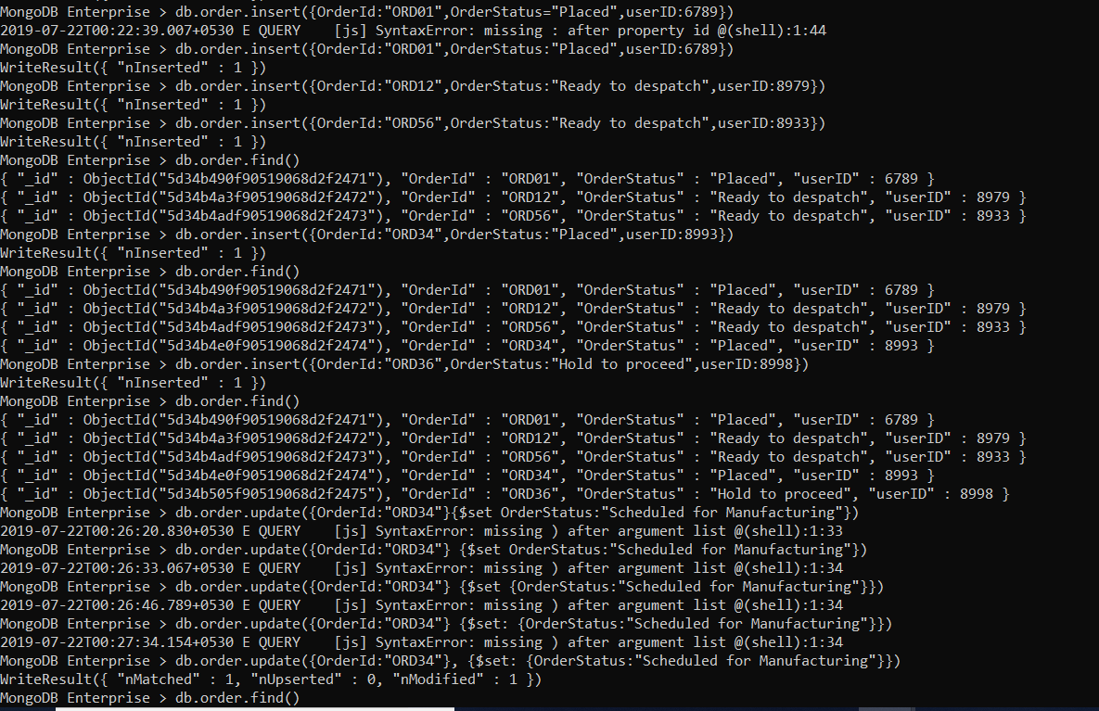

* You are also asked to find a document with incorrect detail such as "maufacturer": "Ferrai" and remove them, if such document exists.

