* Create new users

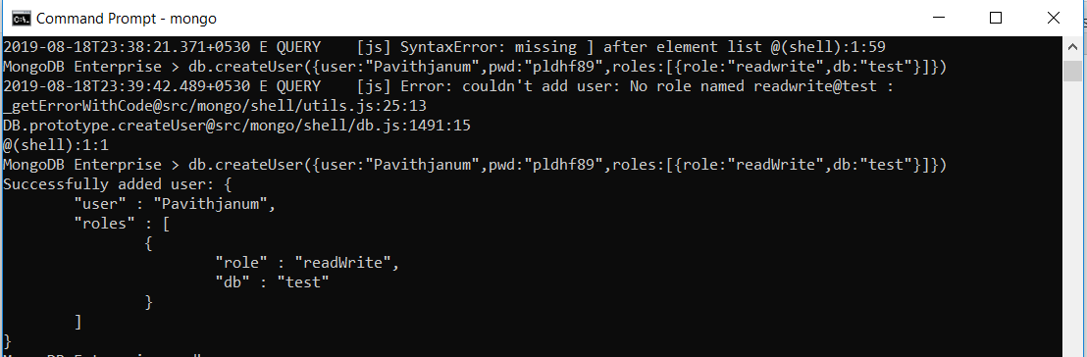

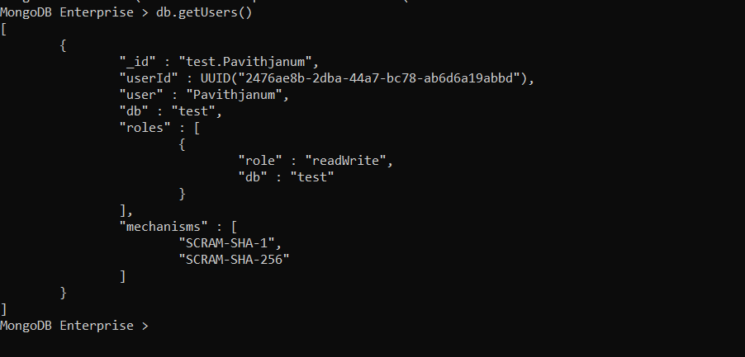

* Create a collection and cap it

