Business Requirement

Application developers of your organization are going to create an application using Python. However, they are finding it difficult to link MongoDB database to their application. Now, you are responsible for connecting the application to the database.

Key Issues

• You must have basic knowledge of Python coding

• You must know how to configure Python drivers in your system

Approach to Solve

• Install the drivers of Python compatible with the current version of MongoDB and install it

• Create a new collection and insert a MongoDB document using IDLE

• Observe the changes in MongoDB

**Solutions:**

• Install the drivers of Python compatible with the current version of MongoDB and install it

**Pip install pymongo**

• Create a new collection and insert a MongoDB document using

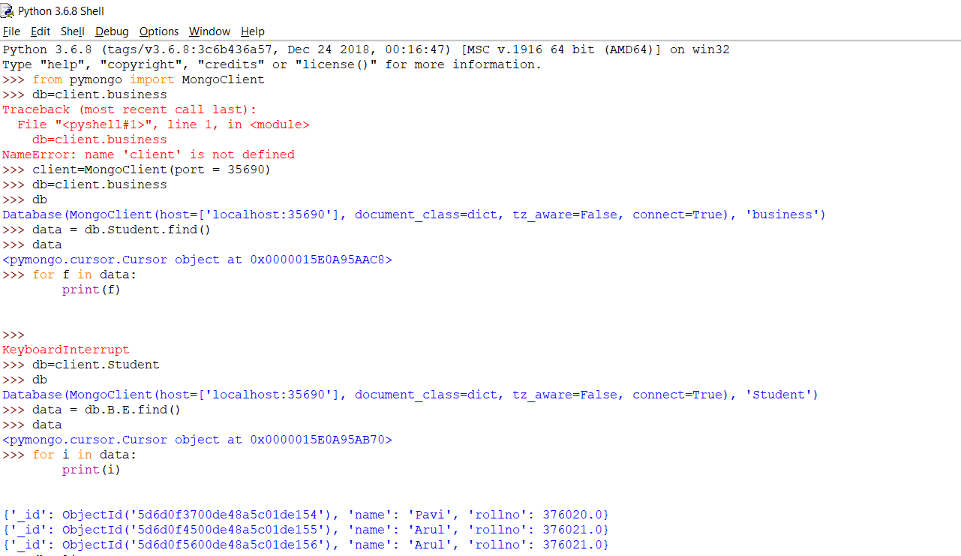

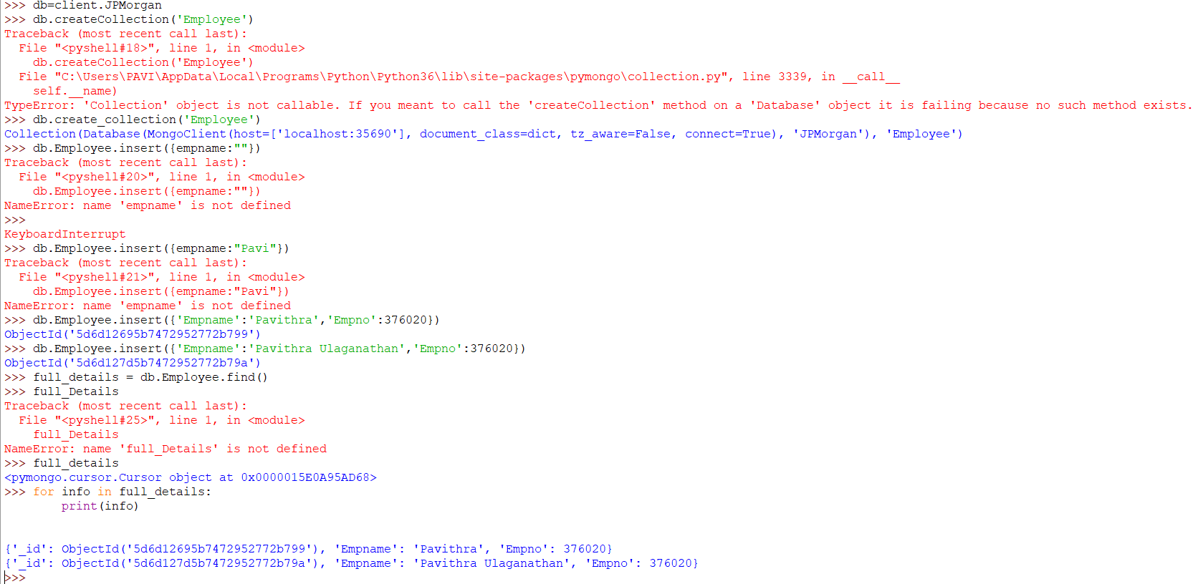

* Observe the changes in MongoDB

