- Test Case generation for Search functionality
Weak Prompt:
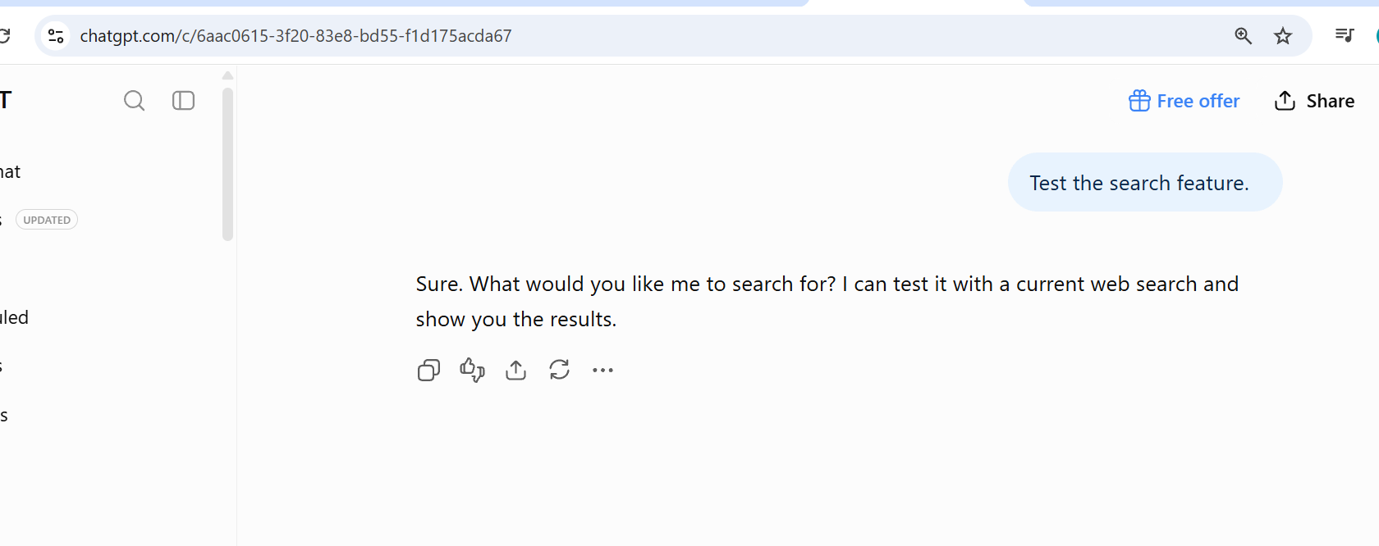

Strong Prompt:

Context:
You are a Senior QA Engineer responsible for testing the Search functionality of an Employer Data module.

Instruction:
Generate comprehensive functional test cases for the Employer Search feature and then review the test cases from a Test Lead perspective to ensure adequate coverage.

Employer Data Fields:
1. Unique Employer ID
2. Employer Name
3. Enrollment Start Date
4. Enrollment End Date
5. Address
6. Phone Number

Search Functionality:
- The Search field supports searching using all the Employer attributes listed above.
- Validate exact, partial, case-sensitive/case-insensitive, invalid, empty, and special-character search behavior where applicable.
- Include positive, negative, boundary, validation, and usability-related functional scenarios.
- Include wildcard/asterisk (*) search scenarios as a mandatory requirement.
- Verify search results accurately match the entered search criteria.
- Verify appropriate behavior when no matching Employer records are found.
- Verify behavior when the search criteria are blank or contain only spaces.
- Verify that special characters and unsupported input are handled correctly.
- For date fields, include valid dates, invalid dates, boundary dates, and date-range scenarios.
- For Employer ID and Phone Number, include valid, invalid, minimum/maximum length, numeric, and special-character scenarios where applicable.
- For Employer Name and Address, include exact match, partial match, case variations, spaces, and special-character scenarios.

Asterisk (*) Search:

Test Case Format:
Generate the output using exactly this pipe-delimited format:

TestcaseID|Title|Step Action|Step Expected|Test Outcome

Persona:
- Develop the test cases as a Senior QA Engineer.
- Review the generated test cases as a Test Lead.

Output:
First provide the complete test case list in the exact pipe-delimited format.

Then provide a short "Test Lead Review" section containing:
- Coverage summary
- Missing/ambiguous requirements
- Recommended additional scenarios
- Assumptions made

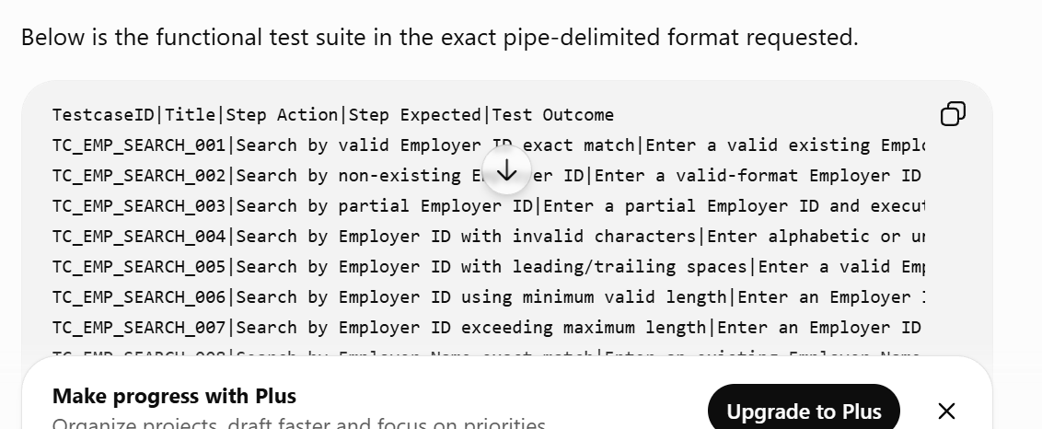

2.Role Based Access Control:

Weak Prompt:
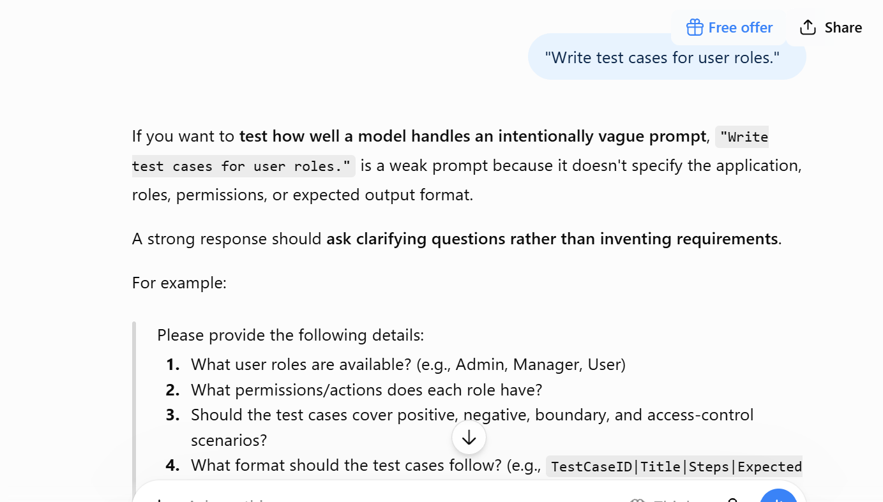

Strong Prompt:
Context: Verify Access to Employer module based on role

Instruction: Adm , mgr and team lead will have access to employer module, where they can add , update and delete employer
where as user and qas role will have no access
Test Case Format:
Generate the output using exactly this pipe-delimited format:

TestcaseID|Title|Step Action|Step Expected|Test Outcome

Persona:
- Develop the test cases as a Senior QA Engineer.
- Review the generated test cases as a Test Lead.

Output:
First provide the complete test case list in the exact pipe-delimited format.

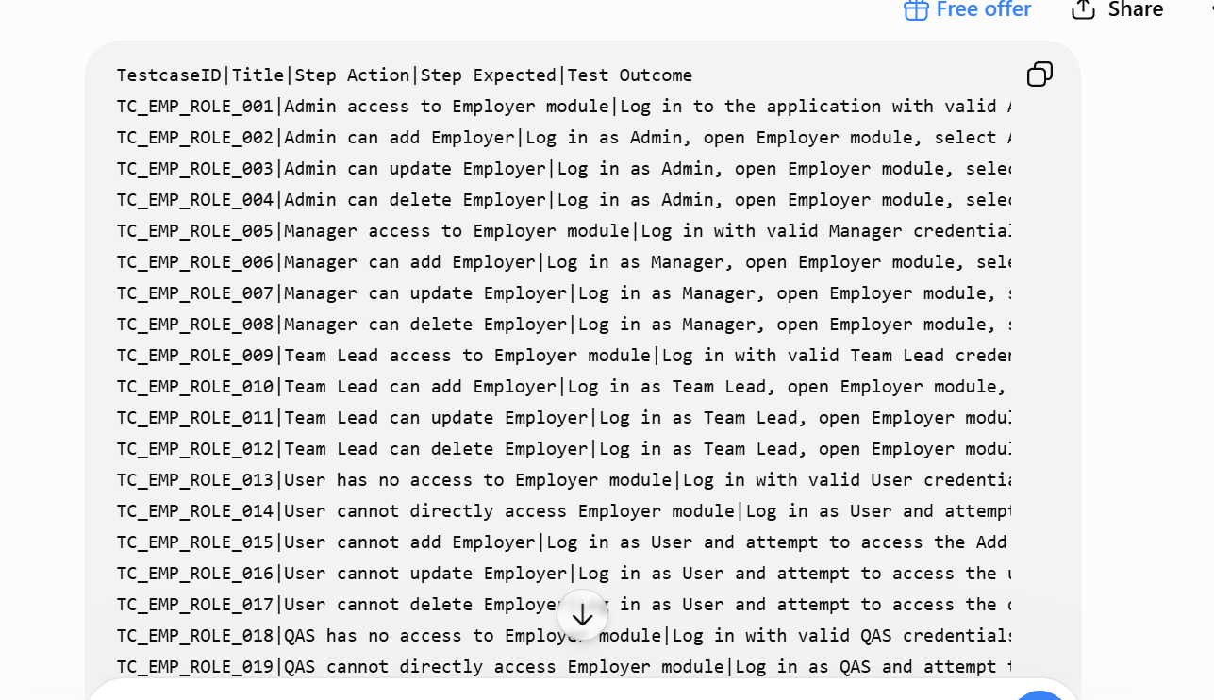

3.File Upload

Context:

You are a Senior QA Engineer responsible for testing the File Upload functionality of an application.

Instruction:

Generate comprehensive functional test cases for the File Upload feature and then review the test cases from a Test Lead perspective to ensure adequate coverage.

File Upload Functionality:

The application allows users to upload files.

The File Upload functionality should be validated for:

1. File selection and successful upload
2. Supported file types
3. Unsupported file types
4. File size validation
5. Minimum and maximum file size
6. Empty/zero-byte files
7. File names with spaces
8. File names with special characters
9. Very long file names
10. Duplicate file names
11. Multiple file uploads, if supported
12. Uploading the same file multiple times
13. Upload cancellation
14. Removing/deleting an uploaded file, if supported
15. Uploading corrupted or invalid files
16. Uploading files with incorrect extensions
17. Upload failure and appropriate error handling
18. Successful upload confirmation
19. Validation message accuracy
20. File upload status/progress, if supported

Supported File Types:

- Clearly validate each supported file extension.
- Validate unsupported file extensions.
- Do not assume specific supported file types unless provided by the requirement.
- Where the supported file types or maximum file size are not specified, mark the scenario as "Requirement clarification needed."

File Size Validation:

Include test cases for:
- Valid file within the allowed size
- File at the exact maximum allowed size
- File exceeding the maximum allowed size
- Zero-byte file
- Very small file
- Very large file

File Name Validation:

Negative Scenarios:

Include test cases for:
- Unsupported file type
- Corrupted file
- Empty file
- File exceeding maximum size
- Invalid file name
- File with incorrect extension
- Upload interruption/failure
- Attempt to upload without selecting a file
- Attempt to upload multiple files when multiple uploads are not supported

Test Case Format:

Generate the output using exactly this pipe-delimited format:

TestcaseID|Title|Step Action|Step Expected|Test Outcome

Persona:

- Develop the test cases as a Senior QA Engineer.
- Review the generated test cases as a Test Lead.

Output:

First provide the complete test case list in the exact pipe-delimited format.

