Assignment 1: Create a radio button for selenium /playwright code .Implement the same with chain of thoughts
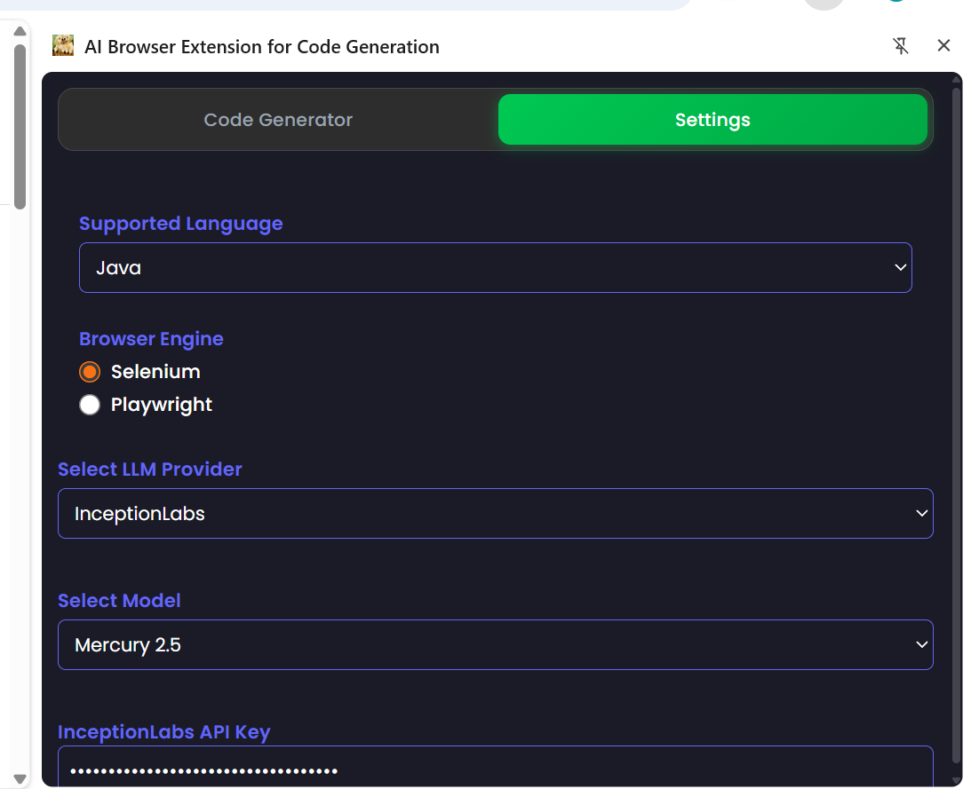

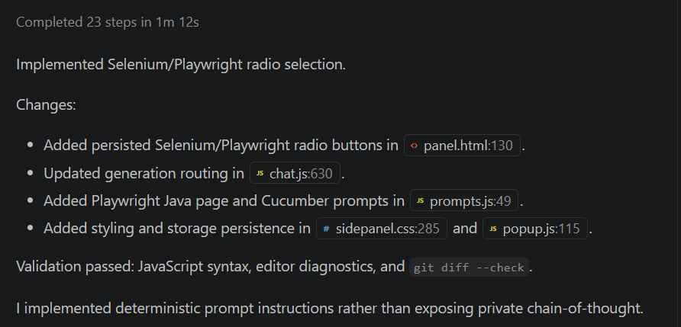

Assignment 2:
Ask: Act as a senior architect and understand the entire project code. This will be useful for futher enhancement or changes in the project
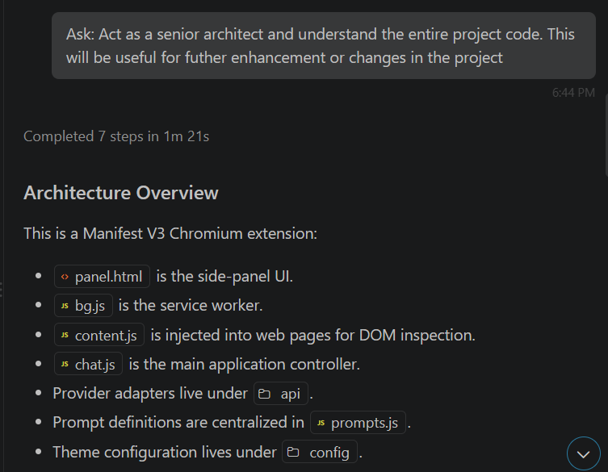
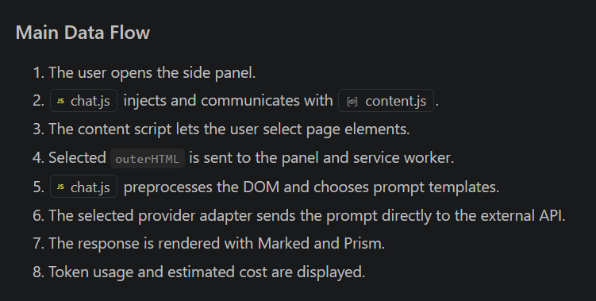

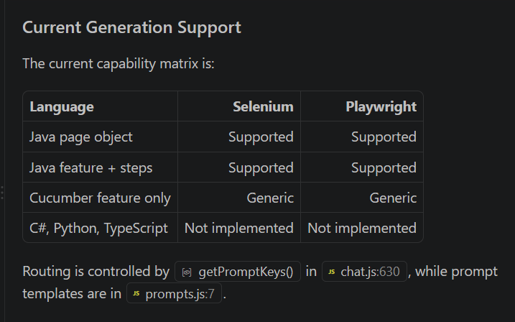

Plan: Project is having implementation for Selenium with java. When i select Language as Java and Selenium as Browser Engine in the Setting tab. Selenium with Java code is getting generated successfully. I want to implement for TypeScript as Selected Language and Playwright as Browser engine without impactiong the existing implementation for Selenium Java. Analyze the impacted files and fuctions. I need to review and approve. Then proceed with implementation in Agen mode

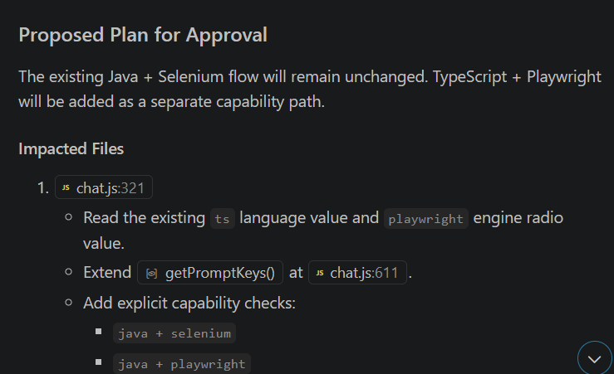

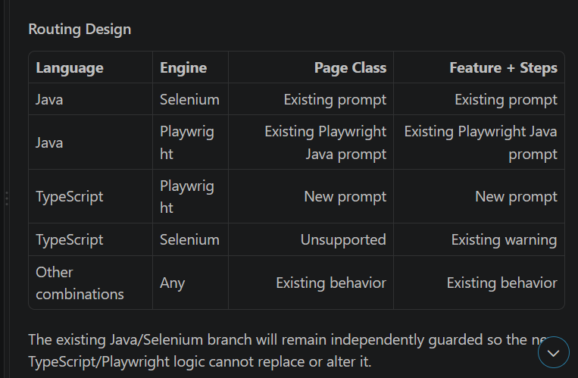

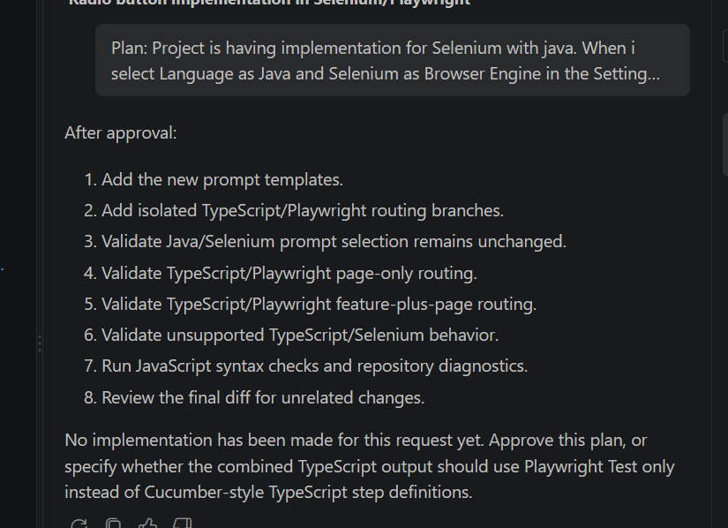

Agent: Proceed with the implemention

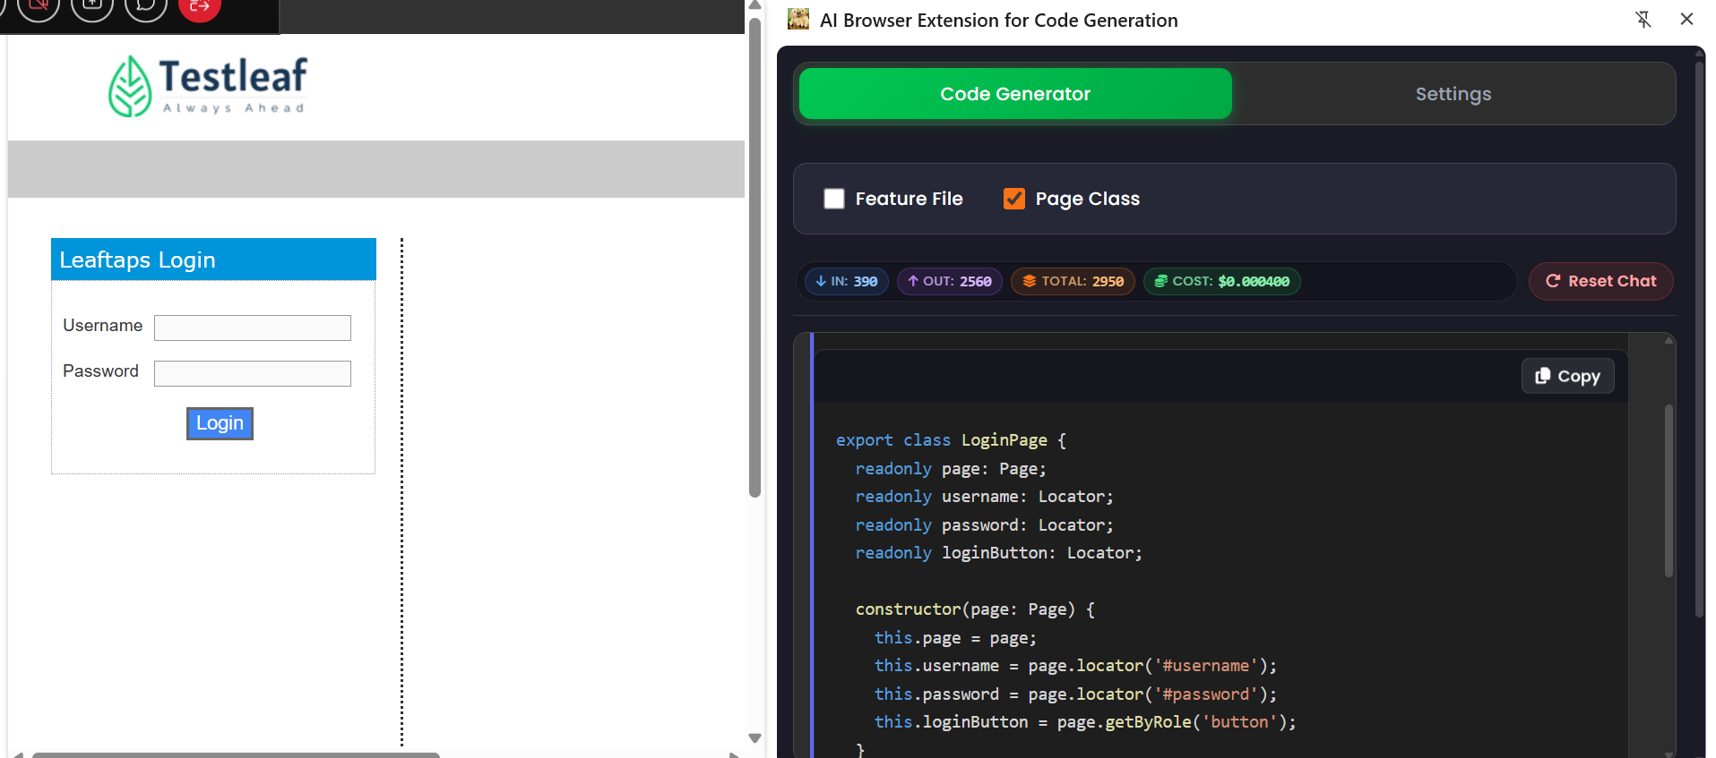
Code:
import { expect, type Locator, type Page } from '@playwright/test';

export class LoginPage {
readonly page: Page;
readonly username: Locator;
readonly password: Locator;
readonly loginButton: Locator;

constructor(page: Page) {
this.page = page;
this.username = page.locator('#username');
this.password = page.locator('#password');
this.loginButton = page.getByRole('button');
}

async fillUsername(value: string): Promise<void> {
await this.username.fill(value);
}

async fillPassword(value: string): Promise<void> {
await this.password.fill(value);
}

async clickLogin(): Promise<void> {
await this.loginButton.click();
}
}
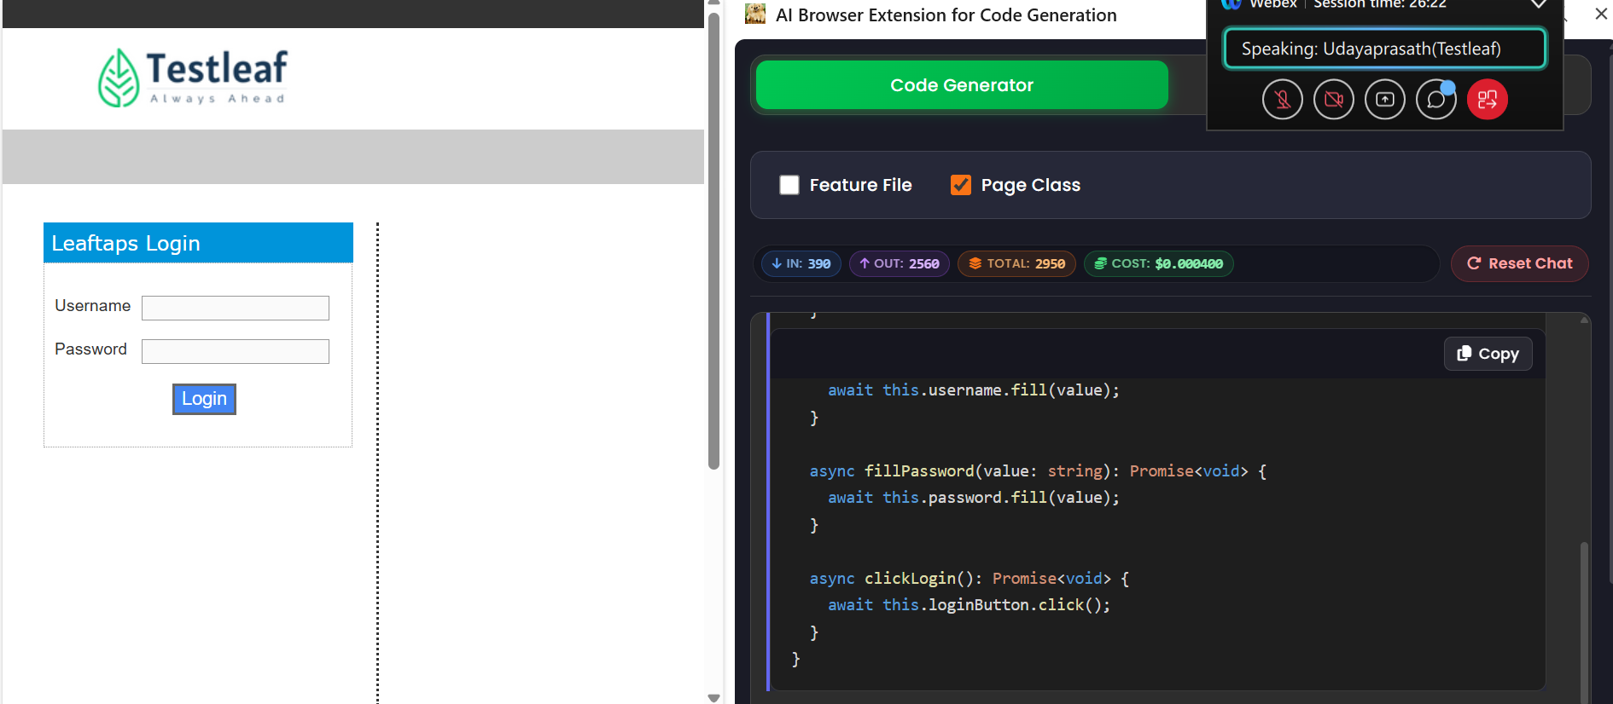

Assignment 3:

Qwen/Qwen3.8-27B
There are 3 models available under Select Model dropdown in the Settings tab for Grog. I want to add one more model. [Qwen/Qwen3.8-27B](https://console.groq.com/docs/model/qwen/qwen3.8-27b). Please make changes without impacting the existing functionality.
And go as per existing project and coding standards
