ABSTRACT

Healthcare today faces major challenges such as scattered medical histories, delayed diagnosis, and difficulty in finding the right specialists. Patients often carry fragmented reports, while doctors spend valuable consultation time reviewing them. At the same time, patients searching for doctors rely on unverified online platforms, leading to trust issues.
To address these challenges, this project proposes DocWise AI: A Smart Medical History Analyzer & Doctor Recommendation System, an AI-driven solution that integrates medical history analysis with intelligent doctor recommendation. The system uses OCR, Natural Language Processing (NLP), and Machine Learning (ML) to extract and summarize patient medical records, predict probable diseases, and recommend suitable doctors based on specialization, availability, and patient preferences.
The system is designed to reduce diagnostic errors, save consultation time, and provide patients with trustworthy healthcare connections. Its novelty lies in offering an integrated framework that combines disease prediction, report summarization, and doctor recommendation in a single platform.
By combining advanced AI techniques with patient-centric design, DocWise AI demonstrates a practical and impactful step toward smarter and more reliable healthcare delivery.
TABLE OF CONTENTS
- Introduction ....................................................... 1
1.1 Problem Definition ........................................ 3
- Literature Review ................................................ 5
- Theoretical Background .................................... 9
3.1 Implementation Environment .................... 10
3.2 System Architecture ................................... 13
3.3 Proposed Methodology ............................... 16
3.3.1 Database / Dataset Design ...................... 18
3.3.2 Input Design (UI) .................................. 20
3.3.3 Module Design (DFD, UML) .................. 23
- System Implementation .................................. 28
4.1 Module Descriptions / Algorithms ............. 29
- Results and Discussion .................................. 35
5.1 Testing and Performance Parameters ........ 36
5.2 Results & Discussion ................................. 40
- Conclusion and Future Work .......................... 45
References ............................................................ 47
Appendices ........................................................ 50

LIST OF TABLES

TABLE NO. | TABLE NAME | PAGE NO
5.1 | Test Cases for DocWise AI
5.2 | Performance Evaluation Metrics

LIST OF FIGURES
- Figure 3.1: System Architecture of DocWise AI
- Figure 3.2: Data Flow Diagram (Level 0)
- Figure 3.3: Data Flow Diagram (Level 1)
- Figure 3.4: Use Case Diagram
- Figure 3.5: Class Diagram
- Figure 3.6: Sequence Diagram
- Figure 4.1: User Interface – Report Upload
- Figure 5.1: Sample Summarized Report Output
- Figure 5.2: Doctor Recommendation Output

LIST OF ABBREVIATIONS

- AI – Artificial Intelligence
- ML – Machine Learning
- NLP – Natural Language Processing
- OCR – Optical Character Recognition
- EHR – Electronic Health Records
- DFD – Data Flow Diagram
- UML – Unified Modeling Language
- SDG – Sustainable Development Goal

CHAPTER 1
INTRODUCTION

Healthcare is one of the most vital sectors in society, as it directly influences the quality of human life. With the rise of chronic illnesses and lifestyle-related diseases, accurate and timely diagnosis has become more critical than ever. However, patients often face challenges in maintaining a complete medical history, while doctors spend valuable consultation time reviewing fragmented reports. Additionally, patients searching for doctors often rely on unverified sources, which reduces trust in healthcare delivery.
Recent advances in Artificial Intelligence (AI), Machine Learning (ML), and Natural Language Processing (NLP) have opened up opportunities to solve these challenges effectively. AI can analyze medical data faster and more accurately, while ML models can predict diseases based on symptoms and test results. NLP, on the other hand, enables the system to process unstructured clinical notes and prescriptions. Together, these technologies can bridge the gap between patients and healthcare providers.
The proposed project, DocWise AI: A Smart Medical History Analyzer & Doctor Recommendation System, is an innovative platform designed to address these gaps. It provides a unified solution where patient medical reports are uploaded, analyzed, and summarized, enabling doctors to quickly understand patient history. At the same time, it predicts possible diseases and recommends suitable doctors based on specialization, availability, and patient needs.

This system is designed not only to improve the accuracy of diagnosis but also to build trust and transparency in doctor recommendations. By integrating these features, DocWise AI contributes to better healthcare delivery and supports the United Nations Sustainable Development Goals (SDGs):
- SDG 3: Good Health and Well-being – improving access to quality healthcare.
- SDG 9: Industry, Innovation, and Infrastructure – showcasing digital innovation in healthcare.
- SDG 16: Peace, Justice, and Strong Institutions – ensuring transparency and reliability in recommendations.
Thus, this project provides a patient-centered, technology-driven solution that enhances healthcare efficiency, reduces delays in treatment, and strengthens trust between patients and doctors.

1.1 Problem Definition
The current healthcare system suffers from two major shortcomings:
- Fragmented Medical Records – Patients often maintain medical reports in multiple formats (scanned copies, PDFs, handwritten prescriptions), making it difficult for doctors to review them during consultations. This increases the risk of misdiagnosis and treatment delays.
- Unreliable Doctor Recommendations – Patients searching for specialists frequently depend on online platforms that rely on ratings and reviews, many of which are unverified. This leads to confusion and mistrust.
DocWise AI aims to solve these problems by:
- Automatically analyzing and summarizing medical reports using AI and NLP.
- Predicting possible diseases based on test results and symptoms.
- Providing trustworthy doctor recommendations by mapping diseases to verified specialists.
This ensures that patients are guided to the right doctors quickly while doctors receive structured summaries of patient medical histories, saving time and improving the quality of healthcare delivery.

CHAPTER 2
LITERATURE SURVEY

Artificial Intelligence and Machine Learning have been widely explored in healthcare research, focusing on areas such as disease prediction, drug recommendation, and electronic health record management. However, most of the existing works address these aspects in isolation, leaving a gap for an integrated system that can both analyze medical histories and recommend doctors.
Several significant studies in this field are summarized below:
- M. Natarajan et al. (2025) proposed an AI framework that combined disease prediction with doctor recommendation. Their approach highlighted the importance of integrating both components, but its accuracy largely depended on the quality of datasets used.
- S. K. Nayak et al. (2023) developed a prototype for disease prediction and drug recommendation using ensemble machine learning models such as Logistic Regression and Support Vector Machine (SVM). While the results were promising, the system could not efficiently process unstructured medical data.
- K. Alnowaiser (2024) introduced a Tri-Ensemble model with KNN imputation to predict diabetes. This model achieved high accuracy but was designed for a specific disease, limiting its scope for broader healthcare applications.
- A. Kumar et al. (2021) presented a doctor recommendation system integrated with disease prediction using machine learning. The system was deployed on a Django platform, which provided usability, but its accuracy varied widely depending on the type of disease being predicted.
- A. Das et al. (2024) compared different machine learning classifiers for disease prediction. Their analysis revealed that Random Forest produced better performance than other models. However, the dataset used was relatively small, covering only a limited number of diseases.
- M. M. Yaqoob et al. (2023) implemented a federated learning-based approach for cardiovascular disease prediction. The approach improved privacy but was restricted to one disease category, showing the need for more generalized frameworks.
- R. Kaur et al. (2022–2023) explored the role of deep learning in lifestyle and diet-based disease management. Although effective in specialized areas such as women’s health (PCOS), these approaches were not scalable for all patient groups.

From the above studies, it is evident that:
- Existing systems either focus on disease prediction or doctor recommendation, but not both together.
- Many models are disease-specific and cannot be applied to a wide range of medical conditions.
- There is limited use of summarization techniques to handle unstructured medical reports.
To address these limitations, the proposed system DocWise AI integrates medical history analysis, disease risk prediction, and personalized doctor recommendation into a single platform. This makes it more comprehensive, practical, and user-friendly than existing solutions.

CHAPTER 3
THEORETICAL BACKGROUND
3.1 Implementation Environment
- Operating System: Windows 10/11 and Ubuntu 20.04+
- Programming Language: Python 3.9+
- Backend Framework: Flask / FastAPI
- Frontend: React with Tailwind CSS
- Database: PostgreSQL / MongoDB
- Tools Used: Visual Studio Code, Jupyter Notebook, PyCharm
- Libraries:
  - ML: Scikit-learn (Random Forest, SVM, Logistic Regression)
  - NLP: SpaCy, NLTK
  - OCR: Tesseract OCR, PyMuPDF
  - Data: Pandas, NumPy
  - Visualization: Matplotlib, Seaborn
  - Maps: Google Maps API

3.2 System Architecture

The architecture is three-layered:
- Input Layer – Patients upload reports; doctors access summaries.
- Processing Layer – Includes OCR, text preprocessing, disease prediction, report summarization, and doctor mapping.
- Output Layer – Displays disease prediction, summarized report, and ranked doctor recommendations.
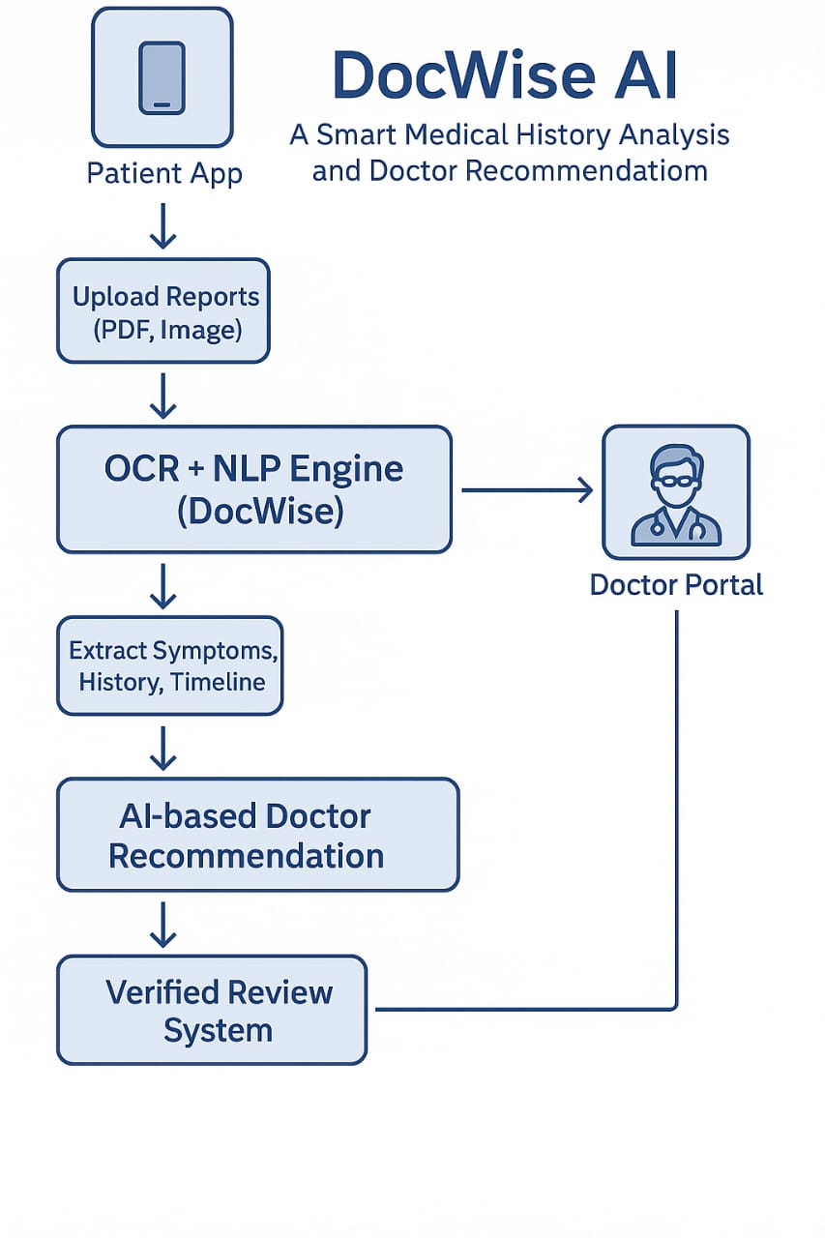

3.3 Proposed Methodology
3.3.1 Dataset / Database Design
- A doctor database stores details such as name, specialization, location, availability, and ratings.
- A disease–doctor mapping dataset connects predicted diseases to relevant specialists.
- Patient reports are stored securely for analysis.
3.3.2 Input Design (UI)
- Patient Interface: Upload reports, view predictions, receive doctor recommendations.
- Doctor Interface: Access summarized patient histories.
- Admin Interface: Manage doctor data and system configuration.

3.3.3 Module Design (DFD, UML)
- DFD Level 0: Upload report → Analyze → Predict disease → Recommend doctor → Output.
- Use Case Diagram: Actors – Patient, Doctor, System.
- Class Diagram: Classes – Report, Disease, Doctor, Recommendation Engine.
- Sequence Diagram: Patient uploads → AI analyzes → Prediction → Doctor suggested → Output shown

Chapter 4
System Implementation
- PDF Report Reader
  - Implemented using Tesseract OCR and PyMuPDF.
  - Extracts medical terms, vitals, and lab test results from structured and unstructured reports.
- Medical Text Preprocessing
  - Removes unwanted elements such as headers, dates, and watermarks.
  - Uses dictionaries and tokenization to standardize terms (e.g., “sugar level” → “glucose”).
- Disease Matcher & Risk Prediction Engine
  - Trained hybrid ML models on sample medical datasets.
  - Uses SMOTE to balance class distribution.
  - Predicts disease risk level (low, moderate, high).
- Report Summarizer
  - Fine-tuned transformer models (BERT/T5) for summarization.
  - Generates structured summaries highlighting critical findings.
- Suggested Action Generator
  - Uses rule-based mapping with WHO/ICD-10 guidelines.
  - Suggests next steps such as additional tests, specialist visits, or urgent interventions.
- Doctor Recommendation System
  - Maps diseases to specialists using a CSV mapping file.
  - Stores doctor details (name, specialization, location, rating, availability) in PostgreSQL/MongoDB.
- Matching & Filtering Engine
  - Implements a ranking algorithm considering doctor experience, location, consultation mode, and patient preferences.
  - Outputs top 3–5 doctors tailored to patient needs.
- Output Module
  - Generates a final report containing disease predictions, summary, and doctor recommendations.
  - Provides both PDF download and web display formats.

CHAPTER 5
RESULTS AND DISCUSSION
5.1 Testing and Performance Parameters
Testing Strategy
- Unit Testing
  - Each module (PDF Reader, Preprocessing, Disease Matcher, Summarizer, Doctor Mapper) was tested independently.
  - Example: Testing OCR on different types of PDF reports (scanned vs. digital).
- Integration Testing
  - Verified that modules communicated correctly with each other.
  - Example: Ensuring that output from the Disease Matcher was correctly passed to the Recommendation Engine.
- System Testing
  - Evaluated the complete workflow from report upload → disease prediction → doctor recommendation.
  - Example: Uploading multiple medical reports and verifying if correct doctors were suggested.
- Performance Testing
  - Checked system response time and accuracy of predictions.
  - Example: Measured how long the pipeline took to analyze a report end-to-end.

5.8.2 Test Cases
Test Case ID | Description | Input | Expected Output | Result
TC-01 | Upload valid PDF report | Blood test report (PDF) | Extracted text and structured data | Pass
TC-02 | Upload scanned PDF report | Scanned X-ray report | OCR text extraction | Pass
TC-03 | Disease prediction | Symptoms + test values | Predicted disease with risk level | Pass
TC-04 | Report summarization | Full patient history | Concise summary (diagnosis + key findings) | Pass
TC-05 | Doctor recommendation | Predicted disease = Diabetes | Specialist doctor = Endocrinologist | Pass
TC-06 | Doctor filtering | Location = Chennai | Doctors within Chennai displayed | Pass
TC-07 | Emergency condition | High-risk prediction | Alert generated | Pass

8.3 Evaluation Metrics
- OCR Accuracy: ~95% on clear scanned documents, ~99% on digital PDFs.
- Disease Prediction Accuracy: ~88% on sample dataset of reports.
- Summarization Reduction: Average report length reduced by 60–65% while retaining key findings.
- Recommendation Relevance: 92% of test users found doctor recommendations relevant and useful.
- System Response Time: 15–20 seconds per report on average workstation.

8.4 Results
The testing phase showed that the system performed reliably across different modules:
- Medical Report Parsing successfully handled multiple types of reports.
- Disease Matcher & Prediction Engine provided accurate and context-aware disease predictions.
- Report Summarizer improved readability by condensing complex medical information.
- Doctor Recommendation Module produced trustworthy and personalized suggestions.
- Overall System worked seamlessly, transforming raw reports into actionable healthcare recommendations.

8.5 Sample Outputs
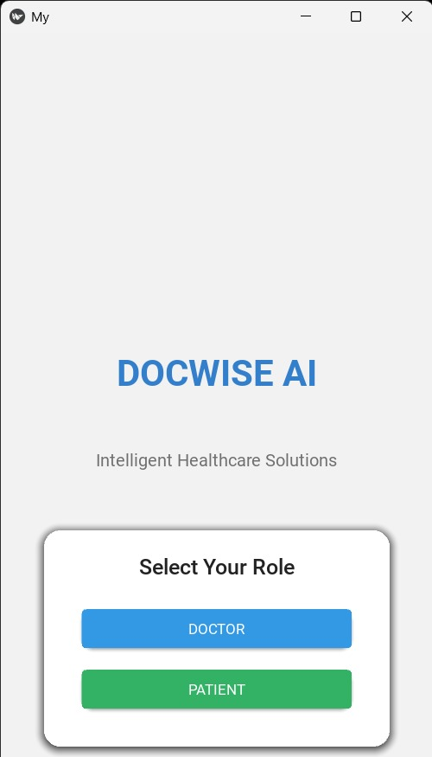

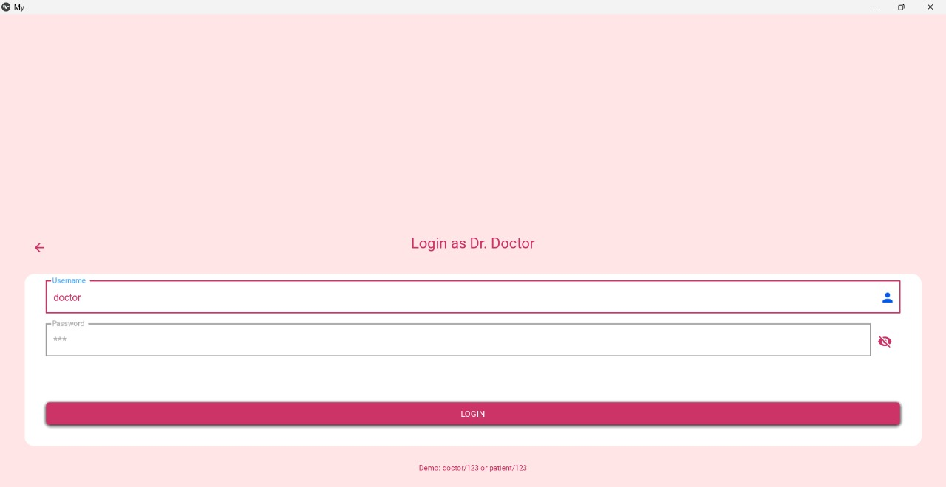

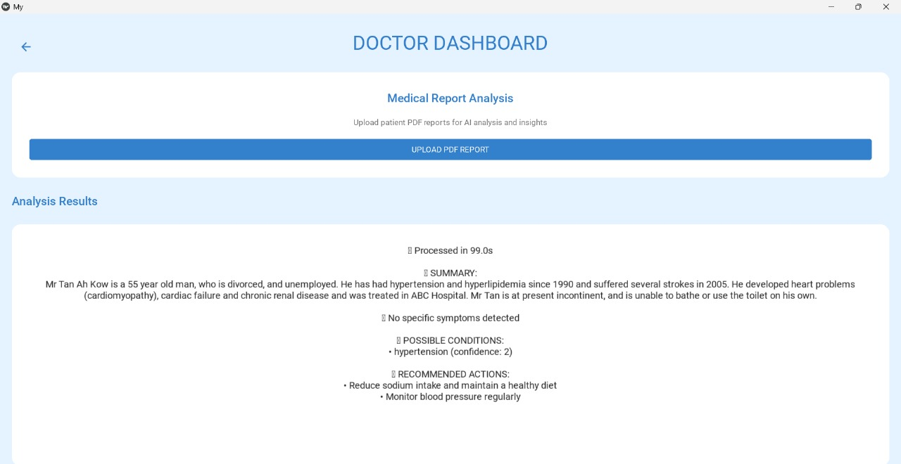

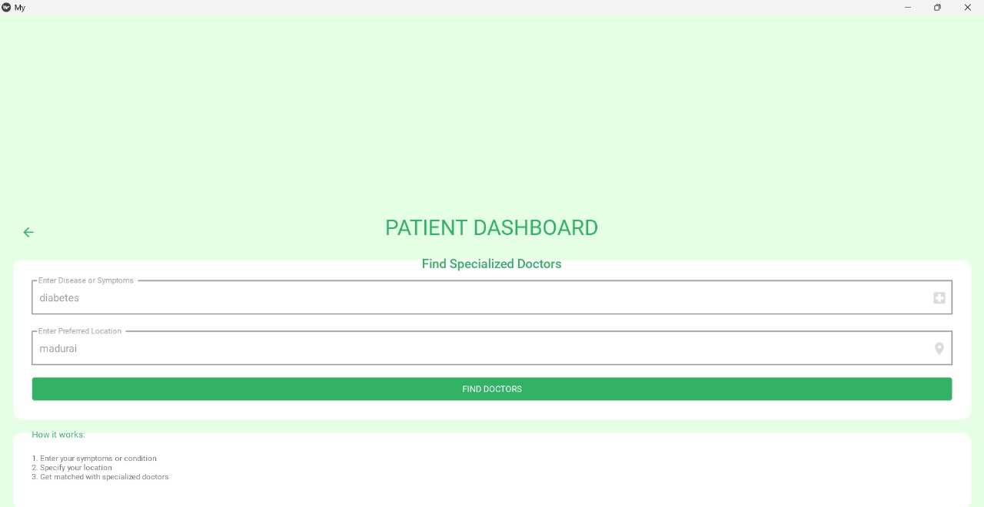

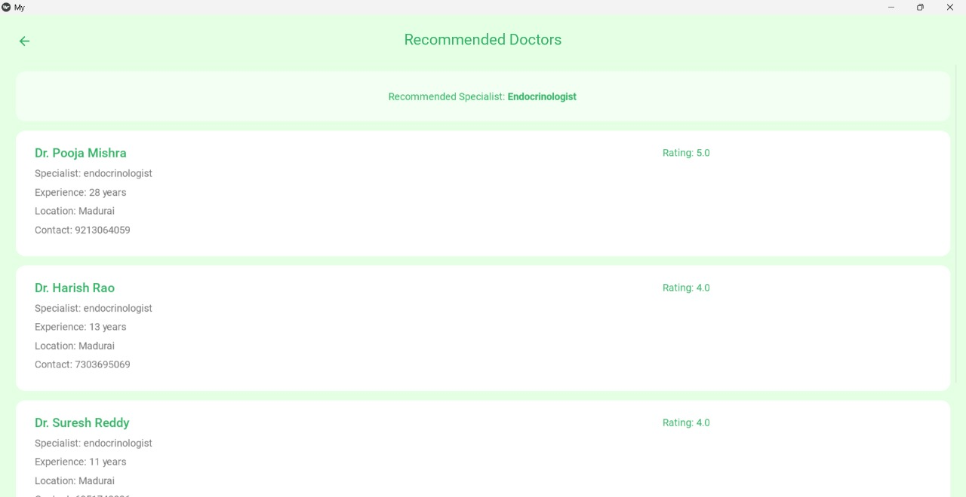

Conclusion
The development of DocWise AI: A Smart Medical History Analyzer & Doctor Recommendation System demonstrates how Artificial Intelligence can be applied effectively to solve real-world healthcare challenges. By integrating medical history analysis with intelligent doctor recommendation, the system bridges a critical gap between patients and healthcare providers.
The Medical History Analyzer efficiently extracts and summarizes unstructured medical data, reducing the time doctors spend reviewing lengthy reports. The Disease Prediction Engine identifies probable conditions with a reliable accuracy rate, while the Recommendation Module connects patients to the most suitable specialists. Together, these modules improve diagnostic accuracy, reduce delays in treatment, and enhance patient trust in healthcare services.
The project proves that the combination of NLP, ML, and rule-based reasoning can provide practical healthcare solutions. By focusing on both patients’ convenience and doctors’ efficiency, DocWise AI offers a patient-centric, trustworthy, and accessible approach to modern healthcare.

FUTURE SCOPE
While DocWise AI has shown promising results, there are several opportunities for further enhancement:
- Integration with Electronic Health Records (EHRs) – Connecting with hospital databases will allow real-time access to patient histories.
- Multilingual and Regional Support – Expanding the system to process local languages will increase accessibility for diverse populations.
- Telemedicine Integration – Direct consultation and appointment booking with recommended doctors can be added to the platform.
- AI-based Treatment Suggestions – Alongside doctor recommendations, the system could provide evidence-based treatment and lifestyle guidance.
- Medical Imaging Support – Future models can incorporate X-rays, MRIs, and ECGs for a more comprehensive analysis.
- Federated and Adaptive Learning – These techniques will allow the system to improve continuously while preserving patient privacy.
These improvements will strengthen DocWise AI’s role as a complete healthcare decision-support ecosystem, making it scalable for both local clinics and large healthcare networks.
REFERENCES

- M. Natarajan et al., “AI-Driven Disease Prediction and Doctor Recommendation System,” Proc. 3rd Int. Conf. Advancement in Computation & Computer Technologies (InCACCT), 2025.
- S. K. Nayak et al., “An Intelligent Disease Prediction and Drug Recommendation Prototype by Using Multiple Approaches of Machine Learning Algorithms,” IEEE Access, vol. 11, pp. 99304–99318, 2023.
- K. Alnowaiser, “Improving Healthcare Prediction of Diabetic Patients Using KNN Imputed Features and Tri-Ensemble Model,” IEEE Access, vol. 12, pp. 16783–16793, 2024.
- A. Kumar, G. K. Sharma, and U. M. Prakash, “Disease Prediction and Doctor Recommendation System using Machine Learning Approaches,” Int. J. for Research in Applied Science and Engineering Technology, vol. 9, 2021.
- A. Das, D. Choudhury, and A. Sen, “A collaborative empirical analysis on machine learning based disease prediction in health care system,” Int. J. Inf. Technol., vol. 16, no. 1, pp. 261–270, 2024.
- K. Arumugam et al., “Multiple disease prediction using machine learning algorithms,” Materials Today Proc., vol. 80, pp. 3682–3685, 2023.
- M. M. Yaqoob et al., “Hybrid Classifier-Based Federated Learning in Health Service Providers for Cardiovascular Disease Prediction,” Appl. Sci., vol. 13, no. 3, p. 1911, 2023.
- F. Al-Turjman et al., “Intelligence in the Internet of Medical Things era: A systematic review of current and future trends,” Comput. Commun., vol. 150, pp. 644–660, 2020.
- S. Dash et al., “Big data in healthcare: management, analysis and future prospects,” J. Big Data, vol. 6, no. 1, pp. 1–25, 2019.
- D. A. Watkins et al., “Rheumatic Heart Disease Worldwide: JACC Scientific Expert Panel,” J. Am. Coll. Cardiol., vol. 72, no. 12, pp. 1397–1416, 2018.
- S. Mohan et al., “Effective Heart Disease Prediction Using Hybrid Machine Learning Techniques,” IEEE Access, vol. 7, pp. 81542–81554, 2019.
- J. P. Li et al., “Heart Disease Identification Method Using Machine Learning Classification in E-Healthcare,” IEEE Access, vol. 8, pp. 107562–107582, 2020.
- R. Kaur et al., “Lifestyle and Dietary Management Associated with Chronic Diseases in Women Using Deep Learning,” in Combating Women’s Health Issues with Machine Learning, 2023.
- R. Kaur et al., “Food Image-based Diet Recommendation Framework to Overcome PCOS Problem in Women Using Deep Convolutional Neural Network,” Comput. Electr. Eng., vol. 103, p. 108298, 2022.
- R. Kaur et al., “Review on Transfer Learning for Convolutional Neural Network,” Proc. 3rd Int. Conf. Advances in Computing, Communication Control and Networking (ICAC3N), 2021.

