# 

JDBC

STEPS IN JDBC:

Problem

Packages:

Bean Package:

Constants Package:

Dao Package:

JdbcImpl Package:

Utils Package:

ContactDao

DB Schema

# 

# JDBC

It is a API which is used to connect java with database.

## STEPS IN JDBC:

1.Open a **connection** to the database.

2. Create a statement object to perform a query.

3. Execute the statement object and return a query resultset.

4. Process the resultset.

5. Close the resultset and statement objects.

6. Close the **connection**.

## Problem

Create an application that allows you to create edit and update contact information of list of

people. Also this should have the functionality to sort by first name or last name

Contact Information includes

First Name

Last Name

Phone Number – Should have office , home and mobile number

Office – extension number + number

Mobile number – country code + number

Home – area code, country code and number

Email Address

Give appropriate data types to the above fields and perform validation checks.

INCLUDE THE JAR FILE TO CONNECT WITH DATABASE.

### Packages:

It contains 5 packages:

Com.zilker.beans

Com.zilker.Constants

Com.zilker.dao

Com.zilker.jdbcimpl

Com.zilker.utils

#### 

#### Bean Package:

It contains a class:Contact.java

Bean class is otherwise called as model where the data members are generated with getters and setters.

#### Constants Package:

It contains a class:Constant.java

Hardcoded strings are defined in this class and these variables are made static and final.

#### Dao Package:

It contains functionality to create,edit,delete and display.

#### JdbcImpl Package:

It contains 2 class:

Jdbc.java

Redirect.java

Jdbc.java gets option from user whether to create,edit,delete and display the contact and redirects to appropriate method.

Note: Switch has to be inside the loop inorder to keep running the program unless exit is given.

Redirect.java scans required values and is set to datamembers of the contact class using getters and setters in beans package and calls dao class.

#### Utils Package:

It has the code to open and close the connection to the database.

Note : open and close connection to the database has to be in separate package so that can be reused.

### ContactDao

ContactDAO inside com.some_name.constants will contain the business logic of create,edit,delete,display.

For create method:

Get all the user credentials and insert into tables.

Create a contactId for each new user automatically.

For edit method:

Get the email from the user which he wants to edit.

Match the email with the contactId in the database and proceed with the edit process.

For delete method:

Get the email from the user which he wants to delete.

Match the email with the contactId in the database and proceed with the delete process.

For display method:

Get the email from the user which he wants to display.

Match the email with the contactId in the database and proceed with the display process.

### DB Schema

Contact

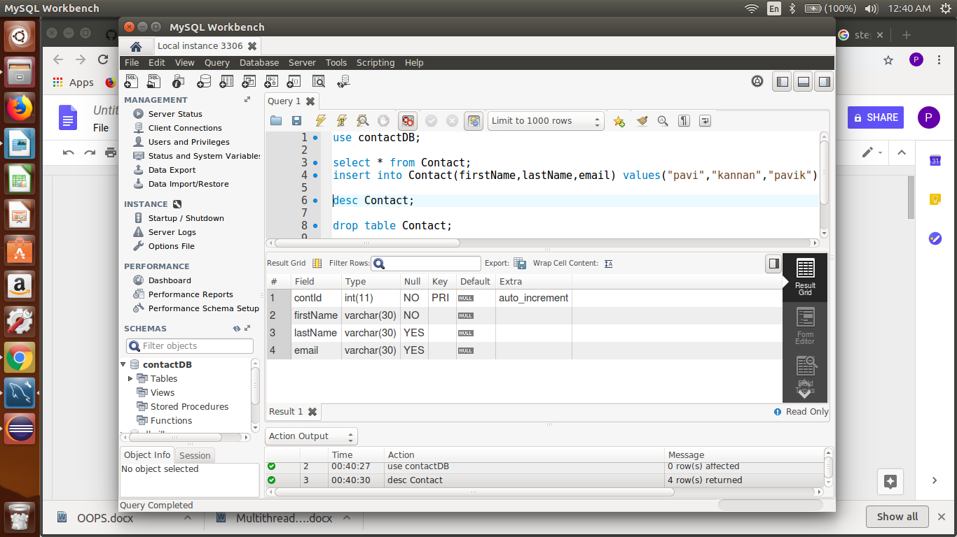

Home

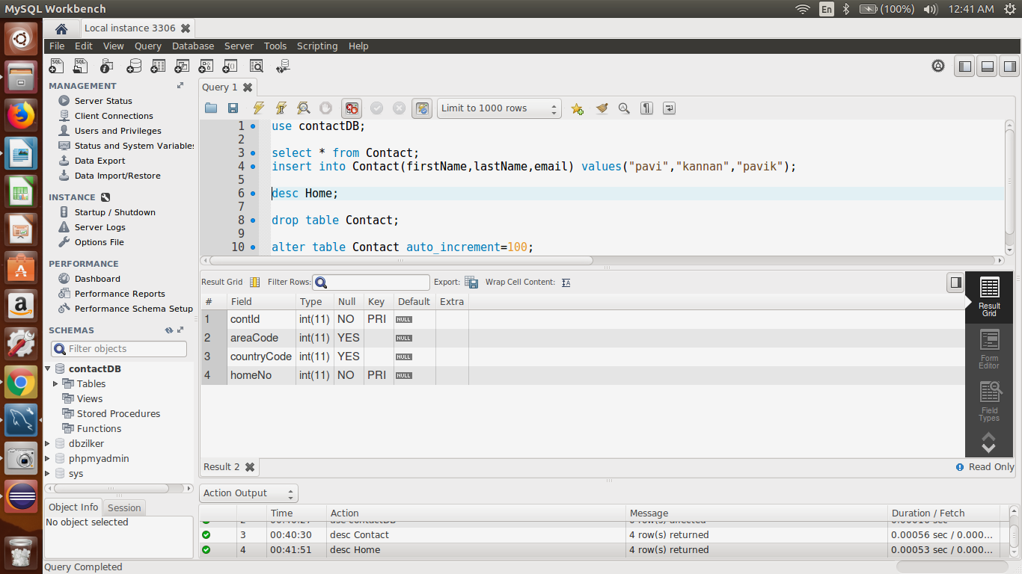

Office

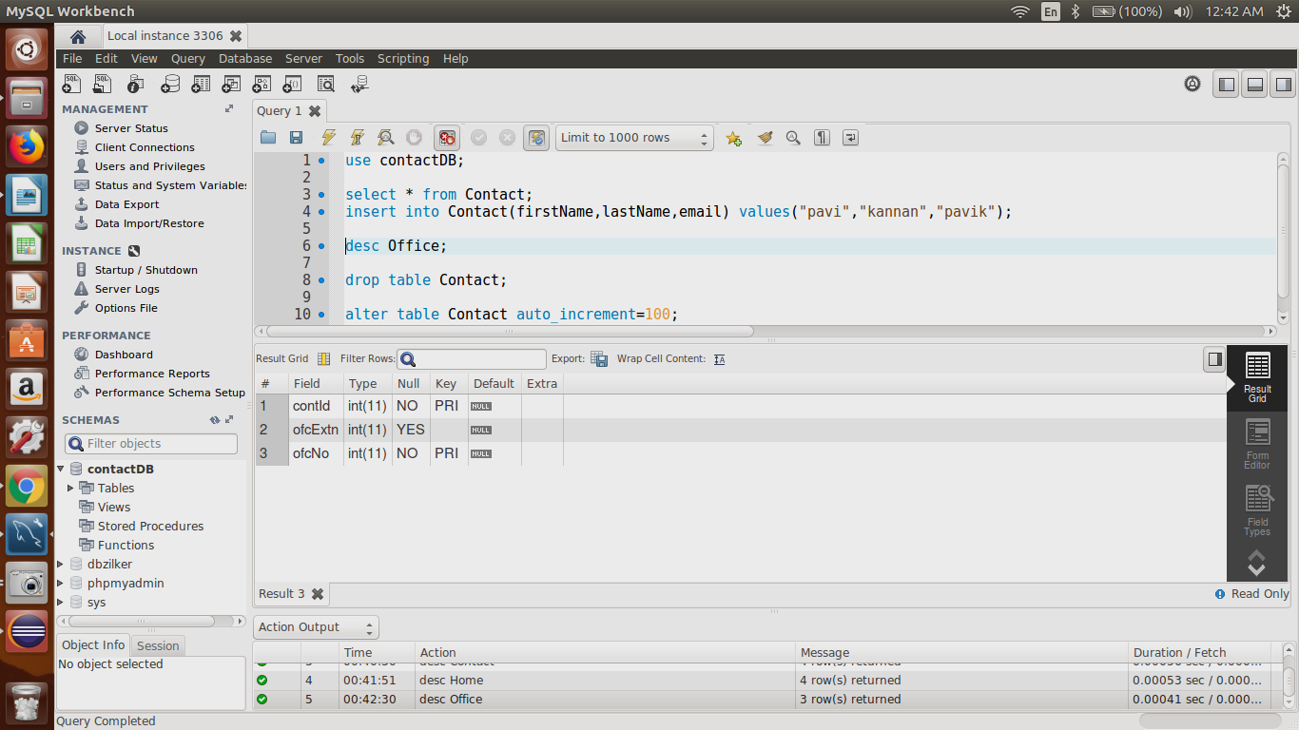

Mobile

