PROJECT
https://docs.google.com/document/d/11kbFude1yL9C3r--VX-HM_bZYuWNusVI1P_mITJTDc4/edit?tab=t.0

Cloning the repository:
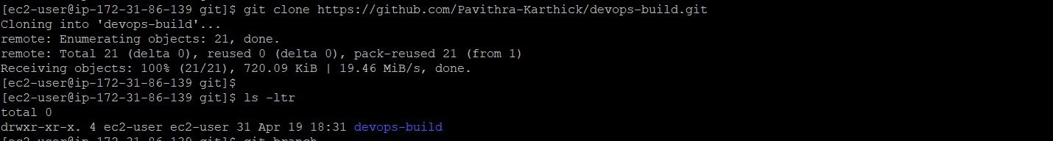
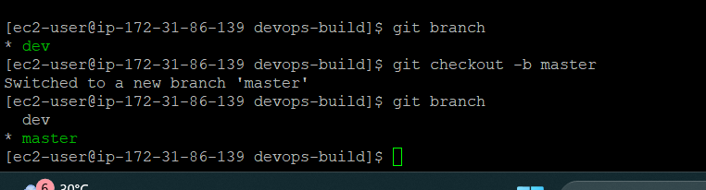
Creating Dockerfile:
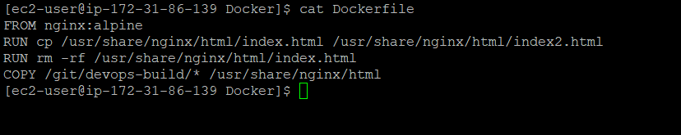
Build.sh file for building the docker image:
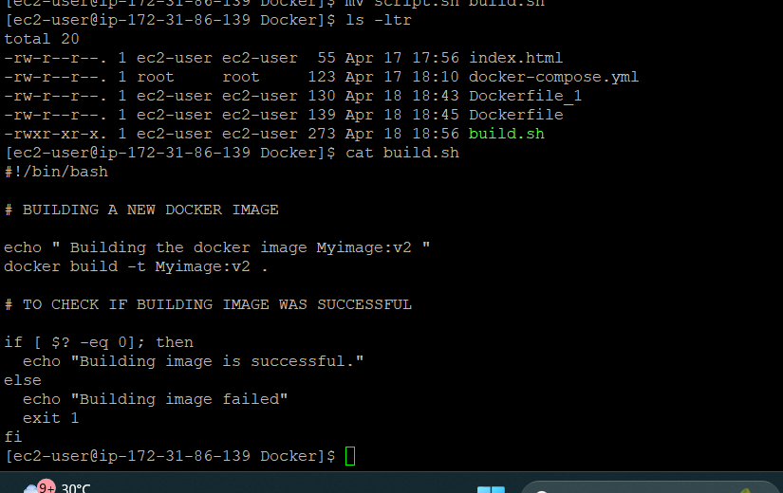
Docker-compose file:
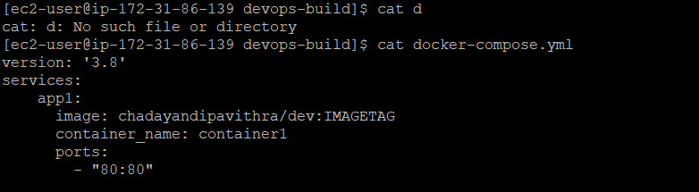
Creating repo’s In dockerhub:
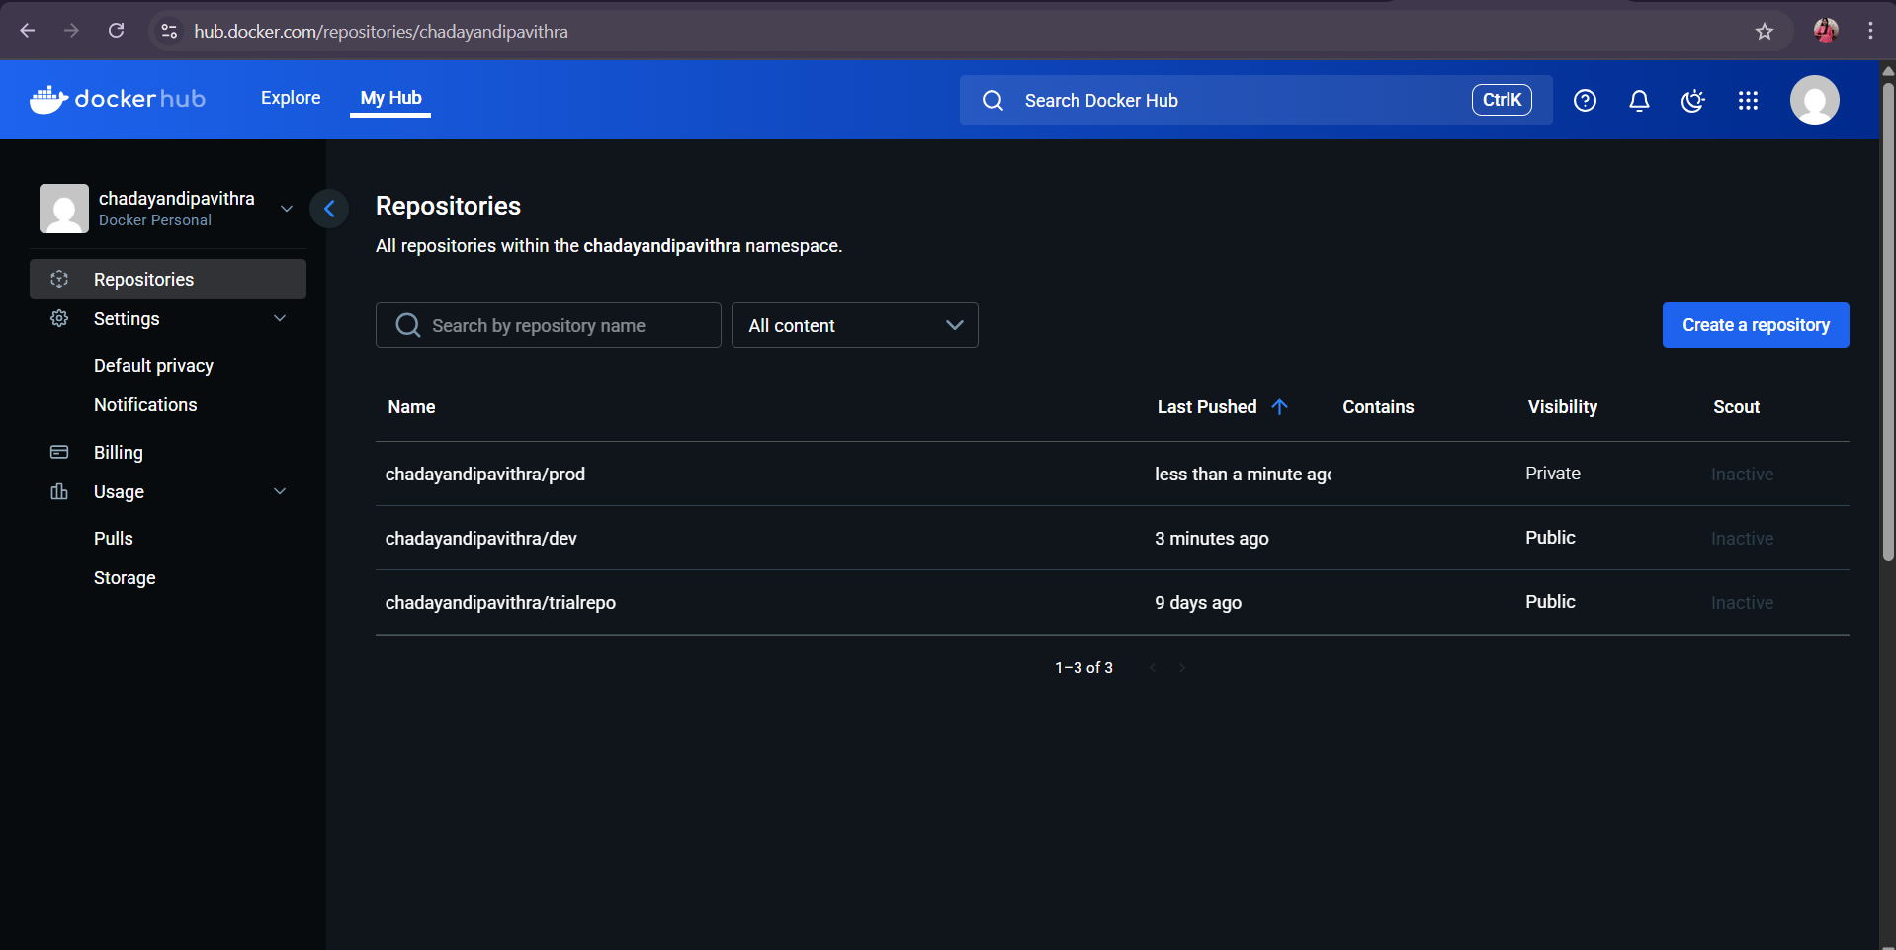
Pushing files to github:
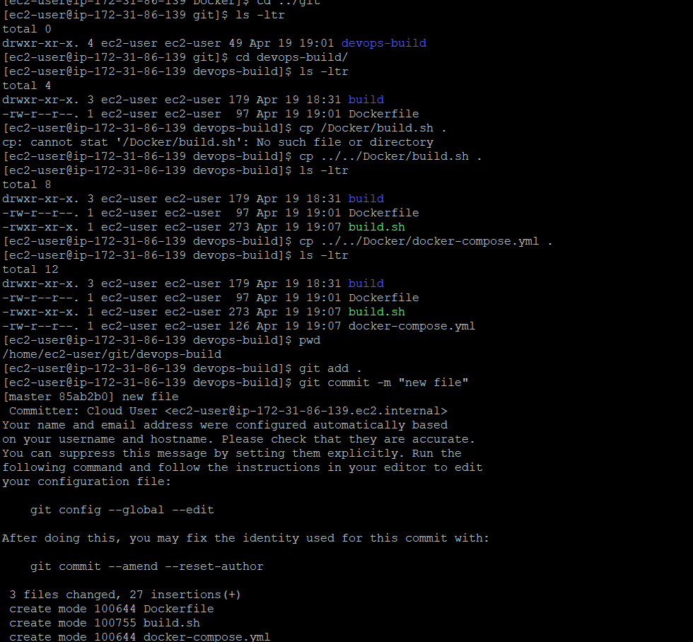

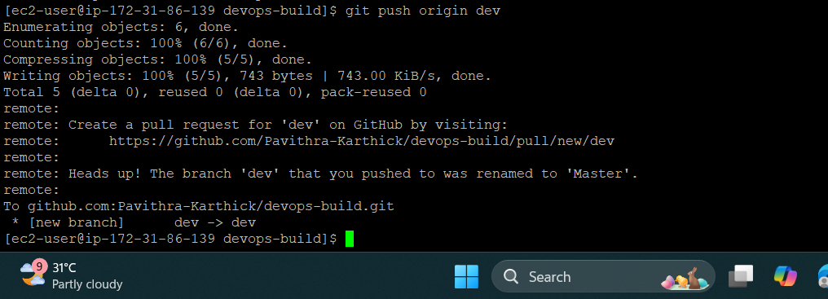

Docker ignore and git ignore files:
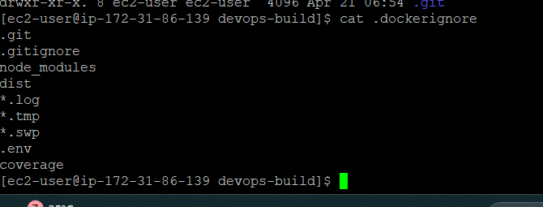

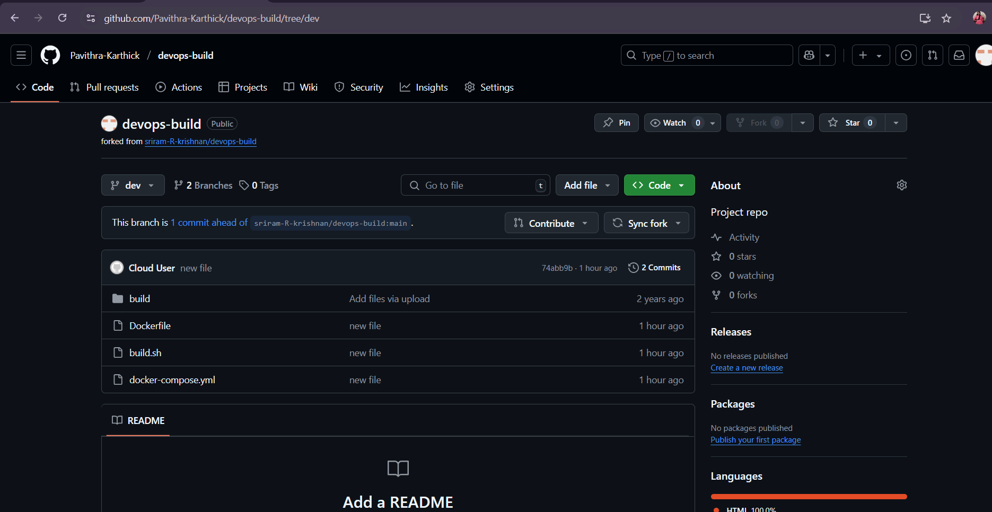

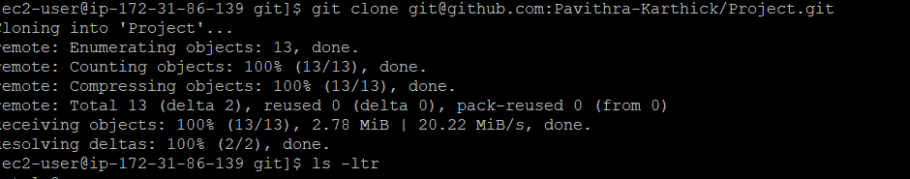
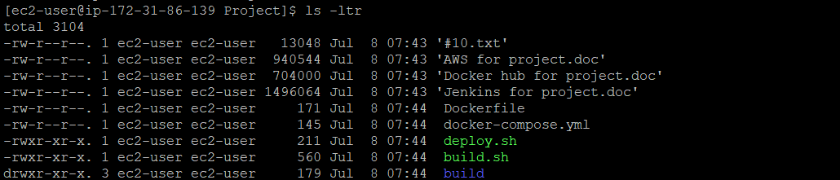
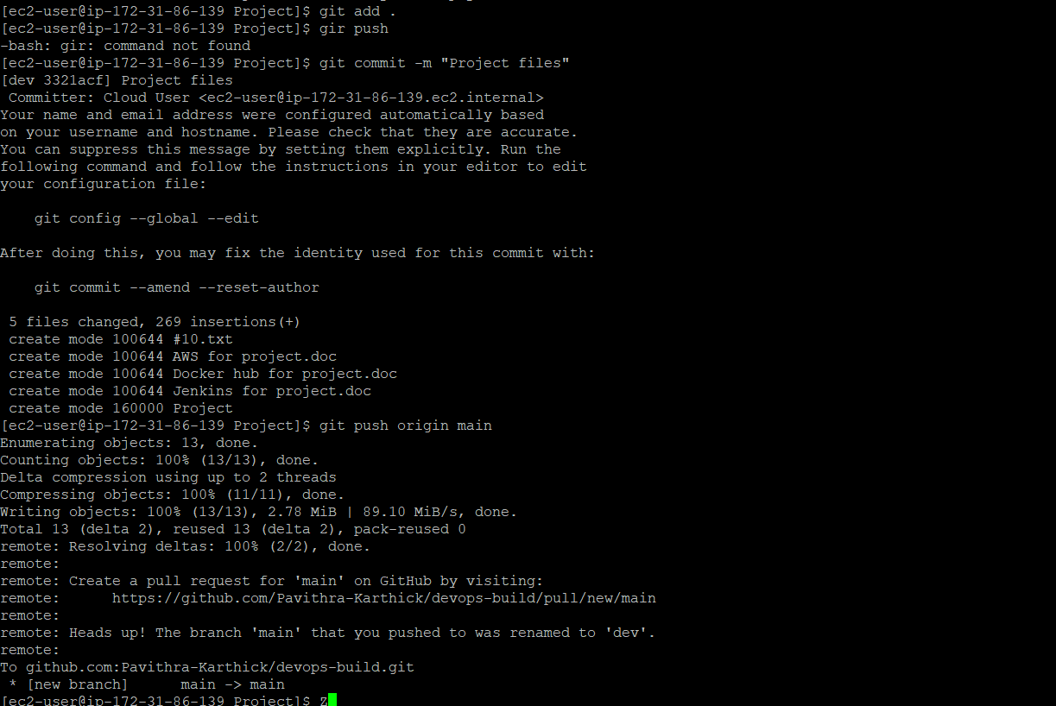

DOCKER IMAGE NAME:
TAG : V3

