VISVESVARAYA TECHNOLOGICAL UNIVERSITY
Jnana Sangama, Belagavi – 590018


Emotion-Based Movie Recommendation System

Submitted in partial fulfillment of the requirements as a part of the curriculum,

Bachelors of Engineering in Artificial Intelligence and Machine Learning

Submitted by

PUNYASHREE LP -1CR24AI094

PAVITHRA N-1CR24AI085

DISHA PAI-1CR24AI038

Under the Guidance of
Mr. Saurav Kumar Topo
Assistant Professor
Department of Artificial Intelligence and Machine Learning


Department of Artificial Intelligence and Machine Learning
CMR INSTITUTE OF TECHNOLOGY
132, AECS Layout, Kundalahalli, ITPL Main Rd, Bengaluru – 560037


CERTIFICATE
Certified that the Mini Project entitled “Emotion-Based Movie Recommendation System” is presented by Punyashree LP(1CR24AI094), Pavithra N(1CR24AI085) and Disha Pai(1CR24AI038) bonafide student(s) of CMR Institute of Technology in partial fulfillment of the requirements as a part of the curriculum, Bachelors of Engineering in Artificial Intelligence and Machine Learning, of Visvesvaraya Technological University, Belagavi during the year 2025-26. It is certified that all correction/suggestion indicated for Internal Assessment have been incorporated in the report deposited in the departmental library. The Entrepreneurial Project report has been approved as it satisfies the academic requirements in respect of the Technical Seminar prescribed for the bachelor of engineering degree.

Mr. Saurav Kumar Topo (Dr. Shyam P Joy)
Signature of the Guide Signature of the HOD

DECLARATION

We, the undersigned, students of CMR Institute of Technology, hereby declare that this mini project report titled

“Emotion-Based Movie Recommendation System”

is is a record of our original work done under the supervision of Mr. Saurav Kumar Topo , Assistant Professor, Department of Artificial Intelligence and Machine Learning. And has not formed the basis of award of any other degree, in this or any other Institution or University. In keeping with the ethical practice in reporting scientific information, due acknowledgements have been made wherever the findings of others have been cited.

1. [PUNYASHREE LP] (USN: 1CR24AI094 ) (Signature )
2. [PAVITHRA N] (USN: 1CR24AI085 ) (Signature )
3. [DISHA PAI] (USN: 1CR24AI038) (Signature )

ABSTRACT

The Emotion-Based Movie Recommendation System is a web-based application designed to provide personalized movie recommendations based on the real-time emotions of users. Traditional recommendation systems mainly rely on user history, ratings, and search patterns, which may not accurately reflect the current mood of users. To overcome this limitation, the proposed system uses facial emotion recognition to analyze user emotions through a webcam and recommend suitable movies accordingly.

The system is developed using Python and Flask for backend processing, while HTML, CSS, and JavaScript are used for frontend development. OpenCV is used for webcam image capture and processing, and DeepFace is used for detecting emotions such as happy, sad, angry, and neutral. Based on the detected emotion and user-selected language, the system fetches movie details, trailers, ratings, and OTT platform information using TMDB APIs.

The proposed system provides a modern Netflix-style user interface and improves user experience by reducing the time spent searching for movies. The project successfully demonstrates the integration of Artificial Intelligence, Computer Vision, and Web Technologies in a real-world entertainment application.

ACKNOWLEDGEMENTS

It is my proud privilege and duty to acknowledge the kind of help and guidance received from several people in preparation of this report. Apart from my own, the success of this report depends largely on the encouragement and guidelines of many others. It would have not been possible to prepare this report in this form without their valuable help, co-operation and guidance.
I would like to express my deep sense of gratitude to our Principal Dr. Sanjay Jain, CMR Institute of Technology, Bangalore for his motivation and for creating an inspiring atmosphere in college by providing state of the art facilities for preparation and delivery of this report.
My sincere thanks to Dr. Shyam P Joy , Head of Department of Artificial Intelligence and Machine Learning, for his whole-hearted support in completion of the Entrepreneurial Project.
I am highly indebted to my project guide Mr. Saurav Kumar Topo, Assistant Professor for guiding and giving timely advice and suggestions in the successful completion of this project.
My sincere thanks to Mr. Saurav Kumar Topo, Assistant Professo, mini-project coordinator for having supported the work related to this project.
Last but not the least, I would like to put forward my heartfelt acknowledgement to all my classmates, friends and all those who have directly or indirectly provided their overwhelming support during my seminar work and the development of this report.

TABLE OF CONTENTS
CERTIFICATE 2
DECLARATION 3
ABSTRACT 4
ACKNOWLEDGEMENTS 5
1. INTRODUCTION 8
1.1 Overview 8
1.2 Problem Statement 8
1.3 Objectives 8
1.4 Scope of the Project 9
2. LITERATURE SURVEY 10
3. METHODOLOGY 11
3.1 SYSTEM DESIGN 11
3.1.1 System Requirements 11
3.1.2 System Architecture / High-Level Design (HLD) 11
3.1.3 Database Design (ER Diagram / Schema) 12
3.1.4 Module Description 13
3.1.5 Dataset Description 14
3.1.6 Model(s) Used 14
3.2 IMPLEMENTATION 15
3.2.1 Technology Stack 15
3.2.2 Implementation of Key Modules 15
3.2.3 Data Preprocessing 16
3.2.4 Feature Engineering 16
3.2.5 Model Training 16
3.2.6 Model Evaluation 16
3.2.7 Comparison of Models 17
3.2.8 Model Deployment 17
4. RESULTS & DISCUSSIONS 18
4.1 Testing Methodology 18
4.2 Screenshots of Results 18
4.3 Performance Evaluation……………………………………………………………19
4.4 Discussion 19
5. CONCLUSION 20
5.1 Conclusion 20
5.2 Limitations 20
5.3 Future Scope 20
6. REFERENCES 21
APPENDIX A: SOURCE CODE 22

1. INTRODUCTION

1.1 Overview
In today’s digital entertainment era, users spend a significant amount of time searching for movies that match their mood and preferences. Traditional movie recommendation systems mainly depend on watch history, ratings, and search patterns. However, these systems often fail to understand the real-time emotional state of users, which plays an important role in content selection. With the advancement of Artificial Intelligence, Computer Vision, and Machine Learning, it has become possible to develop smarter recommendation systems that provide personalized suggestions based on user emotions.

The Emotion-Based Movie Recommendation System is a web-based application that detects the facial emotions of users through a webcam and recommends suitable movies accordingly. The system uses DeepFace and OpenCV for emotion detection and integrates TMDB APIs to fetch movie details such as ratings, trailers, posters, and OTT platform availability. The application also supports language-based movie recommendations and provides a modern Netflix-style user interface for better user interaction.

This project demonstrates the practical application of Artificial Intelligence in the entertainment industry by combining emotion recognition, web development, and recommendation systems into a single platform. The proposed system enhances user experience by reducing search time and delivering personalized entertainment suggestions.

1.2 Problem Statement
Users often spend a considerable amount of time searching for movies that suit their current mood. Existing recommendation systems mainly rely on user history, ratings, and browsing behavior, but they do not analyze the real-time emotions of users. As a result, users may receive recommendations that do not match their emotional state. This reduces personalization and affects the overall entertainment experience. Therefore, there is a need for a system that can detect user emotions in real time and provide movie recommendations accordingly.

1.3 Objectives
- To develop a web-based emotion-based movie recommendation system.
- To detect user emotions using facial expressions captured through a webcam.
- To recommend movies based on detected emotions and selected language preferences.
- To provide movie details such as ratings, trailers, posters, and OTT platform availability.
- To design an interactive and user-friendly Netflix-style interface.
- To integrate Artificial Intelligence, Computer Vision, and Web Technologies into a single application.

1.4 Scope of the Project
The project focuses on developing a real-time movie recommendation system based on facial emotion recognition. The system captures user facial expressions using a webcam and analyzes emotions such as happy, sad, angry, neutral, and surprise. Based on the detected emotion and user-selected language, relevant movie recommendations are displayed along with trailers, ratings, and OTT platform details.

The project is limited to movie recommendations only and does not include music, series, or other entertainment content recommendations. The accuracy of emotion detection depends on lighting conditions, webcam quality, and facial visibility. The system requires an internet connection for API access and movie data retrieval.

2. LITERATURE SURVEY
1. Traditional Movie Recommendation Systems
Traditional recommendation systems used by streaming platforms mainly depend on collaborative filtering and content-based filtering techniques. These systems analyze user watch history, ratings, and preferences to recommend movies. However, they fail to consider the real-time emotional state of users. The proposed system improves personalization by incorporating emotion detection.

2. Facial Emotion Recognition using Deep Learning
Facial emotion recognition systems use Computer Vision and Deep Learning algorithms to identify human emotions from facial expressions. Libraries such as DeepFace and OpenCV provide efficient emotion analysis using webcam input. Existing systems focus mainly on emotion detection but do not integrate personalized movie recommendation features.

3. AI-Based Personalized Recommendation Systems
AI-based recommendation systems provide personalized suggestions using Machine Learning algorithms. These systems are widely used in OTT platforms and e-commerce applications. However, most systems rely only on historical data rather than live emotional analysis. The proposed project combines real-time emotion detection with recommendation systems.

4. TMDB API-Based Entertainment Applications
Many web applications use TMDB APIs to fetch movie details such as posters, ratings, trailers, and streaming platform availability. While these applications provide rich movie information, they lack intelligent emotion-based recommendation capabilities. The proposed system integrates TMDB APIs with emotion recognition for enhanced user experience.

3. METHODOLOGY

3.1 SYSTEM DESIGN

3.1.1 System Requirements
Functional Requirements
- The system shall capture facial expressions using a webcam.
- The system shall detect emotions using AI-based facial analysis.
- The user should be able to select a preferred movie language.
- The system shall recommend movies based on detected emotions.
- The system shall display movie posters, ratings, trailers, and OTT platform details.
- The system shall provide a responsive and interactive user interface.

Non-Functional Requirements
- The system should provide fast movie recommendations.
- The system should be user-friendly and interactive.
- The system should support real-time emotion detection.
- The system should maintain accuracy in emotion recognition.
- The system should be scalable for future improvements.

Hardware and Software Requirements
Category | Development
OS | Windows 10 / Ubuntu 22.04
Processor | Intel Core i5 or above
GPU | Not Required
RAM | 8 GB
Software | Python 3.x, VS Code
Libraries | OpenCV, DeepFace, NumPy, Requests

3.1.2 System Architecture / High-Level Design (HLD)
The system consists of the following layers:
- Client Layer
The frontend interface developed using HTML, CSS, and JavaScript allows users to interact with the system.
- Application Layer
Flask handles backend processing, routing, and communication between modules.
- Emotion Detection Layer
OpenCV captures webcam input and DeepFace analyzes facial emotions.
- Recommendation Engine
The detected emotion is mapped to movie genres for recommendation generation.
- API Integration Layer
TMDB APIs fetch movie posters, trailers, ratings, and OTT platform details.
- Output Layer
Recommended movies are displayed in a Netflix-style interface.

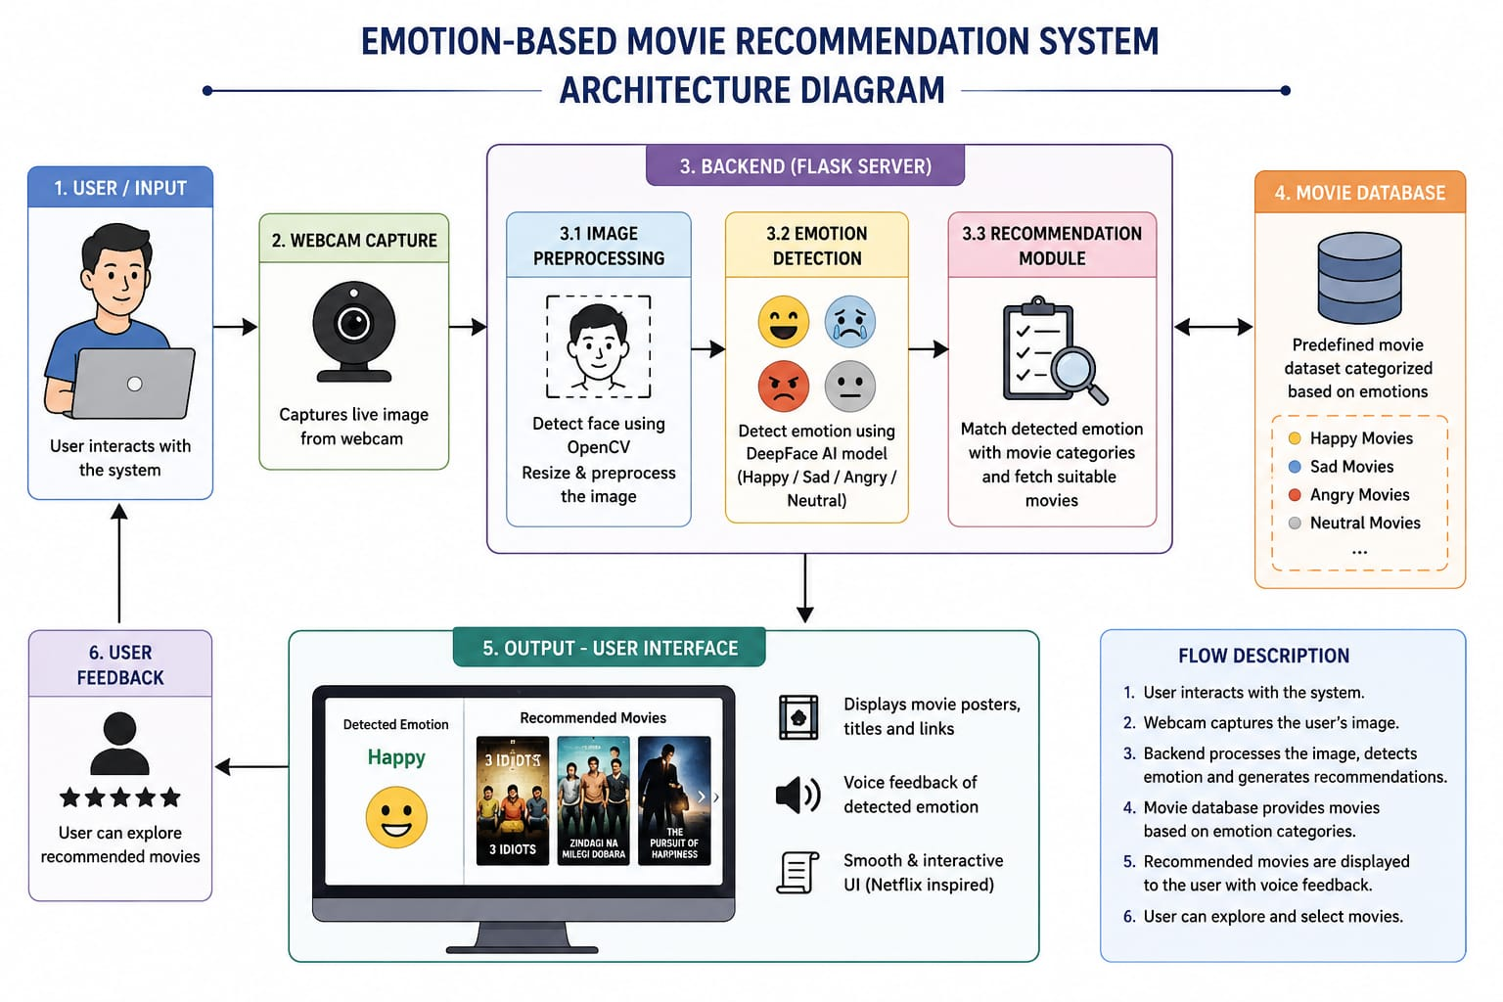
Figure 3.1: System Architecture Diagram

3.1.3 Database Design (ER Diagram / Schema)
Not Applicable.
The project does not use a dedicated database management system. Movie information is fetched dynamically using TMDB APIs, and temporary processing is handled within the Flask application.

3.1.4 Module Description
No. | Module Name | Description
1 | User Interface Module | Developed using HTML, CSS, and JavaScript to provide an interactive Netflix-style UI for users.
2 | Webcam Capture Module | Uses OpenCV to capture real-time facial expressions from the webcam.
3 | Emotion Detection Module | Uses DeepFace to analyze facial expressions and detect emotions such as happy, sad, angry, and neutral.
4 | Recommendation Module | Maps emotions to movie genres and fetches movie recommendations using TMDB APIs.
5 | Movie Information Display Module | Displays posters, ratings, trailers, and OTT platform details to users.

3.1.5 Dataset Description
The project uses real-time webcam input instead of a traditional dataset. DeepFace uses pretrained facial emotion recognition models trained on publicly available facial expression datasets. Movie information is fetched dynamically from the TMDB API database.

3.1.6 Model(s) Used
The project uses the DeepFace framework for facial emotion recognition. DeepFace is a Deep Learning-based facial analysis library capable of detecting emotions such as happy, sad, angry, neutral, surprise, and fear.

Model Used:
- DeepFace Emotion Recognition Model

Justification:
- High accuracy in emotion detection
- Easy integration with Python and Flask
- Supports real-time webcam analysis

Libraries Used:
- DeepFace
- OpenCV
- NumPy

3.2 IMPLEMENTATION

3.2.1 Technology Stack
Layer | Technology / Tool | Reason for Choice
Frontend | HTML, CSS, JavaScript | Provides responsive and interactive UI
Backend | Flask | Lightweight and easy Python web framework
Database | SQLite / Predefined Movie Dataset | Used to store movie categories and emotion-based recommendations
ML/AI Library | DeepFace | Provides accurate facial emotion recognition
Deployment | Localhost | Suitable for testing and project demonstration

3.2.2 Implementation of Key Modules
Module 1: Emotion Detection Module
The Emotion Detection Module captures facial expressions using OpenCV and analyzes them using DeepFace. Frames from the webcam are processed continuously to identify user emotions in real time. The detected emotion is then sent to the recommendation engine.
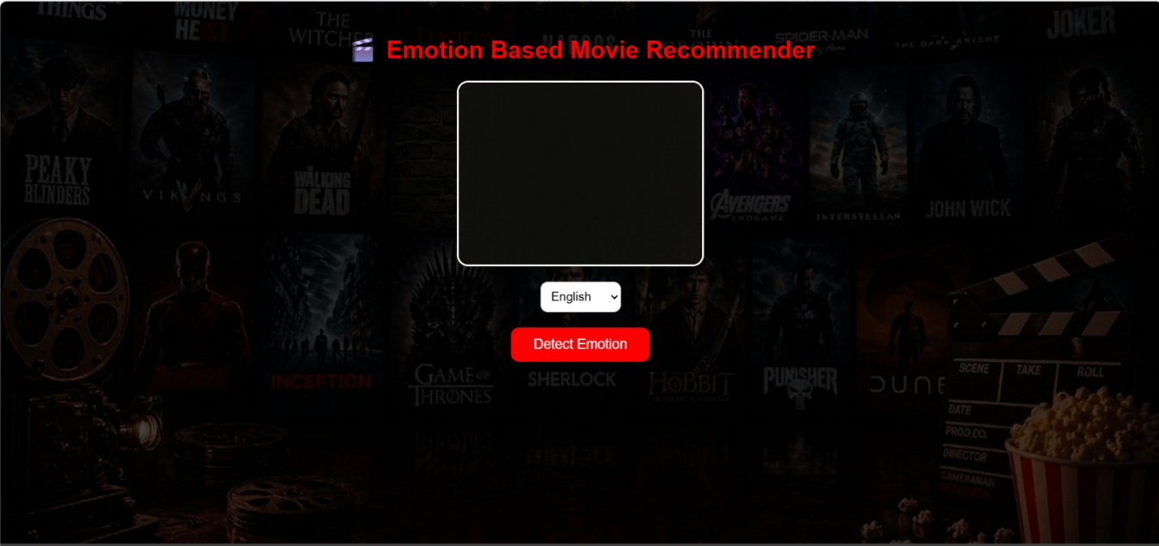
Figure 4.1: Emotion Detection Module

Module 2: Movie Recommendation Module
This module maps detected emotions to suitable movie genres. TMDB APIs are used to fetch movie details such as posters, ratings, trailers, and OTT platform availability. The results are displayed dynamically on the frontend.
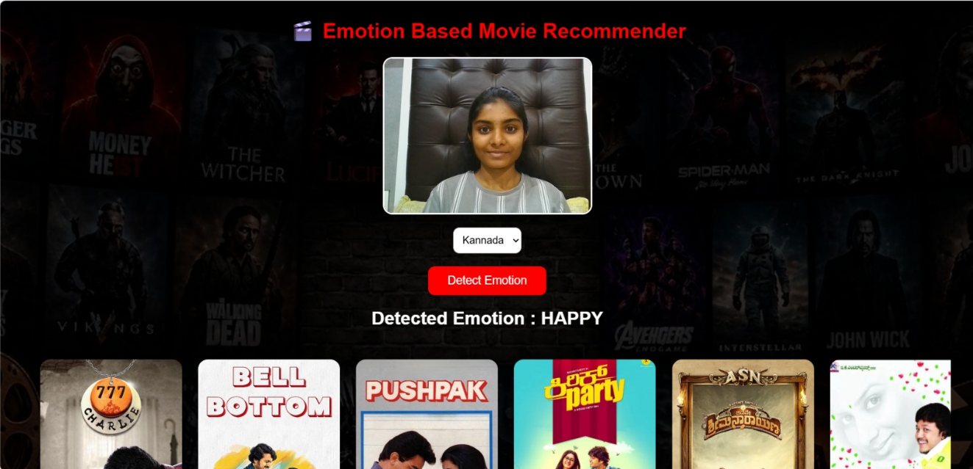

Figure 4.2: Movie Recommendation Output

3.2.3 Data Preprocessing
The webcam frames are resized and converted into suitable formats before emotion analysis. Face detection is performed to isolate facial regions for accurate prediction. Noise reduction and frame normalization improve emotion detection performance.

3.2.4 Feature Engineering

The project mainly relies on DeepFace pretrained models; therefore, explicit feature engineering is minimal. Facial landmarks and emotion-related facial features are extracted automatically by the Deep Learning model.

3.2.5 Model Training
The project uses pretrained DeepFace models; hence no separate model training was performed. The model operates using CPU-based real-time inference during emotion detection.

3.2.6 Model Evaluation
The performance of the system is evaluated based on:
- Emotion detection accuracy
- Recommendation relevance
- User interaction speed
- API response time

3.2.7 Comparison of Models
Model | Accuracy | Remarks
Haar Cascade | Moderate | Basic face detection only
DeepFace | High | Accurate emotion recognition
FER Model | Moderate | Limited real-time performance

3.2.8 Model Deployment
The application is deployed using Flask. The backend server handles emotion detection and API communication, while the frontend displays movie recommendations dynamically in the browser.

4. RESULTS & DISCUSSIONS

4.1 Testing Methodology
The system was tested using unit testing and integration testing methods. Individual modules such as webcam capture, emotion detection, API integration, and recommendation generation were tested independently. Integration testing was conducted to ensure smooth communication between frontend and backend modules. User acceptance testing was also performed to verify recommendation quality and interface usability.

4.2 Screenshots of Results
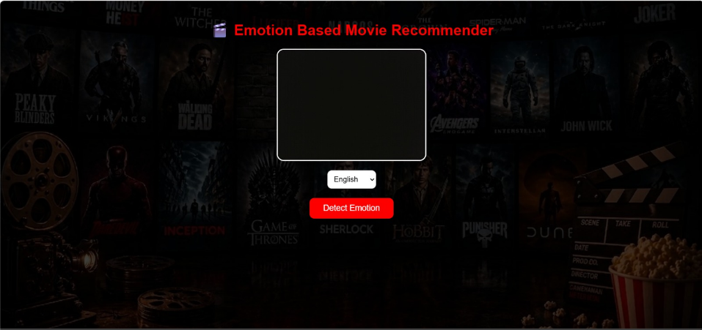
Figure 4.1: Home Page Interface
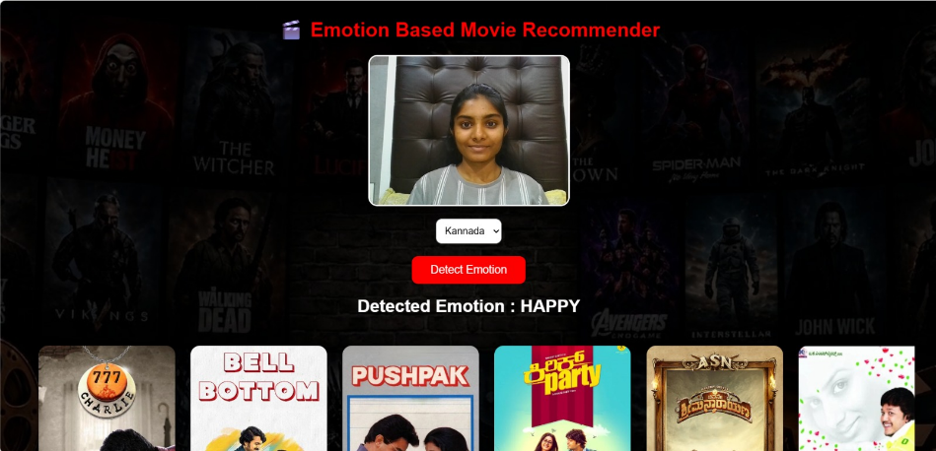
Figure 4.2: Emotion Detection Output
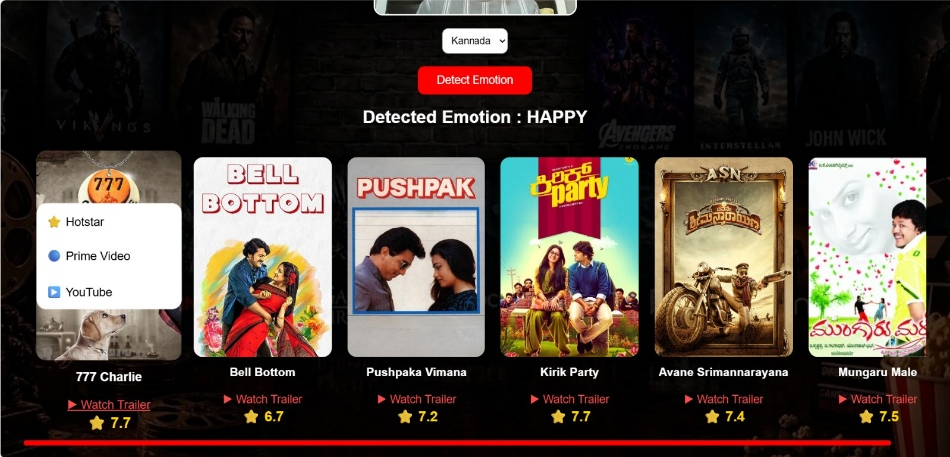
Figure 4.3: Movie Recommendation Display and Trailer and OTT Platform Display

4.3 Performance Evaluation

The system achieved efficient real-time emotion detection with accurate movie recommendations. DeepFace provided high emotion recognition accuracy under proper lighting conditions. The recommendation system responded quickly using TMDB APIs and delivered relevant movie suggestions based on user emotions.

4.4 Discussion
The project successfully combines Artificial Intelligence, Computer Vision, and Web Technologies into a single application. The system effectively detects user emotions and recommends suitable movies accordingly. The Netflix-style interface improves user interaction and overall entertainment experience. The project demonstrates the practical application of AI in real-world recommendation systems

5. CONCLUSION

5.1 Conclusion
The Emotion-Based Movie Recommendation System was developed successfully to provide personalized movie recommendations using facial emotion recognition. The system captures user emotions through a webcam, analyzes them using DeepFace, and recommends suitable movies based on emotional state and language preference.
The project achieved its objectives by integrating AI, Computer Vision, and Web Technologies into a single platform. The system improved user experience by reducing the time spent searching for movies and providing emotionally relevant recommendations. This project also enhanced understanding of Flask development, API integration, and real-time emotion detection.

5.2 Limitations
- Emotion detection accuracy depends on lighting conditions and webcam quality.
- The system supports only movie recommendations.
- Internet connection is required for API access.
- Real-time processing speed may vary depending on system performance.

5.3 Future Scope
- Extend the system to recommend music and web series.
- Improve emotion detection accuracy using advanced Deep Learning models.
- Add user login and personalized watchlist features.
- Develop a mobile application version of the system.
- Integrate voice-based emotion analysis for improved recommendations.

6. REFERENCES

- DeepFace Documentation, Available: https://github.com/serengil/deepface
- OpenCV Documentation, Available: https://opencv.org/
- Flask Documentation, Available: https://flask.palletsprojects.com/
- TMDB API Documentation, Available: https://developer.themoviedb.org/
- Ian Goodfellow, Yoshua Bengio, Aaron Courville, Deep Learning, MIT Press, 2016.
- Szeliski, Richard, Computer Vision: Algorithms and Applications, Springer, 2011.

APPENDIX A: SOURCE CODE
GitHub Repository: [https://github.com/<username>/<project-name>]
[Instruction: Give only small snippet of the major file content]
A.1 [Module / File Name: e.g., app.py / main.js / model_train.py]
[add link to file in the github]
A.2 [Module / File Name: e.g., model_utils.py]
[add link to the file in the github]

