# CTS_JAVA FSE NURTURE 4.0

#JUNIT BASIC TESTING EXERCISES:

#EXERCISE 1:

# SETTING UP JUNIT

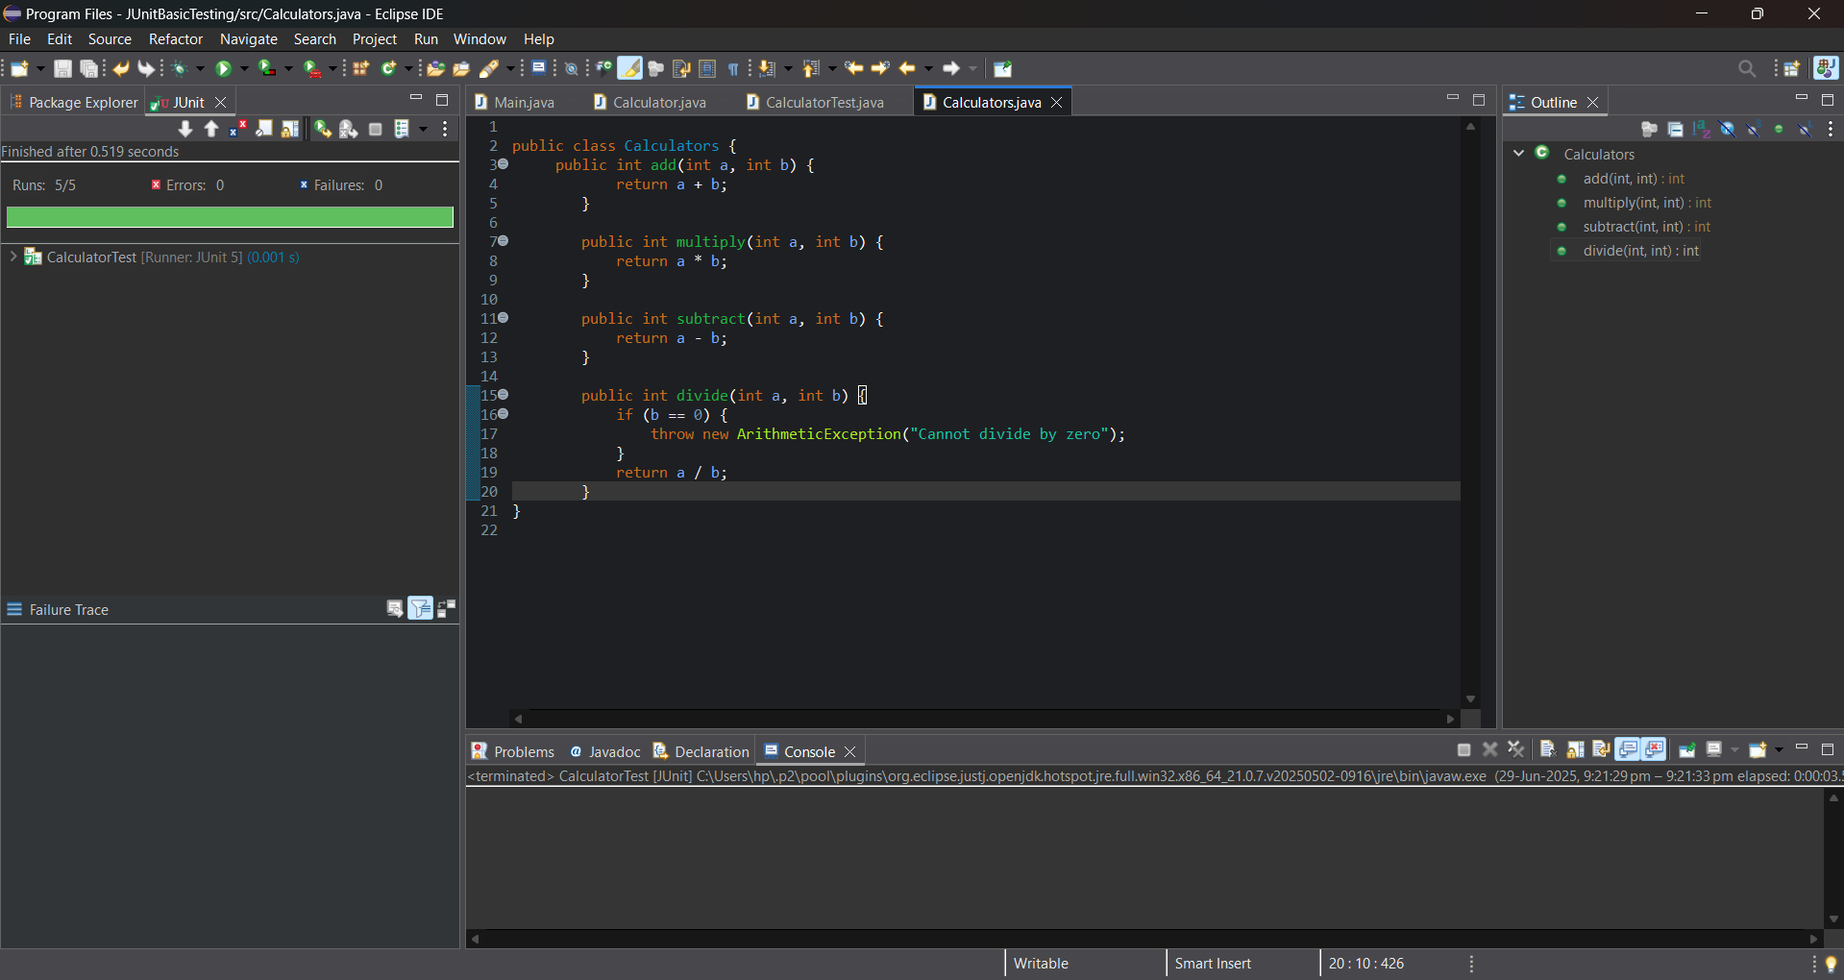

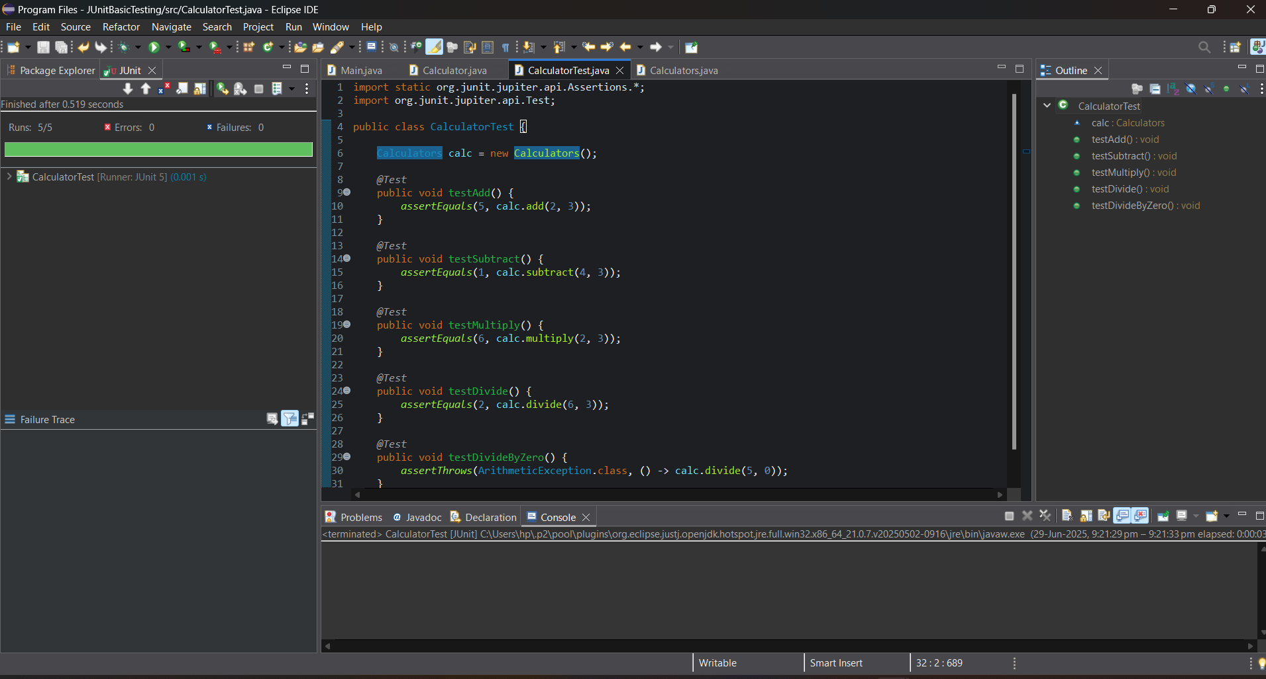

#EXERCISE 3:

#ASSERTIONS IN JUNIT

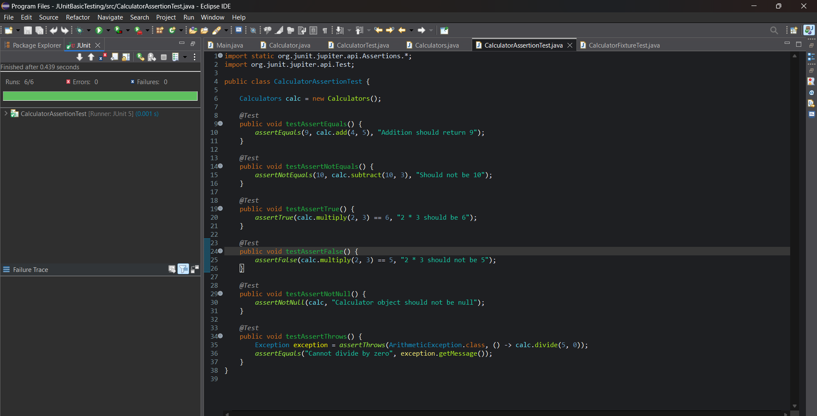

#**Exercise 4: ARRANGE-ACT-ASSERT (AAA) PATTERN, TEST FIXTURES, SETUP AND TEARDOWN METHODS IN JUNIT:**

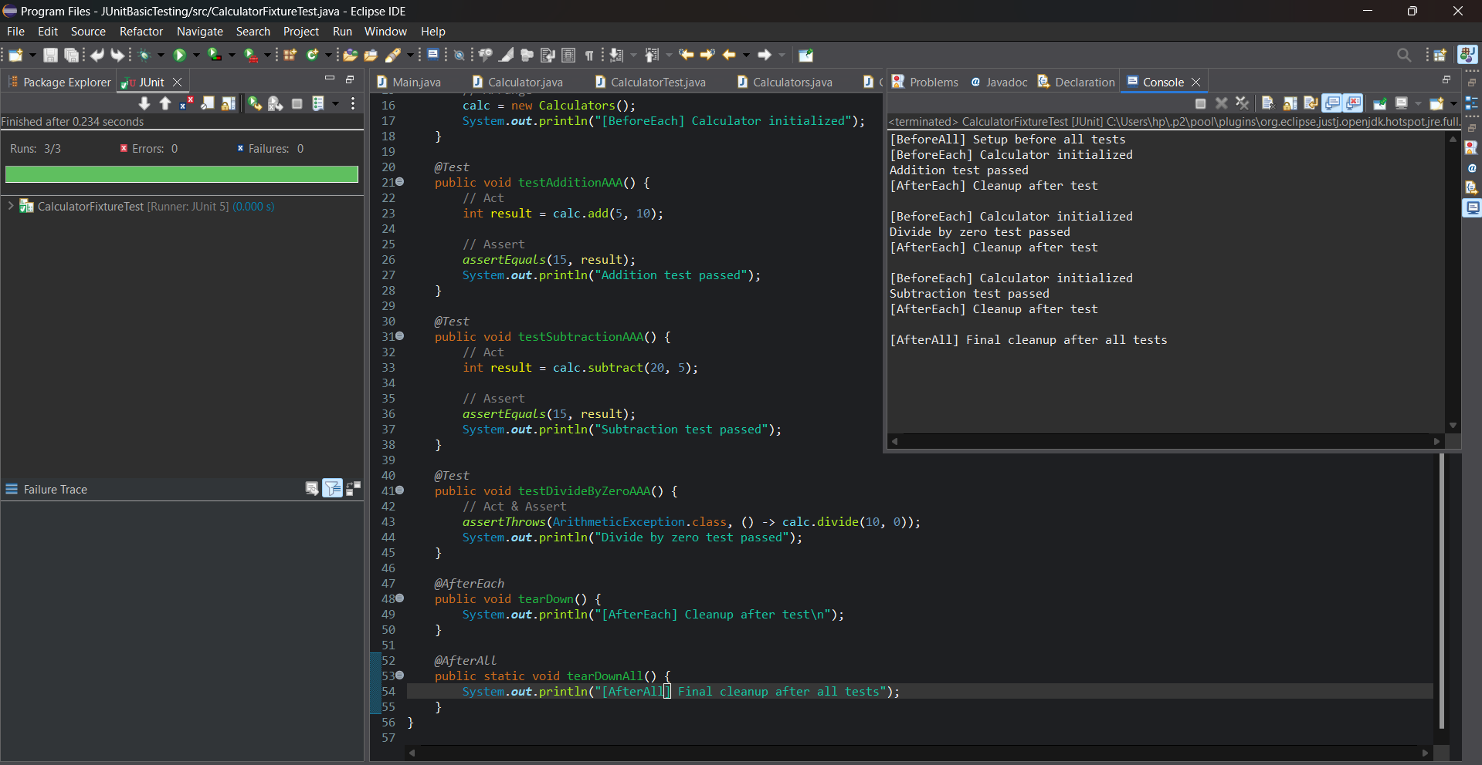

#MOCKITO EXERCISES:

#EXERCISE 1: MOCKING AND STUBBING

#EXERCISE 3: ARGUMENT MATCHING:

#LOGGING USING SLF4J:

#EXERCISE 1: LOGGING ERROR MESSAGES AND WARNING LEVELS:

