**Report BUG report POSTMAN**

1. **Put request---**When entering already existing contact number status code expected - 409 Conflict is specified in API document but getting 400 Bad Request

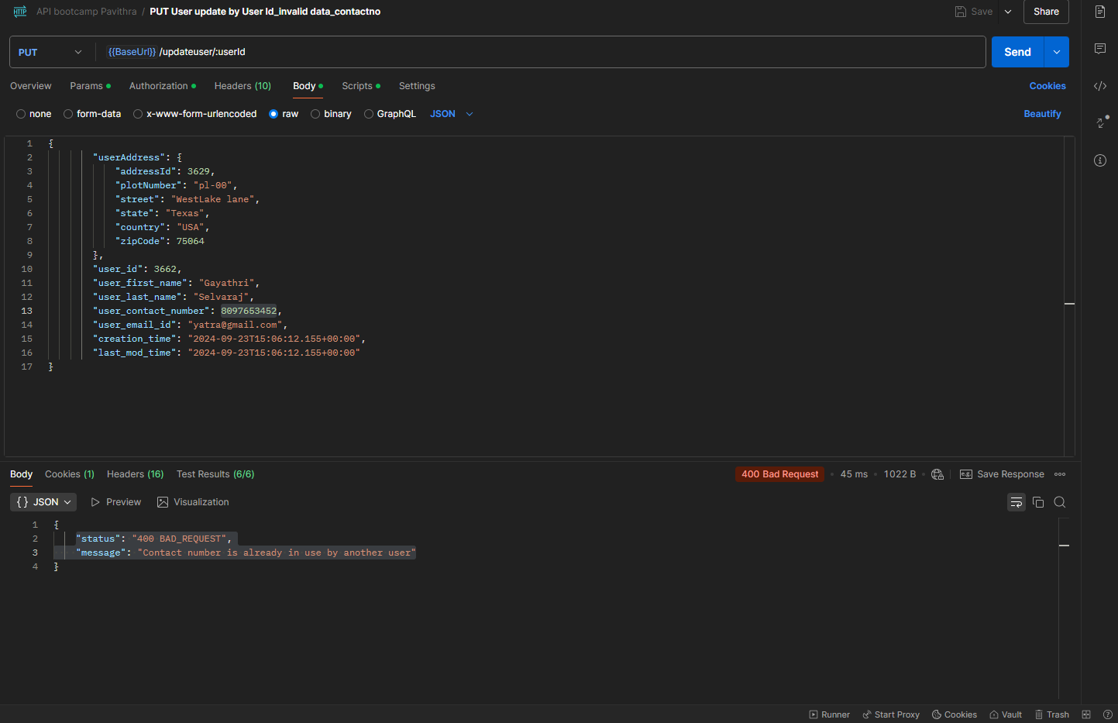

1. **Put request---**When entering already existing email id status code expected - 409 Conflict is specified in API document but getting 500 internal server error

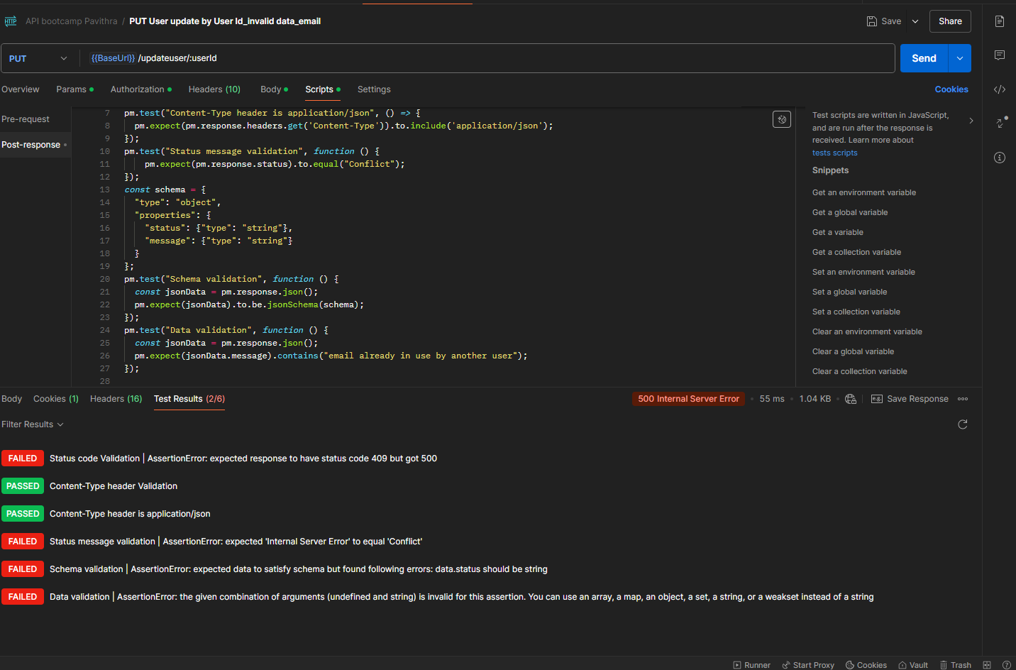

1. Zip Code field -accepts null values in put request. It’s not showing any error message

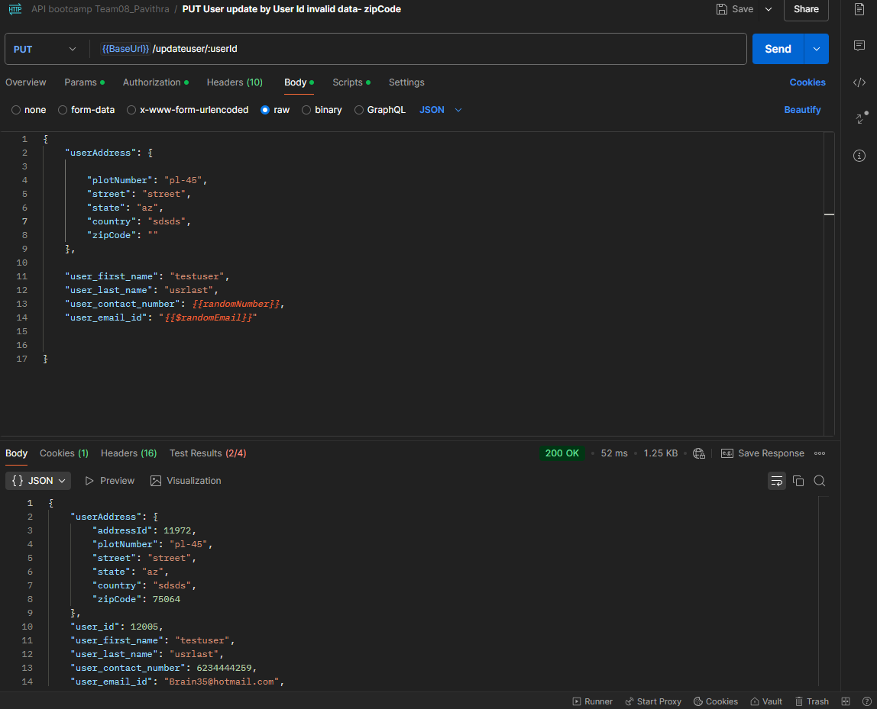

Zip code is given alphabets its simply showing bad request. Message like ”should contain alphanumeric or numeric field” is not specified

