Data Analysis on Disaster dataset
A REPORT ON DATA ANALYSIS USING NUMPY AND PANDAS



By

Batch-8
N.Pavithra(324103210149) P. Thanuja(324103210150)
P. Laxmi prasanna(324103210151)

Under the esteemed guidance
Of
Dr.P.V.S.L.Jagadamba
Professor,
CSE Department

Gayatri Vidya Parishad College of Engineering for Women(A)
[Approved by AICTE NEW DELHI]
[Accredited by National Board of Accreditation(NBA) for B.Tech .CSE ,ECE & IT– valid from 2019-22 and 2022-25]

[Accredited by National Assessment and Accreditation Council(NAAC) with A Grade-Valid from 2022-2027]
Kommadi, Madhurawada, Visakhapatnam – 530048
2025-26
GAYATRIVIDYAPARISHADCOLLEGEOFENGINEERINGFORWOMEN

DEPARTMENTOFCOMPUTERSCIENCEANDENGINEERING

CERTIFICATE

This is to certify that the project report is a bonafide work of Advanced Python Programming lab (Skill course) of the following II B.Tech I semester students in the Department of Computer Science and Engineering, Gayatri Vidya Parishad College of Engineering for Women(Autonomous) during the academic year 2025– 26, in fulfillment of the requirement for the project.

N.Pavithra(324103210149) P. Thanuja (324103210150)
P. Laxmi prasanna(324103210151)

Signature of the Guide Signature of the HOD

Dr.P.V.S.L.Jagadamba Dr.P.V.S.L.Jagadamba
Professor, Professor,
Dept.ofCSE Dept.ofCSE

ExternalExaminer

TABLEOFCONTENTS

Tasks Page no.
- Data Loading and Inspection | 5- 6
1.1 Dataset Description | 5
1.2 Description of Dataset using python commands | 6
- Data Cleaning | 7- 8
2.1 Identify the missing values in the dataset | 7
2.2 Handling the missing values | 7
2.3 Identification of discrepancies | 8
2.4 Ensuring the consistency of the data by removing discrepancies (if any) | 8
- Data Wrangling | 9 - 11
3.1 Perform Merging and Sorting | 9
3.1 Derive new columns and convert the data types | 10
3.2 Apply transformations or encoding on String columns | 11
- Filtering and Indexing | 12 - 13
Apply filtering and Indexing operations | 12-13
- Aggregation and Indexing | 14 - 15
Apply Aggregation and Indexing operations | 14-15
- Visualization | 16- 20
Apply various plots to visualize data | 16-20
- Develop Streamlit App | 21-27
7.1 Introduction | 21
7.2 Widgets used | 21
7.3 Front End design | 22
7.4 Output Screens | 23 - 27
- Conclusion | 28

- Data Loading and Inspection
This section of the Streamlit application handles data loading and inspection for a disaster dataset. It starts by providing a file uploader widget that allows the user to upload CSV files. Once a file is uploaded, the application reads the contents using Pandas and stores them in a DataFrame named df. After successfully loading the dataset, the application displays a preview of the first few rows to help users understand the structure and initial values present in the data.
Additionally, it presents a detailed statistical description of the dataset, including numerical and categorical columns, using the describe() function with the include='all' parameter. This gives users insights into important metrics such as mean, standard deviation, unique values, and data distribution.
The code also includes a fix for displaying df.info() within Streamlit. Since df.info() normally outputs to the console, a StringIO buffer is used to capture this information. The captured text is then displayed inside the Streamlit interface using st.text(), allowing users to view data types, memory usage, and non-null counts directly in the app.
Finally, a horizontal divider is added using st.markdown('---') to visually separate this section from the rest of the application, improving readability and structure. This entire block ensures the user can fully inspect the uploaded dataset before proceeding to further processing or analysis.

Source code
st.header("1. Data Loading & Inspection")
uploaded_file = st.file_uploader("📂 Upload Disaster Dataset (.csv)", type=["csv"])
if uploaded_file:
df = pd.read_csv(uploaded_file)
st.subheader("1.1 Dataset Preview")
st.dataframe(df.head())
st.subheader("1.2 Dataset Description")
st.write(df.describe(include='all'))
# FIX df.info() (StringIO buffer)
st.subheader("Dataset Info")
buffer = io.StringIO()
df.info(buf=buffer)
info_str = buffer.getvalue()
st.text(info_str)
st.markdown("---")
output
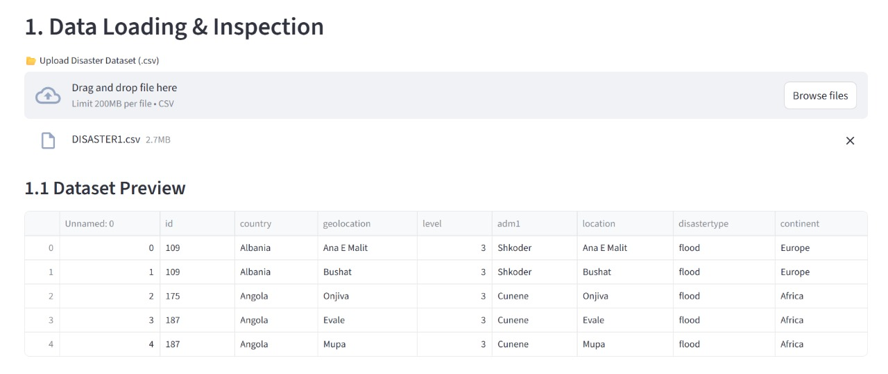

2.Data Cleaning
This section of the Streamlit application focuses on cleaning the uploaded dataset. It begins by displaying the total number of missing values in each column using df.isnull().sum(), helping users identify incomplete data. Missing values are then handled by replacing them with the string "Unknown" to ensure that no empty fields remain, and the cleaned DataFrame is displayed for verification.
Next, the code checks for discrepancies in important columns such as country and disastertype by printing their unique values. This helps users detect inconsistent spellings or formatting issues. To further improve consistency, the application converts all values in the country column to title case, ensuring uniform capitalization across entries.
Finally, a horizontal divider is added to separate this data cleaning section from the upcoming sections, improving readability and structure of the Streamlit interface. This block ensures the dataset is clean, consistent, and readyfor further analysis.
Source code:
st.header("2. Data Cleaning")
st.subheader("2.1 Missing Values")
st.write(df.isnull().sum())
st.subheader("2.2 Handling Missing Values (Fill with 'Unknown')")
df_clean = df.fillna("Unknown")
st.dataframe(df_clean)
st.subheader("2.3 Check for Discrepancies")
if "country" in df_clean.columns:
st.write("Unique Countries:", df_clean['country'].unique())
if "disastertype" in df_clean.columns:
st.write("Unique Disaster Types:", df_clean['disastertype'].unique())
st.subheader("2.4 Ensuring Consistency (Fix Capitalization)")
if "country" in df_clean.columns:
df_clean['country'] = df_clean['country'].astype(str).str.title()
st.markdown("---")
Output
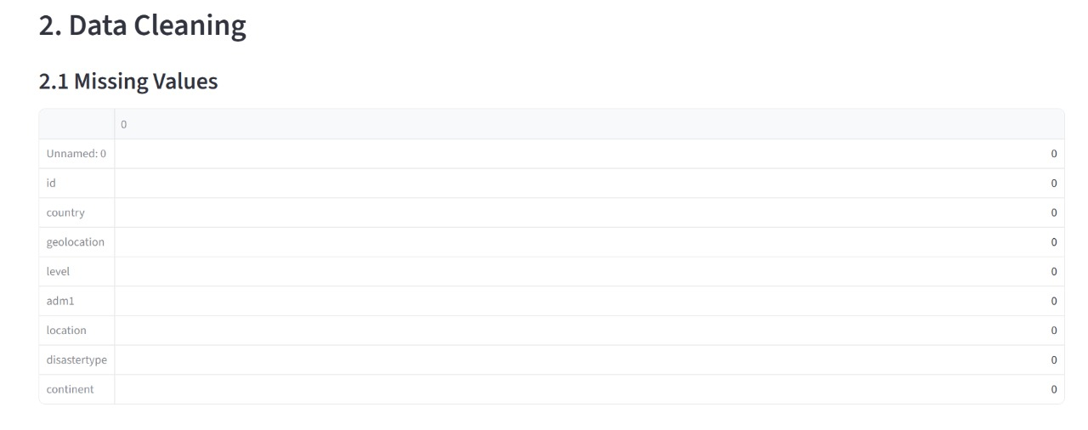
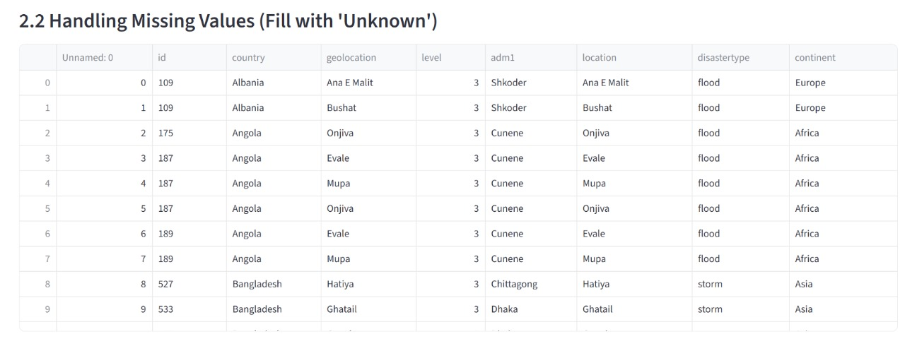
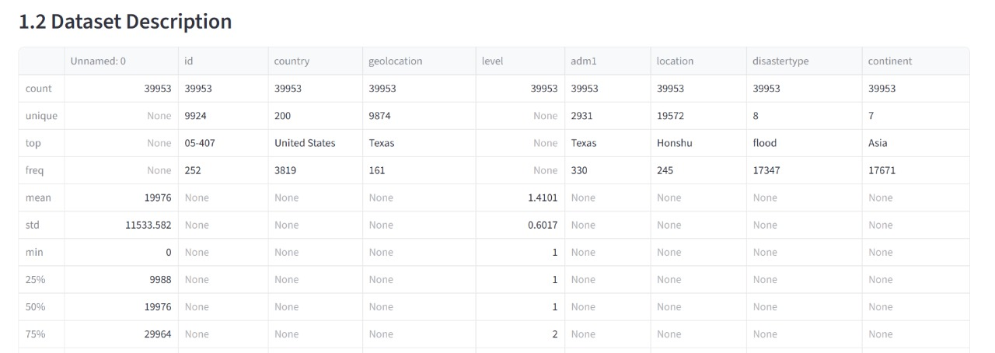
3.Data Wrangling
This section handles data wrangling to prepare the cleaned dataset for deeper analysis. It begins by sorting the dataset alphabetically based on the country column, allowing users to view the records in an organized manner if the column exists.
Next, the code creates new derived features. If a location column is present, a new column namedlocation_length is generated by calculating the number of characters in each location entry. This helps in analyzing text-based fields and identifying unusually short or long entries.
The section also includes basic encoding of categorical data. When the disastertype column exists, a copy of the dataset is made, and a new column disastertype_code is created using category codes. This converts text labels into numeric values, which are often required for machine learning algorithms.
A horizontal divider is finally added to separate this wrangling section from the next part of the Streamlit app. Overall, this block organizes, enhances, and transforms the dataset to make it more structured and analysis-ready.
Source code
st.header("3. Data Wrangling")
st.subheader("3.1 Sorting by Country")
if "country" in df_clean.columns:
st.dataframe(df_clean.sort_values(by="country"))
st.subheader("3.2 Create New Columns & Convert Types")
if "location" in df_clean.columns:
df_clean['location_length'] = df_clean['location'].astype(str).apply(len)
st.dataframe(df_clean)

st.subheader("3.3 Encoding String Columns")
if "disastertype" in df_clean.columns:
df_encoded = df_clean.copy()
df_encoded['disastertype_code'] = df_encoded['disastertype'].astype('category').cat.codes
st.dataframe(df_encoded)
st.markdown("---")
output
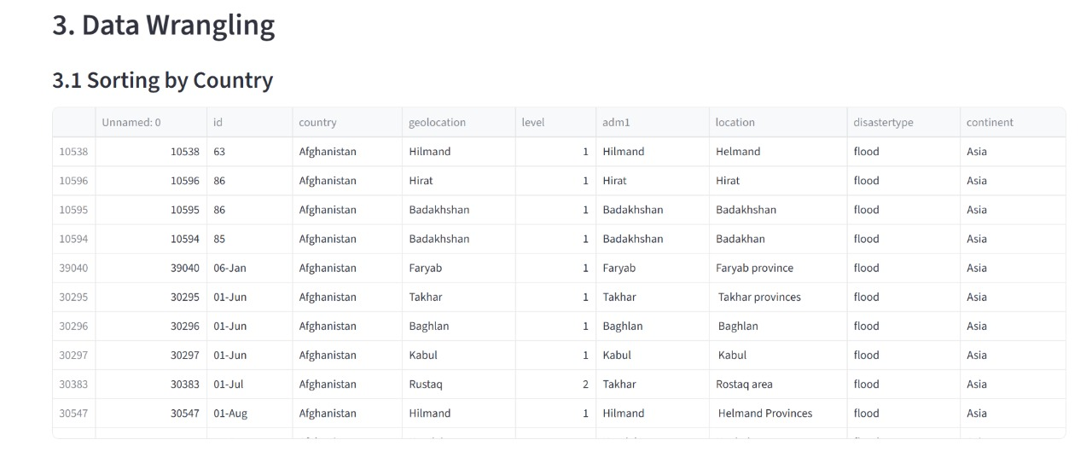
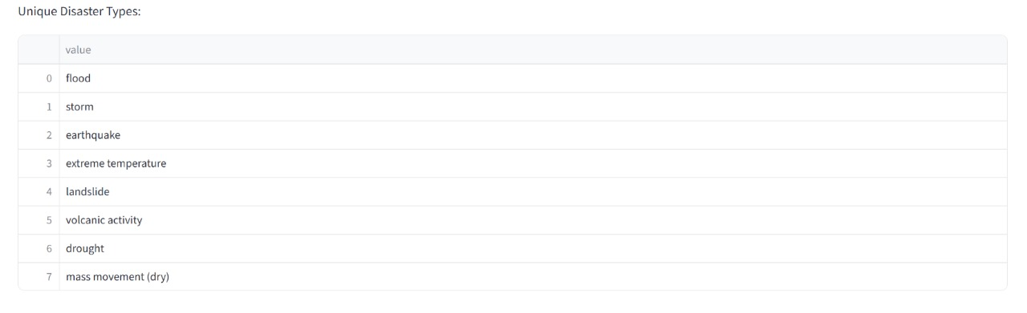

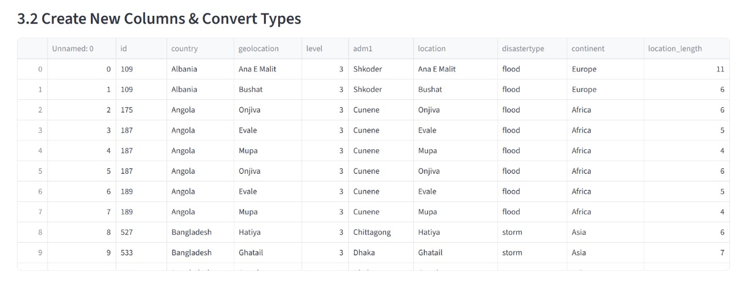

4. Filtering and Indexing
This section of the application focuses on filtering and indexing operations on the cleaned dataset. It begins by displaying a header for filtering, followed by a subsection specifically designed to filter records where the continent value is "Asia".
Before applying the filter, the code checks whether the continent column exists in the DataFrame. If the column is present, it displays all rows that belong to Asia using a simple conditional filter. If the column is missing, the app shows an informational message indicating that the required column is not found.
A horizontal divider is added at the end to neatly separate this filtering section from the next part of the Streamlit application.
Source code
st.header("4. Filtering & Indexing")
st.subheader("Filter: Continent = Asia")
if "continent" in df_clean.columns:
st.dataframe(df_clean[df_clean['continent'] == "Asia"])
else:
st.info("Continent column not found.")
st.markdown("---")
output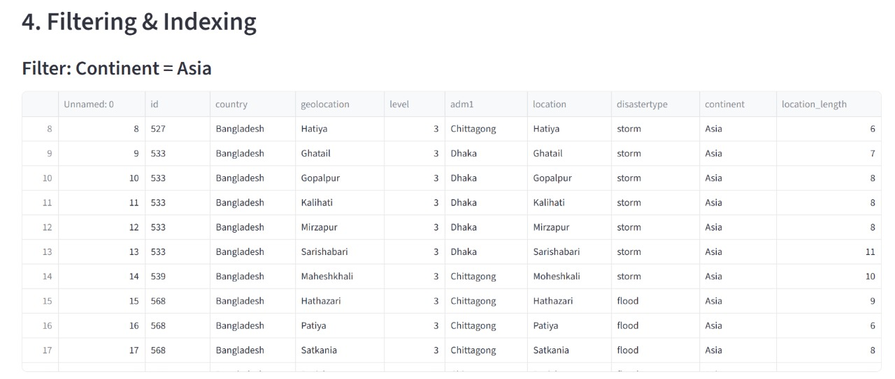

5. Aggregation
This part of the analysis presents a comprehensive summary of disaster occurrences by country, offering a clear view of how disaster events are distributed across different regions in the dataset. By grouping the records based on the country field and calculating the total number of occurrences for each group, the application reveals which countries appear most frequently and which have fewer recorded events. This information is valuable for identifying geographical hotspots, understanding regional patterns of vulnerability, and recognizing areas that may require further investigation or resource allocation. The resulting table provides a straightforward numerical breakdown, allowing users to quickly compare countries, detect imbalances in data representation, and establish a foundational understanding before proceeding to more advanced visualizations or statistical analyses.
Source Code:
st.header("5. Aggregation")
st.subheader("Count of Disasters per Country")
if "country" in df_clean.columns:
st.write(df_clean.groupby("country").size())
Output:

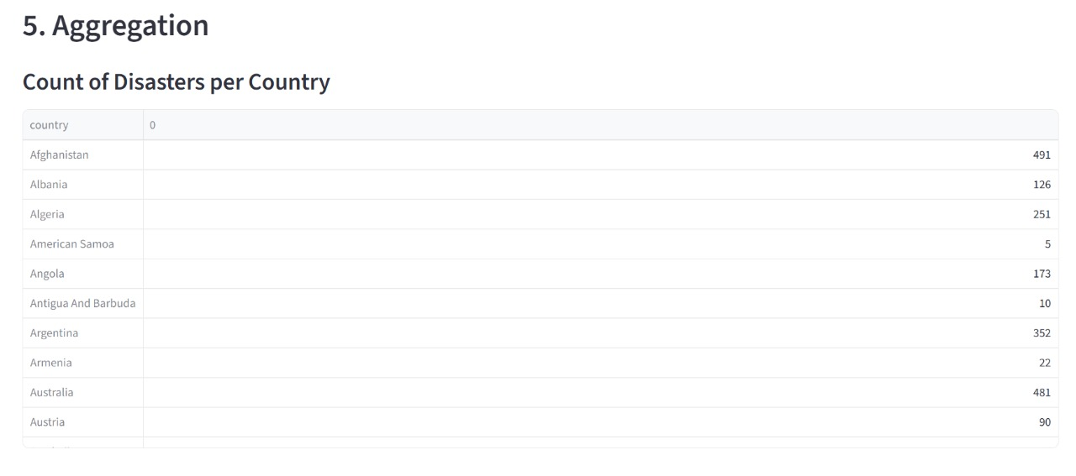

6. Visualization
This section presents a series of enhanced and visually appealing plots designed to provide deeper insights into the disaster dataset through clear, intuitive, and aesthetically refined graphics. Each plot has been carefully chosen and styled to highlight different dimensions of the data while maintaining a consistent pastel-themed visual identity for improved readability and elegance.
The first visualization is a pastel horizontal bar chart that displays the distribution of disasters across countries. By using soft Tableau pastel colors and a horizontal orientation, this chart effectively accommodates long country names while offering an easy comparison of disaster frequencies. The inclusion of light gridlines and descriptive axis labels ensures that the chart is both visually pleasing and informative, giving users a quick overview of which countries experience the most recorded disasters.
On the right, a donut-style pie chart illustrates the proportional distribution of different disaster types within the dataset. Using the same pastel color palette, the donut chart not only presents percentage values clearly but also enhances visual focus with a central white circle that creates the donut effect. This chart allows users to quickly grasp which disaster categories dominate the dataset and how each type contributes to the overall data composition.
Following these visuals, the section includes a histogram combined with a smooth KDE (Kernel Density Estimate) curve, showcasing the distribution of location name lengths. This dual-plot approach blends a traditional histogram with a fluid probability density curve, providing both a discrete count-based perspective and a smoothed representation of the underlying distribution. Styled using complementary pastel tones, the plot helps users observe patterns in textual data, detect skewness, and understand variation in location naming conventions.
Overall, this improved visualization section delivers a rich, visually cohesive analytical experience. By combining clarity, aesthetics, and statistical depth, each plot contributes to a comprehensive understanding of the dataset, transforming raw information into intuitive insights that support exploration, pattern detection, and informed decision-making.

Source Code:
st.header("6. Visualization (Improved Beautiful Plots)" pastel_colors = list(mcolors.TABLEAU_COLORS.values())
col1, col2 = st.columns(2)
- Pastel Horizontal Bar Chart
with col1:
if "country" in df_clean.columns:
st.subheader("🌍 Pastel Bar Chart: Disaster Count by Country")
country_counts = df_clean['country'].value_counts()
fig_bar, ax_bar = plt.subplots(figsize=(8, 6))
ax_bar.barh(
country_counts.index,
country_counts.values,
color=pastel_colors[:len(country_counts)])

ax_bar.set_xlabel("Disaster Count")
ax_bar.set_ylabel("Country")
ax_bar.set_title("Disasters by Country (Pastel Style)")
ax_bar.grid(axis='x', linestyle='--', alpha=0.4) st.pyplot(fig_bar)
2. Beautiful Donut Pie Chart
with col2:
if "disastertype" in df_clean.columns:
st.subheader("🥧 Disaster Type Distribution (Donut Chart)")

fig2, ax2 = plt.subplots(figsize=(7, 7))
df_clean['disastertype'].value_counts().plot(
kind='pie',
autopct="%1.1f%%",
colors=pastel_colors,
ax=ax2,
pctdistance=0.85)
# donut effect
centre_circle = plt.Circle((0, 0), 0.60, fc='white')
fig2.gca().add_artist(centre_circle)
ax2.set_ylabel("")
st.pyplot(fig2)
st.markdown("---")
- Histogram + Smooth KDE Curve
st.subheader("📈 Location Length Distribution (Histogram + SmoothKDE)")
if "location_length" in df_clean.columns:
fig3, ax3 = plt.subplots(figsize=(9, 6))
ax3.hist(
df_clean['location_length'],
bins=12,
alpha=0.6,
color=pastel_colors[3],
edgecolor="black" )
df_clean['location_length'].plot(
kind='kde',
ax=ax3,
linewidth=3,
color=pastel_colors[1])
ax3.set_xlabel("Location Name Length")
ax3.set_ylabel("Frequency")
ax3.set_title("Location Name Length Distribution (KDE + Histogram)")
ax3.grid(axis='y', linestyle='--', alpha=0.4)
st.pyplot(fig3)
st.success("✔Streamlit App Running Successfully!")
else:
st.warning("⚠ Upload a CSV file to continue.")
Output:
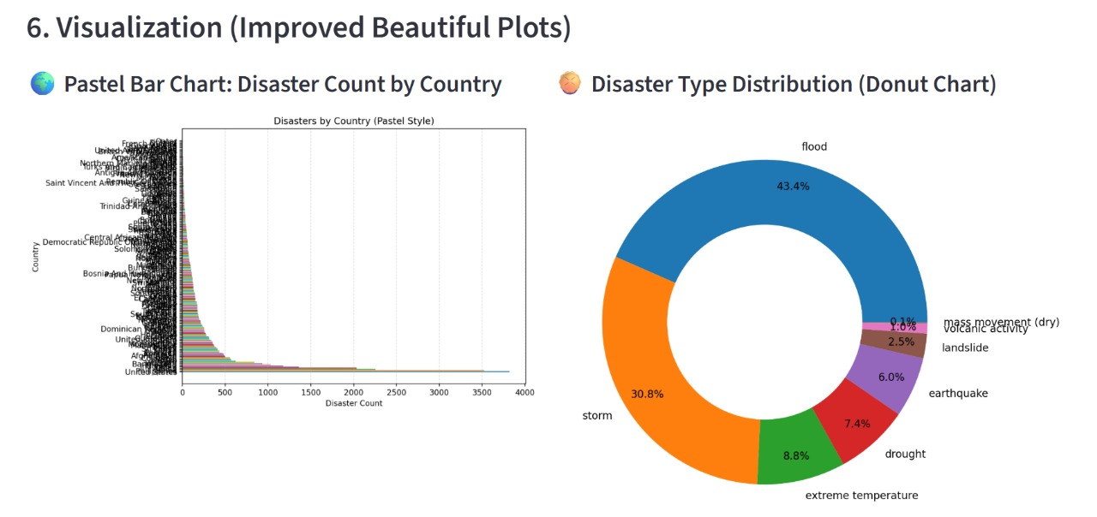

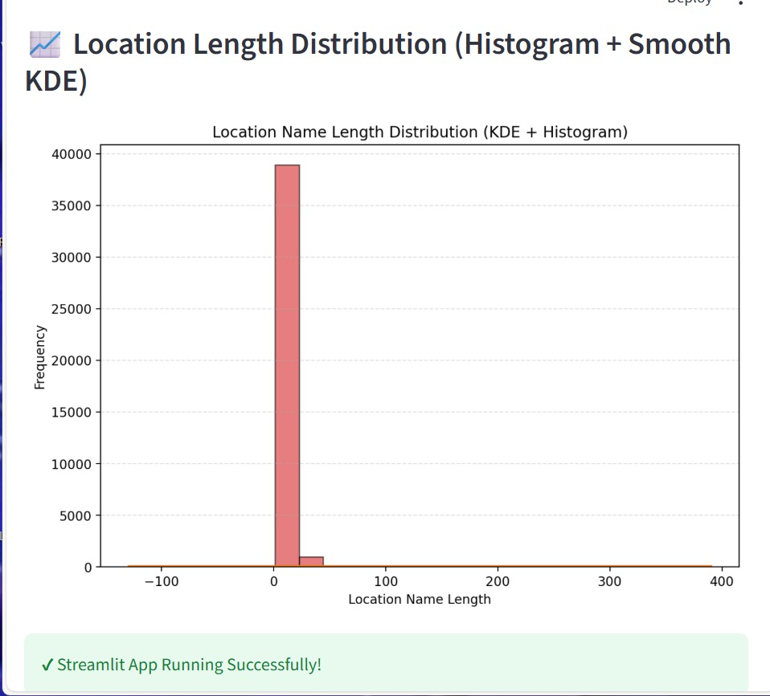

7 . Streamlit app

7 .1 Introduction
The Disaster Dataset Analysis App is an interactive Streamlit application designed to analyze and visualize disaster-related data.
It allows users to upload a disaster dataset (CSV file) and perform the following tasks:
- Inspect and describe the dataset (structure, summary, and info)
- Clean and preprocess data (handle missing values, fix capitalization, etc.)
- Perform data wrangling (sorting, encoding, and creating new columns)
- Filter and aggregate data for insights
- Generate beautiful and informative visualizations (bar, donut pie, histogram + KDE)
The goal is to help users explore patterns in global disasters interactively and visually—without needing coding knowledge.

7.2 Widgets Used

Widget / Function | Purpose
st.set_page_config() | Sets the app title and layout to wide view
st.title() / st.header() / st.subheader() | Adds structured headings and titles for sections
st.markdown() | Inserts lines, emojis, and formatted text
st.file_uploader() | Lets users upload a CSV file dynamically
st.dataframe() / st.write() | Displays data tables and summaries
st.text() | Shows textual output (like df.info())
st.info() / st.warning() / st.success() | Displays colored message boxes for feedback
st.columns() | Creates multiple column layouts for side-by-side charts
st.pyplot() | Renders Matplotlib visualizations within the app
These widgets make the application fully interactive and visually clean.

7.3 Front-End Design Details
- Theme: Minimalist and modern layout using Streamlit’s wide-page configuration.
- Color Palette: Soft pastel shades from Matplotlib’s TABLEAU_COLORS for a clean and aesthetic appearance.
- Layout:
  - Each section (Data Loading, Cleaning, Wrangling, etc.) is separated by horizontal lines (st.markdown("---")) for clarity.
  - Two-column layout (st.columns(2)) for displaying charts side-by-side.
- Visuals:
  - Bar Chart (Pastel Style): Displays disaster counts per country using horizontal bars.
  - Donut Pie Chart: Shows the proportion of each disaster type with a central white circle for modern design.
  - Histogram + KDE Plot: Combines a bar histogram and a smooth distribution curve for numeric insights.
- Typography & Icons: Uses emojis to enhance visual engagement.
- Feedback Indicators: Green success messages and yellow warnings guide user interaction.
Source code:
import streamlit as st
import pandas as pd
import numpy as np
import matplotlib.pyplot as plt
import io
import matplotlib.colors as mcolors

# Streamlit Page Configuration
st.set_page_config(page_title="Disaster Dataset Analysis", layout="wide")
st.title("🌪 Disaster Dataset Analysis App")
st.markdown("---")
# --------------------------
# 1. DATA LOADING & INSPECTION
# --------------------------
st.header("1. Data Loading & Inspection")
uploaded_file = st.file_uploader("📂 Upload Disaster Dataset (.csv)", type=["csv"])
if uploaded_file:
df = pd.read_csv(uploaded_file)
st.subheader("1.1 Dataset Preview")
st.dataframe(df.head())
st.subheader("1.2 Dataset Description")
st.write(df.describe(include='all'))
# FIX df.info() (StringIO buffer)
st.subheader("Dataset Info")
buffer = io.StringIO()
df.info(buf=buffer)
info_str = buffer.getvalue()
st.text(info_str)
st.markdown("---")
# --------------------------
# 2. DATA CLEANING
# --------------------------
st.header("2. Data Cleaning")
st.subheader("2.1 Missing Values")
st.write(df.isnull().sum())
st.subheader("2.2 Handling Missing Values (Fill with 'Unknown')")
df_clean = df.fillna("Unknown")
st.dataframe(df_clean)
st.subheader("2.3 Check for Discrepancies")
if "country" in df_clean.columns:
st.write("Unique Countries:", df_clean['country'].unique())
if "disastertype" in df_clean.columns:
st.write("Unique Disaster Types:", df_clean['disastertype'].unique())
st.subheader("2.4 Ensuring Consistency (Fix Capitalization)")
if "country" in df_clean.columns:
df_clean['country'] = df_clean['country'].astype(str).str.title()
st.markdown("---")
# --------------------------
# 3. DATA WRANGLING
# --------------------------
st.header("3. Data Wrangling")
st.subheader("3.1 Sorting by Country")
if "country" in df_clean.columns:
st.dataframe(df_clean.sort_values(by="country"))
st.subheader("3.2 Create New Columns & Convert Types")
if "location" in df_clean.columns:
df_clean['location_length'] = df_clean['location'].astype(str).apply(len)
st.dataframe(df_clean)
st.subheader("3.3 Encoding String Columns")
if "disastertype" in df_clean.columns:
df_encoded = df_clean.copy()
df_encoded['disastertype_code'] = df_encoded['disastertype'].astype('category').cat.codes
st.dataframe(df_encoded)
st.markdown("---")
# --------------------------
# 4. FILTERING & INDEXING
# --------------------------
st.header("4. Filtering & Indexing")
st.subheader("Filter: Continent = Asia")
if "continent" in df_clean.columns:
st.dataframe(df_clean[df_clean['continent'] == "Asia"])
else:
st.info("Continent column not found.")
st.markdown("---")
# --------------------------
# 5. AGGREGATION
# --------------------------
st.header("5. Aggregation")
st.subheader("Count of Disasters per Country")
if "country" in df_clean.columns:
st.write(df_clean.groupby("country").size())
st.markdown("---")
# --------------------------
# 6. VISUALIZATION (IMPROVED)
# --------------------------
st.header("6. Visualization (Improved Beautiful Plots)")
pastel_colors = list(mcolors.TABLEAU_COLORS.values())
col1, col2 = st.columns(2)
# ----- 1. Pastel Horizontal Bar Chart -----
with col1:
if "country" in df_clean.columns:
st.subheader("🌍 Pastel Bar Chart: Disaster Count by Country")
country_counts = df_clean['country'].value_counts()
fig_bar, ax_bar = plt.subplots(figsize=(8, 6))
ax_bar.barh( country_counts.index, country_counts.values,
color=pastel_colors[:len(country_counts)])
ax_bar.set_xlabel("Disaster Count")
ax_bar.set_ylabel("Country")
ax_bar.set_title("Disasters by Country (Pastel Style)")
ax_bar.grid(axis='x', linestyle='--', alpha=0.4)
st.pyplot(fig_bar)
# ----- 2. Beautiful Donut Pie Chart -----
with col2:
if "disastertype" in df_clean.columns:
st.subheader("🥧 Disaster Type Distribution (Donut Chart)")
fig2, ax2 = plt.subplots(figsize=(7, 7))
df_clean['disastertype'].value_counts().plot( kind='pie',autopct="%1.1f%%", colors=pastel_colors, ax=ax2, pctdistance=0.85
)
# donut effect
centre_circle = plt.Circle((0, 0), 0.60, fc='white')
fig2.gca().add_artist(centre_circle)
ax2.set_ylabel("")
st.pyplot(fig2)
st.markdown("---")
# ----- 3. Histogram + Smooth KDE Curve -----
st.subheader("📈 Location Length Distribution (Histogram + Smooth KDE)")
if "location_length" in df_clean.columns:
fig3, ax3 = plt.subplots(figsize=(9, 6))
ax3.hist( df_clean['location_length'], bins=12,
alpha=0.6,
color=pastel_colors[3],
edgecolor="black")
df_clean['location_length'].plot(
kind='kde',
ax=ax3,
linewidth=3,
color=pastel_colors[1])
ax3.set_xlabel("Location Name Length")
ax3.set_ylabel("Frequency")
ax3.set_title("Location Name Length Distribution (KDE + Histogram)")
ax3.grid(axis='y', linestyle='--', alpha=0.4)
st.pyplot(fig3)
st.success("✔ Streamlit App Running Successfully!")
else:
st.warning("⚠ Upload a CSV file to continue.")
Output :
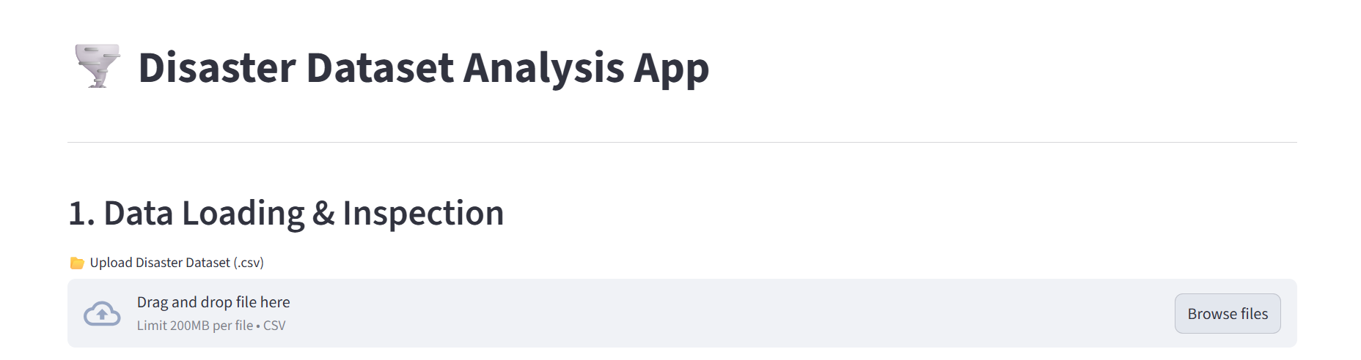

CONCLUSION
The Disaster Dataset Analysis App provides an efficient and interactive way to explore and understand disaster-related data.
Using Streamlit’s powerful interface, users can easily upload datasets, clean data, perform analysis, and visualize insights—all in one place without writing complex code.
The app demonstrates the importance of data preprocessing, aggregation, and visualization in uncovering meaningful patterns, such as identifying the most affected countries or the most common types of disasters.
Through visually appealing charts and user-friendly design, it enhances data interpretation and supports informed decision-making.
Overall, this project showcases how Python and Streamlit can be combined to build a simple yet effective analytical dashboard for real-world datasets.

