AI WEATHERWISE
Deliver Intelligent Weather Forecasts and Insights
PROJECT DOCUMENTATION
Backend REST API Project
Node.js • Express.js • MongoDB • OpenWeatherMap • Google Gemini AI
PROJECT DOCUMENTATION
Submitted By:
Team ID: 6ab22dc818c4954598226ac8
Team Leader : Pavithra v
Team member : Pooja sri
Team member : Saranya
Team member : Preethi
Course: BCA
College: DRBCCC Hindu College
University: University of Madras
Academic Year: 2026-2027

1. PROJECT DESCRIPTION
AI WeatherWise is a RESTful backend application developed using Node.js, Express.js, MongoDB, and Mongoose. The system provides real-time weather information for cities and integrates Google Gemini AI to generate natural-language weather summaries and personalized recommendations.
The application provides secure user authentication using JSON Web Tokens (JWT) and bcrypt password hashing. Registered users can create, view, update, and delete their favorite locations. Weather information is obtained through the OpenWeatherMap API, while Gemini AI is used to generate recommendations based on weather conditions.
The application also includes a fallback mechanism. If an external weather or AI service is temporarily unavailable, the system returns fallback information instead of stopping the application. The project is implemented as a headless backend, so Postman or Thunder Client is used for API testing instead of a graphical frontend.

2. OBJECTIVES
- To provide real-time weather information for a selected city.
- To provide secure user registration and login.
- To allow registered users to manage favorite locations.
- To generate AI-based weather summaries and recommendations.
- To protect private APIs using JWT authentication.
- To provide role-based access for administrative operations.
- To maintain user and location information using MongoDB.
- To continue providing meaningful responses when an external AI or weather service is unavailable.

3. PROBLEM STATEMENT
Weather applications commonly provide numerical information such as temperature, humidity, and wind speed. Users may still need to interpret these values before deciding what to wear or whether current conditions are suitable for outdoor activities. Users who regularly monitor several cities also need a convenient method to save and manage those locations.
AI WeatherWise addresses these requirements by combining real-time weather information, saved locations, secure authentication, and AI-generated recommendations in a single REST API platform.

4. PROPOSED SOLUTION
AI WeatherWise provides a centralized backend through which users can register, log in, manage favorite locations, obtain live weather information, and request AI-generated weather insights.
The application uses OpenWeatherMap for real-time environmental information. Weather information can be processed by Google Gemini AI to produce an easy-to-understand summary and activity or clothing recommendations. MongoDB stores registered users and their saved locations. JWT authentication protects user-specific APIs, while role-based middleware protects administrative operations.
Register/Login → Save Location → Fetch Weather → Generate AI Insight → Receive Response

5. SOFTWARE REQUIREMENTS
Component | Requirement
Operating System | Windows 10/11
Runtime | Node.js
Backend Framework | Express.js
Database | MongoDB
ODM | Mongoose
Authentication | JWT
Password Security | bcryptjs
Weather Service | OpenWeatherMap API
AI Service | Google Gemini AI
API Testing | Postman / Thunder Client
Development Environment | Visual Studio Code
Package Manager | npm

6. HARDWARE REQUIREMENTS
Component | Minimum Requirement
Processor | Intel Core i5 / AMD Ryzen 5 or equivalent
RAM | 8 GB
Storage | 1 GB free space
Internet | Required for live Weather and Gemini APIs

7. TECHNOLOGIES USED
Node.js: Provides the runtime environment for executing the backend JavaScript application.
Express.js: Creates REST API routes and handles HTTP requests and responses.
MongoDB: Stores user accounts and favorite locations.
Mongoose: Provides schemas and models for communication between Node.js and MongoDB.
JSON Web Token: Authenticates users and protects private API endpoints.
bcryptjs: Hashes user passwords before they are stored.
OpenWeatherMap API: Provides live temperature, humidity, condition, feels-like temperature, and wind speed.
Google Gemini AI: Generates natural-language weather summaries and recommendations.
Postman / Thunder Client: Tests REST API endpoints for the headless backend.

8. SYSTEM ARCHITECTURE
AI WeatherWise follows a modular backend architecture based on the MVC concept. The Model layer contains Mongoose schemas, the Controller layer contains application logic, the Routing layer connects HTTP requests to controllers, and Middleware performs JWT authentication and administrator authorization.
Postman / Thunder Client
|
v
Express Routes
|
v
Middleware
JWT / Admin Role
|
v
Controllers
/ \
v v
MongoDB External APIs
/ \
v v
OpenWeatherMap Gemini AI
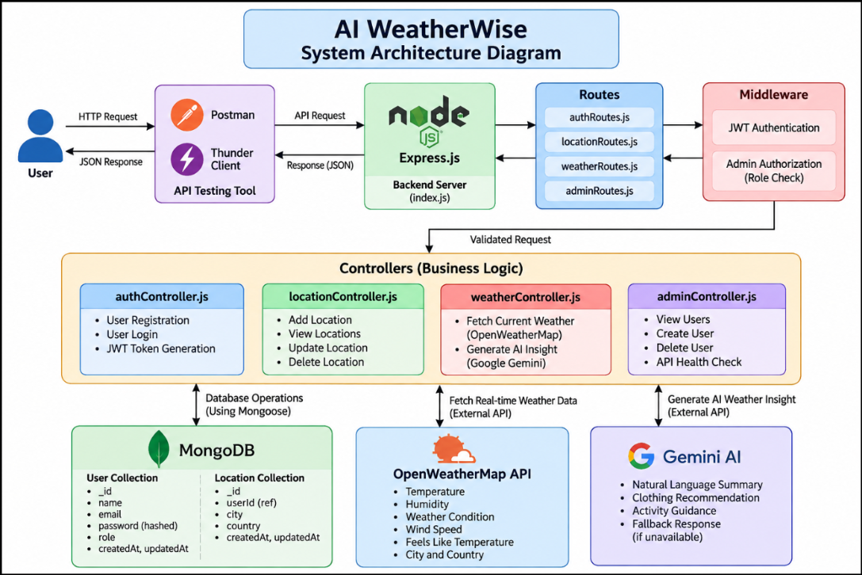

9. PROJECT STRUCTURE
AI-Weatherwise/
|
|-- config/
| `-- db.js
|
|-- controllers/
| |-- authController.js
| |-- locationController.js
| |-- weatherController.js
| `-- adminController.js
|
|-- middleware/
| |-- authMiddleware.js
| `-- adminMiddleware.js
|
|-- models/
| |-- User.js
| `-- Location.js
|
|-- routes/
| |-- authRoutes.js
| |-- locationRoutes.js
| |-- weatherRoutes.js
| `-- adminRoutes.js
|
|-- index.js
|-- package.json
|-- .env
`-- .gitignore
The index.js file is the main application entry point. It initializes Express, loads environment configuration, connects to MongoDB, registers API routes, and starts the server.
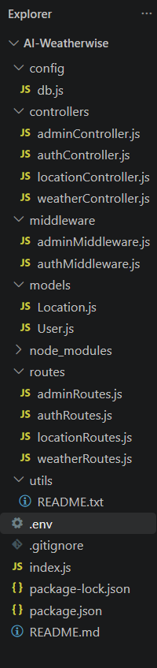

10. DATABASE DESIGN
The project uses MongoDB with Mongoose for database management.

10.1 User Entity
Field | Description
_id | Unique MongoDB ObjectId
name | Name of the user
email | Unique email address
password | Hashed password
role | Authorization role; reader for normal users and admin for administrator
createdAt | Record creation timestamp
updatedAt | Record update timestamp

10.2 Location Entity
Field | Description
_id | Unique location ID
userId | Reference to the owner
city | Favorite city
country | Country
createdAt | Creation timestamp
updatedAt | Update timestamp

10.3 Entity Relationship
One registered user can store multiple favorite locations. Therefore, User to Location is a one-to-many relationship.
USER
|
| 1
|
|------< Many
|
LOCATION
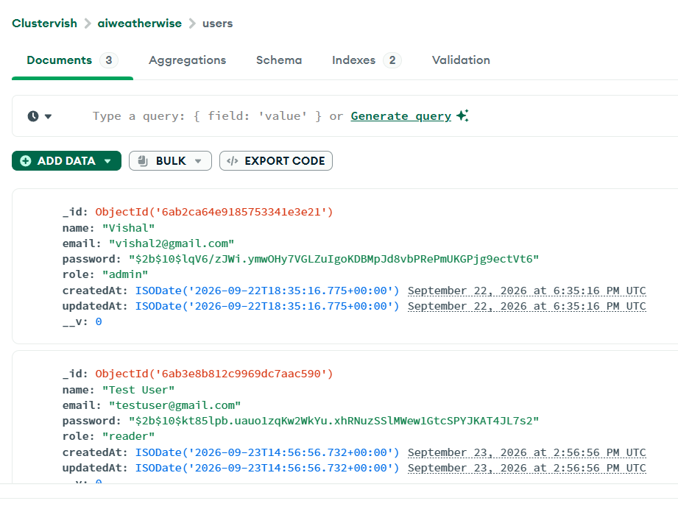
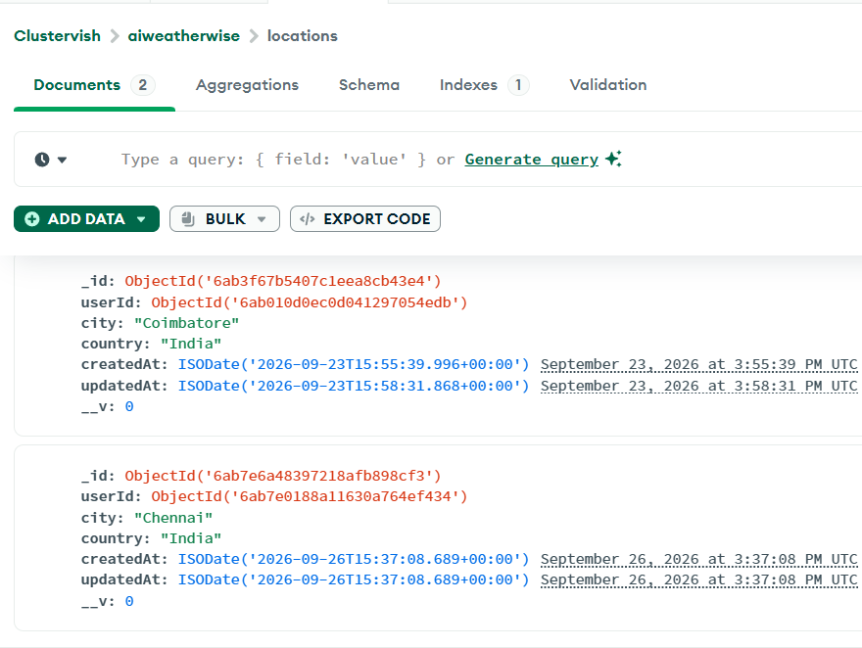

11. AUTHENTICATION MODULE
A new user provides a name, email, and password. Before the account is stored, the password is hashed using bcrypt.
Endpoint: POST /api/auth/register
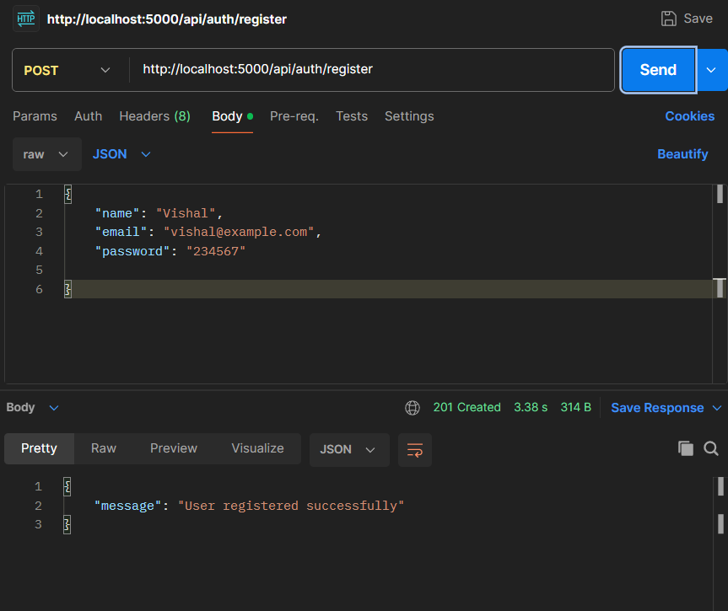
{
"name": "Vishal",
"email": "vishal@example.com",
"password": "******"
}

12. LOGIN AND JWT AUTHENTICATION
Registered users log in using email and password. After successful verification, the backend generates a JWT token. Protected APIs require this token through Bearer authentication.
Endpoint: POST /api/auth/login
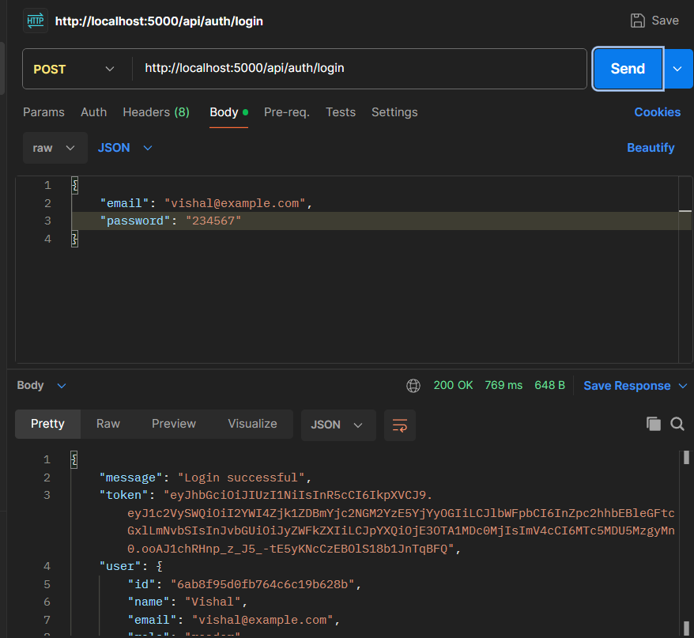
Authorization: Bearer <JWT_TOKEN>

13. FAVORITE LOCATION MANAGEMENT
Registered users can maintain favorite locations using complete CRUD operations.
Operation | Method | Endpoint
Create | POST | /api/locations
Read | GET | /api/locations
Update | PUT | /api/locations/:id
Delete | DELETE | /api/locations/:id

{
"city": "Chennai",
"country": "India"
}
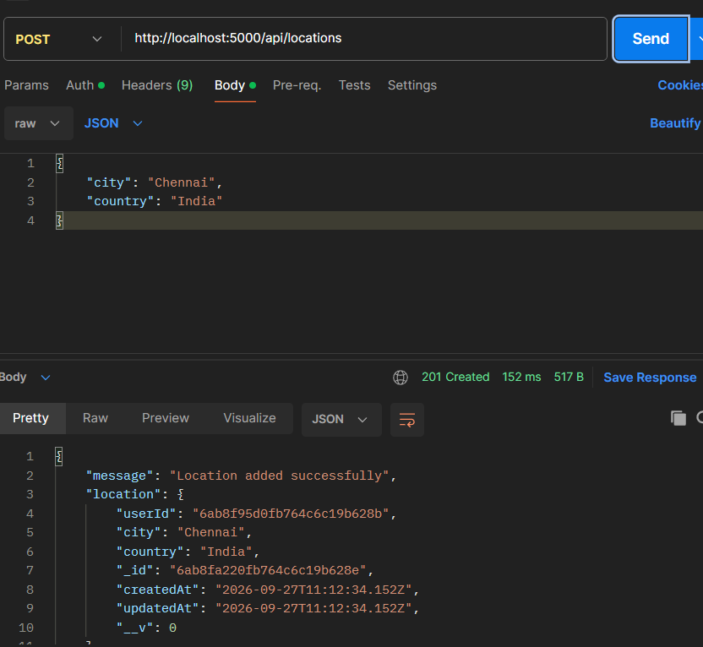

14. REAL-TIME WEATHER MODULE
The Weather module retrieves current weather information through OpenWeatherMap. The response contains city, country, temperature, feels-like temperature, humidity, condition, wind speed, and source.
Endpoint: GET /api/weather/current/:city
GET /api/weather/current/Chennai
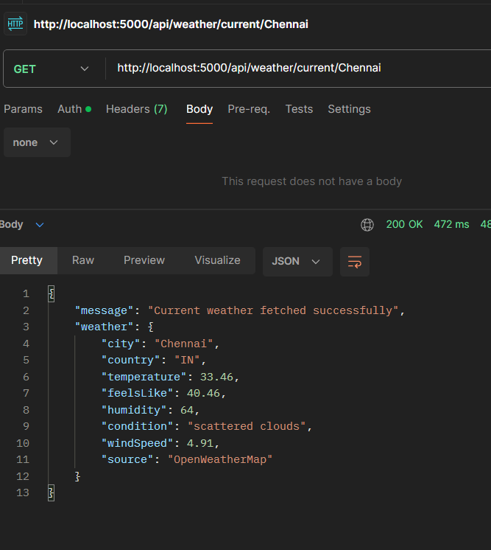

15. AI WEATHER RECOMMENDATION MODULE
Google Gemini AI converts weather information into a natural-language summary and personalized activity or clothing recommendations.
Endpoint: POST /api/weather/insights
{
"city": "Chennai",
"weather": {
"temperature": 30,
"humidity": 70,
"condition": "scattered clouds",
"windSpeed": 4.5
}
}
When Gemini is available, the response identifies Gemini as the source and returns an AI-generated insight.
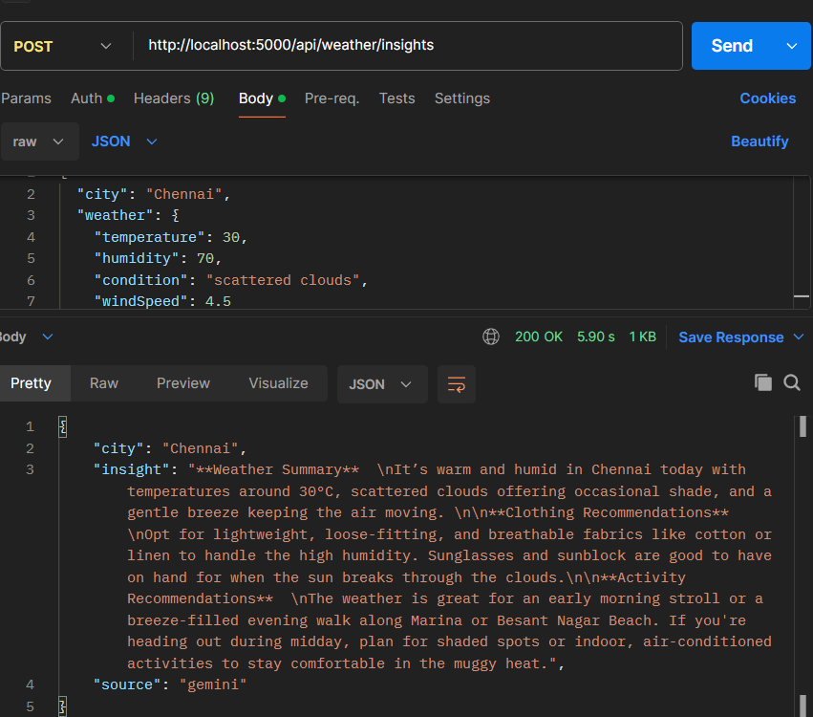

16. FALLBACK MECHANISM
If Gemini or another external service is temporarily unavailable, the backend returns a meaningful fallback response instead of terminating the workflow. This improves application reliability.
{
"city": "Chennai",
"insight": "Weather in Chennai: scattered clouds, temperature 30°C and humidity 70%. Choose comfortable clothing and plan outdoor activities according to the current weather conditions.",
"source": "fallback"
}

17. ADMIN MODULE
AI WeatherWise implements basic role-based administrative operations. Normal users use the reader role, while administrative operations require the admin role.
Operation | Method | Endpoint
View Users | GET | /api/admin/users
Create User | POST | /api/admin/users
Delete User | DELETE | /api/admin/users/:id
API Health | GET | /api/admin/health

Admin middleware prevents normal users from accessing administrator endpoints.
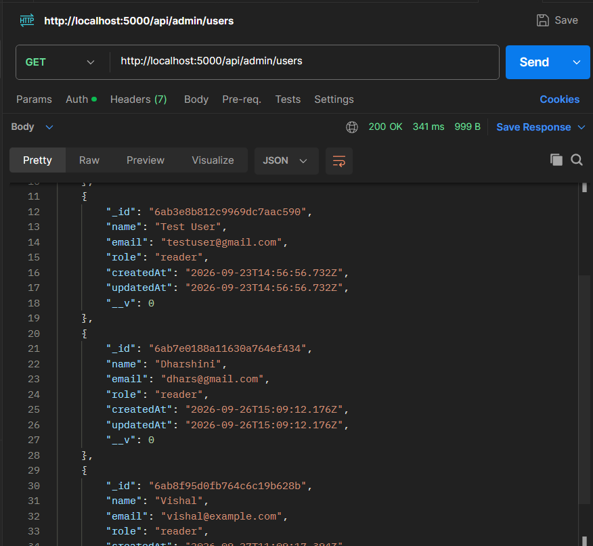

18. API SUMMARY
Module | Method | Endpoint | Access
Register | POST | /api/auth/register | Public
Login | POST | /api/auth/login | Public
Current Weather | GET | /api/weather/current/:city | Public
AI Recommendation | POST | /api/weather/insights | Authenticated
Add Location | POST | /api/locations | Authenticated
View Locations | GET | /api/locations | Authenticated
Update Location | PUT | /api/locations/:id | Authenticated
Delete Location | DELETE | /api/locations/:id | Authenticated
View Users | GET | /api/admin/users | Admin
Create User | POST | /api/admin/users | Admin
Delete User | DELETE | /api/admin/users/:id | Admin
API Health | GET | /api/admin/health | Admin

19. SECURITY
Password Hashing: Passwords are hashed using bcrypt before being stored in MongoDB.
JWT Authentication: Protected routes require a valid JWT token.
User-Specific Location Access: Favorite locations are associated with the authenticated user's ID.
Role-Based Authorization: Administrative endpoints require the admin role.
Environment Variables: Sensitive configuration values are stored in .env and must not be committed to a public repository.

20. ENVIRONMENT CONFIGURATION
The application uses environment variables for database connectivity, authentication, weather, and Gemini integration.
PORT=5000
MONGO_URI=<MongoDB connection string>
JWT_SECRET=<JWT secret>
GEMINI_API_KEY=<Gemini API key>
WEATHER_API_KEY=<OpenWeatherMap API key>
Actual keys, passwords, connection strings, and JWT tokens must not be included in screenshots or public documentation.

21. PROJECT EXECUTION
Install dependencies and start the backend from the project directory:
npm install
npm start
After successful execution, the application connects to MongoDB and starts the Express server.
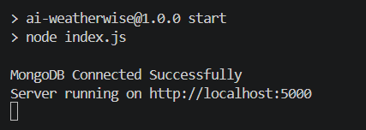

22. API TESTING
Test | Expected Result
User Registration | User created successfully
User Login | JWT token generated
Invalid Authentication | Protected request rejected
Add Location | Location stored in MongoDB
View Locations | Saved locations returned
Update Location | Existing location updated
Delete Location | Location removed
Weather API | Live weather information returned
Gemini Insight | AI recommendation generated when the service is available
Gemini Failure | Fallback recommendation returned
Admin Users | Admin can retrieve user information
Admin Health | Server health response returned

23. RESULT
AI WeatherWise was successfully implemented as a RESTful weather intelligence backend. The system supports secure registration and login, JWT-protected APIs, MongoDB persistence, complete favorite-location CRUD operations, real-time weather retrieval using OpenWeatherMap, AI-generated weather insights using Google Gemini, fallback recommendations when the AI service is unavailable, role-based administrative operations, and API testing through Postman or Thunder Client.

24. CONCLUSION
AI WeatherWise provides a secure and practical backend solution for accessing weather information and receiving intelligent weather recommendations. The project combines Node.js and Express.js for REST API development, MongoDB and Mongoose for data management, OpenWeatherMap for live weather information, and Google Gemini AI for natural-language insights. JWT and bcrypt provide authentication and password security, while role-based authorization protects administrative operations.
The fallback mechanism improves reliability by ensuring that temporary external-service failures do not prevent the system from returning a meaningful response. Overall, the project demonstrates the integration of backend development, database management, external APIs, authentication, and generative AI in a single application.

