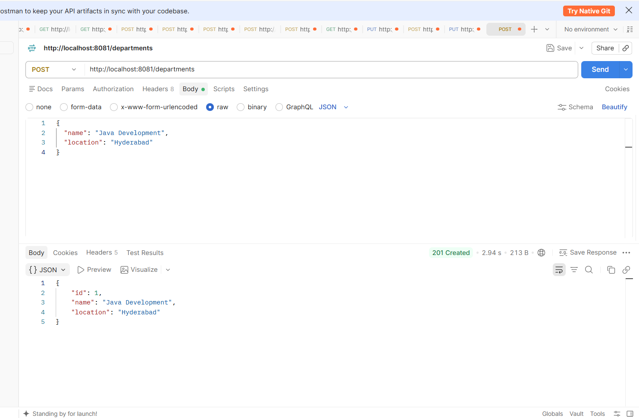

A new department is created by entering its name and location. The 201 Created response confirms that the department was added successfully.

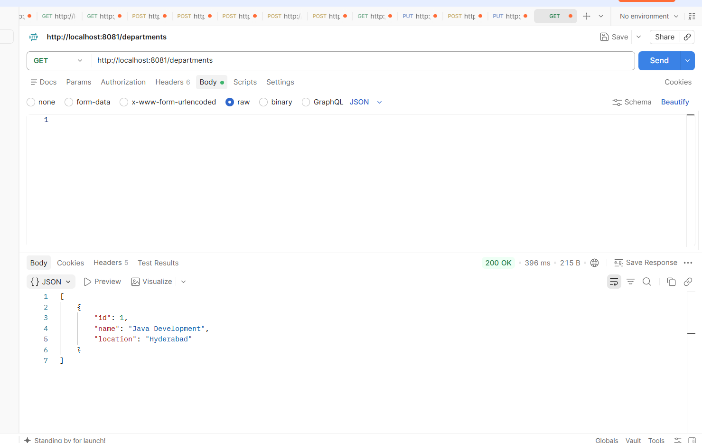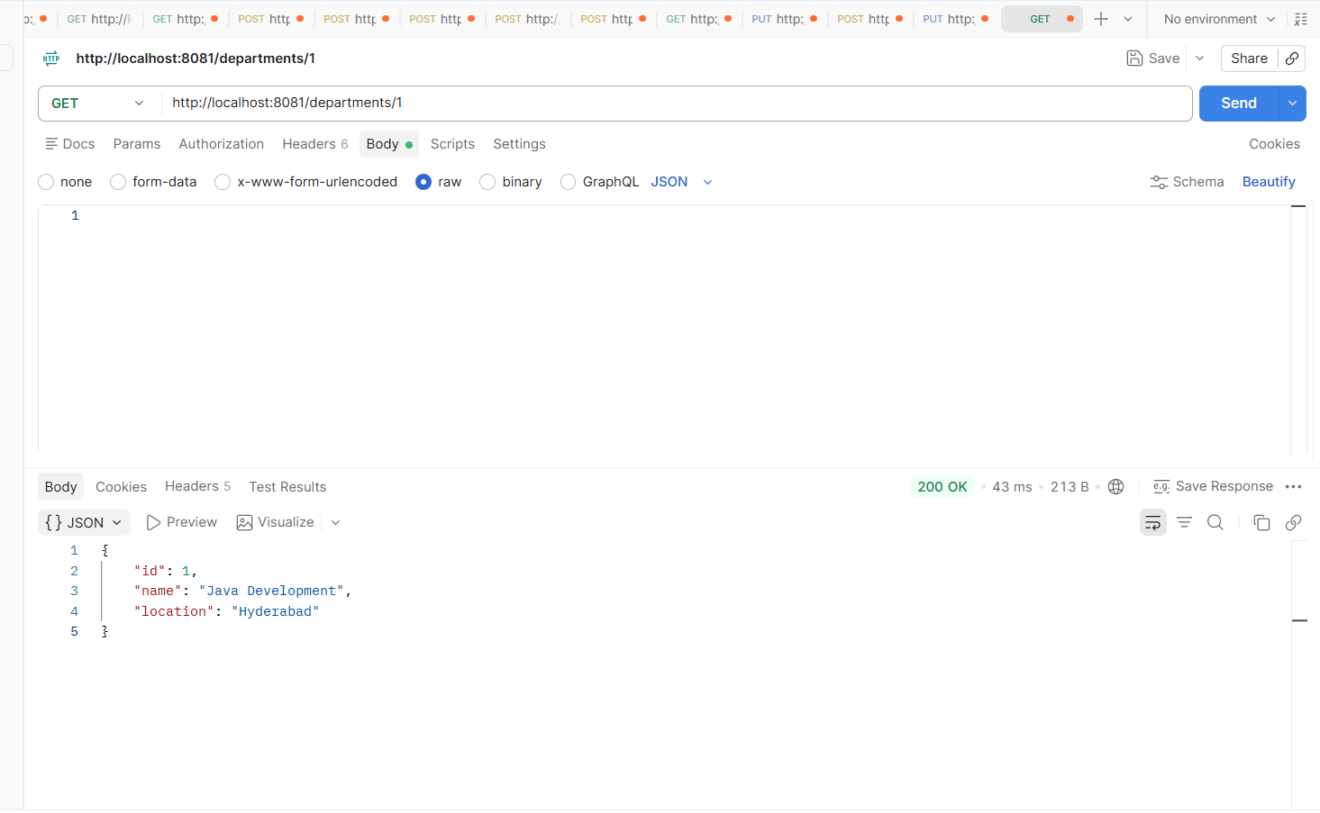
All saved departments are retrieved and displayed with their details. The 200 OK response confirms that the request completed successfully.

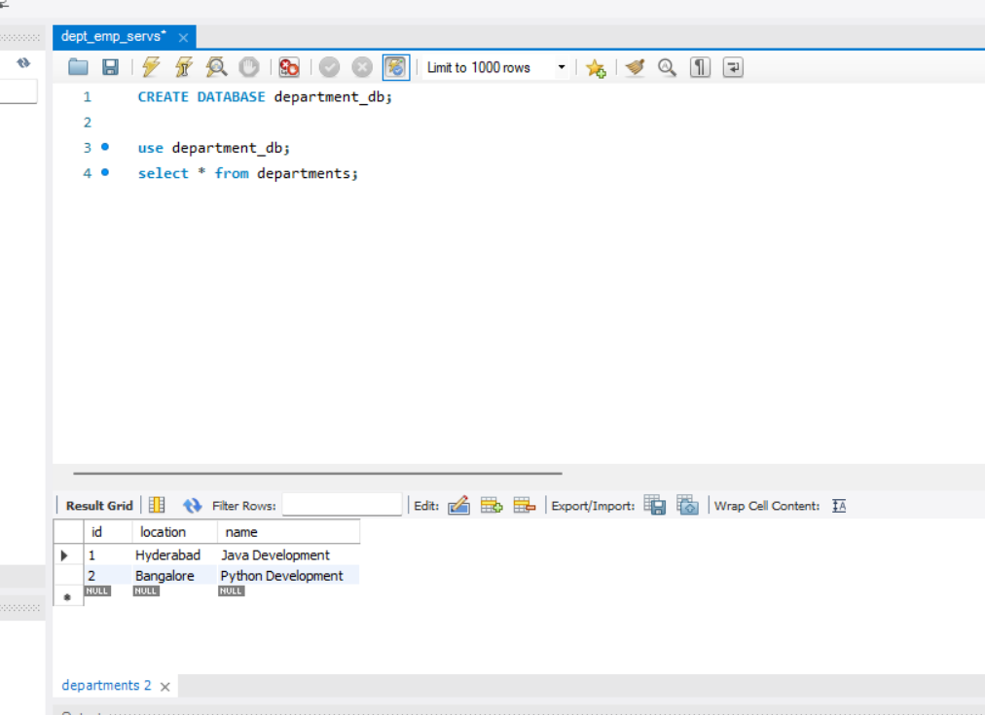
The department records are checked in MySQL to confirm that the details are saved in the database.
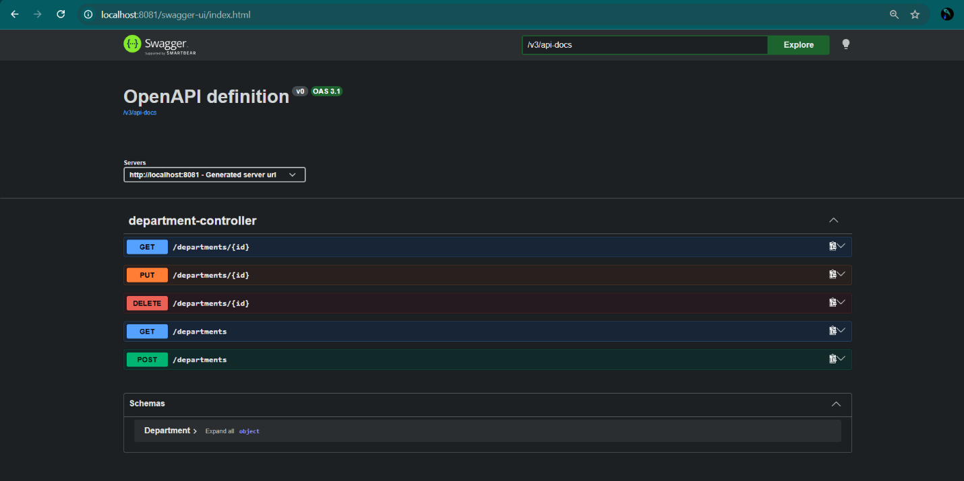
Swagger displays the available Department Service APIs, which can be used to test the department operations.

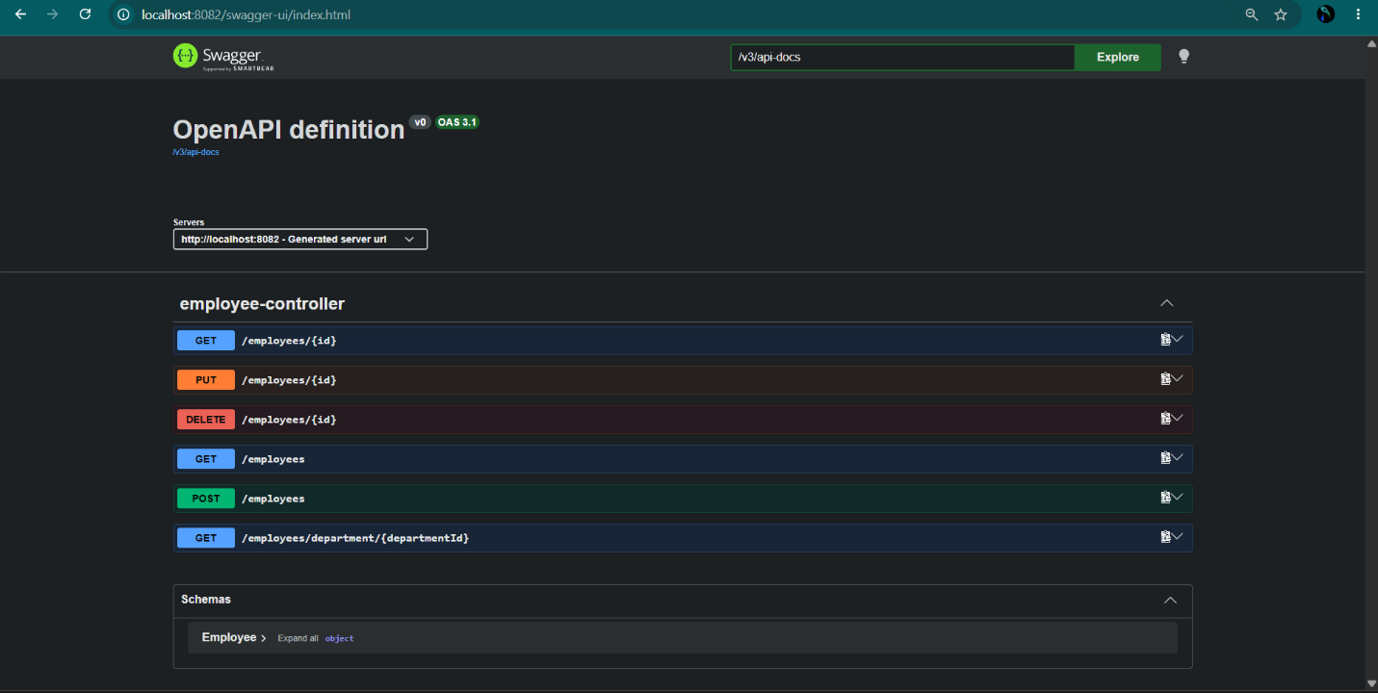
Swagger displays the Employee Service APIs for creating, viewing, updating, and deleting employees, as well as finding employees by department ID.
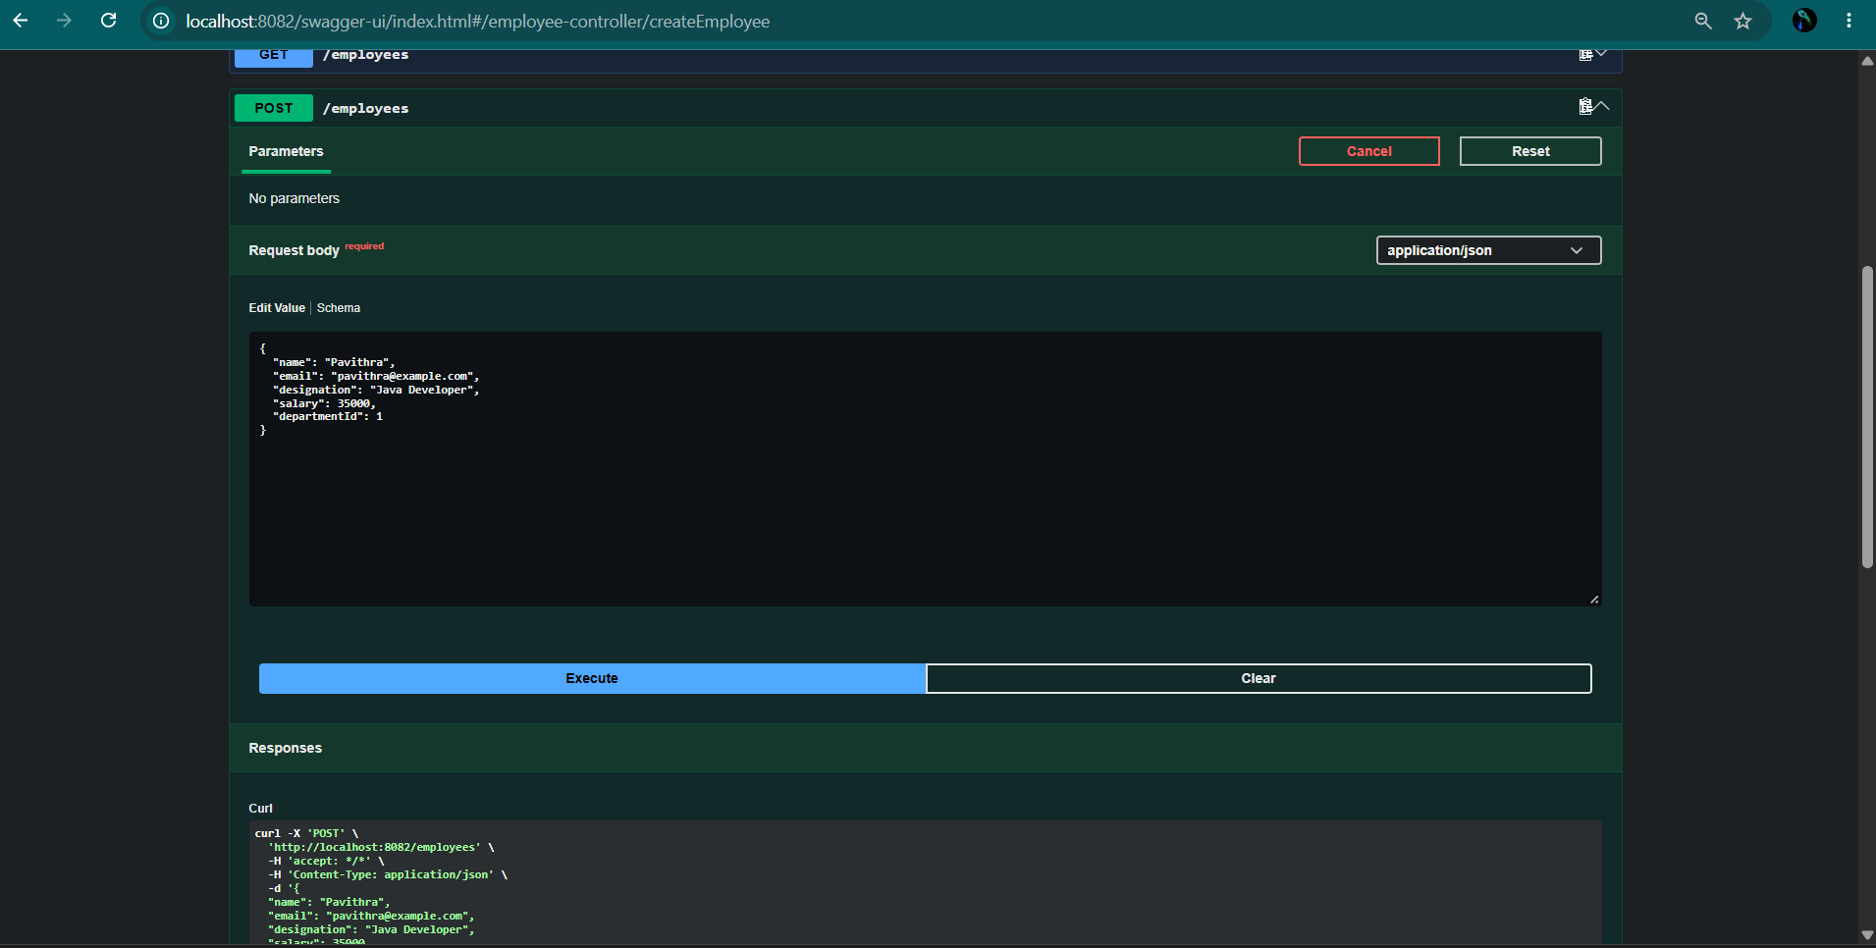
Employee details are submitted to create a new employee. The successful response displays the saved employee information.

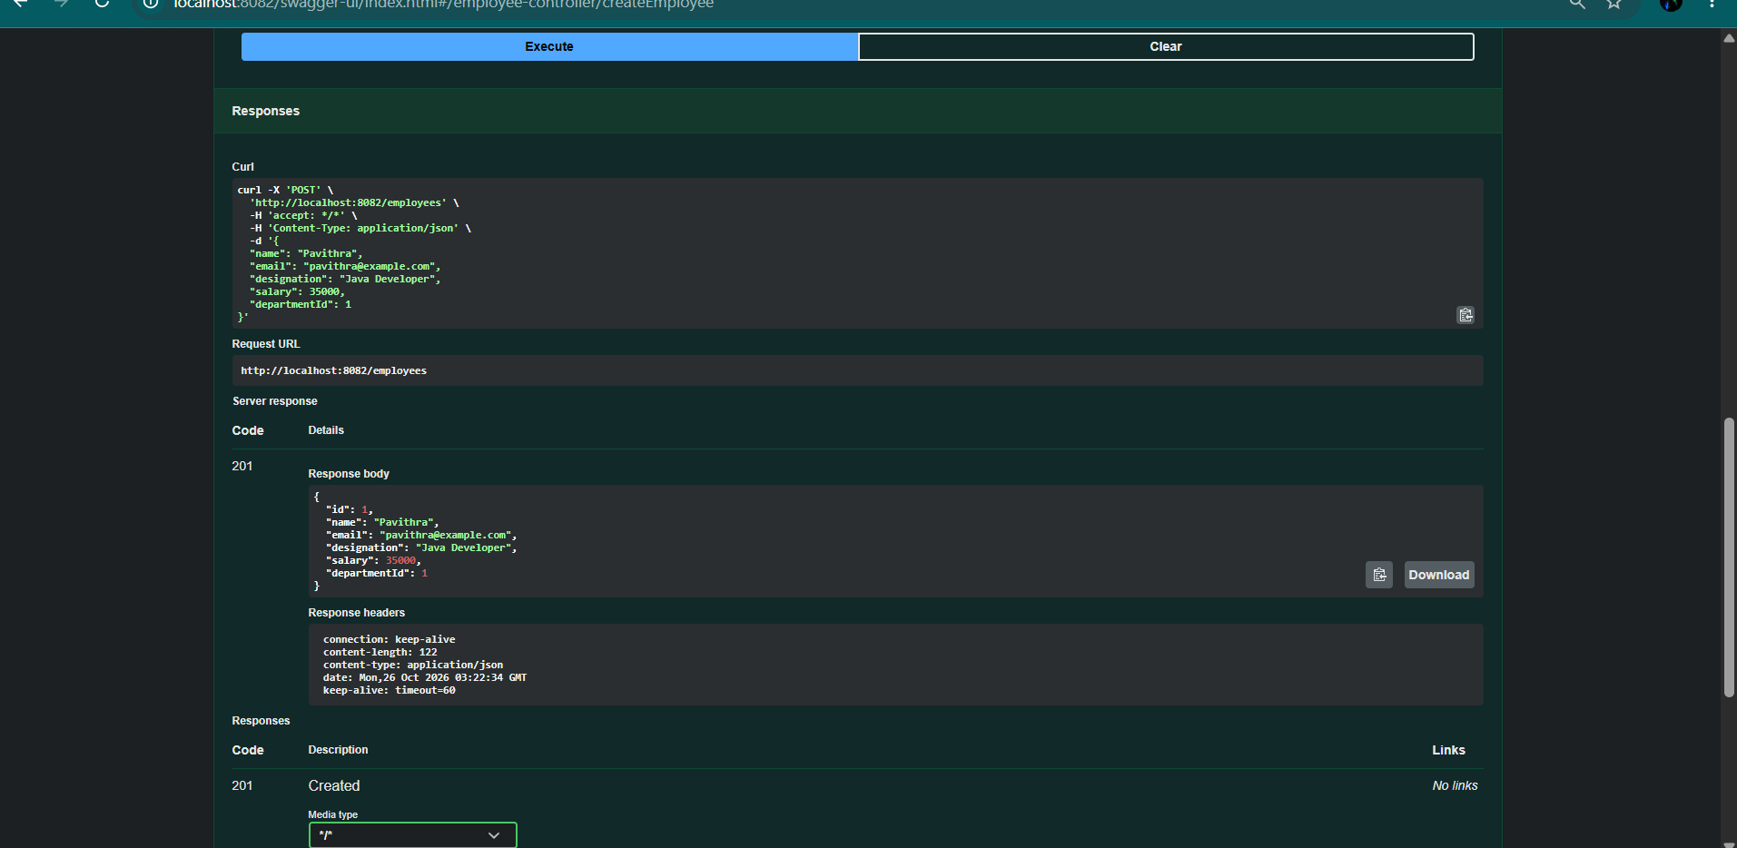
The GET API retrieves the saved employee records and displays their details, confirming that the data can be fetched successfully.

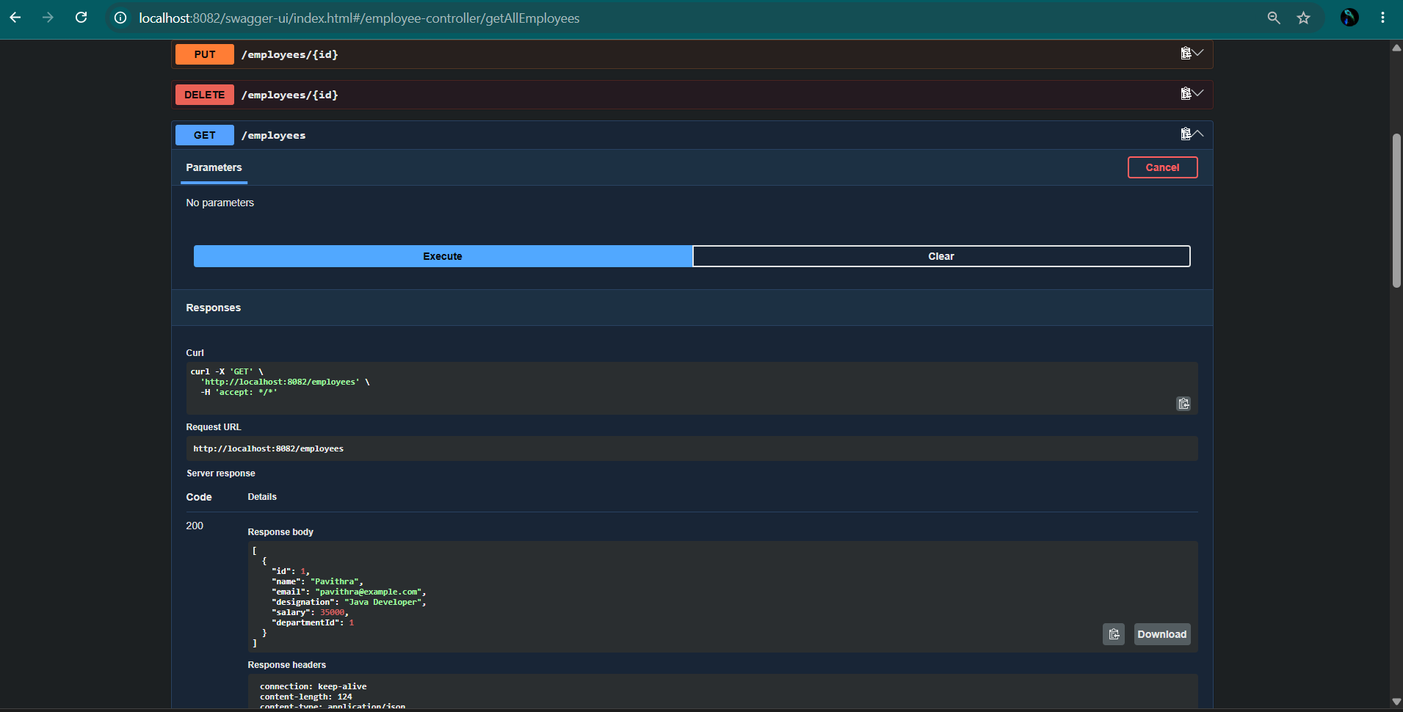
The department ID is used to retrieve employees linked to that department. The response displays the matching employee records.

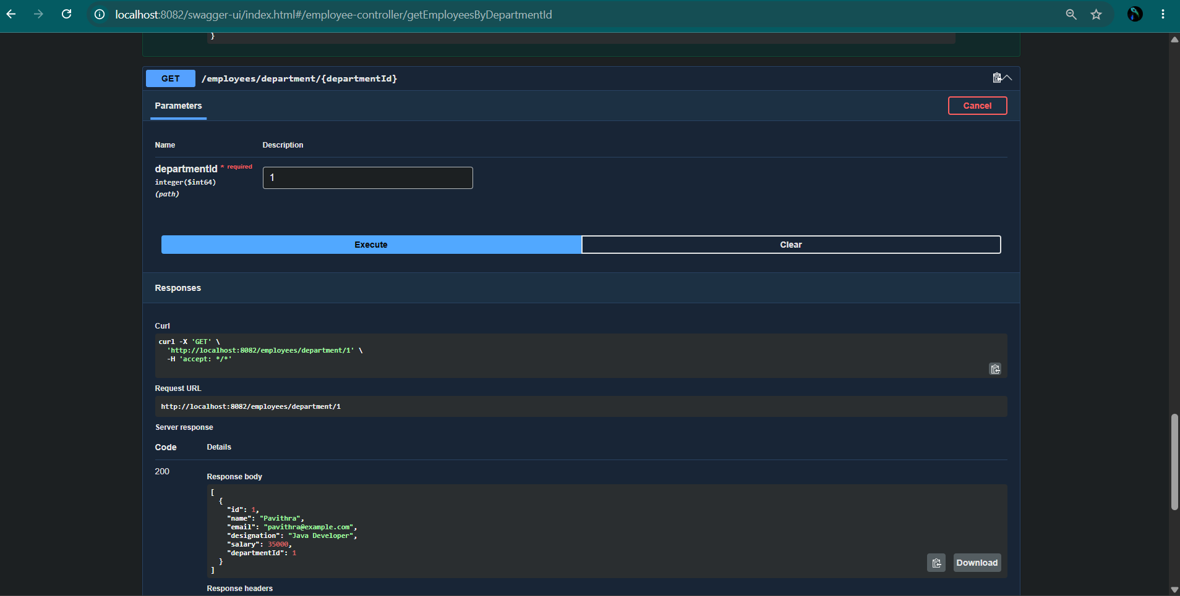
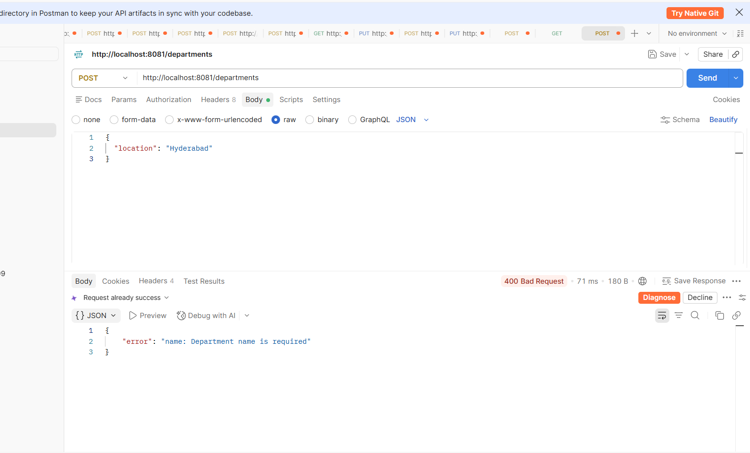
Validation: The Department Service validation was tested by sending a POST request without the required department name. The API returned 400 Bad Request with the message Department name is required, confirming that invalid requests are handled correctly.
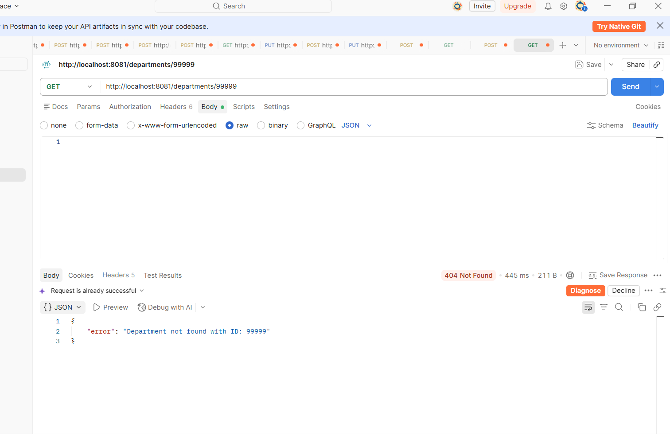

API was tested with department ID 99999, which does not exist in the database. It returned 404 Not Found with the message “Department not found with ID: 99999,” confirming that exception handling works correctly.

