EDUGENIE
Google Gemini Powered Learning Assistant

BRAINSTORMING&IDEATION DOCUMENT
Project Documentation

1. Introduction
EduGenie is a Generative AI based learning assistant designed to support students in their learning activities. The idea is to provide simple explanations, interactive learning support, question answering and assessment through an AI-powered interface. Google Gemini can be used as the Generative AI component to understand student questions and generate useful learning responses.

2. Problem Identification
Students may face difficulty understanding complex topics, finding quick explanations and checking their knowledge. Learning support is often not personalized to the student's level. EduGenie addresses these challenges by providing an interactive assistant that can explain concepts, generate examples and support self-learning.
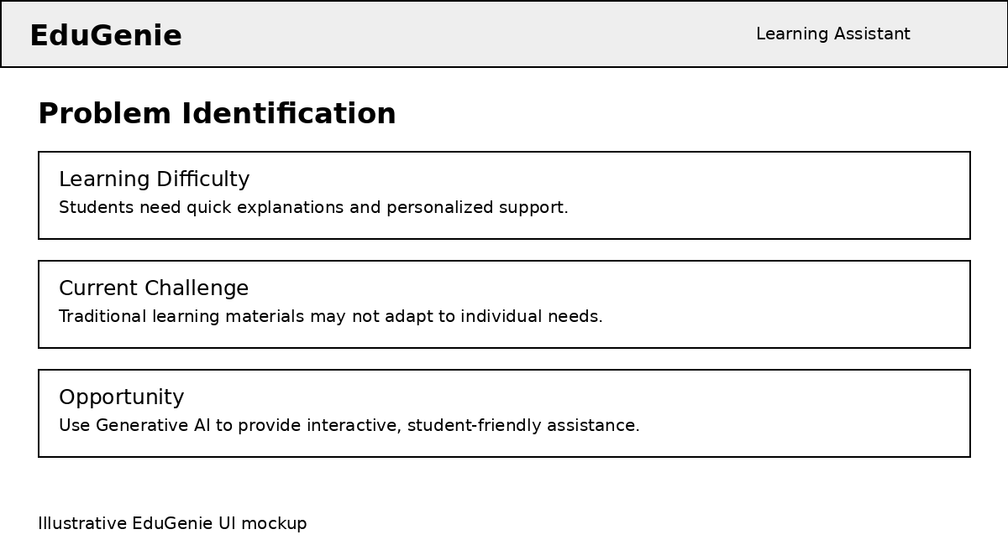
Related screenshot / illustrative project interface

3. Brainstorming
During brainstorming, several possible features were considered. These include an AI learning chat, personalized explanations, topic summaries, examples, quizzes, instant feedback, assessment generation and progress support. The ideas were compared based on usefulness, simplicity and feasibility.
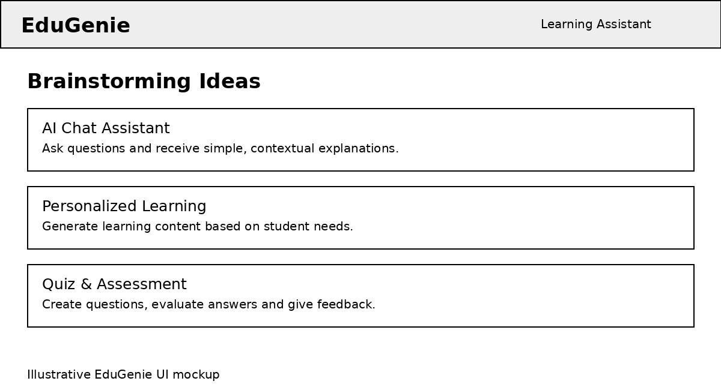
Related screenshot / illustrative project interface

4. Proposed Solution
The proposed solution is a Google Gemini powered learning assistant. A student enters a question or topic, the system processes the request using the AI model, and EduGenie presents a clear response. The system can also generate learning questions and feedback to make study more interactive.
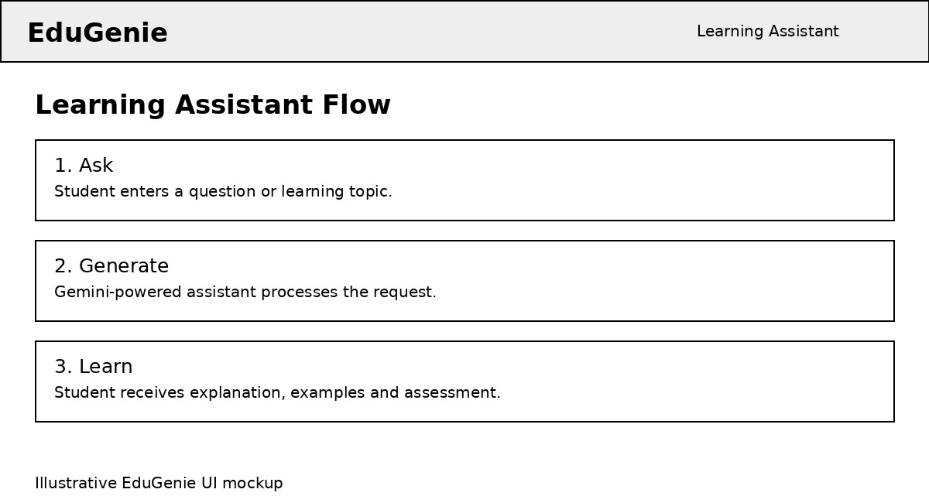
Related screenshot / illustrative project interface

5. Key Features
• AI-based question answering
• Simple topic explanations
• Personalized learning support
• Automatic quiz and question generation
• Instant answer feedback
• Learning examples and summaries
• User-friendly interface
• Support for continuous self-learning

6. User Needs and Target Users
The main target users are students who need quick and easy learning assistance. Teachers and educators can also use the concept to prepare questions, explanations and learning activities. The interface should be simple so that users can focus on learning instead of technical operations.

7. Assessment and Feedback
Assessment is an important part of EduGenie. The system can generate questions from a selected topic, accept student answers and provide immediate feedback. Explanations can help students understand why an answer is correct or incorrect and identify topics that require additional practice.
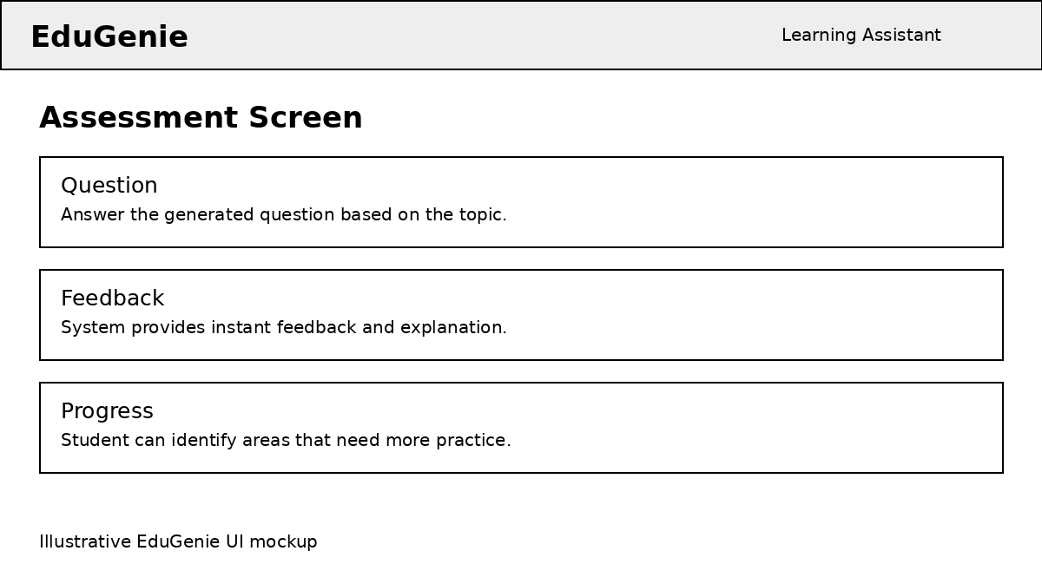
Related screenshot / illustrative project interface

8. Conclusion
The brainstorming and ideation process helped define EduGenie as a practical Generative AI learning assistant. By combining a simple user interface with Google Gemini based AI capabilities, the project can support interactive learning, personalized explanations and assessment. The final solution can be further improved with more learning features and user feedback.

