CAR PARKING SYSTEM USING IOT

NAME: PAVITHRA S

NM:au721221106066

EMAIL:21ecb05@karpagamtech.ac.in

DEVELOPMENT PART 2

APP: FIRST STEP CREATE BROKER

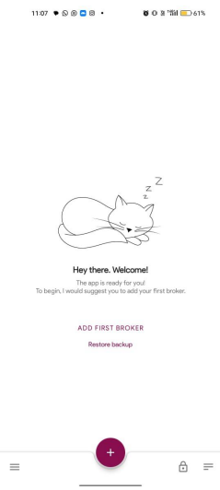

STEP 2:EDIT BROKER

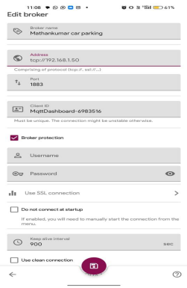

**STEP 3:**

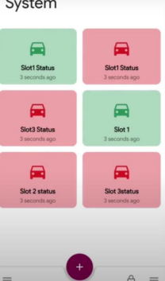

**PROGRAM:**

#!/usr/bin/python

import time

import RPi.GPIO as GPIO

import time

import os,sys

from urllib.parse import urlparse

import paho.mqtt.client as paho

GPIO.setmode(GPIO.BOARD) GPIO.setwarnings(False)

'''

define pin for lcd

'''

# Timing constants

E_PULSE = 0.0005

E_DELAY = 0.0005

delay = 1

# Define GPIO to LCD mapping LCD_RS = 7

LCD_E = 11

LCD_D4 = 12

LCD_D5 = 13

LCD_D6 = 15

LCD_D7 = 16

slot1_Sensor = 29

slot2_Sensor = 31

GPIO.setup(LCD_E, GPIO.OUT) # E GPIO.setup(LCD_RS, GPIO.OUT) # RS GPIO.setup(LCD_D4, GPIO.OUT) # DB4 GPIO.setup(LCD_D5, GPIO.OUT) # DB5 GPIO.setup(LCD_D6, GPIO.OUT) # DB6

GPIO.setup(LCD_D7, GPIO.OUT) # DB7

GPIO.setup(slot1_Sensor, GPIO.IN)

GPIO.setup(slot2_Sensor, GPIO.IN)

# Define some device constants

LCD_WIDTH = 16 # Maximum characters per line

LCD_CHR = True

LCD_CMD = False

LCD_LINE_1 = 0x80 # LCD RAM address for the 1st line

LCD_LINE_2 = 0xC0 # LCD RAM address for the 2nd line

LCD_LINE_3 = 0x90# LCD RAM address for the 3nd line

def on_connect(self, mosq, obj, rc):

self.subscribe("Fan", 0)

def on_publish(mosq, obj, mid):

print("mid: " + str(mid))

mqttc = paho.Client() # object declaration

# Assign event callbacks

mqttc.on_connect = on_connect

mqttc.on_publish = on_publish

url_str = os.environ.get('CLOUDMQTT_URL', 'tcp://broker.emqx.io:1883') url = urlparse(url_str)

mqttc.connect(url.hostname, url.port)

'''

Function Name :lcd_init()

Function Description : this function is used to initialized lcd by sending the different commands

'''

def lcd_init():

# Initialise display

lcd_byte(0x33,LCD_CMD) # 110011 Initialise

lcd_byte(0x32,LCD_CMD) # 110010 Initialise

lcd_byte(0x06,LCD_CMD) # 000110 Cursor move direction

lcd_byte(0x0C,LCD_CMD) # 001100 Display On,Cursor Off, Blink Off

lcd_byte(0x28,LCD_CMD) # 101000 Data length, number of lines, font size lcd_byte(0x01,LCD_CMD) # 000001 Clear display

time.sleep(E_DELAY)

'''

Function Name :lcd_byte(bits ,mode)

Fuction Name :the main purpose of this function to convert the byte data into bit and send to lcd port

'''

def lcd_byte(bits, mode):

# Send byte to data pins

# bits = data

# mode = True for character

# False for command

GPIO.output(LCD_RS, mode) # RS

# High bits

GPIO.output(LCD_D4, False) GPIO.output(LCD_D5, False) GPIO.output(LCD_D6, False) GPIO.output(LCD_D7, False) if bits&0x10==0x10:

GPIO.output(LCD_D4, True) if bits&0x20==0x20:

GPIO.output(LCD_D5, True) if bits&0x40==0x40:

GPIO.output(LCD_D6, True) if bits&0x80==0x80:

GPIO.output(LCD_D7, True)

# Toggle 'Enable' pin

lcd_toggle_enable()

# Low bits

GPIO.output(LCD_D4, False) GPIO.output(LCD_D5, False) GPIO.output(LCD_D6, False) GPIO.output(LCD_D7, False) if bits&0x01==0x01:

GPIO.output(LCD_D4, True) if bits&0x02==0x02:

GPIO.output(LCD_D5, True) if bits&0x04==0x04:

GPIO.output(LCD_D6, True)

if bits&0x08==0x08:

GPIO.output(LCD_D7, True)

# Toggle 'Enable' pin

lcd_toggle_enable()

'''

Function Name : lcd_toggle_enable()

Function Description:basically this is used to toggle Enable pin '''

def lcd_toggle_enable():

# Toggle enable

time.sleep(E_DELAY)

GPIO.output(LCD_E, True)

time.sleep(E_PULSE)

GPIO.output(LCD_E, False)

time.sleep(E_DELAY)

'''

Function Name :lcd_string(message,line)

Function Description :print the data on lcd

'''

def lcd_string(message,line):

# Send string to display

message = message.ljust(LCD_WIDTH," ")

lcd_byte(line, LCD_CMD)

for i in range(LCD_WIDTH):

lcd_byte(ord(message[i]),LCD_CHR)

lcd_init()

lcd_string("welcome ",LCD_LINE_1)

time.sleep(0.5)

lcd_string("Car Parking ",LCD_LINE_1) lcd_string("System ",LCD_LINE_2)

time.sleep(0.5)

lcd_byte(0x01,LCD_CMD) # 000001 Clear display # Define delay between readings

delay = 5

while 1:

# Print out results

rc = mqttc.loop()

slot1_status = GPIO.input(slot1_Sensor) time.sleep(0.2)

slot2_status = GPIO.input(slot2_Sensor) time.sleep(0.2)

if (slot1_status == False):

lcd_string("Slot1 Parked ",LCD_LINE_1) mqttc.publish("slot1","1")

time.sleep(0.2)

else:

lcd_string("Slot1 Free ",LCD_LINE_1) mqttc.publish("slot1","0")

time.sleep(0.2)

if (slot2_status == False):

lcd_string("Slot2 Parked ",LCD_LINE_2) mqttc.publish("slot2","1")

time.sleep(0.2)

else:

lcd_string("Slot2 Free ",LCD_LINE_2) mqttc.publish("slot2","0")

time.sleep(0.2)