FAULT TOLERANCE CLUSTERING OF SCIENTIFIC WORKFLOW WITH RESOURCE PROVISIONING IN CLOUD
Ponsy R.K. Sathiabhama, B.Pavithra
Department of ComputerTechnology
Madras Institute of Technology, Anna University, Chennai, India
'ponsy@mitindia.edu, 'pavithra3001@gmail.com

Abstract— Cloud computing environment has features that supports the computation of Scientific Workflows and provides easy deployment of workflows. Workflow is predefined ordered tasks executed based on its data dependency and control dependency. Scientific workflow consists of fine and coarse grained computational granularity tasks which are efficiently executed using task clustering. Task clustering is a proficient method which reduces the overhead caused due to execution and it enhances the computational granularity of scientific workflow tasks executed on distributed resources. Transient failures such as task failures in a job can have major impact on the runtime performance of workflow execution. Existing Fault Tolerant Clustering strategies are analysed in faulty execution environment. Besides task failure, hardware failure is also considered where the virtual machine failure occurs. Scheduling the workflows in cloud computing environment is an NP-Complete problem and it is challenging when tasks failures are considered. To overcome these failures, the workflow scheduling system should be fault tolerant. A clustering algorithm is proposed for resource provisioning to efficiently reduce resource wastage and system overhead. Among various Scientific Workflows, Montage Workflow with different number of tasks is taken for simulation to analyse the proposed work.

Index Terms—Scientific Workflows, Task Clustering, Task Failure, Fault Tolerance, Cloud computing, WorkflowSim

INTRODUCTION
Cloud computing offers easy access to high performance computing, storage infrastructure through web services. It provides considerable scalability, reliability and configurability along with high performance. Given the recent popularity of cloud computing, and the applicability of cloud computing to the scenario of data and computation intensive scientific workflow applications, there is an increasing demand to investigate scientific cloud workflow systems. Scientific cloud workflow systems support complex e-science applications such as disaster recovery simulation, earthquake modelling, weather forecast, astrophysics and high energy physics and climate modelling.
Workflows are defined as a set of computational tasks and a set of data or control dependencies between them. The workflows are represented as a Directed Acyclic Graph (DAG) in EXtended Markup Language (XML) based formats. Each node of the DAG represents an independent task or an application. The directed edge in the DAG represents an execution dependency among the tasks present in them. These are widely used by the scientific community to analyze and process large amounts of scientific data efficiently.
Workflow technology has been successfully used in business and scientific applications for many years.
• Business Workflows - Business workflows aim to automate and optimize an organization's processes administered by human or computer agents in an administrative context. The main purpose of building a workflow for companies is to enable customers to make better use of its services and gain profits from them. The main concerns are the workflow integrity and security.
• Scientific Workflows – Scientific workflows usually help scientists in streamlining knowledge-intensive activities in their experiments that are domain specific, especially in proving scientific goals or hypotheses. Such scientific processes are exploratory in nature and have new analysis methods that are rapidly evolved from initial ideas and preliminary workflow designs.
A DAG can be used to represent a set of programs where the input, output or execution of one or more programs is dependent on one or more other programs. The data flow and control flow of a workflow, where t is task and d is the data given as input to tasks is shown in Fig.1.
There are two types of dependency the edges can represent: control flow and data flow. Control flow graph made up of tasks and precedence constraints to control the flow. The tasks are the operations and the edges indicating the operations order. The data flow is not only the control, but also about the data that flows between and through the connections from one task to another and that drives the computation of the workflow.

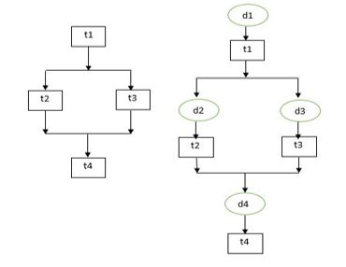

- Data Flow and Control Flow
The paper is organized as follows. In Section II the related work to our method is stated. Section III presents the summary of problem identified in the existing clustering mechanisms. Considered System model and fault tolerance classification is presented in IV and V. Our novel approach is explained in Section VI. The results of our experimental study are discussed in Section VII. The conclusion is drawn in Section VIII.

RELATED WORKS
In [1], Weiwei Chen et al (2016) proposed the dynamic estimation of parameters where the runtime data are collected during execution of workflow and updating the values for determining the clustering factor. These paper includes machine leaning technique namely maximum likelihood estimation for the prior knowledge to adjust parameter estimation. They consider the overhead-aware DAG (O-DAG) model for task clustering. Task clustering is mainly considered to reduce the system overhead during the execution of workflow. Retry is the fault tolerant technique used in clustering.
In [2], Weiwei Chen et al (2012) proposed the work for increasing the computational granularity for the execution of scientific workflows. They propose two failure modeling frameworks namely task failure model and job failure model. The overhead, runtime and failure parameters are analyzed to improve the makespan of the workflow execution.
In [3], Weiwei Chen et al (2013) proposed balancing methods for addressing the load balance problem for the execution of workflows. Three imbalance metrics namely task runtime variation, task impact factor and task distance variance are measured. The balance factors are mainly to provide a trade-off between runtime and data dependency balancing, such that these factors does not affect each other during the execution of workflow.
In [4], Jyoti Sahni et al (2016) focused more about the degree of parallelism among the tasks at the level of a workflow while also reducing the system overheads and resource wastage. They mainly consider two imbalance factors namely Runtime imbalance and dependency imbalance. Clustering algorithms are performed with imbalance factors and they aim to improve the runtime and load consolidation abilities of different approaches.
In [5], Anju Bala et al (2015) proposed a model that predicts the task failures using machine learning methodologies. They also provide the model for locating the actual failures after executing workflow in Cloud environment. They make a focus on designing intelligent task failure prediction model for proposing proactive fault tolerance, which is done by predicting task failures for scientific applications. The models have been implemented by using machine learning methods with the help of evaluated performance metrics. It also presents Naive Bayes approach with maximum prediction accuracy.
In [6], Gideon Juve et al (2013) considered different scientific workflows for assessing their performance. Six workflows are considered like astronomy, bioinformatics and earthquake science and gravitational-wave physics. The tasks that are available for computation are analysed. The I/O intensive, memory intensive and computational intensive characteristics are observed for every workflow considered. It also includes the analysis of inefficiency caused during execution by different factors. The profiling of such workflows can be useful for selecting algorithms for scheduling and resource provisioning and further analysis of workflow performance in different environments.
In [7], Rodrigo N. Calheiros et al (2014) offered an algorithm which uses unused time of provisioned resources and budget excess to replicate tasks. The proposed algorithm increases the possibility of meeting deadlines and reduces the total execution time of applications. It uses cloud infrastructures where the applications are workflows with deadline constrained and resources are of dynamically allocated. They propose strategies for correcting the delays which are caused by undervaluing the execution time of the tasks or performance of the resources used.
In [8], Sucha Smanchat et al (2015) discussed the taxonomy of scheduling problem and techniques which are proposed based on systematic analysis. The scheduling classifications that are unique to workflow namely, scheduling of the process, task and resource are given. The resources considered are virtual machine instances. The structure of the workflow is given more importance because of dependencies between them and also considers the difficulties in processing them in parallel instances. In order to estimate workflow makespan, cost and for finding the critical path of the workflow, the structure of the workflow plays an important role.
In [9], Marta Mattoso et al (2015) proposed a taxonomy where the issues in dynamic steering of high performance computing are identified for scientific workflows. The main notions are workflow lifecycle, user support for real-time monitoring, interference, analysis and notification by adjusting the workflow execution at runtime. They also explained the challenges and the potential of dynamically exploring workflows to improve the execution, maintaining the provenance data of the workflows. Dynamic workflow features namely adaptive and user-steered workflows are helpful in Large-scale experiments. It also studied fine-tuning adjustments made during the execution of HPC workflows.
In [10], Weiwei Chen et al (2012) proposed a simulator named WorkflowSim, which extended the existing CloudSim simulator by providing a higher layer of workflow management. The simulator assists in workflow optimization techniques by considering system overheads and failures in simulating scientific workflows.
In [11], Rodrigo N. Calheiros et al (2010) proposed a simulation tool called Cloudsim that supports workflow execution and was the predecessor of the workflowsim tool. It simulates and models cloud computing systems for different application providing environments. The CloudSim toolkit supports both system modelling and behaviour modeling of cloud system components such as data centres, VMs and resource provisioning policies. It is a suitable research tool that can handle the system overheads and complexities arising from simulated environments.
In [12], Ewa Deelman et al (2015) described about the design, development and evolution of the Pegasus Workflow Management System where workflows from different scientific domains like astronomy, seismology and bioinformatics are considered. It mainly focuses to achieve scalable and reliable execution of workflows across different computing infrastructures. It supports large-scale applications with I/O intensive, data intensive, computation intensive workflows. It also supports platforms such as Grid and cloud.
In [13], Yi Gu et al (2016) proposed analytical cost models and formulated workflow mapping as optimization problems for minimum end-to-end delay and maximum frame rate. A mapping algorithm was offered to minimize the latency based on a recursive critical path optimization procedure. Simulation based comparisons with existing algorithms are performed with large-scale experiments. It also used real time scientific workflows through active system implementation and deployment in real networks.

PROBLEM DESCRIPTION
Clustering of scientific workflows is efficient method of executing the workflow. The fault tolerant clustering techniques used in horizontal clustering are utilised and used for proposed hybrid clustering to reduce the increase in execution time caused due to the overheads. The fault tolerant algorithms used are executed in dynamic environment where the parameter values are observed during the runtime of the workflows. Cluster size k is the important factor which is used in the clustering. With the above factors the makespan of the workflow execution is reduced. Along with the transient failure, the the hardware failure VM failure is also included.

SYSTEM MODEL
A workflow is represented in DAG. In DAG representation, the nodes in the graph represent the workflow task and dependencies between the tasks are represented by the edges connecting the nodes, where the dependencies give the order in which the tasks are executed.
The output produced by the tasks in nodes are given as input to another task in node as input in the execution of the workflow. The data-flow dependencies are represented as the input and output files in the workflow. Each task is considered as a program and a set of parameters which is needed to be executed.
A typical example of workflow execution environment is shown in Fig.2. The host which submits the workflow for execution also prepares worker nodes and an execution site where the jobs are executed separately.
The main components in the system are described as follows:
- Workflow Mapper
Workflow Mapper performs a process called Task Clustering. Task Clustering is a process where more than one task is combined together to form a single job based on different characteristics to reduce the system overhead which is caused during the execution of workflow. This type of merging is done by Workflow Mapper.
Workflow Mapper is responsible for generating the workflow that is executable in provided environment, which was delivered by the user. It also does the functionalities such as to get required data, identifying the software and to determine the required resources for the execution.
Workflow Mapper generates tasks list and allocates these tasks to an execution site for proper resource. It is done by importing the DAX file and other additional information from metadata such as number of input files, number of child tasks for particular task, file size of the task and so on. This above mentioned data are obtained from Workflow Generator.
- Local Execution Engine
Engine executes the jobs in the workflow. The workflow is executed in the order of the dependencies between the tasks. The Clustering Engine considers only the tasks that are free in the workflow engine and also should confirm the constraint required for clustering.
The waiting time required by the job in the execution engine is called as workflow engine delay. It is also given by the time required, when a job submitted from job scheduler till they are executed. The Workflow Engine takes care of the dependencies between the tasks and confirms whether the parent task has been completed before the child task are executed.
- Job Scheduler and Local Queue
Job scheduler directs the execution of job on the local and remote resources and also manages individual jobs in the workflow.
The time taken for the workflow engine to submit the job in the local queue and the time taken for the job scheduler to supervise the job running is stated as Queue delay. The queue delay provides efficiency of the job scheduler. The resource required for the execution of jobs in the workflow is an important factor for the calculation of queue delay.
- Clustering Engine
The system overhead is greatly reduced by the clustering of tasks based on several factors. This clustering of several tasks as jobs is done by the clustering engine. The job is considered as an entity where it has multiple tasks grouped together which can be executed either in a parallel or in sequential manner.
- Workflow Scheduler
Workflow scheduler schedules the job of the workflow to be executed to the worker node where the resources required for the job execution is allocated. The scheduling is done based on the conditions provided by the users.
- Failure Generator
It generates failures such as task failure, job failure and VM failure in the execution environment at different layers. The failures are generated after the job execution. The generation of failure is done using different mathematical distributions where the average failure rate considered is provided by the user.
- Failure Monitor
The monitor gathers the failure records of the job which include job id, task id and VM id or resource id while the execution of workflow is ongoing. These records are further transferred to the engine where the changes in the scheduling of the job are modified dynamically.
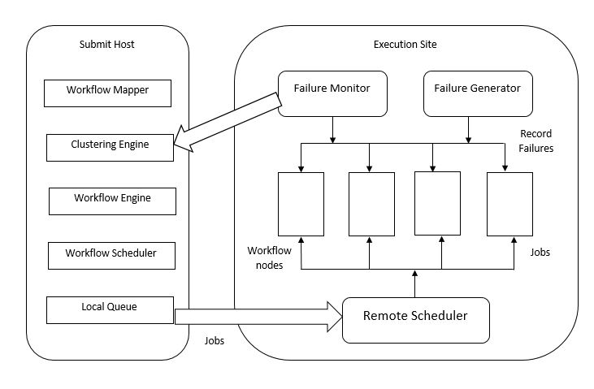Fig.2. Workflow Execution Environment

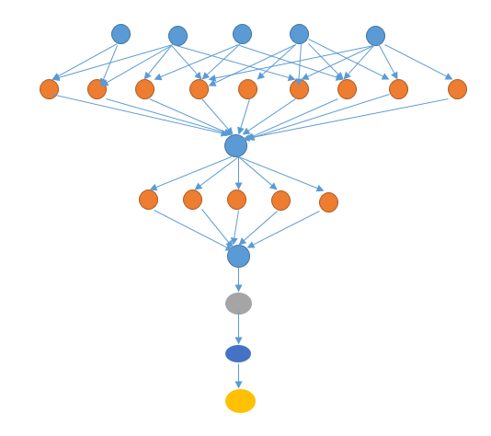

Fig.3. Montage Workflow with 25 nodes

SYSTEM MODEL
The cloud environment in our system model has a single data center that provides heterogeneous Virtual Machine (VM) resource types, VT = vt1, vt2, ..., vt_{m} where m is the number of virtual machines Each VM type has a specific configuration with respect to memory, CPU. A static VM start up time is not assigned to all VMs, but is influenced by the start time of the task in the dataset.

Fault tolerance classification

A fault or failure can be either a hardware defect or a software or programming mistakes. The failure in workflow execution can occur for various reasons namely the variation in the configuration of execution environments, services non-availability or software components non-availability, system running out of memory, overloaded resource conditions and faults in computational and network components.
Based on fault tolerance policies various fault tolerance techniques can be used that can either be task level or workflow level. Reactive policies reduce the effect of failures after the fault has occurred and it does not stop the failure from occurring. There are different techniques are available for fault tolerance as shown in the Fig.4.
- Task-level techniques cover the effects of the failure of tasks in the workflow execution. They are as follows-
- Retry- The task that are failed are retried in the same cloud resource. It is the simplest technique in task level.
- Check pointing/ Restart -For long running applications, this method is most efficient task level fault tolerance technique. When a task fails, the system state can be rolled back to the checkpoint and allowed to continue from that point, rather restarting the application from the beginning.
- Replication- The entire workflow is replicated and different replicas are run on different resources till the workflow is completed even when some failures occurs during execution. Replication is a method of maintaining different copies of a data item or object on different resources. Replication adds redundancy in the system.
- Job Migration-When task failure occurs during execution, tasks can be migrated to another machine.
- Task Resubmission-Whenever a failed task is detected during execution of workflows, the task is resubmitted either to the same or to a different resource at runtime without interrupting the workflow of the system.
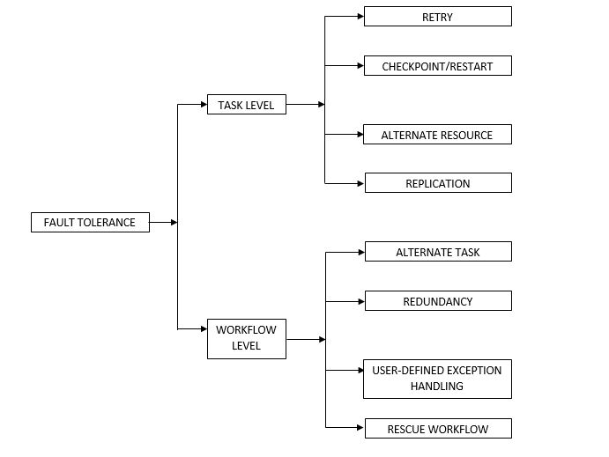Fig.4. Taxonomy of Fault tolerance methods.

The workflow-level techniques deploy the workflow structure such as execution flow to deal with failures or flawed conditions.
- Alternate Task- In case of the task failure, different implementation of the task if the previous task failed in the execution of the workflow.
- Redundancy-Multiple alternative tasks are executed simultaneously in this technique.
- User defined exception handling-During task failure for workflows, the user specifies what treatment should be given for that particular task failure.
- Rescue workflow-This technique allows the workflow to proceed, if the task fails and is executed until it becomes impossible to move forward without catering the failed task.
FAILURE MODEL
To analyze the system overhead Gamma distribution and Weibull distribution are used. Two important parameters namely shape parameter and size parameter along with inter arrival time are considered.
The Gamma distribution is used for modeling the system overhead and task runtime whereas the Weibull distribution is responsible for inter arrival time. This distribution is used to find k where k is the number of tasks in a cluster is estimated using Maximum Likelihood Estimation (MLE).
The system overheads are mainly considered for execution since O-DAG is used. The overheads along with task failures are used. The static execution environment uses the fixed parameter values along with fixed overhead values. In dynamic execution the parameters for calculating MLE is not fixed, because the values are calculated at runtime providing the dynamic execution of the workflows.
This model mainly overlooks the optimal clustering size k* for execution and it is calculated using MLE. The inter-arrival time of the failures is a main factor to calculate k*. The overhead includes system overhead like queue delay, data transfer delay and so on.

PROPOSED WORK
The workflow is given input in XML format and is submitted to the workflow management system. In the system, it is sent to mapper, engine and scheduler after which the tasks are executed. The proposed architecture as shown in Fig.5, when task failure occurs the fault tolerance is done using clustering and scheduling.
Task clustering has been widely used for reducing system overheads effect involved in running fine grained tasks on distributed platforms.
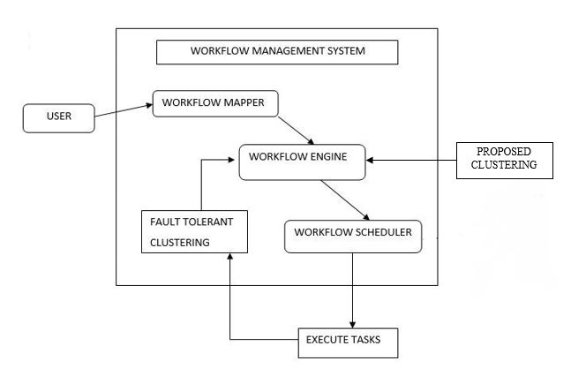
Fig.5. Architecture of Proposed work

Task clustering techniques may be categorized into two broad sorts namely Horizontal and Vertical Clustering.
Horizontal clustering tasks are merged at the same horizontal level of the workflow graph, where level or depth of a task t is defined as the longest distance from the entry tasks to task t. Vertical clustering, on the other hand, tasks at sequential levels which have a single parent and single child relationship are merged.
Dynamic Clustering (DC) adjusts the clustering factor according to the task failure rates measured from jobs that have already been completed, either successfully or failed which is usually the average value of task failure records.

FAULT TOLERANCE CLUSTERING ALGORITHMS
Selective Reclustering (SR) selects the tasks that are failed during execution in a clustered job and clusters them into a new clustered job or considers them as individual jobs. SR involves collecting the task ids in failure records.

Selective Reclustering
Input: W: workflow; N: max number of tasks in a job
Output: Set of clustered tasks executed along with their execution time
Procedure SELECTIVE_RE_CLUSTERING (Jc)
- TL←GETTASKS(Jc)
- Jnew ←{}
- for all tasks t in TL do
- if t is failed then
- Jnew .add(t)
- end if
- end for
- Wf←Wf+Jnew
- end procedure

In Dynamic Reclustering (DR), both the algorithms SR and DC are combined together. This algorithm is used to check whether using both strategies can improve workflow performance. Only tasks which are failed during execution are included into new clustered jobs in DR and the clustering factor k, is also adjusted according to the detected task failure rates.

Dynamic Reclustering
Input: W: workflow; N: max number of tasks in a job
Output: Set of clustered tasks executed along with their execution time
Procedure DYNAMIC_RE_CLUSTERING (J_{c})
- TL←GETTASKS(J_{c})
- J_{new} ← {}
- for all tasks t in TL do
- if t is failed then
- J_{new} .add(t)
- end if
- if J_{new} .size()>k* then
- Wf←Wf+J_{new}
- J_{new ←{}}
- end if
- end for
- Wf←Wf+J_{new}
- end procedure

The above algorithm uses retrying technique of fault tolerance mechanisms that are performed during the execution of scientific workflows.
The proposed Hybrid clustering algorithm performs horizontal clustering and also forms clusters when there is a one parent one child relationship between the tasks.
Thus when the tasks that have one parent one child relationship are clustered together and executed in the same VM. This algorithm also reduces the resource utilization of VM, where in Horizontal Clustering the tasks with the one parent one child relationship is executed as separate tasks with separate VM allocated for them.

Hybrid clustering Algorithm
Input: : Wf: workflow; N: max number of tasks in a job
Output: Set of clustered tasks executed along with their execution time
Procedure HYBRID_CLUSTERING (Wf,N)
- for level <Dep(Wf) do
  - TL←TASKS_IN_LEVEL(Wf,level)
  - CL←MERGE(TL,N)
  - Wf←Wf-TL+CL
- end for
- end procedure
- Procedure Merge(TL,N)
- J_{c}←{}
- CL←{}
- While TL is not null do
  - J_{c}.add(TL.pop(N))
  - CL.add(J_{c})
  - for all t in TL do
  - J_{c}←{t}
  - while t has only 1 child tchild and tchild has only1 parent do
  - J_{c}.add (tchild)
  - TLmerged← TLmerged + tchild
  - t←{} tchild
  - end while
  - CL.add(J_{c})
  - end for
- End while
- Return (CL,TLmerged)
- end procedure

Procedure RE_CLUSTERING (J_{c})
- J_{new}←CopyOf J_{c}
- Wf←Wf+J_{new}
end procedure

VII. EXPERIMENTAL RESULTS
The code is executed in Workflowsim simulation tool. The fault tolerance algorithm namely horizontal clustering, selective reclustering and dynamic reclustering are executed. The dataset considered is Montage workflow with 25 tasks which is a DAG file in XML format. The factor k is the clustering size of tasks t in workflow execution. Along with 25 tasks, 50, 100, 1000 tasks are considered as datasets. Both clustering algorithms with various cluster sizes namely 2, 3, 5 are considered with the datasets containing different number of tasks are simulated 20 times.
The workflow execution using SR algorithm, here the cluster size does not change itself to produce optimized results. The above Fig. 5.1 shows the montage workflow execution with cluster size 3 where the fault tolerance occurs in horizontal clustering which is followed by SR algorithm respectively. The following Fig.6 shows the same dataset execution with cluster size k=5 using SR algorithm.

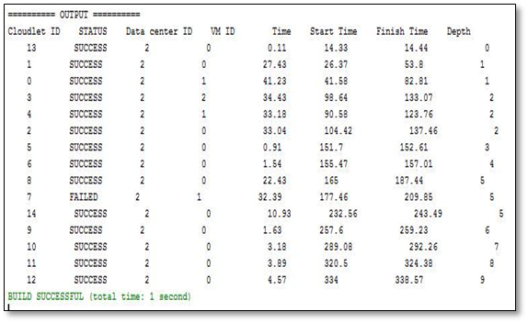
Fig.6 Execution of workflow with 25 nodes
HORIZONTAL CLUSTERING RESULTS
The following results are for horizontal clustering with SR and DR algorithms. The montage workflow is considered with different set of tasks with 25, 50, 100, 1000 tasks and are executed using horizontal clustering and for fault tolerance clustering SR algorithm is used
Table 1.1. SR in Horizontal Clustering
Montage Workflow | cluster size_2 | cluster size_3 | cluster size_5
25 tasks | 405.1615 | 428.5755 | 572.199
50 tasks | 515.378 | 609.399 | 677.671
100 tasks | 781.6425 | 873.3045 | 939.918
1000 tasks | 3580.583 | 3054.619 | 3047.884
. The table 1.1 shows the execution of montage workflow with different clustering sizes.
Table 1.2. DR in Horizontal Clustering
Montage Workflow | cluster size_2 | cluster size_3 | cluster size_5
25 tasks | 347.419 | 378.945 | 452.657
50 tasks | 492.068 | 558.84 | 557.967
100 tasks | 782.442 | 705.725 | 672.767
1000 tasks | 3481.6 | 3096.93 | 2529.84
The table 1.2 shows the execution of montage workflow with different clustering sizes with k value 2, 3, 5 clusters using DR method.

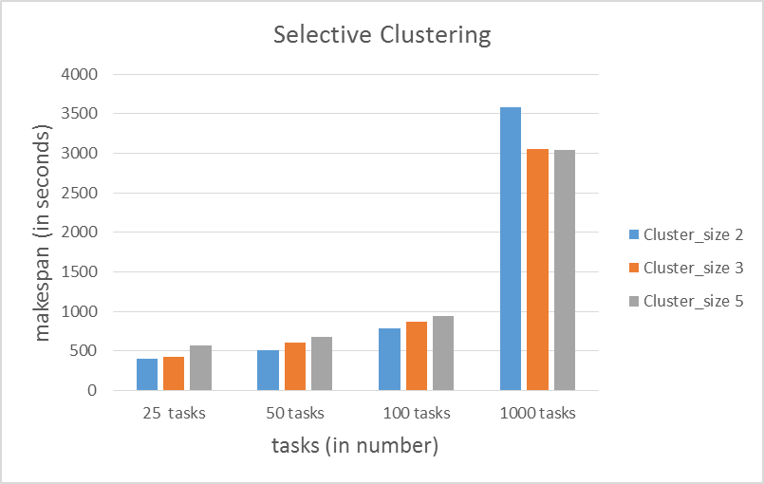
Fig.7 Graph for SR in Horizontal Clustering

The graphical representation of the performance of SR clustering, when executing montage workflow as fault tolerant technique while performing horizontal clustering is shown in Fig.7
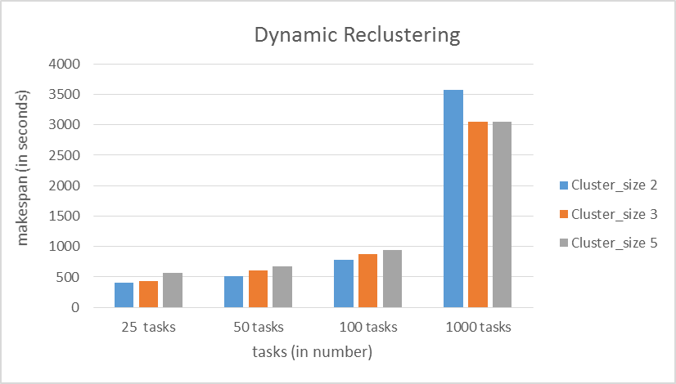
Fig.8. Graph for DR in Horizontal Clustering
The graphical representation of the performance of SR clustering, when executing montage workflow as fault tolerant technique while performing hybrid clustering is shown in Fig.10.

HYBRID CLUSTERING RESULTS
The following results are for proposed hybrid clustering with SR and DR algorithms. The same montage workflow dataset is considered with different set of tasks with 25, 50, 100, 1000 tasks and are executed using horizontal clustering and for fault tolerance clustering SR algorithm is used. The table 1.3 shows the execution of montage workflow with different clustering sizes.
Table 1.3. SR in Hybrid Clustering
Montage Workflow | cluster size_2 | cluster size_3 | cluster size_5
25 tasks | 114.831 | 144.13 | 213.796
50 tasks | 123.147 | 166.402 | 231.69
100 tasks | 176.348 | 217.248 | 306.96
1000 tasks | 1487.55 | 1829.91 | 2254.309
The table 1.4 shows the execution of montage workflow with different clustering sizes with k value 2, 3, 5 clusters. It shows the performance of Hybrid clustering with DR algorithm.
Table 1.4. DR in Hybrid Clustering
Montage Workflow | cluster size_2 | cluster size_3 | cluster size_5
25 tasks | 143.19 | 194.04 | 348.45
50 tasks | 159.86 | 211.99 | 496.77
100 tasks | 247.28 | 350.9 | 651.52
1000 tasks | 3,067.59 | 3,556.20 | 3,299.64
The graphical representation of the performance of SR clustering, when executing montage workflow as fault tolerant technique while performing hybrid clustering is shown in Fig.9.

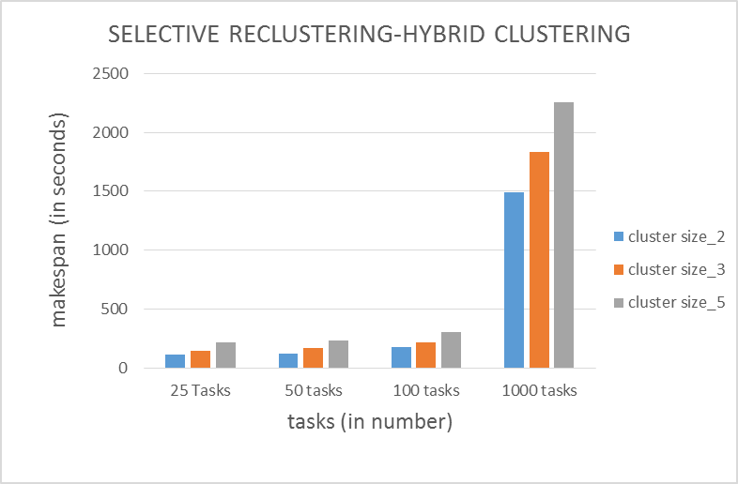
Fig.9. Graph for SR in Hybrid Clustering
The graphical representation of the performance of SR clustering, when executing montage workflow as fault tolerant technique while performing hybrid clustering is shown in Fig.10.

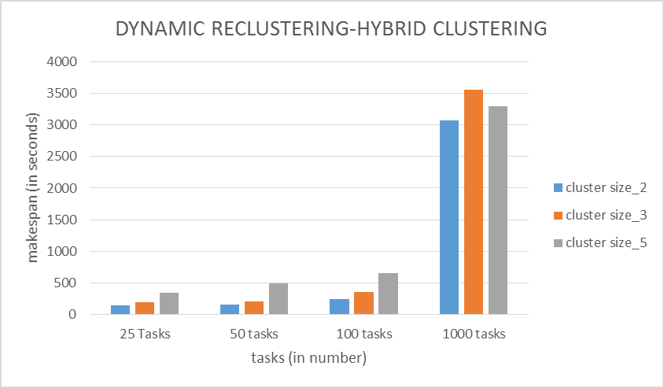 Fig.10. Graph for DR in Hybrid Clustering

The Performance of the horizontal clustering algorithm with SR algorithm and DR algorithm for Montage workflow with different tasks are discussed. The proposed hybrid clustering algorithm with SR and DR algorithm are also discussed. In Our proposed work the timespan is reduced considerably and the number of VM required for workflow execution is also reduced.

VIII. Conclusion And Future Enhancement
Clustering of scientific workflows is efficient method of executing the workflow. The fault tolerant clustering only includes transient failures particularly task failure. Along with the transient failure, the hardware failure VM failure is also included. The hardware failure disrupts the workflow scheduling execution. As future work, different machine learning techniques can be applied for clustering the tasks in workflow and different fault tolerance techniques in task level such as checkpoint, replication and other techniques can be employed for improvement in execution level of workflows.

REFERENCES
- Weiwei Chen, Rafael Ferreira Da Silva, Ewa Deelman and Thomas Fahringer (2016), ‘Dynamic And Fault-tolerant Clustering For Scientific Workflows’, IEEE Transactions On Cloud Computing, vol. 4, no. 1, pp.49-62.
- Weiwei Chen and Ewa Deelman (2012), ‘Fault Tolerant Clustering in Scientific Workflows’, IEEE Eighth World Congress on Services, pp.10-16.
- Weiwei Chen, Rafael Ferreira Da Silva, Ewa Deelman and Rizos Sakellariou (2013), ‘Balanced Task Clustering in Scientific Workflows’ , IEEE 9th International Conference on e-Science, pp.188-195.
- Jyoti Sahni and Deo Prakash Vidyarthi (2016), ‘Workflow-and-Platform Aware task clustering for scientific workflow execution in Cloud environment’, Elsevier Future Generation Computer Systems, vol.64, pp.61-74.
- Anju Bala and Inderveer Chana (2015), ’Intelligent failure prediction models for scientific workflows’, Elsevier Expert Systems with Applications, vol.42, pp.980-989.
- Gideon Juve , Ann Chervenak, Ewa Deelman, Shishir Bharathi, Gaurang Mehta and Karan Vahi (2013), ‘Characterizing and profiling scientific workflows’, Future Generation Computer Systems , vol.29 , pp.682–692.
- Rodrigo N. Calheiros, Rajkumar Buyya (2014), ‘Meeting Deadlines of Scientific Workflows in Public Clouds with Tasks Replication’, IEEE Transactions on Parallel and Distributed Systems, vol.25, no.7, pp.1787-1796.
- Sucha Smanchat and Kanchana Viriyapant (2015), ‘Taxonomies of workflow scheduling problem and techniques in the cloud’, Future Generation Computer Systems, vol.52, pp.1–12.
- Marta Mattoso, Jonas Dias, Kary A.C.S. Ocana, Eduardo Ogasawara, Flavio Costa,Felipe Horta, Vitor Silva and Daniel de Oliveira (2015), ‘Dynamic steering of HPC scientific workflows: A survey’, Future Generation Computer Systems, vol.46, pp.100–113.
- Weiwei Chen and Ewa Deelman (2012), ‘WorkflowSim: A Toolkit for Simulating Scientific Workflows in Distributed Environments’, IEEE 8th International Conference on E-Science, pp.1-8.
- Rodrigo N. Calheiros, Rajiv Ranjan, Anton Beloglazov, Cesar A. F. De Rose and Rajkumar Buyya (2011), ‘CloudSim: a toolkit for modeling and simulation of cloud computing environments and evaluation of resource provisioning algorithms’, Software: Practice Experience, vol.41, no.1, pp. 23–50.
- Ewa Deelman, Karan Vahi, Gideon Juve, Mats Rynge, Scott Callaghan, Philip J. Maechling, Rajiv Mayani, Weiwei Chen, Rafael Ferreira da Silva, Miron Livny and Kent Wenger (2015), ‘Pegasus, a workflow management system for science automation’, Future Generation Computer Systems, vol.46, pp.17–35.
- Yi Gu and Chase Qishi Wu (2016), ‘Performance Analysis and Optimization of Distributed Workflows in Heterogeneous Network Environments’, IEEE Transactions on Computers, vol. 65, no.4, pp.1266-1282.
- Bhaskar Prasad Rimal and Martin Maier (2017), ‘Workflow Scheduling in Multi-Tenant Cloud Computing Environments’, IEEE Transactions on Parallel And Distributed Systems, vol.28, no.1, pp.290–304.
- Fan Zhang, Junwei Cao, Kai Hwang, Keqin Li and Samee U. Khan (2015),‘Adaptive Workflow Scheduling on Cloud Computing Platforms with Iterative Ordinal Optimization’,IEEE Transactions On Cloud Computing, vol.3, no.2, pp.156-169.
- Hamid Mohammadi Fard, Radu Prodan, and Thomas Fahringer (2013), ‘A Truthful Dynamic Workflow Scheduling Mechanism for Commercial Multicloud Environments’,IEEE Transactions On Parallel And Distributed Systems, vol. 24, no. 6, pp.1203-1213.
- Jia Zhao, Kun Yang, Xiaohui Wei, Yan Ding, Liang Hu, and Gaochao Xu (2016), ‘A Heuristic Clustering-Based Task Deployment Approach for Load Balancing Using Bayes Theorem in Cloud Environment, IEEE Transactions On Parallel And Distributed Systems, vol. 27, no. 2, pp.305-317.

- Mateusz Z otkiewicz, Mateusz Guzek, Dzmitry Kliazovich ad Pascal Bouvry (2016), ‘Minimum Dependencies Energy-Efficient Scheduling in Data Centers’, IEEE Transactions On Parallel And Distributed Systems, vol.27, no. 12, pp.3561-3575.
- Xiaomin Zhu, Ji Wang, Hui Guo, Dakai Zhu, Laurence T. Yang and Ling Liu (2016), ‘Fault-Tolerant Scheduling for Real-Time Scientific Workflows with Elastic Resource Provisioning in Virtualized Clouds’, IEEE Transactions on Parallel and Distributed Systems, vol. 27, no. 12, pp.3501-3517.
- Yong Zhao, Youfu Li, Ioan Raicu , Shiyong Lu, Wenhong Tian and Heng Liu (2015), ‘Enabling scalable scientific workflow management in the Cloud’, Future Generation Computer Systems, vol.46, pp.3–16.

